Insights into the binding mechanism of polyphenols and fish myofibrillar proteins explored using multi-spectroscopic methods

Wanlin Xie ª; Yuan Huang ª; Yuanzhi Xiang ª; Shanbai Xiong ^{a, b}; Anne Manyande ^{c}; Hongying Du ^{a, b,} *

ª Key Laboratory of Environment Correlative Dietology, Ministry of Education, College of Food Science and Technology, Huazhong Agricultural University, Wuhan, Hubei, P.R. China;
^{b} National R & D Branch Center for Conventional Freshwater Fish Processing, Wuhan, 430070, Hubei, P.R. China;
^{c} School of Human and Social Sciences, University of West London, Middlesex, TW8 9GA, UK;

*: Corresponding author
Hongying Du: Email: hydu@mail.hzau.edu.cn; Tel: +86-27-87283007.
Abstract: As the most abundant protein existing in fish, myofibrillar protein (MP) is likely to hydrolyze which affects the quality of fish during preservation. Polyphenols, which are some of the most popular antioxidants and antimicrobials, have been widely used in freshwater fish preservation and storage to prevent protein degradation. However, their binding behavior and mechanism is still unclear. In this study, the binding mechanisms of two types of polyphenols (Chlorogenic acid: CGA; Quercetin: QUE) and MP extracted from grass carp were investigated through multi-spectroscopic methods. Different spectroscopic methods (fluorescence spectroscopy and synchronous fluorescence spectroscopy) were used to explore the interaction modes between polyphenols and fish extracted MP. In addition, circular dichroism spectroscopy was used to detect microstructure changes of MP under different preservation approaches. Results showed that nanocomposites were generated when MP interacted with either CGA or QUE. The addition of CGA did not affect the α-helix content of MP, whereas QUE diffused the β-turns of myofibrillar proteins and promoted the formation of α-helices. At the same time, the fluorescence quenching effect of CGA/QUE on MP was static quenching, and the binding constants, number of binding sites and corresponding thermodynamic parameters of MP were calculated. It was concluded that the binding of CGA to MP depends on Van der Waals forces and hydrogen bonds, while QUE binds to MPs on the basis of electrostatic interactions. In addition, the fluorescence quenching of MPs with CGA is related to tryptophan and tyrosine residues, while the fluorescence quenching effect of QUE on MPs is related only to tryptophan residues.
Key words: Myofibrillar protein; Polyphenols; Interaction; Fluorescence; Circular dichroism;
1. Introduction
Freshness is one of the most important factors that defines the market value of aquatic products. Due to its abundant protein and fats, fresh fish is very easily perishable, and its shelf life lasts only a few days. A series of autolytic processes always start just after fishing, which would generate favorable conditions for bacterial growth causing further deterioration (García et al. 2017; Fidalgo et al. 2019). Therefore, the preservation of perishable freshwater fish is a very significant problem worldwide. Protein degradation and lipid oxidation are the two key factors which cause the decrease in the quality of aquatic products during storage. Protein degradation could lead to worse textural characteristics, and to some extent reduce the processing applicability of the raw material (Subbaiah et al. 2015). Lipid hydrolysis and oxidation often occur during the storage of freshwater fish (Cao et al. 2019), dry-salted fish (Guo et al. 2019), mussel (Zhou et al. 2019b), seafood (Mariutti and Bragagnolo 2017) etc., which could induce an increase in peroxide value (POV), thiobarbituric acid reactive substances (TBARS) and total oxidation (TOTOX) and a decrease in eicosapentaenoic acid (EPA) and docosahexaenoic acid (DHA) (Zhou et al. 2019a).
Many methods are utilized in fish storage to reduce the spoilage of fish, such as antioxidants, freezing, cold storage, ice storage, chilled storage, modified-atmosphere packaging (Sampels 2015; Tolstorebrov et al. 2016b; Ghaly et al. 2010; López-García et al. 2014), high pressure (Norton and Sun 2008), etc.. Among these methods, natural antioxidants have been widely used in aquatic products. Many studies have reported their effectiveness in reducing protein and lipid deterioration (Zhao et al. 2019; Bu et al. 2017; Li et al. 2012). Among these antioxidants, polyphenols are commonly used in preserving aquatic products, which could be directly extracted from natural products (Jiang et al. 2019; Sánchez-Zapata et al. 2013; Ozogul and Uçar 2013). For example, tea polyphenols infused with sodium alginate coating effectively improved the quality of fresh Japanese sea bass fillet during refrigerated storage (Nie et al. 2018); Extracts obtained from grape seed, sage and oregano significantly inhibited lipid oxidation and fishy odor generation of hairtail fish balls (Guan et al. 2019). Fish gelatin combined with grape seed extract inhibited protein oxidation and degradation, and showed better quality and freshness than the control group (Zhao et al. 2019); Several natural plant extracts were also utilized to maintain the good quality of the frozen chub mackerel (scomber japonicus) burgers (Ozogul and Uçar 2013); extractions from fruit peels were utilized for preserving goat fish parupenaeus indicus (Paari et al. 2012); Olive leaf supplementation was applied to food preservation in different food industries (Souilem et al. 2017). However, the mechanism of the preservation effects of polyphenols is unknown, and still needs to be investigated.
Fish proteins are an important source of nutrition and provide flavor in freshly harvested aquatic products (Ashie et al. 1996). Nonetheless, fish proteins are inevitably prone to hydrolysis during preservation, which can hydrolyze proteins and release peptides or free amino acids (FAC) (Hultmann and Rustad 2004; Tolstorebrov et al. 2016a; Zheng et al. 2019). The occurrence of this phenomenon definitely affects the edibility and nutritional value of the protein. Therefore, besides the main problems of microbial development, the inhibition of protein degradation and oxidation has attracted more and more attention, as it also affects the economic performance of aquaculture and fisheries (Yang et al. 2019; Bouletis et al. 2017). In previous studies of fish storage, myofibrillar protein (MP) degradation has been reported as one important factor that leads to quality deterioration of aquatic products (Lu et al. 2017; Ge et al. 2018). Thus, the aim of the present study was to explore the binding mechanism of the interactions between polyphenols and fish MP performed using fluorescence, circular dichroism, and ultraviolet techniques. This study expects to offer some new insights into understanding the preservation mechanism of polyphenols, and support some theoretical basis for the design of preservatives of fresh aquatic products.

2. Materials and methods
2.1 Materials
Fresh grass carp (~4kg) was purchased from the local market in Huazhong Agricultural University (Hubei, China). Fish was gutted, cleaned, filleted and mechanically deboned. The dorsal white muscle samples were frozen in liquid nitrogen and kept at -80 °C until used for the extraction of myofibrillar proteins.
Chlorogenic acid (CGA) was purchased from Dalian Meilun Biotechnology Co., Ltd (Dalian, China) and quercetin (QUE) from Shanghai Yuanye Biotechnology Co., Ltd (Shanghai, China). All chemicals used in the present study were of analytical grade and purchased from Sinopharm Chemical Reagent Co., Ltd (Shanghai, China).
2.2 Myofibrillar Protein extraction
MP was extracted from grass carp (n = 3) as described in our previous work (Sun et al. 2014). Briefly, dorsal white fish muscle was minced and rinsed in a low-salt phosphate buffer (0.05 mmol/L NaCl, 3.38 mmol/L NaH₂PO₄, 15.5 mmol/L Na₂HPO₄, pH=7.5) to remove water-soluble protein and other substances using a homogenizer (T18 digital ULTRA TURRAX, IKA, Germany) and a refrigerated centrifuge (Avanti J-26 XP, Beckman Coulter, CA, USA). Then the obtained pellets were extracted at 4℃ in a high salt phosphate buffer (0.45 mmol/L, pH=7.5). After centrifugation, the supernatant was poured into deionized water at 4℃ to precipitate MP. Finally, the precipitate (MP) was collected by centrifugation, then diluted with 0.6 M NaCl Tris-HCl (pH=7.5) buffer and kept in the fridge at 4℃ until further analysis. The MP concentration was determined using the Lowry method (Lowry et al. 1951), with serum albumin used as a standard.
2.3 Preparation of working solutions
MP was dissolved in phosphate buffer (10 mM, pH=7.5). CGA and QUE in absolute ethyl alcohol, respectively. Then they were diluted to 0.5 mM and stored in the dark. The final concentration of MP was 2 g/L and small molecule concentrations were diluted to 1, 3, 5, 7 and 9 mg/L. MP was treated with different concentrations of CGA and QUE in the following study.
2.4 Fluorescence spectra measurements
Fluorescence spectroscopy was used to investigate the interactions of MP with CGA and QUE. The fluorescence emission spectra of MP were recorded in the presence of 0，5，10，15，20 μmol/L polyphenols using a fluorescence spectrophotometer (F-4600, Hitachi, Japan) at two different temperatures (296 K and 311 K). Samples were illuminated using an excitation wavelength of 280 nm and the resulting emission spectra were measured at the wavelength ranging from 290 nm to 450 nm. Synchronous fluorescence spectra were collected in 270-330 nm (Δλ=15nm) and 250-350 nm (Δλ=60 nm). Moreover, the fluorescence excitation-emission matrix (EEM) spectra were obtained with the excitation wavelength at 200-500 nm (every 2 nm).
In addition, all fluorescent spectra were corrected by subtracting the blank fluorescence (sample without protein) to avoid polyphenol interference. All the mixtures were balanced for 5 min before measurement. All analyses were carried out in triplicate.
To reveal the probable quenching mechanism between MP and polyphenol, the fluorescence quenching data were analyzed using the Stern-Volmer equation:
$\frac{F_{0}}{F}=1+K_{q}τ_{0}\left[Q\right]=1+K_{sv}\left[Q\right]$ (1)
Where F₀ and F are the fluorescence intensities of MP before and after addition of the quencher, respectively. K_{SV} is the Stern-Volmer quenching constant (K_{SV}=K_{q}τ₀), which is determined by the linear regression of a plot of F₀/F versus [Q]. K_{q} is the bimolecular quenching constant, τ₀ (10⁻⁸ s) the average lifetime of fluorophore without the quencher, and [Q] the concentration of polyphenol.
There were two types of fluorescence-quenching mechanisms: static (complex formation) and dynamic (collisional processes) (Liu et al. 2003). For the static quenching, the biding constant (K_{a}) and binding sites (n) of the interaction between the quencher and protein were calculated according to a double logarithmic equation (Gao et al. 2010; Liu et al. 2003):
$log\left[{\left(F_{0}-F\right)}/F\right]=logK_{a}+nlog\left[Q\right]$ (2)
To further characterize the intermolecular forces between MP and polyphenol, thermodynamic parameters, such as enthalpy (ΔH°) and entropy(ΔS°), were calculated according to the Van’t Hoff equation (Liu et al. 2003; Gao et al. 2004)，ΔG was estimated from the Gibbs-Helmholtz equation (Buddanavar and Nandibewoor 2017):
$\ln{K_{a}=-{∆H}/{RT}}+{∆S}/R$ (3)
$∆G=∆H-T∆S$ (4)
Where R and T are the gas constants (8.314 J mol⁻¹ K⁻¹) and the experimental temperature, respectively. K_{a} is the binding constant at a corresponding temperature (296 K and 311 K).
2.5 Particle size measurement
The particle size measurements were carried out using a Nanoseries ZS instrument (Zetasizer Nano-ZS, Malvern Instruments, Worcestershire, UK). The original mixed solutions including the MP and polyphenol were diluted 10-fold with acetate buffer before analysis. Each measurement was repeated three times on three separately prepared samples, and at least 12 runs were carried out for each measurement.
2.6 Circular Dichroism (CD) Spectra
The CD spectra of MP solution (1 mg/mL) containing 0, 5, 10, 15, 20 μmol/L polyphenol were recorded with a JASCO J-815 spectropolarimeter (JASCO, Japan Spectroscopic Co., Japan). An accumulation of five scans with a scan speed of 200 nm/min was performed at 25℃ and data were collected from 250 to 197 nm. The contents of the secondary structure were calculated using the Spectra Manager 2.1 software (JASCO, Japan) based on Yang’s study (Yang et al. 1986).
2.7 Statistical Analyses
All the experiments were conducted in triplicate and the statistical analyses were performed using SPSS version 19.0 for Windows (SPSS Inc., Chicago, IL). The statistical data processing, curve fitting and smoothing were performed using the software, OriginPro 8.5 (OriginLab Corp., Northampton, USA). Significant differences between the means (p < 0.05) were determined by the one-way ANOVA test followed by Tukey’s post-hoc test.

3. Results and Discussion
3.1 Fluorescence quenching of MP using CGA and QUE
Fluorescence quenching is defined as the decrease in the quantum yield of fluorescence from a fluorophore triggered by molecular interactions with a quencher molecule. It is an effective method for detecting conformation changes in proteins and complex formation, since protein alterations often lead to changes in the emission spectra of tryptophan (Lakowicz and Masters 1991). Fluorescence spectroscopy is an effective method for measuring protein conformational changes. The conformational changes of MP were evaluated by measuring the intrinsic fluorescence intensity of protein before and after adding the quenchers. Fluorescence measurements provide information about the molecular environment in a vicinity of the chromophore molecules. The excitation and emission bandwidths were both 5 nm. The temperature of the sample was kept by the recycled water throughout the experiment.
The fluorescence emission spectra of MP were investigated with the interaction of different concentrations of CGA and QUE at 298K, which are represented in Fig. 1. Here, Fig. 1A and Fig. 1B illustrate the fluorescent spectra of MP in the absence and presence of increasing concentrations of CGA and QUE at 298K, respectively. The fluorescence signals of the MP continuously decreased after titration with rising concentrations of quenchers, which means that both CGA and QUE could interact with MP and quench its intrinsic fluorescence. As shown in Fig. 1A, there was a slight red-shift of MP fluorescence in the emission maximum wavelength from 329 nm to 335 nm, when the solution of CGA was added. This suggests that the binding of CGA was associated with the changes in the dielectric environment of MP, since the chromophore was placed in a more hydrophobic environment after the addition of CGA. In Fig. 1B, it was clear to see that the fluorescence intensity of the MP was quenched at varying degrees. But there was no significant difference observed for both peak position and peak amplitude in the fluorescence spectrum of MP after adding QUE, which means the new complex generated with lower fluorescence or non-fluorescence led to the occurrence of fluorescence quenching.
The fluorescence quenching of MP can be classified as either dynamic quenching or static quenching. Increase in temperature results in greater diffusion coefficient, thus it increases the dynamic quenching and Stern-Volmer constant (K_{SV}). Nevertheless, higher temperature leads to the dissociation of weakly-bound complex which can decrease static quenching and the corresponding K_{SV}. In order to investigate the mechanism of quenching of MP fluorescence induced by CGA and QUE, titration experiments were performed.
When the titration was carried out at low concentration of protein, CGA and QUE were only partially bound to MP. The Stern-Volmer plots for CGA-MP and QUE-MP systems were obtained at 296 K and 311 K after treating the fluorescence quenching data according to Equation (1). The results are depicted in Fig. 2. The Stern-Volmer quenching constant (K_{SV}) and the bimolecular quenching rate constant (K_{q}) obtained from the slopes of these plots are indicated in Table 1. Values of K_{SV} of the CGA-MP system dropped with increasing temperature. That characterized the property of CGA which induced fluorescence quenching of MP as static quenching, and shows that there was a combination reaction that occurred between MP and CGA. The quenching style of CGA is in line with the finding reported by Yin et al., where the quenching of MP using gold nanoclusters occurred through the collisional mechanism. On the contrary, the value of K_{SV} of the QUE-MP system rose with increasing temperature, thus the QUE induced quenching of MP belong to the dynamic fluorescence quenching. The calculated values of the bimolecular quenching rate constant (K_{q}) were found to be 5.562×10¹⁴ and 5.349×10¹⁴, 5.176×10¹⁴ and 5.760×10¹⁴ (296 K and 311K) for CGA-MP and QUE-MP reaction systems, respectively. Another indicator for the efficiency of quenching or fluorophore accessibility to the quencher has been suggested to fall in the range of 10¹² or higher. From the above, it seems plausible to assume that static quenching and dynamic quenching are the mechanisms involved in fluorescence analysis of the CGA-MP and QUE-MP systems, respectively.
3.2 Binding parameters
Assuming the independent bindings of different polyphenols to their binding sites on MP, values of the binding constant (K_{a}) and binding sites (n) of CGA-MP and QUE-MP interaction at different temperatures were obtained from fluorescence data according to Equation 2. Values of K_{a} and n obtained for CGA-MP and QUE-MP systems are presented in Table 2. The K_{a} values were found to be 1.02× 10⁹ and 1.64× 10⁹, 4.20×10⁶ and 3.22×10⁶ M⁻¹ (296 K and 311 K), for CGA and QUE, respectively. Results indicate that the binding affinity of MP to CGA was stronger than that of MP to QUE. This could be explained by the difference of the polyphenol structures. Both molecules of CGA and QUE have phenolic hydroxyl, carbonyl group, alcoholic hydroxyl and phenyl ring. CGA has two phenolic hydroxyl groups and three alcoholic hydroxyl groups while QUE has four phenolic hydroxyl groups and one alcoholic hydroxyl group. Although they have the same number of hydroxyl groups, quercetin has two phenyl rings which resulted in a stronger steric-hindrance effect than CGA. Thus the binding affinity of MP to CGA is stronger, which makes it easier to form hydrogen bonds than that of QUE.
The decreased trend of the K_{a} value of the temperature also suggests that the CGA-induced quenching mechanism was static quenching. The values of K_{a} about the QUE-MP system fell within the range of 4.20-3.22× 10⁶ M⁻¹, which means there was moderate binding affinity between the QUE and MP. The increased trend in temperature of the K_{a} value of also indicates that the QUE-induced quenching mechanism was dynamic quenching. Both values of ‘n’ for CGA-MP and QUE-MP systems were found to show a downtrend with increasing temperature, which suggests that the complexation stability reduced as the temperature rose. Both binding site numbers of CGA and QUE were found to be close to 1.0, which shows the binding molar ratio of 1:1 between both polyphenols and MP.
3.3 Thermodynamic parameters
Thermodynamic measurements could help to determine the major binding forces between polyphenols and myofibril. The binding forces between polyphenols and the MP include hydrophobic forces, hydrogen bonds, electrostatic forces and Vander Waals’ interactions (Mansouri et al. 2018). The thermodynamic parameters, such as enthalpy change (ΔH), entropy change (ΔS) and free energy change (ΔG), depend on temperature, which could be determined to specify the noncovalent acting forces between MP and polyphenols. The ΔH and ΔS for the interaction between MP and polyphenols were calculated based on the van’t Hoff Equation 3 and the ΔG was obtained using the Gibbs-Helmholtz Equation 4. Therefore, the values of ΔH, ΔS and ΔG are presented in Table 3. For ligand–protein interaction, ΔH > 0, ΔS > 0 represent the hydrophobic interaction; ΔH < 0, ΔS < 0 exhibit hydrogen bonds and Vander Waals’ interactions; ΔH < 0, ΔS > 0 signify electrostatic forces (Peng et al. 2016). From Table 3, the negative values of ΔH and ΔS indicated that CGA may bind to MP by means of hydrogen bonds and Vander Waals’ interactions. Negative ΔH and positive ΔS showed that electrostatic forces contributed greatly to the interaction of QUE and myofibril. The negative values of ∆G revealed that the binding process in CGA-MP and QUE-MP reacting systems was spontaneous.
3.4 Synchronous fluorescence spectra
The synchronous fluorescence spectra are usually used to investigate protein conformations, which could monitor the microenvironment changes of fluorophores in the MP before and after binding with polyphenols. Changes of synchronous fluorescence spectroscopy fixing Δλ at 60 nm and 15 nm reflected changes of hydrophobicity of Spectra of Trp and Tyr residues, respectively (Wu et al. 2019). The shift of maximum emission wave-length (λem) corresponded to the polarity change surrounding the fluorophore molecule. Generally, blue-shift of λem suggests that the hydrophobicity environment around Tyr or Trp residues increased, while the red-shift of λem indicates the exposure of Tyr or Trp residues to a hydrophilic phase. Results of synchronous fluorescence spectra of all polyphenol and MP interacting systems are shown in Fig. 3. There was small blue shift tendency at the Δλ = 15 nm and a red shift tendency at Δλ = 60 nm for the λem of CGA-MP interacting system (Fig. 3A). That means the hydrophobic environment surrounding Tyr residue and the hydrophilic environment around the Trp residue of MP occurred upon interaction with CGA. Nevertheless, a slight red-shift λem of Trp was observed at Δλ = 60 nm (Fig. 3B), indicating that the hydrophilic environment around the Trp residue increased upon interaction with QUE. But there was no notable change of Δλ = 15 nm spectrum or any right or left shift at all. This implies that QUE affected the microenvironment of Trp residue with greater changes when compared with Tyr residue. These results indicate that there was significant deformation of the MP conformation when there was an interaction between polyphenols and MP.
3.5 Particle size analysis
The results about the particle sizes of CGA-MP and QUE-MP systems with various concentrations of CGA and QUE are displayed in Table 4. It could be seen that the particle size distribution in the QUE-MP system was strongly related to the changes of QUE concentrations, but the particle size distribution in the CGA-MP system was almost similar under various CGA concentrations. As seen in table 4, the average particle size of MP is almost 462.67±35.67 nm at 25 ℃, and the average particle size increased to 491.33±10.70 nm and 493.57±9.38 nm but without any significant difference (p>0.05), after adding 0.5×10⁷ mol/L CGA and QUE, respectively. In general, the average particle size of polyphenol-MP complexes increased as the concentration of polyphenol solution rose. As the range of polyphenol concentration increased from 0.5×10⁷ mol/L to 2×10⁷ mol/L, the average particle size of CGA-MP changed from 491.33±10.70 nm to 524.13±67.68 nm but without any significant difference. However, the particle size of QUE-MP significantly increased from 493.57±9.38 to 597.2±23.37 (p<0.05).
3.6 Conformational changes investigated by Circular dichroism
The circular dichroism (CD) technique has been widely used for detecting secondary structure information, including α-helixes, β-sheets, β-turns and random coils (Niu et al. 2019). In the current study, the CD spectra of MP without or with CGA and QUE are presented in Fig. 4. The negative peak from 200 to 240nm is due to the α-helixes constituents in proteins (Mahdieh et al. 2013). The secondary structure contents of MP in the absence or presence of CGA or QUE were calculated using Jascow32 software. The α-helical percentage of free MP was 34.50% under the experimental conditions. It increased to 34.80% in the presence of QUE. The increasing α-helical content suggests that the binding of QUE within the hydrophobic cavity of the binding site partly strengthened the protein folding of the side chain. Further, the α-helical contents of MP increased to 37.60% in the presence of CGA. These results illustrate that the simultaneous effects of CGA and QUE could lead to changes of MP conformation, as the effect of CGA was greater than QUE, which is in accordance with the results obtained from synchronous fluorescence spectra.
3.7 Antioxidant and antimicrobial activities of CGA and QUE
It is well-known that freshness is one of the most important attributes that define the market value of fish, and several additives have been investigated to validate the effects of keeping the quality and freshness of fish, and prolonging the shelf-period. As the degradation of MP is one important factor influencing the quality deterioration of aquatic products (Lu et al. 2017; Ge et al. 2018), the interaction between two polyphenols (CGA and QUE) and MP were investigated in the current work, which might be related to antioxidant activities of these additives to fish muscle. As a model system, it could provide some basic framework for the application of polyphenols on real foods, such as cold snakehead fish (Cao et al. 2020) Pacific white shrimp (Qian et al. 2015), or chilled grass carp (Cao et al. 2019), etc.
Furthermore, these additives also play a key role in antimicrobial activities during different processing and storage conditions. For example, the synergistic and additive interaction between QUE and common fish bacterial pathogens have been investigated (Prasad et al. 2014); and polyphenols have been found to be candidate antimicrobial agents for use with meat and meat products (Papuc et al. 2017). The interaction between polyphenols and bacterial cell membrane proteins might be the reason for enhancing the antimicrobial activity of antibiotics (Brvar et al. 2010). With the investigation on the binding mechanism of polyphenols and MP using multi-spectroscopic methods, the current study could also provide an avenue to investigate the antimicrobial activities of additives.

4. Conclusion
In the present study, the interactions of polyphenols with fish MP were investigated using mutispectroscopic techniques. The interaction between both polyphenols and MP were static quenching. The binding interactions of both QUE and CGA with fish MP were spontaneous complexation processes mostly formed by electrostatic forces, hydrogen bonds and Vander Waals’ interactions, respectively. Compared with QUE, CGA had a stronger binding ability and more binding sites for grass carp MP. The results of synchronous fluorescence spectra and Circular dichroism showed changes in the secondary structure, molecular microenvironment and the conformational changes of protein. The binding of polyphenols to MP is a crucial factor in the deep understanding of their freshness protection mechanism during freshwater fish storage, which could partly provide useful theoretical basis for freshwater fish processing and aquatic product storage.

Acknowledgement
Financial support of this work was provided by the National Nature Science Foundation of China (Grant NO. 31772047), the Fundamental Research Funds for the Central universities (No. 2662019PY031) and the China Agriculture Research System (CARS-45-27).

Conflicts of interest
There are no conflicts of interest to declare.

References
Ashie IN, Smith JP & Simpson BK (1996) Spoilage and shelf-life extension of fresh fish and shellfish. Critical Reviews in Food Science & Nutrition. 36(1-2), 87-121.
Bouletis AD, Arvanitoyannis IS & Hadjichristodoulou C (2017) Application of modified atmosphere packaging on aquacultured fish and fish products: A review. Critical Reviews in Food Science & Nutrition. 57(11), 2263-2285.
Brvar M, Perdih A, Oblak M, Mašič LP & Solmajer T (2010) In silico discovery of 2-amino-4-(2,4-dihydroxyphenyl)thiazoles as novel inhibitors of DNA gyrase B. Bioorganic & Medicinal Chemistry Letters. 20(3), 958-962.
Bu T, Jin Y, Li X, Zhang J, Xu D, Yang W & Lou Q (2017) Effect of electron irradiation and bayberry polyphenols on the quality change of yellowfin tuna fillets during refrigerated storage. Radiation Physics and Chemistry. 138, 67-71.
Buddanavar AT & Nandibewoor ST (2017) Multi-spectroscopic characterization of bovine serum albumin upon interaction with atomoxetine. Journal of Pharmaceutical Analysis. 7(3), 148-155.
Cao Q, Du H, Huang Y, Hu Y, You J, Liu R, Xiong S & Manyande A (2019) The inhibitory effect of chlorogenic acid on lipid oxidation of grass carp (Ctenopharyngodon idellus) during chilled storage. Food and Bioprocess Technology. 12, 2050-2061.
Cao XH, Islam MN, Chitrakar B, Duan ZH, Xu WX & Zhong SY (2020) Effect of combined chlorogenic acid and chitosan coating on antioxidant, antimicrobial, and sensory properties of snakehead fish in cold storage. Food Science & Nutrition.
Fidalgo LG, Castro R, Trigo M, Aubourg SP, Delgadillo I & Saraiva JA (2019) Quality of Fresh Atlantic Salmon (Salmo salar) Under Hyperbaric Storage at Low Temperature by Evaluation of Microbial and Physicochemical Quality Indicators. Food and Bioprocess Technology. 12(11), 1895-1906.
Gao H, Lei L, Liu J, Kong Q, Chen X & Hu Z (2004) The study on the interaction between human serum albumin and a new reagent with antitumour activity by spectrophotometric methods. Journal of Photochemistry and Photobiology A: Chemistry. 167(2), 213-221.
Gao W, Li N, Chen Y, Xu Y, Lin Y, Yin Y & Hu Z (2010) Study of interaction between syringin and human serum albumin by multi-spectroscopic method and atomic force microscopy. Journal of Molecular Structure. 983(1), 133-140.
García MR, Cabo ML, Herrera JR, Ramilo-Fernández G, Alonso AA & Balsa-Canto E (2017) Smart sensor to predict retail fresh fish quality under ice storage. Journal of Food Engineering. 197, 87-97.
Ge L, Xu Y, Xia W & Jiang Q (2018) Synergistic action of cathepsin B, L, D and calpain in disassembly and degradation of myofibrillar protein of grass carp. Food Research International. 109, 481-488.
Ghaly AE, Dave D, Budge S & Brooks MS (2010) Fish spoilage mechanisms and preservation techniques: review. American Journal of Applied Sciences. 7(7), 859-877.
Guan W, Ren X, Li Y & Mao L (2019) The beneficial effects of grape seed, sage and oregano extracts on the quality and volatile flavor component of hairtail fish balls during cold storage at 4 °C. LWT. 101, 25-31.
Guo XY, Chen SN, Cao JY, Zhou JY, Chen YZ, Jamali MA & Zhang YW (2019) Hydrolysis and oxidation of protein and lipids in dry-salted grass carp (Ctenopharyngodon idella) as affected by partial substitution of NaCl with KCl and amino acids. Rsc Advances. 9(68), 39545-39560.
Hultmann L & Rustad T (2004) Iced storage of Atlantic salmon (Salmo salar): effects on endogenous enzymes and their impact on muscle proteins and texture. Food Chemistry. 87(1), 31-41.
Jiang L, Belwal T, Huang H, Ge Z, Limwachiranon J, Zhao Y, Li L, Ren G & Luo Z (2019) Extraction and Characterization of Phenolic Compounds from Bamboo Shoot Shell Under Optimized Ultrasonic-Assisted Conditions: a Potential Source of Nutraceutical Compounds. Food and Bioprocess Technology. 12(10), 1741-1755.
López-García MM, Ramil-Novo LA, Vázquez-Odériz ML & Romero-Rodríguez MA (2014) Development of a Quality Index Method for Freshness Assessment of Thawed Greenland Halibut (Reinhardtius hippoglossoides) Stored at Chilling Temperature. Food and Bioprocess Technology. 7(6), 1847-1852.
Lakowicz JR & Masters BR (1991) Principles of Fluorescence Spectroscopy, Third Edition. Die Naturwissenschaften. 78(10), 456.
Li T, Hu W, Li J, Zhang X, Zhu J & Li X (2012) Coating effects of tea polyphenol and rosemary extract combined with chitosan on the storage quality of large yellow croaker (Pseudosciaena crocea). Food Control. 25(1), 101-106.
Liu J, Tian JN, Zhang J, Hu Z & Chen X (2003) Interaction of magnolol with bovine serum albumin: a fluorescence-quenching study. Analytical & Bioanalytical Chemistry. 376(6), 864-867.
Lowry OH, Rosebrough NJ, Farr AL & Randall RJ (1951) Protein measurement with the Folin phenol reagent. Journal of Biological Chemistry. 193(1), 265-275.
Lu H, Zhang L, Li Q & Luo Y (2017) Comparison of gel properties and biochemical characteristics of myofibrillar protein from bighead carp (Aristichthys nobilis) affected by frozen storage and a hydroxyl radical-generation oxidizing system. Food Chemistry. 223, 96-103.
Mahdieh M, Malihe P, Mohammad Reza S, Maryam G & Jamshidkhan C (2013) Investigation on the interaction between cyclophosphamide and lysozyme in the presence of three different kind of cyclodextrins: determination of the binding mechanism by spectroscopic and molecular modeling techniques. Molecules. 18(1), 789-813.
Mansouri A, Mousavi M, Attar F, Saboury AA & Falahati M (2018) Interaction of manganese nanoparticle with cytochrome c: A multi-spectroscopic study. International Journal of Biological Macromolecules. 106, 78-86.
Mariutti LRB & Bragagnolo N (2017) Influence of salt on lipid oxidation in meat and seafood products: A review. Food Research International. 94, 90-100.
Nie X, Wang L, Wang Q, Lei J, Hong W, Huang B & Zhang C (2018) Effect of a Sodium Alginate Coating Infused with Tea Polyphenols on the Quality of Fresh Japanese Sea Bass (Lateolabrax japonicas) Fillets. Journal of Food Science. 83(6), 1695-1700.
Niu Y, Xia Q, Jung W & Yu L (2019) Polysaccharides-protein interaction of psyllium and whey protein with their texture and bile acid binding activity. International Journal of Biological Macromolecules. 126, 215-220.
Norton T & Sun D-W (2008) Recent Advances in the Use of High Pressure as an Effective Processing Technique in the Food Industry. Food and Bioprocess Technology. 1(1), 2-34.
Ozogul Y & Uçar Y (2013) The Effects of Natural Extracts on the Quality Changes of Frozen Chub Mackerel (Scomber japonicus) Burgers. Food and Bioprocess Technology. 6(6), 1550-1560.
Paari A, Naidu HK, Kanmani P, Satishkumar R, Yuvaraj N, Pattukumar V & Arul V (2012) Evaluation of Irradiation and Heat Treatment on Antioxidant Properties of Fruit Peel Extracts and Its Potential Application During Preservation of Goat Fish Parupenaeus indicus. Food and Bioprocess Technology. 5(5), 1860-1870.
Papuc C, Goran GV, Predescu CN, Nicorescu V & Stefan G (2017) Plant Polyphenols as Antioxidant and Antibacterial Agents for Shelf-Life Extension of Meat and Meat Products: Classification, Structures, Sources, and Action Mechanisms. Comprehensive Reviews in Food Science and Food Safety. 16(6), 1243-1268.
Peng X, Wang X, Qi W, Su R & He Z (2016) Affinity of rosmarinic acid to human serum albumin and its effect on protein conformation stability. Food Chemistry. 192, 178-187.
Prasad VGNV, krishna BV, Swamy PL, Rao TS & Rao GS (2014) Antibacterial synergy between quercetin and polyphenolic acids against bacterial pathogens of fish. Asian Pacific Journal of Tropical Disease. 4, S326-S329.
Qian Y-F, Xie J, Yang S-P, Huang S, Wu W-H & Li L (2015) Inhibitory effect of a quercetin-based soaking formulation and modified atmospheric packaging (MAP) on muscle degradation of Pacific white shrimp (Litopenaeus vannamei). LWT - Food Science and Technology. 63(2), 1339-1346.
Sánchez-Zapata E, Díaz-Vela J, Pérez-Chabela ML, Pérez-Alvarez JA & Fernández-López J (2013) Evaluation of the Effect of Tiger Nut Fibre as a Carrier of Unsaturated Fatty Acids Rich Oil on the Quality of Dry-Cured Sausages. Food and Bioprocess Technology. 6(5), 1181-1190.
Sampels S (2015) The Effects of Storage and Preservation Technologies on the Quality of Fish Products: A Review. Journal of Food Processing & Preservation. 39(6), 1206-1215.
Souilem S, Fki I, Kobayashi I, Khalid N, Neves MA, Isoda H, Sayadi S & Nakajima M (2017) Emerging Technologies for Recovery of Value-Added Components from Olive Leaves and Their Applications in Food/Feed Industries. Food and Bioprocess Technology. 10(2), 229-248.
Subbaiah K, Majumdar RK, Choudhury J, Priyadarshini BM, Dhar B, Roy D, Saha A & Maurya P (2015) Protein Degradation and Instrumental Textural Changes in Fresh Nile Tilapia (Oreochromis niloticus) during Frozen Storage. Journal of Food Processing & Preservation. 39(6).
Sun F, Huang Q, Hu T, Xiong S & Zhao S (2014) Effects and mechanism of modified starches on the gel properties of myofibrillar protein from grass carp. International Journal of Biological Macromolecules. 64(2), 17-24.
Tolstorebrov I, Eikevik TM & Bantle M (2016a) Effect of low and ultra-low temperature applications during freezing and frozen storage on quality parameters for fish. International Journal of Refrigeration. 63, 37-47.
Tolstorebrov I, Eikevik TM & Bantle T (2016b) Review: Effect of low and ultra-low temperature applications during freezing and frozen storage on quality parameters for fish. International Journal of Refrigeration. 63, 37-47.
Wu H, Zeng W, Chen G, Guo Y, Yao C, Li J & Liang Z (2019) Spectroscopic techniques investigation on the interaction of glucoamylase with 1-deoxynojirimycin: Mechanistic and conformational study. Spectrochimica Acta Part A: Molecular and Biomolecular Spectroscopy. 206, 613-621.
Yang F, Jia S, Liu J, Gao P, Yu D, Jiang Q, Xu Y, Yu P, Xia W & Zhan X (2019) The relationship between degradation of myofibrillar structural proteins and texture of superchilled grass carp (Ctenopharyngodon idella) fillet. Food Chemistry. 301, 125278.
Yang JT, Wu CS & Martinez HM (1986) Calculation of protein conformation from circular dichroism. Methods Enzymol. 130(4), 208-269.
Zhao X, Wu Je, Chen L & Yang H (2019) Effect of vacuum impregnated fish gelatin and grape seed extract on metabolite profiles of tilapia (Oreochromis niloticus) fillets during storage. Food Chemistry. 293, 418-428.
Zheng P, Hao G, Weng W & Ren H (2019) Antioxidant Activities of Hydrolysates from Abalone Viscera Using Subcritical Water-Assisted Enzymatic Hydrolysis. Food and Bioprocess Technology. 12(6), 910-918.
Zhou X, Zhou D-Y, Liu Z-Y, Yin F-W, Liu Z-Q, Li D-Y & Shahidi F (2019a) Hydrolysis and oxidation of lipids in mussel Mytilus edulis during cold storage. Food Chemistry. 272, 109-116.
Zhou X, Zhou DY, Liu ZY, Yin FW, Liu ZQ, Li DY & Shahidi F (2019b) Hydrolysis and oxidation of lipids in mussel Mytilus edulis during cold storage. Food Chemistry. 272, 109-116.

Figure legends:
Fig. 1. Effect of different quencher concentrations on the fluorescence spectrum of MP. Spectrum 1 refers to the fluorescence spectrum of MP (5 μM), while spectra 2–5 were obtained by adding increasing concentrations (5–30 μM with 5 μM intervals) of quenchers: CA (Fig. 2A) and QUE (Fig. 2B).
Fig. 2. Stern-Volmer plots of the fluorescence quenching of MP (0.05 mg/ml) in the presence of various concentrations of CGA and QUE at 298 and 311 K. (A): CGA; (B): QUE.
Fig. 3. Synchronous fluorescence spectra of the CGA-MP system and QUE-MP system. Spectra 1–5 were obtained by adding a series of increasing concentrations (10⁻⁷M) of quenchers: 0, 0.5, 1.0, 1.5, 2.0. Note: CA: A-Δλ = 15 nm and B-Δλ = 60 nm; QUE: C-Δλ = 15 nm and D-Δλ = 60 nm.
Fig. 4. CD spectra of MP (curve a, black), MP-QUE (curve b, blue), MP-CGA (curve c, red). C_{MP}= 0.1mg/mL; C_{QUE} = C_{CA} = 1.0 × 10⁻⁷mol/L.

Table 1 Stern–Volmer quenching constants and bimolecular quenching rate constants for the interaction of polyphenol with MP at various temperatures.
Polyphenols | Temperatures T/K | Stern-Volmer equation | K_{sv}/  (L·mol⁻¹) | K_{q}/  (L·mol-1·s⁻¹) | R²
CGA | 296 | F₀/F=5.562×10⁶［Q］+0.8458 | 5.562×10⁶ | 5.562×10¹⁴ | 0.9856
 | 311 | F₀/F=5.349×10⁶［Q］+0.9179 | 5.349×10⁶ | 5.349×10¹⁴ | 0.9856
QUE | 296 | F₀/F=5.176×10⁶［Q］+0.9713 | 5.176×10⁶ | 5.176×10¹⁴ | 0.9848
 | 311 | F₀/F=5.760×10⁶［Q］+1.0061 | 5.760×10⁶ | 5.760×10¹⁴ | 0.9987

Table 2. Binding constants K and binding number n of polyphenol and MP at different temperatures
Polyphenol | Temperatures T/K | Double logarithmic equation | Ka/(L·mol⁻¹⁾ | n | R²
CGA | 296 | lg［(F₀-F)/F］=1.3466lg［Q］+9.0077 | 1.02×10⁹ | 1.3466 | 0.9977
 | 311 | lg［(F₀-F)/F］=1.2252lg［Q］+8.2145 | 1.64×10⁸ | 1.2252 | 0.9928
QUE | 296 | lg［(F₀-F)/F］=0.9900lg［Q］+6.6230 | 4.20×10⁶ | 0.9900 | 0.9908
 | 311 | lg［(F₀-F)/F］=0.9628lg［Q］+6.5078 | 3.22×10⁶ | 0.9628 | 0.9981

Table 3 Thermodynamic parameters for the binding of CGA/QUE with MP.
System | Temperature T/K | ΔH/(kJ/mol) | ΔS/(J/mol K) | ΔG/(kJ·mol⁻¹)
CGA-MP | 296 | -93.19 | -142.38 | -51.04
 | 311 |  |  | -48.91
QUE-MP | 296 | -13.56 | 80.99 | -37.53
 | 311 |  |  | -38.75

Table 4. Particle sizes and polydispersity index of CGA-MP and QUE-MP systems. Note: Different capital or lowercase means significant difference among different concentrations in the same group.
Polyphenol Type | CGA-MP | QUE-MP
Polyphenol Concentration/  （×10⁻⁷mol·L⁻¹） | Particle Diameter/nm | Particle  Diameter/nm
0 | 462.67±35.67ª | 462.67±35.67^{C}
0.5 | 491.33±10.70ª | 493.57±9.38^{B,C}
1 | 508.00±30.43ª | 507.37±24.63^{B}
1.5 | 513.73±40.99ª | 531.73±8.82^{B}
2 | 524.13±67.68ª | 597.2±23.37^{A}

Fig. 1. Effect of different quencher concentrations on the fluorescence spectrum of MP. Spectrum 1 refers to the fluorescence spectrum of MP (5 μM), while spectra 2–5 were obtained by adding increasing concentrations (5–30 μM with 5 μM intervals) of quenchers: CGA (Fig. 2A) and QUE (Fig. 2B).
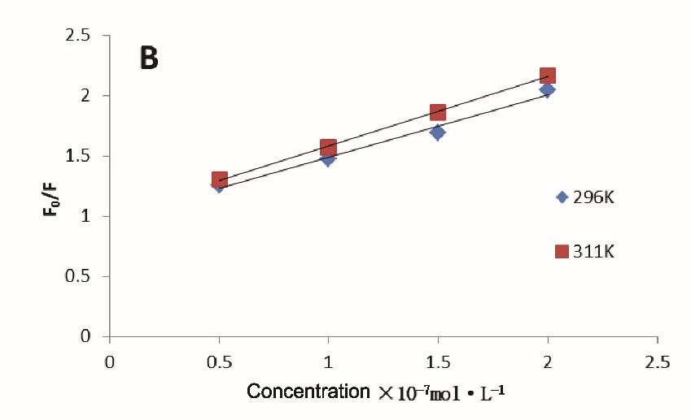
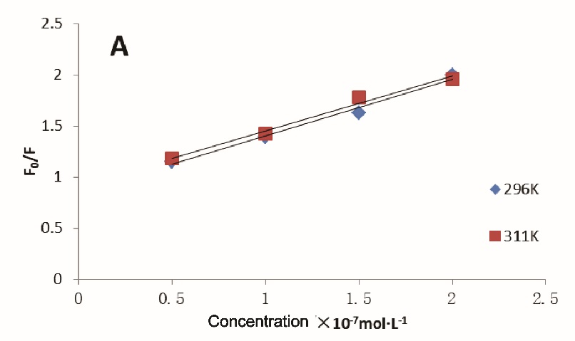
Fig. 2. Stern-Volmer plots of the fluorescence quenching of MP (0.05 mg/ml) in the presence of various concentrations of CGA and QUE at 298 and 311 K. (A): CA; (B): QUE.

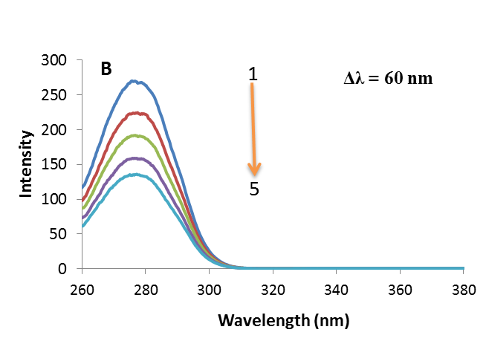
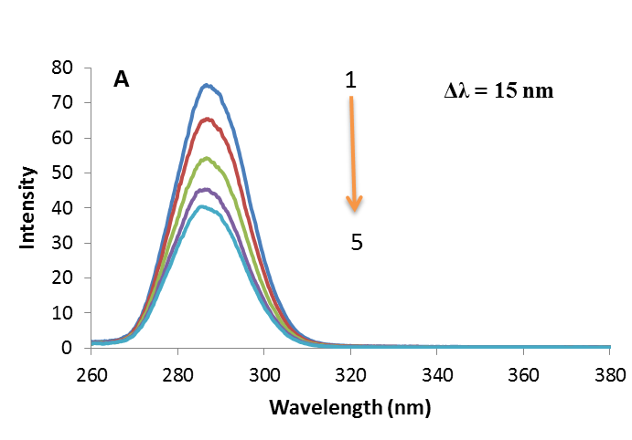
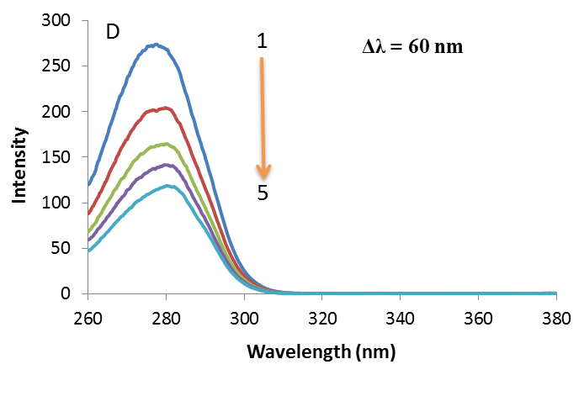
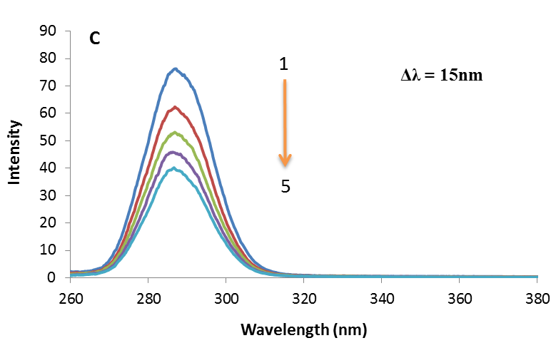
Fig. 3. Synchronous fluorescence spectra of the CGA-MP and QUE-MP systems. Spectra 1–5 were obtained by adding a series of increasing concentrations (10⁻⁷M) of quenchers: 0, 0.5, 1.0, 1.5, 2.0. Note: CA: A-Δλ = 15 nm and B-Δλ = 60 nm; QUE: C-Δλ = 15 nm and D-Δλ = 60 nm.

Fig. 4. CD spectra of MP (curve a, black), MP-QUE (curve b, blue), MP-CGA (curve c, red). C_{MP}= 0.1mg/mL; C_{QUE} = C_{CA} = 1.0 × 10⁻⁷mol/L.

