James Sibley Watson’s The Fall of the House of Usher:
Surrealism - Improvisation – Complementary Serendipities.
Introduction

“There is a way of going to the movies as others go to church and I think that, from a certain angle, completely independent of what is given, it is there that the only absolutely modern mystery is celebrated.”

James Sibley Watson’s and Melville Webber’s The Fall of the House of Usher is an extraordinary film. Edgar Allan Poe’s novella (first published in 1839) is compressed into a little over twelve minutes of avant-garde cinema. According to the film historian Jan-Christopher Horak, Sibley-Watson’s film was “the most widely seen American avant-garde film of the era.” It was “hailed by the Chairman of the National Board of Review as the most outstanding contribution to the motion picture as an art form since The Cabinet of Dr. Caligari (1920),” and “the film was screened both theatrically and non-theatrically hundreds of times all over the United States.” The musicologist Charles E. Brewer has recently provided much insight into the film. Sibley Watson gave an incomplete synopsis of his version of the story in 1929:

In a doomed house live the last two children of a once powerful family. The sister falls victim of a strange malady which resembles death. Her brother, unbalanced by hereditary madness, nails her up alive in a coffin. A traveller comes to the house. He tries to sooth the troubled conscience of the brother by reading aloud to him. The words of the book become confused with the noises from the burial vault. The buried woman is struggling to burst her coffin. The door of the vault is forced open, feet are hear on the stair. Starved, broken from her struggle, the girl falls upon her brother and in her now final death …. [incomplete]

Brewer notes that for the most part the musical images of the novella are elided, including Roderick Usher’s “wild improvisations of his speaking guitar” that provide temporary distraction for him from his fate. These figures are instead replaced in the film by other prominent visual images of stairs (present in the novella), the hammer and a glove (not present in the novella). In a commentary, Sibley Watson states: “the importance of the piece lies in its mood – in a development of emotional tone almost without action. We decided to make a picture with a mood rather than a story.” In his 1929 article, Sibley Watson recalled his desire to use new cinematic techniques to “invoke in its audiences the esthetic impressions and moods which the tale created in its readers.” There are therefore no intertitles, unlike the other much longer film of the same name La Chute de la Maison d’Usher by Jean Epstein and Luis Buñuel also released in 1928, a film that is less refined in both its narrative and in its cinematography. In Sibley Watson’s and Webber’s film, this is an important departure from standard technique, and the film therefore moves as one piece from beginning to end. Some scholars have addressed interesting cultural and cinematic facets of the film. Brewer documents the creation of a score by the composer Alec Wilder (1907-80) as an avant-garde musical companion to the film. The film historian Lisa Cartwright has focussed on the cinematic context and modernism, especially with regard to German Expressionism. The film historian Lucy Fischer has connected the film with European filmmakers associated with Expressionism, Surrealism, Futurism, and Cubism. Fisher for instance notes that the sets “with their peculiar angles, their impossible spaces, their bizarrely decorated surfaces, and their discrepancies of scale,” are “transpositions of Expressionist plastics to the cinema.” Cartwright links Watson’s thinking with a correspondence between Sibley Watson and the poet e.e.cummings just before the filming of Usher. Cartwright states that Sibley Watson:

discussed the use of a wide range of devices to put cummings’ systems into effect, and used a number of them in the filming of The Fall of the House of Usher. Along with the dissolve, he mentions double exposure, tracking shots taken from a camera mounted to a ceiling track, [and] the attachment of a gyroscope to the shutter.

She also connects the film with the geometric thought of Ezra Pound’s Vorticism, but the Surrealist context of the film is not discussed in any of this scholarship.
The first part of the present study therefore details this context for the film, and shows how the film can also be understood in relation to Surrealism. This understanding is grounded in Surrealist and psychoanalytic theory. The following section provides a different kind of context for my own improvisation. Using sources from the 1920s, I show how organ improvisation was thought of in this period. These two sections are used as context to reveal the continuities and differentiations of my own practice and to show how Surrealist principles can be extended through musical improvisation. The spirit of Surrealism therefore can act as means of impetus, germination and enterprise, or a set of principles that are as valuable today as they were a hundred years ago. My discussion of an improvisation recorded in Arundel Cathedral (available on youtube), uses these contexts as a means of showing a particular interpretation, and this study acts as accompaniment and anthropology of the improvisation which acts as a development and enhancement of a narrative. This contributes to what the musicologist Marcel Cobussen has identified as a purpose of improvisation studies “to make unusual connections between music and various scholarly disciplines” and “to extend and emphasize the significance of improvisation beyond the domain of music.” I prefer to understand this work as research-situated practice, in which practice is contextualised, a term I use instead of Artistic-Practice as Research or practice-lead research that take practice as the primary means of research. I understand my practice as being in a research ecology which permits the complementary serendipities of research, film, artistic contexts, and improvisation.
The way I have chosen to order this study is not prescriptive for others. Essential to the research is an awareness of one’s own history and a reflection on and a response to it. This is where the present work overlaps but differs with autoethnographical approaches. It only partly “offers personal commentary and critique on cultural practices,” but more properly situates practice within cultural narratives and shows where practice extends these narratives. It does not “attempt consciously to create a reciprocal relationship with audiences,” but rather seeks to create a methodology grounded in traditional research methodology that can be replicated and extended as suggested in the conclusion of this study.

Surrealism and Usher

The film scholar Romona Fotiade has argued that films such as Ferdinand Léger’s Ballet Méchanique (1924), later used with music by George Antheil (1926), Marcel Duchamp’s Anémic Cinema (1926), Man Ray’s Ermak-Baki (1926) are all Surrealist works. Sibley-Watson may have seen Léger’s film when it was shown in New York in 1924. I argue here that Sibley Watson’s and Webber’s Usher should also be understood as Surrealist cinema. Léger’s film, like Sibley Watson’s film contains pulsing machine-like repetitive images, prismatic effects and dissolves, and text, but, unlike Usher, it is written without a narrative. Similar images and techniques are used in these other films and also appear in Sibley Watson’s Usher. For instance, at 2.58 in Léger’s Ballet Méchanique, this prismatic effect is shown:

Fig. 1: Léger’s Ballet Méchanique

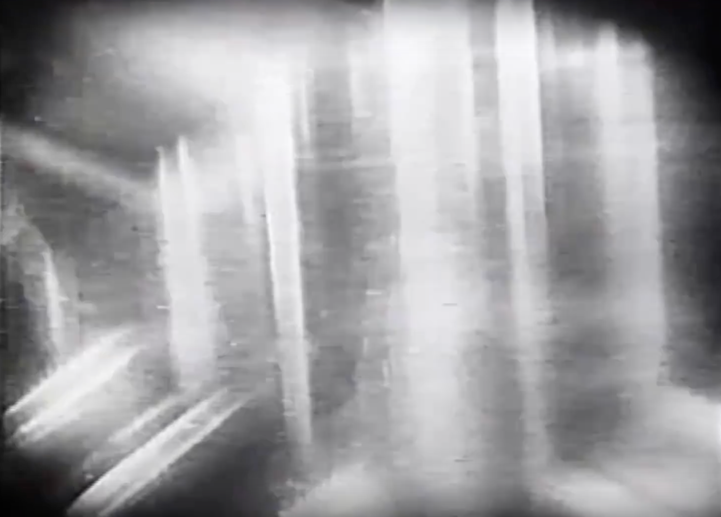

In a similar tradition is Man Ray’s Le Retour A La Raison (1923), and his Ermak-Baki (1926) which contains this prismatic image at 1.02:

Fig. 2 Man Ray’s Ermak-Baki

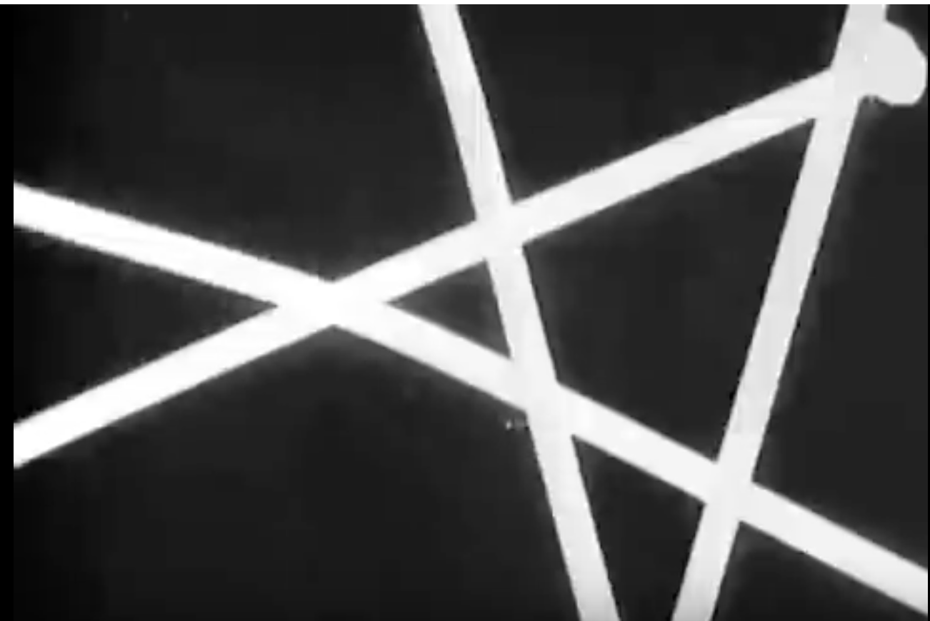

A similar idea is used in Usher at 11.27:

Fig. 3 The Fall of the House of Usher

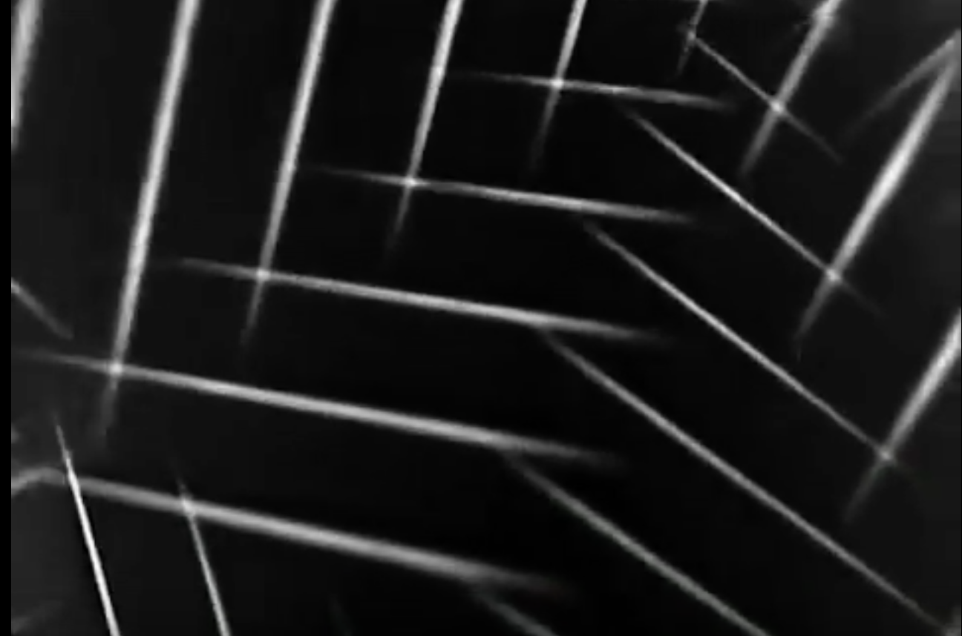

Specifically, however, I would contend that the legacy of Surrealism is precisely to be found not only in the images or techniques employed in Usher but in the “moods” of the film that are evoked through these techniques, and the artificial tricks of light used to create the distortions of representation and perception through which another (intrinsically Surrealist) reality is called into being. Sibley Watson describes the set as “broken with moving prisms and tinted with light.” The techniques therefore accentuate two fundamental ideals of Surrealism: automatism and collage that Elsa Adamowicz notes were “essential modes of Surrealist production, breaking away from traditional codes of mimesis and the aesthetics of coherence, and exploring the language of the irrational and the chance encounter.” The techniques, I would argue, effect a Surrealist sense of what the critic Jean-Pierre Cauvin, with reference to André Breton’s aesthetics, refers to as “dépaysement: the sense of being out of one’s element, of being distorted by the unfamiliarity of a situation experienced for the first time.”
Indeed, specifically referring to the cinema, Breton states that: “I think that what we valued most in it, to the point of taking no interest in anything else, was its power to disorient (son pouvoir de dépaysement),” which Breton associates with what he calls “the marvel beside which the merits of a given film count for little.” This sense of dépaysement or disorientation is achieved in Sibley Watson’s and Webber’s Usher through fading, dissolving, and prismatic images. Such techniques become part of the dialectical process by which technique comes to unveil different heightened and unexpected syntheses which Breton termed the “marvellous,” as well as providing psychoanalytical windows onto the characters’ states.
For the Surrealist poet Louis Aragon, such a heightened sensibility had a combative and even transcendent quality: “the relationship which is produced from the negation of the real by the marvellous is essentially ethical, and the marvellous is always the materialisation of a moral symbol in a violent opposition with the morality of the world in whose centre it appears.” What is disorientating, therefore, acts to dislocate the viewer from one quotidian reality to open them to another more profound emotional and spiritual arena or trauma and surprise that is akin to the Lacanian psychoanalytic register of the Real which can be understood both as an idealised pre-conscious state, but is here understood as a traumatic zone of truth that is known, but consciously avoided. The Real is also the domain, in the genre of horror, where the impossible becomes figured as possible: where puppets come to life or the dead come to life to commit atrocities against the living. In both Poe’s novella and Sibley Watson’s and Webber’s film, the supposed ‘death’ of Roderick’s sister slowly creeps up on him until her spectral form comes to envelop him: the Real that is avoided returns. The seed of destruction of the House of Usher is therefore an internal psychological splinter, a poison that is working its way towards external realisation. This process strongly resonates with the Surrealist interest in psychological emancipation. The relationship between psychoanalysis and Surrealism is important to an understanding this film. Surrealism was born partly from Breton’s experience of World War I (he trained in medicine at various hospitals including St Dizier in Nantes and the Salpêtrière-la-Pitié in Paris) and partly from his readings of Freud. It therefore derives from the clinical made aesthetic. As the Surrealism scholar Anna Balakian states:

In his first surrealist manifesto, dated 1924, Breton gave Freud ample credit for his discoveries in dream interpretation, his method of investigation, and the new rights he thereby granted to the human imagination. … He foresaw as the ultimate achievement of dream study the marriage of the two states, in appearance so contradictory, of dream and reality, into one sort of absolute reality which he called surreality.

In his book Les Vases Communicants, dedicated to Freud, Breton pays credit to Freud by observing that he discussed the question of “what happens in dreams to time, space, and the principle of causality?” It is precisely these questions that are addressed in Sibley Watson’s film where, in a Surrealist sense, the viewer comes to understand consciously the temporal and spatial effects of the dream state. But what the viewer also comes to understand is that the symbols presented in the film are not merely for interpretation but need to be understood as representations of the characters’ realities. Philippe Soupault stated that “the cinema was for us an immense discovery of the moment when we were elaborating surrealism. […] we then considered the film as a marvellous mode for expressing dreams.” Romona Fotiade, following Breton’s comments in Surrealism and Painting (first version 1928), confirms that the “Surrealists credited the new eye of the camera with an accurate ability to capture the otherwise inexpressible, visual unfolding of dreams, thus paving the way for an unprecedented revolution in poetic language, away from the constraints of logical and verbal discourse,” and this is again why the film does not simply follow the literal narrative of Poe’s story. Dreams were an important precept of what the Surrealists called automatic writing (enacted to reveal interior truth) in Breton’s and the Surrealist poet Soupault’s Les Champs magnétiques (1919). They provide a time out of clock-bound time, and an attenuation and concentration of time. The experience of the film is therefore an intensification of the novella, but this compression paradoxically allows the film to seem and feel longer than it really is.
The ideal of the dream is exploited in a number of ways in the film. Firstly the place and identity of the location are fixed in the story. The space is therefore prima facie defined, and Sibley Watson’s and Webber’s film deliberately distorts the internal space of the house, and the time-scale in which the events happen. The film moves in and out of the way in which Roderick and Madeline experience time allowing the viewer to experience diegetically something of their experience of disorientation. This temporal disorientation lends the entire film the quality of an extended dream sequence.
The ideal of the dream as film allows time and the narrative of Usher to be collapsed. Once Madeline has taken the wine (in the film, not the novella), disorienting her from reality, her time and character is understood as separate from Roderick’s time by the viewer. She is seemingly ‘dead’ or in a form of suspended animation unseen by Roderick, whose own time corresponds to his (parallel) psychosis. Only at the climactic moment does her spectral figure and her time-paradigm impinge upon him, an effect which is heightened by the fading and dissolving of her spectral image.
Secondly, Surrealism is present in the psychological symbols of the glove and the hammer. The glove is not connected explicitly to Roderick in the film; we do note see him wear it, but understand that it is his hand in the glove that it is Roderick who touches Madeline’s prone body at 6.06. The glove represents a form of respect for Madeline, but in its touch and absence of touch it arguably implies also a suppressed libidinal and incestuous desire that could be understood as a reason for Roderick’s actions: he therefore seals Madeline away from himself in the dungeon of the house. The glove represents a form of vicarious physicality that the Surrealist poet Robert Desnos, writing about the cinema in 1923 as “the most powerful of all cerebral drugs” links to a form of erotic experience for the viewer. The hammer is a rich symbol because there is no physical contact between the characters and no evidence that this ‘instrument’ is either the cause of Madeline’s death or is used to seal her in the dungeon. Roderick is not seen with a hammer in his hands and the hammer is not present in the novella. It functions in the film as a figure of the Freudian Unheimlich [the Uncanny] which Freud explicitly connects with the compulsion to repeat what constitutes the death drive. The critic Hal Foster describes the uncanny as “the return of a familiar phenomenon (image or object, person or event) made strange by repression.” The hammer therefore acts as a symbol of Roderick’s repression of his own complicity and even culpability for his Sister’s state. It also simultaneously acts (for him) as a means of supressing and protecting him against his own sense of his forthcoming demise. In a Surrealist sense, the hammer and the glove function as objets-trouvés or serendipitous ‘found objects.’ They are evocative of what the Surrealists called the “marvellous,” that is here transmuted into the realm of the psychotic. In psychoanalytical terms, they can be understood as ‘partial-objects,’ physical objects that manifest and embody the desire of the drives, in the case the death drive. They form part of what Breton, echoing this thought in 1924, describes as figments of the:

powers of invention, which, within the limits of our present understanding of the dream process, must surely be vitalised by contact with dream-engendered objects representing pure desire in concrete form. But the aim I was pursuing went far beyond the mere creation of such objects: it entailed nothing less than the objectification of the very act of dreaming, its transformation into reality.
The hammer is partly dreamed by Roderick, but also partly sensed and felt like a phantom-limb. Like the unnamed woman in Schoenberg’s monodrama Erwartung (1909), Roderick (in the film) is unsure if he has killed his sister. Instead, he is condemned to a form of automatic and repetitive reflex of using a hammer; his delirious state, seemingly unaware of the difference between dream and reality, is externalised for the viewer. In his gestures we can perceive something of the “pure psychic automatism” that Breton identified in his definition of Surrealism in the First Surrealist manifesto (1924):
SURREALISM, noun. (masc.) Pure psychic automatism by which it is intended to express, either verbally or in writing, the real function of thought; thought dictated in the absence of all control exerted by reason, and outside all aesthetic or moral preoccupations.
ENCYCL. Philos. Surrealism is based on the belief in the superior reality of certain forms of association thus far neglected, in the omnipotence of the dream, and in the disinterested play of thought. It leads to the definitive destruction of all other psychic mechanisms and to its substitution for them in the solution of the principal problems of life.
For Breton and the Surrealists, only through revealing the hidden life of our unconscious, by engendering a heightened or ecstatic sensibility of automatism, can real truth or a deeper state of being be revealed. The destruction of the ego was a necessary predicate of this transformation. Roderick Usher is only too aware of his own impending destruction and this is the final revelation that he awaits and prefigures through his empty-handed hammering gestures at 8.00 in the film. He is a portrayed in the film as a stylised Baudelairian dandy, as a flanêur sans boulevard, “the last scion of an ancient, decayed house” as the psychoanalytic writer Marie Bonaparte puts it in 1933, whose decadence is mediated through design redolent of cubist paintings but more specifically of Robert Delaunay’s Orphic paintings, and makeup and hair in the film that is typical of 1920s fashion photography. The film therefore translates the decadent nineteenth-century, symbolist ambience of the novella into contemporary life. But his decadence (symbolised in his aristocratic mien, his withdrawal from daily life and society, his adoration of arcane chivalric literature, and his (self-) indulgence in what Marie Bonaparte calls his “acute form of anxiety-hysteria”) acts as an artificial screen to his own destruction that will be broken down at the end of the story. His persona, or rather his imago as an idealised image of himself, therefore becomes a symbol of his destruction.
Finally, there is the image of the stairs, which repeat but lead nowhere in the film. The stairs are often seen (on either side of the screen in the film as in Fig. 4) as part of a collage of images. The stairs are juxtaposed with other images, the hammer for instance, or morphed into moving books (as a reflection of Roderick’s mental disturbance) but these changes should be understood not as effect but as adding something to the picture that is essential information. It is not merely enriching the level of information or making it more complex, but symbolically making present something that the viewer needs to know. Their movement evokes the eternal, the absurd, and a sensation of delirium without beginning or end. That they appear and disappear in the film symbolizes that they remain present as part of the psychological arrière-plan that spontaneously erupts to the surface of vision.

Fig. 4 Stairs and the silhouette of the Hammer with Madeline at 4.56 in Usher

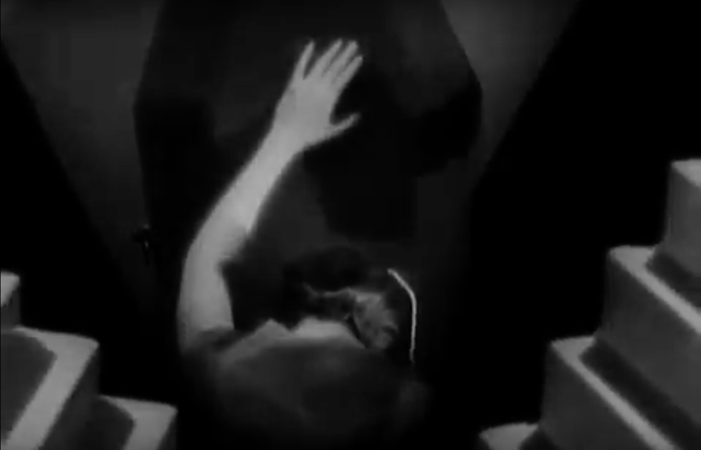

The stairs are also a psychological projection for the viewer of Usher’s psychotic state of mind where the psychotic is “structured by the other” as the Lacanian analyst and theorist Nestor Braunstein states. In Fig. 4, Madeline is seemingly drowning or pushed down by the weight of the stairs as she grasps (in a gesture of pleading or even perhaps of worship) at the silhouette of the hammer. In Poe’s story Madeline is suppressed by her almost complete absence, and made invisible through her entombment, but she is given much more presence in the film, allowing the viewer to understand her relationship with her brother and her fate. The hammer becomes a visual metonym here of Roderick and his impact upon her. It is what Lacan, following Freud, calls a Vorstellungs-Repräsentanz in Seminar XI, that the Slovene philosopher Slavoj Žižek calls “the signifier which acts as a representative – a trace – of the excluded (‘repressed’) - representation.” The Lacanian theorists Patricia Gherovici and Manya Steinkoler’s thought perfectly differentiate Usher’s state. He is caught “in the nightmare of living in a constant dream. Neurotics wake up from their dreams while psychotics do not.” “The psychotic,” they state, “is subjected to the other, without mediation through intruding ideas, hallucinations, voices, imposed thoughts and commands … hallucinations are the reality for the delusional person.” Or as Braunstein states more pointedly:

the signifier looses its symbolic dimension and, as Freud intelligently anticipated, the word-representation is real and cannot be distinguished from the thing-representation. The Real appears without the buffering of speech, the hallucination is its clinical manifestation. This is madness.

The stairs are a form of visual diegesis in which we experience something of Roderick’s psychosis. They project a concrete hallucinatory image for the viewer of that which is uncontrollable. In the film these steps are linked with the mechanical footsteps of Madeline as she comes up from her entombment, linking Roderick’s psychosis with her fate.

Film accompaniment

Sibley Watson’s film therefore provides a rich symbolic depth-structure that can be excavated with the aid of music. Brewer notes that “with one exception, for most of the period from its release in 1928 until the early 1950s, Usher was presented with either improvised music or stock compositions.” This singular exception was a piano score created by the composer Alec Wilder for a private screening in 1930.
In America, it was standard practice to use the piano or organ as accompaniment, where an orchestra could not be used for financial or logistical reasons. Organ accompaniment textbooks from the 1920s provide a rich insight into the culture of playing in which this film was situated. They also address the questions asked by the film scholar Michael Slowik about how music should be related to narrative events, whether pre-existing or recorded music should be used, what styles are appropriate, and what the cultural connotations are when using various musical styles and techniques. C. Roy Carter’s Theatre Organists Secrets for examples is subtitled: A Collection of Successful Imitations, Tricks and Effects for Motion Picture Accompaniment on the Pipe Organ. It shows the organist (in detail) how to imitate snoring, laughter, a kiss, assorted animal noises including dog barks, train whistles, roosters crowing, cow’s mooing and also mechanical instrument sounds such as hand organs and the accordion-harmonium. All this is presented with musical examples and registrations (combinations of organ stops), and is touted in the introduction as essential knowledge needed for the “perfect accompaniment to the Silent Drama.” Many organ accompaniment treatises begin with words of advice and caution to the performer. The substance of Erno Rapee’s Encyclopedia of Music for Pictures book is to provide a taxonomic account of which piece of classical, popular, or folk music, and perhaps what we would call ‘light’ music today can be used for appropriate scenes. The organist can use this information like an index to look up which pieces may be appropriate for Grand Opera not to mention, under H for example: Hawaiians, Hebrews, Hobos, Hungarians, and Hurries (chase scenes). Indeed in the 1920s, Belwin (and many other publishers) produced dozens of books specifically addressing certain types of scenes based on local colour, situation, emotion, race and other features.
The organist’s job, in short, was to be a continuity person, even to the point, as the well-known early British cinema organist George Tootel explains, of making up for the deficiencies of continuity in the film itself. Michael Slowik affirms this when he states that in the “era of late silent film music was nearly always continuous,” and that “by the 1920s the goal had become to make the music seem as though it were internal to the film – that is, as if it were part of the film’s production(.)…and [thereby] aligning the audience more closely with the characters’ internal emotions,” an aim that I have espoused in my own rendering of Usher which aims to complement and bring out the Surrealist dream-like quality of the film. The organists’ role, somewhat ironically similar to the function of the church organist with regard to the liturgy, is to provide an invisible acousmatic music that enhances and informs the visual and spiritual experience that Breton describes as a celebration of the “only absolutely modern mystery.” In the cinema, the organist performs this task by using contrasting and appropriate written pieces and improvised transitions in between them with the right admixture of discretion, colour, flair, not to mention psychological insight that Tootel prescribes; he must, according to Tootel, not only be a “a first-rate performer, but a very able musician.” He states that:

The Mission of the cinema organist is to accompany the film and provide the musical counterpart to the photoplay. To do this adequately he must possess keen and artistic sense of tone-colours, expert ability in extemporisation, and an extensive library of music comprising compositions of all types.

Tootel goes on to extol the necessities of excellent technique and that the organist must have “an active imagination and use it.” For Tootel, the organist must assess “the style, period, and atmosphere of the story.” “Pre-viewing” is essential, as is the creation of suggestion sheets (a records of ideas). For Tootel the “most complete and advanced phase” of cinema playing is found in extemporisation. In his treatise, he gives a fascinating demonstration of thematic transformation for different types of scenes as a means of showing the sort of skill required. Other sources support these general tenets and demonstrate a culture in which cinema organists in the 1920s used a mixture of set pieces with improvised transitions, cues for improvisation, or provided their own extempore music.

A new Usher

I now wish to draw these strains of Surrealism and improvisation together in a discussion of an improvisation that I recorded to Usher in Arundel Cathedral, England, in November 2016. My approach to improvisation is conditioned by study in France and a lifelong involvement with French music. It should first be stated that a disorientation is already present within this project, because the organ used was in a Catholic Cathedral, not a cinema house, and therefore the meaning of the classical organ as a form of superego prosthesis between man and God is here used in a way that is deliberately incongruous with both the film and Surrealist aesthetics which were radically opposed to religion. The church organ is also a qualitatively different type of instrument, lacking many toy and effect stops found on cinema organs (such as drums and piano). Ironically, therefore, the use of the church organ (pace Breton) inculcates or sublimates the sacred mystery into Breton’s cinematic “absolutely modern mystery,” or better, considering its role and position in religion and churches, it provides a new form of Surrealist complementarity or subversiveness.
Secondly, it must be noted that both Giorgio de Chirico in his 1913 essay “Point de musique” [No Music] and later Breton, in Surrealism and Painting (1925), regarded music as superfluous, inferior and not able to inhabit properly the Surrealist world. Breton descries “auditive images” as “inferior to visual images.” But in his essay “Golden Silence” [Silence d’Or] after explaining his preference for “silence to music” and admitting his “absolute ignorance of the laws of musical composition,” (which somewhat detracts from the gravitas of any pronouncement he makes on music), he calls for a rapprochement between music and poetry that “could only be accomplished at a very high emotional temperature.” It could therefore be posited that, despite Breton’s antipathy to instrumental music, musical improvisation provides an ideal Surrealist act both as juxtaposition with film that arguably enables the “very high temperatures” Breton calls for. Indeed, it might also be argued that the “interior word” employed through “automatic literature” is both “inseparable “from an “interior music” and that improvisation, through its own Surrealist automatism is able to provide this rapprochement that Breton links to one of his highest ideals: “love.” Not all Surrealists were against music. Commenting on a possible position for music in the pantheon of Surrealist thought, Max Ernst stated that:

In Surrealism, manifesting as “pure psychic automatism,” one can wonder what role music would play in automatic writing for the texts, in the friction for graphics [frottage], or in floating wood for magical objects. The answer is rather obvious: they are the dictations of actual raw resonances [representations of raw sound], which would place our unconscious in possession of this latent music, latent at the same time in itself, and in the resonant stimuli that it would accommodate.

Improvisation, if understood as music added to film (following the composer and film theorist Michel Chion), would seem to be an ideal Surrealist complement in Ernst’s terms. If it is understood as a form of spontaneity derived from habit and from the resources of the player’s unconscious, it could also be understood as a form of external “dictation” of “raw resonances” that calibrate the “latent music” that Ernst speaks of with the “resonant stimuli” of the film. Improvisation can not only respond to film (not merely as mimesis), but it represents an externalization of an inner narrative. The player is at once surprised by the images and by the music that is automatically generated, and in this surprise, this serendipity promotes “the marvellous.” This “marvellous” serendipity is essential to the experience of improvisation for player and audience alike, and it is precisely the personal quality of an improvisation, making each showing of the film different, that (pace Chion) makes music an essential ingredient to the elaboration of silent film.
Part of the personal quality of an improvisation is correlated by the Surrealist concept of “Automatism,” which Anne Le Baron states “has its most direct musical parallel in free improvisation. I define this as a non-idiomatic improvisation embodying a unity of mind and action: musical concept and performance take place simultaneously.” LeBaron goes on to discuss the first of Roger Dean’s creation of three algorithms for musical improvisation with its emphasis on unconscious constraints and selections of material in sub-conscious decision-making. Discussion of constraints is a frequent touchstone of improvisation studies as George E. Lewis and Benjamin Piekut (echoing Thomas Mann cited below) observe, and it is theorised by these scholars in terms of a “knowledge base,” cultural identity, pedagogy, habit, or its relation to composition. This commentary is particularly germane to LeBaron’s comment on the necessity for “an art of risk and the refusal of past accomplishments and proven techniques in favour of delving into the unknown and unchartered.” In this sense, the improvisation presented here in some senses minimizes certain risks (this is an essential aspect of any kind of secure performance) while allowing a flow within a homogeneous style; it adheres to a personal style, certain idiomatic harmonic mannerisms, a location in musical history and nationality. However, at the same time it also arguably challenges the familiar location of such music (in the church), and the religious placement of this idiomatic material through a recontextualization that allows improvisation to function as a medium of dépaysement. In a Surrealist sense then, improvisation should be understood as a marshalling of diverse resources, meanings, locations and identities to empower a higher musical synthesis, one that is open at every moment to surprise. This surprise then could be understood as the end result, or the payoff of a certain plasticity within a language and style or within a community of improvisers. When Thomas Mann describes the attendant audience’s discussion of a piano improvisation by the fictional composer Adrian Leverkühn in his novel Doctor Faustus (1943-47), he sets out elegantly the way in which what I have described as serendipity has theological ramifications:

The limitations were debated, which this conception had to tolerate, by virtue of culture, tradition, imitation, convention, pattern. Finally the human and creative element was theologically recognised, as a far-reflected splendour of divinely existent powers; as an echo of the first almighty summons to being, and the productive inspiration as in any case coming from above.

The surrealist “marvellous” therefore contains within itself a form of secular revelation or articulation that complements Mann’s thought.
The improvisation for this film deliberately attempts to create a flat, terse and dream-like interior choreography that is performative, as Stravinsky writes in his Poetics of Music, of an “unarticulated language.” There are therefore no real leitmotifs or melodies that would develop characterisation in a more obviously traditional manner (redolent of the organ improvisation in the 1920s). In my interpretation there is little attempt, like Sibley Watson’s and Webber’s own approach to Poe’s novella, to use musical mimesis, and in no sense is the improvisation redolent of theatre organ improvisations in the 1920s that were essentially tonal. Rather the harmonic language associated with French (Catholic church) music improvisation is employed, a much less tonal language than that employed for standard organ improvisation in the 1920s. This style is characterized usually by the development and recontextualization of clear theme(s) (this is not explicit in my improvisation), but more particularly by a slow harmonic movement in which certain trill or tremolo patterns are used to effect a sense of internal movement. The effect is useful in large acoustic spaces where slower harmonic rhythm allows the ear to perceive the increase and decreasing of dissonance and tension, fluctuation in volume and the density of sound, and the way in which an improvisation is shaped through time. This kind of slow harmonic movement facilitates the deliberately-flat texture that is used in this improvisation. The music is terse, and relies on small and subtle internal harmonic/colour changes to complement the structure of the narrative. The “mood,” of the film and novella is of doomed human beings playing out their endgame. The texture of the organ is an attempt to provide a mirrored dreamscape or a complementary serendipity of the action.
Inside the textures employed are a number of systems. Before the improvisation I had a general plan of what would happen. The film overall is defined by two crescendos corresponding to the two climaxes in the film: Madeline’s entombment symbolized in the throwing down of the gloves and hammer, and her physical collapse onto Roderick. In my mind these form two climaxes, a smaller one that then provides the stimulus for the ascent to the second larger one that then accentuates the quicksilver decrescendo as the house crumbles into the tarn. I had thought of Debussy’s song Colloque sentimental (1904) as one model for the relationship between Roderick and Madeline because, at the moment the spectres start to speak, the language moves from basically whole-tone to become octatonic. The general foreboding and pallor of death from the start is represented by the whole-tone scale, as found in Debussy’s Pelléas et Mélisande (1902) and Richard Strauss’s Electra (1909). This scale is employed extensively in the section depicting the stairs because the whole-tone scale lacks a stable polar note or tonic. Thus the sense of the unending stairs is conveyed through the language. The language moves from the whole-tone realm (that of Roderick and the house itself) to the essentially octatonic world of Madeline, whose presence acts first to engage Roderick’s psychosis and then transfigure it in death.
There were several other things that interested me in the process of improvisation. Firstly there was the way in which harmonic systems, which can be practiced in improvisation, could undergo a flux of what I call ‘dirtiness’; they could be made more or less dissonant through added notes that did not belong to the prevalent system. This ‘dirtiness’ was also used as a means of transition between one system and another. This in Stravinskian terms is something that I have called a “systematic hybridity” in which structures (whole-tone, octatonic for example) are distorted by added non-systematic pitches. This was therefore a fundamental way of achieving the kind of dépaysement or disorientation that would act as what I call a complementary serendipity to the fading, dissolving, and prismatic images, which a new ”image” is created that is a “rapprochement of two more or less distant realities, as the poet Pierre Reverdy stated.”
The second element that interested me was the way in which the organ could not merely follow the film but through this distortion, actually foreshadow action i.e. it could tell the viewer something before they saw it. What this meant is that the organ, an acousmatic instrument, provides a kind of spectral presence, in which an inflection towards a brighter perhaps major-quality harmony, for instance at the moment where Roderick’s hat appears to bounce around as a disembodied figment of himself that also implies a certain fairground sleight-of-hand (an invisible mechanical manipulation), could be employed inside the texture without the sense of mimesis or representation, but rather through psychological understatement and suggestion. Another example of this choreography can be found in the moment when Madeline raises her arms in like a high-priestess or a cobra preparing to strike. The chords in the organ provide a shadow, dream-like choreography for this action, a dream within a dream as it were. What results therefore is a Surrealist improvisation that accentuates the pallor of the film, an externalisation of the internal, psychoanalytic choreography of the characters.
A third aspect of the improvisation is the way in which themes from opera or pre-existing works could be adapted. This was not a conscious aspect of the improvisation, but something I noticed on reflection. So, for instance the long solo at 1.15, I realised, upon reflection, was derived from the Love theme in Act II, scene II of Richard Wagner’s Tristan und Isolde:
Ex. 1: Wagner, Tristan und Isolde Act II, Scene II

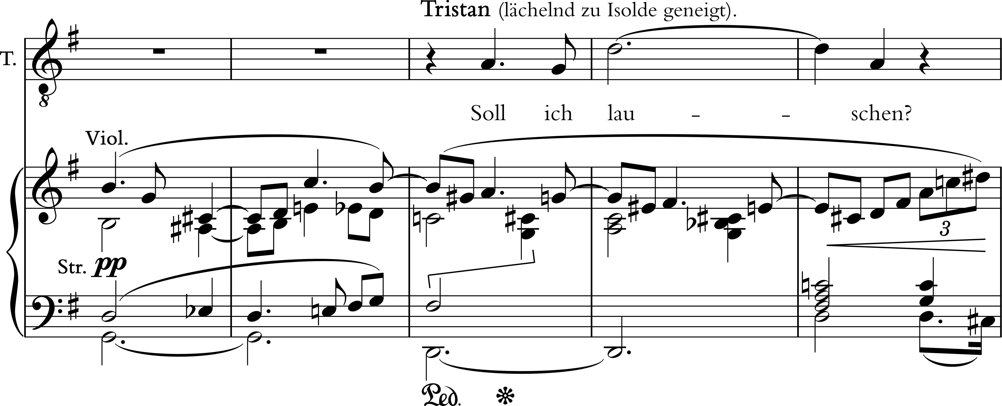
In fact this is so dissolved it can barely be detected. The melody used is inspired partly by the incantatory style of the French composer Jean-Louis Florentz’s (1947-2004) adaptations of Ethiopian chant, especially in his Laudes (1985) but also ound throughout his organ and orchestral music. Closer to the original is the music at 3.27, which is redolent of this passage from the organ part of the Nunc Dimitis of The Second Service (1971) by the Scottish composer Kenneth Leighton (1929-88), a setting of the Evening Canticles (Magnificat and Nunc Dimitis) dedicated to the memory of the organist Brian Runnett who had died in a car accident. This is a piece I have played and conducted many times.

Ex. 2: Leighton, Second Service, Nunc Dimitis m. 10-13 (organ part)

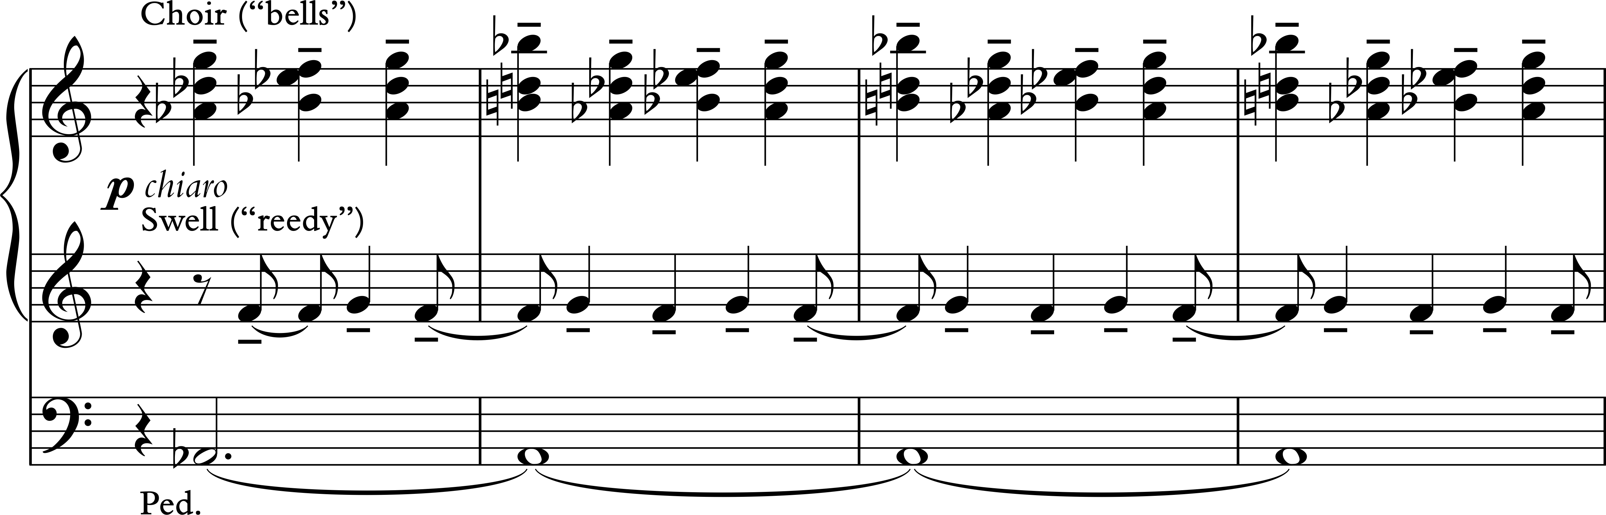

Also present are two distinct motives, the first that that is perhaps unconsciously derived from the opening of Debussy’s piano prelude Voiles (1909), but much slowed-down:

Ex. 3: Debussy, Voiles b. 3-4
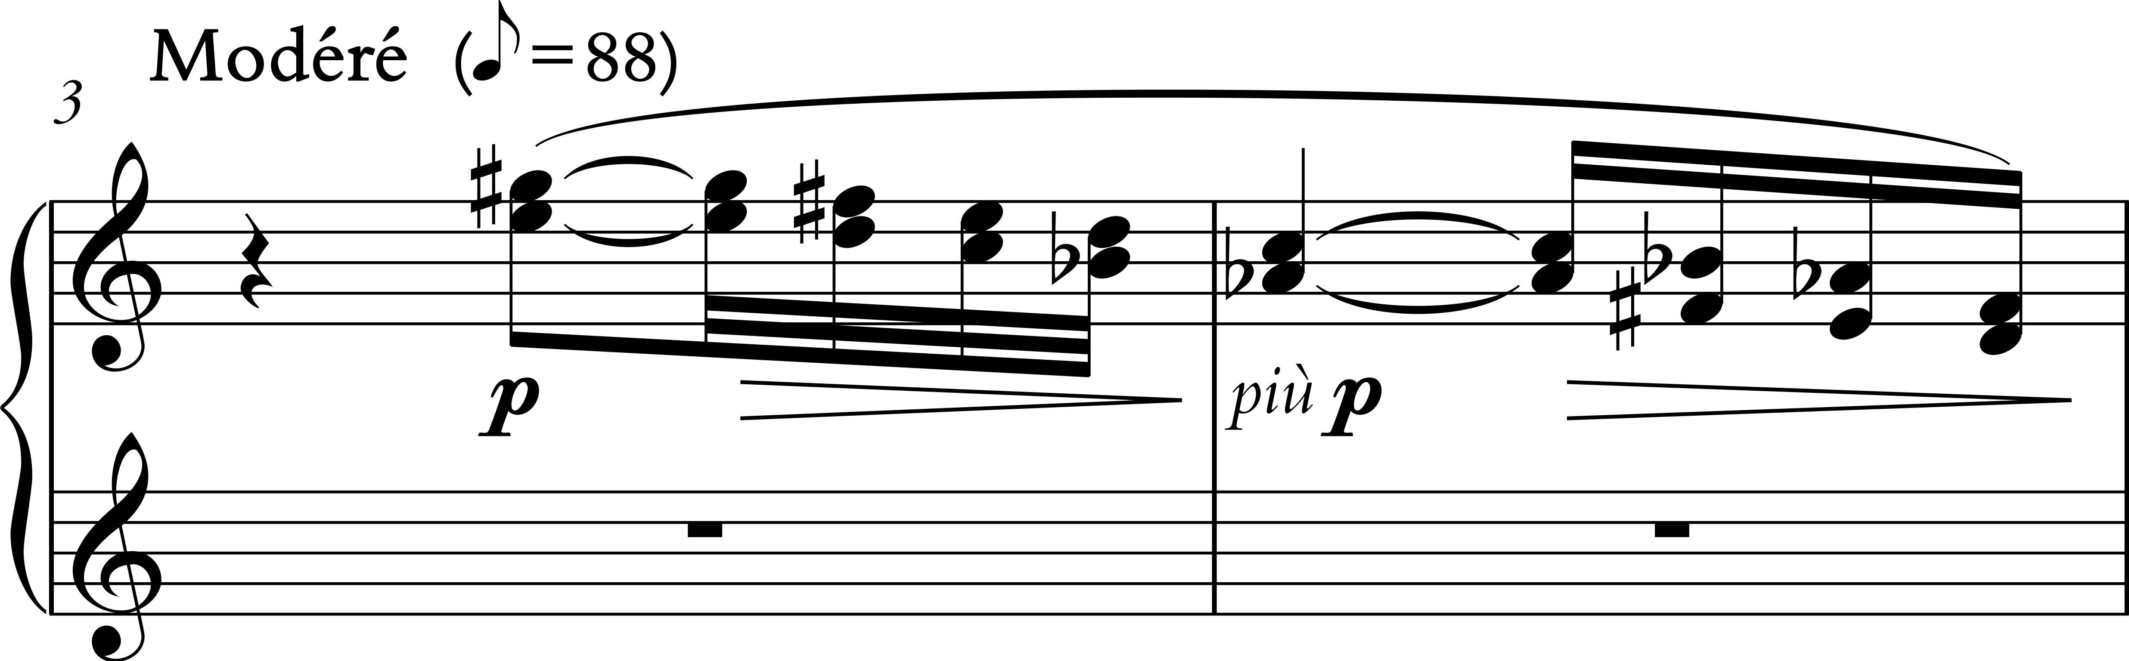

And the second from Golaud’s theme in Debussy’s Pelléas et Mélisande (1902), which occurs at night-time in the opera, and is described by Olivier Messiaen in his commentary as “death hidden behind love”, a thought entirely germane to Roderick’s relationship to his sister:
Ex. 4: Debussy, Pelléas et Mélisande 2 bars before fig. 45 as notated by Olivier Messiaen
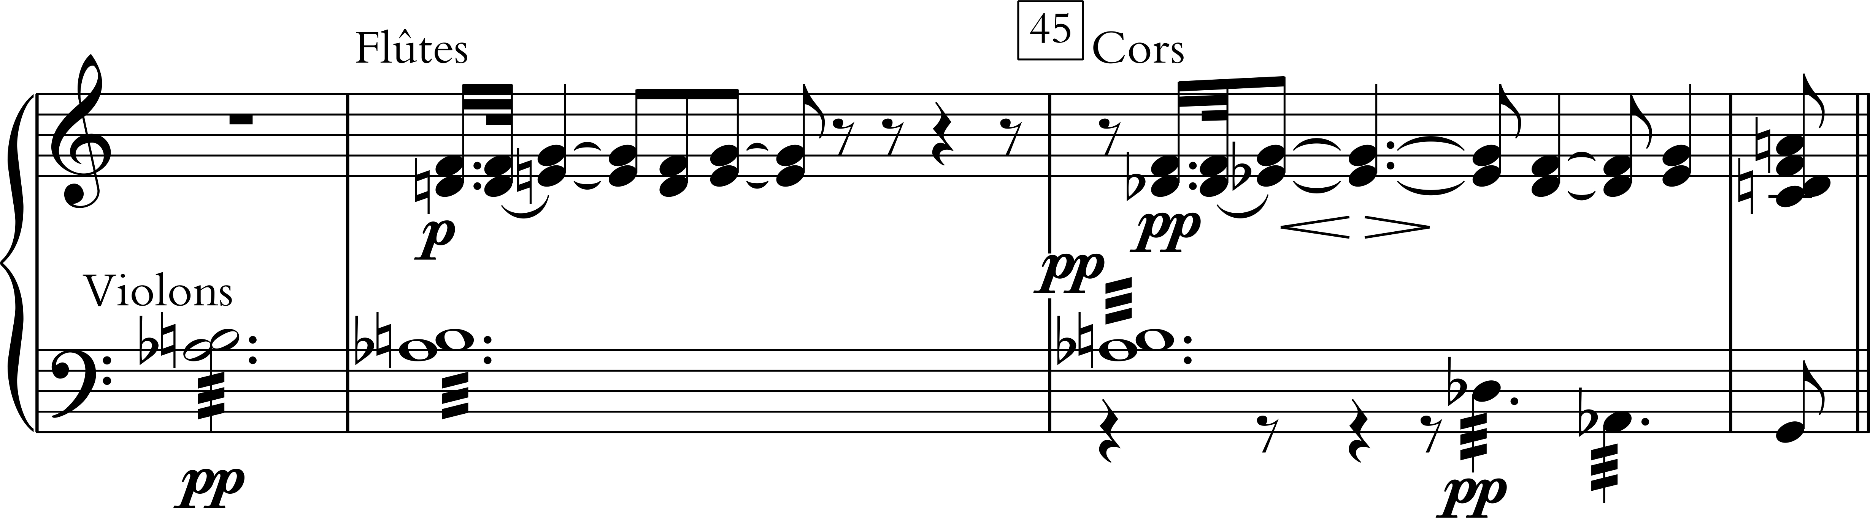

If this process outlined here can be thought of as what the musicologist Gary Peters has called “reappropriation” then it was extremely unconscious, and I would prefer to think of these examples as presences that exhume themselves serendipitously in response to poetic and visual images. They can be regarded, not as a finished process, because here I am dealing with one improvisation recorded in November 2016, but ideas on their way to an unknown destination, perhaps in another improvisation or even in another person’s work. What follows here is an analysis of the film (and the short story) with reflections on the improvisation that provide a form of anthropology of the interpretation, and that give what Cobussen calls “particularities, individual vectors, and singular connections.” The following table therefore presents an index of the way in which the improvisation complements the film and the short story.

Fig. 5 Complementary analysis of Usher (film and short story) and Improvisation

Timing | Film and short story | Improvisation
0.00-0.42 | Opening credits and colliding images from the first page of the novella. The novella begins with the words: “Son cœur est un luth suspendu; Sitôt qu’on le touche il résonne” (De Béranger). Both the film and the short story have a sense of disorientation, gothic darkness and the pervasive sense of death and doom. | Repetitive E’s in the pedal redolent of the opening chorus of Brahms’s Deutsches Requiem “Selig sind, die da Leid tragen” (Blessed are that that mourn…); whole-tone chords above with added notes.
0.43-1.07 | The traveller comes into view. This melds into the image of colliding stairways. | Whole-tone chords continue, but a new repetitive and short falling motive in the r.h. is clearly heard. This motive (from ex. 3 here called A) is related to falling motive that accompanies the stairs later. The pedal notes move through G to B flat.
1.08-1.14 | The stairs become a crack, which appears in the screen (this is the crack noticed by the traveller as he arrives at the house, and the crack that will eventually spell the ruin of the House of Usher) i.e. its inhabitants and the building itself.  Madeline appears through the ‘crack’. | The B flat is reached before the crack appears. This alternation between E as a centre of doom and B flat (both notes are present in the whole-tone scale and in two of the three transpositions of the octatonic scale). B flat becomes the tonal centre of Madeline in this solo.
1.15-1.53 | Madeline is seen. Madeline only appears to the traveller twice in the novella, passing through the room as if in a deathly trance, and at the end. Much more is made of the character in this film. She avoids walking through the crack, and instead comes to supper with her Brother. Roderick avoids touching her throughout this scene: he does not touch her when he pulls her chair out for her, nor when she swoons after drinking the wine. | B flat (major) has arrived. A long and exotic sounding melody, mixing octatonic sounds with sounds borrowed from the composer Jean-Louis Florentz’s adaptation of Ethiopian modes. The melody is played on the Great organ: 16 and 2 2/3: a stop that normally sounds an octave and a fifth higher than the 8ft, but is here 2 octaves and a fifth higher. It is a favourite sound of Olivier Messiaen, used for example in Prière après la communion, piece 16 of his Livre du Saint Sacrament (1984). Ex. 1 was an important source for this melody (see above).
1.54-2.09 | The pouring of the wine. | A new and insistent whole-tone figure (two thirds) motive is added under the end of the long melody and then is clearly heard by itself (ex. 4 above, here named motive B). This motive is heard in advance tells us something of what the effect of the wine will be. The solo melody (16 and 2 2/3) is continued.
2.10-2.17 | As soon as Madeline drinks, floating and distorted images of the serving salver come into play. The viewer is unsure if this is what Madeline is seeing or imagining, but it prefigures what is about to be seen. | End of the long solo. The falling whole-tone motive (A) reoccurs linking the crack, Madeline’s psychological fall, and eventually the stairs.
2.17-2.29 | Madeline’s sees the salver floating towards her. | The music here is very similar (on B flat) to that which prefigured the appearance of the crack and Madeline’s first appearance to the viewer.
2.30-239 | Madeline sees what is in the salver and the image starts to rotate. The viewer comes to experience diegetically something of her own disorientation. | The whole-tone atmosphere continues but with more notes that do not belong to the collection. This is clearly heard when a new solo on Motive B arrives.
2.40-2.54 | Roderick stands up concerned to see what has happened to his sister. | The level of dissonance increases slightly as he moves over towards her; the atmosphere is still prevailingly whole-tone. Motive B is extended and clearly related now to motive A.
2.55-2.57 | The screen is dark: we are occluded from the scene. Perhaps Roderick touched her in this occlusion, we do not know. | The whole-tone music covers this darkness and provides a continuity from one state of vision to the next.
2.57-3.19 | Roderick is leaning over her, seemingly concerned but clearly fascinated be her state. She begins to move. As she moves, images dissolve towards her; the viewer is unsure if these are the hammer (that will nail her into the coffin) or the coffin itself. Either way, Sibley Watson and Webber diegetically let the viewer into something of Madeline’s future. The image of Madeline disappears. | As Madeline begins to move, the chords become much more clearly octatonic. Which becomes Madeline’s realm.
3.21-3.27 | Drops of water falling on water with an effect again redolent of the stairs (but horizontal). | A new repetitive and partly mimetic motive that is more dissonant: it is not strictly whole-tone or octatonic but has elements of both mixed together.
3.27-3.45 | The traveller arrives in the house. Different staircases are seen. The traveller reaches for the door bell.  Through the sound of the door bell, Madeline is seen coming down the stairs. | This deliberately confused and disorientating sound continues. As the traveller reaches for the door bell, the organ gives an indication of what this might sound like before, the viewer sees ringing bells. The bells sound is created by a solo 2 ft stop on the choir organ and in my mind this sound is redolent of similar music marked ‘like bells’ in the Nunc Dimitis of The Second Service (1971) by Kenneth Leighton (1929-88), (see ex. 2 above). Leighton’s memorial idea is conceived in a more purely-tonal manner than presented here.
3.45-4.03 | The bell images dissolve now and Madeline is seen. | The bells motive now dissolves into a more tonal version of motive A (in A flat).
4.04-4.18 | The traveller again. We now know that the traveller is looking at Madeline, who, as in her appearance in the novella, is unaware of him. | Motive A stops and the texture suddenly becomes much more whole-tone and redolent of the opening of the film.
4.19-4.29 | Madeline and the stairs, now moving. | Whole-tone but more dissonant with a version of motive B.
4.30-5.00 | The first appearance of the hammer in silhouette, beating regular time. The stairs take over as a dominating motive, becoming crooked and uneven. | A small turning motive in the organ prefigures the arrival of the hammer. The music is mostly whole-tone but with an accelerating level of dissonance.
5.00-5.16 | Another mysterious image: possibly an eye (a image frequently invoked in Surrealist poetry and film). | Motive A is reversed here en crescendo.
5.16-5.31 | Roderick looms over an ailing Madeline. She seems afraid and unsure of him. The room (and image appears to tilt for the viewer again diegetically suturing the viewer to Madeline’s disorientation. | The whole-tone crescendo continues using part of motive A, moving towards are a half-diminished chord and back to the whole-tone sounds.
5.32-548 | More floating images – perhaps a hammer, or the coffin. | Whole-tones chords which gradually move to the octatonic collection on E.
5.49-6.06 | Madeline appears en noir. She has changed into funereal attire. She is being prepared for burial. Her veil is removed. | A large crescendo beginning with some of the 8ft reeds. The full swell is added at 6.04.
6.06-6.31 | A gloved hand (Roderick’s?) is smoothing down Madeline’s dress as she lies pronated. This is only moment where Roderick touches her, but even here he does not make contact with her flesh. | The crescendo intensifies (all octatonic). This comes in waves moving up the keyboard, stopping and moving down again to begin another ascent.
6.31-6.44 | The hammer begins and becomes more insistent. | Change to the whole-tone scale again. The sense of rhythmic beating and propulsion becomes more incessant as a toccata pattern sets in.
6.44-6.51 | The hammer and the gloves are thrown done – the ‘work’ is achieved. | Octave D’s in the r.h. under which three chords move from B flat, through F sharp to D major (with an added 6th).
6.52-7.12 | Usher is looking at something. Images of Madeline appear mirrored. | The volume of the organ decreases. This moment starts a long build up towards the end. Distorted whole-tone chords.
7.13-7.42 | Images of Madeline and then a focus on Roderick, the shifting cubist-style lighting providing a diegesis for the viewer of Roderick’s mounting agitation and disorientation. | This is marked by a chord used by the composer Charles Tournemire (at b.59 of his Improvisation sur le Victimae Paschali (recorded on 30 April 1930) transcribed by his student Maurice Durufle and published in 1958. The chord is a 9th chord: C, E, G Sharp, B, D. Shifting major and minor chords.
7.43-8.11 | A hand reaching towards the viewer (it is Madeline). Her image is replaced by the hammer. We then see Roderick psychotically repeating the hammer movement. | Just before this image is seen, whole-tone chords return. More dissonant whole-tone chords (repetitive and redolent of motive B): the chords underlie the psychotic obsession instituted by this image.
8.12-8.33 | Roderick has come down the stairs and is momentarily interrupted from one psychotic dream by another. Like the salver that had seemingly moved of its own accord towards Madeline at the dinner table, his hat is now moving. He resumes his hammering. | The atmosphere is predominately whole-tone with dissonance that interferes with this collection (motive B dominates).
8.32-8.50 | The broken image of Madeline enters from the right and moves across to the left as Roderick dissolves into the right of the screen. Both characters are independent, inhabiting their own psychotic worlds, and circling around each other. Madeline’s arms reach up as she goes up the stairs. | While-tone, but as Madeline’s arms are outreached, then the half-diminished chord. The base of this chord is minor, which provides a contrast for what follows.
8.51-9.08 | Silhouette of Madeleine raising her hands. The steadiness of this shot is interrupted by shuddering shots of the stairs again returning to the silhouette of Madeleine. | The minor base of the chord has now turned major emphasizing the gaunt magnificence of Madeline (shot slightly from below to accentuate her hauteur). As the silhouette of Madeleine returns so to the whole-tone chords.
9.09-9.27 | Usher staring left, approached by a half-dissolved Madeline from the right, seemingly creeping up on the back of Roderick’s mind. He turns but cannot see her; he is not really looking but in dazed dream. Instead of seeing Madeline, books rise up. Stories in the novella are, according to the narrator, comforting to Roderick (the books replace the presence of Madeline for a moment in his psychosis). | A version of the falling motive (A) is heard clearly. A repetitive motive it underscores the obsession that the two main characters have for each other despite their lack of any physical contact.
9.28-9.33 | Roderick’s hat starts to dance (presumably the viewer diegetically see what he sees here). | Octatonic chords turn to major chords with added sixths. The organ, an instrument sometimes exhibited at fairgrounds, here hints subliminally at this world (the top hat reminded me of what is worn by a circus ring-master).
9.34-9.44 | The illusion of the hat has disappeared and we are back in a diegesis of Roderick’s psychosis, this time books. This section of the film represents the part where the narrator is telling Roderick a story, that of the “Mad Trist” of Sir Launcelot Canning to calm his nerves. The noises in the story begins to be echoed by the “cracking and ripping” that is further described as “distinct, hollow, metallic, and clangorous, yet apparently muffled, reverberation,” which occurs below them in the dungeon. The veracity of these sounds gradually move from the realm of the imaginary and symbolic (the distant and synaesthetic) to the Real and to the physical manifestation of Madeline. | The organ volume has now increased. The Tournemire chord becomes octatonic.
9.44-9.55 | Image of Madeline lying dead but with two hands (Roderick?) reaching out to her. These dissolve into the stairs and words (redolent of Man Ray’s Ermak-Baki (1926), The word BEAT impinge upon Roderick’s consciousness (sounds heard from the dungeon. | Octatonic, the pedal (now with the 16ft reed drawn) punctuates the chords.
9.55-1000 | Again the hands, possibly Roderick’s, manifest for the viewer as a physical extension of his psychosis. | A return to the octatonic world but with some dissonances that muddy these waters.
10.00-10.11 | Floating word: BEAT. | Whole-tone.
10.11-10.19 | The words become the pages of the book being turned over by the narrator. | octatonic again roulades in the right-hand.
10.19-10.33 | Pulsating images, like pistons moving back and forwards: a remembrance of the hammer perhaps. New word CRACK – followed by a silhouette of Madeline raising the cover of tomb. | More intensely octatonic, The hands have moved up the keyboards en crescendo and this gives the greater sensation of increased density, intensity and volume of sounds. As the word CRACK appears (backwards), a menacing new pedal motive. The level of dissonance added to the octatonic collection increases throughout this passage.
10.34-10.47 | Madeline appears - transfigured, beautiful but terrible. | Before we see Madeline the organ moves between minor chords a third apart (a somewhat clichéd gothic effect) but that provides a foil for the next appearance of Madeline.
1048-1054 | Madeline has arisen, and, lit from behind, she raises her arms in triumph over death. | The minor chords are a foil for the major chords here underscoring Madeline’s future ‘triumph’.
10.55-10.59 | Roderick is still being read too but the words on the screen have become more distorted, reflecting his mental state. The sounds of Madeline’s approach are made manifest diegetically to the viewer (remembering that the film is silent and that all sound is added to the work) through the confused words presented to the viewer; again this is a diegesis of Roderick’s sensation. | The music of triumph continues here but with more dissonant chords.
11.00-11.36 | Stairs. The stairs becomes mixed with images of Madeline walking (somewhat mechanically). Her feet moves a little like the hammer at 6.31. Her feet are dissolved into images of the stairs – the film gives the sense of her mechanical movement seemingly detached from he reality of the stairs. | Major – octatonic – whole-tone. A toccata is in full swing here. A repetitive figure in the pedals underscores the walking and the mechanical repetition of the stairs. The motive is only interrupted by mechanical thuds (two-note chords in the feet) at 11.27. The repetitive theme continues.
11.37-11.43 | Usher points the traveller to something a door opens and Madeline arrives on the threshold. | Whole-tone chords; the repetitive pedal motive continues. Roderick points, but the pedal motive conveys the idea that he hears as if in a dream what is coming. This is clear in the novella: he senses her coming and his own doom.
11.44-11.53 | Madeline arrives: avenging and terrible. She dives forward, lunging towards her brother. | A single A-minor chord is gradually distorted by G sharp and other notes. The pedal drops out: the repetition indicative of psychosis has been made manifest in the figure of Roderick’s Sister. The Impossible has become possible and the Real is manifested.
11.54-12.00 | We see her mirrored image (a diegesis perhaps of Roderick’s terror). | The organ chord becomes significantly more dissonance emphasising perhaps Roderick’s confusion and the terror of what looms above him.
12.00-12.07 | Madeline lands on Roderick, kneeling perhaps in supplication and realisation, and passes through his body, killing him with her presence. Madeline lies still – her presence has seemingly evaporated her brother who is perhaps below her. | As she lands on him, the chord is both octatonic and shrouded in other dissonances. The pedal plays C and G in the bottom register at maximum volume. The density and intensity of the chords is liminal.
12.08-12.54 | The traveller flees. The house falls, cracked as if by a hammer silhouetted in the moonlight. It falls into the black tarn leaving only the vestige of moonlight, which is dissolved into black. | Large decrescendo and return to the whole-tone world of the beginning of the film. Small distant thuds on the pedal (E) leaving a dissonant whole-tone chord to dissolve into silence.

Conclusion
This study has placed an organ improvisation to Sibley Watson’s and Webber’s Usher into the context of the aesthetics of Surrealism and differentiated this improvisation from theories of organ improvisation in the cultural milieu of the film. It has shown that the present improvisation provides a complementary serendipity to the film as a Surrealist dream sequence – film as dream, improvisation as a manifestation of automatic thought - as a “mood,” and as a means of exacerbating or drawing out the psychoanalytical topoi present in the film: the mixing of reality and a dream state and, in particular, the repression of the traumatic Real. Improvisation helps “celebrate the modern mystery” of film (Breton), but also exacerbates what Salvador Dalí calls the “very spiritual and very physical” light of the cinema; in a Surrealist sense, it brings the religious presence of the church organ into a productive engagement with secular film shown above. What I have tried to show in this study is that while contexts – Surrealism, psychoanalysis, historical practice (from treatises and from personal anthropology) – can be superficially separated, knowledge of these things organically bleeds into practice. For the practitioner, nothing is done in a vacuum. The improvisation therefore represents a crucible in which substantive evidence of degrees of experience and other forms of knowledge coalesces with “embodied knowledge in which body-mind dualism becomes bodymind unity.” The analysis above attempts to recover some of the sources of thought. The improvisation does not merely act as a re-creation of the previous musical ideas (seen in examples 1-4), nor a translation of these ideas, but rather a dissolving of these materials into a different context, such that the original context really cannot be recovered except by the author. What has been demonstrated then does not merely ask what organ music does to/for film, nor merely what operative aesthetics conditions are in action, but it exposes how the narrative of a specific film draws out the inner resources of the player. Improvisation in this sense acts as quilting point of an internal reservoir. To examines the work (the result) itself as important as focusing on the interior and anthropological response of the player. The kind of anthropology of improvisation given above provides a particular and personal blueprint that shows the specific organizing of complex systems and structures for improvisation, an organization that is founded on an individual’s recollection, sifting and conscious and unconscious decision making that remain temporally and physically contingent. The final product of an improvisation is already the beginning of another set of possibilities. The ecology of improvisation is open-ended but requires nourishing. It is not just that the petrol tank needs to be larger, but that the quality of the fuel needs to be refined and maintained. The process I have described above needs to follow a similar line of thought as a laboratory space, which provides a fidelity to the importance not only of interior experience, but also of imagination that was important to the Surrealists. The space and process becomes richer when linked to intellectual, artistic and cinematic contexts. Musical ideas can be connected with relationships between characters, between images and the narrative of the work. Such a methodology would facilitate improvisers to experience and even exceed their own limits through the serendipity of improvisation as complementary to film, and to allow for the possibility of the “marvellous” to arrive.

Bibliography
Acosta, S., Goltz, H.H. and Goodson, P. 2015. “Autoethnography in action research for health education practitioners.” Action Research, 0(0): 1-21.
Adamowicz, Elsa. 1998. Surrealist Collage in Text and Image: Dissecting the Exquisite Corpse. Cambridge: Cambridge University Press.
Altman, Rick. 2004. Silent Film Sound New York: Columbia University Press, 2004).
Anderson, Gillian B. 1988. Music for Silent Films 1894-1929: A Guide compiled and with an Introduction. Washington: Library of Congress.
Arfouilloux, Sébastien. 2009. Que la nuit tombe sur l’orchestre: Surréalisme et musique. Paris, Fayard.
Balakian, Anna. 1959. Surrealism: the Road to the Absolute. New York: Noonday press.
Balmer, Yves, Thomas Lacôte and Christopher Brent-Murray. 2016. “Messiaen the Borrower: Recomposing Debussy through the deforming prism,” Journal of the American Musicological Society, Vol. 69 No. 3, Fall 2016, 699-791.
Balmer, Lacôte and Brent-Murray. 2017. Le Modèle et l’Invention: Olivier Messiaen et la technique de l’emprunt. Lyon: Symétrie.
Bartleet, Brydie-Leigh and Carolyn Ellis eds. 2009. Music Autoethnographies: Making Autoethnography: Sing/Making Music Personal. Bowen Hills: Australia Academic Press.
Bauduin, Tessel M. 2014. Surrealism and the Occult: Occultism and Western Esotericism in the Work and Movement of André Breton. Amsterdam: American University Press.
Borgdorff, Henk. 2007. “The Debate on Research in the Arts,” Focus on Artistic Research and Development, no. 2. Bergen: Bergen National Academy of the Arts.
Bonaparte, Marie. 1949. The Life and Works of Edgar Allan Poe: a Pschyo-analytic Interpretation [1933], trans. John Rodker. London: Imago.
Bowie, Malcolm. 1991. Lacan. London: Fontana.
Nestor Braunstein. 2015. “You cannot choose to go Crazy,” Lacan on Madness: Yes, You Can’t, ed. Patricia Gherovici and Manya Steinkoler. New York: Routledge, 85-98.
Breton, André. 1992. Les Vases Communicants (1932). Œuvres Complètes II. Paris: Gallimard, 101-215.
Breton. 1972. Surrealism and Painting (1925). Trans. Simon Watson Taylor. London: Macdonald.
Breton. 1999, “Silence d’Or,” (1944) in Œuvres Complètes III. Paris: Gallimard. 728-33.
Breton. 1999. “Comme dans un bois” (1951), in Œuvres Complètes III (Paris: Gallimard,902-7.
Breton. 1988.“Manifeste du Surréalisme” (1924), Œuvres completes I. Paris: Gallimard, 309-46.
Breton. 1988. “Seconde manifeste du Surréalisme,” Œuvres completes I, Paris: Gallimard, 775-828.
Breton. 1965. “Crise de l’objet,” in Le Surréalisme et la peinture [1936] (Paris: Gallimard, 1965), 275-81.
Brewer, Charles E. 2015. “The Rochester Amateurs and The Fall of the House of Usher,” The Edgar Allan Poe Review, Vol. 16, No. 1, 44-53.
Burkholder, J. Peter. 1995. All made of Tunes: Charles Ives and the Uses of Musical Borrowings. New Haven: Yale University Press.
Cartwright, Lisa. 1995. “U.S. Modernism and the Emergence of “The Right Wing of Film Art”: The Films of James Sibley Watson, Jr., and Melville Webber,” in Lovers of Cinema: The First American Film Avant-garde 1919-45, ed. Jan-Christopher Horak. Madison: University of Wisconsin Press,
Cauvin, Jean-Pierre. 1982. “Introduction: The Poethics of André Breton,” Poems of André Breton: A Bilingual Anthology, trans. and ed. Jean-Pierre Cauvin and Mary Ann Caws. Austin: University of Texas Press, xvi-xxxvii.
Caws, Mary Ann. 1970. The Poetry of Dada and Surrealism. Princeton: Princeton University Press.
Chion, Michel. 2003. Film: A Sound Art, trans. Claudia Gorbman. New York: Columbia University Press.
Cobussen, Marcel. 2017. The Field of Musical Improvisation. Leiden: Leiden University Press.
Creed, Barbara. 2007. ”The Untamed Eye and the Dark side of Surrealism: Hitchcock, Lynch and Cronenberg,” in The Unsilvered Screen ed. Graeme Harper and Rob Stone. London and New York: Wallflower Press, 115-33.
Doğantan-Dack, Mine, ed. 2015. Artistic Practice as Research in Music; Theory, Criticism, Practice. Abingdon: Routledge.
Fischer, Lucy. 1987-88. “The Films of James Sibley Watson, Jr., and Melville Webber: A Reconsideration,” Millenium Film Journal 19, 40-49.
Dean, Roger. 1992. New Structures in Jazz and Improvised Music since 1960 Philadelphia: Open University Press.
Evans, Dylan. 1996. An Introductory Dictionary of Lacanian Psychoanalysis (London: Routledge).
Foster, Hal. 1993. Convulsive Beauty. London: MIT Press.
Freud, Sigmund. 1955. “The Uncanny,” (1919) in The Standard Edition of the Complete Psychological Works, Vol. XVII, trans. and edited by James Strachey London: Hogarth Press, 217-52.
Fotiade, Romona. 2007. “From Ready-Made to Moving Image: The Visual Poetics of Surrealist Cinema,” in The Unsilvered Screen: Surrealism on Film, ed. Graeme Harper and Rob Stone. London and New York: Wallflower Press, 9-22.
George, W. Tyacke. 1914. Playing to Motion Pictures. London: The Kinematograph Weekly.
Gherovici, Patricia and Manya Steinkoler eds. 2015. “Introduction,” Lacan on Madness: Yes, You Can’t, ed. Gherovici and Steinkoler. New York: Routledge, 1-16.
Hayes, Kevin J. 2000. “One-man modernist, ”The Cambridge Companion to Edgar Allan Poe ed. Hayes. Cambridge: Cambridge University Press. 225-240.
Hitchcock, Alfred. 1997. “Why I am afraid of the dark,” (1960) in Sidney Gottlieb ed., Hitchcock on Hitchcock. London: Faber and Faber, 142- 45.
Horak, Jan-Christopher. 2008. “A neglected genre: James Sibley Watson’s industrial films,” Film History, Volume 20, 35–48.
Kaminsky, Peter. 2016. “Listening to Performers’ Writings and Recordings: An Analysis of Debussy’s “Colloque Senimental” “, MTO, Volume 22, No. 3.
Kinchin, Ian M. and Christopher Wiley. 2017. “Tracing pedagogic frailty in arts and humanities education: An autoethnographic perspective,” Arts and Humanities in Higher Education published 10 March 2017. Available at http://epubs.surrey.ac.uk/813547/
Lacan, Jacques. 1979. Seminar XI, The Four Fundamental Concepts of Psychoanalysis, trans. Alan Sheridan. London: Penguin.
Lacan. 2007. “The Mirror stage as formative of the I Function as revealed in Psychoanalytic Experience,”Écrits, trans. Bruce Fink. New York: Norton, 75-81.
Lang, Edith and George West. 1920. Musical Accompaniment of Moving Pictures. Boston: The Boston Music Company.
Anne LeBaron. 2002. “Reflections of Surrealism in Postmodern Musics,” in Postmodern Music/Postmodern Thought, ed. Judy Lochhead and Joseph Auner. New York and London: Routledge, 27-73.
Lewis, George E. and Benjamin Piekut. 2016. “Introduction: On Critical Improvisation Studies,” The Oxford Handbook of Critical Improvisation Studies, Vol. I. New York: Oxford University Press, 1-35.
Luz, Ernst. 1925. Motion Picture Synchrony. New York: Music Buyers Corporation.
Mann, Thomas. 1968. Doctor Faustus: The Life of the German Composer Adrian Leverkühn, as told by a Friend, trans. H.T. Lowe-Porter. London: Penguin Modern Classics.
Matthews, J.H. 1971. Surrealism and Film. Ann Arbor: The University of Michigan Press.
Marks, Martin Miller. 1997. Music and the Silent Film: Contexts and Case studies 1895-1924. New York: Oxford University Press.
Matheson, Neil ed. 2006. The Sources of Surrealism: Art in Context. Aldershot: Lund Humphries.
Messiaen, Olivier. 2001. Technique de Mon Langage Musical, trans. John Satterfield. Paris: Leduc.
Messiaen. 2001. Traité de Rythme, de Couleur, et d’Ornithologie, Tome VI. Paris: Leduc.
McQuiston, Kate. 2013. We'll Meet Again: Musical Design in the Films of Stanley Kubrick. New York: Oxford University Press.
Noys, Benjamin. 2010. “The Horror of the Real: Žižek’s Modern Gothic,” International Journal of Žižek Studies, Vol. 4 no. 4.
Peters, Gary. 2009. The Philosophy of Improvisation. Chicago: University of Chicago Press.
Poe, Edgar Allan. The Fall of the House of Usher, available at http://www.gutenberg.org/files/932/932-h/932-h.htm
Powell, Kimberley. 2007. “Moving from still life: Emerging conceptions of the body in Arts Education,” International handbook of Research in Arts Education, part two ed. Liora Bresler. Dordrecht: Springer, 1083-86.
Ramachamdran, V.S. and Sandra Blakeslee. 1999 Phantoms in the Brain: Nature and the Architecture of the Mind. London: Fourth Estate.
Rapee, Erno. 1928. Encyclopedia of Music for Pictures New York: Belwin.
Reverdy, Pierre. 1975. “L’image” in Œuvres complètes: Nord Sud, Self Defense et autre écrits sur l’art et la poesie (1917-1926). Paris: Flammarion, 73-5.
Sartre, Jean-Paul. 1974. “Motion Picture Art.” The Writings of Jean-Paul Sartre Vol. 2 Selected Prose, ed. Michael Contat and Michel Rybalka, trans. Richard McCleary (Evanston: Northwestern University Press, 1974), 53-9.
Sartre. 2000. Words [1964], trans. Irene Clephane. London: Penguin.
Sholl, Robert. 2007. “Love, Mad Love, and the Point Sublime,” Messiaen Studies Cambridge: Cambridge University Press, 34-62.
Sholl. 2015. “Stop it, I like it! Embodiment, Masochism and Listening for Traumatic Pleasure,” Thresholds of Listening: Sound, Technics, Space, ed. Sander van Maas. New York: Fordham, 153-74.
Sholl. 2017. “Pärt and the Sound of One hand clapping,” in White Light: Arvo Pärt and Media, ed. Laura Dolp. Cambridge: Cambridge University Press, 47-73.
Slowik, Michael. 2014. After the Silents: Hollywood Film Music in the Early Sound Era 1926-1934. New York: Columbia University Press.
Stravinsky, Igor. 1947. Poetics of Music trans Ralph Knodel and Ingolf Dahl. Cambridge, Mass: Harvard University Press.
Igor Stravinsky, Igor and Robert Craft. 1961. Expositions and Developments London: Faber.
Tootel, George. Undated. How to Play the Cinema Organ: A Practical Book by A Practical Player London: W. Paxton and Co.
Wintle, Christopher. 1988. “Elektra and the ‘Elektra Complex’“ Salome/Electra, ENO Opera Guides. London: John Calder, 63-79.
Žižek, Slavoj. 2010. “In His Bold Gaze My Ruin Is Writ Large,” Everything you always wanted to know about Lacan but were afraid to ask Hitchcock, ed. Žižek, 2nd edition. London: Verso. 210-72.
Zupančič, Alenka. 2008. The Odd One In: On Comedy. Cambridge, Mass.: MIT Press.

André Breton, “Comme dans un bois,” (1951), in Œuvres Complètes III (Paris: Gallimard, 1999), 904 [Breton’s italics].
Breton’s admiration for Poe is clear in Breton, “Manifeste du Surréalisme” (1924), Œuvres complètes I (Paris: Gallimard, 1988), 309-46 but his attitude was decidedly cooler in the “Seconde manifeste du Surréalisme,” Œuvres completes I, 775-828.
Jan-Christopher Horak, “A neglected genre: James Sibley Watson’s industrial films,” Film History, Volume 20 (2008), 35–48.
Charles E. Brewer, “The Rochester Amateurs and The Fall of the House of Usher,” The Edgar Allan Poe Review, Vol. 16, No. 1 (2015), 46.
Edgar Allan Poe, The Fall of the House of Usher, available at http://www.gutenberg.org/files/932/932-h/932-h.htm
Brewer, “The Rochester Amateurs,” 47.
Brewer, “The Rochester Amateurs,” 48.
Brewer, “The Rochester Amateurs,” 47.
Lisa Cartwright, “U.S. Modernism and the Emergence of “The Right Wing of Film Art”: The Films of James Sibley Watson, Jr., and Melville Webber,” in Lovers of Cinema: The First American Film Avant-garde 1919-45, ed. Jan-Christopher Horak (Madison: University of Wisconsin Press, 1995), 160, summarizing Lucy Fischer “The Films of James Sibley Watson, Jr., and Melville Webber: A Reconsideration,” Millenium Film Journal 19 (Fall-Winter 1987-88), 40-49. Romona Fotiade, “From Ready-Made to Moving Image: The Visual Poetics of Surrealist Cinema,” in The Unsilvered Screen: Surrealism on Film, ed. Graeme Harper and Rob Stone (London and New York: Wallflower Press, 2007), 15.
Fisher cited in Cartwright, “U.S. Modernism and the Emergence of “ “The Right Wing of Film Art”: The Films of James Sibley Watson, Jr., and Melville Webber,” 161.
Cartwright, “U.S. Modernism and the Emergence of “The Right Wing of Film Art”,” 171.
Anne LeBaron has argued for the presence of Surrealism in postmodern musics and its continuing relevance and presence in contemporary music. LeBaron, “Reflections of Surrealism in Postmodern Musics,” 27-73.
This improvisation can be seen at https://www.youtube.com/watch?v=E5tFr2iFrUw
Marcel Cobussen, The Field of Musical Improvisation (Leiden: Leiden University Press, 2017), 13.
For a recent guide to the field of APaR see Artistic Practice as Research in Music: Theory, Criticism, Practice, ed. Mine Doğantan-Dack (Abingdon: Routledge, 2015).
Ian M. Kinchin and Christopher Wiley, “Tracing pedagogic frailty in arts and humanities education: An autoethnographic perspective,” Arts and Humanities in Higher Education published 10 March 2017. Available at http://epubs.surrey.ac.uk/813547/ see also Brydie-Leigh Bartleet and Carolyn Ellis eds., Music Autoethnographies: Making Autoethnography: Sing/Making Music Personal (Bowen Hills: Australia Academic Press, 2009). Acosta, Goltz and Goodson define their framework for collaborative and analytic autoethnography as a form of enquiry where, “practitioner-researchers investigate the contextualised self and Other via personalised narratives, self-reflection, and dialogic discussions; and connect their new knowledge to socio-economic, cultural, and political determinants of individual and group beliefs, values, attitudes and behaviours.” Acosta, S., Goltz, H.H. and Goodson, P. (2015) “Autoethnography in action research for health education practitioners.” Action Research, 0(0): 4 cited in Kinchin and Wiley, 4.
For more on this see Sébastien Arfouilloux, Que la nuit tombe sur l’orchestre: Surréalisme et musique (Paris: Fayard, 2009), 459-61.
Fotiade, “From Ready-Made to Moving Image: The Visual, Poetics of Surrealist Cinema,” 15. Léger’s Ballet Méchanique is available at https://www.youtube.com/watch?v=yrfibt6Bkwc
Ermak-Baki us available at https://www.youtube.com/watch?v=ezkw2i8INlU&t=59s
Watson cited in Cartwright, “U.S. Modernism and the Emergence of “The Right Wing of Film Art”’,” 161.
Elsa Adamowicz, Surrealist Collage in Text and Image: Dissecting the Exquisite Corpse (Cambridge: Cambridge University Press, 1998), 5, cited in Anne LeBaron, “Reflections of Surrealism in Postmodern Musics,” in Postmodern Music/Postmodern Thought, ed. Judy Lochhead and Joseph Auner (New York and London: Routledge, 2002), 28.
Jean-Pierre Cauvin, “Introduction: The Poethics of André Breton,” Poems of André Breton: A Bilingual Anthology (Austin: University of Texas Press, 1982), xvii.
Breton, “Comme dans un bois,” 904 [Breton’s italics]. Robert Desnos describes the marvelous as “the supreme aim of the human mind since it gained possession of the creative power conferred upon it by poetry and imagination.” Desnos, in Journal Littéraire on April 18, 1925, cited in J.H. Matthews, Surrealism and Film (Ann Arbor: The University of Michigan Press, 1971), 9.
See Breton, Manifeste du Surréalisme, Œuvres complètes I, 319-21.
Quoted by Patrick Waldberg in Le Surréalisme: sources, histoire, affinités, a catalogue published by the Galerie Charpentier, 1964; stated in Mary Ann Caws, The Poetry of Dada and Surrealism (Princeton: Princeton University Press, 1970), 20.
For more on this see Benjamin Noys, “The Horror of the Real: Žižek’s Modern Gothic,” International Journal of Žižek Studies, Vol. 4 no. 4, 2010. For more on the Real as an idealized pre-conscious state see Jacques Lacan, “The Mirror stage as formative of the I Function as revealed in Psychoanalytic Experience,” in Écrits, trans. Bruce Fink (New York: Norton, 2007), 75-81. For a good summary of “the mirror stage,” see Malcolm Bowie, Lacan (London: Fontana, 1991), 21-6.
For more on this Lacanian ideal of the Real, see Alenka Zupančič, The Odd One In: On Comedy (Cambridge, Mass.: MIT Press, 2008), 51. See also Lacan, Seminar XI, The Four Fundamental Concepts of Psychoanalysis, trans. Alan Sheridan (London: Penguin, 1979), 167, and Dylan Evans, An Introductory Dictionary of Lacanian Psychoanalysis (London: Routledge, 1996), 162-4.
Although Freud is the most universally acknowledged source for Surrealasm, Breton had also read works by French psychiatrists Pierre Janet, Jean-Martin Charcot, Charles Richet, the Swiss Théodore Flournoy,, the American Frederic Myers, and the British psychiatrist William James, by 1922. See Tessel M. Bauduin, Surrealism and the Occult: Occultism and Western Esotericism in the Work and Movement of André Breton (Amsterdam: American University Press, 2014), 41.
Balakian, Surrealism: the Road to the Absolute (New York: Noonday Press, 1959). 126.
Breton, Les Vases Communicants (1932), Œuvres complètes II (Paris: Gallimard, 1992), 107 [Breton’s italics].
Balakian, Surrealism: the Road to the Absolute, 132.
Balakian, Surrealism: the Road to the Absolute, 133.
Soupault cited in Matthews, Surrealism and Film, 9.
Fotiade, “From Ready-Made to Moving Image,” 14.
The idea of dream sequence was later taken up (under the influence of Salvador Dali) in Alfred Hitchcock’s Spellbound (1945). Hitchcock explicitly links Poe’s writings to Surrealism and links this to his work, citing the Epstein/Buñuel Usher. See Alfred Hitchcock, “Why I am afraid of the dark,” (1960) in Sidney Gottlieb ed., Hitchcock on Hitchcock (London: Faber and Faber, 1997), 144. The House of Usher in Poe’s description itself is quite probably a model for the Bates’ Mansion in Hitchcock’s Psycho (1960). Poe’s description of the house with its “vacant eye-like windows” can be understood as a function of the Lacanian gaze, where the object viewed appears to look back at the viewer (this is the effect created by the camera angle from below in Hitchcock’s film when the House, with its lit windows, split off from and yet paradoxically also part of the gaze, seems to stare back at the viewer. The other possible allusion to Poe’s story in Psycho occurs, on a psychoanalytical level, where Norman Bates fails to drown Marion’s car in the swamp. This prefigures his killing of her as an attempt to dissolve the guilt (promoted by his dead mother) of his desire for her. In Poe’s story, the house sinks into the tarn, creating a form of absolution, returning the House, following Bonaparte’s interpretation, to the inaccessible Real, the zone of the dead Mother. Poe’s novella can then be reverse-engineered so that its narrative can be read as a resistance to this (inevitable) Real, which entrains the characters’ trauma. See Lacan, Seminar XI, 55. Lacan states: “It is not remarkable that at the origin of the analytic experience, the real should have presented itself in the form of that which is unassimilable in it – in the form of trauma…”.
Robert Desnos, “Eroticisme,” Paris-Journal 20 April 1923, in The Sources of Surrealism: Art in Context ed. Neil Matheson (Aldershot: Lund Humphries, 2006), 760, Sexual obsession and frustrated desire would be central themes of perhaps the two most famous Surrealist films, Salvador Dalí and Luis Buñuel’s Un Chien andelou (1929) and L’Âge d’or (1930).
Freud states that “whatever reminds us of this inner ‘compulsion to repeat’ is perceived as uncanny.” Sigmund Freud, “The Uncanny,” (1919) in The Standard edition of the Complete Psychological Works, Vol. XVII, trans. and edited by James Strachey (London: Hogarth Press, 1955), 238.
Hal Foster, Convulsive Beauty (London: MIT Press, 1993), 7.
In Freud these partial-objects are breasts, faeces and the penis as directed by Eros and Thanatos (the love and death drives).
Breton, “Crise de l’objet,” in Le Surréalisme et la peinture [1936] (Paris: Gallimard, 1965), 277.
For more on phantom limbs see V.S. Ramachamdran and Sandra Blakeslee, Phantoms in the Brain: Nature and the Architecture of the Mind (London: Fourth Estate, 1999).
For more on the history of automatism see Bauduin, Surrealism and the Occult: Occultism and Western Esotericism in the Work and Movement of André Breton, 35-61. Bauduin opines that at the basis of the shows that the early Surrealist experiments (of 1922) with sleep was: “Spiritualism, dynamic psychiatry, and psychical research, are, in turn, linked by an underlying development: somnambulism.” p. 37. Madeline and Roderick are portrayed in the film of Usher with different degrees of this concept: Madeline in a trance, and Roderick in his psychotic and mechanical repetition of hammering. Somnambulism was, as Tessel points out, “an integral part of (popular) culture,” (p. 39) and it featured in the German Expressionist film The Cabinet of Dr Caligari, a precursor to Usher, that was known and admired by the Surrealists. Bauduin, 40 and 47.
Breton, “Manifeste du Surréalisme” (1924), Œuvres complètes I, 328.
Marie Bonaparte, The Life and Works of Edgar Allan Poe: a Pschyo-analytic Interpretation [1933], trans. John Rodker (London: Imago, 194é9), 238. Salvador Dalí reported that Bonaparte’s book was much discussed in Parisian cafés after its publication. This is cited in Kevin J. Hayes, “One-man modernist.” The Cambridge Companion to Edgar Allan Poe, ed. Hayes (Cambridge: Cambridge University Press, 2000), 236.
Bonaparte, The Life and Works of Edgar Allan Poe, 241.
Anne LeBaron notes that “collage became the visual parallel to automatism … originating from the French word coller, it means “pasting, sticking, or gluing”.” LeBaron, “Reflections of Surrealism in Postmodern Musics,” 28.
Marie Bonaparte interprets Madeline’s entombment as a return to the womb. “Madeline, it must be remembered, is not only Usher-Poe’s sister – she is also a double of the mother previously represented by the mansion.” Bonaparte, The Life and Works of Edgar Allan Poe, 245.
Slavoj Žižek, “In His Bold Gaze My Ruin Is Writ Large,” Everything you always wanted to know about Lacan but were afraid to ask Hitchcock, ed. Žižek, 2nd edition (London: Verso, 2010), 238.
Nestor Braunstein, “You cannot choose to go Crazy,” Lacan on Madness: Yes, You Can’t, ed. Patricia Gherovici and Manya Steinkoler (New York: Routledge, 2015) 89, Gherovici and Steinkoler, “Introduction,” Lacan on Madness, 4.
Gherovici and Steinkoler, “Introduction,” 3 and 4.
Braunstein, “You cannot choose to go Crazy,” 92.
Brewer, ’The Rochester Amateurs,” 49. See also Brewer, “Alec Wilder’s ‘Fall’ from the Avant Garde,” Paper given at the AMS convention, Milwaukee, 2014. My thanks to Charles Brewer for providing this and other material to me.
Brewer, “The Rochester Amateurs,” 49.
Michael Slowik, After the Silents: Hollywood Film Music in the Early Sound Era 1926-1934 (New York: Columbia University Press, 2014), 34. Slowik states that in the major theatres in the US, “the average size of motion picture orchestras roughly tripled in the late 1910s and the early 1920s, with the premiere theaters featuring forty or more orchestral musicians.” He goes on to testify that “music – especially in upscale motion picture palaces – became nearly as important as the feature film.” (p. 34)
Michael Slowik, After the Silents, 13.
Erno Rapee, Encyclopedia of Music for Pictures (New York: Belwin, 1928). Michael Slowik summarises: “According to [Rick] Altman, classical music would typically be used for large impersonal scenes, while popular music was more likely to accompany intimate or sentimental sequence.” Slowik, After the Silents, 35, citing Rick Altman, Silent Film Sound (New York: Columbia University Press, 2004), 315.
For a good account of the history of the instruction books for silent film accompaniment see Martin Miller Marks, Music and the Silent Film: Contexts and Case studies 1895-1924 (New York: Oxford University Press, 1997), 9-11. Marks comments on the variability of practices from theatre to theatre and the extensive production of .cue sheets, anthologies, and indexes to help “in the preparation of accompaniments.” (p. 10). See also Music for Silent Films 1894-1929: A Guide compiled and with an Introduction by Gillian B. Anderson (Washington: Library of Congress, 1988), xix-xxxii. Item 292 in the guide is The Fall of the House of Usher, Instrumentation: piano score held at The Museum of Modern Art Collection, 86 pages, 29cm. Music: 3236 item 24 (49 exposures), cited on p. 41, also held at the Féderation Internationale des Archives du Film in Brussels, and also in the Arthur Kleiner Collection, University of Minnesota, Austrian Institute.
George Tootel, How to Play the Cinema Organ: A Practical Book by A Practical Player (London: W. Paxton and Co, undated), 81.
Slowik, After the Silents, 35 and 36.
Breton, “Comme dans un bois,” Œuvres Complètes III, 904.
Tootel, How to Play the Cinema Organ, 10 and 12.
Tootle, How to Play the Cinema Organ, 53.
Tootle, How to Play the Cinema Organ, 55. Tootel’s italics
Tootel, How to Play the Cinema Organ, 73.
Tootle, How to Play the Cinema Organ, 74-5.
Tootle, How to Play the Cinema Organ, 93-102.
See for example W. Tyacke George, Playing to Motion Pictures (London: The Kinematograph Weekly, 1914); Edith Lang and George West, Musical Accompaniment of Moving Pictures (Boston: The Boston Music Company, 1920), and Ernst Luz, Motion Picture Synchrony (New York: Music Buyers Corporation, 1925).
In Surrealism and Painting, Breton states that: “Everything that is doddering, squint-eyed, vile, polluted and grotesque is summed up for me in that one word, God.” Footnote to p. 10 of Surrealism and Painting, trans. Simon Watson Taylor (London: Macdonald, 1972).
Breton, “Comme dans un bois,” 904 [Breton’s italics].
See LeBaron’s summary of this, “Reflections of Surrealism in Postmodern Musics,” 29-30. Sébastien Arfouilloux points out that Chirico’s attitude to music changed considerably with his friendship with Stravinsky and his work (from 1924) with the Ballet Suédois. See Que la nuit tombe sur l’orchestre, 177-87.
Breton, “Silence d’Or,” (1944) in Œuvres Complètes III (Paris: Gallimard, 1999), 729, 731. Arfouilloux points out that Breton’s association for music was partly a matter of personal taste, as much as a “ideological divergence from the representations of the musical world contemporary with the movement.” Que le nuit tombe sur l’orchestra, 191-2.
Breton, “Silence d’Or,” 732. For more on Surrealism and love see Sholl, “Love, Mad Love, and the Point Sublime,” Messiaen Studies (Cambridge: Cambridge University Press, 2007), 34-62.
François-Bernard Mâche, “Surréalisme et musique, remarques et gloses,“ La Nouvelle Revue Française (December 1974), 34-49, cited in LeBaron, “Reflections of Surrealism in Postmodern Musics,” 32.
Michel Chion, Film: A Sound Art, trans. Claudia Gorbman (New York: Columbia University Press, 2003), xi.
LeBaron discusses the relationship between Automatism and improvisation in twentieth-century music in, “Reflections of Surrealism in Postmodern Musics,” 37-41.
LeBaron, “Reflections of Surrealism in Postmodern Musics,” 37.
Roger Dean, New Structures in Jazz and Improvised Music since 1960 (Philadelphia: Open University Press, 1992), 202-3, summarised in LeBaron, “Reflections of Surrealism in Postmodern Musics,” 38.
George E. Lewis and Benjamin Piekut. “Introduction: On Critical Improvisation Studies,” The Oxford Handbook of Critical Improvisation Studies, Vol. I (New York: Oxford University Press, 2016), 8-10.
LeBaron, “Reflections of Surrealism in Postmodern Musics,” 38.
Some of the tenets are discussed by LeBaron, “Reflections of Surrealism in Postmodern Musics,” 38.
On plasticity and Improvisation see Claudio Ciborra cited in Lewis and Piekut, “Introduction: On Critical Improvisation Studies,” 14.
Thomas Mann, Doctor Faustus: The Life of the German Composer Adrian Leverkühn, as told by a Friend, trans. H.T. Lowe-Porter (Penguin Modern Classics, 1968; first published by Secker and Warburg, 1949), 112.
Igor Stravinsky, Poetics of Music, trans. Ralph Knodel and Ingolf Dahl (Cambridge, Mass: Harvard University Press, 1947), 128.
There is a lovely description of going to the theatre as a child in which the philosopher Jean-Paul Sartre identifies the mimetic quality of the choices of repertoire used in film and the “strict musical development,” of the orchestral music played by the piano which allowed him to engage with the characters on screen: “We communicated through music; it was the sound of what was going on inside them.” Sartre, Words [1964], trans Irene Clephane (London: Penguin, 2000), 78. In his 1931 essay, “Motion Picture Art,” Sartre believes that the effects of musical, thematic development, are different and inappropriate to the types of thematic unity through “resemblance” and “subtle correlations” created in the cinema. See The Writings of Jean-Paul Sartre Vol. 2 Selected Prose, ed. Michael Contat and Michel Rybalka, trans. Richard McCleary (Evanston: Northwestern University Press, 1974), 57.
On the piano the effect of movement and speed can be created very quickly by changing registers (using arpeggios for examples as in the piano works of Maurice Ravel (such as in Une barque sur l’océon or Ondine) moving across the pedal with a sustain pedal, but on the organ, despite the acoustic of churches, there is no sustain pedal. The organist therefore has to employ the legato and sustaining qualities of the instrument as part of the improvisation. This trill or tremolando effect is seen for instance in transcriptions of Charles Tournemire’s improvisations recorded in 1930, the improvisations of Pierre Cochereau, Jean Guillou, Olivier Messiaen as well as contemporary practitioners such as Olivier Latry and Thierry Escaish.
For more on this song see Peter Kaminsky, “Listening to Performer’s Writings and Recordings: An Analysis of Debussy’s “Colloque Sentimental,” “ MTO, Volume 22, No. 3 (2016).
See for example Christopher Wintle, “Elektra and the ‘Elektra Complex,’“ Salome/Electra, ENO Opera Guides (London: John Calder, 1988), 79.
The octatonicism employed is perhaps redolent of the music of Messiaen in the 1930s, but it does not use the systematic, discrete chord patterns that sometimes define Messiaen’s usage of what he calls the second Mode of Limited Transposition. See Messiaen, Technique de Mon Langage Musical, trans. John Satterfield (Paris: Leduc, 2001), 87-90.
Robert Sholl, “Stop it, I like it! Embodiment, Masochism and Listening for Traumatic Pleasure,” Thresholds of Listening: Sound, Technics, Space, ed. Sander van Maas (New York: Fordham, 2015), 158.
Pierre Reverdy states “The Image is a pure creation of spirit. It is not born of a comparison but of the rapprochement of two more or less distant realities. The more distant and pertinent the rapport between the two realities, the stronger the image – the more it will have emotive power and poetic reality[.]…But it is not the image which is great - it is the emotion provoked by it; the greatness of the image can be judged by this measure…it is the surprise and joy of finding oneself before a new thing.” Pierre Reverdy, ‘L’image’ in Œuvres complètes: Nord Sud, Self Defense et autre écrits sur l’art et la poesie (1917-1926) (Paris: Flammarion, 1975), 73-5. (This article first appeared in Nord Sud no. 13, March 1918). This passage is quoted in Breton’s Manifeste du Surréalisme, Breton, Œuvres Complètes I, 324.
Slowik, After the Silents, 36. Slowik states that by the 1920s orchestras regularly anticipated scene changes by switching to a new music cue a second or two prior to the scene change, thus giving the impression that the music was part of the film’s production rather than an external agent commenting on it.’
For studies of composer’s adaption of previous material see J. Peter Burkholder All made of Tunes: Charles Ives and the Uses of Musical Borrowings (New Haven: Yale University Press, 1995), and more recently Yves Balmer, Thomas Lacôte and Christopher Brent-Murray, “Messiaen the Borrower: Recomposing Debussy through the deforming prism,” Journal of the American Musicological Society, Vol. 69 No. 3, Fall 2016, 699-791, and also their Le Modèle et l’Invention: Olivier Messiaen et la technique de l’emprunt.(Lyon: Symétrie, 2017).
Olivier Messiaen, Traité de Rythme, de Couleur, et d’Ornithologie, Tome VI (Paris: Leduc, 2001), 69.
Gary Peters, The Philosophy of Improvisation (Chicago: University of Chicago Press, 2009), 18.
Cobussen, The Field of Musical Improvisation, 30.
This diagram is adapted from the form of analysis used by Kate McQuiston in We'll Meet Again: Musical Design in the Films of Stanley Kubrick (New York: Oxford University Press, 2013).
“His heart is a suspended string; when it is touched, it resounds” [my translation]. http://www.gutenberg.org/files/932/932-h/932-h.htm
Marie Bonaparte writes of this story: “The legendary theme of the dragon, which must be killed to win some woman – with or without the aid of treasure - is as old as the world. It is the perfect expression of the Œdipus wish: the dragon, symbol of the father, is killed and the mother set free to belong to the victorious son.” The Mother, symbolised in Madeline therefore punishes Roderick for his “infantile incestuous wishes towards his Mother” (expressed in Bonaparte’s interpretation, in the Mad Trist), but he is also punished for not seeking his mother, but supressing her. Bonaparte, The Life and Works of Edgar Allan Poe, 249.
The black tarn can be considered with reference to the Lacanian register of the Symbolic, representing as Bonaparte states of its atmosphere “…but a transference from one who once existed: the dead mother who still survived in the unconscious memory of her son.” However, I prefer to think of it as a symbolic cut or vestige of the Real: the lingering presence of unconscious trauma around the house, an unconscious soup into which the house is destined to fall and disappear beneath its surface. Bonaparte, The Life and Works of Edgar Allan Poe, 243.
Salvador Dalí “Film-arte: fil antiartistico,“ Ciutat, 1927 reproduced in The Sources of Surrealism ed. Matheson, 767.
Henk Borgdorff, “The Debate on Research in the Arts,” Focus on Artistic Research and Development, no. 2 (Bergen: Bergen National Academy of the Arts, 2007).
Kimberley Powell, “Moving from still life: Emerging conceptions of the body in Arts Education,” International handbook of Research in Arts Education, part two ed. Liora Bresler (Dordrecht: Springer, 2007), 1083.
Cobussen discusses Bruno Latour’s Actor Network theory in relation to musical improvisation in Part II of The Field of Musical Improvisation.
Arfouilloux, Que la nuit tombe sur l’orchestre, 163. Breton’s speaks of the role of the imagination in his Manifeste du Surréalisme, Œuvres complètes I, 312-16.

