Bypassing the Supercrip Trope in Narrative Representations of Blind Visual Artists
Dr. Catalin Brylla, Senior Lecturer in Film, University of West London
catalin.brylla@uwl.ac.uk (preferred correspondence email: cbrylla@yahoo.com)

Abstract
Mainstream narratives depicting (totally) blind people who create visual art have repeatedly used the supercrip trope. For a seeing audience this trope highlights the screen character’s extraordinary skill and perseverance in creating aesthetic artefacts despite lacking – what is presumed to be – the essential sensory input. This type of representation fails to portray the diversity and complexity of individual character traits but conveniently place blindness at the story’s center; this turns the artistic process into a metonymized surface manifestation of ‘abnormality’ and ‘otherness’. My own documentary practice explores filmic strategies that bypass the supercrip trope through emphasizing the ‘everydayness’ of the artistic creation process. The aim is for a seeing audience to experience the creation process as an ordinary, everyday act – amongst many others – in which the blindness is neither foregrounded nor ‘backgrounded’. This is illustrated in relation to my documentary Terry (2017), a film that represents a blind artist’s painting process through narrative fragments and the depiction of improvisation and failure. These strategies evoke the multi-layered and heterarchical plurality of everydayness, which potentially reduces the formation of the supercrip trope. This methodology can be applied to a variety of disability contexts prone to perpetuating the supercrip stereotype.

Blind Visual Artists and the Supercrip Stereotype
This paper has two objectives, both reflecting my position as a (non-disabled) media scholar and documentary practitioner: Firstly, it maps the recurrence of the ableist supercrip stereotype in relation to blind artists creating visual art, which reinforces the (seeing) audience’s sense of otherness towards the screen character. Secondly, it explains the pragmatic methodology behind the making of my feature documentary film Terry, a filmic character portrait about Terry Hopwood-Jackson, a blind English painter, which attempts to bypass the supercrip stereotype through representing the painting process as an ordinary, everyday act. However, the challenge of this lies in the assumption that a seeing audience may by default perceive a blind person producing visual art as an extraordinary, ‘superhuman’ achievement, which is why the mediation of the ‘everyday’ of a blind character needs to transcend the ability-disability dichotomy. This endeavor is considerably impeded by the way blind visual artists have been represented in films so far.

Many films, including Proof (Jocelyn Moorhouse, 1991), Window of the Soul (2001, Walter Carvalho and João Jardim), Sargy Mann (Peter Mann, 2005), The Real Superhumans and the Quest for the Future Fantastic (Robin Bicknell and Elizabeth Trojian, 2007) and Dark Light: The Art of Blind Photographers (Neil Leifer, 2009), exhibit a fascination with the trope of the blind visual artist. Almost all have proven successful with non-blind audiences and reviewers at film festivals and other media outlets. The factor which most captivates audiences and contributes to the success of these narratives is the apparent paradox of a human being who may lack the requisite sensory input but is still ‘superhumanly’ capable of performing a certain task – a unique selling point that has been particularly highlighted in the films’ paratexts through poignant taglines, such as “Sargy Mann: How a blind painter sees” (“Sargy Mann”) and “the amazing stories of people with extraordinary super powers” (The Real Superhumans and the Quest for the Future Fantastic). The disabled community has provided media producers with a rich repository of these kinds of paradox, which they have indeed capitalized on (e.g. deaf musicians, paraplegic dancers, etc.), guaranteeing that the films will be commercially viable and perceived as artistically and aesthetically intriguing. In this light, the discourse of this paper is not only relevant to the representation of blind visual artists, but to any context prone to producing and maintaining the supercrip stereotype.

The key narrative technique in these films is to engage the viewer with the emotional world of the characters as they undertake a journey towards a seemingly impossible goal, in which their blindness provides the cohesive narrative force. On a literal level that goal is the creation of the artistic artefact despite their disability. On a metaphorical level, it usually is the accomplishment of self-acceptance, self-esteem or self-validation, achieved through surmounting major obstacles, such as trauma, social exclusion, bitterness or the physical restrictions resulting from the disability (Pointon 87). Both journeys render the blind character a supercrip, assigning super-human, almost magical abilities to disabled people in order to elicit the respect of the non-disabled viewers (Barnes 12). Tobin Siebers (111) explains that the supercrip image is an ableist “masquerade” that exaggerates disability for the purpose of affirming abled-bodiedness – only through extraordinary powers, the disabled can validate themselves according to abled ‘normativity’.

The supercrip trope bestowed on blind visual artists simultaneously implies the diametrically opposed trope of the ‘tragic figure’, which is essentially overcome through creating the art. Both tropes capitalize on the disability as a major plot device, and they conform to the two main representations of blindness art historian Moshe Barasch (147) has identified in Western art and literature: the blind person as the possessor of a mysterious link with a supernatural reality or as an unfortunate, deprived of humanity’s most precious gift. Both tropes turn the blind character into a simplified object of interest (or a spectacle) to be looked at by a seeing spectator (Kleege, Sight Unseen 44–47). Furthermore, blindness in these narratives also functions as the polar opposite of non-blindness – that is, blindness is treated as a disability or a significant deficiency that is narratively, aesthetically and philosophically intriguing to a seeing person (Kleege, More than Meets the Eye 14). Cultural, social and disability scholars have long argued that perceived stereotypes of simplistic binary opposites and the objectifying emphasis on ‘out-of-the-norm’ physical traits in art, literature and the media are key mechanisms for maintaining otherness through socio-cultural boundaries and for perpetuating the oppression of any disadvantaged minority group (see, for example, Dyer; Schillmeier, “Othering Blindness: On Modern Epistemological Politics”).

The purpose of this article, however, is not to condemn such films per se – after all, these stories have to be told – but to highlight how the conventions they employ risk turning the character into a stereotypical supercrip persona on screen, and how this ableist simplification can be prevented. When analyzed individually, these films may not, at first glance, appear stereotypical, especially as they seem to portray the intimate stories of blind artists from their own subjective perspective. However, albeit well-meaning, the filmmakers appear unaware of the fact that, when the film texts are taken as a body, the frequency of certain narrative techniques and simplified character roles result in a coherent mode of ableist filmic representations that may have adverse effects on public attitudes towards disabled people (Shakespeare 164–65; Riley 76), but it may also impact on their own self-esteem, self-perception and self-identity (Zhang and Haller 322). In particular the supercrip motif, which sets a rather high bar for blind people to create ‘superhuman art’, can have disadvantageous effects on the cognitive and social performance of individual people, for example through stress arousal (Schmader et al.).

Undoing the Supercrip Stereotype through Everydayness
Ableist stereotypes of blind people generally forfeit the portrayal of diverse, complex or even ambiguous character traits (Schillmeier, “Othering Blindness: On Modern Epistemological Politics”; Badia Corbella and Sánchez-Guijo Acevedo), rendering the characters one-dimensional entities who function mainly through their impairment – a lazy shortcut for writers and filmmakers who want to draw their audience into the story (Shakespeare 165). Disability becomes, according to David Mitchell and Sharon Snyder (59), a “surface manifestation of internal symptomology”, standing for the equally abnormal subjectivity of the individual, and serves as the determinant for extraordinary stories and characters. It is indeed rare to see blind characters undertaking ordinary everyday tasks, such as housework or shopping (Badia Corbella and Sánchez-Guijo Acevedo 76). This is especially true for the above mentioned films, in which the majority of scenes focus on the extraordinariness of the visual art being performed by someone with a visual impairment.

This broad lack of the ordinary in stories featuring blind characters is summed up by blind therapist Tasha Chemel, who argues that “instead of focusing on the ordinary, society chooses the extraordinary in blind people, imposing on them a need to overcome, to inspire and stand as shining examples of the extraordinary power of the human spirit”. Sarcastically labelling this approach to representation as “inspirational porn”, Stella Young sets the record straight by explaining that “disabled people don’t do anything out of the ordinary, they just use their bodies to the best of their capacities”. Young’s statement calls for non-disabled people to look beyond what they deem extraordinary, and instead consider the ordinary lives of disabled people from their own everyday perspective. In the same vein, disability scholars (for example, Schillmeier, “Dis/Abling Practices”; Zhang and Haller) suggest portraying disability through the ordinary as a possible corrective to ‘othering’ stereotypes.

This focus on ordinary experience from the character’s perspective within an everyday context in which the disability is neither foregrounded nor ‘backgrounded’, is a major strategy for preventing the formation of the supercrip stereotype in general. However, the concept of the ‘everyday’ is complex and slippery. Instead of searching for a definition, Ben Highmore (Ordinary Lives 2) argues that it is more useful to explore its diverse “grammar, its patterns of association, its form of connection and disconnection”. Kathleen Stewart adds that the everyday is inherently ambiguous, multi-layered, multi-rhythmic, heterarchical and elusive (2–5). This indeterminate plurality requires corresponding techniques in narrative representation, which have the potential to maintain the particularity and complexity of blind characters without forcing them into the supercrip schema that operates through simplified binaries.

Michael Taussig (147) suggests that acknowledging the plurality of the everyday discloses its commonality, despite one person’s everyday being different from another’s. It attributes a common sense to the everyday, an ability to experience general everydayness, rather than a particular everyday framed by a specific social, cultural, economic and indeed somatic-ability context. For this everydayness to be experienced across communities, it must be neither coherent nor fixed, singular nor totalized in its representation. This paradigm is critical for representing the creation of visual art by a blind artist in an ordinary manner, thus bypassing the supercrip trope. After all, a seeing (and otherwise non-disabled) viewer is likely to perceive this apparent paradox as an extraordinary phenomenon and achievement if embedded in coherent plots with schematic characters that fulfil simplified narrative functions. Instead, my documentary Terry employs a plethora of strategies to mediate a sense of everydayness that transcends the ability-disability dichotomy and prevents the formation of coherent plots and schematic characters. The limited scope of this paper only allows the elaboration of two of these: 1) narrative fragments and 2) improvisation and failure.

Narrative Fragments
Terry is an English middle-aged, professional painter who completely lost his sight 20 years ago. Being not able to afford a dedicated studio space, he creates his impressionistic paintings in his small and cluttered bedroom, using plasticine to sketch compositions, which he then paints – the only time he needs assistance during the process is with mixing colors, which his partner Pam does under his instructions. Figures 1-4 show Terry painting “The Spirit of the Moonbather” throughout the film. Since Terry considers painting one of his passions in addition to several other activities he performs as part of his everyday life, the documentary attempts to capture the multitude of these activities, thus mediating his multi-layered character beyond just that of being a painter.

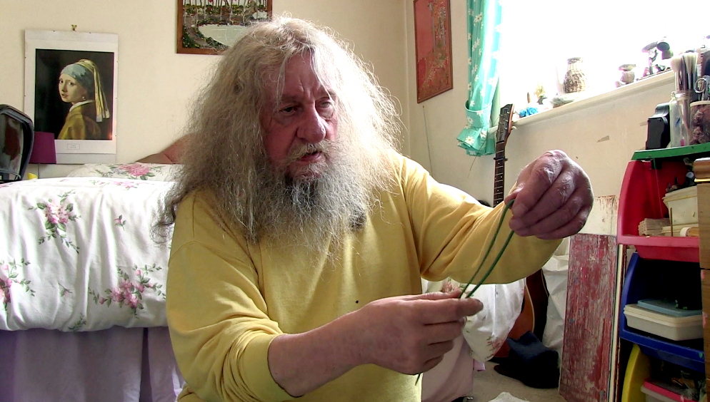
Figure 1: Using plasticine (description: Terry is sitting on the floor in front of his bed, molding plasticine into long stripes, which he can use for sketching compositions.)

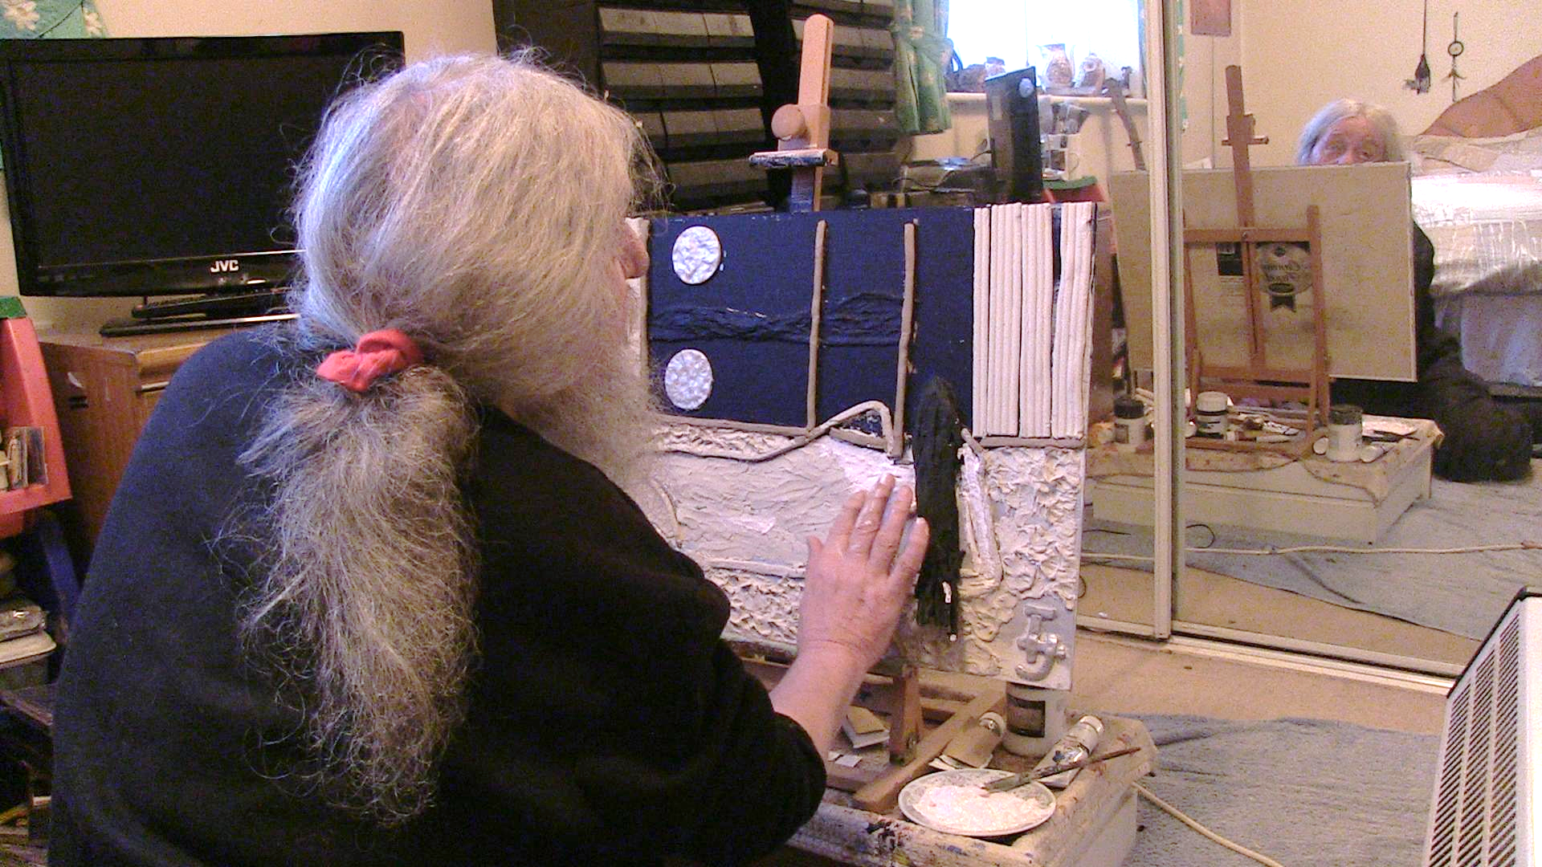
Figure 2: Painting (description: Terry is sitting on the floor in front of his bed, applying paint to a half-finished painting. We only see his back and the painting, but we can see half of his face reflected in the wardrobe mirror in front of him. The painting portrays the back of a woman looking out of a window at night. She looks at a full moon and the moon’s reflection in a lake.)

To enable this, the painting process is shown in a variety of scenes interspersed with non-related, ordinary events. It is subsumed by a ‘flow of life’, which Siegfried Kracauer (251) describes as a larger, invisible context that mediates everydayness. For Kracauer, the cinematic quality of everydayness depends on the permeability of the flow of life within it (254). The more it appears to the viewer that an event has emerged from the invisible, everyday continuum, the more the viewer experiences the elusive flow of the everyday without actually perceiving it – the flow is “explicitly implied”. In order to further disperse a narrative focus on the creation process, the painting scenes are not placed at the very beginning and end of the film, and they are intertwined with a plethora of other ordinary routines in Terry’s life, such as smoking, writing CD labels on his Braille typewriter, solving crosswords or pouring his favorite whiskey. In addition, the film portrays these events as open-ended, fragmented episodes. These fragments are vague and indefinite in relation to plot consistency by deliberately omitting contextual exposition, which prompts the spectator to infer the indeterminate flow of the everyday. According to Harvie Ferguson (156–57), the self in contemporary everyday life is a fragmented project in the process of constant transformation, shaped by disconnection and discontinuity; everyday life is the arena of this fragmentation, in which all the fragments appear without any established priority.

Furthermore, the scenes of the painting process comprise less than half of the film’s narrative, whereas the supercrip films mentioned earlier are literally suffused with the process of creating visual art. This is a crucial filmmaking intervention that prevents the painting process from becoming a metonym for Terry’s persona; it is merely one facet of his life, and although it is his greatest passion, it is as much a part of his everyday as his daily whiskey. A good example is the intercutting of the painting process with the repetitive ‘fag break’ motif; after painting sessions, Terry relaxes by smoking a cigarette. In terms of their visual dynamic, the painting and the smoking motifs are very different, the former exhibiting a range of actions and objects, while the latter is restricted to Terry’s quasi-static body and the cigarette. This exemplifies Highmore’s and Stewart’s aforementioned interaction between disparate, fragmented, heterarchical and rhythmically different events that constitute Kracauer’s everyday flow.

Nevertheless, Terry’s painting process is inherently teleological – it is a goal-driven endeavor, with a clear progression, especially since Terry works only on one particular painting during the film. Within the narrative timeline, this carries the risk of emphasizing the accomplishment of a concrete goal to a particular purpose, thus invoking the supercrip trope. Again, narrative fragmentation is the key strategy countering this, as it involves the omission of exposition and context surrounding the painting as a process and an artefact. For instance, although the first painting scene starts at the beginning of the actual painting process, it is not clear why or for whom Terry is painting this picture, nor what it will depict (the visual motif of the woman looking out of a window at night is only revealed gradually through visual fragments). Furthermore, the spectator never sees the finished painting, so it is uncertain whether Terry completes it or where it will end up – throughout the film we see his paintings hung on the walls, but also stowed away in corners, and even dumped in the garden. Any of these locations could represent its ultimate fate. Thus, the painting process starts and finishes in medias res, without revealing its wider context and the end product.

Withholding a glimpse of the final painting may have an additional advantage: the seeing spectator is exempt from drawing aesthetic conclusions about the painting, thus escaping the potentially uncomfortable dilemma of having to judge the final product either in terms of its objective, aesthetic quality or as an achievement by a disabled person. Again, this reflects Terry’s own attitude towards his paintings: in an interview (not used in the film), he mentions that he does not regard them as aesthetic objects but as ordinary things he creates without the necessity (or visual ability) to judge them. Hence, his comment in an earlier scene about discarding paintings that do not ‘behave’ whilst he works on them stresses the significance of his tactile, momentary interactions with them during the creation process, almost discarding the aesthetic value of the final product. It ultimately remains ambiguous as to whether Terry considers the outcome a successful achievement or not. As for him painting is a passion but also an ordinary process that creates momentary pleasures regardless of the end result, the lack of a clear goal-driven plot means that the spectator, too, is able to experience the moment, instead of being distracted by expectations about the outcome.

Improvisation and Failure
Another strategy used to represent Terry’s painting process as an ordinary, quotidian event is the emphasis on his bricolage approach, in which improvisation and failure are mediated in relation to embodied skills (Dant 43). Documentary narratives depicting manual labor and artistic performances usually exclude episodes of improvisation, failure and experimentation. In particular with disabled artists, filmmaker’s seem to be averse to showing awkward or unsuccessful bodily actions, probably attempting to prevent the perception of degradation through the filming process. Yet, this tactic bears the risk of reinforcing the supercrip trope, which is why in my film several scenes depict Terry in moments of improvisation, clumsiness or disappointment, which, intermingled with elaborate, successful and dexterous moments, constitutes the multi-rhythmic everydayness of his painting process.

One such moment of improvisation is when he creates the moon, exhibiting his reliance on embodied skills acquired through past experience of trial and error (figure 3): he first places a chunk of hard plasticine between his thigh and his calf to warm it up and make it malleable; he keeps checking it – all the while, working on another piece of plasticine – until he thinks it is ready; he then uses a plastic cup to form the moon, which he places onto the canvas. These seemingly peripheral and incidental moments of material interaction do not significantly advance the painting process but are essential to mediating Terry’s implicit co-ordination of what he perceives and how he responds. Perception and action are the major mechanisms for sedimented corporeal knowledge, which disposes the agent to respond in ordinary ways to ordinary situations (Crossley 110). These ordinary reactions are improvisations, or bricolage, based on past experience as well as the present situation, and the filmic focus on these mediates Terry’s experience and material interaction as a unique moment in time, rather than a milestone in a longer, goal-driven narrative process.

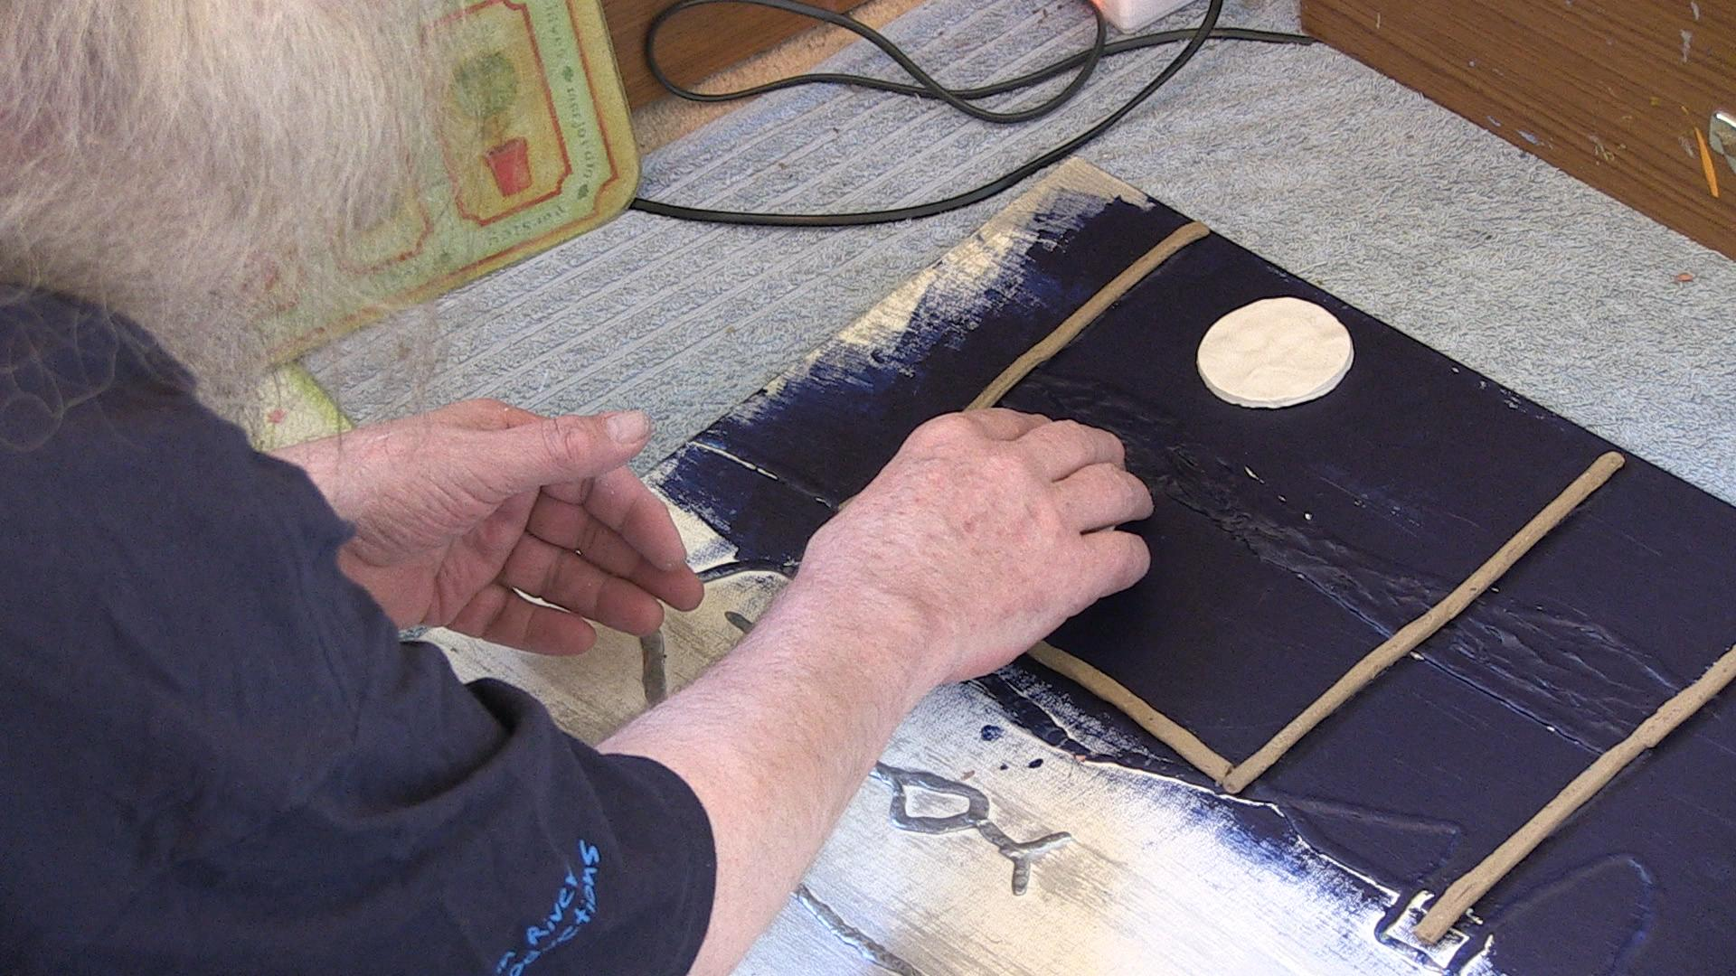
Figure 3: The moon (description: Terry places a white moon made of plasticine onto the canvas. The canvas has a background painted in blue, and several brown stripes of plasticine outline the window.)

A major element of everyday bricolage is the randomness of failure. The everyday is interspersed with disjunctures, disruptions, interferences and the work of repair, which reveal its elasticity (Trentmann 69). Embodied knowledge has to be readjusted in the moment in order to deal with sudden disruptions and failures, and this leads either to an improvised repair or suspension of the task. These unexpected moments highlight not only the uniqueness of the moment, but also the particularity of the body as it temporarily deviates from its usual routines.

Also, repair or suspension make time appear more viscous and devoid of energy, thus foregrounding the ‘banal’ everydayness we are more accustomed to experiencing as a background filler in conventional plots (Bakhtin 248). For example, Terry complains several times about the plasticine being too warm and soft (revealing the time of year and the weather when these scenes were shot), and in several instances, he struggles to separate the sticky plasticine strips from one another and it sticks to his fingers instead of the canvas, or he finds it difficult to mold properly. All these moments stretch time by forcing Terry to unsuccessfully repeat his attempts, culminating in one instance where he has to abort the process of forming a woman’s hair with black plasticine (figure 4), which is taken as an editorial cue to end the narrative fragment in medias res, still unresolved, and never to return to it.

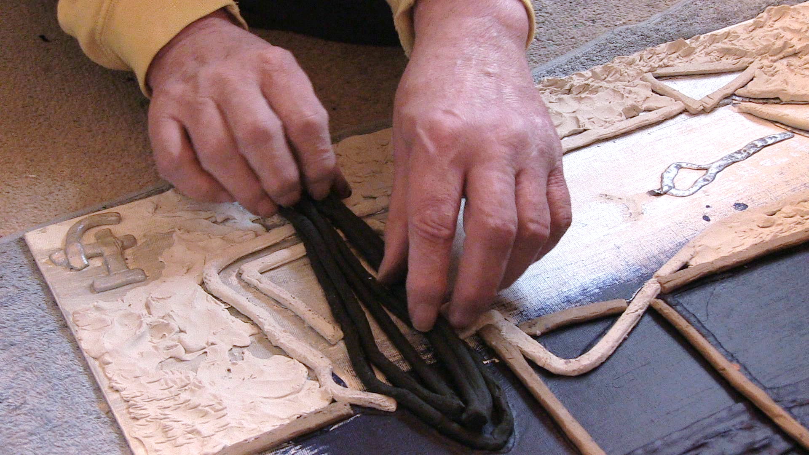
Figure 4: Sticky plasticine (description: Terry is struggling to place black stripes of plasticine as part of the woman’s hair in the unfinished painting.)

Documentaries about disabled (and non-disabled) artists tend to exclude such images of repeated, unsuccessful attempts, concerned that it could undermine the character’s dexterity and create moments of dead time that disrupt the narrative flow and the supercrip-focused plot structure. My film, by contrast, celebrates random failure as an essential attribute of everydayness and the particularity of multi-layered and complex characters, precisely because it slows time down and heightens the spectator’s experience of momentary material interactions with ordinary objects. However, since these moments of disruption are intermingled with successful moments that display Terry’s acquired dexterity, the painting process oscillates between fragments with slow and fast narrative rhythms, both randomly emerging from Kracauer’s everyday flow.

Final Thoughts
The techniques of narrative fragmentation and ambiguity, as well as the inclusion of improvisations and failure, not only mediate Terry’s own uncertain perspective towards painting, but they also turn his art into an indefinable, indeterminate and open-ended everyday practice rather than a glorious goal-driven project performed by a supercrip. The everyday is heterogeneous and ambivalently oscillates between flow and disruption, movement and arrest, anticipation and surprise, regularity and deviation, repetition and randomness. Representing the everyday in such a varied manner is essential. Highmore warns against everyday representations that are subjected to a seemingly appropriate, homogenous and coherently theorised discourse, because what is deemed an appropriate and coherent form for portraying the everyday automatically results in the exclusion of its other manifold aspects (Everyday Life and Cultural Theory 21). This approach enables the filmic mediation of a collective everydayness, which potentially transcends the experiential boundary between a seeing spectator and the blind screen character, and which undoes the schematic narrative stereotype of the supercrip artist.

One of my objectives when making this documentary was to embody the experience of everydayness (for Terry and for the viewer) within the painting process. Every depicted stage of the process is different, revealing disparate elements of Terry’s persona: for example, his autonomy when applying the plasticine, yet his dependence on his partner when mixing colors and applying the paint. His relationship to the painting itself remains ambiguous, and the painting’s genesis and fate, unresolved. The film represents a tentative and unfinished character portrait, with no apparent purpose or goal in terms of traditional disability activism or classical narrative engagement; it portrays a person who, ordinarily, is not a fixed character but a ‘work-in-progress’. According to Tobin Siebers (92), it is precisely this fundamental concept of the human being as a work-in-progress, without fixed definitions, that can overcome socially constructed boundaries between ability and disability.
Works Cited
Badia Corbella, Marta, and Fernando Sánchez-Guijo Acevedo. “The Representation of People with Visual Impairment in Films.” Journal of Medicine and Movies, vol. 6, no. 2, 2010, pp. 69–77.
Bakhtin, M. M. “Forms of Time and of the Chronotope in the Novel.” The Dialogic Imagination: Four Essays, edited by Michael Holquist, University of Texas Press, 1981, pp. 84–258.
Barasch, Moshe. Blindness: The History of a Mental Image in Western Thought. Routledge, 2001, https://doi.org/10.4324/9780203827215.
Barnes, Colin. Disabling Imagery and the Media: An Exploration of the Principles for Media Representations of Disabled People. The British Council of Organisations of Disabled People and Ryburn Publishing, 1992.
Chemel, Tasha. In Search Of the Ordinary. http://blindnessandarts.com/papers/TashaChemel2.htm. Accessed 10 Apr. 2017.
Crossley, Nick. “The Phenomenological Habitus and Its Construction.” Theory and Society, vol. 30, no. 1, 2001, pp. 81–120.
Dant, Tim. “Recording the ‘Habitus.’” Seeing Is Believing? Approaches to Visual Research, edited by Christopher J. Pole, Elsevier JAI, 2004, pp. 41–60, https://doi.org/10.1016/s1042-3192(04)07004-1.
Dyer, Richard. “Stereotyping.” Media and Cultural Studies: Keyworks, edited by Meenakshi Gigi Durham and Douglas Kellner, Blackwell, 2006, pp. 353–65.
Ferguson, Harvie. Self-Identity and Everyday Life. Routledge, 2009, https://doi.org/10.4324/9780203001776.
Highmore, Ben. Everyday Life and Cultural Theory: An Introduction. Routledge, 2002, https://doi.org/10.4324/9780203464229.
---. Ordinary Lives: Studies in the Everyday. Routledge, 2011, https://doi.org/10.4324/9780203842379.
Kleege, Georgina. More than Meets the Eye: What Blindness Brings to Art. Oxford University Press, 2018, https://doi.org/10.1093/oso/9780190604356.001.0001.
---. Sight Unseen. 1st ed 1st printing edition, Yale University Press, 1999, https://doi.org/10.1136/bmj.320.7226.66.
Kracauer, Siegfried. Theory of Film: The Redemption of Physical Reality. Oxford University Press, 1960.
Mitchell, David T., and Sharon L. Snyder. Narrative Prosthesis: Disability and the Dependencies of Discourse. University of Michigan Press, 2000, https://doi.org/10.3998/mpub.11523.
Pointon, Ann. “Disability and Documentary.” Framed: Interrogating Disability in the Media, edited by Ann Pointon and Chris Davies, British Film Institute, 1997, pp. 84–92.
Riley, Charles A. Disability and the Media: Prescriptions for Change. University Press of New England, 2005.
“Sargy Mann: How a Blind Painter Sees.” BBC News, 14 June 2015. www.bbc.co.uk, http://www.bbc.co.uk/news/magazine-33109430.
Schillmeier, Michael. “Dis/Abling Practices: Rethinking Disability.” Human Affairs, vol. 17, no. 2, Jan. 2007, pp. 195–208.
---. “Othering Blindness: On Modern Epistemological Politics.” Disability & Society, vol. 21, no. 5, Aug. 2006, pp. 471–84.
Schmader, Toni, et al. “An Integrated Process Model of Stereotype Threat Effects on Performance.” Psychological Review, vol. 115, no. 2, 2008, pp. 336–56, doi:10.1037/0033-295X.115.2.336.
Shakespeare, Tom. “Art and Lies? Representations of Disability on Film.” Disability Discourse, edited by Mairian Corker and Sally French, Open University Press, 1999, pp. 164–72.
Siebers, Tobin. Disability Theory. University of Michigan Press, 2008, https://doi.org/10.3998/mpub.309723.
Stewart, Kathleen. Ordinary Affects. Duke University Press, 2007, https://doi.org/10.1215/9780822390404-001.
Taussig, Michael. “Tactility and Distraction.” Cultural Anthropology, vol. 6, no. 2, 1991, pp. 147–53.
The Real Superhumans and the Quest for the Future Fantastic. http://style5.tv/portfolio/the-real-superhumans-and-the-quest-for-the-future-fantastic/. Accessed 29 Jan. 2018.
Trentmann, Frank. “Disrupting Is Normal: Blackouts, Breakdowns and the Elasticity of Everyday Life.” Time, Consumption and Everyday Life: Practice, Materiality and Culture, edited by Elizabeth Shove et al., Berg, 2009, pp. 67–84, https://doi.org/10.5040/9781474215862.ch-004.
Young, Stella. I’m Not Your Inspiration, Thank You Very Much. https://www.ted.com/talks/stella_young_i_m_not_your_inspiration_thank_you_very_much?language=en. TED talk, TEDxSydney.
Zhang, Lingling, and Beth Haller. “Consuming Image: How Mass Media Impact the Identity of People with Disabilities.” Communication Quarterly, vol. 61, no. 3, July 2013, pp. 319–34.

The reason for using the character’s first name as the film’s title reflects my intimate relationship (as a filmmaker) with Terry, rather than infantilizing him. It is also meant to express an ‘ordinary’ familiarity between spectator and screen character, thus aiding the perception of everydayness.
‘In Search Of the Ordinary’ <http://blindnessandarts.com/papers/TashaChemel2.htm> [accessed 10 April 2017]
‘I’m Not Your Inspiration, Thank You Very Much’ (presented at the TED talk, TEDxSydney, 2014) <https://www.ted.com/talks/stella_young_i_m_not_your_inspiration_thank_you_very_much?language=en> [accessed 5 December 2017].
As Highmore (Ordinary Lives 2) establishes that the terms ‘everyday’ and ‘ordinary/ordinariness’ can be taken to be synonymous, this paper follows suit and uses these terms interchangeably.

