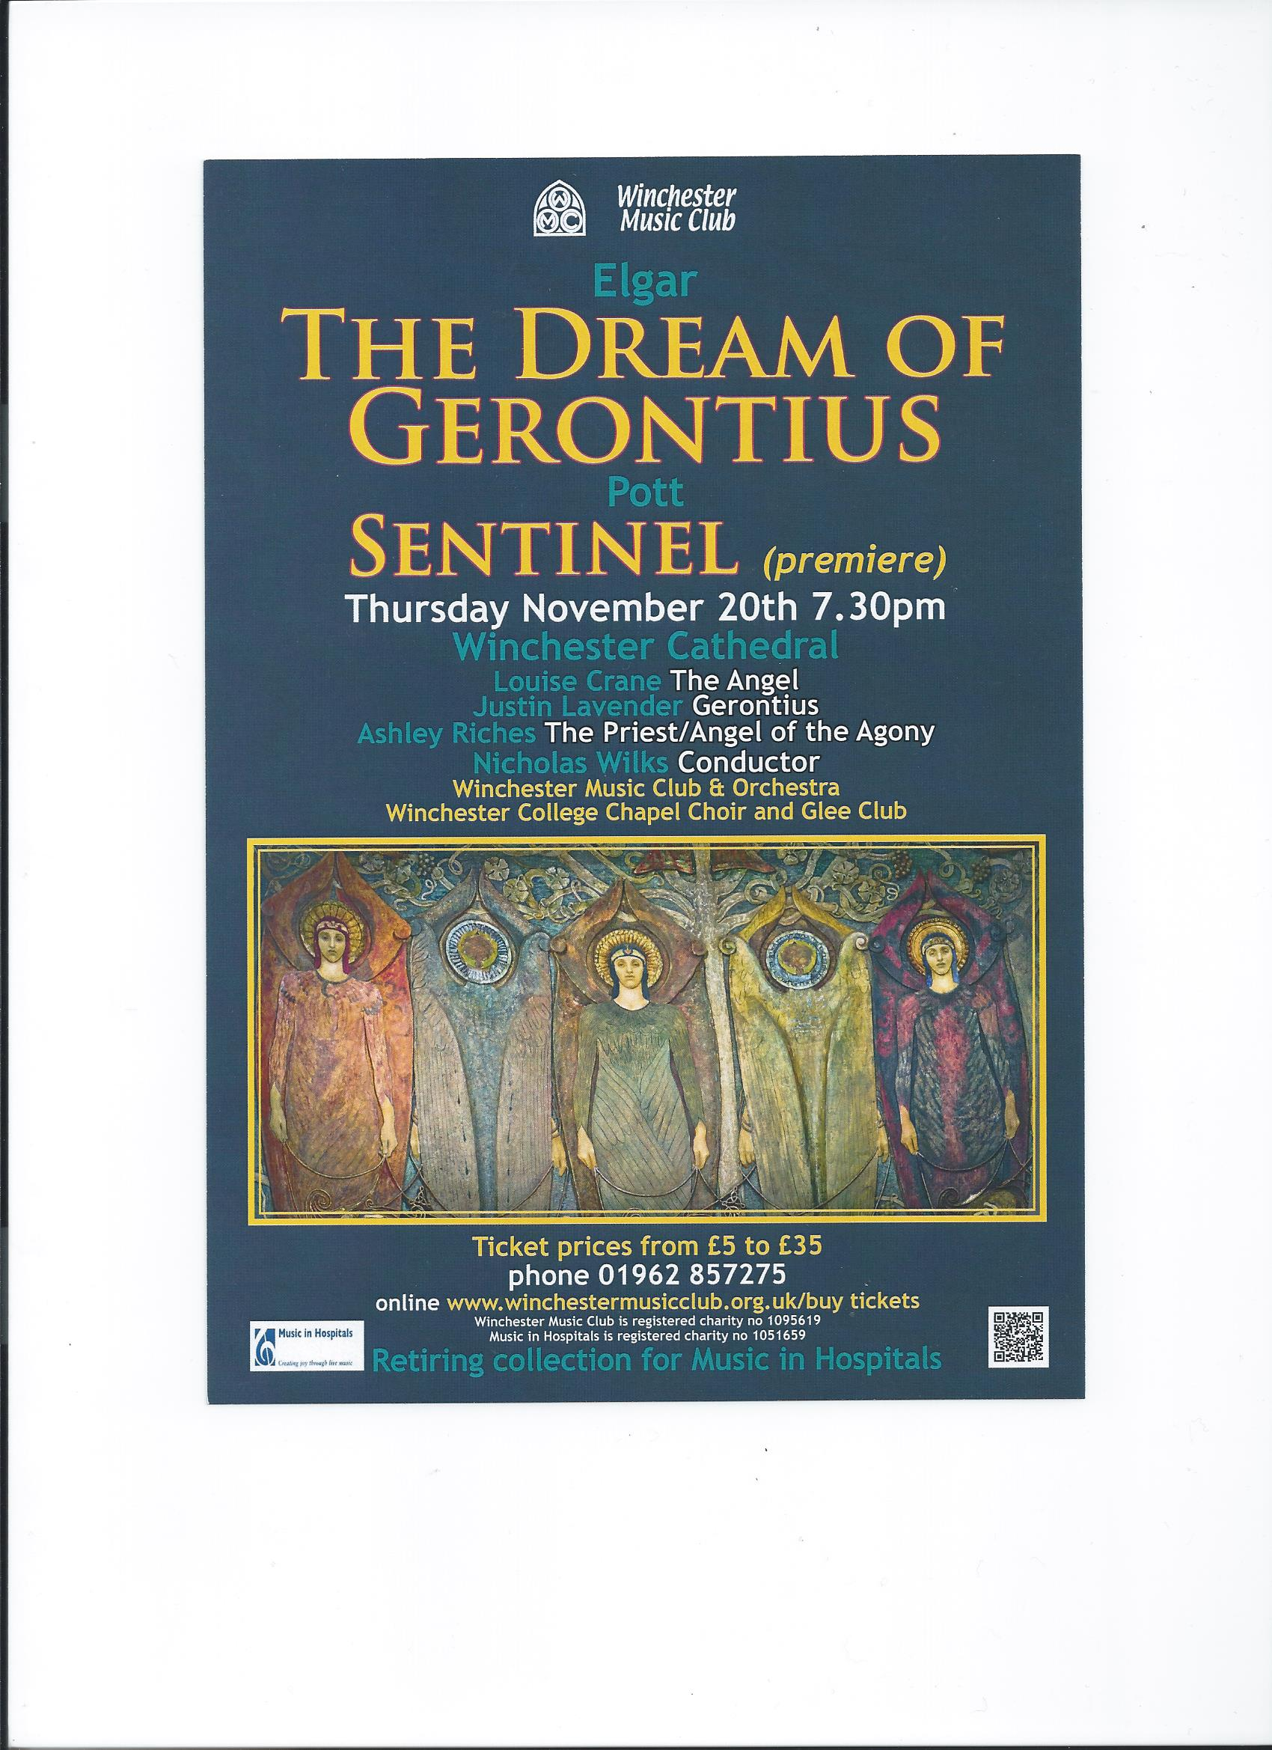

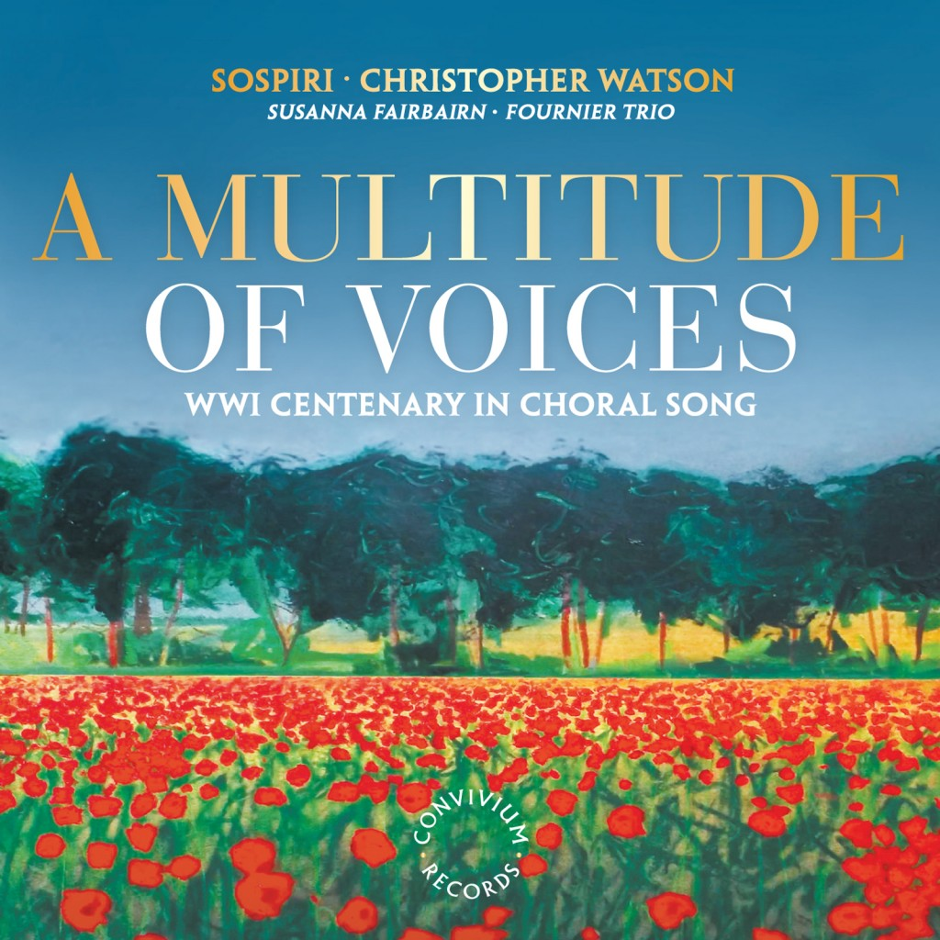

Sentinel
SATB double chorus a cappella. Circa 9’00”.
Programme note:
Sentinel was commissioned jointly in 2013 by Winchester College and the Oxford-based chamber choir Sospiri (the title also of a hauntingly nostalgic short work for string orchestra by Elgar). The commission formed part of a project commemorating the fallen of The Great War, with Winchester College furnishing the first public performance on 20th November 2014 and Sospiri presenting the work on CD (they made their recording in August 2014 and released it the following October).
Sentinel merges text by the poets Edward Thomas (killed at Arras in 1917) and Isaac Rosenberg (a fatality exactly a year later, a few miles to the north-east). This conflation embraces various tensions. First, the Thomas lines are prose, while Rosenberg’s come from three separate poems. Secondly, those by Thomas date from 1913 and owe their premonitory intensity partly to an innate existential anguish from which he suffered throughout his adult life (unending night rain is a recurrent metaphorical reflection of this in both his prose and his verse), whereas Rosenberg’s agony springs from the ghastly immediacy of the trenches, his sanity seemingly imperilled by a constant circumstantial denial of the sanctity of individual life. An autodidact from a relatively humble background in Bristol and London’s East End, Rosenberg arguably exceeded all his public school contemporaries in the outwardly Classical formality of his poetry, yet frequently conjured grievously memorable effect from its brutal collision with nightmare images of the Western Front.
Like Chopin in 1839, composing his ‘raindrop’ Prelude in the wintry Mallorcan monastery at Valdemossa, I imagined rain as a sombre continuum, spread here among divided choral parts and implicitly present beneath more agitated music, always re- emerging with stealthy persistence. At the end, where this seems to pass beyond hearing rather than fall truly silent, I was responding to a line about rain in November, a poem by John Burnside, which I had recently set: It won’t stop until you listen. This aptly reflected also the death wish of Thomas, for whom only extinction in the field of battle could ever bring about the peace which he craved.
Conceiving a work suitable for both large and small choral ensembles presents its own particular challenges. In trying to rise to them, I hope that I may also have found a suitable reflection of such a contrast in texts which bring together bleak individual introspection (specific to its own time and place) and a more universal tone of passionate outcry against the perennial futility of all human conflict.
© Francis Pott, 2014.

Sentinel
The rain has been and will be for ever over the earth.
The heavy black rain falling straight through the air
that once was a sea of life.

God’s blood is shed.
He mourns from His lone place
His children dead.

Wan, fragile faces of joy,
To you I stretch my hands.
You yearn to me, lure and sadden
My heart with futile bounds.

I am alone in the dark still night,
and my ear listens to the rain …roaring
softly in the trees of the world.

The summer is gone, and never can it return.
Memory, the last chord of the lute, is broken.

The desolate land of France.
There they lie huddled,
Man born of man, and born of woman.
Earth has waited for them,
All the time of their growth
Fretting for their decay.
None saw their spirits’ shadow shake the grass.

Now there is neither life nor death.
The rain has been and will be for ever over the earth.

Text collated from

[i] Edward Thomas: Rain
[prose picture from The Icknield Way, written in 1911 and published in 1913;
shown in italic print]

and

[ii] Isaac Rosenberg: On Receiving News of the War [extract],
Home Thoughts from France [extracts],
Dead Man’s Dump [extracts].

Link to video of Francis Pott talking about the composition of this work:
https://www.youtube.com/watch?v=-gcENdGzHGk

