Low-energy residential building optimisation for energy and comfort enhancement in semi-arid climate conditions

SeyedehNiloufar Mousavi¹, Mohammad Gheibi^{2,3}, Stanisław Wacławek⁴, Neale R. Smith⁵, Mostafa Hajiaghaei-Keshteli⁶, Kourosh Behzadian^{*7,8}

¹Tecnologico de Monterrey, Escuela de Ingeniería y Ciencias, Ave. Eugenio Garza Sada 2501, Monterrey, 64849, N.L., Mexico
² Institute for Nanomaterials, Advanced Technologies and Innovation, Technical University of Liberec, 46117 Liberec, Czech Republic
³Association of Talent under Liberty in Technology (TULTECH), 10615 Tallinn, Estonia
⁴Tecnologico de Monterrey, Escuela de Ingeniería y Ciencias, Ave. Eugenio Garza Sada 2501, Monterrey, 64849, N.L., Mexico
⁵Tecnologico de Monterrey, Escuela de Ingeniería y Ciencias, Monterrey, Mexico
⁶Tecnologico de Monterrey, Escuela de Ingeniería y Ciencias, Puebla, Mexico
⁷School of Computing and Engineering, University of West London, Ealing, London, W5 5RF, UK
⁸Civil, Environmental and Geomatic Engineering, University College London, Gower St, London WC1E6BT, UK
Email: kourosh.behzadian@uwl.ac.uk (Corresponding Author)
Abstract
The application of energy-efficient strategies in buildings, such as the Green Building Concept, can significantly impact human comfort and resource consumption. However, due to the complexity of decision-making factors and the variety of available materials, computational models are necessary to identify the most effective solutions and optimise building energy performance. This study presents an integrated framework that uses machine learning algorithms and a Petri Net control system to optimise the thermal, comfort, and energy efficiency of both vertical and horizontal building envelopes in semi-arid climate zones. The framework incorporates several passive techniques for building energy parameters, including material thickness and melting point, window types, wall insulation thickness and thermal emissivity, wall solar absorbance, window wall ratio, fenestration position, air tightness, roof solar reflectance, roof insulation thickness and conductivity (W/(m·°C)), and floor insulation thickness. An experiment design was developed using Box-Behnken Design-Response Surface Methodology (BBD-RSM) for statistical optimisation, which was coupled with Design Builder simulation model. The methodology was demonstrated by applying it to a residential building in Mexico. Meta Additive Regression was used to analyse the output factors, which showed higher confidence compared to REP Tree and M5P Tree algorithms in green buildings. The results demonstrate that an annual energy reduction of 50 kW/m² per household can be achieved by using an optimised building envelope.
Keywords: Building optimisation; energy efficiency; machine learning; phase change materials; semi-arid climate; thermal comfort.

List of abbreviation
At | Air tightness (ASHRAE 62.1) | LEED | Leadership in Energy and Environmental Design
ANN | Artificial Neural Networks | ML | Machine Learning
ANOVA | Analysis of Variance | PCM | Phase Change Material
ASHRAE | American Society of Heating, Refrigerating and Air-Conditioning Engineers | PH | Passive House
BBD-RSM | Box-Behnken Design-Response Surface Methodology | PMV | Predicted Mean Vote
CFD | Computational Fluid Dynamics | P/M | Roof thermal storage (PCM melting point)
CTF | Contrast Transfer Function | P/T | Roof thermal storage thickness
DB | DesignBuilder | RI/T | Roof insulation thickness
DE | Frequency distribution | RI/C | Roof insulation conductivity
DNN | Deep Neural Networks | RMSPE | Root Mean Square Percentage Error
DSS | Decision Support System | RSA | Roof Solar absorbance
Et | Total Energy | RUV | Housing Registry Organisation
EBT | Ensemble Bagging Trees | Ti | thermal improvement
EPW | Energy Plus Weather | WEKA | Waikato Environment for Knowledge Analysis
FDM | Finite Difference Method | W/E | Wall thermal emissivity
Fi/T | Floor insulation thickness | WI/T | Wall insulation thickness
Fp | Fenestration position | WSA | Wall solar absorbance
HVAC | Heating, Ventilation, and Air Conditioning | Wt | Window types
INFONAVIT | Institute of the National Housing Fund for Workers | WWR | Window-Wall Ratio
IoT | Internet of Things

Introduction
The global temperature has been steadily increasing over the last few decades due to excessive energy consumption and the resulting emissions (Ritchie & Roser, 2017). Buildings account for more than 30% of global energy production, and 47% of this energy is used for cooling and heating systems (Yu et al., 2020). Experts predict that the demand for cooling will increase by 179% by 2050 due to global warming (Berardi, 2017).
To address energy efficiency concerns in the construction industry, the concept of Green Building was created to maximise resources and reduce the impact of emissions on the environment (Francoet al., 2021). Several rating systems, such as Leadership in Energy and Environmental Design (LEED) and Passive House (PH) (Naghedi et al. 2022), have been developed to evaluate green buildings based on environmental standards. These ratings aim to increase thermal comfort for residents while reducing building energy demand and carbon emissions. Some strategies that can be employed to achieve these improvements include using thermally enhanced envelope materials, optimal orientation, airtightness, and efficient glazing (Figueroa-Lopez, A et al., 2021).
Using Scientometric analysis, the key topics and their connections related to Design-Builder publications in the Scopus databank over the last decade were generated schematically, as shown in Fig. 1. This analysis confirms that energy efficiency and thermal comfort, which are the two main components related to architectural design, have been among the most popular research topics over the last decade. This was achieved through the use of the VOS viewer platform.
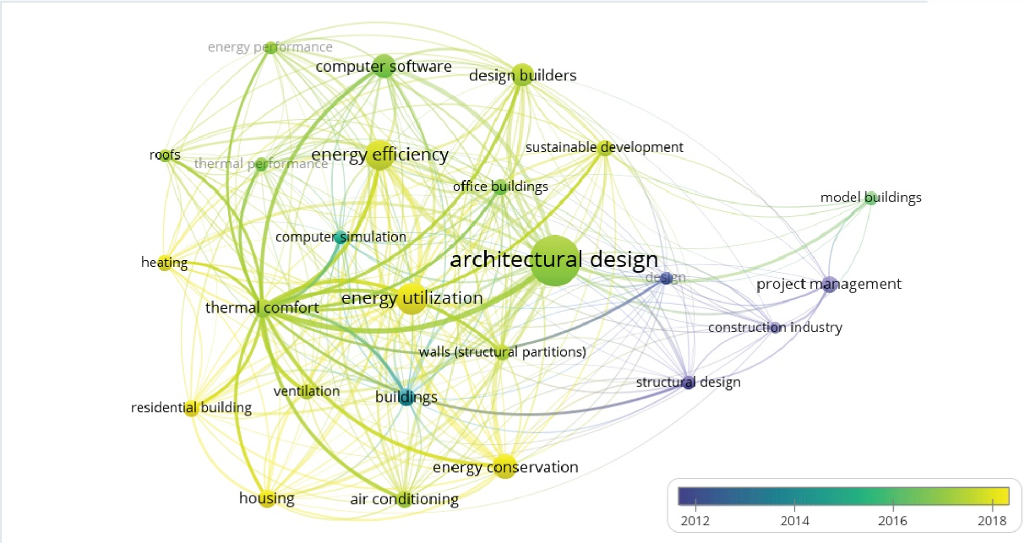
Fig. 1. Popular research topics and keywords of the publications in the DB field over the last decade

The building industry is one of the most energy-demanding markets worldwide. The energy efficiency market in buildings is segmented into various categories such as lighting, Heating, Ventilation, and Air Conditioning (HVAC), building envelope, among others. According to Fig. 2, which represents the market share of these segments in the United States in 2020, the building envelope segment could generate an annual profit of US$20,586 million. Furthermore, Fig. 3 highlights the cumulative energy savings achieved through LEED-certified projects in the US, showing significant energy savings of over US$5 billion for electricity use in buildings between 2016 and 2020. Financial factors were found to be one of the main obstacles and motivators to further develop low-carbon solutions adopted by communities (Wang et al., 2021).

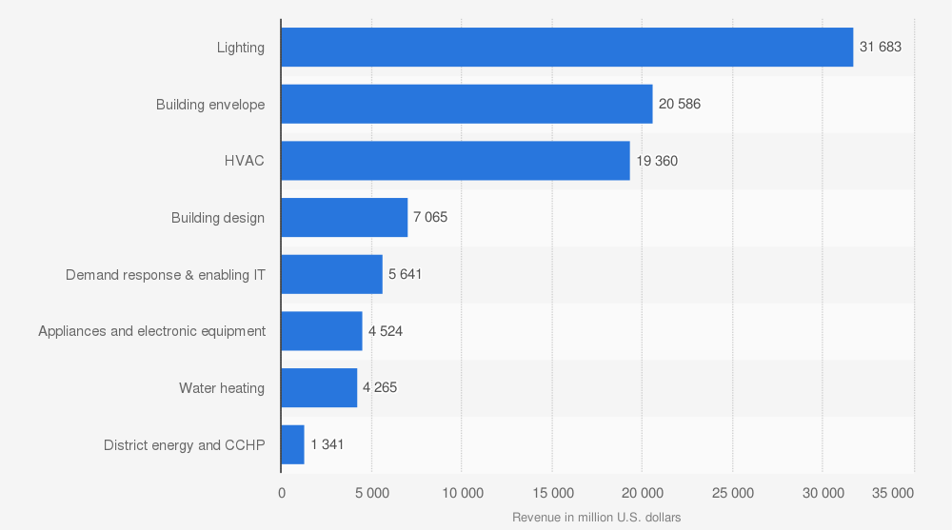
Fig. 2. Revenue of the building efficiency market in the US in 2020
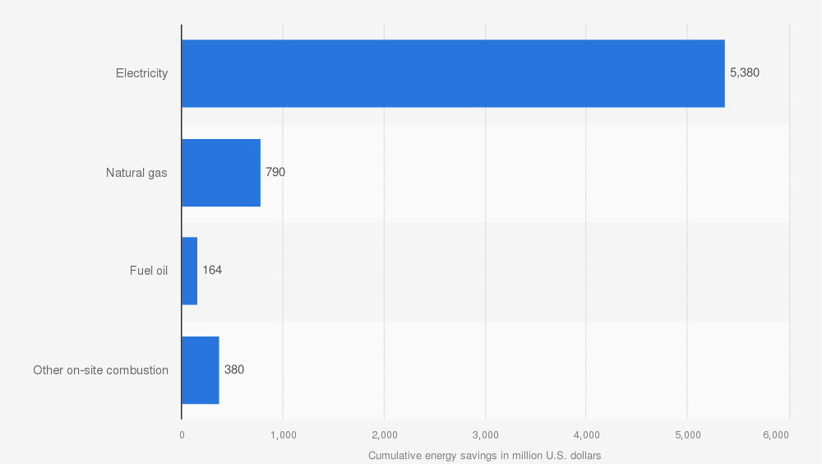
Fig. 3. Cumulative energy savings from LEED-certified projects in the US between 2000 and 2016
Building Energy Simulationsoftware programmes are used to predict and measure building envelope thermal behaviour and energy demands. Dynamic simulation tools such as EnergyPlus, TRNSYS, and Modelica provide reliable results, as stated by Mara et al. (2021). However, the accuracy of input parameters can be prone to errors. To address this issue, the Building Energy Simulation Test serves as a comparative diagnostic procedure for the ASHRAE (American Society of Heating, Refrigerating, and Air-Conditioning Engineers). The test confirms that the Design-Builder (DB) software has a highly accurate diagnostic method (Design Builder Software, 2022). The DB operates based on Energy-Plus v8.1 dynamic building energy simulation, as presented in Fig. 4. It can measure thermal comfort, energy demand, renewable energy supply, Computational Fluid Dynamics (CFD), and daylighting using different functions and standards (Garg, et al., 2020).
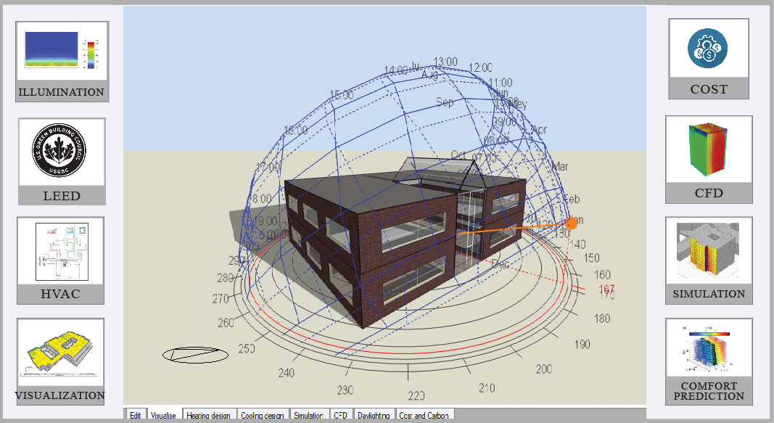
Fig. 4. Schematic plan of DB software with the key functions

Building envelope parameters and energy consumption
There are several envelope parameters that can influence building energy consumption, including Window-Wall Ratio (WWR), orientation, insulation, thermal storage, glazing solar absorbance, and thermal conductivity. Ahmed et al. (2020) used the Design-Builder (DB) software to simulate a typical office building and achieve near-zero energy consumption while also measuring the economic impact of their approach. Grande-Acosta et al. (2020) reported that envelope optimisation in a tropical climate can result in a 30% reduction in cooling energy consumption. Abu-Rayash and Dincer (2021) also evaluated smart sustainable cities in eight domains including building envelope optimisation. Overall, envelope optimisation is a critical aspect of building energy consumption, and research has shown that utilising techniques such as simulation software and optimising parameters such as WWR and insulation can significantly reduce energy consumption and promote sustainable cities.

Vertical envelope enhancement
The thermal properties of building walls and windows have a significant impact on indoor temperature and occupants' comfort. Researchers such as Bashirpour-Bonab et al. (2019), Chen et al. (2020), Świrska-Perkowska et al. (2020), Wu et al. (2021), Chen et al. (2021), Fathalian et al. (2020) and Zhang et al. (2021) have conducted studies on various aspects of building envelopes to enhance energy efficiency and thermal comfort.
For instance, Bashirpour-Bonab et al. (2019) evaluated the effects of different facades on energy efficiency under various climate conditions and found that travertine material is best suitable for warm and humid climates, colour concrete for cold weather, and refractories for average temperate climates. Chen et al. (2020) reviewed the impact of factors such as window-wall ratio (WWR), building shape, insulation, and orientation on energy savings and concluded that energy performance benchmarking is urgently needed. Świrska-Perkowska et al. (2020) compared different insulation thicknesses for solar walls under different climatic conditions and orientations, which resulted in 24-31% decrease in the annual heat balance of the envelope. Furthermore, Wu et al. (2021) examined the influence of thermal performance of walls with Phase Change Material (PCM) on peak heat flow, that were reduced by 62.29%. Chen et al. (2021) employed a genetic algorithm optimisation model to improve the thermal comfort and energy efficiency of buildings by optimising the wall U-value and external wall solar absorptance, resulting in a substantial reduction of energy consumption by 37.5% and enhancement of thermal comfort by 33.5%. Fathalian and Kargarsharif (2020) analysed different shading and glazing with DB simulation that led to a reduction in energy consumption by 15.2%, while Zhang et al. (2021) incorporated silica aerogel and PCM into triple-glazed windows with appropriate optical properties and melting temperature that can improve thermal comfort while minimising energy consumption in the severe cold climate of China. These studies highlight the importance of building envelope design for enhancing energy efficiency and occupants' comfort in buildings.

Horizontal envelope enhancement
The roof and floor are horizontal elements of a building that allow solar radiation to enter the interior, either directly or indirectly. These components have a significant impact on the building's energy consumption, including their thermal storage capacity, solar reflectance, and thermal conductivity. Piselli et al. (2019) conducted a study on the relationship between the solar reflectance capability of building roofs and their thermal insulation for energy efficiency in various global climates. Cool roofs have been widely studied, and despite differences in proposed boundary conditions, they have been shown to achieve energy savings between 15% and 30% (Gagliano, 2012; Pisello, 2014; Lei 2017). For example, Mousavi et al. (2023) found that green roofs in residential buildings can increase comfort by 13% and reduce energy by 14%. However, cool roofs do have a disadvantage of aging (Morini et al., 2018). In semi-arid climates, the application of white paint on roofs has resulted in a 13°C surface temperature reduction and a 66% reduction in roof slab total heat flux (Kachkouch et al., 2018)‎. In terms of comfort, the use of cool roofs in hot climates has been shown to reduce discomfort hours by 53%.
Meng et al. (2019) used a numerical method to analyse different insulation positions in the floor to improve the unit's thermal performance. Guo et al. (2020) measured the annual cooling energy reduction after applying a cool roof and evaluated its impact when combined with night ventilation. Jain et al. (2020) used a genetic algorithm to find the best performing thermal combination, which combined phase change materials (PCM), green roofs, and reflective coatings with DB simulation. Yu et al. (2020) investigated the ideal thickness and melting point of PCM using CFD simulation, which resulted in a surface temperature reduction of 3.7 °C. Rangel et al., (2022) experimentally evaluates the use of PCM and natural ventilation to improve the thermal performance of roofs in semi-arid climate conditions and demonstrates that PCM with natural ventilation can significantly reduce indoor air temperature and improve thermal comfort.

Building energy optimisation
Optimising building components involves using optimisation algorithms to identify the most effective and feasible options for various parameters, such as thermo-properties of materials, building orientation, and WWR. The goal is to achieve higher thermal comfort and lower energy consumption. Nguyen et al. (2014) noted that building optimisation involves a pre-processing phase, an optimisation phase, and a post-processing phase. Machairas et al. (2014) evaluated different algorithms for envelope selection, while Shi et al. (2016) investigated various energy enhancement strategies for envelope optimisation during the design stage. Gou et al. (2018) used a neural network to optimise envelope components, resulting in improved comfort and energy efficiency.
Liu et al. (2021) optimised six parameters of heat transfer coefficients and solar radiation absorption coefficients for exterior walls, windows, roofs, and WWR with a random forest model, which led to notable results. In recent years, multi-objective optimisation models with a focus on energy optimisation have gained attention. Rosso et al. (2020) studied energy and cost in residential buildings based on a few retrofit strategies, while Salata et al. (2020) evaluated the effectiveness of retrofitting buildings in the context of climatic challenges.
Table 1 presents a summary of recent studies on optimisation techniques in the building sector that aim to enhance energy efficiency, thermal comfort, and environmental sustainability. The studies analysed various design parameters, such as solar combined heat and power systems, HVAC and passive systems, renewable supply systems, wall insulation, and window glazing. As can be seen, Most studies focused on energy optimisation in buildings, with only a few addressing occupant comfort. Additionally, the majority of studies were conducted in temperate climates, and the performance metrics included energy performance, economic factors, emissions, thermal comfort, and daylight illuminance. The optimisation techniques utilised various algorithms such as genetic algorithm, multi-time scale rolling, constrained nonlinear, PSO algorithm, Box-Behnken + MOO, NSGA-II, Radiance + Octopus, and Box-Behnken + response surface prediction.

Table 1. Comparison between previous literature regarding building optimisation parameters and methods.
Design parameters | Climate | Method | Performance metrics | Reference
Solar Combined Heat and Power system | Subtropical | Genetic algorithm | Energy performance | Wang et al., 2022
Combined Heat and Power system | Subtropical | Multi-time scale rolling | Economic, Energy performance | Wang et al., 2022
HVAC, passive system including PCM, window size | Temperate oceanic | Constrained nonlinear | Energy performance | De Araujo Passos et al., 2023
Renewable supply system | Continental | PSO algorithm | Energy performance, economic,  Emission | Chen et al., 2022
Wall insulation | Tropical, Subtropical, Warm temperate, Temperate, Cold temperate, Arid and semi-arid | Orientation differential insulation | Energy performance economic, | Li et al., 2023
Insulation, solar heat gain, window, heat transmission coefficient of roof, window to wall ration (WWR) | Temperate | Box-Behnken +MOO | Thermal comfort,  Energy performance | Li et al., 2021
Building azimuth, WWR, windows, solar reflectance, glazing | Temperate | NSGA-II | Thermal comfort,  Energy performance | Zhai et al., 2019
WWR, orientation, window glazing | Continental | Multi-factor combination  Exploration | Emission performance | Zhou et al., 2018
Orientation, WWR, building shape, Glazing, and Shading types | Continental | Radiance + Octopus | Daylight Illuminance, Thermal comfort, Energy performance | Zhang et al., 2017
Heat transfer coefficient of the roof, air change, wall heat transfer coefficient, floor heat transfer coefficient, COP of air conditioner, Insulation thickness, WWR, solar heat gain coefficient of windows | Temperate | Box-Behnken + Response surface prediction | Energy performance | Liu et al., 2021

According to the above literature, studies that involve more than three design parameters require a design approach that is capable of efficiently exploring the design space. The Box-Behnken Design-Response Surface methodology is an appropriate method for such studies. This study aims to develop a novel energy optimisation framework for building envelopes. The framework divides the envelope into horizontal and vertical components and considers various retrofit and new build scenarios to determine the best thermal and energy performance solutions while also accounting for occupants' comfort in the model.
This study's distinctiveness emphasises on creating a comprehensive energy and comfort optimisation framework for building envelopes as the entire envelope while previous research often focused on optimising individual components, such as windows or insulation. Additionally, this study emphasises the importance of considering occupants' comfort in the optimisation process. By including comfort as a parameter in the model, the framework can produce more realistic and practical solutions that are likely to be adopted by building owners and occupants. To demonstrate the efficacy of this framework, we applied it to a typical middle-class house in Mexico, specifically a Type C house representing approximately 24% of all registered houses as per the Unique Housing Registry Organisation.
The next sections present the methodology used in this study. This includes a discussion of the simulation aspects, simulation model, optimisation methods, and machine learning computations. The results are presented in section 3 followed by critical discussion. Finally, conclusions are drawn based on the key findings of the study, and recommendations are made for future research in this area.

Materials and methods
The methodology used in this study involves several techniques and steps, including DB simulations, statistical optimisation, machine learning approaches, sensitivity analysis, and control system implementation. A design model is developed and calibrated using real data collected from design experiments in a real case study. These experiments are generated using the Box-Behnken Design-Response Surface Methodology (BBD-RSM) for statistical optimisation, coupled with the DesignBuilder simulation model. The study also applies machine learning computations using Meta Additive Regression, REP Tree, and M5P Tree algorithms to implement a prediction system for green buildings. A sensitivity analysis was also conducted for the optimised solution with a focus on Sustainable Development Goals.

Methodology
The methodology used in this study includes several steps as presented in Fig. 5. Firstly, a case study building was selected based on typical residential construction in Mexico (Mousavi et al., 2022). Three parameters including electricity consumption, comfort, and thermal behaviour of the unit were simulated using DB software. Passive strategies for the vertical and horizontal building envelope were defined based on the literature, and upper and lower boundaries were established by trial and error. An experiment was then designed using the Box-Behnken method, and simulation optimisation was performed based on three output parameters, leading to the selection of the optimum state.
A Petri Net model was used to develop the control system, allowing for monitoring of the simulation. Machine learning algorithms, including Meta Additive Regression, REP Tree, and M5P Tree, were used to test the prediction application confidence. A Decision Support System was employed to support decision making, including monitoring, prediction, and control stages (Gheibi et al., 2018; Akbarian et al., 2022). The monitoring section was based on DesignBuilder simulations, the prediction stage utilised machine learning computations, and the control system was executed by Petri Net modelling (Shahsavar et al., 2021; Pouresmaeil et al., 2022; Zamanikherad et al., 2022).
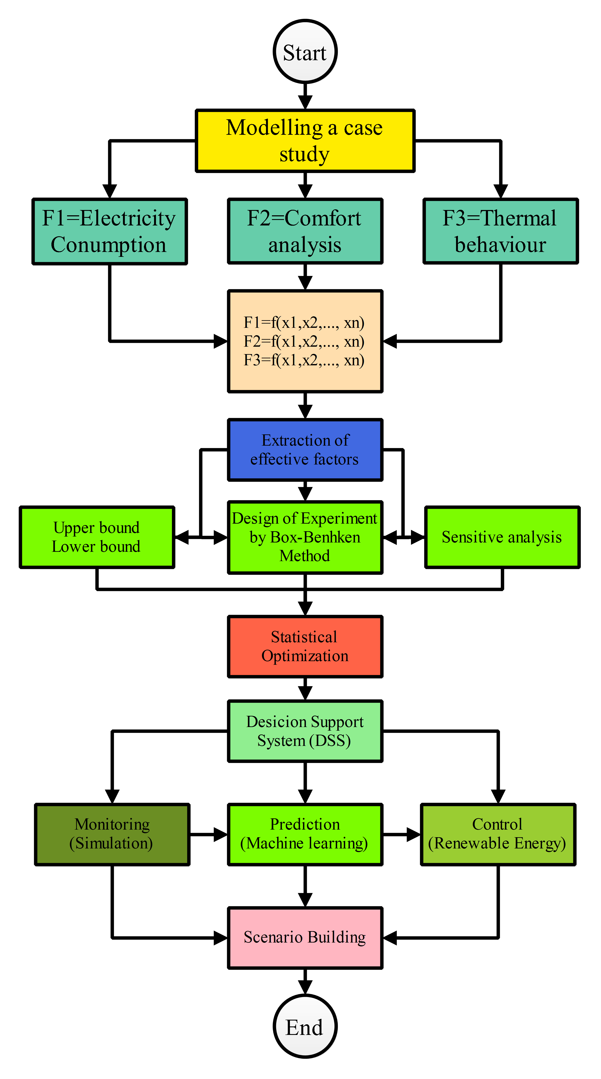
Fig. 5. The research roadmap in this study

Case study
The proposed methodology has been applied to a real case study of a typical building in Monterrey City, located in the state of Nuevo León, Mexico. The city has an annual energy consumption rate of 2.4 TWh and is situated at an altitude of 515 meters above sea level (McNeil et al., 2018). Monterrey is in a semi-arid climate sample zone, classified as group "B" on the Köppen scale modified by García, falling under the subgroup "BSx" (Garcia, 2001). On average, the city experiences 3,386 hours of temperatures exceeding 25°C per year, with the highest average temperature being 35°C. According to national meteorological data, the average annual temperature between 1981-2010 is 27.9°C. However, for the purpose of this study, weather data for simulation was based on the Energy Plus Weather (EPW) file, which covers a 25-year interval of average hourly data up to the year 2015. The EPW file documents the maximum temperature of 35°C in July and the maximum relative humidity value of 95% in September. The Housing Registry Organisation (RUV) has registered eight types of houses, and as shown in Table 2 (RUV, 2022), the Traditional class accounts for 33.37% of all registered houses.
Table 2. Residential building classification based on INFONAVIT.
Class | Segment | Minimum VSMM* | Maximum VSMM* | Residency level (%)
1 | Economical | <118 | 118 | 2.4
2.1 | Popular B1 | 118 | 128 | 1.53
2.2 | Popular B2 | 128 | 158 | 16.77
2.3 | Popular B3 | 158 | 200 | 23.88
3 | Traditional | 200 | 350 | 33.37
4 | Media | 350 | 750 | 18.95
5 | Residential | 750 | 1500 | 2.89
*Times the monthly minimum wage

The classification of these classes is based on The National Housing Fund for Workers (INFONAVIT, by its Spanish acronym), which considers the average annual salary of the buyers. The Traditional class is designed for middle-income families. For this study, a two-story building has been designed, with a rectangular geometry of 4.5 m × 8 m and a height of 2.7 m for the ground floor, and a rectangular geometry of 4.5 m × 10 m with a height of 2.7 m for the second floor, as shown in Fig. 6. The building's characteristics are presented in Table 3.
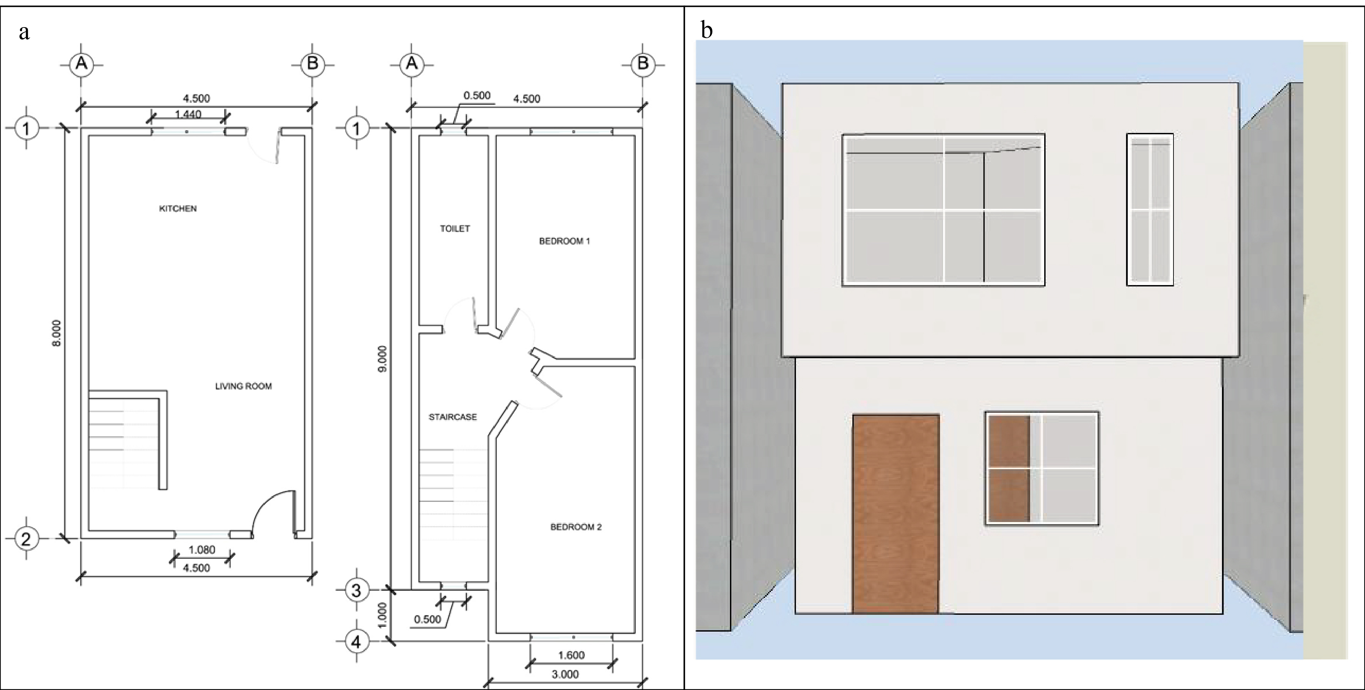
Fig.6. Plan (left) and perspective view (right) of the case study.

Table 3. Base case model specifications.
Characteristics | Description
Location | Monterrey, 25.6866° North, 100.3161° West
Orientation | Main façade facing west
Plan shape | Rectangle
Number of floors | 2 floors
Floor to floor Height | 2.7 m
Gross wall area | 99.16 $m^{2}$
Window area | 9.95 $m^{2}$
Type of glass | 6 mm Single glass
Solar absorptance | 0.5 for wall / 0.6 for roof
Occupancy density | 5 persons
Infiltration | 0.5 ACH
System type | Package DX
Thermostat setting | Cooling = 25°C / Heating = 21°C
Schedule | Weekdays (18:00 – 9:00)  Weekend and holidays (00:00 - 24:00)
COP | 2.5

Simulation model
The simulation software used in this study was DesignBuilder V.60.1.19, which employs the EnergyPlus engine designed according to ASHRAE standards and suitable for warm and semi-arid climates. The simulator uses either the Contrast Transfer Function (CTF) or the Finite Difference Method (FDM), depending on the materials used. For special materials like PCM, FDM is selected due to the larger time steps that are available. This algorithm discretises building enclosures such as walls, floors, and ceilings into various nodes and numerically solves the heat transfer equations using a Finite Difference Method. In this research, the Crank Nicholson or fully implicit methods could be selected.
To validate the simulation method, the experimental unit results were compared with the simulation results of the DB. Fig. 7 shows the actual units and insulation applications used in the study. The unit block was located on the 4th level rooftop of a building on Garza Sada Street, with coordinates of 25°38'52.3"N 100°17'26.4"W and dimensions of 2.2 m by 1.4 m. HVAC was installed, but it was disabled for free flow measurement during the simulated time frame.
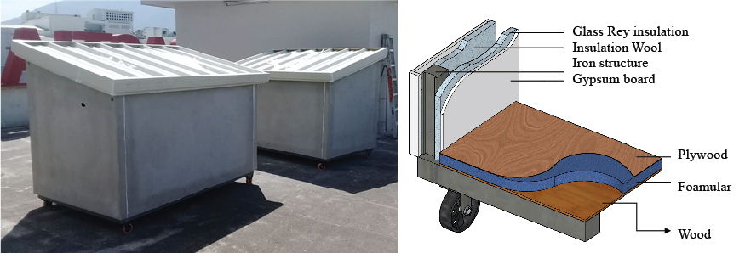
Fig. 7. Experimental unit actual photo and material illustration.

In order to validate the simulation method, an experimental chamber was used to record real data (ambient temperature sensors and weather station) for August 4th and 5th, 2020, as depicted in Fig. 8. Next, a model was created using the DB, and a weather file in EPW format was generated using TRNSYS to simulate the same amount of radiation and temperature. Finally, the EnergyPlus engine was used to simulate the results, which were compared to the real data. The Root Mean Square Percentage Error (RMSPE) was approximately 1%, confirming that the simulation was calibrated and that the error rate was within the acceptable rate of 5%, which is typically due to device inaccuracies.

Fig. 8. comparison between experimental and simulated model ambient temperature

The parametric optimisation functions are designed to address energy, comfort, and thermal indicators, as shown in Fig. 9. These functions incorporate various variables, including passive strategies such as building insulation, thermal storage material, solar absorbance of external layers, airtightness, glazing system, WWR, and fenestration orientation.
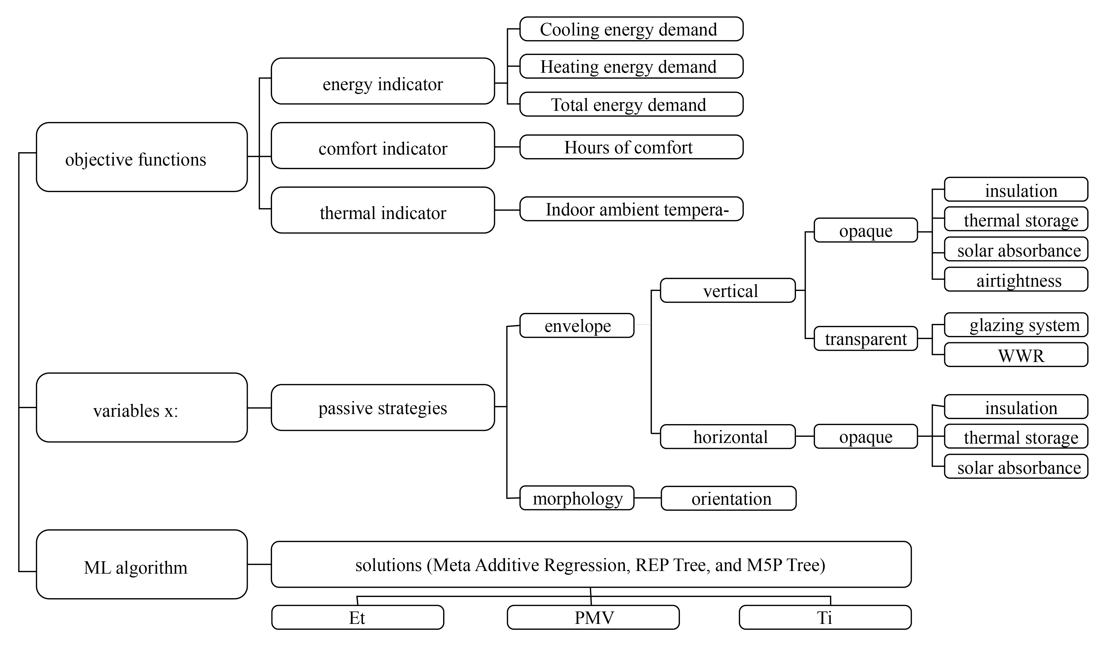
Fig. 9. The optimisation model flow diagram: objective functions, variables integrated, and optimal solutions are presented.

Optimisation and machine learning
To find the optimal combination of energy efficient methods for the vertical and horizontal envelope, we employed the Box-Behnken method using Design expert 7.0.0 software. This method has been previously used to find optimal materials and waste management solutions in other studies (Eftekhari et al., 2021; Almertaha et al., 2019; Erfani et al., 2019). The upper and lower bounds of each variable were determined based on trial and error and are presented in Table 4. Note that characteristics of passive strategies can be found in Table A.3 and Table A.4 in appendix.
This study utilises machine learning (ML) algorithms implemented in Waikato Environment for Knowledge Analysis (WEKA) 3.8.6, a data mining tool, to make high-performance predictions. This can be similar to improve the performance of DSS in disaster management and contaminant control by using ML algorithms for predicting responses (Akbarian et al., 2022; Mohammadi et al., 2021). The study incorporates simulated data to classify and train the model and uses a feasibility model to identify the optimal ML method with the highest confidence value for predictions. The ML algorithms used to predict responses include energy, comfort, and thermal indicators based on effective vertical and horizontal features. The MAR, REP Tree, and M5P Tree algorithms are utilised for this purpose.

Table 4. Upper and lower boundaries for different EEM scenarios.
 | EEM | Boundaries
Vertical envelope | Window types (W/(m·°C)) | 5.8 – 1.6
Vertical envelope | Wall insulation thickness  Wall thermal emissivity  Wall solar absorbance | 0 - 0.10 m  0.1 - 0.9  0.1 - 0.9
Vertical envelope | WWR (NOM-ENER)  Fenestration position | 22% -40%  0 – 360 (N – S)
 | Air tightness (ASHRAE 62.1) | 0.35 – 1 (Homes)
Horizontal envelope | Roof Solar reflectance  Roof insulation thickness  Roof insulation conductivity (W/(m·°C))  Roof thermal storage (PCM melting point)  Roof thermal storage thickness | - - 0.9  0 – 0.12 m  0.32 – 0.42 (W/(m·°C))  18 – 29 °C  0.03 – 0.07 m
Horizontal envelope | Floor insulation thickness | 0 - 0.12 m

Control system and Petri Net modelling
Petri Nets are commonly used to model concurrent systems, and they have been effectively utilised in the context of building energy supply, such as in the production of biogas energy in green buildings (Gheibi, 2019; Shahsavar, 2021). This study aims to further extend the application of Petri Nets in the domain of building energy supply by proposing a control system that employs linear programming of a Petri Net model to implement energy efficiency management strategies. The approach involves using linear programming to determine optimal conditions for the building's energy supply, followed by using the Petri Net model as a control system to manage the energy supply and ensure that the building operates within the desired parameters.
The study first applies an optimisation model to determine the optimal boundary for each building envelope, and subsequently develops a Petri Net model to assist engineers and architects in the selection of effective materials for efficient building management. By incorporating the Petri Net model as a control system, real-time adjustments can be made to maintain peak efficiency of the building. The findings of this study have significant implications for the design and operation of building energy supply systems, with potential for long-term energy savings.

Decision Support System (DSS)
This study proposes the incorporation of a DSS in energy-efficient residential units to provide decision-making support for building managers or occupants to optimise energy consumption. The DSS offers various features, including model-based or information-based analyses, which allow for the evaluation of sensitivity by changing variables and monitoring variable integration performance. DSS involve three sections, which are monitoring, prediction and control. In this study monitoring is through DesignBuilder simulation, prediction is through machine learning, and Petri-net model is controlling feature.
By providing real-time information on energy usage, the DSS enables informed decisions to reduce energy consumption and improve the building's thermal comfort. The proposed DSS's key benefit is the integration of passive scenarios in energy-efficient residential units, which use natural resources such as sunlight, air, and water to reduce energy consumption. The DSS can identify areas where passive scenarios can be integrated and evaluate their performance, leading to significant energy savings. In addition to optimising energy consumption, the DSS can provide insights into the building's performance, identifying areas where energy-efficient upgrades can be implemented and tracking their effectiveness.
The DSS also optimises indoor comfort by providing real-time information on temperature, humidity, and other environmental factors that impact indoor comfort. By analysing this data, the DSS can detect spaces where indoor comfort can be improved without compromising energy efficiency. For instance, the DSS can recommend adjustments to temperature setpoints, ventilation rates, and other building systems to optimise indoor comfort while minimising energy consumption, leading to a more comfortable and healthier indoor environment for building occupants. The DSS can also help recognise when thermal comfort is compromised due to factors such as poor insulation or air leaks, improving indoor comfort and energy efficiency simultaneously, resulting in reduced energy bills and improved occupant satisfaction.
Finally, the proposed DSS in energy-efficient residential units provides decision-making support to optimise energy consumption, incorporating passive scenarios and providing insights into the building's performance. It optimises indoor comfort by providing real-time information and improving thermal comfort simultaneously, leading to a sustainable and comfortable living environment.

Results and discussion
The Results presented in this section include, simulation and optimisation, optimum scenario simulation and sensitive analysis, machine learning outcomes, Petri Net modelling, and DSS presentation.

Simulation and optimisation
The integration of Box-Benhken Design for Response Surface Methodology illustrates the linear relationship between the factors impacting the horizontal and vertical envelopes with respect to energy consumption, comfort, and thermal improvement parameters. Eq. A.1-A.3 and A.4-A.6 in the appendix document the linear equations for the horizontal and vertical envelopes, respectively. A lack of fit test was performed for four statistical models - Linear, 2FI, Quadratic, and Cubic - for each measure of the horizontal and vertical envelopes. The Quadratic model outperformed the others in all cases for energy, comfort, and thermal improvement factors, as indicated in Table 5. The Quadratic model with an R-Squared of above 0.95 for energy consumption in both vertical and horizontal envelopes was selected. However, the R-squared value of 0.65 for the vertical envelope was lower than the predicted R-squared of 0.89 for the horizontal envelope, indicating that the ML application can be useful as an online soft monitoring system within the DSS for estimation of measures. The prediction of R-Squared for the comfort parameter was above 0.9, whereas the thermal parameter had the lowest prediction ability for the vertical envelope with an R-Squared of 0.25. This could be attributed to variable seasonal outdoor temperatures and the larger surface area of the vertical envelope.
The results of the Analysis of Variance (ANOVA) show that in terms of improving the horizontal envelope, roof solar absorbance and floor insulation thickness are the most important variables. The P-values for these two factors, as well as for Et, PMV, and Ti, were found to be significant, as shown in Table 6. It was found that thermal storage on the roof only affects comfort, as indicated by the significant P-value for PMV. This is consistent with the findings of Jamil et al. (2016), who reported that this strategy can reduce hours of discomfort by up to 34% in temperate oceanic climates. Although the thickness of roof insulation had a significant impact on absorbance for Et (with a P-value below 0.0001), the P-values for PMV and Ti were insignificant. A similar pattern was observed for the insulation thickness factor in the vertical envelope. However, the most significant variable for this envelope was found to be window type, with a P-value of < 0.0001, except for PMV.

Table 5. The results of statistical models in BBD-RSM.
 |  | Horizontal envelope |  | Vertical envelope
 | Type of statistical model | R-Squared | Predicted R-Squared | R-Squared | Predicted R-Squared
Energy efficiency | Linear | 0.67 | 0.55 | 0.64 | 0.52
Energy efficiency | 2FI | 0.69 | -0.06 | 0.71 | -0.27
Energy efficiency | Quadratic | 0.98 | 0.89 | 0.95 | 0.65
Energy efficiency | Cubic | 1.00 |  | 1.00
Comfort improvement | Linear | 0.722 | 0.629 | 0.234 | -0.035
Comfort improvement | 2FI | 0.740 | 0.182 | 0.533 | -0.962
Comfort improvement | Quadratic | 0.983 | 0.911 | 0.733 | -0.909
Comfort improvement | Cubic | 1.000 |  | 0.991
Thermal improvement | Linear | 0.48 | 0.36 | 0.55 | 0.41
Thermal improvement | 2FI | 0.53 | -0.06 | 0.65 | -0.40
Thermal improvement | Quadratic | 0.86 | 0.67 | 0.87 | 0.25
Thermal improvement | Cubic | 0.89 |  | 0.97

Optimum scenario simulation and sensitive analysis
Fig. 10 shows dual effective variable sensitive analyses for the parameters of Et, PMV, and Ti. The figure shows that for the horizontal envelope, the steepest slope variations are related to roof absorbance and floor insulation, which have a significant influence on energy, comfort, and thermal improvement. In contrast, for the vertical envelope, window types and fenestration position have steeper relationships with Et and Ti, while WWR has a greater impact on PMV than window types or other variables. Alhagla et al. (2019) have emphasised the importance of WWR and the selection of a higher U-value for window types in hot climatic areas. Additionally, Zhao and Due (2020) concluded that an optimised window type scenario can lead to a maximum reduction of 26.7% in energy consumption and 2.53% in discomfort hours.

Table 6. ANOVA results in BBD-RSM study.
 |  |  | Et |  | PMV |  | Ti
 |  | Source | F-Value | P-value Prob > F | F-Value | P-value Prob > F | F-Value | P-value Prob > F
 |  | Model | 43.29 | < 0.0001 | 56.32 | < 0.0001 | 5.84 | < 0.0001
Horizontal | RSA | Roof Solar absorbance | 26.30 | < 0.0001 | 38.54 | < 0.0001 | 18.47 | 0.0002
Horizontal | RI/T | Roof insulation thickness | 170.45 | < 0.0001 | 7.38 | 0.0116 | 0.16 | 0.6912
Horizontal | RI/C | Roof insulation conductivity | 0.20 | 0.6580 | 0.41 | 0.5252 | 0.02 | 0.8796
Horizontal | P/M | Roof thermal storage (PCM melting point) | 1.02 | 0.3216 | 157.73 | < 0.0001 | 1.52 | 0.2280
Horizontal | P/T | Roof thermal storage thickness | 5.61 | 0.0256 | 6.00 | 0.0214 | 1.39 | 0.2487
Horizontal | Fi/T | Floor insulation thickness | 615.71 | < 0.0001 | 896.55 | < 0.0001 | 65.10 | < 0.0001
Vertical | Wt | Window types | 70.13 | < 0.0001 | 6.89 | 0.0143 | 59.59 | < 0.0001
Vertical | WI/T | Wall insulation thickness | 187.08 | < 0.0001 | 2.09 | 0.1604 | 13.12 | 0.0012
Vertical | W/E | Wall thermal emissivity | 2.53 | 0.124 | 0.24 | 0.6260 | 7.37 | 0.0116
Vertical | WSA | Wall solar absorbance | 5.13 | 0.0321 | 1.82 | 0.1894 | 4.84 | 0.037
Vertical |  | WWR (NOM-ENER) | 3.05 | 0.0923 | 8.13 | 0.0084 | 5.09 | 0.0327
Vertical | Fp | Fenestration position | 17.21 | 0.0003 | 0.38 | 0.5432 | 24.76 | < 0.0001
Vertical | At | Air tightness (ASHRAE 62.1) | 49.21 | < 0.0001 | 0.96 | 0.3351 | 5.58 | 0.026

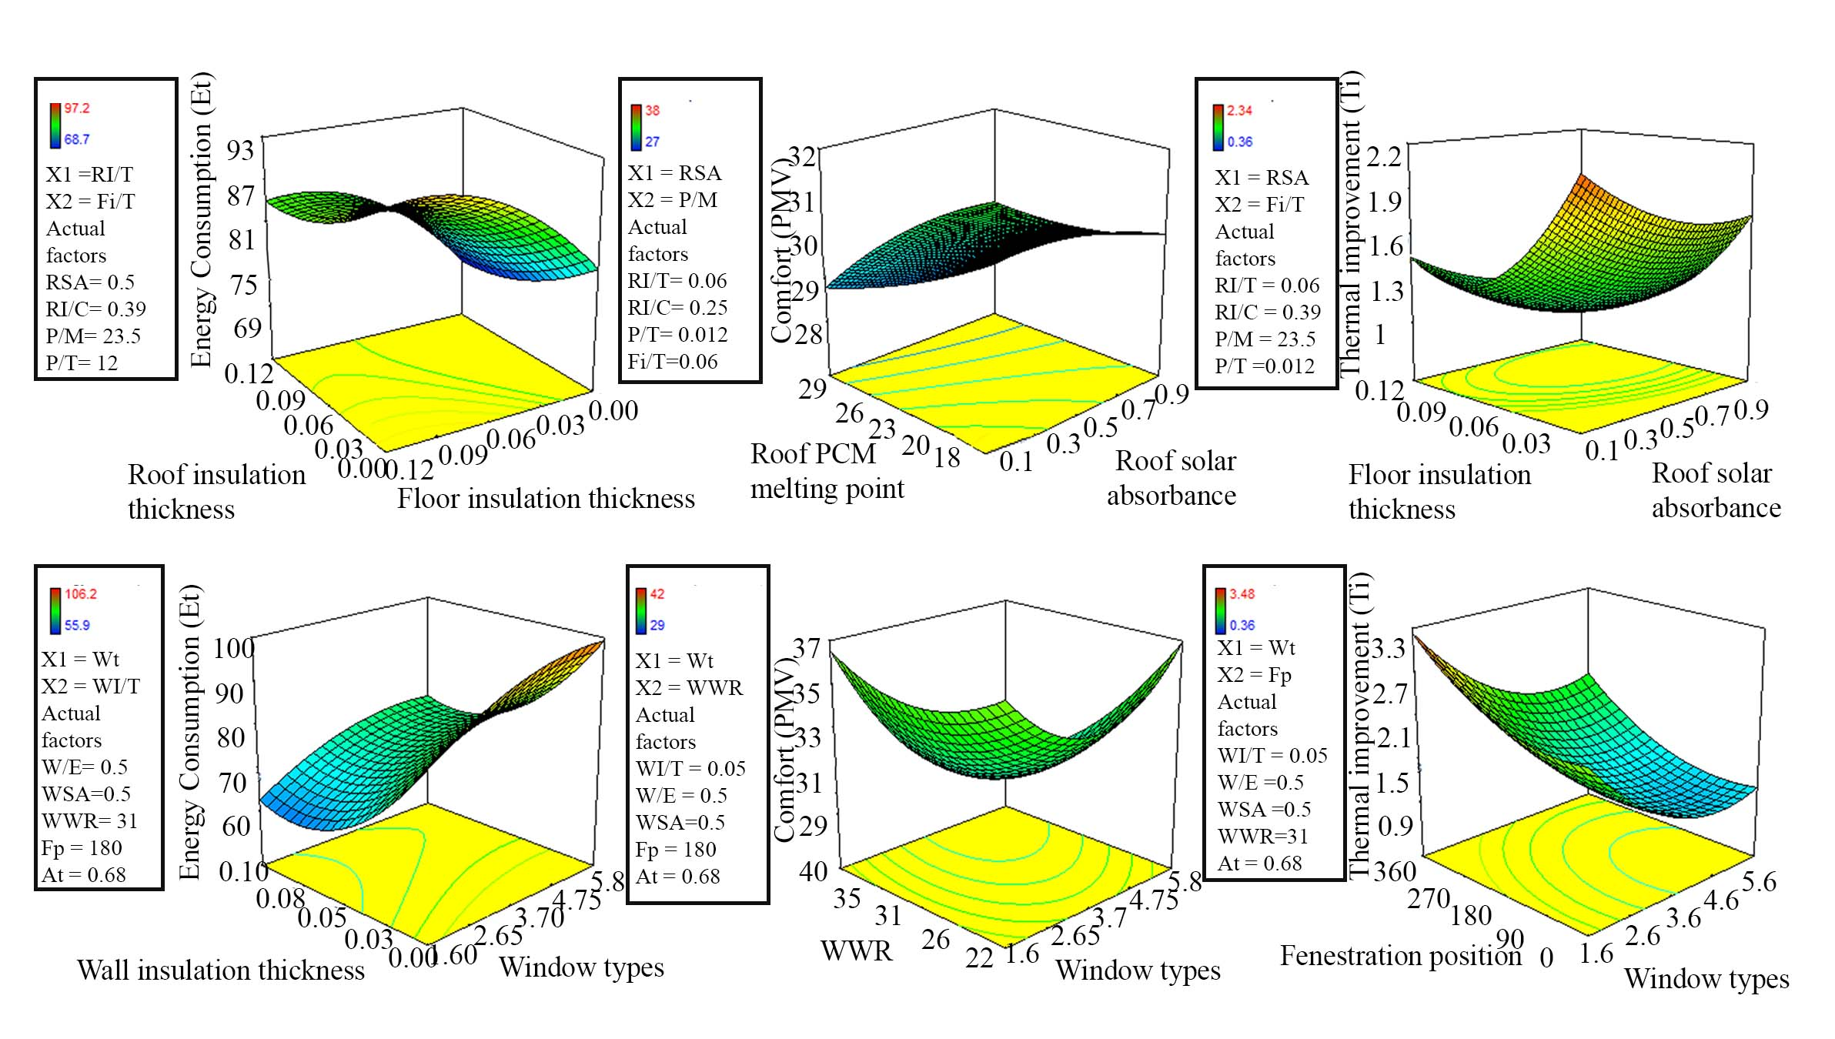
Fig. 10. Sensitive analysis of effective factors in the presented study.
The details of two optimum strategies for the horizontal and vertical envelopes based on BBD-RSM computations are summarised in Table A.1 and A.2. The horizontal envelope scenario includes RSA, RI/T, RI/C, P/M, P/T, and Fi/T, with optimum values of 0.1, 0.9 m, 0.32 W/(m·°C), 23 °C, 17.4 m, and 0 m, respectively. The vertical envelope scenario includes Wt, WI/T, W/E, WSA, WWR, Fp, and At, with optimum values of 1.7 W/(m·°C), 0.09 m, 0.86, 0.65, 24%, 300.97°, and 0.42 ACH, respectively. We combined these two scenarios and simulated them using DB to compare energy consumption, PMV, indoor air quality, and radiant temperature of the optimum case against the base case, as shown in Fig. 11. In the optimum case, total energy consumption was reduced by 50 kW/m², and the cooling and heating requirements were reduced, as presented in Fig. 11a. The number of hours of comfort, based on a PMV index of 85% acceptability (|PMV| > 0.75), improved by 325 hours annually. Acar et al. (2021) also found similar results by optimising a building envelope to achieve a maximum of 61.1% reduction. Nasrollahzadeh (2021) generated 2,600 solutions and concluded that the optimum case resulted in a total energy saving of 36% and a decrease in hours of discomfort by 14%. In the optimum scenario, during a typical summer week (July 3rd-10th), the indoor temperature curve decreased, as presented in Fig. 11 (c), with a maximum temperature drop of 3.6 °C. The results were similar for the radiant temperature.

Fig. 11. Optimum case comparison against base case with regards to energy consumption (a), PMV (b), indoor air temperature (c), and radiant temperature (d).

Performance of machine learning predictions
ML model was trained by simulated data obtained from the previously mentioned variables and outcomes of Et, PMV, and Ti integrated into WEKA 3.8.6. To evaluate the model performance (here prediction accuracy), it needs to be tested by using unseen data or another portion of data that were not used for model training, which can also be called validation process. ML algorithms of MAR was mainly selected for the horizontal envelope, as presented in Table 7, with a high correlation of above 0.95 for all output data. Also, the M5P algorithm established a correlation of 0.88 between energy consumption (Et) and the vertical envelope variables. However, finding a relationship between comfort (PMV) and the vertical variables is difficult, as the highest accuracy was achieved through a Rep tree with a low correlation of 0.66. As mentioned previously, both subjective and objective parameters can impact comfort (Li et al., 2022). Amasyali and El-Gohary (2021), simulated different scenarios using EnergyPlus and trained models for 5760 data, using regression trees, Ensemble Bagging Trees (EBT), Artificial Neural Networks (ANN), and Deep Neural Networks (DNN), and found a high correlation of variables with energy consumption. For example, they found a 7 times improvement in energy consumption with a 2.97% variation coefficient, indicating the potential of integrating ML algorithms for energy and comfort predictions.

Table 7. The outcomes of WEKA 3.8.6 data mining algorithm for effective parameters in energy consumption, comfort, and thermal improvement.
Responses | Et |  | PMV |  | Ti
Categories | Horizontal | Vertical | Horizontal | Vertical | Horizontal | Vertical
Algorithms | MAR | M5P tree | MAR | Rep tree | MAR | MAR
Correlation coefficient | 0.98 | 0.88 | 0.99 | 0.66 | 0.95 | 0.84
Mean absolute error | 1.2 | 4.93 | 0.37 | 1.4 | 0.1 | 0.33
Root mean squared error | 1.4 | 6.7 | 0.46 | 2.1 | 0.14 | 0.44
Relative absolute error | 20 | 45 | 12 | 74 | 37 | 50
Root relative squared error | 18 | 49 | 12.5 | 78 | 40 | 57
Total Number of Instances | 18 | 20 | 18 | 24 | 17 | 20
Equation | Eq. A.7 | Eq. A.8 | Eq. A.9 | Eq. A.10 | Eq. A.11 | Eq. A.12

Petri Net and DSS
The present DSS was developed to enhance the energy efficiency of buildings in semi-arid climates. The system integrates Petri Net modelling with BBD-RSM optimisation, and its novel model for energy and comfort management is depicted in Fig. 12. The model considers various effective parameters, including RSA, RI/T, Fi/T, P/T, P/M, RI/C, Wt, WI/T, At, Fp, WSA, WWR, and W/E, which are sequentially evaluated and modified to obtain their optimal values through a loop. The initial values of these parameters were set to: RSA= 0.1, RI/T= 0.09 m, Fi/T= 0 m, P/T= 0.017 m, P/M= 23 °C, RI/C= 0.39 W/(m·°C), Wt= 1.72 W/(m·°C), WI/T= 0.09 m, At= 0.42 ACH, Fp= 300°, WSA= 0.65, WWR= 24%, and W/E=0.8. The optimisation process is carried out in two parallel loops for the horizontal (blue) and vertical (green) envelopes. The horizontal loop initially evaluates RSA, RI/T, and Fi/T, whereas the vertical loop focuses on Wt, WI/T, and At due to their significant impact on Et. The second series of parameters, P/T and Fp, are then adjusted, followed by P/M paralleled with WSA, RI/C, concurrently with WWR, and finally W/E. By applying the optimum scenarios obtained through Petri Net modelling, total energy efficiency and consumption can be effectively controlled, as demonstrated in Fig. 12.

Fig. 12. Petri Net modelling in present study.

Managerial Insights and sustainability
The parameters analysed in this study can support building managers and experts in achieving three of the main Sustainable Development Goals worldwide (Sustainable development, 2022), namely Sustainable Cities and Communities, Responsible Consumption and Production, and Climate Action, as illustrated in Fig. 13. By reducing energy consumption in buildings, lowering temperatures in internal spaces, and decreasing carbon emissions, these goals can be advanced. Other researchers have also provided useful insights to support decision-makers, such as Ghadami et al. (2021) who helped a city planner with energy planning for smart cities, Bogel et al. (2021) who explored energy transition behavioural factors, Shahsavar et al. (2022) who implemented a framework for municipal plastic waste management, and Qureshi et al. (2021) who designed a management system for sustainable transportation. The frameworks and optimisation models introduced in this study demonstrate the suitability and challenges of various control and optimisation algorithms for the residential building industry, and the findings and recommendations contribute to the development and management of energy-efficient and comfortable buildings. The smart sustainable control system of designing green buildings in semi-arid climate conditions can be categorised into two rules and frameworks:
(1) Horizontal design checking: verifying and controlling the thickness of floor insulation in all design plans to ensure optimal energy, comfort, and thermal indicators. Justifying the thickness of roof insulation to optimise energy consumption in semi-arid areas.
(2) Vertical design checking: determining the ideal thickness of wall insulation for energy efficiency during the design process. Controlling and double-checking of floor insulation thickness in all design plans due to adjusting all energy, comfort, and thermal indicators in the optimum conditions. Maintaining an optimal WWR feature to ensure optimal comfort indicators. Adjusting the window type to achieve improved thermal indicators.

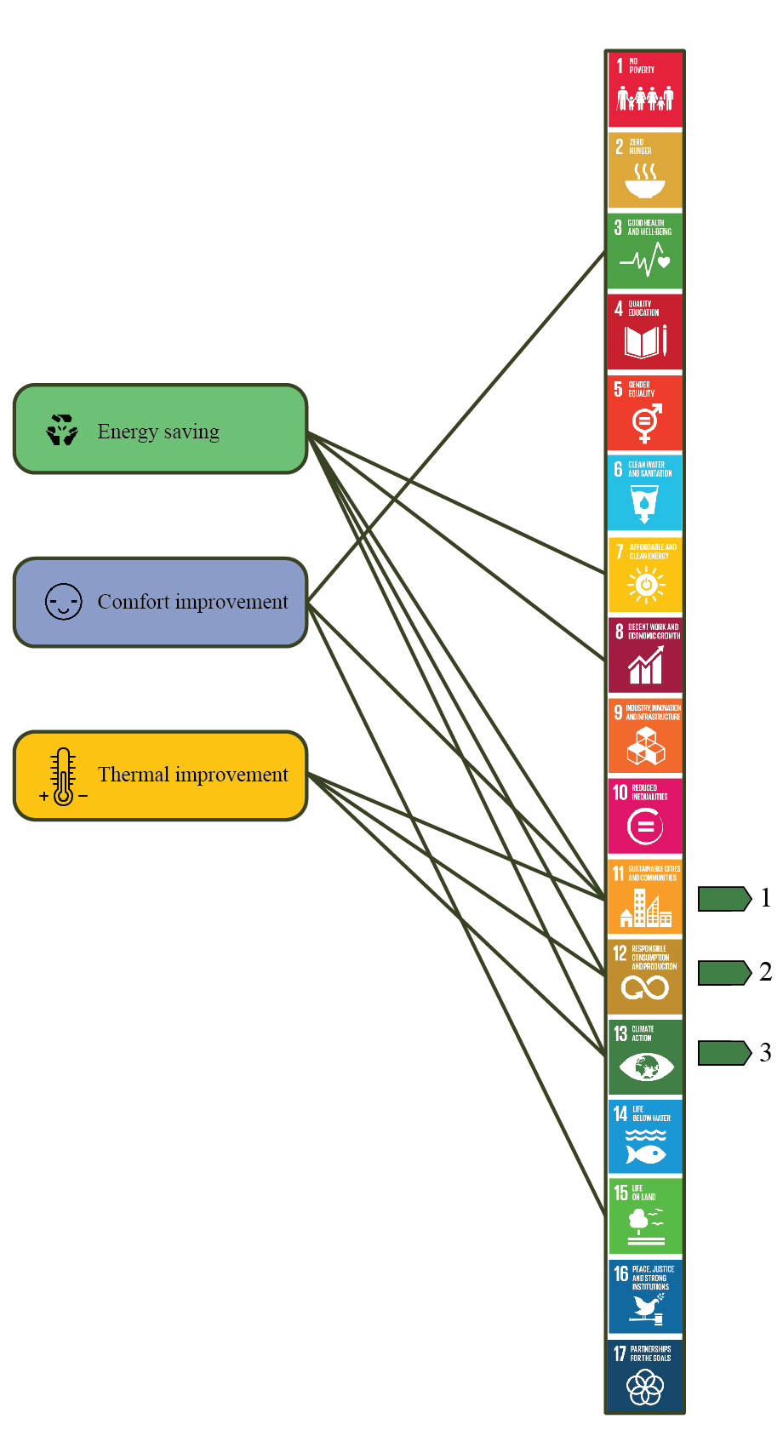
Fig. 13. Managerial insight with relation to Sustainable Development Goals.

Conclusions
The building industry has become increasingly concerned with energy scarcity and climate issues, leading to the promotion of Energy Efficient Measures by establishments such as LEED and PH. These measures can be implemented during the design and retrofit stages, with various scenarios and strategies depending on location, building type, and classification.
This study defines seven scenarios for the vertical and six for the horizontal envelope, which were optimised in pairs using BBD-RSM for the statistical model. Building simulation DB was used to analyse cases with respect to energy reduction, comfort, and thermal improvement factors, and the optimum case outcome was compared against a base case, followed by sensitivity analysis. A validated simulation method was used to develop a Petri Net model for DSS control purposes.
ANOVA study showed that RSA, FFi/T, and Wt had the highest impact on all thermal, energy, comfort indicators. However, the effectiveness of variables differed depending on the output factors, as presented in the Petri Net model. The optimum value for thirteen strategies suggested the following values for the horizontal and vertical envelopes, respectively: RSA= 0.1, RI/T= 0.09 m, Fi/T= 0 m, P/T= 0.017 m, P/M= 23 °C, RI/C= 0.39 W/(m·°C) and Wt= 1.72 W/(m·°C), WI/T= 0.09 m, At= 0.42 ACH, Fp= 300°, WSA= 0.65, WWR= 24%, and W/E=0.86. The simulation of the optimum case showed a 50 kW/m² drop in annual energy consumption, an increase of 325 hours of comfort inside the spaces, and a 3.6 °C decrease in temperature during summer.
Sensitivity analysis showed that for energy and thermal factors in the horizontal envelope, roof solar absorbance and floor insulation are the most significant factors, whereas with respect to comfort, PCM melting point and roof solar absorbance are key factors. MAR and M5P tree algorithms were the most appropriate ML methods for energy and thermal factors. However, for comfort, which is the most unpredictable parameter, the Rep tree presented the highest prediction capability with a correlation of only 0.66.
This study supports three of the seventeen SDG, which are sustainable cities and communities, responsible consumption and production, and climate action goals. An extension of this work could be to use this methodology to optimise the application of active systems in buildings and determine their impact on sustainable development goals achievement for managers and decision makers. Another extension could be to include life cycle assessments of the proposed scenarios and an environmental impact analysis, which would allow for the identification of economically optimal and environmentally effective selection of parameters for designers and engineers to create sustainable cities.

Declaration of competing interest
The authors declare that they have no known competing financial interests or personal relationships that could have appeared to influence the work reported in this paper.
Acknowledgments
This research was mainly funded by the Consejo Nacional de Ciencia y Tecnología (CONACYT). SeyedehNiloufar Mousavi acknowledges the support provided by the Consejo Nacional de Ciencia y Tecnología (CONACYT) given through its PhD scholarship program. We also acknowledge NRGY Solutions for providing us with experimental data. The authors wish to thank the editor and anonymous reviewers for making constructive comments which improved the quality of the paper.

References
Abu-Rayash, A. and Dincer, I., 2021. Development of integrated sustainability performance indicators for better management of smart cities. Sustainable Cities and Society, 67, p.102704.
Acar, U., Kaska, O. and Tokgoz, N., 2021. Multi-objective optimization of building envelope components at the preliminary design stage for residential buildings in Turkey. Journal of Building Engineering, 42, p.102499.
Ahmed, S.M., Ahmed, S.M. and Zeyad, M., 2020. An approach of a Nearly Zero-Energy Building (nZEB) to build an official zone with Micro-grid. In 2020 6th IEEE International Energy Conference (ENERGYCon) (pp. 662-667). IEEE.
Akbarian, H., Gheibi, M., Hajiaghaei-Keshteli, M. and Rahmani, M., 2022. A hybrid novel framework for flood disaster risk control in developing countries based on smart prediction systems and prioritized scenarios. Journal of Environmental Management, 312, p.114939.
Alhagla, K., Mansour, A. and Elbassuoni, R., 2019. Optimizing windows for enhancing daylighting performance and energy saving. Alexandria Engineering Journal, 58(1), pp.283-290.
Almertaha, A.H., Eftekhari, M., Chamsaz, M. and Gheibi, M., 2019. Synthesize of silver-nanoparticles by plant extract and its application for preconcentration of cadmium followed by flame atomic absorption spectrometry. Environmental technology, 40(14), pp.1831-1839.
Amasyali, K. and El-Gohary, N., 2021. Machine learning for occupant-behavior-sensitive cooling energy consumption prediction in office buildings. Renewable and Sustainable Energy Reviews, 142, p.110714.
Analytics, G.A.R.D., 2004. EnergyPlus Testing with ANSI/ASHRAE Standard 140-2001 (BESTEST).
ANSI/ASHRAE, 2020. ANSI/ASHRAE Standard 55‐2020: thermal environmental conditions for human occupancy.
Bashirpour-Bonab, H., 2019. Simulation and optimization of energy consumption systems in buildings in varying climatic conditions. International Journal of Energy and Water Resources, 3(3), pp.203-211.
Berardi, U., 2017. A cross-country comparison of the building energy consumptions and their trends. Resources, Conservation and Recycling, 123, pp.230-241.
Bögel, P.M., Upham, P., Shahrokni, H. and Kordas, O., 2021. What is needed for citizen-centered urban energy transitions: Insights on attitudes towards decentralized energy storage. Energy Policy, 149, p.112032.
Chen, B., Liu, Q., Chen, H., Wang, L., Deng, T., Zhang, L. and Wu, X., 2021. Multiobjective optimization of building energy consumption based on BIM-DB and LSSVM-NSGA-II. Journal of Cleaner Production, 294, p.126153.
Chen, S., Zhang, G., Xia, X., Setunge, S. and Shi, L., 2020. A review of internal and external influencing factors on energy efficiency design of buildings. Energy and Buildings, 216, p.109944.
Chen, Y., Quan, M., Wang, D., Du, H., Hu, L., Zhao, Y., Guo, M. and Liu, Y., 2022. Optimization and comparison of multiple solar energy systems for public sanitation service buildings in Tibet. Energy Conversion and Management, 267, p.115847.
De Araujo Passos, L.A., van den Engel, P., Baldi, S. and De Schutter, B., 2023. Dynamic optimization for minimal HVAC demand with latent heat storage, heat recovery, natural ventilation, and solar shadings. Energy Conversion and Management, 276, p.116573.
DesignBuilder Software Ltd - Home (2022). Available at: https://designbuilder.co.uk/ (Accessed: 16 March 2022).
Eftekhari, M., Gheibi, M., Azizi-Toupkanloo, H., Hossein-Abadi, Z., Khraisheh, M., Fathollahi-Fard, A.M. and Tian, G., 2021. Statistical optimization, soft computing prediction, mechanistic and empirical evaluation for fundamental appraisal of copper, lead and malachite green adsorption. Journal of Industrial Information Integration, 23, p.100219.
Erfani, S.M.H., Danesh, S., Karrabi, S.M., Gheibi, M. and Nemati, S., 2019. Statistical analysis of effective variables on the performance of waste storage service using geographical information system and response surface methodology. Journal of environmental management, 235, pp.453-462.
Fathalian, A. and Kargarsharif, H., 2020. Investigating the effect of different energy saving strategies on energy rating of building by design builder software (case study: office building). Journal of Environmental Science and Technology, 22(7), pp.199-214.
Figueroa-Lopez, A., Arias, A., Oregi, X. and Rodríguez, I., 2021. Evaluation of passive strategies, natural ventilation and shading systems, to reduce overheating risk in a passive house tower in the north of Spain during the warm season. Journal of Building Engineering, 43, p.102607.
Franco, M.A.J.Q., Pawar, P. and Wu, X., 2021. Green building policies in cities: A comparative assessment and analysis. Energy and Buildings, 231, p.110561.
Gagliano, A., Patania, F., Nocera, F., Ferlito, A. and Galesi, A., 2012. Thermal performance of ventilated roofs during summer period. Energy and Buildings, 49, pp.611-618.
García, E.-Comisión Nacional para el Conocimiento y Uso de la Biodiversidad (CONABIO), (1998).'Climas' (clasificación de Koppen, modificado por García). Escala 1:1000000. México
Garg, V., Mathur, J. and Bhatia, A., 2020. Building Energy Simulation: A Workbook Using Designbuilder™. CRC Press.
Ghadami, N., Gheibi, M., Kian, Z., Faramarz, M.G., Naghedi, R., Eftekhari, M., Fathollahi-Fard, A.M., Dulebenets, M.A. and Tian, G., 2021. Implementation of solar energy in smart cities using an integration of artificial neural network, photovoltaic system and classical Delphi methods. Sustainable Cities and Society, 74, p.103149.
Gheibi, M., Karrabi, M. and Eftekhari, M., 2019. Designing a smart risk analysis method for gas chlorination units of water treatment plants with combination of Failure Mode Effects Analysis, Shannon Entropy, and Petri Net Modeling. Ecotoxicology and Environmental Safety, 171, pp.600-608.
Gheibi, M., Karrabi, M., Shakerian, M. and Mirahmadi, M., 2018. Life cycle assessment of concrete production with a focus on air pollutants and the desired risk parameters using genetic algorithm. Journal of environmental health science and engineering, 16(1), pp.89-98.
Guo, R., Gao, Y., Zhuang, C., Heiselberg, P., Levinson, R., Zhao, X. and Shi, D., 2020. Optimization of cool roof and night ventilation in office buildings: A case study in Xiamen, China. Renewable Energy, 147, pp.2279-2294.
Grande-Acosta, G.K. and Islas-Samperio, J.M., 2020. Boosting energy efficiency and solar energy inside the residential, commercial, and public services sectors in Mexico. Energies, 13(21), p.5601.
Jain, A.S., Saikia, P. and Rakshit, D., 2020. Thermal energy performance of an academic building with sustainable probing and optimization with evolutionary algorithm. Thermal Science and Engineering Progress, 17, p.100374.
Jamil, H., Alam, M., Sanjayan, J. and Wilson, J., 2016. Investigation of PCM as retrofitting option to enhance occupant thermal comfort in a modern residential building. Energy and Buildings, 133, pp.217-229.
Kachkouch, S., Ait-Nouh, F., Benhamou, B. and Limam, K., 2018. Experimental assessment of thermal performance of three passive cooling techniques for roofs in a semi-arid climate. Energy and Buildings, 164, pp.153-164.
Lei, J., Kumarasamy, K., Zingre, K.T., Yang, J., Wan, M.P. and Yang, E.H., 2017. Cool colored coating and phase change materials as complementary cooling strategies for building cooling load reduction in tropics. Applied energy, 190, pp.57-63.
Li, P., Lu, Y., Qian, Y., Wang, Y. and Liang, W., 2022. An explanatory parametric model to predict comprehensive post-commissioning building performances. Building and Environment, 213, p.108897.
Li, Q., Zhang, L., Zhang, L. and Wu, X., 2021. Optimizing energy efficiency and thermal comfort in building green retrofit. Energy, 237, p.121509.
Li, T., Liu, Q., Mao, Q., Chen, M., Ma, C., Wang, D. and Liu, Y., 2023. Optimization design research of insulation thickness of exterior wall based on the orientation difference of solar radiation intensity. Applied Thermal Engineering, p.119977.
Liu, Y., Chen, H., Zhang, L. and Feng, Z., 2021. Enhancing building energy efficiency using a random forest model: A hybrid prediction approach. Energy Reports, 7, pp.5003-5012.
Liu, Y., Wang, X.J., Zhou, S. and Chen, H., 2021. Enhancing public building energy efficiency using the response surface method: an optimal design approach. Environmental Impact Assessment Review, 87, p.106548.
Machairas V, Tsangrassoulis A, Axarli K. Algorithms for optimization of building design: a review. Renew Sustain Energy Rev 2014;31:101–12.
Magni, M., Ochs, F., de Vries, S., Maccarini, A. and Sigg, F., 2021. Detailed cross comparison of building energy simulation tools results using a reference office building as a case study. Energy and Buildings, 250, p.111260.
McNeil, M., Castellanos, S., de León Barido, P. and Pérez, D.S., 2018. Mexico space cooling electricity impacts and mitigation strategies. In Analysis Supporting the Summit on Space Cooling Research Needs and Opportunities in Mexico February 15-16 Casa de la Universidad de California, Mexico City.
Meng, X., Du, J., Wang, Y. and Gao, Y., 2019. Thermal performance optimization of building floors under air-conditioning intermittent operation by numerical simulation. Journal of Building Physics, 43(2), pp.99-120.
Mohammadi, M., Gheibi, M., Fathollahi-Fard, A.M., Eftekhari, M., Kian, Z. and Tian, G., 2021. A hybrid computational intelligence approach for bioremediation of amoxicillin based on fungus activities from soil resources and aflatoxin B1 controls. Journal of Environmental Management, 299, p.113594.
Morini, E., Nicolini, A., Castellani, B., Rossi, F., Berardi, U., 2018. Effects of aging on retro-reflective materials for building applications. Energy Build. 179, 121–132.
Mousavi, S., Gheibi, M., Wacławek, S. and Behzadian, K., 2023. A Novel Smart Framework for Optimal Design of Green Roofs in Buildings Conforming with Energy Conservation and Thermal Comfort. Energy and Buildings, 128, p.113111.
Mousavi, S., Gijón-Rivera, M., Rivera-Solorio, C.I. and Rangel, C.G., 2022. Energy, comfort, and environmental assessment of passive techniques integrated into low-energy residential buildings in semi-arid climate. Energy and Buildings, 263, p.112053.
N guyen A, Reiter S, Rigo P.;1; A review on simulation-based optimization methods applied to building performance analysis. 2014;:1043-58
Sadeghi, M., Naghedi, R., Behzadian, K., Shamshirgaran, A., Tabrizi, M.R. and Maknoon, R., 2022. Customisation of green buildings assessment tools based on climatic zoning and experts judgement using K-means clustering and fuzzy AHP. Building and Environment, 223, p.109473.
Nasrollahzadeh, N., 2021. Comprehensive building envelope optimization: Improving energy, daylight, and thermal comfort performance of the dwelling unit. Journal of Building Engineering, 44, p.103418.
Pisello, A.L. and Cotana, F., 2014. The thermal effect of an innovative cool roof on residential buildings in Italy: Results from two years of continuous monitoring. Energy and Buildings, 69, pp.154-164.
Piselli, C., Pisello, A.L., Saffari, M., de Gracia, A., Cotana, F. and Cabeza, L.F., 2019. Cool roof impact on building energy need: The role of thermal insulation with varying climate conditions. Energies, 12(17), p.3354.
Pouresmaeil, H., Faramarz, M.G., ZamaniKherad, M., Gheibi, M., Fathollahi-Fard, A.M., Behzadian, K. and Tian, G., 2022. A decision support system for coagulation and flocculation processes using the adaptive neuro-fuzzy inference system. International Journal of Environmental Science and Technology, pp.1-12.
Qureshi, K.N., Alhudhaif, A. and Jeon, G., 2021. Electric-vehicle energy management and charging scheduling system in sustainable cities and society. Sustainable Cities and Society, 71, p.102990.
Rangel, C.G., Rivera-Solorio, C.I., Gijón-Rivera, M. and Mousavi, S., 2022. The effect on thermal comfort and heat transfer in naturally ventilated roofs with PCM in a semi-arid climate: An experimental research. Energy and Buildings, 274, p.112453.
Rosso, F., Ciancio, V., Dell'Olmo, J. and Salata, F., 2020. Multiobjective optimization of building retrofit in the Mediterranean climate by means of genetic algorithm application. Energy and Buildings, 216, p.109945.
RUV – Registro Único de Vivienda (2022). Available at: http://portal.ruv.org.mx/ (Accessed: 28 March 2022).
Salata, F., Ciancio, V., Dell'Olmo, J., Golasi, I., Palusci, O. and Coppi, M., 2020. Effects of local conditions on the multi-variable and multi-objective energy optimization of residential buildings using genetic algorithms. Applied energy, 260, p.114289.
Shahsavar, M.M., Akrami, M., Gheibi, M., Kavianpour, B., Fathollahi-Fard, A.M. and Behzadian, K., 2021. Constructing a smart framework for supplying the biogas energy in green buildings using an integration of response surface methodology, artificial intelligence and petri net modelling. Energy Conversion and Management, 248, p.114794.
Shahsavar, M.M., Akrami, M., Kian, Z., Gheibi, M., Fathollahi-Fard, A.M., Hajiaghaei-Keshteli, M. and Behzadian, K., 2022. Bio-recovery of municipal plastic waste management based on an integrated decision-making framework. Journal of Industrial and Engineering Chemistry.
Shi, X., Tian, Z., Chen, W., Si, B. and Jin, X., 2016. A review on building energy efficient design optimization rom the perspective of architects. Renewable and Sustainable Energy Reviews, 65, pp.872-884.
Świrska-Perkowska, J., Kucharczyk, A. and Wyrwał, J., 2020. Energy efficiency of a solar wall with transparent insulation in polish climatic conditions. Energies, 13(4), p.859.
THE 17 GOALS | Sustainable Development (2022). Available at: https://sdgs.un.org/goals (Accessed: 6 April 2022).
Wang, J., Wang, J., Yang, X., Xie, K. and Wang, D., 2022. A novel emergy-based optimization model of a building cooling, heating and power system. Energy Conversion and Management, 268, p.115987.
Wang, Y., Fang, X., Yin, S. and Chen, W., 2021. Low-carbon development quality of cities in China: Evaluation and obstacle analysis. Sustainable Cities and Society, 64, p.102553.
Wang, Z., Tao, H., Cai, W., Duan, Y., Wu, D. and Zhang, L., 2022. Study on the multitime scale rolling optimization operation of a near-zero energy building energy supply system. Energy Conversion and Management, 270, p.116255.
Wu, Q., Wang, J. and Meng, X., 2021. Influence of wall thermal performance on the contribution efficiency of the Phase-Change Material (PCM) layer. Case Studies in Thermal Engineering, 28, p.101398.
Yu, J., Yang, Q., Ye, H., Luo, Y., Huang, J., Xu, X., Gang, W. and Wang, J., 2020. Thermal performance evaluation and optimal design of building roof with outer-layer shape-stabilized PCM. Renewable Energy, 145, pp.2538-2549.
Zamanikherad, M., Montazeri, A., Gheibi, M., Fathollahi-Fard, A.M. and Behzadian, K., 2022. An efficient design of primary sedimentation tanks using a combination of the response surface, metaheuristic, and scenario building methods. International Journal of Environmental Science and Technology, pp.1-32.
Zhai Y, Wang Y, Huang Y, Meng X. A multi-objective optimization methodology for window design considering energy consumption, thermal environment and visual performance. Renew Energy 2019;134:1190–9. https://doi.org/10.1016/J.RENENE.2018.09.024.
Zhang, A., Bokel, R., van den Dobbelsteen, A., Sun, Y., Huang, Q. and Zhang, Q., 2017. Optimization of thermal and daylight performance of school buildings based on a multi-objective genetic algorithm in the cold climate of China. Energy and Buildings, 139, pp.371-384.
Zhang, S., Hu, W., Li, D., Zhang, C., Arıcı, M., Yıldız, Ç., Zhang, X. and Ma, Y., 2021. Energy efficiency optimization of PCM and aerogel-filled multiple glazing windows. Energy, 222, p.119916.
Zhao, J. and Du, Y., 2020. Multi-objective optimization design for windows and shading configuration considering energy consumption and thermal comfort: A case study for office building in different climatic regions of China. Solar Energy, 206, pp.997-1017.
Zhou, Z., Wang, C., Sun, X., Gao, F., Feng, W. and Zillante, G., 2018. Heating energy saving potential from building envelope design and operation optimization in residential buildings: A case study in northern China. Journal of cleaner production, 174, pp.413-423.

