‘Why did the Titanic sink?’ – bridging two disciplines to teach epistemic insight with lower secondary school students

Berry Billingsley
Sherralyn Simpson and
Manzoorul Abedin

Abstract

This article describes a workshop to develop students’ understanding of how to investigate a cross-disciplinary question that bridges science and history. The question ‘Why did the Titanic sink?’ is interpreted scientifically and then historically to help students to better appreciate the strengths and limitations of each discipline’s methods, language and norms of thought. Finally, students are encouraged to consider how this question could be further informed by additional disciplinary perspectives to provide a deeper and fuller answer. The results of the intervention, although in the early stages, have been encouraging, working towards the learning outcomes of the Epistemic Insight Curriculum Framework.

Epistemic insight for key stages 2 and 3 (ages 7–14)

Big questions that bridge science and other disciplines do not easily fit into a single subject and rarely, if ever, have simple agreed-upon answers. They can provide opportunities both to teach disciplinary knowledge – or what we call here epistemic insight – and to consider how knowledge claims within and across different disciplines can be constructed and tested. One way to do this is to frame a question that bridges science and another discipline in order to help students to appreciate and compare their different disciplinary approaches. In this article, we explain how an epistemic insight- driven activity or workshop entitled ‘Why did the Titanic sink?’ provides a way to develop epistemic insight through either individual or collaborative teaching.

Workshop overview

The Epistemic Insight Initiative is developing a range of workshops that are designed for each age group, from primary to upper secondary. The aim is that teachers include these workshops in their teaching in order to give students a better appreciation of how disciplines work and how they can interact to address different types of questions (Billingsley and Arias, 2017). In this article we explain a pedagogy that connects and compares two disciplines by asking and exploring a cross- disciplinary question.

‘Why did the Titanic sink?’ is a workshop designed for the lower secondary school (years 7–8, ages 11–13) and there is also a version tailored to upper primary. When we deliver the workshop in schools, we work closely with the subject teacher or teachers to discuss how the pedagogy works. The workshop has been delivered in five schools so far, with over 170 student participants and six teachers. Data gathered in the workshops will be analysed at the end of the workshop run. In this article, we focus on explaining the workshop design and the intended learning.
Workshop activity

To introduce the activity, the whole class is asked the question ‘Why did the Titanic sink?’. So far, this has produced a range of responses; here is a selection of these:

- It was an iceberg. A submarine did it.
- Someone left the doors open.
- The weather was bad, and they didn’t see the iceberg. It was a big whale.
- There was fire in the coal bunker and this damaged the walls so water could get in.

These responses demonstrate a range of prior knowl- edge about the disaster, which can then be sorted into a scientific perspective and a human history perspective. This discussion enables students to begin to consider how this question can be answered by more than one disci- pline. We then explain that the question itself is framed to bridge two disciplines, science and history, and that in this session we will be working with both disciplines to understand and explain why the Titanic sank. By analys- ing how each discipline makes sense of the question, students can begin to see how their different disciplinary lenses (i.e. preferred questions, methods and norms of thought) bring to light and explore different aspects.
We then introduce the ‘bubble tool’ (Figure 1) and ask students to consider whether the question could be investigated by science alone, or whether they envisage that a historical perspective will add value. The ‘bubble tool’ can also be used with other questions to consider whether each is very, partly, or less likely to be amenable to scientific investigation.

[Insert figure 1]

‘Being a scientist’ perspective

Students work with the question in small groups, initially through the lenses of science and engineering, to investi- gate how the materials and design of the ship might have affected what happened. To help them, they are given some details about the ship’s design: in particular, that the Titanic’s bulkheads (internal walls that divided up the ship) created 16 compartments that were said to be water- tight, and a design that could withstand a breach of four compartments. Another aspect of the design shared with students is that the compartments were open at the top. The walls of several compartments at the bow and side of the ship were damaged by the iceberg collision (Bassett, 1998). Students are told that one theory is that water was able to flow over the compartment walls when the ship tipped up. The compartments may also have meant that a considerable amount of water was trapped in the bow, rather than distributing evenly and keeping the ship horizontal for longer. When six compartments had been flooded, the Titanic’s fate was sealed, sinking within 2.5 hours of collision (Titanic Inquiry Project, 2017).

Students are then given materials such as plastic, card, tape and fasteners to work with, which they can use to model this design, and a bowl of water in which to test ideas and make observations. For example, students can construct a model ship that has several second, stopping after each compartment is filled to make and record observations.

[Insert figure 2]

Working with a model provides a safe and easy way to collect data to test ideas about what happened to the ship following the collision; however, one of the limitations is that these observations and experiments are with a Titanic model within the classroom. On a practical note, it should be ensured that there are towels or similar to dry up spilled water. We also found that having some extra weights to hand was useful to demonstrate what might happen if a large amount of weight built up at one end of the ship.

[Insert figure 3]

Table 1 lists the ‘overview’ and ‘working scientifically’ sections of the science national curriculum in England (DfE, 2015) to highlight the epistemic insight that this session helps to address. Students will develop knowledge and conceptual understanding of the nature, processes and methods of science through scientific enquiry and testing. The Titanic experiment provides an opportunity for students to think and work scientifically to test their hypothesis of how the model Titanic will behave when increasingly flooded with water. Data (observations) are collected and the results are recorded and analysed by each group. Students’ explanations are modified to take account of new evidence and they then use their evidence to defend their ideas. These findings and conclusions are subjected to peer review, where groups discuss their findings and conclusions with other groups.

Students are invited to consider further questions arising from this investigation. Students have been particularly engaged throughout this activity, following instructions to control the variables and to respond with their observations. If variables changed, such as water being poured across the compartments of the model instead of into one compartment at a time, or metal balls being added to the first compartment to increase weight, then the outcome changed. This elicited discussion about the Titanic’s design and if this was at fault, particularly in relation to the height of the bulk- heads. Students were encouraged to put forward their observations of the experiment, through recurrent use of scientific language of prediction, testing and, importantly, ‘observation’, thereby building their understanding of the nature of science and the strengths and limitations of working with a model and making direct observations.

[Insert Table 1]

‘Being a historian’ perspective

Turning to a historical perspective, the sinking of the Titanic happened at the commencement of George V’s reign and post-Edwardian society. This was the golden age of Ireland’s shipbuilders and a time when transatlantic passenger trade of both immigrants and wealthy individuals was highly profitable and competitive. The Titanic was one of three transatlantic steam liners and the second to be operational, built by the Irish shipbuilders Harland and Wolff. There was a delay in its maiden voyage because its sister ship, the Olympic, needed repairs and, therefore, the Titanic crossed the Atlantic later than originally anticipated, during ‘iceberg season’. It was built with the most up-to-date technology and extreme luxury to carry passengers and mail (National Archives, n.d.; Tikkanen, 2019).

History makes sense of past events differently, depending on what is known at the time and a historian’s perspective, and there is an opportunity here to compare and try to explain differences between historical accounts. For example, newspaper reports soon after the disaster stated that no lives were lost, and this then changed to reporting of more than 1500 deaths. A selection of additional sources, such as a dockmaster’s logbook, a boarding pass and newspaper reports, are provided for students to view and discuss, illustrating a range of historical sources. Students then present their historical understanding of the events and characters that surrounded the Titanic disaster through group discussion and role play. Each group is issued with a set of character cards, revealing a summary of several key characters’ involvement in the Titanic disaster. The characters include:

- Captain Edward Smith of the Titanic;
- First Officer William Murdoch; l lookout crewman Frederick Fleet; l architect Thomas Andrews;
- Radio operator Jack Phillips;
- Captain Stanley Lord of the Californian, the nearest ship to the disaster.

[Insert figure 4]

Other characters are also available to stretch students’ learning. The session plan, handouts and PowerPoint are available on the Epistemic Insight Initiative website www.epistemicinsight.com and by emailing LASAR@ canterbury.ac.uk.

The character cards are differentiated for key stages 2 and 3, adjusting the language used and level of detail included (Figure 4). Each student tells their character’s story to their group. This creates plenty of lively debate, where some students become very passionate, defending their character’s position. Others find it difficult to decide whom to blame, seeing the characters as complicit or having joint responsibility for the disaster. Some take a very logical approach, considering each character’s actions in turn to try to assess responsibility.

The activity asks students to reach a group consensus on ‘who was to blame’ for the sinking of the Titanic. In a whole-class discussion, each group puts forward the character who they feel was most at fault and the reasons why. This produces good class discussion, with different characters being proposed. Students are also asked to explain ‘How do we know?’ To address this question, each character card has a list of sources, such as news- papers, court inquiry reports and other accounts found within national archives or encyclopaedias. These sources are differentiated for primary and secondary school students by the level of detail included. For example,
the card for secondary level includes dates and specific names of sources. For primary, the text refers to generic labels such as newspapers. Secondary students have the opportunity to consider a range of evidence, for example a first-hand diary account written by a Titanic passenger that can also be investigated through a secondary source, such as a history text book that discusses the account; however, students must bear in mind that all sources are open to the notion of bias.

Bridging the disciplines

The history lens analyses the timeline of events and individual accounts gathered from a variety of sources of evidence to investigate the human story of the sinking of the Titanic. The question of blame or fault is investigated through a range of historical sources. The perspectives of each disciplinary lens can then be compared and discussed together to look at how they might add up and where, if at all, they seem to disagree. When this activity was used, students were quick to appreciate that, in this case, the lens of science had questioned the materials, the design of the ship and the conditions to which it was subjected, through the methods of testing out a hypothesis and gathering evidence by making observations with a model.

[Insert figure 5]

However, the lens of history went to the human story to establish the potential for human error, investigating the events that led to the disaster through the method of analysing a range of sources of historical information, such as testimonies, reports and accounts from the time. Considering the nature of each discipline enabled students to consider the power and limitations of using one discipline alone to answer the question.

The session then comes back to how the disciplines interact and the question of whether someone in particular is to blame. If we say on the basis of our scientific investigation that the design was at fault, then does this mean that we can and should hold the ship’s designers and engineers fully accountable? This narrows down our explanation to what we have discovered scientifically. Another conclusion is that there is a bigger story, where we say that many characters and factors have contributed to the disaster. At this point, students can use the ‘Discipline Wheel’ (Figure 5) to explore whether there are other disciplines that could deepen our understanding still further.

Epistemic Insight Curriculum Framework

This workshop aimed to highlight a way of learning that recognises how a question is framed or interpreted and then investigated through science and another discipline. This approach provides opportunities for critical thinking and scholarly curiosity about the strengths and limitations of each discipline when answering a question (Billingsley and Hardman, 2017). The Epistemic Insight Curriculum Framework for schools sets out a learning sequence with objectives in each of the three categories of primary, lower secondary and upper secondary, for students aged 5–16 (Billingsley et al., 2018). The epistemic insight learning outcomes discussed below are identified at key stage 2 and key stage 3 for the Titanic workshop.

Learning outcomes

Students through the activity can explain that:

Key stage 2
- Science begins with observations of the natural world and constructing ways to explain our observations. Some methods are more scientific than others.
- Science has some similarities to and some differences from other ways of knowing that we learn about in school. An example of a similarity is that scientific and historical enquiry are human endeavours arising from our curiosity about our world. A difference is that historical questions are about the past whereas scientific questions are about the natural world and its methods test ideas using first-hand observations.

Key stage 3

- l Science informs our thinking about every aspect of our lives. Some questions are more amenable to science than others. There are some questions that science hasn’t yet answered and may never be able to answer.
- A school is a multidisciplinary arena. Different disciplines have different preferred questions, methods and norms of thought.

Student and teacher comments

We are in the early stages of delivering the intervention, which has been received well by teachers, although it is appreciated that there are currently great demands upon a teacher’s time. This epistemic insight workshop is representative of how, through a slight shift in pedagogy, lessons can be developed that enable students to consider ways to address bigger questions that cross subject boundaries to develop scholarly ‘expertise’ (Billingsley, Nassajii and Abedin, 2017). It is observed that, thus far, students have responded well to the Titanic activity and are very engaged in both the science experiment and the historical investigation. We would very much welcome opportunities to work with more schools. Please contact us to find out more about our free workshops and teacher development sessions.

References

Bassett, V. (1998) Causes and Effects of the Rapid Sinking of the Titanic.
Madison, WI: University of Wisconsin. Available at: http:// writing.engr.psu.edu/uer/bassett.html.

Billingsley, B. and Arias, A. R. (2017) Epistemic insight and classrooms with permeable walls. School Science Review, 99(367), 44–53.

Billingsley, B. and Hardman, M. (2017) Theme editorial: Epistemic insight: teaching and learning about the nature of science in real-world and multidisciplinary arenas. School Science Review, 98(365), 57–58.

Billingsley, B., Nassaji, M. and Abedin, M. (2017) Entrenched compartmentalisation and students’ abilities and levels of interest in science. School Science Review, 99(367), 26–31.

Billingsley, B., Nassaji, M., Fraser, S., Lawson, F. (2018) A framework for teaching epistemic insight in schools. Research in Science Education, 48, 1115–1131. Available at: https://link.springer.com/ article/10.1007/s11165-018-9788-6.

DfE (2015) National Curriculum in England: Science Programmes of Study. Department for Education. Available at: www.gov.uk/government/publications/national- curriculum-in-england-science-programmes-of-study/national-curriculum-in-england-science-programmes-of-study.
Tikkanen, A. (2019) Titanic. In Encyclopaedia Britannica. Available at: www.britannica.com/topic/Titanic.

Titanic Inquiry Project (2017) Available at: www.titanicinquiry.org.

National Archives (n.d.) TITANIC 100 years: 1912 - 2012. Available at: www.nationalarchives.gov.uk/titanic.

Figure 1 The ‘bubble tool’ for analysing different types of questions
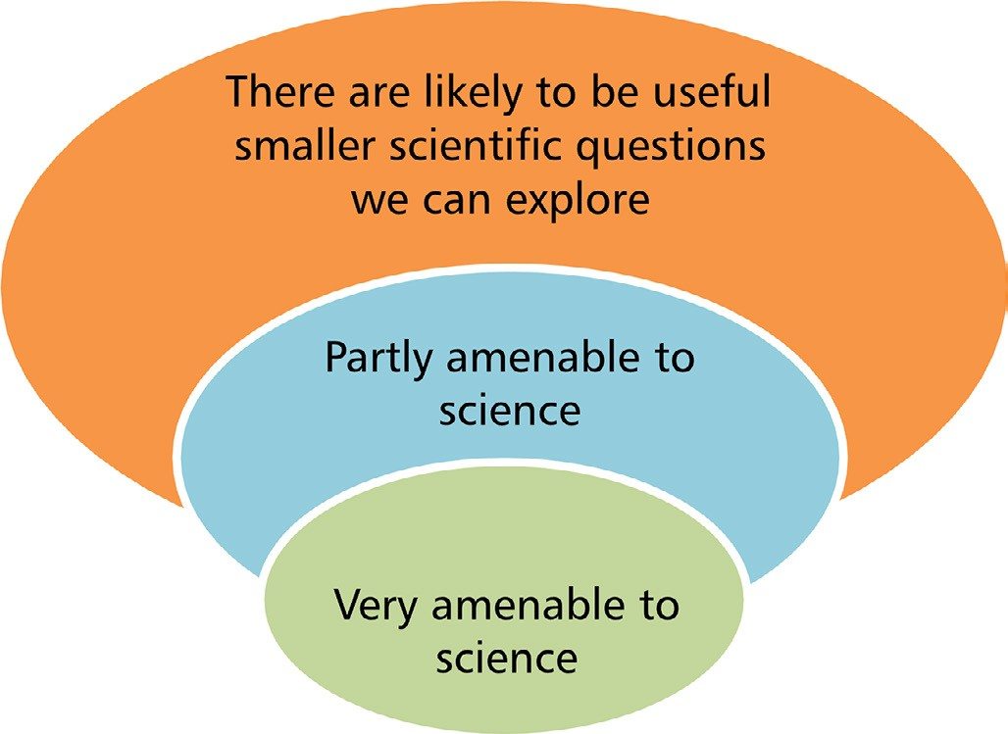

Figure 2 Titanic model made from plastic containers

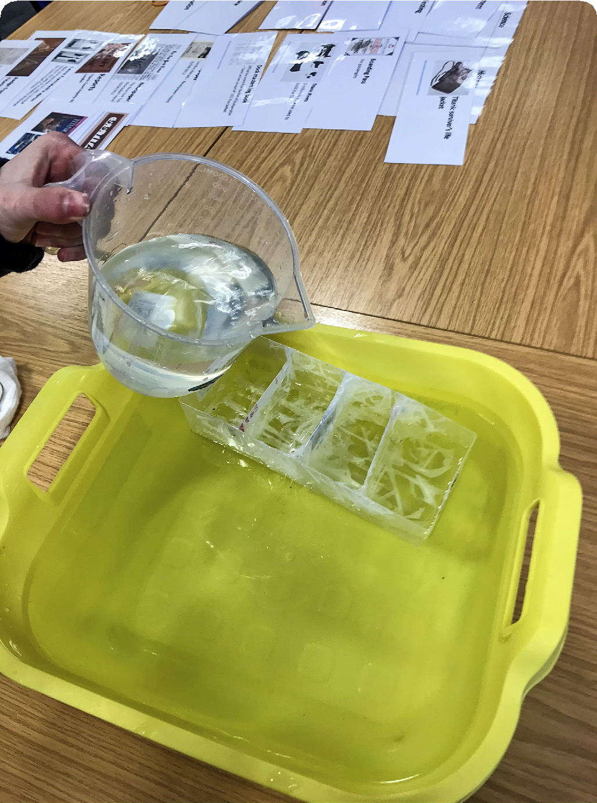
Figure 3 Titanic model demonstration – with an additional weight in the front compartment

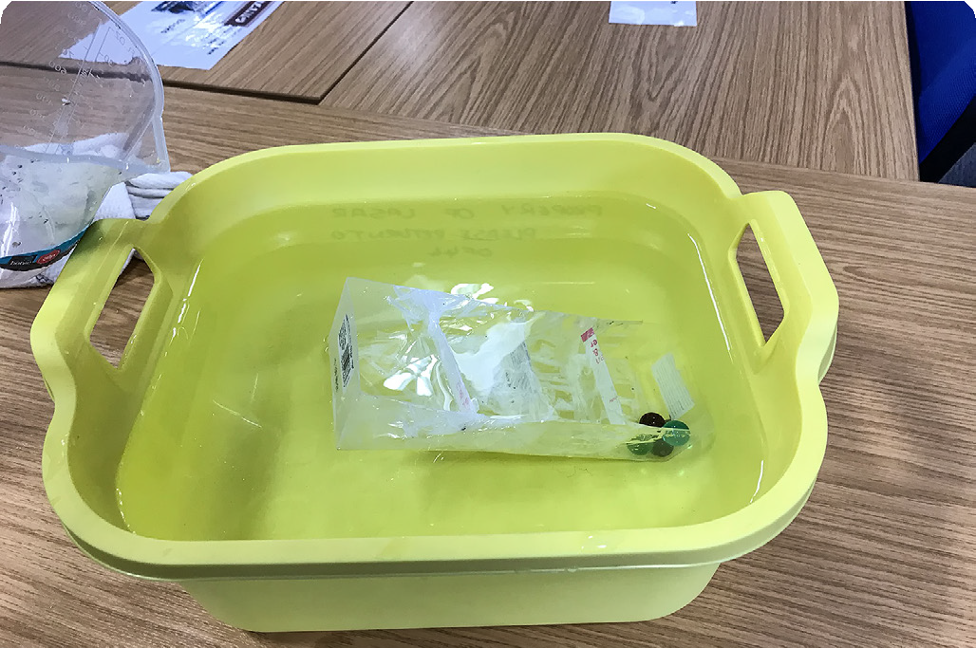

Figure 4 Examples of character cards

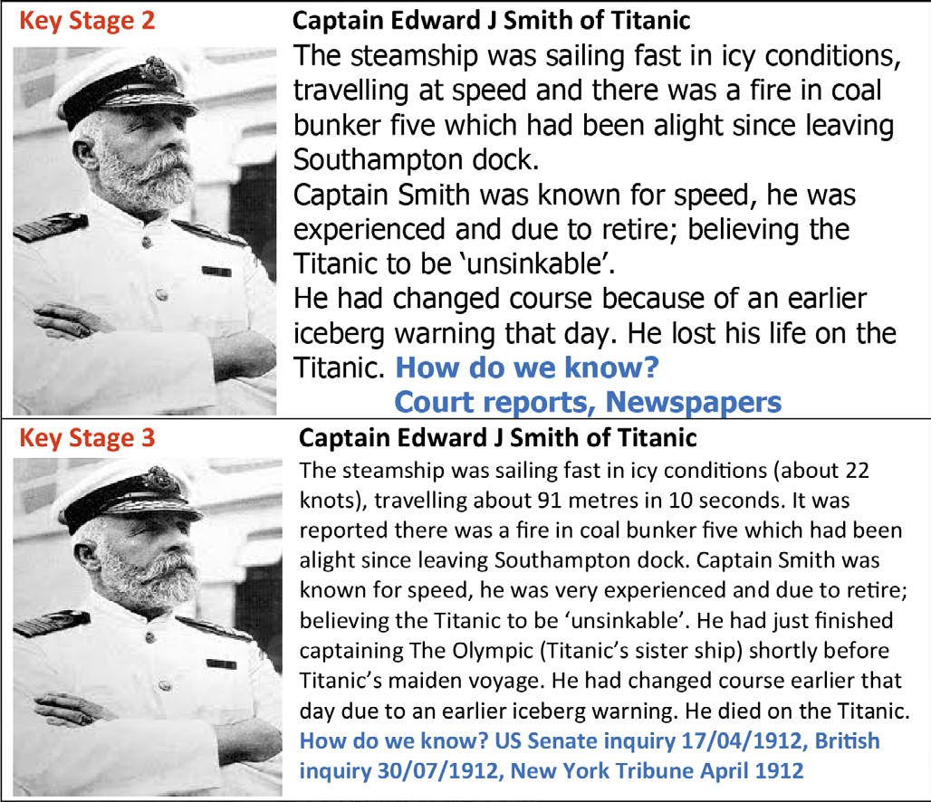

Figure 5 The ‘Discipline Wheel’ – a tool to prompt discussion about which disciplines can help us to investigate and understand Titanic’s story

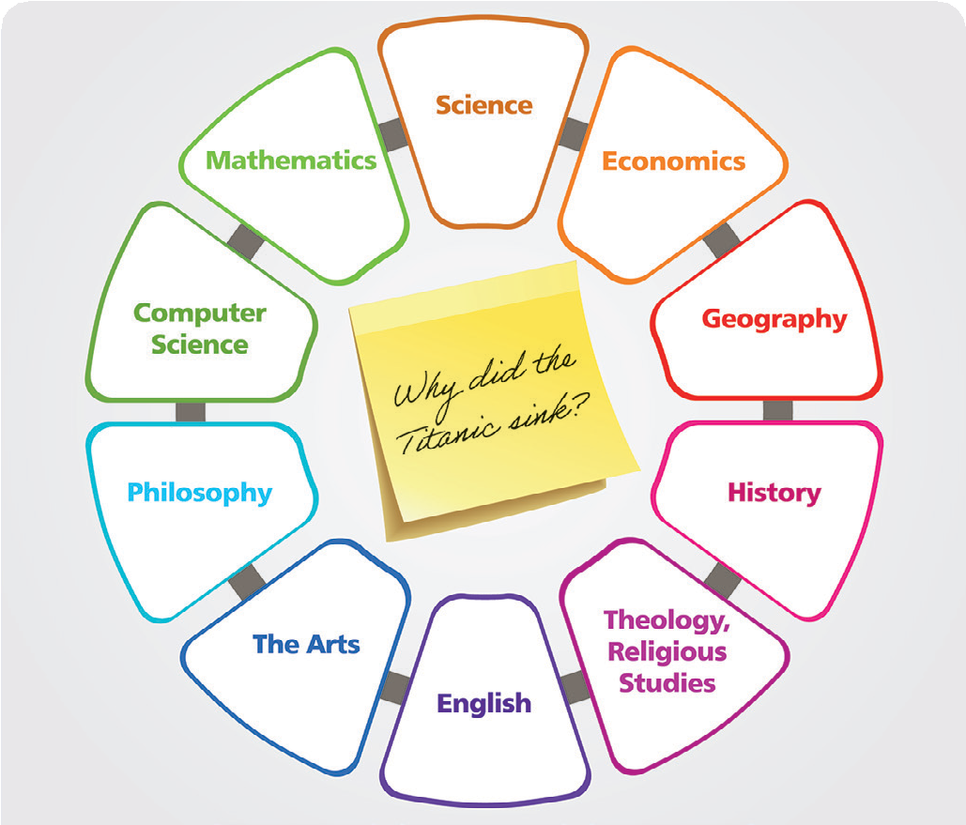

Table 1 Science programmes of study: key stages 2 and 3 national curriculum in England (DfE, 2015)

 | Key stage 2 (upper primary) | Key stage 3 (lower secondary)
Overview | Pupils should select the most appropriate ways to answer science questions using different types of scientific enquiry, including observing changes over different periods of time,  noticing patterns, grouping and classifying things, carrying out comparative and fair tests and finding things out using a wide range of secondary sources of information. | Pupils should understand that science is about working objectively, modifying explanations to take account of new evidence and ideas and subjecting results to peer review. Pupils should decide on the appropriate type of scientific enquiry  to undertake to answer their own questions and develop a deeper understanding of factors to be taken into account when collecting, recording and processing data. They should evaluate their results and identify further questions arising from them.
Working scientifically | Year 5 and 6 pupils should make their own decisions about what observations to make, what measurements to use and  how long to make them for, and whether to repeat them; choose the most appropriate equipment to make measurements and explain how to use it accurately. They should decide how to record data from a choice  of familiar approaches; look for different causal relationships in their data and identify evidence that refutes or supports their ideas. They should use their results to identify when further tests and observations might be needed; recognise which secondary sources will be most useful to research their ideas and begin to separate opinion from fact. | Experimental skills and investigations  l ask questions and develop a line of enquiry based on observations of the real world, alongside prior knowledge and experience.  l make predictions using scientific knowledge and understanding.  l select, plan and carry out the most appropriate types of scientific enquiries to test predictions, including identifying independent, dependent and control variables.

