Abstract

Background
Variability exists between different echo machines and different modalities when measuring tissue velocities. We assessed the consistency of tissue velocity measurements made by machines from different manufacturers across different modalities in an in vitro-model and in patients. Furthermore, we present freely available software tools to repeat these evaluations.

Methods and Results
We constructed a simple setup to generate reproducible motion, and used it to compare velocities measured using 3 echocardiographic modalities: M-mode, speckle tracking, and tissue Doppler, with a straightforward, non-ultrasound, optical gold standard.
In the clinical phase, 25 patients underwent M-mode, speckle tracking and tissue Doppler measurements of s’, e’ and a’ velocities.
In-vitro, the M-mode and speckle tracking velocities were concordant with optical assessment. Of the three possible tissue Doppler measurement conventions (outer edge, middle and inner edge) only the middle agreed with the optical assessment (discrepancy -0.20(95%CI -0.44 to 0.03)cm/s, p=0.11, outer +5.19(4.65 to 5.73)cm/s, p<0.0001, inner -6.26(-6.87 to -5.65)cm/s, p<0.0001). A similar pattern occurred across all 4 studied manufacturers. M-mode was therefore chosen as the in-vivo gold standard.
Clinical measurements of s’ velocities by speckle tracking and the middle line of the tissue Doppler showed good agreement with M-mode, while the outer line overestimated significantly (+1.27(0.96 to 1.59)cm/s, p<0.0001) and the inner line underestimated (-1.82(-2.11 to -1.52)cm/s, p<0.0001).
Conclusions
Echocardiographic velocity measurements can be calibrated by simple, inexpensive tools. We found that the middle of the tissue Doppler trace represents velocity correctly. This article includes downloadable vendor-independent software, so that our findings may be replicated, extended or contradicted.

Keywords:
Echocardiography, Tissue Doppler, Velocity, Calibration

Introduction

Simple quantities, such as distance and velocity, should be uncontroversial. Yet with tissue Doppler, we are sometimes uncertain about both. Where on an envelope to measure velocity is controversial¹⁻⁶. Moreover, different machines are said to give different velocities⁷⁻¹⁰. The discrepancies are not trivial, especially in diseases that depress velocities. Worse, the same machine using the different modalities (e.g. tissue Doppler and M-mode) gives different velocities for the same structure in the same patient. Current guidelines from all major echocardiography societies show examples where the outside of the trace envelope has been measured rather than the middle^{11,12}. ASE guidelines recommend measuring the “outer edge of the dense (or bright) envelope of the spectral recording, i.e. the modal velocity” #ref#.
Clinical practice evades these discrepancies in two ways. First, conventional protocols avoid measuring the same velocity by two methods, so that the discrepancy goes unnoticed¹³⁻¹⁸. Second, end-users expect their equipment for measuring quantities such as blood pressure or body weight to be calibrated rather than merely assumed to be correct. In contrast, we never ask whether echocardiographic systems for measuring velocity have been calibrated, even in the face of conflicts that are puzzling.
Available phantoms can measure blood velocity or distance¹⁹⁻²², but tissue Doppler velocity calibration is less straightforward. We therefore developed a simple setup and used it to:
- investigate for consistent differences between tissue Doppler and M-mode derived measurements of tissue velocity
- evaluate the performance of speckle tracking based tissue velocity measurements
- decide where to make measurements on tissue Doppler traces
We present detailed instructions on assembly, and downloadable software in the online supplement (S1-S9).

Methods

In-vitro calibration of echocardiographic velocity measurements

Data acquisition
The in-vitro setup was designed with an ultrasound probe moving repeatedly towards and away from a tissue-mimicking phantom (online supplement S1) at 10 separate velocities, from 10 to 20 cm/s. B-mode, M-mode and pulsed wave tissue Doppler images of the phantom were recorded twice at each velocity. Each velocity was measured independently by automated optical tracking of a video recording of probe motion. This velocity was used as the gold standard because it was measured independently of any ultrasound components.
Automated peak velocity measurements were made from the M-mode and tissue Doppler traces (Fig. 1). All the software used was developed in-house using Matlab (Mathworks Inc.) and is downloadable in the online supplement (S6-S9). The M-mode algorithm traces round the outer edge of the data (i.e. top of the M-mode trace).
The tissue Doppler algorithm, for each column of the image, identifies the point of highest intensity and the outer and inner edges of the envelope. In this paper, we call the point of highest intensity (i.e. point of brightest white on the Doppler trace at any instant in time) the “middle” for simplicity and to contrast it with the outer and inner edges. This point in statistical terms is the modal velocity, i.e. the velocity possessed by the largest quantity of reflective tissue. If the distribution of velocities is symmetrical, then this will be the same as the middle of the distribution.
Speckle tracking was performed on the B-mode cine loops using vendor-independent algorithms developed in-house (downloadable from online supplement). The speckle tracking algorithm uses a block-matching method with sum-of-absolute-differences. The velocity vectors within the region of interest (automatically selected as a 50×70 pixel region in the centre of the image to capture the phantom motion) were averaged to obtain the velocity profile.
Peak velocities were averaged across 4-6 “beats” from the two acquisition repetitions at each tested velocity.
The experiment was performed using 4 different machines: GE Vivid I, Philips iE33, Toshiba Artida and Siemens Acuson SC2000. Tissue Doppler, M-mode and B-mode images were analysed with automated software as described above. This study was not a comparison of manufacturers’ equipment but rather a test of measurement convention.

Non-ultrasound automated optical velocity measurement
To provide a measure of velocity completely independent of all the ultrasound hardware, software and concepts, we developed a simple piece of software for video recordings made on any smartphone or video capture device. We used an iPhone (Apple Inc.) to record the movements of the probe juxtaposed with a ruler. Our software (downloadable from online supplement) permits automatic measurements of velocity against time from the .MOV video file. This allowed our phantom to be used across a variety of velocities without having to assume linearity of the actuator system.

Statistical analysis
The discrepancy in peak measurements between the reference non-ultrasound optical tracking and each of the other modalities was calculated for each of the ten tested velocities. The differences for all tested velocities were compared across modalities using ANOVA. Where there was significant inhomogeneity, the individual modalities were compared to optical assessment using paired Student’s t-tests. Bland-Altman plots were also displayed for comparing each modality with optical.
Data are presented as difference in mean peak measurement from optical and 95% confidence interval.

In-vivo validation

Subjects
25 sequential patients (16 male) in sinus rhythm (a mixture of patients with normal hearts and those with disease, from the routine echocardiography program in our hospital) underwent M-mode, B-mode and tissue Doppler imaging. The study was approved by the local research ethics committee and all patients provided written informed consent.

Data acquisition
M-mode, B-mode and tissue Doppler traces were acquired at the septal and lateral annuli as per standard clinical guidelines. Each set of acquisitions was conducted twice. Measurements of septal and lateral s’, e’ and a’ were obtained from the M-mode and tissue Doppler traces using automated software (Fig. 2). The M-mode tracing software uses a correlation-based method to follow each M-mode line across time, and averages the lines to obtain the overall M-mode trace. The tissue Doppler tracing algorithm scans each column of the image to identify the highest intensity point and edges of the envelope. The peak velocity measurements were averaged across 5-6 beats.
Speckle-tracked measurements of peak s', e' and a' of the B-mode images were obtained using the automated software as for the in-vitro images. The peak velocities within the region of interest (30×50 pixel region at the annuli, around the regions of highest velocity) were averaged across 5-6 beats.

Statistical analysis
In-vivo, M-mode was the gold standard because optical tracking was not possible. Difference in peak measurement between M-mode and the other modalities was calculated for each patient. The differences for all patients were compared across modalities using ANOVA and where there was significant inhomogeneity, individual modalities were compared against M-mode using paired Student’s t-tests. Bland-Altman plots were displayed for comparing each modality with M-mode.

Reproducibility
Scientific findings can only be considered reliable if experimental results are reproducible in independent hands. To help this we provide:

Hardware
- Details of where examples of all equipment may be purchased, with total cost <€1200.
- Assembly instructions.

Software
Downloadable software for any reader’s echocardiographic system for:
- Vendor-independent quantification of M-mode recordings
- Vendor-independent quantification of pulse-wave Doppler recordings
- Vendor-independent quantification of speckle-tracked tissue velocities
Downloadable software for any reader’s video capture device (e.g. camera phone) for:
- Vendor-independent quantification of velocity by optical tracking

Results

In-vitro calibration of echocardiographic velocity measurements
Using the in-vitro model, the M-mode, speckle tracking and tissue Doppler (middle line) traces broadly agreed with non-ultrasound optical assessment. Fig. 3 shows a representative example of the M-mode, speckle tracking and tissue Doppler (outer, middle and inner line) traces overlaying the optical trace. All raw traces are available from the authors.
Peak velocity measurements from the four tested manufacturers showed a similar relationship between M-mode, speckle tracking and tissue Doppler (outer, middle and inner lines) against optical (Fig. 4). M-mode and speckle tracking peak measurements were concordant with optical and of the three tissue Doppler conventions (outer, middle and inner line) only the middle line agreed with optical. The outer line significantly overestimated and the inner line significantly underestimated velocity (discrepancy using GE Vivid I: outer=+5.19(95% CI 4.65 to 5.73)cm/s, p<0.0001, inner=6.26(-6.87 to -5.65)cm/s, p<0.0001). For all four manufacturers, Bland-Altman analysis (Fig. 5) showed agreement between M-mode, speckle tracking and the middle line of tissue Doppler against non-ultrasound optical assessment. The outer line overestimated and the inner underestimated velocities. The biases between each modality and optical are summarised in Table 1.
ANOVA confirmed the disagreement between modalities (GE Vivid I p<0.0001). Individual Student’s t-tests showed there was a significant difference between optical and the outer and inner Doppler lines (p<0.0001). There was no significant difference in peak measurements between the optical and M-mode (p=0.16), speckle tracking (p=0.27) and the middle tissue Doppler value (p=0.11). Peak measurements using different manufacturer equipment showed similar results.
Fig. 6 shows the peak measurement at each velocity across manufacturers using the outer, middle and inner line. The distribution of peak velocity measurement across manufacturers using the outer tissue Doppler line was 1.57(0.58 to 2.57)cm/s, middle 0.58(0.22 to 0.96)cm/s and inner 1.01(0.37 to 1.66)cm/s.

In-vivo measurements
Septal annulus measurements showed concordance between M-mode, speckle tracking and tissue Doppler middle line. Fig. 7 shows representative speckle tracking and tissue Doppler (outer, middle and inner line) traces overlaying the M-mode trace, for one patient. Peak measurements from speckle tracking and tissue Doppler middle line were concordant with M-mode (Fig. 8). Peak velocity measurements from the outer line of tissue Doppler overestimated (1.27(0.96 to 1.59)cm/s, p<0.0001) and the inner underestimated (-1.82(-2.11 to -1.52)cm/s, p<0.0001).
The different modalities disagreed with each other (ANOVA p<0.0001), but individual Student’s t-tests showed that this was caused by the outer and inner lines of the tissue Doppler trace (outer and inner p<0.0001). There was no significant difference between M-mode and speckle tracking (p=0.12) and between M-mode and the middle of the tissue Doppler trace there was a small difference which met the criteria for statistical significance (p=0.04).
The lateral annulus showed the same pattern. The M-mode, speckle tracking and middle tissue Doppler measurements were concordant, while the outer line of tissue Doppler significantly overestimated the peak and the inner line significantly underestimated it (Fig. 8).
Discrepancy between the modalities was confirmed by ANOVA (p<0.0001), and individual Student’s t-tests showed that this was caused by the outer and inner lines of the tissue Doppler (outer and inner p<0.0001). No significant difference was observed between M-mode and speckle tracking (p=0.07) and between M-mode and the middle line of the tissue Doppler there was a small but statistically significant difference (p=0.05).
Bland-Altman analysis (Fig. 9) showed agreement between speckle tracking and the tissue Doppler middle line against M-mode, not shared by the outer and inner lines of tissue Doppler. The biases between each modality and M-mode for septal and lateral s’ measurements are summarised in Table 2.

Discussion
In this study we describe a simple method for calibrating echocardiographic measurements. Our application of this approach showed that the clinical standard for defining tissue velocity by M-mode and by speckle tracking is correct. However, the current guideline recommendations for tissue Doppler velocity measurements (Fig. 10) appear to cause overestimation.
Traditional guidance for tracing of Doppler envelopes is to draw around the outer margin^{11,12}, i.e. the “peak” (in the sense of greatest instantaneous velocities) and then to measure the “peak” (in the sense of the highest velocity during one cardiac cycle). The extent to which instantaneous peak velocity exceeds instantaneous mean velocity depends on the thickness of the Doppler envelope and human judgement of the upper margin (Fig 11). It is affected by sweep speed, region of interest, gain and filter settings. Only Doppler line thickness of one pixel would resolve this problem definitively.
Until then, an easy yet accurate convention might be to measure instantaneous mean velocity, i.e. the “middle” line. The instantaneous mean velocity refers to the brightest part of the spectral Doppler envelope, i.e. the modal velocity which is the velocity of the largest quantity of tissue within the sample volume. Our automated algorithm identifies the brightest point (i.e. modal velocity) at each time point on the spectral trace. In this paper we refer to the modal velocity as the “middle” line on the spectral Doppler trace in order to distinguish it from the outer and inner edges. In principle, the modal velocity may not necessarily lie exactly in the middle of the trace envelope, unless the distribution of velocities is symmetrical.

Implications for clinical practice
Insisting on using the same machine for all scans is logistically impossible for most hospitals. Outside echocardiography, equipment is usually calibrated to permit interchangeability when assessing quantities such as height and blood pressure. Velocity is just as simple a physical quantity, but reluctance to calibrate leaves clinicians trapped in “vendor lock-in”^{13-18, 23}.
Regardless of the age of the machine we tested (none of which had previously undergone a velocity calibration in the hospital), the middle of the tissue Doppler trace is closely concordant with M-mode velocity, speckle-tracked velocity, and ruler-and-stopwatch direct observation. This is not suggestive of a drift in calibration with time. Rather, it suggests that the advice to read the outer extreme of a velocity trace has always been incorrect. Unfortunately, illustrations in some existing guidelines do not follow this rule^{11,12#}.

Unfortunate consequences of lack of transparency
Lack of transparency at two levels has contributed to this unfortunate situation. First, manufacturers of echocardiography equipment do not make routinely available full details of how the Doppler traces are derived.
Second, there are guidelines which definitively instruct clinical sonographers worldwide on how to conduct their millions of echocardiographic measurements per year. But the laboratory experiments used to develop these guidelines appear not to yet have been published, so it is difficult to establish whether there was some difference in experimental methodology, or in analysis, that might be responsible for our study having contrasting findings to the guidelines.

Who is responsible for correctness of measurements?
When incorrect velocities are reported, in good faith, by a clinician correctly following a protocol, it is not clear where the responsibility lies. If the measurement arises through an automated commercial system, the clinician may point to the manufacturer; in turn the manufacturer may say it is the clinician who has ultimate responsibility. If, instead, the measurement is carried out manually but (for example) using the outer line of tissue Doppler, the clinician may point to established convention passed down by their teachers; the teachers in turn may point to guidelines; and the guidelines in turn point to established convention.
Both these vicious circles of diversion of responsibility are only sustainable because all clinicians in the loop assume that it is unthinkable for them to conduct their own calibration and close the dispute, as would normally happen in a science.
We as clinicians can improve the correctness of our measurements: first, we could calibrate our measurement protocols ourselves. This papers shows how we did it in our hospital. Second, if this is too burdensome, we could require ultrasound manufacturers attending for sales visits not to merely assert that the measurements produced by their products are correct, but to demonstrate it by bringing a calibration setup that we can test ourselves such as this. We should expect openness from manufacturers as to the limitations of their hardware and software.
Incorrect measurement practice or systems have corrosive impact and global reach. Currently there appears to be no deterrent to giving incorrect recommendations or marketing systems that give incorrect values²⁴, perhaps because there is no chance of this being discovered. Even if it is discovered, the world leaders in reliable measurements seem curiously reluctant to name specific manufacturers whose systems provide erroneous results²⁴. The ability for ordinary echocardiography laboratories to validate and willingness for them to publicly report calibration would create a powerful deterrent to producing recommendations, or systems, carelessly.

Systematic errors that may be concealed within commercial systems
Secrecy around analysis algorithms is never helpful because it prevents our community recognising faulty measurement methodology. Mårtensson et al. present an elegant analysis of multiple ultrasound hardware and analysis systems²⁴. Of the systems they analysed, they found that one showed excellent tracking of true displacement, while another showed extensive tracking failure, giving artefactual positive displacements during zero displacement phases. The remaining systems appeared to have a range of subtle to dramatic upward biases, which grew across the duration of the recordings.
A similar result was observed with velocity measurements, with one system failing to track zero velocity phases. The systems which showed significant bias in displacement tracking overestimated peak velocities by 34%, but using a different machine of the same model overestimated velocities by 6%. They concluded that displacement and velocity measurements could differ significantly depending on the machine or analysis software, and how the manufacturer has implemented the theory behind the measurement. Since the details of the algorithms used for measurement appear to be commercial secrets, it is virtually impossible to identify the reason for the differences in measurements.
Our system is open to inspection. The hardware components are available off-the-shelf and have properties clearly and publically defined by their manufacturers. Our vendor-independent software is downloadable from the journal and its method of operation is clearly defined and open to improvement. We hope our experiments will be improved upon by further workers who will similarly share their methods openly.

Study limitations
In patients, it is not possible to measure the same beat using multiple modalities, and measuring different beats with different methodologies runs the risk of discrepancy due to biological variability²⁵ rather than the measurement algorithms being discrepant. In order to minimise the effect of this variability, we conducted each acquisition twice and averaged peak velocity measurements across acquisitions and multiple beats.
For the patient studies, we have used M-mode as the ‘gold standard’ to assess the validity of different modalities. Since there is no method to obtain an independent measurement, we consider this an acceptable assumption offering simplicity (requiring only time and distance calibration to be correct) and agreement with non-ultrasound optical assessments from in-vitro studies.
Raw B-mode data from the machines is in proprietary format, whose details are not available. We therefore used uncompressed DICOM data for speckle tracking. We found that although the acquired frame rate was >50Hz, there were cases where frame rate dropped (≈30-40Hz) when data was exported as DICOM, resulting in sub-optimal speckle tracking. This was resolved by averaging across multiple beats. Manufacturers may in future volunteer, or be forced, to reveal the formats in which they store data in machines, without imposing secrecy.

Conclusion
We test echocardiographic velocity measurements from different manufacturers in multiple modalities (M-mode, speckle tracking and tissue Doppler) against an ultrasound-independent standard of optical tracking. Our in-vitro results and patient studies show that the middle of the tissue Doppler trace gives velocity measurements that are consistent with the other ultrasound modalities as well as an entirely independent optical assessment. The middle line is also the most reproducible between manufacturers. Echocardiographers who think it desirable for the velocities they report to match between different equipment, different settings or different modalities should use the middle line as the “guideline”, if they consider consistency to be relevant.

Acknowledgements
The authors are grateful to the European Research Council (281524) and NIHR Biomedical Research Centre scheme for providing funding support for this study. DF and KW were funded by the BHF (FS/10/038). GC was funded by the BHF (FS/12/12/29294).

References###

1. Chen Q-m, Li W, O'Sullivan C, et al. Clinical in vivo calibration of pulse wave tissue doppler velocities in the assessment of ventricular wall motion. A comparison study with m-mode echocardiography. Int J Cardiol. 2004;97:289–295
2. Olsen NT, Jons C, Fritz‐Hansen T, et al. Pulsed‐wave tissue doppler and color tissue doppler echocardiography: Calibration with m‐mode, agreement, and reproducibility in a clinical setting. Echocardiography. 26:638-644
3. Kukulski T, Voigt JU, Wilkenshoff UM, et al. A comparison of regional myocardial velocity information derived by pulsed and color doppler techniques: An in vitro and in vivo study. Echocardiography. 2000;17:639-651
4. Tartiere JM, Logeart D, Tartiere-Kesri L, Cohen-Solal A. Colour tissue doppler underestimates myocardial velocity as compared to spectral tissue doppler: Poor reliability between both methods. Eur J Echocardiogr. 2008;9:268-272
5. McCulloch M, Zoghbi WA, Davis R, et al. Color tissue doppler myocardial velocities consistently underestimate spectral tissue doppler velocities: Impact on calculation peak transmitral pulsed doppler velocity/early diastolic tissue doppler velocity (e/ea). J Am Soc Echocardiogr. 2006;19:744-748
6. Ballo P, Bocelli A, Motto A, et al. Concordance between m-mode, pulsed tissue doppler, and colour tissue doppler in the assessment of mitral annulus systolic excursion in normal subjects. Eur J Echocardiogr. 2008;9:748-753
7. Denes M, Farkas K, Erdei T, Lengyel M. Comparison of tissue doppler velocities obtained by different types of echocardiography systems Echocardiography. 2010;27:230-235
8. Kjaergaard J, Korinek J, Belohlavek M, et al. Accuracy, reproducibility, and comparability of doppler tissue imaging by two high-end ultrasound systems. J Am Soc Echocardiogr. 2006;19:322-328
9. Walker A, Olsson E, Wranne B, et al. Accuracy of spectral doppler flow and tissue velocity measurements in ultrasound systems. Ultrasound Med Biol. 2004;30:127-132
10. Lindqvist P, Kiviniemi J, Henein M. Inconsistent myocardial velocity values between echocardiographs: Only gain related? Eur J Echocardiogr. Conference proceedings. 2009:ii64
11. A standard transthoracic echocardiogram. British Society of Echocardiography. 2012. Accessed on 22/07/2013 from http://www.bsecho.org/tte-minimum-dataset/
12. Nagueh SF, Appleton CP, Gillebert TC, et al. Recommendations for the evaluation of left ventricular diastolic function by echocardiography. Eur J Echocardiogr. 2009;10:165–193.
13. Evangelista A, Flachskampf F, Lancellotti P, et al. European association of echocardiography recommendations for standardization of performance, digital storage and reporting of echocardiographic studies. Eur J Echocardiogr. 2008;9:438-448
14. Vesely MR, Li S, Kop WJ, et al. Test-retest reliability of assessment for intraventricular dyssynchrony by tissue doppler imaging echocardiography. Am J Cardiol. 2008;101:645-650
15. Bull SC, Main ML, Stevens GR, et al. Cardiac toxicity screening by echocardiography in healthy volunteers. Echocardiography. 2011;28:502-507
16. Cobankara V, Guclu A, Kuru O, et al. Evaluation of biventricular myocardial performance index in patients with behçet's disease. J Int Med Res. 2012;40:328-332
17. Yip GW, Zhang Y, Tan PY, Wang M, Ho P-Y, Brodin LA, Sanderson JE. Left ventricular long-axis changes in early diastole and systole. Clinical Science. 2002;102:515-522
18. Uretsky S, Shah A, Bangalore S, et al. Assessment of left atrial appendage function with transthoracic tissue doppler echocardiography. Eur J Echocardiogr. 2009;10:363-371
19. Eriksson A, Persson HW, Lindstrom K. A computer-controlled arbitrary flow wave form generator for physiological studies. Review of Scientific Instruments. 2000;71:235-242
20. Coiado OC, Costa ET. Pulsatile flow phantoms for quality control of doppler ultrasound imaging. In: Dössel O, Schlegel W, eds. World congress on medical physics and biomedical engineering, 2009, Munich, Germany. Springer Berlin Heidelberg; 2009:875-878.
21. Tissue simulation & phantom technology - CIRS. Accessed on 22/07/2013 from http://www.cirsinc.com/
22. Blue phantom ultrasound training medical models and ultrasound simulators. Accessed on 22/07/2013 from http://www.bluephantom.com/
23. van der Hulst AE, Delgado V, ten Harkel ADJ et al. Tissue doppler imaging in the left ventricle and right ventricle in healthy children. Eur J Echocardiogr. 2011;12:953-960
24. Mårtensson M, Bjällmark A, Brodin LÅ. Evaluation of tissue Doppler-based velocity and deformation imaging. Eur J Echocardiogr. 2011;12(6):467-476
25. Finegold JA, Manisty CH, Cecaro F, et al. Choosing between velocity-time-integral ratio and peak velocity ratio for calculation of the dimensionless index (or aortic valve area) in serial follow-up of aortic stenosis. Int J Cardiol. 2013;167(4):1524-1531

Tables

Manufacturer | M-mode | Speckle tracking | Tissue Doppler
 |  |  | Outer line | Middle line | Inner line
GE Vivid I | 0.06(-0.02 to 0.15)  p=0.16 | 0.19(-0.13 to 0.51)  p=0.27 | 5.19(4.65 to 5.73)  p<0.0001 | -0.20(-0.44 to 0.03)  p=0.11 | -6.26(-6.87 to -5.65)  p<0.0001
Philips iE33 | 0.13(-1.31 to 1.56)  p=0.59 | 0.13(-0.15 to 0.4)  p=0.38 | 3.46(3.14 to 3.78)  p<0.0001 | -0.32(-0.6 to -0.03)  p=0.05 | -5.65(-6.77 to -4.53)  p<0.0001
Toshiba Artida | -0.66(-1.24 to -0.07)  p=0.05 | -0.35(-0.56 to -0.14)  p=0.10 | 7.57(6.82 to 8.33)  p<0.0001 | 0.40(0.03 to 0.77)  p=0.06 | -6.28(-6.83 to -5.73)  p<0.0001
Siemens SC2000 | -0.18(-0.33 to -0.03)  p=0.04 | -0.37(-0.73 to -0.01)  p=0.07 | 5.26(4.73 to 5.78)  p<0.0001 | -1.72(-2.03 to -1.41)  p<0.0001 | -8.61(-9.48 to -7.74)  p<0.0001

Table 1: Average Bland-Altman biases in peak velocity measurements (cm/s) across 10 tested velocities and four manufacturers (GE, Philips, Toshiba and Siemens) using M-mode, speckle tracking and tissue Doppler (outer, middle and inner line) compared against non-ultrasound optical assessment, shown with 95% confidence intervals.
Measurement |  | Speckle tracking | Tissue Doppler
 |  |  | Outer line | Middle line | Inner line
Septal | s’ | 0.26(-0.06 to 0.59)  p=0.12 | 1.27(0.96 to 1.59)  p<0.0001 | -0.24(-0.47 to -0.03)  p=0.04 | -1.82(-2.11 to -1.52)  p<0.0001
 | e’ | -0.14(-1.59 to 1.3)  p=0.32 | 1.22(0.80 to 1.65)  p<0.0001 | -0.44(-2.11 to 1.23)  p=0.02 | -2.06(-4.33 to 0.2)  p<0.0001
 | a’ | -0.03(-0.35 to 0.3)  p=0.87 | 2.01(1.72 to 2.30)  p<0.0001 | 0.10(-0.22 to 0.41)  p=0.54 | -1.64(-2.01 to -1.27)  p<0.0001
Lateral | s’ | -0.41(-0.84 to 0.02)  p=0.07 | 1.55(1.01 to 2.09)  p<0.0001 | -0.52(-1.03 to -0.02)  p=0.05 | -2.49(-3.02 to -1.98)  p<0.0001
 | e’ | -0.12(-0.44 to 0.21)  p=0.48 | 1.98(1.43 to 2.54)  p<0.0001 | -0.47(-0.93 to -0.02)  p=0.05 | -2.39(-2.93 to -1.85)  p<0.0001
 | a’ | 0.12(-0.5 to 0.74)  p=0.70 | 2.43(1.87 to 2.98)  p<0.0001 | 0.14(-0.29 to 0.58)  p=0.52 | -2.03(-2.48 to -1.59)  p<0.0001

Table 2: Average Bland-Altman biases across 25 patients of septal and lateral s’ velocity measurements (cm/s) in-vivo using speckle tracking and tissue Doppler (outer, middle and inner line) compared against M-mode, shown with 95% confidence intervals.

Figures
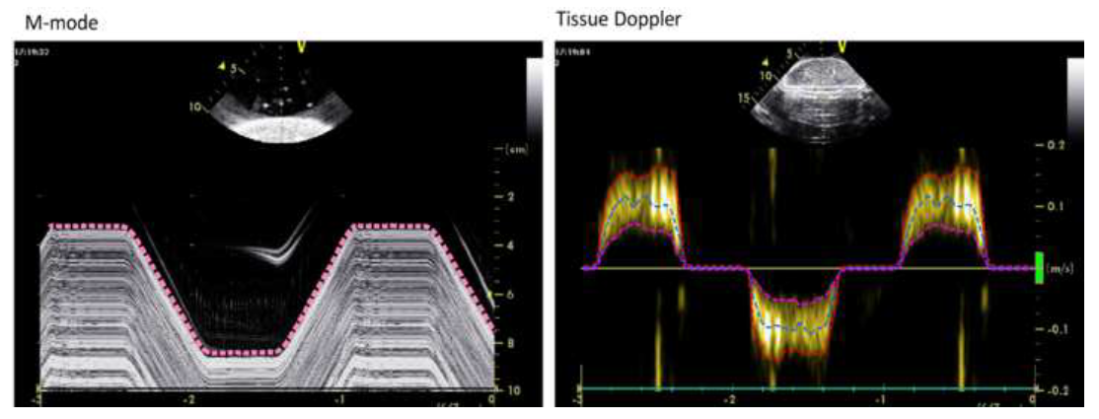
Fig. 1: Representative automated M-mode (pink) and tissue Doppler outer (red), middle (blue) and inner (purple) traces obtained for one of the tested velocities using GE Vivid I.

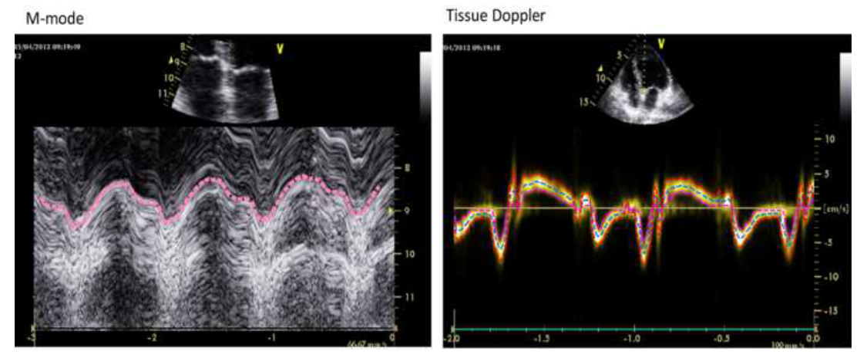
Fig. 2: Representative automated M-mode (pink) and tissue Doppler outer (red), middle (blue) and inner (purple) traces for Patient 5.

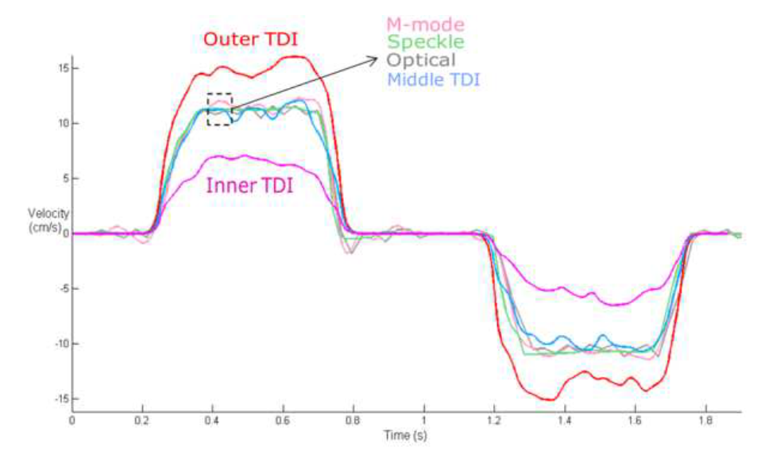
Fig. 3: M-mode (pink), speckle tracking (green) and tissue Doppler outer (red), middle (blue) and inner (purple) traces overlaying the corresponding non-ultrasound optical tracking trace (grey) for one of the tested velocities using GE Vivid I.

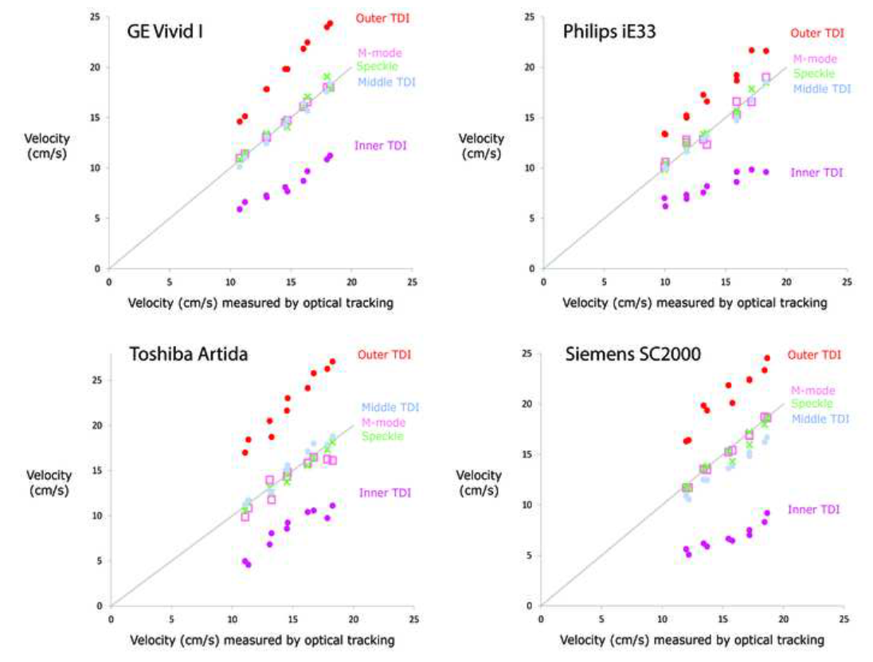
Fig. 4: Comparison of peak measurement using optical tracking, M-mode (pink square), speckle tracking (green cross) and tissue Doppler (outer line (red dot), middle line (blue dot), inner line (purple dot)) for the ten tested velocities using GE Vivid I Philips iE33, Toshiba Artida and Siemens SC2000.

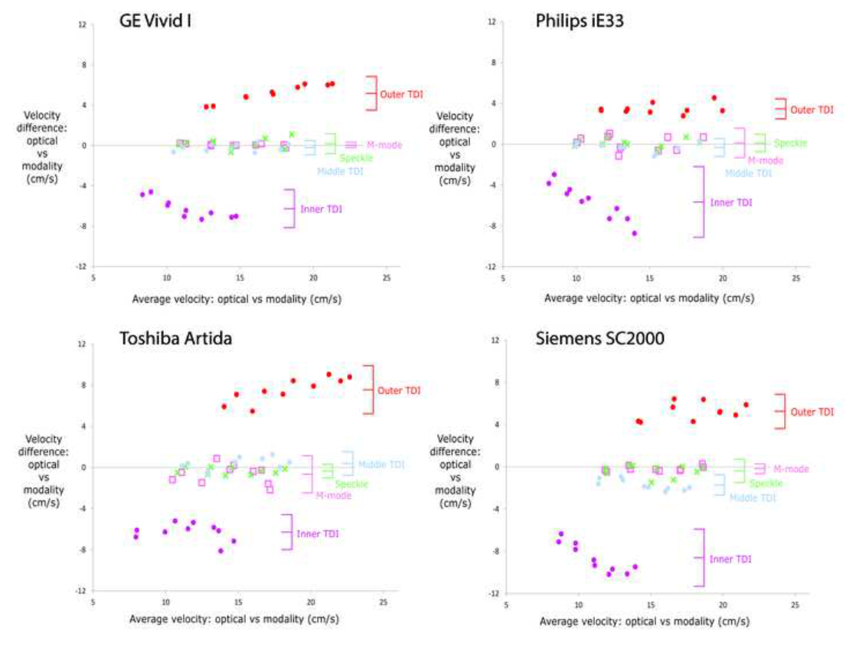
Fig. 5: Modified Bland-Altman plots showing M-mode (pink square), speckle tracking (green cross), tissue Doppler (outer line (red dot), middle line (blue dot), and inner line (purple dot)) compared against non-ultrasound optical tracking for the ten tested velocities using GE Vivid I Philips iE33, Toshiba Artida and Siemens SC2000. Each vertical bar shows the bias (middle horizontal line) and the limits of agreement i.e. ±2SD (upper and lower horizontal lines).

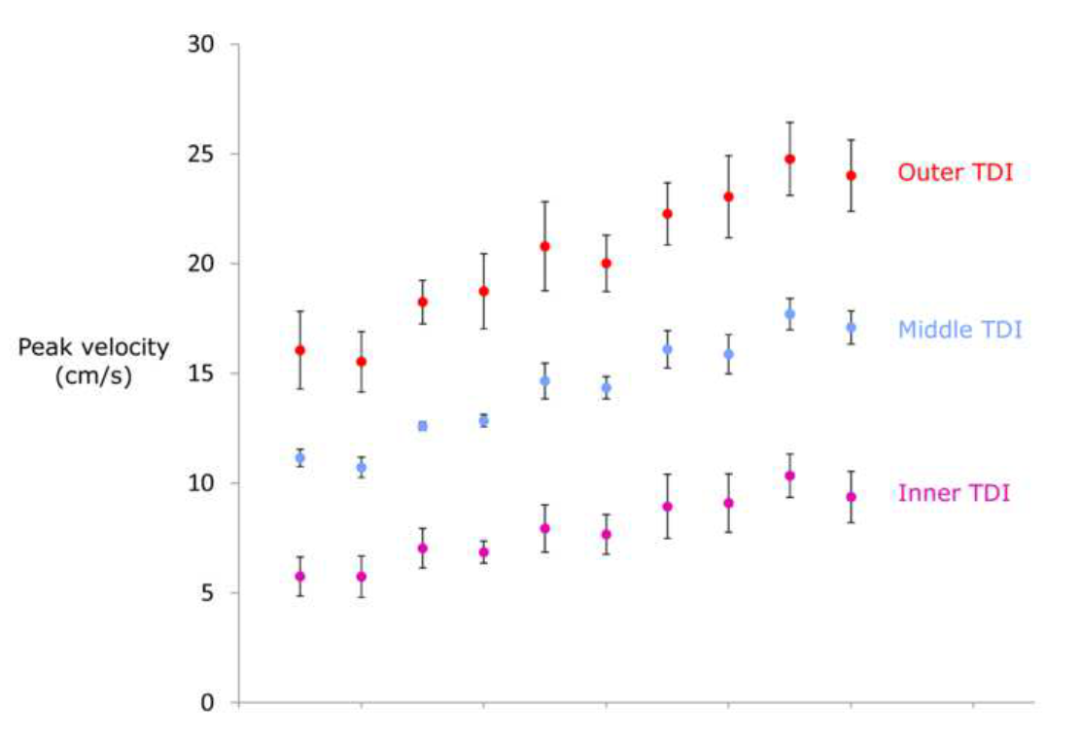
Fig. 6: Distribution obtained from four manufacturers’ equipment for ten tested velocities using the outer (red dot), middle (blue dot) and inner (purple dot) line of the tissue Doppler trace. Error bars show the standard deviations of each.

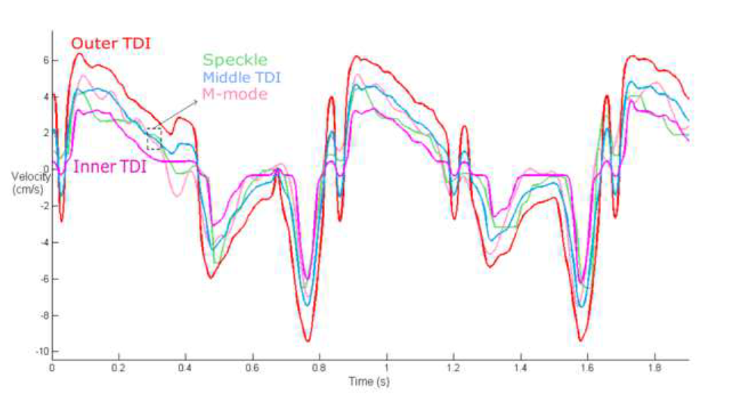
Fig. 7: Speckle tracking (green) and tissue Doppler outer (red), middle (blue) and inner (purple) traces overlaying the M-mode trace (pink) for Patient 5.

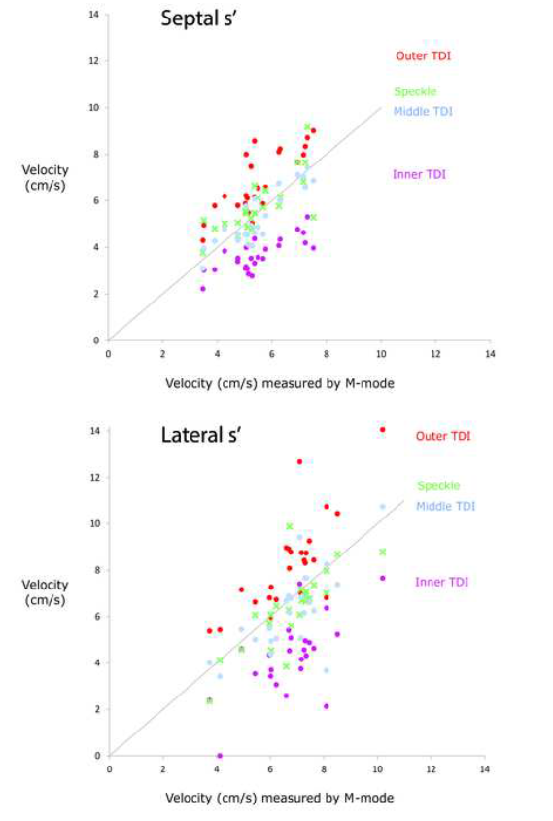
Fig. 8: Comparison of septal and lateral s’ measurement using M-mode (x-axis), speckle tracking (green cross) and tissue Doppler (outer (red dot), middle (blue dot) and inner line (purple dot)) across 25 patients.
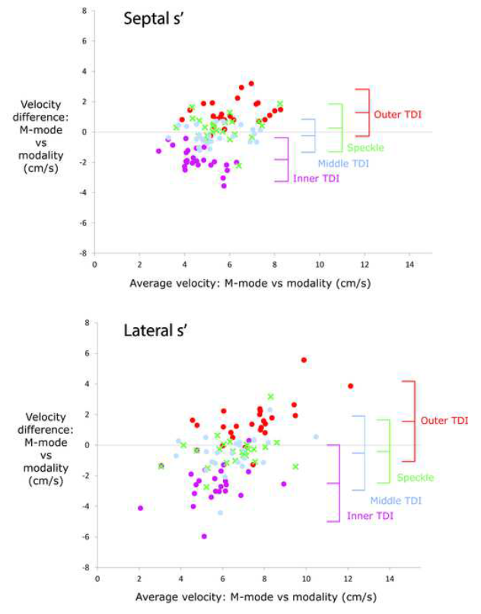
Fig. 9: Modified Bland-Altman plots showing septal and lateral s’ measurements using speckle tracking (green), tissue Doppler outer (red), middle (blue) and inner (purple) compared against M-mode for 25 patients. Each vertical bar shows the bias (middle horizontal line) and the limits of agreement i.e. ±2SD (upper and lower horizontal lines).
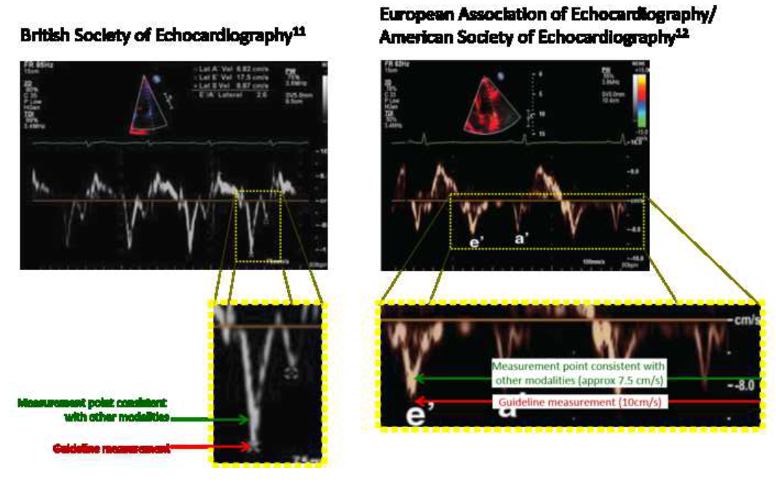
Fig. 10: In our local national guidelines (left panel and inset), the cursor positioned on the edge of the envelope is some way from the location that we would now recommend as matching the other modalities. In the legend of the Figure from the EAE/ASE guidelines (right panel and inset), the e’ wave was reported to be 10cm/s, which from examining the wave labelled e’ seems to have arisen from the very extreme outer edge of the envelope. In light of our current study findings, it appears that the actual velocity would be considerably smaller at approximately 7.5cm/s.

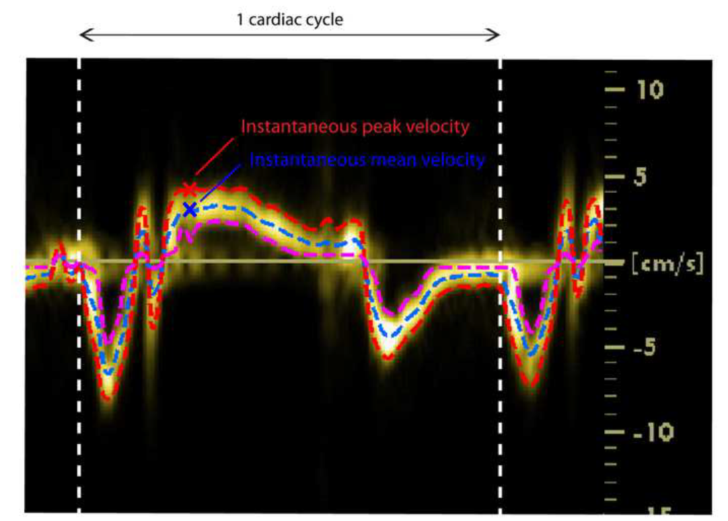
Fig. 11: Measurement of instantaneous peak velocity (red) and instantaneous mean velocity (blue) on tissue Doppler traces.

