Study of Improved non-coring needle insertion into Implanted Intravenous Ports using a Portacator®.
Andrew Barton, Keith Pamment, Dennis Fitzpatrick
Andrew Barton, Advanced Nurse Practitioner Vascular Access & IV Therapy Lead, Frimley Health NHS Foundation mTrust
Keith Pamment, Senior Research Technician, City University, London.
Dennis Fitzpatrick, Biomedical Engineering Research, University of West London.

NOTE TO SUB: Please speak remove product mention after first use (refer to ‘the IP) instead of Portacator, and tone down any overtly complimentary language about the product
Abstract
Implanted IV Ports (IPs) are increasingly more common in the healthcare setting. Patients with IPs encounter a great degree of variance in the experience of having their IPs accessed. Successful IP access depends on the experience and skill of the Healthcare professional as malpositioned attempts are not only painful for the patient but can also cause damage to the outer casing of the IP. The more skin punctures over the Port, the higher the risk of infection in the subcutaneous tissue.
The Portacator® is a sterile single-use product that sits on the skin over the IP insertion site. Its purpose is to enable the successful insertion of a non-coring needle into the centre of the IP. The efficacy of using the Portacator® was investigated using a standalone Port test Rig and also by conducting a clinical evaluation on patients in two hospital units. Users were able to insert a non-coring needle closer to the absolute Port chamber centre when using the Portacator® as only two fingers are used to hold the Portacator® securely in place that allows for an unobstructed view of the access site for central insertion. The Portacator® provided an easy reference for central non-coring needle insertion.
An evaluation of the Portacator® was undertaken in two hospital units that support patients with IPs that require regular IV therapy infusions for long term chronic illness. The Portacator® improved the success rate of first time IP puncture with a non-coring needle. Patient satisfaction increased alongside a greater confidence that the IP was accessed correctly. Nursing also staff felt better supported and more confident in successful first attempt IP access using the Portacator®.

Introduction
Intravenous (IV) therapy remains an important element of clinical treatment in today’s healthcare setting where drugs, fluids, antibiotics and blood products are all routinely administered into a vein (Higginson 2017). The benefit of IV therapy, compared to oral therapy is well documented. IV therapy also provides 100% bioavailability in most cases and facilitates more reliable control of drug blood plasma concentrations (Doherty 2010). As with most clinical procedures the risks and complications associated with IV therapy should be considered before starting treatment. Complications associated with IV therapy administration are also dependent upon the vascular access device (VAD) being used (Hugill 2017) and the decision of placing a VAD with its intended use in mind. Peripheral intravenous (PIV) catheters are the most common devices used for IV therapy administration, (Bitmead & Oliver 2018) partly because they are inexpensive and relatively easy to place in most patients. However, PIV insertion is painful, invasive and can be associated with increased risks of infection (Abolfotouh et al 2014). For some patients, particularly those who have long term or chronic illness, it can be very difficult to insert a PIV. Poor peripheral vein availability will often require intervention by the specialist vascular access team to place the device (Paul 2015). However, PIV insertion can still lead to prolonged pain and trauma for the patient. In these circumstances, alternative more reliable long term VADs should be considered.
The Vessel Health and Preservation Framework (Jackson et al 2013) has provided significant evidence to assist in the decision-making process when choosing which VAD to select and as early as possible to avoid repeated insertions of devices that might not last for the duration of the intended treatment (Weston et al 2017). For patients with long-term chronic illness, a more permanent VAD is considered to be the best practice. Placement of these VADs is more routine, partly due to the increased number of nurse led vascular access teams that have taken over responsibility for the insertion, care and maintenance of vascular devices (Shawyer 2016). While peripherally inserted central catheters (PICC) appear to be the most common long term VAD used in long-term chronic illness, up to 18 months in some cases, there is a definitive limit on how long the catheter can remain inserted in the patient. There is also an increased risk of thrombosis associated with PICCs (Chopra et al 2015). Arguably a more reliable long-term VAD would be an implantable port (Patel 2014).
Implantable ports (IPs) that have a catheter tip terminated in the lower 3rd of the superior vena cava are classed as central venous access devices (CVADs) (York 2012). These devices facilitate drug administration into the central venous system and have been shown to provide a safer and more effective way of delivering long-term IV therapy into the body (Ogston-Tuck 2012). The Port itself is essentially a small round chamber, usual made of either plastic or titanium or both that is implanted under the skin in a subcutaneous pocket, most commonly situated on the upper chest. The catheter is then tunnelled under the skin, in the subcutaneous tissue, to the internal jugular, axillary vein or subclavian vein where it enters the venous system.
The decision to insert an IP will be multifactorial and depend on the availability and skill of the vascular access team to insert the device and the patient’s consent to undergo the procedure. Another factor that should be considered is the confidence and skill of healthcare staff to access the device to administer treatment for the patient and to provide on-going care and maintenance of the port for the duration of the treatment course that could last months or even years. It is often accessing, maintenance and care of the IP that raises the most concerns amongst healthcare professionals (Dougherty 2011).
Quite often, patients that have IPs will be admitted into secondary acute care with an unrelated clinical issue that requires the patient to have IV therapy or venepuncture. The healthcare professionals who need to gain IV access are often reluctant to access the IP due to lack of experience. The lack of confidence and skill in accessing IPs outside of specialist units can lead to increased anxiety for the patient who may have to endure repeated attempts to gain peripheral intravenous access or blood sampling (Bow et al 1999).
Factors that affect the successful access of IPs depend primarily on the patient’s body type, the location of the IP, its subcutaneous depth and angle of insertion. Inserting a non-coring needle into the IP must be done aseptically (RCN 2010) and with confidence as a failed attempt, requiring a second stab is painful for the patient and can cause bleeding and haematoma at the insertion site. The more skin punctures over the port, the higher the risk of infection in the subcutaneous tissue (Zaghal et al 2012).
When accessing an IP, the Port is usually stabilised with the fingers of one hand whilst simultaneously inserting the non-coring needle through the skin and underlying subcutaneous tissue into the centre of the Port chamber with the other hand. Normally, the location of the IP chamber and the placement of the non-coring needle is determined by touch, feeling around the ‘bump’ of the IP to identify the rim of the chamber in order to determine the optimum location to insert the non-coring needle. Subsequently, there can be a certain amount of guess work involved for optimum needle insertion. Mispositioned non-coring needle insertion is not only painful for the patient but can also cause damage to the outer casing of the IP.
With these issues in mind, a solution to improving IP access has subsequently led to the design and development of the Portacator® by DenKe Medical Ltd. The Portacator® is a small plastic device that sits on the skin over the IP insertion site and is designed to locate and stabilise the IP to facilitate a more accurate needle insertion into the centre of the Port chamber.
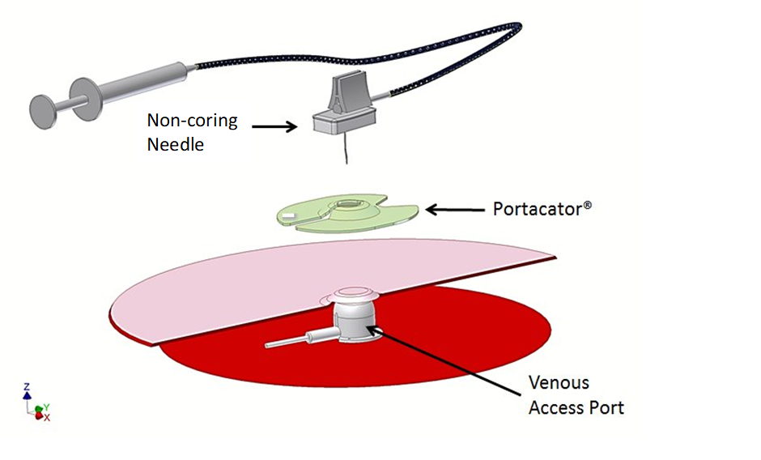
Fig. 1 The Portacator® locates the Port holding it securely in place allowing for easy needle access to the subcutaneous Port chamber.
The Portacator® shown in Fig. 1 is designed to fit over the Port indentation, stabilising the IP in place securely with two fingers whilst allowing the user to have a clear unobstructed view of the skin covering the central area of the IP chamber where the non-coring needle is to be inserted. After the non-coring needle has been fully inserted and confirmation that the device is functional, the hinge action of the Portacator® allows easy removal by gently pulling the Portacator® apart and sliding the two respective pieces away from the IP without disturbing the non-coring needle that is left in situ.

Evaluation
The efficacy of using the Portacator® was investigated by comparing needle insertion points into a constructed Port test Rig and also on the valuable feedback from clinical staff and home users who self-inject their medication and flush using the Portacator®. Accuracy of needle insertion, centrally into a port chamber was evaluated using the test Rig shown in Fig. 2 where a camera is located inside the simulated Port chamber to detect needle insertion points through the rubber skin. A movement mechanism simulates Port movement associated with locating and holding subcutaneous Ports securely in place.
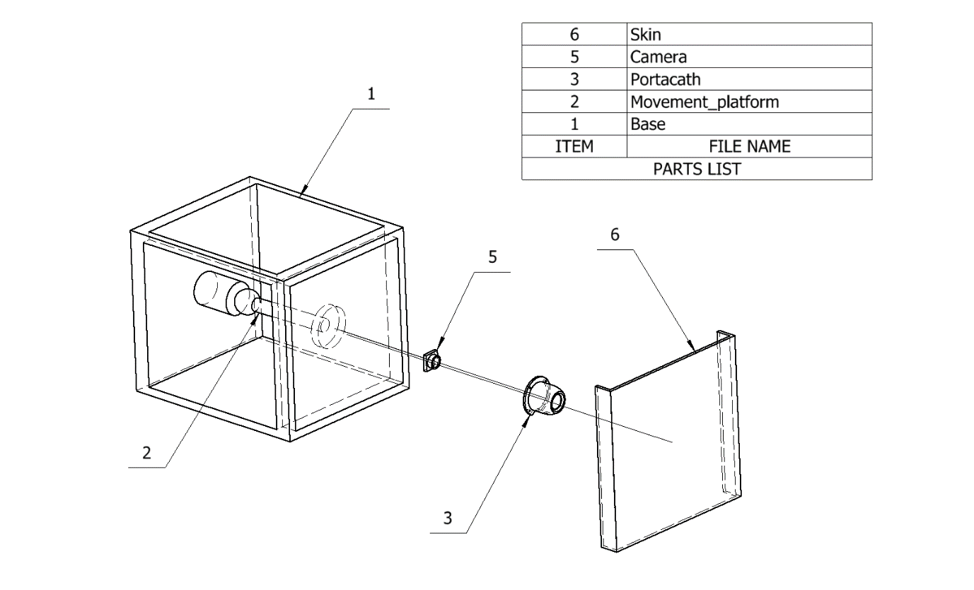
Fig. 2 Port test Rig incorporates a camera to record needle insertion points.

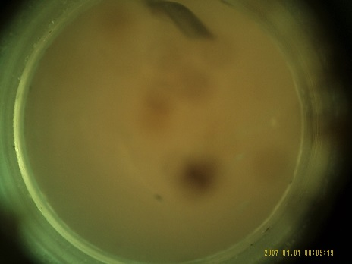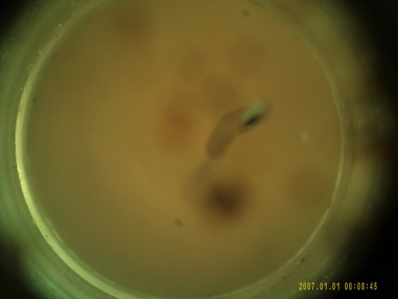
- b)
Fig. 3 Non-coring needle insertion into simulated port chamber a) without Portacator® and b) using the Portacator®.
Fig. 3 shows the difference of the Needle Insertion Point (NIP) without the Portacator® (Fig. 3a) and using the Portacator® (Fig. 3b). In some instances, the location of the NIP was not registered as the needle was inserted outside of the port chamber. Fig. 4 compares the distribution of NIPs without using the Portacator® (Figs.4a and 4c) and with using the Portacator® (Figs.4b and 4d). In Figs. 4a and 4c, there is a wide distribution of NIPs compared to those shown in Figs.4b and 4d where the NIPS are more closely grouped together. In two other cases, the inserted needle missed the Port completely.
s
(a) (b)
(c) (d)
Fig. 4 Distribution of needle insertion by two separate subject groups 1 and 2.
Subject group 1. a) without using the Portacator® (3.15mm ±1.05¹) and b) Using the Portacator® (2.10mm ±0.7¹).
Subject group 2. c) without using the Portacator® 2.56mm ±1.1¹) and d) Using the Portacator® (1.87mm ±1.12¹).
1– mean ± SD. 10mm diameter.

Some experienced users were able to demonstrate that they could use two fingers to hold the Port in place without using the Portacator® but admitted that the Portacator® provided a more secure hold and also provided an easy reference for central needle insertion. All users commented on the ease by which the Portacator® is removed simply by separating the two flanges and sliding away the Portacator® away without disturbing needle placement.
In Fig. 4, the number of needle insertion attempts by each group was greater when not using the Portacator® compared to using the Portacator®. This was because the users were determined to ‘have another attempt’ at inserting the needle more towards the Port centre. However, there was little improvement in the needle insertion point being more central compared to using the Portacator® that required less attempts to achieve a more central needle insertion into the Port.

Clinical Evaluation
An evaluation of the Portacator® was undertaken in two busy hospital units in the United Kingdom. The first was a Medical day unit, the second an Intravenous Therapy unit, both units support patients with IPs that require regular IV therapy infusions for long term chronic illness. The Medical day unit includes staff that are less confident in accessing IPs, where historically, regular support was requested for the vascular access team to assist in accessing their patient’s IPs. The evaluation took place over a period of 13 weeks and enrolled 11 patients with IPs across both units. The evaluation looked at the success rate with the Portacator® on the first attempt. Of the 11 IPs accessed, 8 out of the 11 patients had experienced at least one or more previous failures in accessing their IPs. All the patients in the evaluation were outpatients and all were having their IPs accessed regularly on a weekly, two weekly or monthly basis. The IV Therapy unit has a good skill mix in accessing IPs but some of the staff are less confident in accessing IPs and also treat patients that historically have difficult access issues with their IPs.
Fig. 5 shows the Portacator® held securely in place over the Port indentation using just two fingers of one hand. This allows for a clear unobstructed view of the skin area covering the Port chamber though which the non-coring needle is inserted.

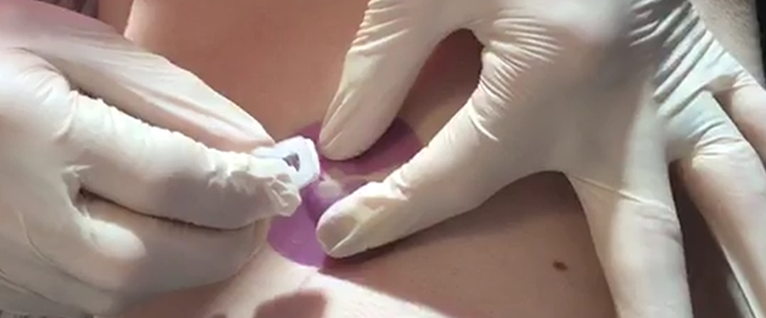
Fig. 5 Portacator® (left hand) holding the port securely in place allowing clear visibility for non-coring needle insertion (right hand) towards port centre.
The Portacator® is removed by pulling the two flanges apart and then sliding the two respective pieces away from the IP without disturbing the inserted non-coring needle as shown in Fig. 6.
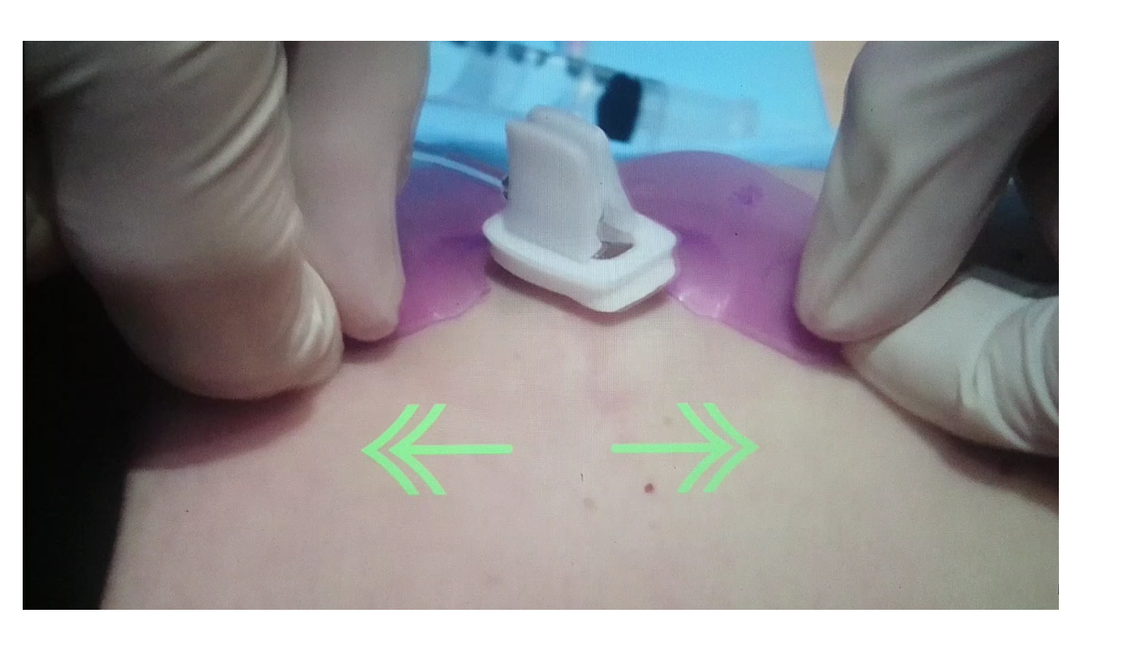Fig. 6 The Portacator® is removed by pulling apart the two flanges and sliding the pieces away without disturbing the needle placement.
Medical Day Unit
The Medical day unit undertook an evaluation of the Portacator® over a 3-month period. Four patients were selected for the evaluation as they had IPs for on-going IV therapy on a 2 or 3 weekly basis. The unit nurses were all trained to use the Portacator® by the vascular access team, a model chest and IP was used for the training and then each nurse was observed once only using the Portacator® on a patient. At the end of the 3-month period the nurses were asked to evaluate the Portacator®.
All 3 nurses used the Portacator® on all 4 patients over the 3-month period. Each nurse evaluated the device and reported an improvement of their confidence level and success rates on inserting the non-coring needle on the first attempt. Previously the success rate had been low at 40% on the first insertion. However, using the Portacator® the success rate increased to 85%. There was also a marked increase in patient satisfaction using the Portacator® as patients reported that they were more confident that the needle was going to be inserted successfully on the first attempt and was less painful. The Medical day unit staff were also very happy and confident when using the Portacator® and have gone on to routinely use the Portacator® when accessing IPs.
Intravenous Therapy Day Unit
The staff in the IV Therapy day unit were more accustomed to accessing IPs, some staff being more experienced than others. Despite this, all the staff participated in the evaluation and trialled the Portacator® over a 3-month period in the same way as in the Medical day unit. Eight patients were included in the evaluation, 5 of the patients had their IPs accessed on a 2 or 3 weekly basis over the 3-month period for IV therapy. The other 3 patients attended the unit on a monthly basis for a simple IP maintenance flush.
All staff were impressed with the Portacator®. However, the more experienced staff found it difficult to adapt their established technique in accessing IPs. Once again, the patient feedback was very positive and patients even felt that the experience of having their IP accessed was more positive when using the Portacator® even when the most experienced staff used the device over their usual technique. Success rates for a successful first stick with a non-coring needle was already slightly higher than the medical day unit at 75% without the Portacator® but increased to 90% with the Portacator®. The main benefit on the IV Therapy unit was improved patient experience and since undertaking the evaluation, most patients will request a Portacator® to be used when accessing their IP. Table 1 summarises the number of successful attempts to access patient Ports using the Portacator® in the Medical Day and Intravenous Therapy Day Units.
Table 1. Number of successful Port access attempts during a 13 week period for the Medical and IV Therapy, Day Units.
Patient  Number | Port  Size | IP  Location | IP Use | Previous Failure | Number of Attempts to Access Port during 13 weeks
 |  |  |  |  | 1 | 2 | 3 | 4 | 5 | 6 | 7 | 8 | 9 | 10 | 11 | 12 | 13
1 | 9fr | Right UC | IVIG | Yes past 3 attempts | 1st |  | 2nd |  | 1st |  | 1st |  | 1st |  | 1st |  | 1st
2 | 9fr | Right UC | IVIG | Yes past 2 attempts | 1st |  | 1st |  | 1st |  |  | 1st |  | 1st |  |  | 1st
3 | 9fr | Left UC | IVIG | Yes past 4 attempts | 2nd |  |  | 1st |  | 1st |  | 1st |  | 1st |  | 1st
4 | 9fr | Right UC | IVAS | NO | 1st | 1st | 1st |  | 1st |  |  | 1st |  |  | 1st | 1st | 1st
5 | 9fr | Right UC | IVAS | Yes past 3 attempts | 1st | 1st | 1st |  | 2nd |  |  | 1st |  |  |  | 2nd
6 | 9fr | Right UC | IVIG | NO | 1st |  |  | 1st |  |  | 1st |  |  | 1st |  |  | 1st
7 | 9fr | Right UC | MS | Yes past 3 attempts | 1st |  |  |  |  | 1st |  |  |  |  |  | 1st
8 | 9fr | Left UC | MS | Yes past 1 attempts | 1st |  |  |  |  |  | 1st |  |  |  |  | 1st
9 | 9fr | Right UC | Chemo | Yes past 1 attempts | 1st |  |  | 1st |  |  | 1st |  |  | 1st |  |  | 1st
10 | 9fr | Left UC | Chemo | NO | 2nd |  | 1st |  |  | 1st |  |  | 1st |  |  | 1st
11 | 9fr | Left UC | Chemo | Yes past 4 attempts | 1st |  | 1st | 1st |  | 1st |  |  | 1st |  |  | 1st

Discussion
The results of the needle insertion distributions in using the Rig, show a greater accuracy of needle insertion nearer the absolute central point of the Port chamber using the Portacator® compared to non-Portacator® use. Users felt that the Port test Rig gave a ‘close to realistic feel’ to actual Port movement when inserting non-coring needles. Overall users were able to insert the non-coring needle closer to the absolute central point of the Port chamber when using the Portacator® compared to non Portacator® use. This was made easier by using only two compared to three fingers to hold the Portacator® securely in place. With two fingers, the site for central insertion was less obscured facilitating a more accurate needle insertion towards the absolute Port centre.
In both the Medical Day Unit and the IV Therapy Day Unit, all but one IP accessed were located on the chest above the breast. One patient had their IP located on the right side of the rib cage. One patient had a relatively deep IP pocket where the IP was located under a dense layer of subcutaneous tissue. In this instance the Portacator® was useful in stabilising the IP and centring the non-coring needle. However, the actual IP rim was not felt so easily under the dense layer of subcutaneous tissue and so a degree of guess work was still employed.
The Portacator® has also been used by a cystic fibrosis patient when accessing their own IP and feedback was very positive. The patient felt that the Portacator® assisted in stabilising the port in order for her to access the device successfully on the first stab. This patient’s IP is located on the left side of her abdomen. Interestingly, it was this patient who provided the inspiration for the inventor to design and develop the Portacator®.
Some experienced users were able to demonstrate that they could use two fingers to hold the Port in place without using the Portacator® but admitted that the Portacator® provided a more secure hold and also provided an easy reference for central needle insertion. All users commented on the ease by which the Portacator® is removed simply by separating the two flanges and sliding away the Portacator® away without disturbing needle placement.
The Portacator® improved the success rate of first time IP puncture with a non-coring needle. Patient satisfaction increased alongside confidence that the IP was accessed correctly.
In the Medical day Unit where the level of nursing skill in accessing IPs is limited, the nursing staff felt better supported whilst using the Portacator® and were more likely to undertake the procedure with greater confidence.
Conclusion
The results from using the test Rig clearly showed that a more central grouping of needle insertion points was achieved using the Portacator® compared to non-Portacator® use. The Portacator® provides an easy reference for central non-coring needle insertion.
The use of the Portacator® improves the technique of accessing IPs, the device is simple to use and easy to discard. It is an inexpensive device which can increase the life of the IP and reduce complications associated with accessing IPs such as pain, haematoma and localised subcutaneous tissue infection. The pain from a malpositioned non-coring needle should not be underestimated, especially after an infiltration of normal saline. Infiltration or extravasation is a real risk if the needle is not in the correct position. An extravasation is the chest tissue that could cause significant injury especially if vesicant chemotherapy is administered; the Portacator® has the potential to reduce that risk.
Using the Portacator® not only increased the success rate of IV Port access but also raised the confidence level of inexperienced staff in accessing IV Ports. Subsequently the Portacator® could be as used as part of a training programme to enhance the skills of staff in accessing IV Ports. Patients also had confidence in their Ports being accessed on the first attempt using the Portacator®. Therefore it may be beneficial to provide training for healthcare workers and carers in the community and also to support patients that want to self-access their Ports at home, ultimately reducing the number of visits to clinical units in hospitals.
The unique design of the Portacator® facilitates an easy location and secure holding of the subcutaneous Port and subsequent insertion of the non-coring needle towards the centre of the Port chamber. The Portacator® is inexpensive and an easy to use intervention to assist with accessing IPs. Its use is easy to implement and is now part of the evaluation organisation’s units IP practice. It is now available in a bespoke IP care and maintenance pack. Staff and patients are very happy in using the device.

References
Abolfotouh M A. Salam M Bani-Mustafa A, White D, Balkhy HH, 2014 Prospective study of incidence and predictors of peripheral intravenous catheter-induced complications. Therapeutics and clinical risk management 10 :993

Higginson R, 2017 Intravenous therapy and infection control British Journal of Healthcare Management 23 (6): 256–261

Harker H, Porter C, Smith E, Cullinane C, 2015 IV access service provision British Journal of Nursing 24 (2): S12–S1

Dougherty L, 2010 Optimizing safe and effective IV practice British Journal of Nursing 19(9): S4–S4

Hugill K, 2017 Preventing bloodstream infection in IV Therapy British Journal of Nursing 26(14): S4–S10

Paul R, 2015 Ultrasound-guided vascular access in intensive/acute cardiac care The ESC Textbook of Intensive and Acute Cardiovascular Care p174.

Bitmead J, Oliver G, 2018 A safe procedure: best practice for intravenous peripheral cannulation British Journal of Nursing 27 (2): S1–S8

Jackson T, Hallam C, Corner T, Hill S, 2013 Right line, right patient, right time: every choice matters British Journal of Nursing 22 (5): S24–S28

Weston V, Nightingale A, O'Loughlin C, Ventura R 2017 The implementation of the Vessel Health and Preservation framework British Journal of Nursing 26 (8): S18–S22

Shawyer V, 2016 Developing a vascular access team British Journal of Nursing 25 (2): S26–S26

Chopra V, Fallouh N, McGuirk H, Salata B, Healy C, Kabaeva Z, Smith S, Meddings J, Flanders SA, 2015 Patterns, risk factors and treatment associated with PICC-DVT in hospitalized adults: a nested case–control study Thrombosis research 135(5): 829-834.
Ogston-Tuck S, 2012 Intravenous therapy: guidance on devices, management and care British Journal of Community Nursing 17(10): 474–484

York N, 2012 The importance of ideal central venous access device tip position British Journal of Nursing 21(21): S19–S24

Dougherty L, 2011 Implanted ports: benefits, challenges and guidance for use British Journal of Nursing 20(4): S12–S19

Patel GS, Jain K, Kumar R, Strickland AH, Pellegrini L, Slavotinek J, Eaton M, McLeay W, Price T, Ly M, Ullah S, 2014 Comparison of peripherally inserted central venous catheters (PICC) versus subcutaneously implanted port-chamber catheters by complication and cost for patients receiving chemotherapy for non-haematological malignancies Supportive Care in Cancer 22(1): 121-128
Zaghal A, Khalife M, Mukherji D, El Majzoub N, Shamseddine A, Hoballah J, Marangoni G, Faraj W, 2012 Update on totally implantable venous access devices Surgical oncology 21(3): 207-215
Bow EJ, Kilpatrick MG, Clinch JJ, 1999 Totally implantable venous access ports systems for patients receiving chemotherapy for solid tissue malignancies: a randomized controlled clinical trial examining the safety, efficacy, costs, and impact on quality of life Journal of Clinical Oncology 17(4): 1267-12

