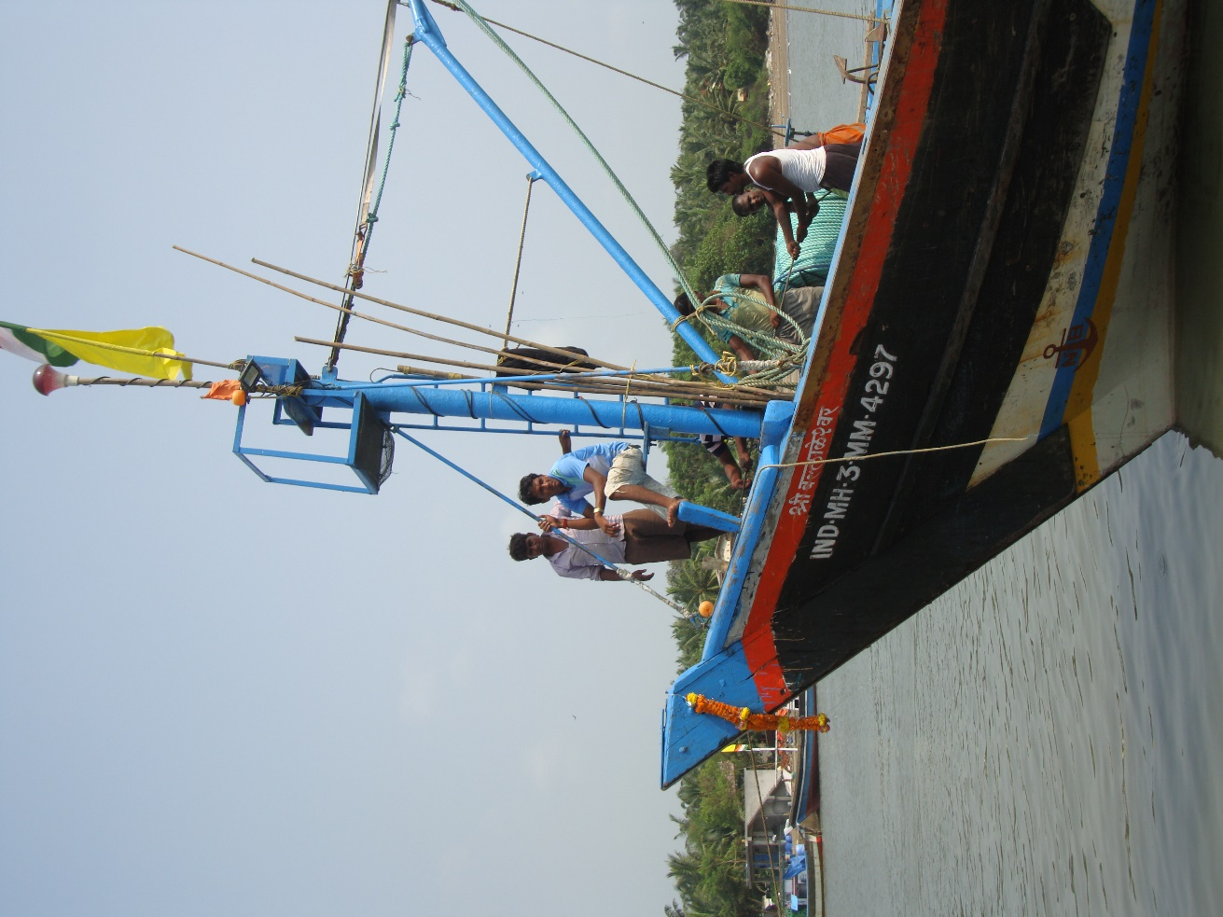

Insights
- The mobile app has empowered the fishers rather than regulated their practices
- Competition among the fishers makes practices fragile and complicates support for collaboration
- Design for sustainability requires a long-term, sociomaterial perspective

A Mobile App for Supporting Sustainable Fishing Practices in Alibaug

Morten Hertzum, University of Copenhagen, Denmark
Veerendra Veer Singh, Central Marine Fisheries Research Institute, India
Torkil Clemmensen, Copenhagen Business School, Denmark
Dineshkumar Singh, Tata Consultancy Services, India
Stefano Valtolina, University of Milan, Italy
José Abdelnour-Nocera, University of West London, UK
Xiangang Qin, Copenhagen Business School, Denmark

In the span of a few decades information and communication technology has transformed the way we work, interact, and comprehend our surroundings. Most of this transformation has been experienced in retrospect rather than planned ahead. Consequently it is difficult to design and introduce technology for sustaining existing sociomaterial networks because they may be as sensitive to the emergent side effects of the technology as to its intended effects. If the network is fragile, important to people’s livelihood or both then these difficulties call for caution. At the same time, technology is believed to hold the potential to improve many people’s lives, not least in developing countries. This double bind has spawned considerable research interest in the design and use of technology for developing countries [3, 6].
In coastal Indian villages, fishing provides jobs and income for nearly a million fishers. More than 60% of them are below the poverty line and earn less than USD 1000 a year; about one third of them are illiterate. Apart from the fishers, fishing also provides the livelihood for several million people in the processing and marketing of the landed fish. Every fishing trip incurs costs in terms of for example ice and diesel, but no guarantee of any catch. For the individual fishers this asymmetry increases their vulnerability to poverty. For fishing as a sector it means a substantial consumption of environment-unfriendly fossil fuel. In addition, the dynamic weather conditions at sea make fishing an unsafe profession. High wind speeds and large waves may not only damage equipment but also cause the fisher boats to go down.
Alibaug is a coastal fishery village and district headquarter in India. The district coastline stretches southward for about 220 kilometers from Mumbai in the north. Two of the authors have for a long time been involved in developing an app for supporting the local fishers in their work; the other authors visited Alibaug for a one-day fieldtrip in September 2017. The fieldtrip consisted of (a) a meeting with fishers and chairpersons of the fishery societies to be introduced to the app and the project, (b) five interviews with small groups of fishers to inquire about their use and experience of the app, (c) a visit to the landing center to see the fisher boats arrive to offload their catch, and (d) a final meeting at one of the fishery societies to hear about the sociomaterial organization of the fishery practices. Figure 1 shows the Alibaug landing center. The day after the fieldtrip we met for a workshop at the INTERACT conference in Mumbai to discuss our field data and reflect on our experiences.

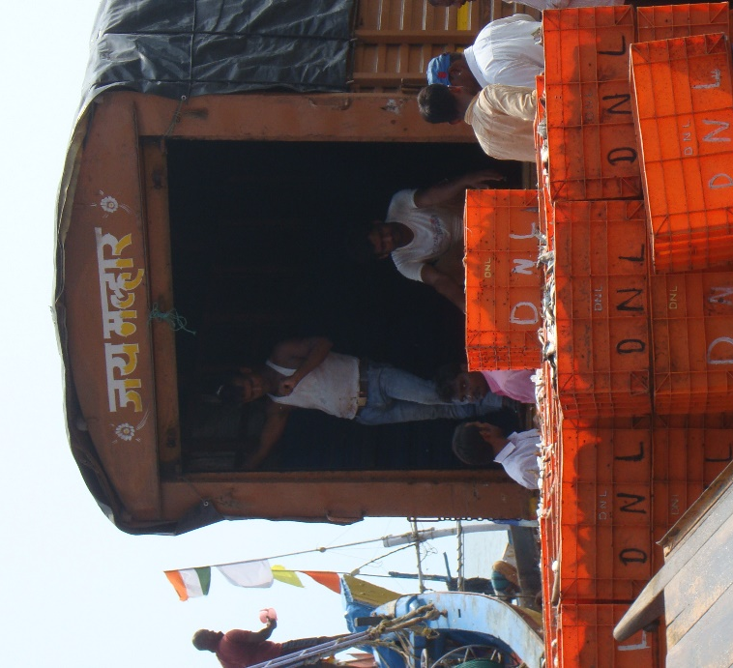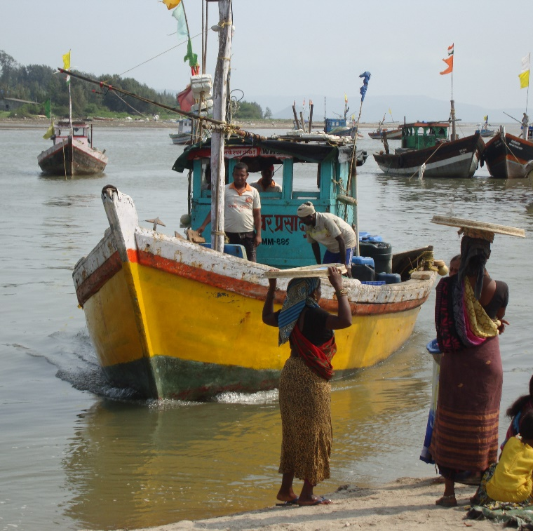
Figure 1. The landing center in Alibaug.

The mobile app
Almost 90% of the fisher families have mobile phones with basic features. On this basis it was decided to develop the app, called mKRISHI® Fisheries [4], for Android phones. Its development has been a decade-long collaboration between Tata Consultancy Services (TCS), Indian Council of Agricultural Research (ICAR), Central Marine Fisheries Research Institute (ICAR-CMFRI), Indian National Center for Ocean Information Services (INCOIS), and the local fishery societies in a consortium led by the Indian Agricultural Research Institute (ICAR-IARI).
While some of the big fishing boats have equipment such as sonars for locating fish, most of the fishers rely on their traditional knowledge and any leads provided by peer fishers. For them fishing is to a large extent trial and error. The app improves this situation by providing a map that shows the locations at which the concentration of fish is predicted to be high. The map is updated four times a day and four days in advance on the basis of satellite data about the sea surface temperature and the water color. For example, the water color gives an indication of the amount of plankton, which attracts fish because it is one of their crucial food sources. A large amount of plankton can, synchronized with thermal fronts, be used for predicting the location of fish. To refine and validate the prediction model the fishers have over a four-year period delivered data about their location and catch and these data have been compared with model predictions.
The second main feature of the app is weather forecasts, which specifically give the wave height, wind speed, and wind direction. Like the predictions of the location of fish, the weather forecasts are also derived from satellite data. Weather forecasts are particularly important because the area is frequented by tropical storms and many of the fisher boats are small and have little or no safety equipment. As late as the last storm two local fishers drowned. To make the information in the app easily perceivable it is presented graphically, see Figure 2. The graphic presentation reduces the need for reading skills. In addition, the project has organized training sessions to explain the content and use of the app.

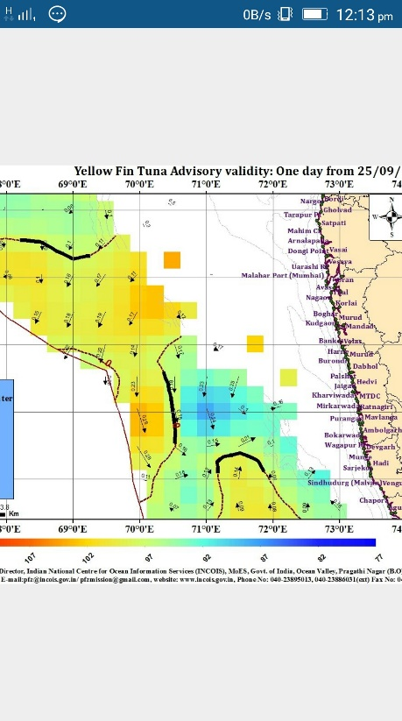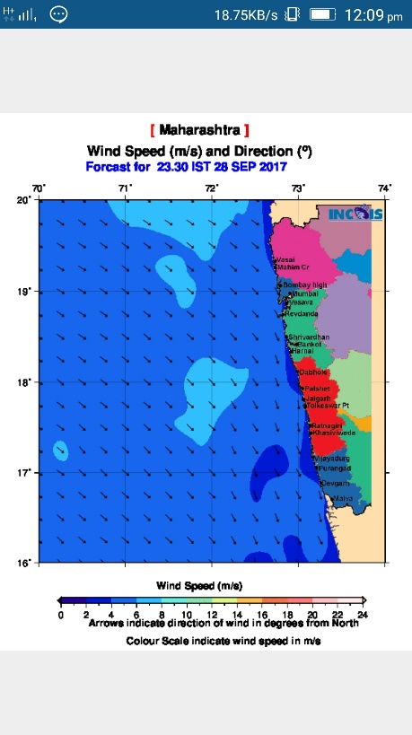

Figure 2. The mKRISHI® Fisheries app showing the map of the predicted location of fish (left) and the weather forecast with indicators of the speed and direction of the wind (right).

Making pertinent information openly available
During the interviews we asked the fishers about their understanding of the map with marks indicating the predicted location of fish. One interviewee explained that “you can go and catch fish everywhere but the marking shows: more fish here!” While the fishers had no conception of how the map was generated, they had first-hand experience with its predictions. On this basis they had a high degree of confidence in the map. That is, the map was perceived as a fairly accurate depiction of where to go to get a good catch. In this sense the app, which was free of charge, made pertinent information openly available. Previously, this information had not been available at all or merely as intuitions held by individual fishers, who would often keep such intuitions to themselves in order not to lose a good catch to someone else. The chairperson of the Alibaug fishery society considered the equal access to information a benefit; individual fishers may agree or disagree. With the app it is more likely that the fishers cluster at the same fishing locations. Thus, they have an increased need for coordinating who goes where. At the same time the app makes for individual practices because each fisher can access the map independently of the others.
By making the (predicted) location of fish openly available the app accentuates a tension between traditional fishers with boats for one-day trips close to the coast and industrial fishers with big boats for multi-day trips further away from the coast. The industrial fishers catch large quantities of fish at the most attractive locations on the map, which are often not reachable within one-day trips. These fish will not come close to the coast and, hence, there are fewer fish for the traditional fishers to catch. While the app merely brings out this tension, the project works to help regulate it in other ways. For example, TCS and ICAR-CMFRI have officials at the landing centers several days a month to monitor the amount of fish landed by traditional versus industrial fishers. This monitoring feeds into long-term efforts to support sustainable fishing practices.

Sustainable practices
The app itself also supports sustainable fishing practices. At a very concrete level its forecasts of the wave height and wind speed increase the fishers’ safety. One interviewee recounted a situation in which the fishers who had already set out were called back: “They think it was a loss because they had to come back without fish, but at least the boats were saved”. An additional 50 fishers never set out on that day, thereby adding to the savings in boats and, possibly, human lives. However, the interviewee’s statement also illustrates that not landing any fish was a considerable price to pay for the more sustainable practice of avoiding high-risk weather conditions.
Another important improvement in the sustainability of the fishing practices is that the fishers use less diesel after the introduction of the app. The reduced diesel consumption benefits the fishers economically and the environment ecologically. It has been possible to document this reduction for the Alibaug fishing community because the distribution of diesel is the responsibility of the local fishery societies, and they keep careful records. The reduced diesel consumption is tied to the app in two ways. First, it indicates that with the support of the map the fishers need to search less to find fish to catch. Second, the weather forecasts support the fishers in selecting routes with a favorable wind direction to balance the loaded boat and reduce drag on the way back to the landing centers on the coast. It is notable that the reduced diesel consumption has been obtained by providing the fishers with an improved overview [2] of the weather conditions and the location of fish. The fishers have been empowered rather than subjected to regulations and prohibitions.
Among the fishers, especially the traditional fishers, there is some concern that the amount of fish may be declining. A decline in the amount of fish would be critical to the fishers and, in turn, to the entire Alibaug society. The project has engaged this concern by working to produce data about the amount of fish. One source of the concern is that the traditional fishers get the experience of fewer fish because more fish are caught before they get close to the coast. The TCS and ICAR-CMFRI officials who monitor the amount of fish landed by traditional and industrial fishers contribute data about this issue. So far, the data produced by the project indicate that the amount of fish is unchanged but the number of fishers increasing. In so far as the app benefits the fishers, it probably contributes to attracting more people to this profession. It is somewhat of a dilemma that the app may make fishing a less sustainable way of making a living (by increasing competition about the fish) for the very reason that it is useful and usable.

Discussion
The project is more than the app. It includes a number of activities in addition to the app and extends over an extended period of time. This way, mKRISHI® Fisheries has infrastructural characteristics [5]: It is better characterized as a gradually evolving organism than as a product with fixed features. For example, the app has been shaped by the data fed back about the fishers’ actual catches at any given location and supplemented by the monitoring of the amount of fish landed by traditional and industrial fishers. In addition, the app has shaped fishing practices by reducing the trial and error needed to locate fish, by informing decisions about when it is unsafe to go fishing, and by improving the fishers’ route selection on returning to the landing centers. None of these changes have happened overnight. Rather, they have evolved – and continue to evolve – gradually through repeated interactions among fishers, fish, project members, satellite data, fishery societies, the app, and the various other components of the sociomaterial infrastructure. It is the long-term perspective and participatory approach of the project that enable it to support sustainable fishing practices. Unfortunately, longevity and participation are frequently mentioned as challenges for research into the design and use of technology for developing countries [3], for example because it conflicts with more fast-paced, detached approaches to research.
The project is also about more than individual use. While this is clearly reflected in the project at large, support for collaboration is notably absent in the app, which instead focuses on feeding information to the fishers. To some extent the absence of support for collaboration in the app reflects a belief that collaboration is better served by other components in the sociomaterial infrastructure. However, it may also reflect limited awareness of the needs and opportunities for collaboration support via the app. For example, when the fishers have secured their catch some of them phone peers on land to have them inquiry about the price of different fish at the nearby landing centers along the coastline. On a particular day a buyer may be interested in a particular kind of fish and therefore willing to pay extra for fresh fish of this kind. Consequently, it has been proposed to extend the app with information about the price at which different fish can currently be sold at the different landing centers. Such information could evolve into directly collaborative features. At the workshop on the day after the fieldtrip it was for example proposed to turn information about fish prices into a facility for buyers to order fish of a particular kind.
Increased support for collaboration should, however, be assessed relative to other design decisions and requirements. For example, the maps with the predicted location of fish are images that are downloaded on the phone when it is online. Thereby, the maps are also available to the fishers when they do not have internet access because they are too far from the coast or because they cannot afford to be online continuously. Designing for offline use has been key to making the app a sustainable option for the fishers. This design requirement probably shifts support for collaboration from the app toward the other components of the sociomaterial infrastructure, at least until the fishers have internet access throughout their fishing trips. Currently, when fishers lose internet access due to their distance from the coast, they rely on radio communication with peers on, or closer to, the coast for information about changes in the app information. Designing for offline use also shows the importance of integrating interaction design with human work interaction design [1]. The fishery societies are central to the human work interaction design because they are an important collaborative component in the sociomaterial infrastructure. At present, the interaction design of the app makes more information available to the fishers independently of the fishery societies. In the further evolution of the project it might be considered to supplement the app with shared, stationary, whiteboard-like devices, which in addition to providing information also create a physical place to meet for collaborative and coordinative purposes. Sustainable fishing practices are just as much about such social issues as about environmental issues.

Acknowledgements
We are grateful to the fishers for their readiness to participate in meetings and interviews during our fieldtrip to Alibaug. The screenshots of the mKRISHI® Fisheries app are reproduced with the courtesy of TCS, ICAR, ICAR-CMFRI, and INCOIS.

References
[1] Abdelnour-Nocera, J. and Clemmensen, T. 2018. Sociotechnical HCI for ethical value exchange. In Global Thoughts, Local Designs - Revised, Selected Papers from IFIP TC 13 Workshops at INTERACT2017. LNCS 10774. Springer.
[2] Hertzum, M. 2018. Looking for "the big picture" on a small screen: A note on overview support in cooperative work. In Global Thoughts, Local Designs - Revised, Selected Papers from IFIP TC 13 Workshops at INTERACT2017. LNCS 10774. Springer.
[3] Ho, M. R., Smyth, T. N., Kam, M. and Dearden, A. 2009. Human-computer interaction for development: The past, present, and future. Information Technologies and International Development 5, 4: 1-18.
[4] Singh, D., Kimbahune, S. and Singh, V. V. 2016. Mobile signal extension in deep sea - Towards a safe and sustainable fisheries. In Proceedings of the ITU Kaleidoscope: ICTs for a Sustainable World. IEEE, 1-8.
[5] Star, S. L. and Ruhleder, K. 1996. Steps toward an ecology of infrastructure: Design and access for large information spaces. Information Systems Research 7, 1: 111-134.
[6] Toyama, K. 2010. Human-computer interaction and global development. Foundations and Trends in Human-Computer Interaction 4, 1: 1-79.

