Addressing Sociotechnical Gaps in the Design and Deployment of Digital Resources in Rural Kenya

Jose Abdelnour Nocera
School of Computing and Technology
University of West London
United Kingdom
jose.abdelnour-nocera@uwl.ac.uk

Souleymane Camara
School of Computing and Technology
University of West London
United Kingdom
souleymane.camara@uwl.ac.uk

ABSTRACT
We argue that designing any aspect of information technology requires an understanding of sociotechnical gaps. These gaps are inherent issues deriving from the difference between what is required socially, or culturally, and what can be done technically. In the context of a British-Kenyan project, we introduce an approach for addressing sociotechnical gaps in the design and deployment of digital resources in resource-constrained and culturally different environments. We illustrate how despite having an online, asynchronous tool to visualise sociotechnical gaps among different stakeholders in a design team, we had to complement it with a pen and paper design metaphor elucidation exercise to elicit and visualise locally meaningful user interface elements.
Categories and Subject Descriptors
H.1.2 [User/Machine Systems]: human factors, Human information processing
General Terms
Design, Human Factors, Theory.
Keywords
sociotechnical, participatory design, culture.

INTRODUCTION
The translation of social insights and knowledge requirements into design decisions for a digital resource is not a simple problem. At times, this requires a redefinition of disciplinary boundaries and a consideration for the actual end-users’ own context and interpretation of the medium of communication. In this paper we discuss one approach to translate these design decisions by exposing and visualising the disciplinary and cultural gaps of the different stakeholders involved in the design and deployment of digital resources in rural Kenya.
We have in previous papers [3, 4] discussed and proposed how to effectively capture and manage stakeholders’ assumptions, sensitivities, knowledge, expectations and agendas vis-a-vis a system design process. We argued and demonstrated using the sociotechnical evaluation matrix (STEM) that this requires an understanding of the inherent sociotechnical issues deriving from the difference between what is required socially, or culturally, and what can be done technically. This is what Ackerman identifies as the sociotechnical gap [1]. It is therefore in the designers’ best interest to make those gaps visible and harmonised for a dependable and fit for purpose system.
STEM was an online and asynchronous design collaboration tool that enabled the visualisation of gaps among geographically scattered researchers situated in different disciplines and countries. Even though this online tool was fed with rich local data from the context of use, and a few end-user proxies were able to collaborate in this space, it was not suitable to discuss requirements and knowledge metaphors required for the design of lower level user interface elements. In this paper we go a step further to present an approach that extended and complemented STEM in order to obtain a better grounded understanding of design components at user interface level.
The approach consisted of a design metaphor elucidation exercise to visually expose cultural differences and boundaries in a multidisciplinary research-led design project. Before introducing this approach, we describe the background in which this was applied, followed by an outline of the rationale underpinning the design exercise.
Permission to make digital or hard copies of all or part of this work for personal or classroom use is granted without fee provided that copies are not made or distributed for profit or commercial advantage and that copies bear this notice and the full citation on the first page. Copyrights for components of this work owned by others than ACM must be honored. Abstracting with credit is permitted. To copy otherwise, or republish, to post on servers or to redistribute to lists, requires prior specific permission and/or a fee. Request permissions from Permissions@acm.org. SIGDOC '15, July 16 - 17, 2015, Limerick, Ireland © 2015 ACM. ISBN 978-1-4503-3648-2/15/07…$15.00 DOI: http://dx.doi.org/10.1145/2775441.2775459.

BACKGROUND
Like STEM, this research is based on the Village eScience for Life project (VeSeL). VeSeL was a multi-disciplinary project involving five UK universities plus one local institution in Kenya (ground of research), with specialists in education, human computer interaction, power engineering, computing, communication technologies and agriculture [3]. The objective was to explore the use of ICT by bringing it to groups of rural farmers in Kenya in order to promote e-Science and provide local communities with access to information to improve the profitability of their farm produce and thus their quality of life.
Two communities self-help groups in rural Kenya (Kiangwaci and Kambu) were our end-users. A primary school was also identified in each community as a potential hub for the ICT solutions and to help improve education.
As in any ICT project even in the developed world, its success is dependent on the processes and the nature of participation of all stakeholders - including the end-users -[7, 11]. Acceptance, adoption and use of ICT in sub-Saharan Africa are not any different and have been held back by a number of socio-economic conditions and methodological approaches employed. This is further exacerbated by the need for connectivity, low-cost devices, power and appropriate user interfaces.
The solutions proposed by VeSeL consisted of a community digital resource kit: digital cameras, laptop and desktop computers, solar panels and chargers and instruction manuals (see Figure 1). Later on, more elaborate solutions were also developed including climate and soil sensors for farmers.
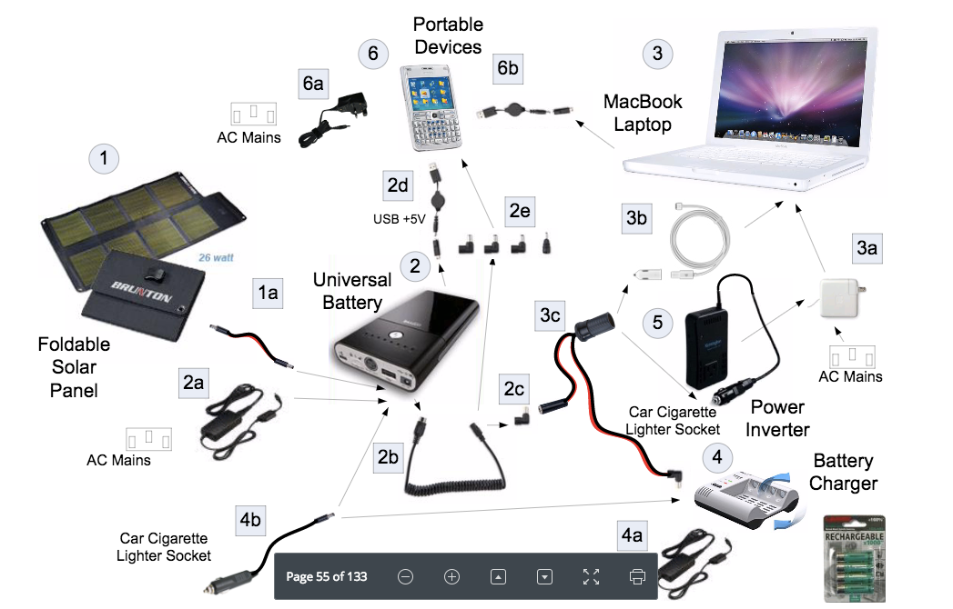
After several research and design field-visits to the rural communities, it became clear that the initial ICT solutions proposed were not all easily adopted. ‘Western’ solutions and specifically their interfaces were not fully understood and therefore could not be easily internalised to the context in situ.
Figure 1. Community digital resource kit

RATIONALE FOR A DESIGN METHAPHOR EXERCISE
The appropriateness of user interfaces and, at times, the language metaphors used in digital technology were not always assimilated and limited end-users from effectively using the solutions.
Researchers demonstrated how to use the resource kit, such as the digital camera and the charging devices. These were then handed to end-users and subsequently left behind. As we observed users attitudes and natural behaviour towards the technology, we intentionally limited interventions to simply answering their questions around these devices (see Figure 2 and 3).
For example, once shown and left with the camera to take pictures of whatever they liked, users often came back to the researcher as soon as the camera went to a power saving mode – when the backlight goes off after a period of inactivity – as this is something they had not been shown before. Interface icons and on camera instructions were not immediately interpreted or understood. The long-term goal was for technologies associated with this kit to be used by the communities as they designed and updated their own digital content management system (CMS).
We also supplied instruction sheets as a reference to help them use the kit. But these were all initially referred to with no success in helping them troubleshoot problems they encountered. When probed, most users in both communities said that these instructions were not easy to understand. Therefore, they have only used what they know or what they have been shown.
We observed that most of the questions around the devices could be described as ‘trivial’ given the fact that they all related to basic functionalities and interpretations. The most common questions included:
- How do I start recording?
- How do I see/find what is there/what I have done?
- How do I start/finish/stop?
- How do I know it is charged?
The authors have for long been contributing to make explicit these issues in ICT design by proposing STEM [4]. However, to effectively design interfaces and information to make them easily digestible and relevant requires giving the driving seat to end-users in this context. We therefore, envisaged a design metaphor elucidation exercise. How would end-users describe or interpret concepts and functionalities of digital technologies in their own world? How can we use this knowledge in the initial design of the CMS?
There is no lack of theoretical thinking to explore paradigms information system (IS) design (e.g. [6]). What is missing is the practicality of addressing the many issues in a sociotechnical participatory design (PD) setting. Many researchers and practitioners have already acknowledged the process of design is filled with this type of gaps and the challenges that they bring [2, 5].

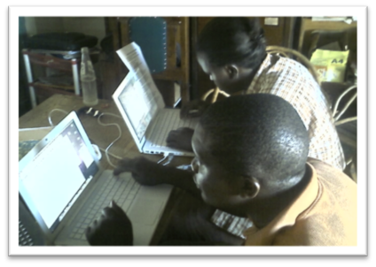
Figure 2. Silanga primary school teachers using laptops

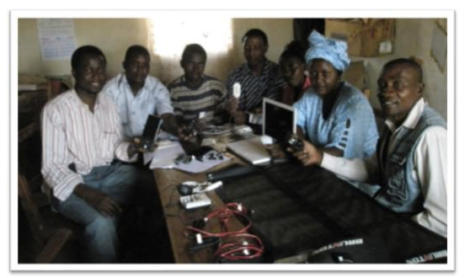
Figure 3. Digital resource kit handover
We employed design metaphors as an approach to addressing these issues in technology adoption in the VeSeL context. Thinking like the end-user and immersing the design into their own context can help solve issues of communication and understand of a design. Metaphors “can be used as a research tool, to understand new subject areas, or as means to generate new ideas about familiar subjects. Metaphors can provide cues to users how to understand products: to orient and personify” [12]
We therefore, set out to engage the rural communities in exploring their own understanding and interpretation of generic key concepts and terminologies found in current digital interfaces.
In order to design and communicate user interfaces and instructions that are easy to use by simple recognition rather than recall, we needed to identify key metaphors that users are familiar with. For instance, a red traffic light means stop; Green means go ahead. But does someone who has never seen a traffic light understand this?
Some design metaphors are not easily understood if they are not part of your everyday life or objects. For instance, the icons based on metaphorical representations of the physical office (see Figure 4) are not obvious to all our end-users in culturally different settings, especially if there are non-urban where the effect of local or national culture is stronger [8].
Not everyone will recognise the save button if you have never used a floppy disk. Even the print button/icon is not that obvious for someone who has not seen a printer before or is only familiar with one type of printer.
Figure 4. Office ‘save’ and ‘print’ icons

THE DESIGN METAPHOR EXERCISE
Each community was asked to represent a number of key concepts and terminologies found in ICT interfaces. This exercise was conducted only with those community members who had had exposure to the resource kit. Both in Kiangwaci and in Kambu we identified a group of primary school teachers (5 to 6 per group) and invited them into a design workshop.
Prior to the workshop, researchers identified 30 interface design concepts and instructions mostly related to the resource kit provided. These were also common concepts found on standard user interfaces (computer, mobile phone, petrol station machine, etc.).
Concepts were presented on a worksheet to capture both end-users own words and design concepts based on their own environment, culture and interpretation (see a sample in Table 1).
Table 1. Data collection template for metaphors
Concept/Instruction | How would you represent it? | Describe in your own words what this means to you
Start
To indicate the beginning of a process (where to start from). Or to start a program/application such as Word.
Open
To open an existing file or document.
Close
To close a file or document that is opened. Or to close window or anything that is open in front of you
Save
To save or keep in good hand a document or file you have created or changed. To keep track of the modifications or new document/file so that when you access it next time, it remembers your changes.
Quit or Exit
To leave a program or application you have been using or is currently open in front of you. For instance, when you finish typing in Word, you may want to quit it and go to the Email program.
Error or Problem
To indicate that there is a problem or that something is wrong with whatever you are doing so that you can pay attention to it.
Cancel
To indicate or confirm that you have changed your mind and don’t want to do the action requested.
Finish
To confirm that you have finished with a process or an action.

We then instructed the group to discuss and identify an image, an object or an idea that could represent each of these concepts. We also added that the aim was to come up with something that most represent these actions for them and for others in the community.
It was important that we let the group come up with ideas by themselves. We therefore added that they may make drawings, or reference to any objects they feel better describe the actions. The group was also asked to write down their description and/or take picture of the objects or drawings they come up with.
We furthermore added that, it was not necessary to have an image for each concept if they cannot draw or access the object they are thinking of. In these instances a good description will suffice. Also, if some of these concepts mean the same thing to them, we did allow them to indicate so.

THE RESULTS
As researchers, we were astounded by what we discovered. Not only that many of the concepts were represented and described differently; they also revealed further and significant meanings of their environment, culture and frames of interpretation.
For example, the concept of “Finish” (to confirm that you have finished with a process or an action) was represented by someone reaching the finish line in a running race.
If we allow an element of interpretation and extrapolate this idea, we will find it fully justified and fitting. Kenya is one of the world’s biggest champions in long distance running. They are proud of that and runners here hare heroes. Therefore, most communities would know what a finish line might suggest.
Another example was the concept of private. Whilst in one community, Kambu, this was represented by underwear, Kiangwaci community chose a fence around a private land. We might not be too surprised by their understanding. In Kiangwaci, land ownership is very important and valuable. Everyone field is clearly delimitated from one another. In Kambu, this is the opposite. They own vast lands yet dry and difficult to farm. What is interesting however, is the communities’ understanding of what is ‘private’ – something belonging to someone.
Below is sample of the findings (Figure 5 and 6).
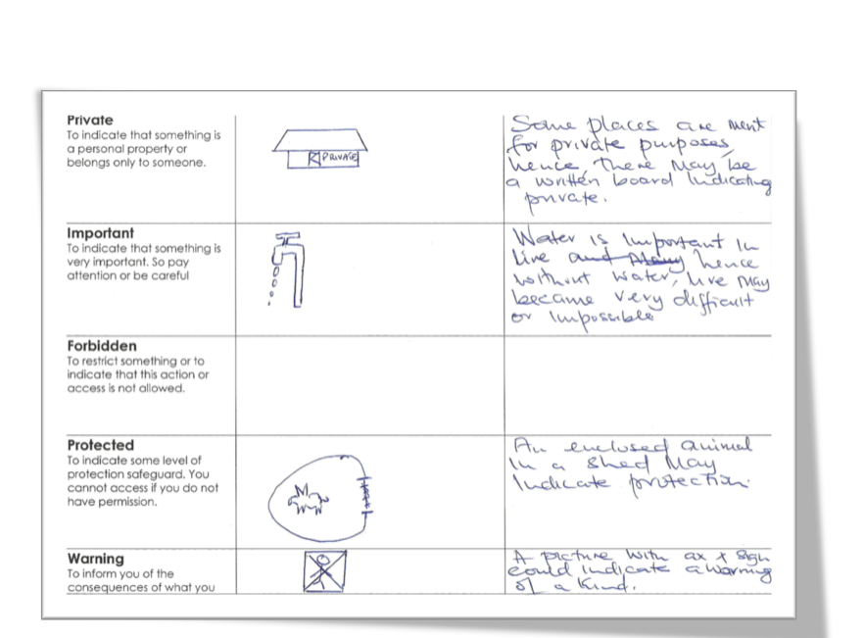
Figure 5. Worksheet from Kiangwachi
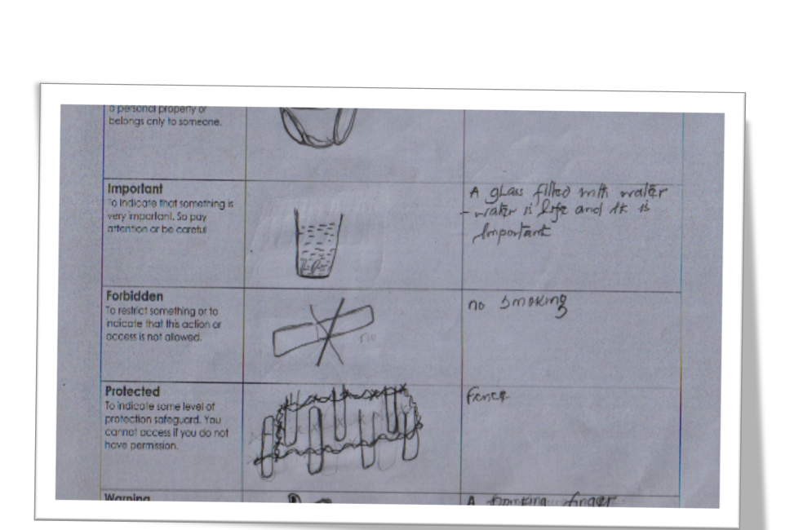
Figure 6. Worksheet from Kambu

These results allowed us to refine our thinking in communicating and designing for our end-users. The team started to organise more workshops each time we were to introduce a new ICT. We also created a working group to help rewrite instructions for the kit and validate it with other community members.

CONCLUSIONS
Unlike other approaches in team work such as the Issue-Based Information System, Collaboration Usability Analysis [10] or Immersive Environments [9], STEM focused on the validity of design decisions and on turning information provided by team members into rich design knowledge via a sociotechnical discussion framed around agreed-upon criteria. But once this knowledge is exposed, we needed a further step in acting on the findings, hence the metaphor exercise reported in this paper. In other words, while we have shown before how STEM visualised the sociotechnical gaps among design stakeholders [4], in this paper we show how we addressed the gap between STEM, as an online design collaboration tool, and the farming communities served by VeSeL.
Our approach to addressing the disciplinary and cultural gaps of different stakeholders involved in the design and use of digital resources has been based on an immersive engagement with end-users. We seek to clearly visualise or depict what end-users understand from what we design – how we communicate design.
It is important to note that despite the fully digital, online and asynchronous text based nature of the interactions of the VeSeL team through STEM, there was always a strong need to maintain face-to-face interactions with the farming communities, who are mostly offline and driven by visual and oral synchronous communication. In this way, we were able to uncover interface design gaps not visible in STEM.
It is feasible that this approach can be valuably applied to different design contexts that require a systematic approach to the processes or contexts similar to that of VeSeL.

REFERENCES
[1] Ackerman, M. 2000. The intellectual challenge of CSCW: the gap between social requirements and technical feasibility. Hum.-Comput. Interact. 15, 2 (2000), 179–203.
[2] Bergvall-Kåreborn, B. et al. 2014. Disregarding History: Contemporary IS Contexts and Participatory Design. Communications of the Association for Information Systems (CAIS). (2014).
[3] Camara, S. et al. 2010. Augmenting Usability: Cultural Elicitation in HCI. Human Work Interaction Design: Usability in Social, Cultural and Organizational Contexts. IFIP AICT Springer. 46–56.
[4] Camara, S. and Abdelnour-Nocera, J. 2013. Revealing the Socio-Technical Context of Design Settings: Toward Participatory IS Design. International Journal of Human-Computer Interaction. 29, 4 (Mar. 2013), 289–307.
[5] Coiera, E. 2007. Putting the technical back into socio-technical systems research. International Journal of Medical Informatics. 76, (Jun. 2007), S98–S103.
[6] Hirschheim, R. and Klein, H.K. 1989. Four paradigms of information systems development. Communications of the ACM. 32, 10 (1989), 1199 – 1216.
[7] Oostveen, A. and van den Besselaar, P. 2004. From Small Scale to Large Scale User Participation. Participatory Design Conference (Toronto, Canada, 2004).
[8] Oyugi, C. et al. 2014. Harambee: a novel usability evaluation method for low-end users in Kenya. Proceedings of the 8th Nordic Conference on Human-Computer Interaction: Fun, Fast, Foundational (2014), 179–188.
[9] Paranto, S. 2002. Using the Web As a Collaborative Tool. J. Comput. Sci. Coll. 18, 1 (Oct. 2002), 154–162.
[10] Pinelle, D. et al. 2003. Task analysis for groupware usability evaluation: Modeling shared-workspace tasks with the mechanics of collaboration. ACM Transactions on Computer-Human Interaction. 10, 4 (Dec. 2003), 281–311.
[11] Puri, S.K. et al. 2004. Contextuality of participation in IS design: a developing country perspective. Proceedings of the eighth conference on Participatory design (2004), 42–52.
[12] Saffer, D. 2005. The role of metaphor in interaction design. Carnegie Mellon University.

