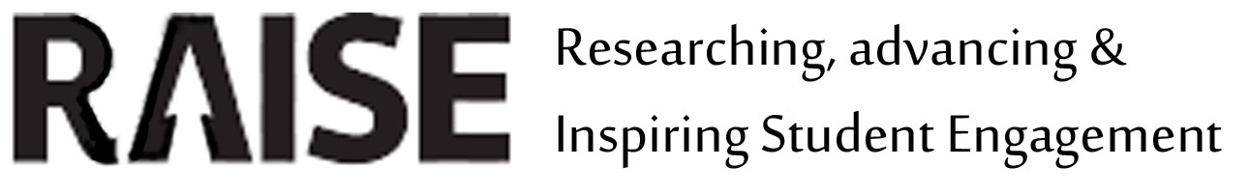
RAISE Conference 2014

Student engagement for all:

Staff, Students and Community
Manchester Met University, 11th-12th September

Proposal Form (workshop)
Please attach and submit by email to grace.barker@newcastle.ac.uk
By March 28th 2014
Please refer to the Guidance for proposals document
Name of presenter: Ingrid Kanuga (lead) assisted by Zabin Visram (peer) and Rakesh Pendre
Institution: University of West London
Address for correspondence: Room H210, St Mary’s Road
Tel: 0208 231 2357 E-mail: Ingrid.Kanuga@wl.ac.uk
Title of workshop:
An interactive staff development workshop on engaging international students with different methods of feedback
Statement of link to conference theme:
(including which conference theme you are submitting under)

Conference Theme: Community.

We all belong to the same community where both students and staff can improve practices from effective feedback methods. Just like students need feedback on their academic progression, lecturers need feedback on how best to provide this in a way that students are engaged.

This workshop allows both students and staff to engage in a discussion on how best to provide formative and summative feedback for international students, which platforms and methods work best from the student perspective and what can we do to improve our level of engagement.

Session Description (300 words maximum, not including references if used. For conference Programme):

In recent years we have piloted and then adapted our learning, teaching and assessment methods to the needs of the international students. As these methods have become more diverse, so have our methods of giving feedback. Our students receive formative and final feedback through different forms and media (in person, in group discussions, written on turnitin or pebblepad, written on paper, peer feedback, mentor feedback, voice recorded).

Influential behaviourist theories have argued that feedback is a strong external stimulus which influences both positive and negative behaviour (Skinner, 1968). Handley et.al (2010) argue that although the learner may not always recognise the benefits of feedback; they are in the best position to evaluate the effectiveness of feedback.

International students are especially dependent on feedback as they have come from different teaching methods and assessment structures and have a need to identify if they are on the right track and if not, what steps to take to get there (Andrade, 2006; HEA, 2010; Kingston and Forland, 2008).

The aim of this practice exchange is to evoke debate on how effective the different forms of feedback are or the international students; if it helps them to achieve higher results and if there are ways we can improve our methods.

Session Outline (200 words maximum) Please include an indication of how the session will be structured (and timings). Activities and discussion time are essential criteria for a workshop:

To initiate the discussion; participants will be presented with the results of a survey completed by 40 international students on a graduate diploma course which asked them to reflect on the effectiveness of the various types of feedback received from lecturers.
The delegates will then be divided into equal groups and will be joined by a student mentor; a student who has progressed from the course and is now a mentor to the current students on the course, and by one of workshop host. Each group will discuss a different survey outcome and present back for further discussion to all delegates.

Summary (50 words maximum for the online Programme):
This workshop allows both students and staff to engage in a discussion on how best to provide formative and summative feedback for international students, which platforms and methods work best from the student perspective and what can we do to improve our level of engagement.

Biography (50 words total maximum for conference programme):
Andrade, M. S. (2006). "International students in English-speaking universities: adjustment factors." Journal of Research in International Education, no. 5 Pg. 131-154.
Higher Edcucation Academy (2010) Assessment and Feedback. Available at: http://www.heacademy.ac.uk/resources/detail/internationalisation/ISL_Assessment_and_Feedback (accessed 02/03/2013).
Kingston, E. and H. Forland (2008). "Bridging the Gap in Expectations between International Students and Academic Staff." Journal of Studies in International Education, no. 12. Pg., 204-221.
Skinner, B.F. 1968. The technology of teaching. New York: Appleton-Century-Crofts.

IT or audio-visual requirements:
Data projectors are standard, but if you require a flip chart then please indicate.

Flip chart paper and pens

Criteria for acceptance of proposals
Each proposal will be reviewed for acceptance at the conference against the following criteria:
-Relevance to the conference title and themes
-Clarity and coherence of the proposal
-Contribution to scholarship and evaluation of student engagement in further and higher education
-Clear opportunities for participants to actively engage in the session, and particularly in workshops to reflect on transferability to their own practice

Data Protection
All the information you supply on this form will be stored in paper and/or electronic format for the purposes of conference administration. Additionally, speaker biographies and summaries of sessions/posters will be published in delegate packs and on the RAISE website.

