Enhancing Community Resilience in Arid Regions: A Smart Framework for Flash Flood Risk Assessment
Mahdi Nakhaei¹, Pouria Nakhaei ², Mohammad Gheibi^{3,5}, Benyamin Chahkandi⁴, Stanisław Wacławek⁵, Kourosh Behzadian^{6,7}, Luiza C Campos^{7*} Albert S Chen⁸
¹Department of Environmental Engineering, College of Engineering, University of Tehran, Tehran, Iran
Email: mahdi.nakhaee@ut.ac.ir ORCID: 0000-0003-2205-3149
²Department of Hydraulic Engineering, Tsinghua University, 100084, Beijing, China
Email: p.nakhaei@yahoo.com ORCID: 0000-0002-9219-8178
³Association of Talent under Liberty in Technology (TULTECH), 10615 Tallinn, Estonia

Email: mohamadgheibi@ymail.com ORCID: 0000-0003-1987-5790
⁴School of Civil Engineering, University of Tehran, Tehran, Iran
Email: beniaminch@gmail.com
⁵Institute for Nanomaterials, Advanced Technologies and Innovation, Technical University of Liberec, Studentská 1402/2, 461 17, Liberec 1, Czech Republic
Email: stanislaw.waclawek@tul.cz ORCID: 0000-0002-8430-8269
⁶School of Computing and Engineering, University of West London, London, W5 5RF, UK
Email: kourosh.behzadian@uwl.ac.uk ORCID: 0000-0002-1459-8408
⁷Department of Civil, Environmental and Geomatic Engineering, University College London, Gower St, London WC1E 6BT, UK Email: l.campos@ucl.ac.uk ORCID: 0000-0002-2714-7358 (Corresponding author)
⁸Centre for Water Systems, Faculty of Environment, Science and Economy, University of Exeter, Exeter, EX4 4QF, UK, Email: A.S.Chen@exeter.ac.uk ORCID: 0000-0002-0953-3992

Abstract
This paper presents a novel framework for smart integrated risk management in arid regions. The framework combines flash flood modelling, statistical methods, artificial intelligence (AI), geographic evaluations, risk analysis, and decision-making modules to enhance community resilience. Flash flood is simulated by using Watershed Modelling System (WMS). Statistical methods are also used to trim outlier data from physical systems and climatic data. Furthermore, three AI methods, including Support Vector Machine (SVM), Artificial Neural Network (ANN), and Nearest Neighbours Classification (NNC), are used to predict and classify flash flood occurrences. Geographic Information System (GIS) is also utilised to assess potential risks in vulnerable regions, together with Failure Mode and Effects Analysis (FMEA) and Hazard and Operability Study (HAZOP) methods. The decision-making module employs the Classic Delphi technique to classify the appropriate solutions for flood risk control. The methodology is demonstrated by its application to the real case study of the Khosf region in Iran, which suffers from both drought and severe floods simultaneously, exacerbated by recent climate changes. The results show high Coefficient of determination (R²) scores for the three AI methods, with SVM at 0.88, ANN at 0.79, and NNC at 0.89. FMEA results indicate that over 50% of scenarios are at high flood risk, while HAZOP indicates 30% of scenarios with the same risk rate. Additionally, peak flows of over 24 m³/s are considered flood occurrences that can cause financial damage in all scenarios and risk techniques of the case study. Finally, our research findings indicate a practical decision support system that is compatible with sustainable development concepts and can enhance community resilience in arid regions.
Keywords: Artificial Intelligence; Classic Delphi method; Flash flood; Risk Assessment; Watershed Modelling.

Introduction
Natural disasters, such as floods, often lead to devastating impacts on people and the environment. According to the Internal Displacement Monitoring Centre (IDMC) report, natural disasters have caused an average of 20 million people to be displaced worldwide between 2008 and 2019, with the most significant displacement occurring in 2010 when more than 40 million people were affected by weather and geophysical disasters (Statista.com). Besides, the Centre for Research on the Epidemiology of Disasters (CRED) reports that countries such as Indonesia, the United States, and China have experienced the most natural disasters in 2020, with Iran and Mexico ranking eighth in the number of disaster occurrences (Statista.com). In 2020, the highest flood damage costs occurred in China, India, Japan, and Pakistan, with estimated losses amounting to 32, 10, 9, and 2 billion U.S. dollars, respectively, according to the India Spend report (Statista.com). Sustainable smart flood management is essential for addressing the risks and impacts of flooding. It involves integrating advanced technologies, data analytics, and real-time monitoring systems to make informed decisions and optimize resources. Nature-based solutions such as wetland restoration, green infrastructure, and floodplain zoning are prioritized, providing flood protection and additional benefits like improved water quality and biodiversity. Engaging communities and adopting participatory approaches empower residents to contribute to flood prevention and preparedness. By embracing sustainable smart practices, it can be addressed climate change challenges, reduce risks, and create resilient communities in flood-prone areas (Hu et al., 2018; Chao et al., 2018; Liu et al., 2021). According to statistical data, there is a pressing need for smart and sustainable approaches to control flood disasters in Asia.
Flash floods are a common type of disaster that can have devastating consequences, particularly in arid regions. Iran, in particular, has been facing severe drought and flash floods, with a significant increase in their frequency, intensity, and impacts due to climate change in recent years. Traditional methods for assessing flood risk typically rely on historical data and statistical approaches, which are insufficient for predicting and managing flood risks in the face of the current climate crisis.
Flooding is one of the most significant challenges faced by human civilisation, and its impact is expected to worsen due to climate change and rapid urbanisation. Changes in vegetation, temperature, and rainfall patterns have resulted in unpredictable flood behaviour (Mahato et al., 2021), making flood forecasting, particularly in real-time applications, a subject of widespread attention globally (Piadeh et al., 2022). Developing a reliable prediction model with practical capabilities is an optimistic goal (Wasko et al., 2021). However, the lack of historical data on extreme flash floods, which are becoming more common due to climate change and typically occur in modern cities, is a major obstacle to effective flood management (Islam et al., 2021). Recent flash floods have been sudden, unpredictable, and highly destructive (Talukdar et al., 2020), and the scales are beyond the range of historical records that conventional statistical approaches will not be able to predict such extreme events. Therefore, flood management frameworks need to include hydrologic models and intelligent prediction systems to address the possibility of future flash floods (Arora et al., 2021). Geographic Information System (GIS), Watershed Modelling System (WMS), Artificial Intelligence (AI), and other contemporary tools are often used individually in scientific studies related to flood risk management (Hashim and Sayl 2021). It is crucial to develop a comprehensive framework that integrates these tools to achieve effective flood risk assessment and management in arid regions (Karami et al. 2022).
In recent times, the well-being of society has been threatened by a range of hazards, including natural disasters, particularly floods. From 1998 to 2017, floods were found to be the most harmful climate-related disaster to humans, with a significant amount of attention being given to the severity of the matter, leading to the creation of various flood management approaches (Wallemacq and House, 2018). Among these, Artificial Intelligence (AI) has emerged as the flagship technology in flood management and prediction techniques, with several experts highlighting its potential (Goyal et al., 2021). For instance, Wang (2021) introduced AI as a tool that enhances the ability to observe flood behaviour, while Liu et al. (2021) proposed a comprehensive flood management schedule that addresses the crisis from beginning to end. Moreover, many scientists have explored the prediction capabilities of AI, such as Kunverji et al. (2021), who used three algorithms, including Decision Tree, Random Forest, and Gradient Boost, to develop an early warning system. Zalnezhad et al., (2022) used three different Neuro-fuzzy Inference System (ANFIS) to conduct regional flood frequency analysis for ungauged catchments in Australia. Also, Zabihi et al., (2023) employed a smart decision support system to propose a unique framework for flood management in three steps i.e., monitoring, prediction and control the flood. Fig. 1 provides an overview of the methods and tools used in AI and flood management to illustrate their relationship between the years 2019-2021.
While AI has been a popular method recently for flood risk management, other tools such as GIS and WMS are also utilised in this field. For instance, Ertan and Çelik (2021) employed GIS to examine the impact of urbanisation on floods in the context of climate change. Similarly, Mourato et al. (2021) proposed a Web-GIS system that incorporates rainfall, hydraulic, and hydrologic models for flood warning and forecasting. This system is capable of updating itself every six hours and provides a prediction of potential floods. Additionally, GIS can be combined with other decision-making concepts such as multi-criteria decision analysis, as demonstrated by Hosseinzadeh et al. (2023), to identified flood management solutions based on several sustainability criteria. WMS is also utilised in modelling flash floods worldwide by various experts (Abd El Shafy and Mostafa, 2021).
Fig. 1. An overview of the methods and approaches of AI in flood management between 2019 and 2021

A plethora of flood management tools such as AI, GIS, and WMS have been used for flood prediction and modelling, as mentioned in the literature (Feng et al., 2021). While these methods have proven to be effective, a knowledge gap has been identified in their implementation individually without considering climate and land changes in the lead-up to flooding (Avand and Moradi, 2021). Therefore, a comprehensive flood management system should integrate the three main components of Flood Modelling and Simulation, Flood Prediction and Flood Risk Assessment and Management. To fill this gap, the research aims to develop a framework that integrates various methods, including flood simulation modelling, statistical methods, AI, geographic evaluations, and decision-making modules, to enhance community resilience and reduce the negative impacts of flash floods in arid regions. The proposed framework will be applied to a real case study in the Khosf region of Iran to demonstrate its practicality and effectiveness in addressing flash flood risks. The abovementioned three components of the flood framework will be described and analysed in the following sections.

Flood modelling and simulation
Fig. 2 shows a schematic of the flood modelling and simulation research area, divided into four time periods: before 2006, 2006-2010, 2010-2021, and 2022. Prior to 2006, early studies mainly focused on 1D and 2D flood simulations, as evidenced by works such as O'Brien et al. (1993), Hailea and Rientjes (2005), Lin et al. (2006); and Stelling and Verwey (2006). Applicable software for flood simulation was also developed between 2006 and 2010, with platforms such as ArcGIS, LISFLOOD, and others utilized for estimation purposes in studies by Begnudelli et al. (2008), Knijff et al. (2008), Luino et al. (2009), and Pistrika et al. (2010). From 2010 to 2021, research increasingly utilized the integration of 1D/2D programming and professional platforms, as seen in studies by Hu et al. (2018), Chao et al. (2018), Liu et al. (2021); and Jadouane and Chaouki (2021). More recently, flood simulation and modelling have been enhanced through the application of metaheuristic algorithms and machine learning computations in works by Sedighkia and Datta (2022), Zhou et al. (2022), Quintana-Romero et al. (2022) and Wand et al. (2022). More recently, Liu et al., (2023) used a model to simulate the waterlogging process for flat irrigation districts in the paddy fields to predict floods in various scenarios. Moreover, Chen et al., (2023) presented a new approach for quick estimation of the risk of urban flooding by using a numerical model with great computing efficiency and a Long-Short Term Memory (LSTM) artificial neural network model.
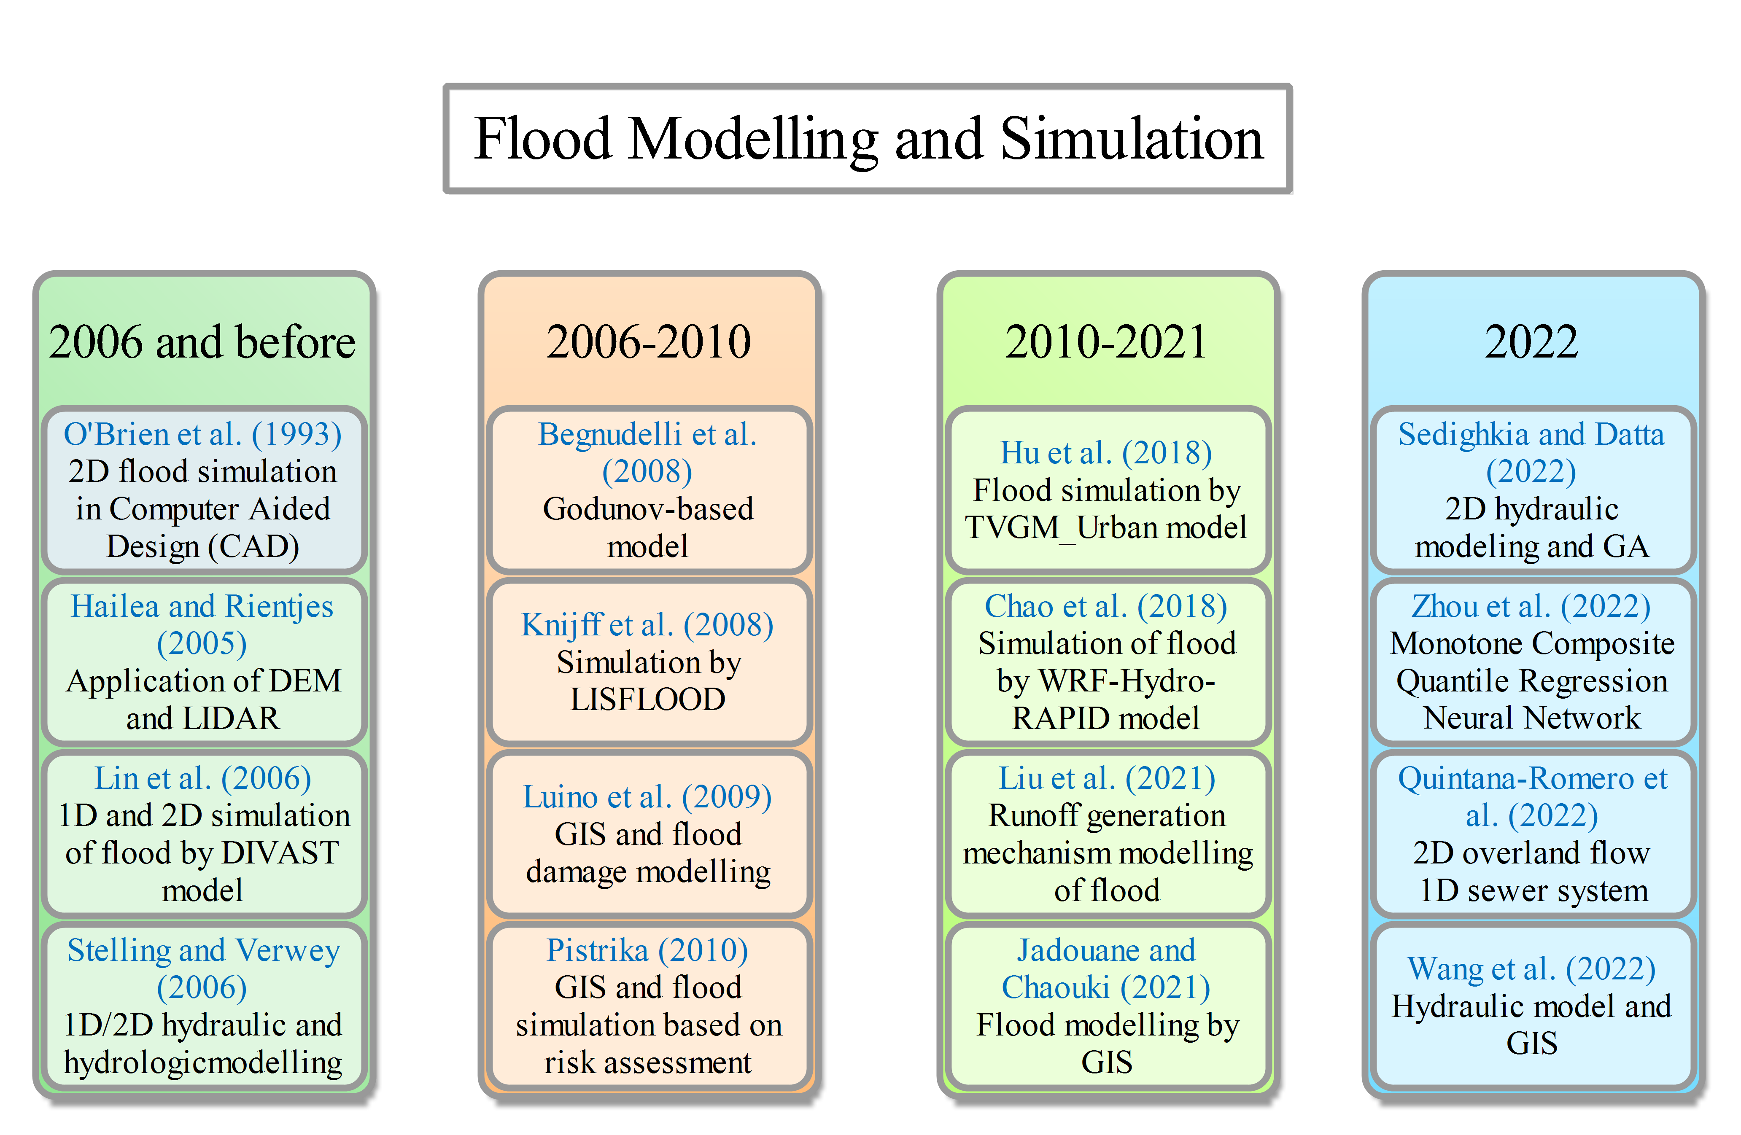
Fig. 2. Types of flood simulation and modelling spanning from before 2006 to 2022

Flood forecasting
The R-Studio software and Scopus databank are used to evaluate flood prediction studies through the Bibliometrics toolbox. The Sankey diagram in Fig. A.1 shows that prediction models are often used in Decision Support Systems (DSS). From 2000 to 2017, hot topics included flood prediction, DSS, risk management, uncertainty, flood management, remote sensing, and climate change. In recent years, data-driven and mining techniques have been commonly used for computations based on time series data. Flood forecasting has been evaluated at different spatial and temporal resolutions, with some studies using convolutional neural networks to analyse radar echo maps. For example, Dtissibe et al., (2020) utilized discharge data as input-output variables to create a flood forecasting model using a multilayer perceptron algorithm. Puttinaovarat, and Horkaew (2020) developed a new flood forecasting system based on combining massive, crowdsourced data with meteorological, hydrological, geospatial, and hydrological information. Ma et al., (2021) validated when and where dike breaks occurred during Typhoon Hagibis which caused catastrophic flooding in Japan in 2019. To accomplish the study's objective, they coupled a hydrodynamic model with statistical analysis while being forced by a 39-h forecast from the Meso-scale model Grid Point Value (MSM-GPV) of the Japan Meteorological Agency. They then got dike-break times for all flooded locations for validation. To construct and assess a forecasting model to anticipate the occurrence of flood events in the future, Moishin et al., (2021) developed a hybrid deep learning (ConvLSTM) algorithm by integrating the predictive benefits of Convolutional Neural Network (CNN) and LSTM Network. Zhou et al. (2022) developed a flood prediction system that combines deep learning computations with Bayesian optimization techniques to evaluate computational time and model efficiency. Similarly, Chen et al. (2022) assessed the performance of deep learning for short-term flood forecasting, incorporating both spatial and temporal features into the model. Sikorska-Senoner (2022) presented a clustering model for the hydrological specifications of case studies used for risk analysis of flood disasters, and the optimal number of clusters was obtained by flood frequency analysis. Zabihi et al., (2023) employed three AI algorithms including Logistic Regression, Neural Network, and Support Vector Machine to predict the flood disasters by clustering rainfall data. Saint-Fleur et al., (2023) also developed a deep artificial neural network for forecasting flash floods, which would enable it to better account for regional variability, scales of rainfall, and hydrological reactions due to its unique architecture.

Flood risk assessment and management
This study evaluated the use of risk assessment for controlling flood disasters, using Scopus databank and Bibliometrix toolbox in R-Studio (see Fig. A.2). There are some known analytical risk assessment methods such as Failure Mode and Effects Analysis (FMEA) and Hazard and Operability study (HAZOP) that have been used in construction projects (Ahmadi et al. 2017) and structural engineering (Yeganeh et al. 2022). However, our literature review shows FMEA and HAZOP have been rarely used for flood risk management. Most studies instead identified high-risk areas by integrating GIS and hydraulic computations. For instance, Quesada-Román et al. (2022) developed a model for risk assessment of flood events based on flood frequency evaluations at peak discharging points, using Topographic Wetness Index (TWI) for risk assessment at different points. Rincón et al. (2022) presented a stochastic model for flood risk assessment in different climates by first analysing the flood hazards in their case study then detecting the high-risk regions, and finally estimating risk functions. Zhang et al. (2022) created a flood risk assessment model to develop a warning system in the Brahmaputra River floodplain of Bangladesh, by integrating HEC-HMS (Hydrological software) and HEC-RAS (Hydraulic software). Bralewski and Bralewska (2022) applied the Poland's national risk assessment methodology to control flood hazards in a case study by categorising risk points. Yang et al., (2023) sought to reduce food losses brought on by drought and floods and to identify drought and flood hazards in rainfed agriculture using conditional probabilities. They produced an index using the meteorological data to create four time-scale drought indicators. For flood risk assessments on a wide spatial area, Kelly et al., (2023) created a unique way of index-based analysis employing a multi-criteria decision-making (MCDM) method. Based on flood hazard, flood exposure, and flood vulnerability indices, an overall Flood Risk Index (FRI) for the Hawkesbury-Nepean Catchment was generated using an MCDM technique. By combining the Interpretative Structural Modeling Method (ISM) with the Bayesian Network (BN) framework, a risk assessment model was presented by Li et al., (2023) that would result in an integrated ISM-BN simulator for accurate flood assessments.
Based on the literature review outlined above, no previous work has conducted a comprehensive analysis of flood risk management that combines flood predictions with risk assessment and decision support systems (DSS). Therefore, this study aims to develop a new DSS framework for flash flood mitigation by integrating GIS-WMS simulation, artificial neural network (ANN) predictions for flash floods, and flood risk assessment and scenario building for decision-making on flood risk mitigating measures. This framework will utilise both smart tools like ANN and digital technologies such as GIS, as well as human experience, to analyse flood predictions and associated risk, feeding the DSS to make informed decisions. The methodology is demonstrated by its application to a real-world case study in Iran, representing an international collaboration for flood simulation, risk assessment, and prediction worldwide (see Fig. A.3). The next section details the methodology, including data gathering, mathematical calculations, software modelling, and AI settings. Results are presented, along with critical discussion and comparison to a similar previously published study. The conclusions draw key findings and provide recommendations for future work.

Material and methods

Methodology
This study proposes a novel framework for smart flood risk management and flood forecasting, which is based on integrated GIS, WMS, and AI algorithms. The framework is illustrated in the flowchart shown in Fig. 3 and includes various components such as data collection, hydrologic and hydraulic modelling of the catchment, and flood simulation and forecasting.
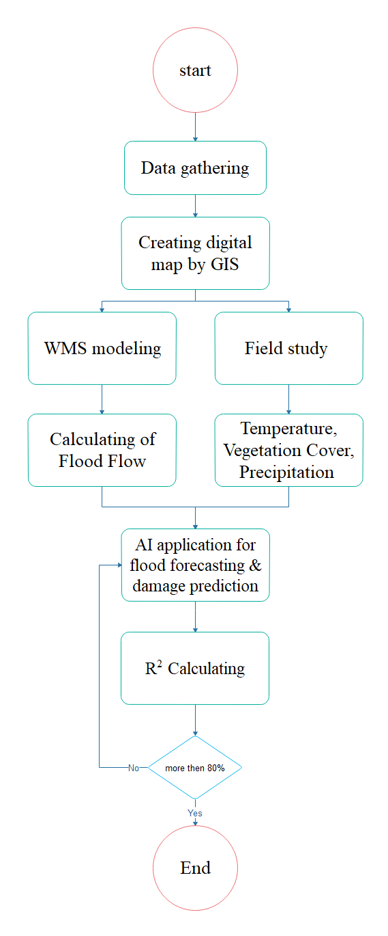
Fig. 3. The flowchart of the methodology.

Data collection involves gathering descriptive and digital information, topographic layers, vegetation land cover, geotechnical, rainfall, and climatic data to form a comprehensive database. GIS software is then used to pre-process the above-mentioned data to prepare inputs for flood modelling,. This is followed by hydrologic and hydraulic modelling of the catchment using the WMS software to simulate surface runoff and estimate flood flow in the case study. AI algorithms are then utilized to identify effective parameters for future flood predictions and identify key performance indicators for evaluating flood resilience. The estimated damages of flood occurrences are then used to analyse flash flood risk assessment based on FMEA and HAZOP methods. Finally, the Classic Delphi (CD) method is employed to identify the best solutions for mitigating flood risk. The steps involved in this framework are further explained in the following sections.

Hydrologic modelling process in GIS and WMS
The digital map created by GIS includes various layers such as topographic, vegetation, geotechnical, and geo-hydrological data (Pareta and Pareta, 2012). This map is used as input data to create a hydraulic model in WMS software version 7.1. The WMS model estimates various parameters based on the physical characteristics of the catchment (Al-Zahrani et al., 2017), such as Sin (the sinuosity factor of the stream which is meandering conditions between any two points in the stream that is defined by the ratio of the maximum stream length to the direct length), MFD (the maximum flow distance within the catchment), CSD (the average distance between the centroid of the catchment and the points with maximum flow), CSS (the slope of the CSD), MFS (the slope of the catchment), AVEL (the mean catchment elevation), SF (catchment shape factor), P (the catchment perimeter), and A (the area of the catchment). These parameters are used to simulate and predict flood discharge, depth, and velocity.
Note that the WMS model was configured with additional parameters, including a Primary Infiltration (PI) time of 0.2 seconds, 10% Impenetrable Percentage (IP), and a Mean Curved Number (MCN) of 78, calculated as (Garen and Moore, 2005):
(1)
The time of concentration (Tc) is computed using the Soil Conservation Service (SCS) method as (Grimaldi and Petroselli, 2012):
(2)
where L is the flow length (m), and Δh = H_{max} – H_{min} is the difference between the maximum and minimum level of the catchment.

AI computations
The AI developed in this study is primarily designed to undertake two main tasks: (1) binary prediction of flood occurrence and (2) estimation of flood damages. The computations of the AI use four machine learning (ML) algorithms, including Support Vector Machine (SVM) used for flood mapping (Bera et al. 2022), Neural Network (NN) (Mahesh et al. 2022), Nearest Neighbours Classification (NNC) (Avand et al. 2022) and Linear & Polynomial Regression (LPR). The algorithms are written in Python language and are configured with the settings illustrated in Table 1 (the programming codes in the Python platform are available in the supplementary file).
The input layer of all ML algorithms consists of five variables, including vegetation land cover, temperature, precipitation, and flash flood flow. The output layer includes the two tasks of flood occurrence and flood damage. The flood flows computed by the WMS simulation are used as the historical data for the input layer, along with corresponding data from other input layer variables in various times of the historical years. Fig. 4 illustrates the structure of input and output layer data in this study. As can be seen in the figure, both data gathering and simulation processes are used to prepare the databank for the ML computations.
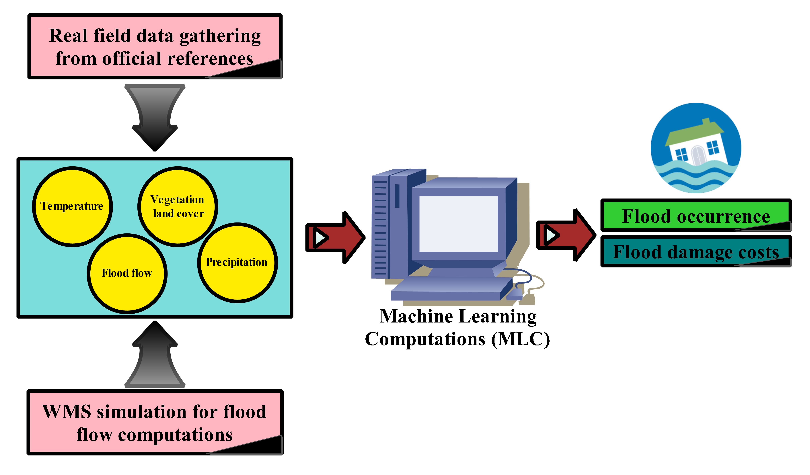
Fig. 4. The structure of AI model in this research
For all AI models, 80% of the total historical data is used for model training, while the remaining 20% is reserved for testing. The general setting of the AI models includes sklearn.model_selection.train_test_split (*arrays, test_size=None, train_size=None, random_state=None, shuffle=True, stratify=None) in Jupiter notebook (Hishinuma and Iiduka, 2019). The specific parameters and settings of the ML algorithms are given in Table 1. The coefficient of determination (R²) is used as the performance indicator to identify the best AI algorithm in this case study (Gheibi et al., 2019). Note that the historic input data used in this study can be divides into three distinct groups as shown in Figures A.10-12 based on precipitation and temperature. The first group (Figure A.10) is related to flood occurrence (0 as no flood and 1 as flood detection). The second group (Figure A.11) classifies the data according to the integer values of MUSD (between 1 and 5) representing the extent of damages. The last group (Figure A.12) classifies 4 different types of vegetation cover in the case study.
Table 1. The specific parameters and settings of the utilised AI algorithms in the Jupiter notebook
Algorithm | Settings | Reference
Support Vector Machine (SVM) | C=1.0, break_ties=False, cache_size=200, class_weight=None, coef0=0.0,  decision_function_shape='ovr', degree=3, gamma='scale', kernel='rbf',  max_iter=-1, probability=False, random_state=None, shrinking=True,  tol=0.001, verbose=False | (Shahzadi et al., 2021)
Neural Network (NN) | MLPClassifier (activation='relu', alpha=0.0001, batch_size='auto', beta_1=0.9,  beta_2=0.999, early_stopping=False, epsilon=1e-08,  hidden_layer_sizes=100, learning_rate='constant',  learning_rate_init=0.001, max_fun=15000, max_iter=250,  momentum=0.9, n_iter_no_change=10, nesterovs_momentum=True,  power_t=0.5, random_state=None, shuffle=True, solver='adam',  tol=0.0001, validation_fraction=0.1, verbose=False,  warm_start=False) | (Kalantar et al., 2021)
Nearest Neighbors Classification (NNC) | KNeighborsClassifier (algorithm='auto', leaf_size=30, metric='minkowski',  metric_params=None, n_jobs=None, n_neighbors=18, p=2,  weights='uniform') | (Shahabi et al., 2020)
Linear & Polynomial Regression (LPR) | copy_X=True, fit_intercept=True, n_jobs=None, normalize=False | (Ling et al., 2022)

Flood risk assessment
Two risk assessment methods, FMEA and HAZOP, are used in this study to evaluate risk levels of flash floods. Different steps in FMEA method is illustrated in Fig. 5 (Chang and Cheng, 2010), and the same is illustrated for HAZOP method (Siddiqui et al., 2014) in Fig. 6. Both methods involved eight experts with relevant expertise, including three experts in crisis management and five experts in water management. Each expert had at least a Master degree in a field related to civil engineering, HSE engineering, hydraulic engineering, environmental engineering, or crisis management, and had more than ten years of experience in their respective fields (Gheibi et al., 2019; Akbarian et al., 2022a). Furthermore, all the experts had experience dealing with at least one flood crisis. The experts were responsible for scoring points in the risk assessment process.
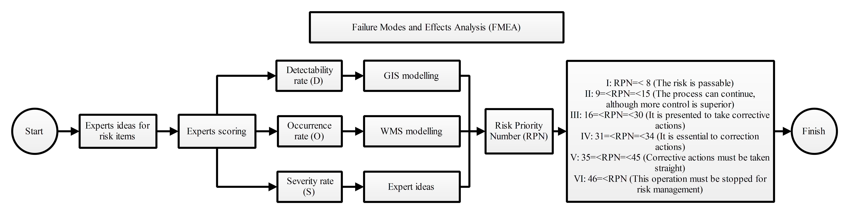
Fig. 5. The FMEA algorithm used in this study for flood risk assessment.
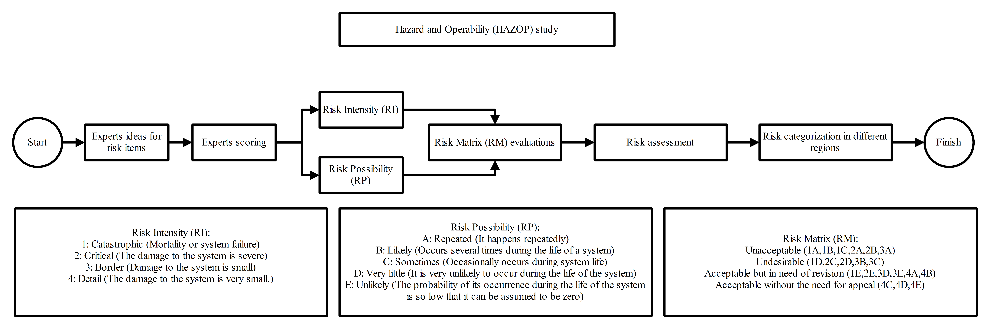
Fig. 6. The HAZOP algorithm used in this study for flood risk assessment.
The FMEA algorithm (Fig. 5) requires three parameters: Detectability rate (D), Occurrence rate (O), and Severity rate (S) (Peddi et al., 2023), which are first specified by GIS modelling, WMS simulation, and experts' opinions, respectively. These parameters are then scored by participating experts, and the score-weighted multiplications of the three parameters are used to calculate the Risk Priority Number (PRN), which can be used to evaluate the risk level of flash floods. More specifically, the D factor is determined by assessing the distance of the risk point from the flood zones in the GIS environment, while the O factor is determined by comparing simulated flash flood flows in WMS to the average flow of the catchment. The S factor is estimated based on the experts' knowledge of previous flood experiences (Ouyang et al., 2022). On the other hand, the HAZOP algorithm (Fig. 6) requires two factors: Risk Intensity (RI) and Risk Possibility (RP), which are evaluated and scored based on experts' opinions and available data (Moezzi et al., 2023). The multiplication of these score-weighted average factors generates Risk Matrix (RM) which is used for flood risk assessment and categorisation in different regions and conditions.

The classic Delphi (CD) decision-making
In this study, the CD method is utilised for decision-making, as illustrated in the flowchart in Fig. 7 (Elmer et al., 2010) . The CD method in this study involved 15 experts from three Iranian universities: Ferdowsi University of Mashhad (FUM), Birjand University of Technology (BUT), and the University of Tehran (UT) (Gheibi et al., 2018). These experts are alumni and faculty members with postgraduate degrees in relevant fields. The decision-making process comprises three stages. First, all possible flood risk mitigation strategies are collected and compiled in an archive. Second, the experts are presented with each strategy and asked to provide their opinions and score each one based on their individual expertise. Third, the experts analyse and evaluate each strategy, and their viewpoints both for and against each strategy are recorded and shared with all experts. Strategies with more than 60% support from the experts are approved and selected, while those with less support are not. This step is repeated three times, and finally, all accepted strategies are prioritized based on their importance.
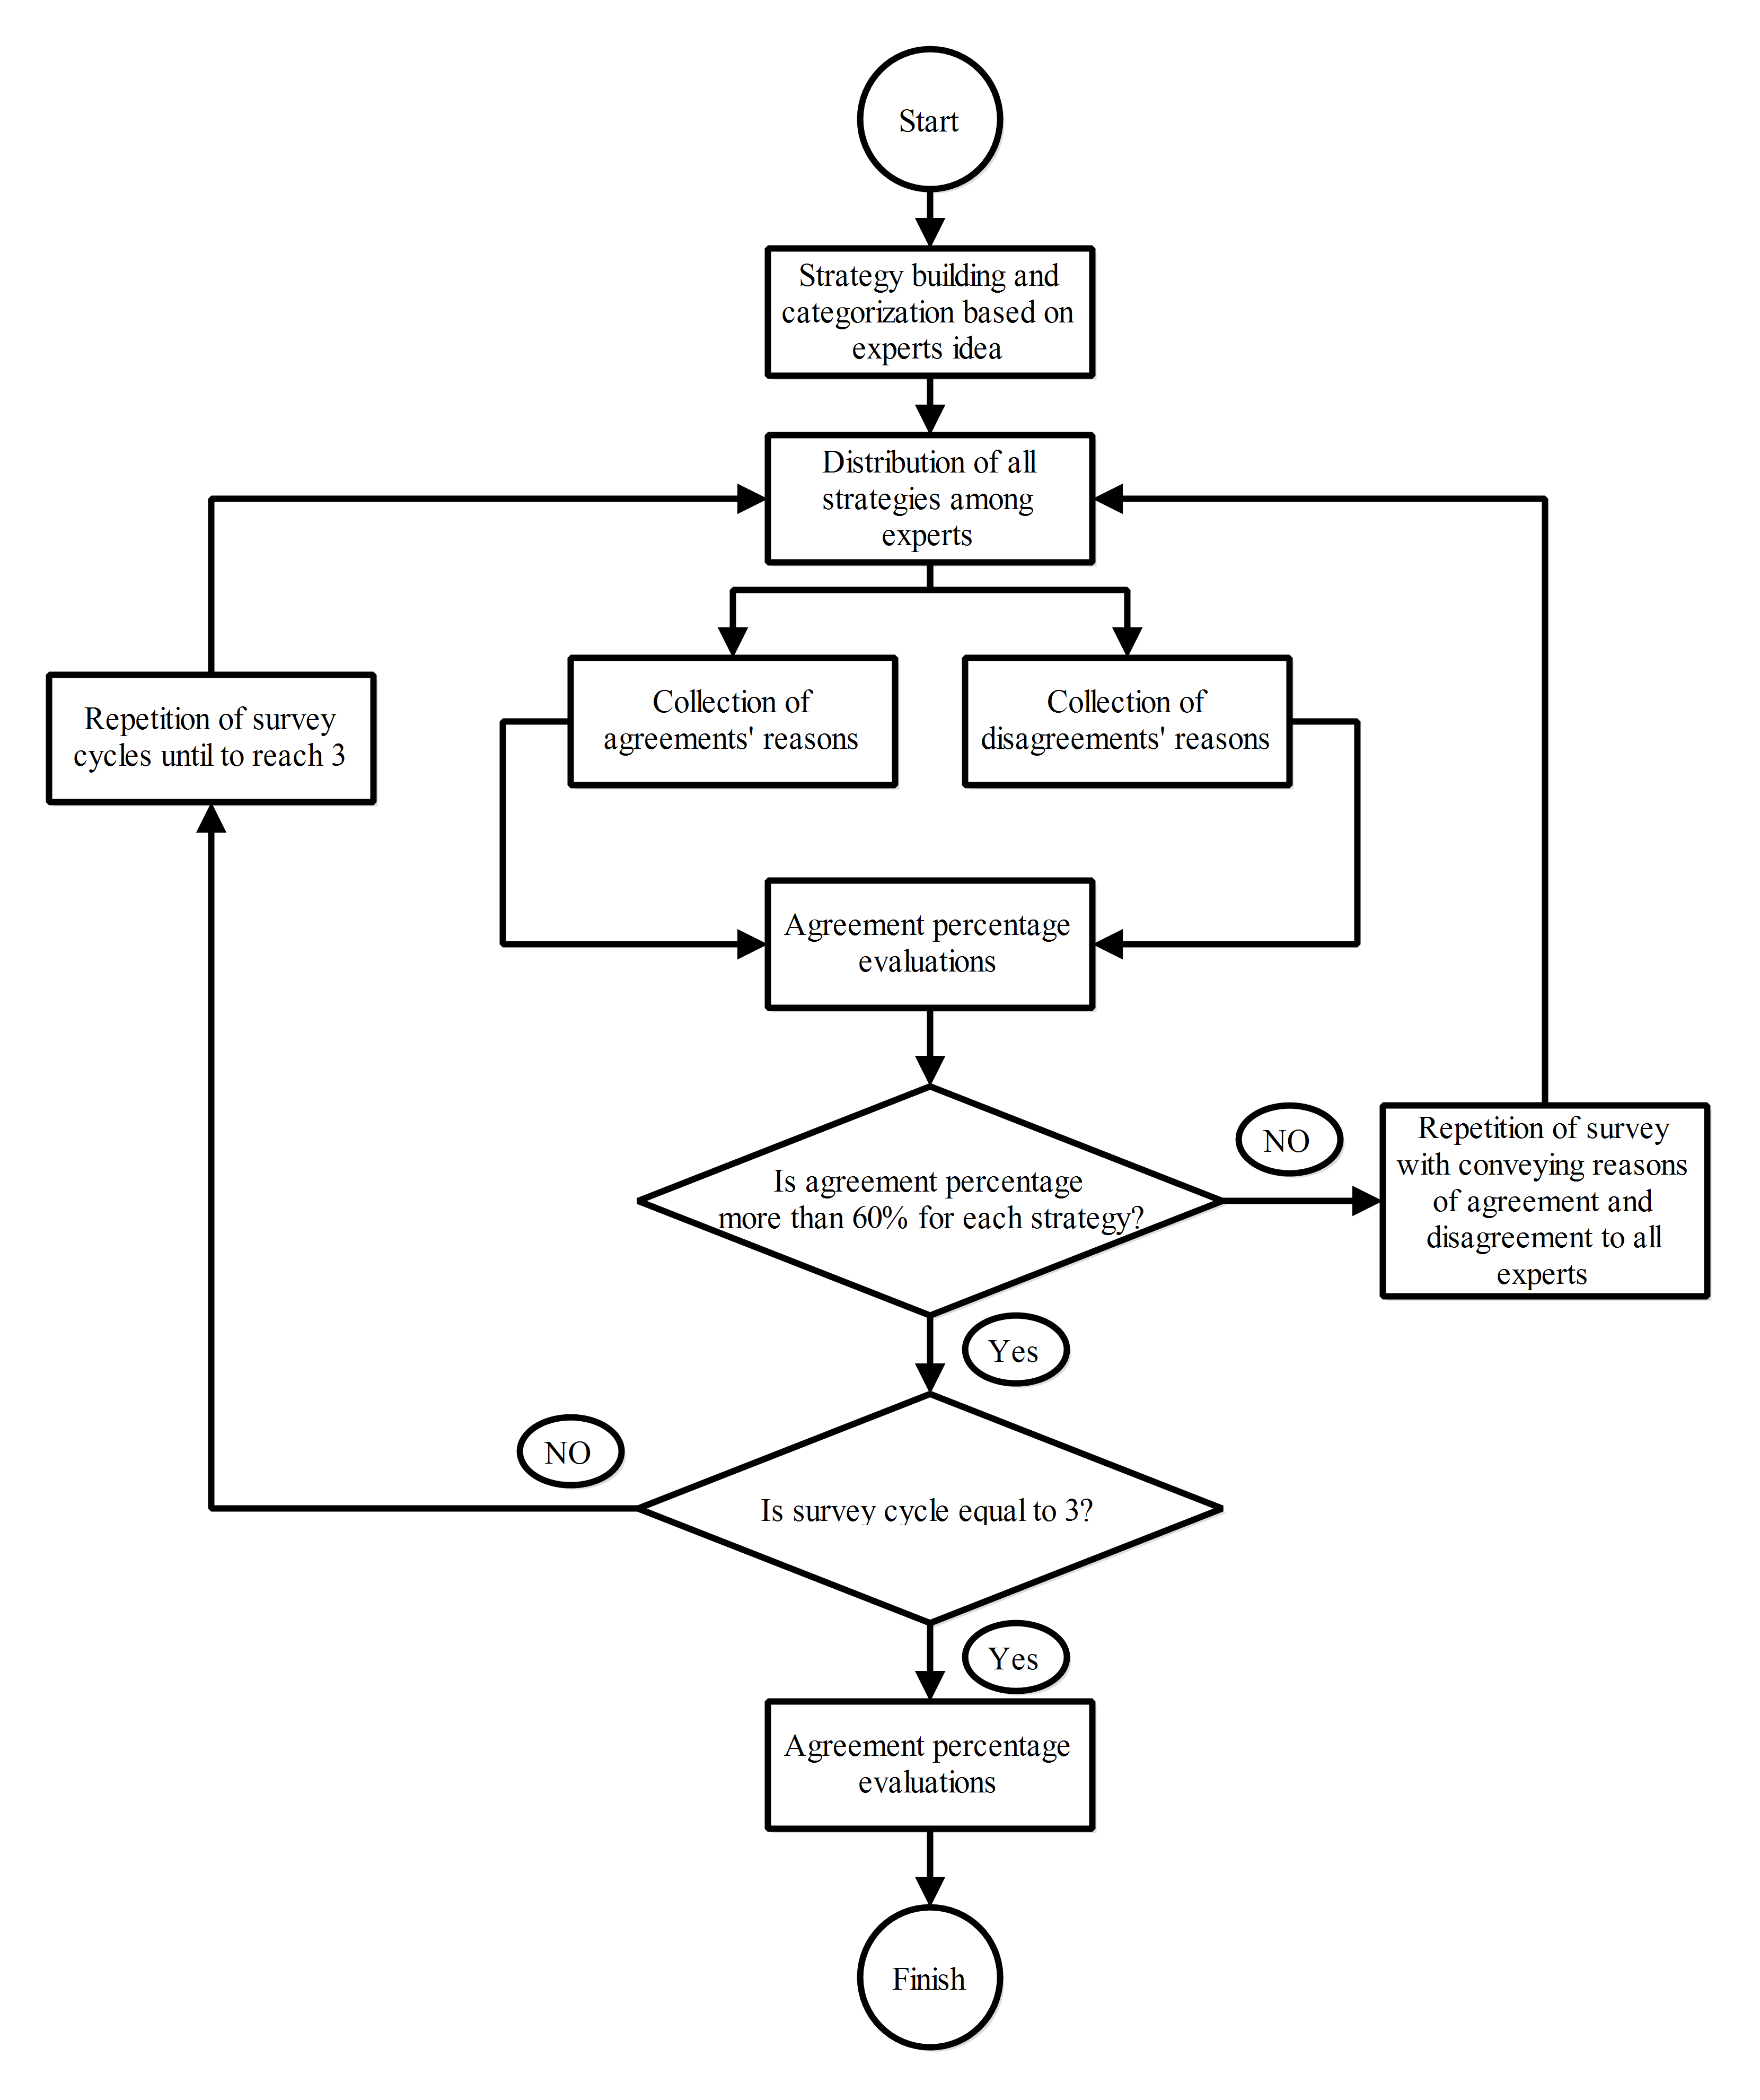
Fig. 7. The CD algorithm used for decision making in this study

Case Study
The methodology presented in this study is applied to a case study in the arid and semi-arid region of Khosf, located in the South Khorasan province of Iran (Fig. A.4). This region has been affected by severe floods in recent decades and has been the subject of various research studies (Mikaniniki et al., 2019). Despite being mostly a desert, the region has a limited ground cover, with seven species including Seidlitzia Rosmarinus, Peganum Harmalla, Haloxylon Aphyllom, Heliotropium Europaecae, Hordeom Bulbosum, spp Alhaji, Gundelia Toriforti-Stipa Barbata, Artemisia Sieberi, and Artemisia Oucheri- Poa Bolbosa (Izanloo et al., 2009). A total of 90 plant species belonging to 31 genera have been identified in the Khosf region. The most significant genera include wheatgrass, spinach, chicory, and butterfly, accounting for 17.8%, 11.7%, 8.8%, and 6.2% of the total flora, respectively (Saghari et al., 2009). The ground cover in Khosf is classified into four categories, as shown in Fig. A.5 with varying levels of flood resilience: strong, semi-strong, average, and weak.
Over the past forty years, the average monthly rainfall in South Khorasan province has been only 9.1mm. In comparison, the central plateau of the country, which is geographically similar to this province, receives more than 18.5mm of rainfall on average each month. Despite the low rainfall, the Khosf region of South Khorasan has experienced four destructive floods in 2005, 2010, and 2015. Table 2 shows the average monthly rainfall for those years and the estimated flood damage caused each year, as reported by the Water Management Organisation of South Khorasan.
Table 2. Average monthly rainfall and flood damage for three floods in the Khosf region
No. | Average Rainfall (mm) | Estimated damages (Million US $) | Year
1 | 5.9 | 1 | 2005
2 | 7.3 | 3 | 2010
3 | 10.4 | 5 | 2015

Results and discussion
The study used GIS to create a digital map of the Khosf region for WMS modelling, based on geo-statistical data and the integrated GIS-WMS platforms as the steps shown in Fig. 8. The WMS software was used to compute a hydrological map of the catchment using linear calculation and a triangular element system. The model was analysed quasi-statically and dynamically, and the results showed that flooding occurs between the catchment's entry and focus points. Fig. 8 also displays the WMS simulation of streams in the catchment, indicating that flooding occurs within the red areas. The WMS modelling generated a single hydrograph for the catchment based on hourly rainfall data (Fig. A.6a). The hydrograph ​​(Fig. A.6b) showed a peak flow of 28.35 (m³/s) for a total duration of 420 minutes, resulting in a flood volume of 474,900 (m³). These results suggest that the Khosf region is vulnerable to flooding, and hence the WMS modelling outputs can be used for managing and mitigating flood risks in the region.
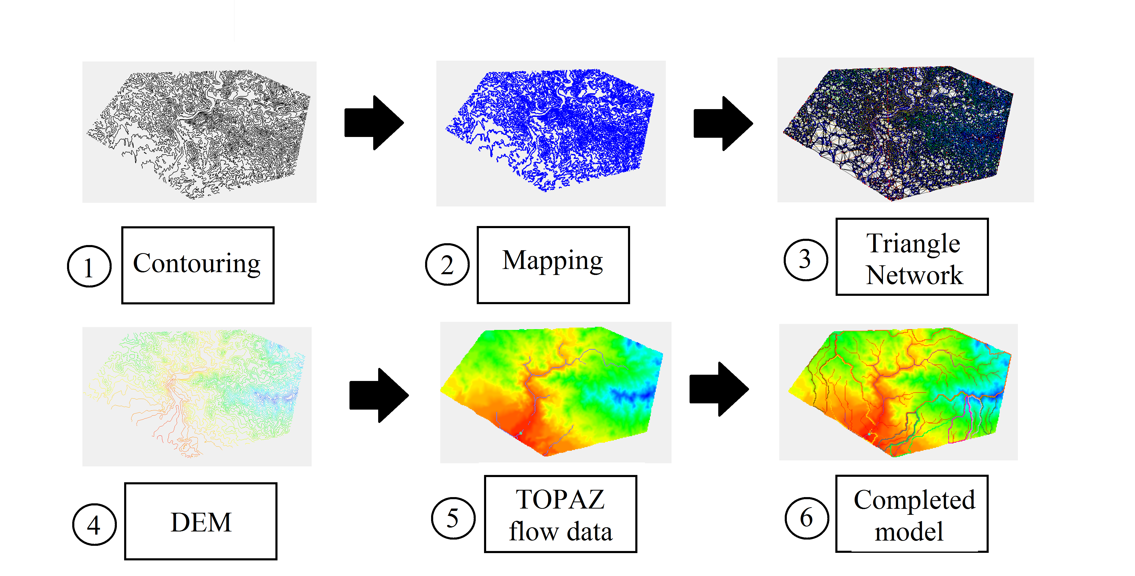
Fig. 8. The steps and processes of WMS modelling in the case study

The rainfall data used in this study were recorded daily as the mean value of hourly data. However, to accurately compute flood flow in the WMS model, hourly precipitation data is required. To account for this, we employed a sequential WMS modelling approach that incorporates hourly flood precipitations to estimate the flood flow.
The data required for ML computations in this study are obtained as described below (variations of recorded data can be seen in Fig. A.7). We used the outputs of the WMS simulation as flood data for the input layer in the ML computations for various catchment conditions. Using hydrologic modelling in WMS, we collected flood flow data (m³/s) for 210 records in the Khosf region, along with data related to catchment and environmental characteristics, including temperature (°C), vegetative ground cover (type), precipitation (mm), and the corresponding damage costs (MUSD in millions of US$) resulting from flood occurrences. Fig. 9 presents the heat maps of the correlations between different effective data in the case study as a pair-wise comparison of the correlation coefficient where lighter colours show a higher amount and darker colours show a lower range of amounts. Fig. 9 demonstrates that the occurrence of floods depends more on damage cost and flood flow, with correlation coefficients of 0.87 and 0.86, respectively, than on other parameters. In contrast, the temperature has the lowest correlation with flood occurrence.
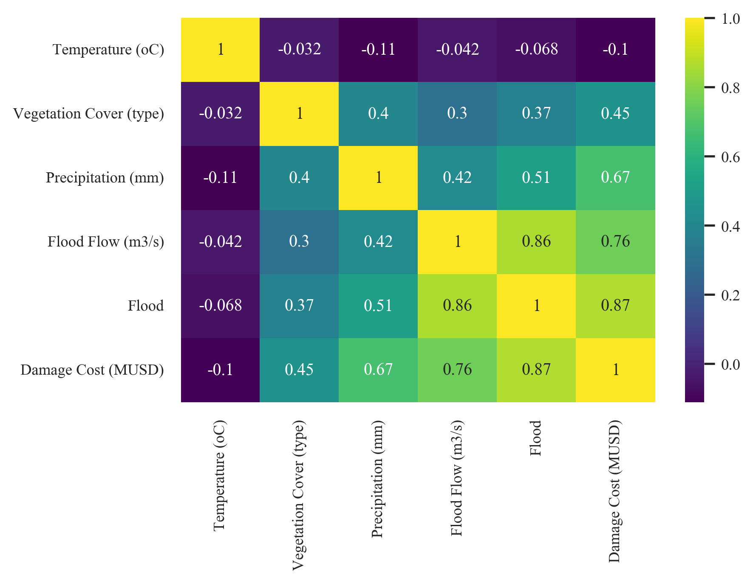
Fig. 9. The heat map and correlation of the input layer data of ML computations in this study; note that lighter colours show a higher amount and darker colours show a lower range of amounts.
The key features of the input layer data are summarised as follows: temperature ranging between 12 and 22°C, four types of vegetative ground cover, precipitation ranging from 0 to 15mm, flood flow ranging between 10 and 30 m³/s, and damage cost ranges up to 5 MUSD (the box plot of these data is available in Fig. A.8). The output layer includes a binary flood occurrence with values of 0 and 1 indicating no flood and flood occurrence, respectively. In this case study, the four types of vegetative ground cover were scored by experts between 1 and 4, with each score representing a different level of flood resilience. Resilience is influenced by various parameters, and among them, vegetation cover type and density play a significant role. The ability to modify vegetation cover through operational activities in the field with relatively low investments underscores the importance of this feature in enhancing resilience. Vegetation cover serves as a natural protective barrier against environmental hazards and contributes to the overall stability of ecosystems. The type of vegetation, such as forests, grasslands, or wetlands, determines its specific characteristics and functions. Different types of vegetation can offer distinct benefits in terms of erosion control, water regulation, biodiversity support, and climate regulation. Furthermore, the density or extent of vegetation cover greatly influences its effectiveness in mitigating risks and promoting resilience. Dense vegetation cover acts as a formidable shield against soil erosion, reduces surface runoff, and enhances water infiltration. It helps to stabilize slopes, prevent landslides, and minimize the impact of flooding events. The advantage of vegetation cover lies in its adaptability and relatively low-cost implementation. Through operational activities such as afforestation, reforestation, or the establishment of green infrastructure, it is possible to modify and enhance the existing vegetation cover. This can be achieved by planting trees, promoting the growth of natural vegetation, implementing agroforestry practices, or restoring degraded ecosystems. Investments in vegetation cover can yield multiple benefits, both in terms of short-term risk reduction and long-term sustainability (Dahri and Abida, 2017). These levels are classified as strong, semi-strong, average, and weak (a picture of each typical vegetative ground cover is available in Fig. A.5).
Once the hydrologic modelling was completed and data were collected for developing AI, machine learning was built in two parts. The first part used three classification algorithms - SVM, NN, and NNC - to determine whether a flood would occur or not. The second part used the LPR algorithm to estimate the corresponding damage caused by the possible flood and to suggest safe measures for mitigating flood risk. Coefficient of determination (R²) indicator is a widely recognised and easily interpretable metric that represents the proportion of the variance in the dependent variable (outcome) that is explained by the independent variables (features). The high coefficient of determination (R²) of the three algorithms - SVM, NN, and NNC given in Table 3- demonstrates their efficiency in predicting flood occurrence. In addition, the model performance for other error indicators of flood occurrence including root mean square error (RMSE), mean absolute error (MAE), or smooth absolute error (SAE) are also shown in Table 3. While SVM and NNC have the best correlation coefficients in comparison to SVM with respect to R², the error function results demonstrate that the NNC algorithm has the best performance for prediction of flood occurrence.
Table 3. The results of error functions in different applied machine learning algorithms as per statistical indicators.
Algorithm | NN | SVM | NNC
RMSE | 0.9 | 0.8 | 0.59
SAE | 31.98 | 23 | 20.66
MAE | 0.76 | 0.54 | 0.49
R² | 0.79 | 0.88 | 0.89

Figs. 10a-c depict partial residual plots that display the estimated relationships between various flood variables and the status of flood or non-flood occurrence for different types of vegetative ground covers. These plots are accompanied by confidence bands and highlight the impact of various factors on flood occurrence and damage costs. Note that the status of flood or non-flood occurrence is based on the definition of the Water Company when flooding and flow spills over rivers result in specific damage to properties and agricultural lands. The plots reveal that for the state of no reported flood (denoted by blue colour) in Fig. 10a, the damage costs for various precipitations are almost uniform in the first three types of land cover (i.e., independent from precipitation). However, for the cases of reported flood occurrence, higher precipitation results in higher damage cost only for land cover type 2 and 3, while the damage costs remain constant for land cover type 1.

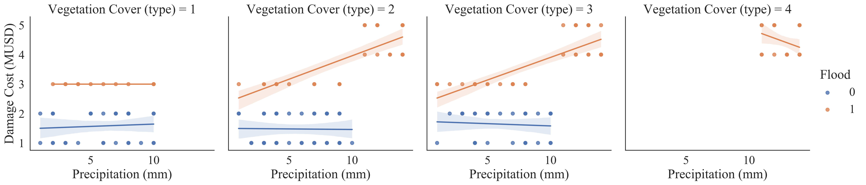
(a)
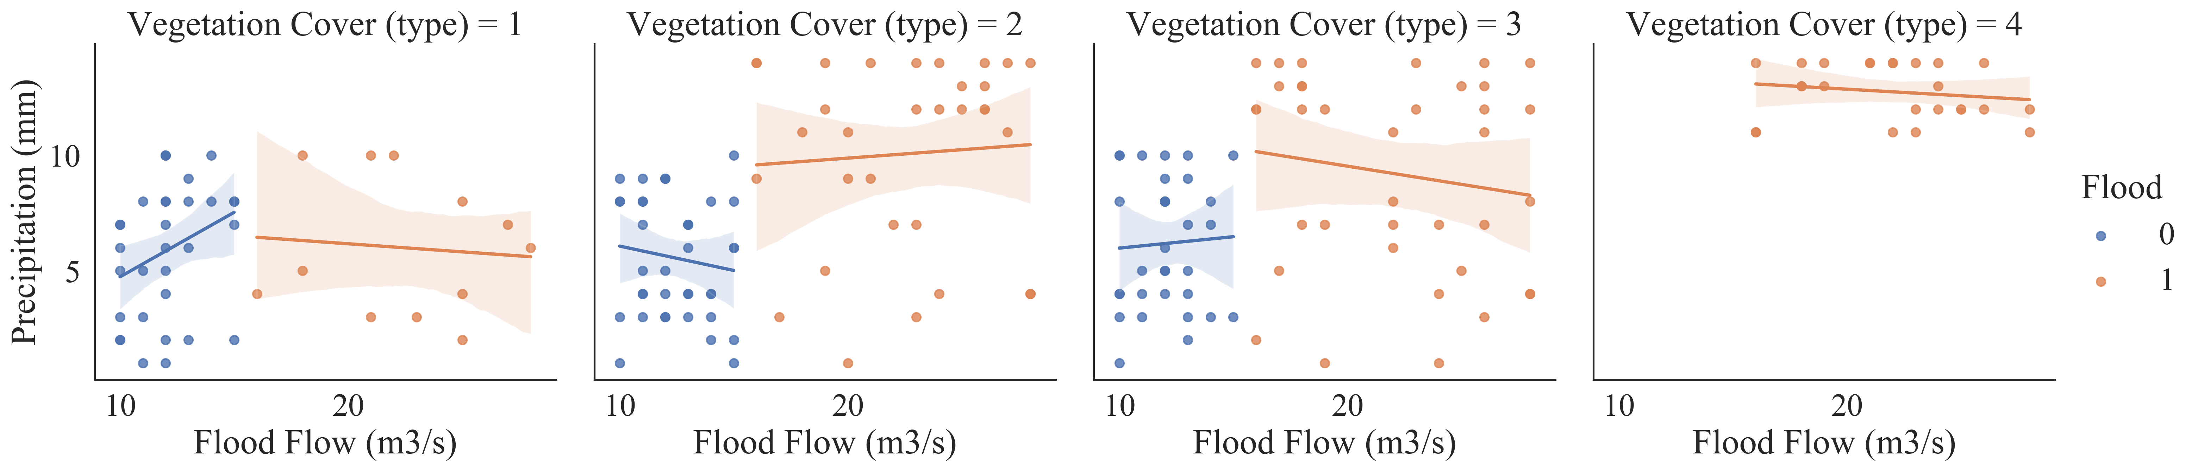
(b)
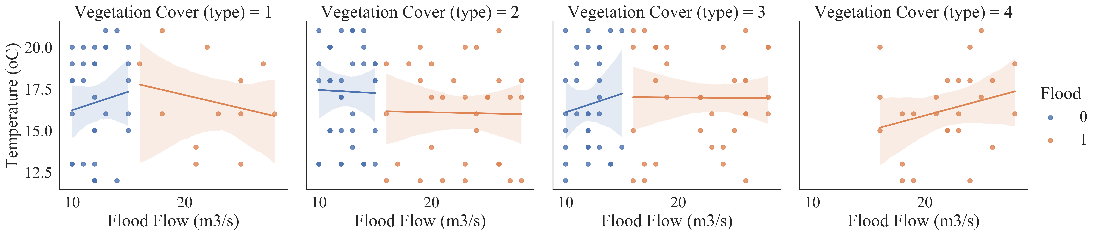
(c)
Fig. 10. Partial residual plots and estimated relationship between the flood variables with associated confidence band based on four vegetative ground covers for (a) precipitation vs damage cost; (b) flood flow vs precipitation; and (c) flood flow vs temperature; note the blue denotes non-flood occurrences and red denotes flood occurrences based on the definition of the Water Company

The estimated linear regression in Fig. 10b shows that flood flow is either directly or inversely proportional to precipitation in vegetation cover types 1 (in non-flood condition) and 4 (in flood condition), with different rates for various land covers. This relationship may be due to the impact of the vegetative ground cover type on the overland runoff and flood flow, especially when it is located in the highest resilience against flood disaster (i.e., vegetative ground cover type = 1). The impact of vegetative ground cover is more pronounced between flood and non-flood occurrences. For example, flood flows are directly proportional to precipitation in flood occurrences, while non-flood occurrences are inversely proportional to precipitation. The impact of vegetative ground cover type has also been reported by other research works (Fazel-Rastgar., 2021; Psomiadis et al., 2019). The estimated relationship between flood flow and temperature is shown in Fig. 10c. For vegetative ground cover type 1, the plots reveal an inverse proportional relationship between the variables. This indicates that no classic relationship can be defined between these flood variables and hence ML tools can be useful in identifying this relationship.
Figs. 11a-b depict the relationship between flood flow and precipitation for different types of vegetative ground cover to determine when flooding is likely to occur. More specifically, flooding occurs when the flow rate exceeds 15m³/s, regardless of the type of ground cover. Additionally, higher levels of rainfall (over 10mm) are generally associated with greater occurrences of flooding in the region, as indicated by the corresponding flow rates although flood occurs for small rainfall depth in some cases as indicated in Fig. 11b.
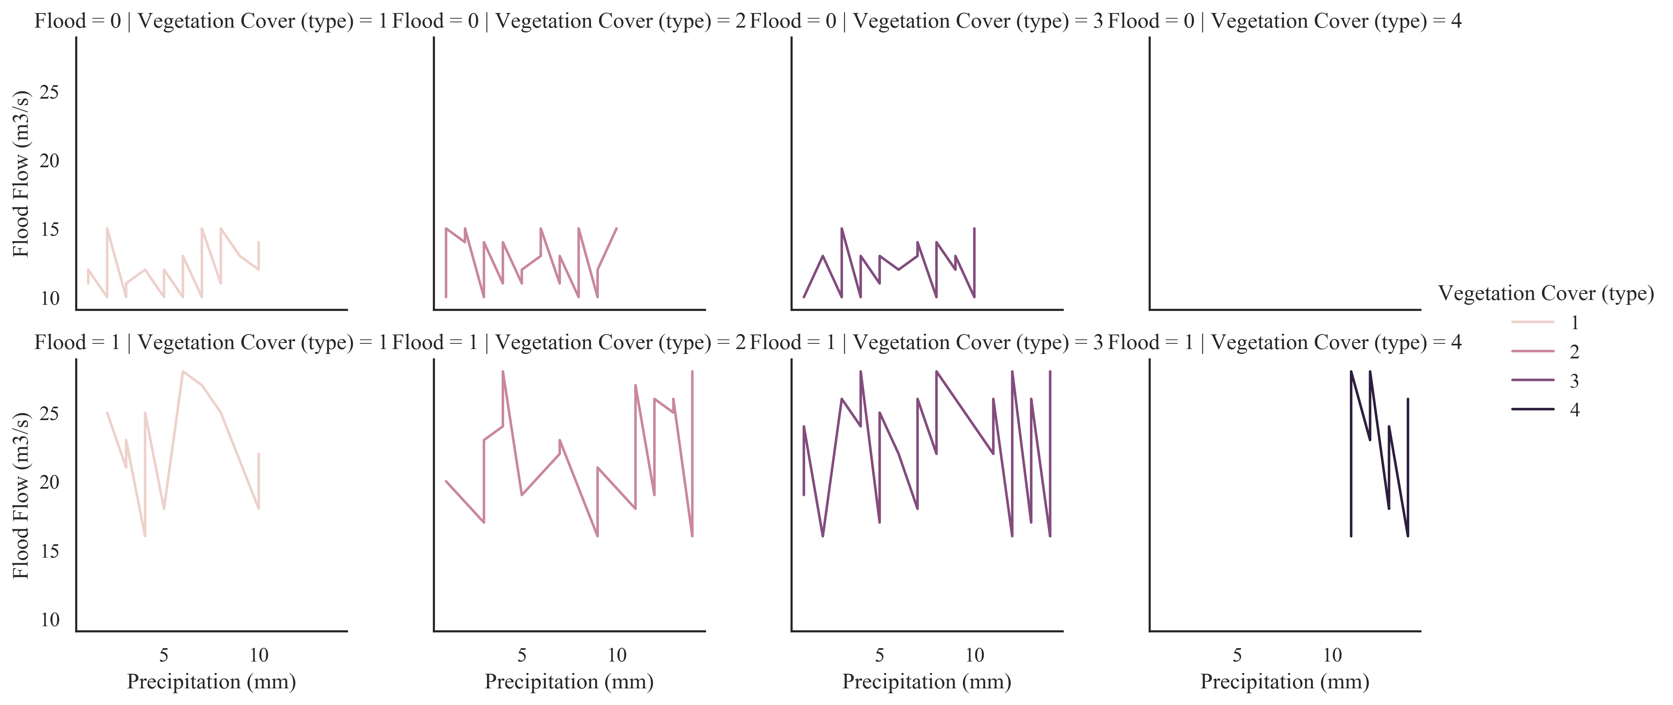
Fig. 11. The relationship of flood flow & precipitation for each vegetative ground cover type; note flood=0 indicates non-flood occurrence and flood=1 indicates flood occurrence
Regression algorithms based on AI are utilised to predict damage costs. Table 4 presents the R² scores, RMSE, SAE and MAE for four different LPR regression methods that were tested to predict overall damage costs. These LPR algorithms consist of one linear regression model and three polynomial regression models with various orders ranging from 1 to 3. The results indicate that the linear model is the most effective, followed by the polynomial model with a second order. Based on the model performance for forecasting flood in different orders of LPR algorithm occurrence, the second order has the best performance compared to other orders in all four indicators. Additionally, higher-order models may result in a slight reduction in the correlation rate, making them less appropriate for this task. Table 5 shows the coefficients of the LPR models that were developed, indicating the most significant parameters for forecasting cost damage. Flood occurrence, precipitation, vegetative ground covers, and flood flow are found to be the most impactful parameters, in that order.
Table 4. The results of R² scores and error values for LPR algorithms in this study.
Regression type | Order | R² | RMSE | SAE | MAE
Linear | 1 | 0.81 | 0.53 | 17.93 | 0.42
Polynomial | 2 | 0.82 | 0.52 | 18.35 | 0.43
Polynomial | 3 | 0.82 | 2.03 | 63.44 | 1.51
Polynomial | 4 | 0.80 | 5.60 | 173.46 | 4.13

Table 5. The coefficients of the regression equation in this study.
Parameter | Temperature (ºC) | Vegetative Ground Cover (type) | Precipitation (mm) | Flood Flow (m3/s) | Flood Occurrence
Linear Coefficients | -0.008 | 0.087 | 0.097 | 0.029 | 1.527
Polynomial Coefficient | -0.011 | 0.116 | 0.097 | 0.016 | 1.698

This study presents a statistical model using multiple linear regression analysis to predict flood occurrence based on temperature and precipitation data with regards to performance indicators such as the R²-squared and adjusted R²-squared values. In addition, the flood risk is then evaluated based on defining three risk level of high, medium, or low for predicted flood values as below:
High risk: Flood prediction >= 0.5
Medium risk: 0.2 <= Flood prediction < 0.5
Low risk: Flood prediction < 0.2
To evaluate the model performance (i.e., the accuracy of the flood predictions), this study applies confusion matrix concept based on the calculations of true positives, true negatives, false positives, and false negatives for flood predictions (Piadeh et al. 2023). The accuracy metric measures the proportion of correctly predicted instances out of the total dataset. Precision represents the proportion of true positives out of all the predicted positives, while recall represents the proportion of true positives out of the actual positives. The combination of precision and recall into a single metric is called the F1 score, as an overall measure of prediction quality (Fig. 12). In this case, the overall model accuracy is calculated as 0.70952 representing the proportion of correctly predicted instances (both floods and non-floods) out of the total dataset. In other words, approximately 70.95% of the flood occurrences were correctly predicted by the model. The precision of the model is calculated as 0.73196. Precision measures the proportion of true positives (correctly predicted floods) out of all the predicted positives. In this case, the model achieved a precision of 0.73196, indicating that around 73.20% of the predicted floods were true flood occurrences.
The recall, also known as sensitivity or true positive rate, is calculated as 0.66981 indicating the model captured approximately 66.98% of the actual flood occurrences. Recall measures the proportion of true positives (correctly predicted floods) out of all the actual positive instances in the dataset. The F1 score is calculated as 0.69951. The F1 score is the harmonic mean of precision and recall and provides a balanced measure of the model’s performance. An F1 score of 0.69951 suggests a reasonable balance between precision and recall, indicating that the model performs reasonably well in predicting both floods and non-floods. The total precipitation value is determined to be 1552. This represents the sum of all precipitation values in the dataset and provides an understanding of the overall precipitation amount. The average temperature is calculated as 16.481, which represents the mean temperature value in the dataset. This value helps gauge the central tendency of temperature data.
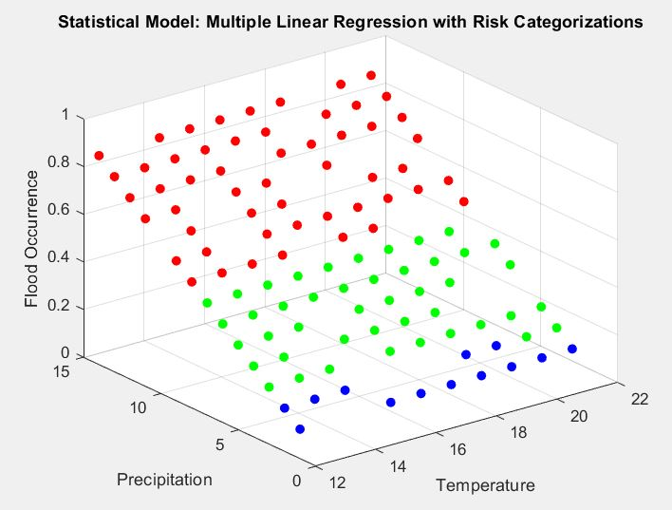
Fig. 12. The hydro-statistical risk assessment of this study.

This study combines GIS-WMS simulation and statistical data to analyse a flash flood case study. This approach can be beneficial for regions with limited facilities and flood detection infrastructure. In another study, Avand et al. (2022) used Digital Elevation Model data to predict floods based on 14 independent inputs and flood occurrences as outputs in different high-risk locations using ML calculations. The number of input data is a critical factor in predicting floods, and the accuracy of the model in two levels of DEM databank is measured at more than 0.97. However, the present study considers all subsections as one zone, which may reduce the efficiency of the model. Despite this, the accuracy of the soft sensor is detected to be more than 0.8 in different regression algorithms for this large case study.
The outputs of FMEA and HAZOP methods for flood risk analysis in three different locations of the case study are presented in Fig. 13, with corresponding results in Figs. 14-15. These three points (A, B and C) were selected based on significant flood flow values computed by WMS. Although all three risk points are based in the Khosf region, their geographical, topological, and hydrological specifications differ. Risk analysis was conducted in three flood flow categorisations: less than 15m³/s, between 15-24m³/s, and more than 24m³/s. The scores in Figs. 14-15 represent the average scoring from all experts invited to conduct the risk analysis.
Fig. 14 indicates that the risk of damage increases significantly in points A and C for flood flows above 15m³/s. Critical situations with an RPN score greater than 46 occur at medium flood flows (above 15m³/s) in points A and C. To control the potential damages, the crisis management system should be fully deployed in these points. However, in point B, the worst flood damage occurs at flood flows greater than 24m³/s. Although the flood damage risks are manageable at points A and B for flood flows less than 15m³/s, flood control measures still need to be taken in these regions. At points B (flood flow: 15-24m³/s) and C (flood flow: less than 15m³/s), the RPN score is equal to 36, indicating the need for implementing flood control strategies promptly. Lastly, it is important to note that point C has low resilience against flash floods due to its topological and geographical characteristics.
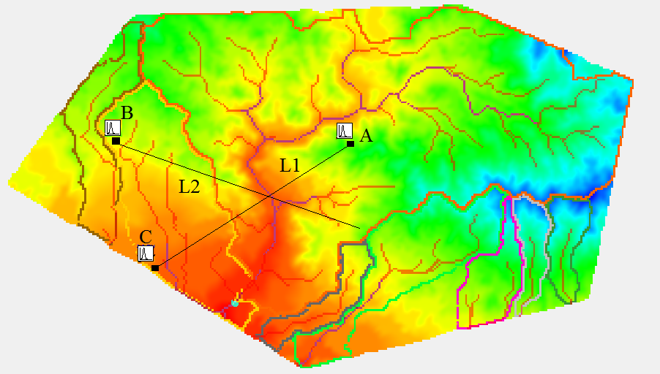
Fig. 13. High-risk points (A, B and C) in the case study with the following key features for L1 and L2; L1: (A=15.43 km², P=9092.38 m, Shape= 2.87 m² m⁻², Sin=0.41 (MSL/L), AVEL=1756.41 m, MFD= 9226.58 m, MFS= 0.0392 mm⁻¹, CSD= 997.49 m, CSS= 0.0401 mm⁻¹ ) and L2: (A=1.15 km², P=4747.6 m, Shape= 38.23 m² m⁻², Sin=0.15 (MSL/L), AVEL=1741.20 m, MFD= 7396.24 m, MFS= 0.0161 mm⁻¹, CSD= 712.13 m, CSS= 0.1429 mm⁻¹)
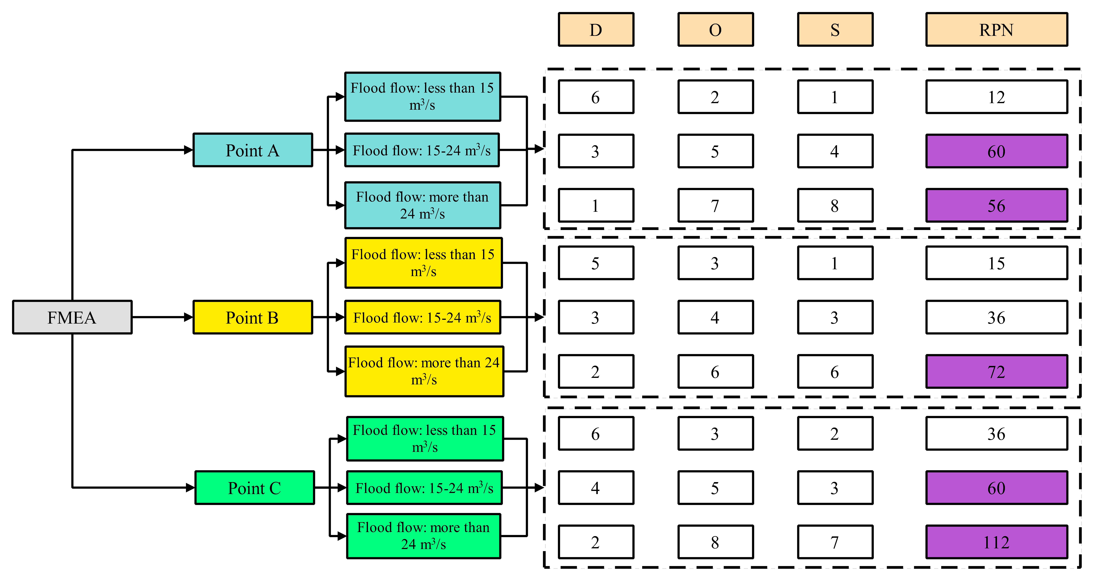
Fig. 14. The outputs of the FMEA method in the case study.
Based on Fig. 15, the results of the HAZOP and FMEA techniques confirm that critical situations in high-risk points occur at flood flows exceeding 24m³/s. These points cover large areas with agricultural and rural land use, and therefore, all crisis management measures and facilities should be used to control the damage during high-risk situations. The online prediction system developed in this study should also be utilised to send sequential alarms to human resources and managers. In point A, flood flows ranging from 15-24m³/s (with a 3C risk value) result in the second level of damages and require implementation of controlling activities in the next step. All other risk situations are considered manageable, and the crisis management system has sufficient time to control the damages. However, according to the HAZOP and FMEA techniques, points A and C are highly dangerous and have low resiliency. Therefore, to approve controlling activities before and during flood disasters using the CD method, there are two categories: High-Risk Regions (HRR) including points A and C, and High Resilience Areas (HRA) including point B.
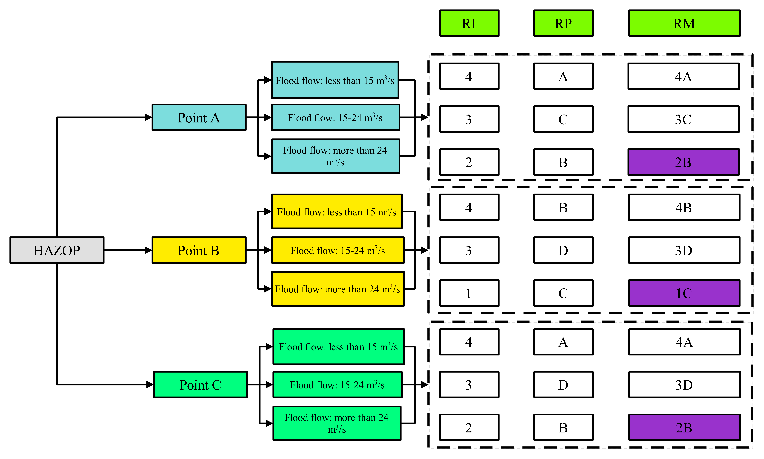
Fig. 15. The results of risk analysis based on the HAZOP method in the case study.

The CD method was used to determine flood control activities for both HRR and HRA, and the results are presented in Fig. 16. Additionally, Table 6 provides a comprehensive list of all approved strategies, which were collected based on the input of experts. The information presented in Fig. 16 indicates that the CD method prioritises flood risk management in HRR1, HRR2, and HRR5 for A and C regions, as supported by Iqbal et al. (2021), Ghosh et al. (2022), and Parvez et al. (2022), respectively. In addition, for point B, HRA2 and HRA4 are identified as the most important priorities, as also suggested by Pally and Samadi (2022) and Hong and Abdelkareem (2022), respectively.

Table 6. The approved strategies for flood mitigation based on two HRR and HRA procedures.
Category | Codes | Solution
HRR | HRR1 | Installation of surveillance cameras equipped with image processing system to quickly detect rising water in the seasonal riverbed (18 and 14 cameras in the direction of flood formation at regions C and A, respectively)
 | HRR2 | Strengthening vegetation in the C zone with an investment of approximately 9 million USD to increase concentration-time in flood conditions
 | HRR3 | Deployment of motorised rescue boats in residential areas with a capacity of at least 15 people near points A (5 boats) and C (8 boats)
 | HRR4 | Deployment of standby Flood-block TM (Modular Flood Prevention Solution) systems in the direction of flood diversion
 | HRR5 | Installation of flood warning systems in rural residential areas with sound distribution equipment to quickly evacuate homes and move to pre-determined high points
 | HRR6 | Drilling of paths leading to natural water pits to store freshwater around agricultural lands (Operations in 7 high-risk agricultural lands in A-zone and 4 cases in C-zone)
 | HRR7 | Implementation of an intelligent online system for detecting free and small waterways in flood conditions based on satellite images to safely direct water flow to renewable reservoirs
HRA | HRA1 | Creating mobile software for rapid relief of the crisis management team in remote residential areas and installing and establishing communication with the victims
 | HRA2 | Installation of surveillance cameras equipped with an image processing system to quickly detect rising water in the seasonal riverbed (6 cameras in the direction of flood formation at region B)
 | HRA3 | Deployment of 3 motorised rescue boats in residential areas with a capacity of at least 15 people near point B
 | HRA4 | Accurate location of flood control structures in the catchment using metaheuristic and GIS algorithms
 | HRA5 | Immediate call for popular volunteer forces to provide relief to flood victims using pre-disaster training

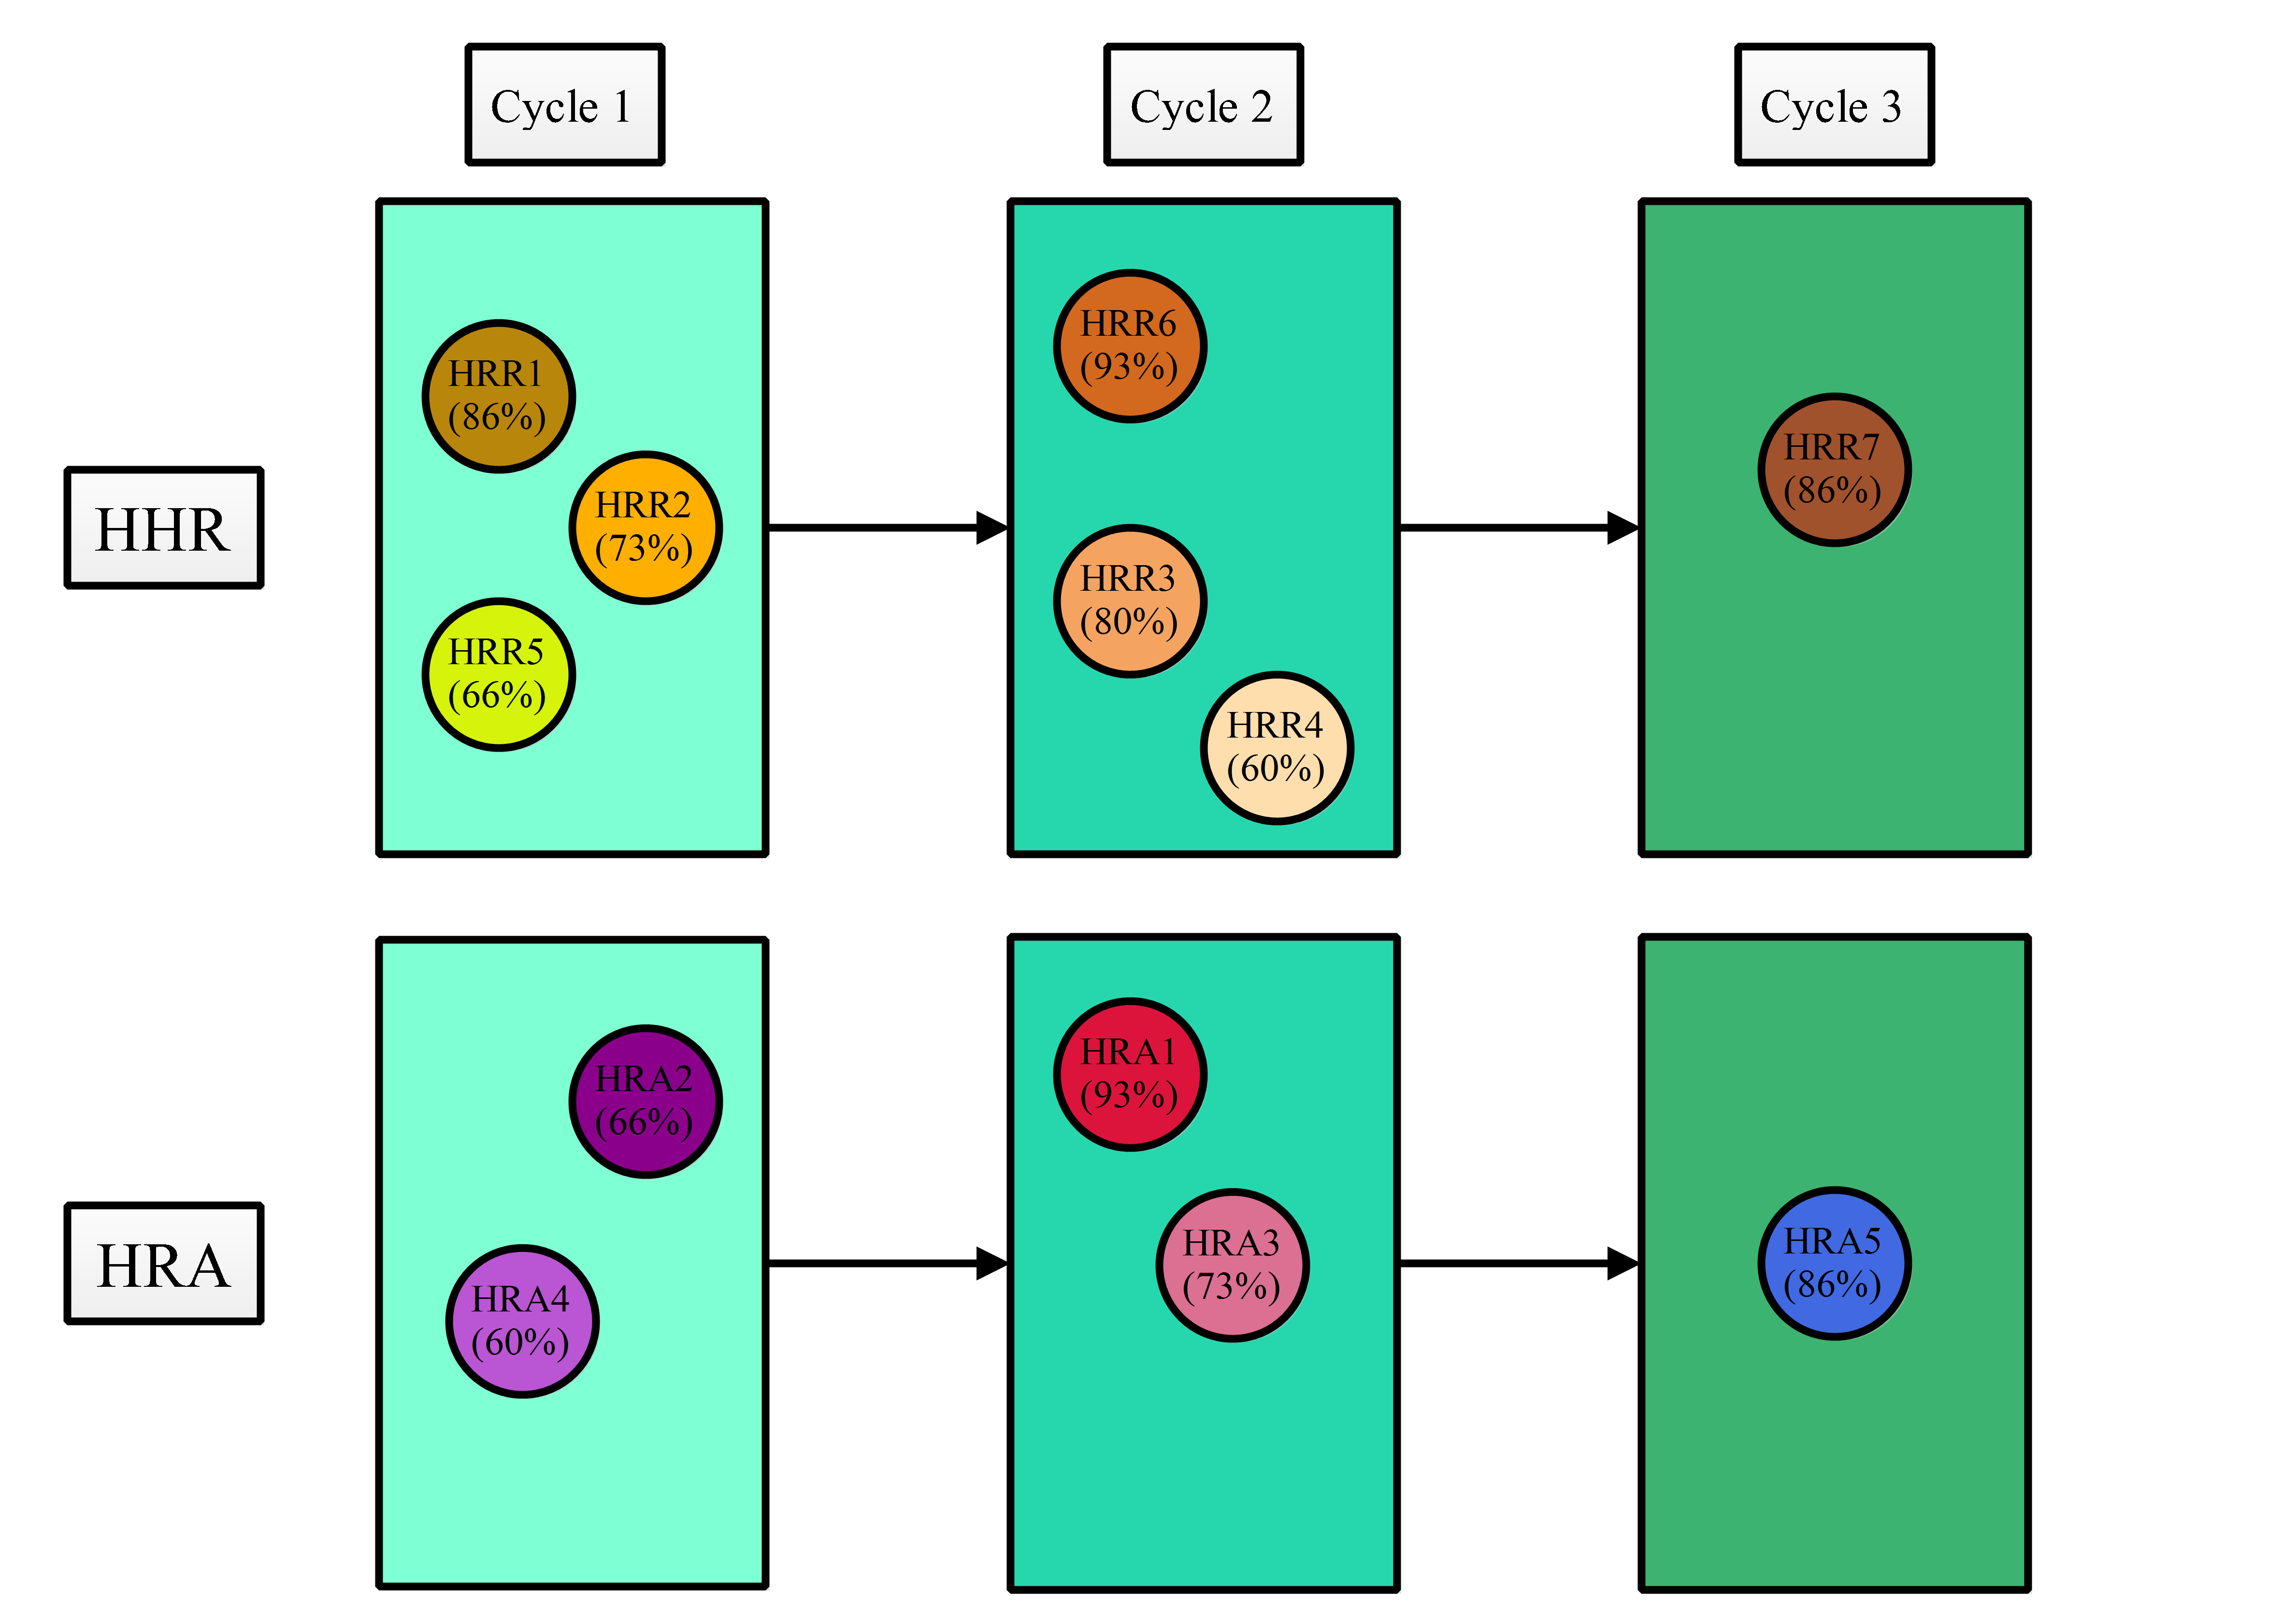
Fig. 16. The outcomes of CD for flood mitigation strategies in the case study.
The Flood Action Plan (FAP) has been developed and presented from various perspectives and scales in different studies. Some studies have aimed to increase citizen responsibility and government performance in flood damage prevention (Brammer, 2010), while others have focused on irrigation, animal livelihood, and pollution control in more developed countries (Newson et al., 2022). In this study, the FAP concentrates on local operation functions and short reaction times, with a focus on utilising all facilities for human health control in developing countries (Akbarian et al., 2022b). The presented plan considers hydrological, social, economic, and political factors as well as available human resources.
Another approach to the FAP is the online assessment of water volume in natural channels using satellite images, as seen in El Faid City, Morocco (Ali et al., 2022). However, this study's crisis management approach is based on available facilities and potential risks, which can be further supported by experts and managers. The methodology used in this study is based on endogenous solutions, with experts serving as the executive trustee board for accurate implementation during a flood.
In the other approach, Khamutova et al. (2022) developed an idea for the presentation of dynamic FAP based on the volume of damage in different regions. Likewise, in the present research, and risk analysis, the corresponding solutions are conveyed in different scenarios and conditions. In fact, the model developed in this study covers all hydrological, social, economic, political and available human resources.
In the present study, the crisis management approach is based on the available facilities and potential risks that can be more supported by experts and managers. In other words, the policy applied in this study was based on endogenous solutions (Kumar et al., 2022). However, the limitations of the present study can be divided in three sections, model uncertainty, data limitations and representativeness and, simplified assumptions. About the model uncertainty, the methodology relies on the use of various modeling techniques, including flash flood simulation modeling, statistical methods, and artificial intelligence algorithms. These models have inherent uncertainties and limitations. The accuracy of the flash flood simulation model (WMS) depends on the representation of hydrological processes and the input data used. The statistical methods applied for data trimming may introduce subjectivity and potential bias in the data selection process. The AI algorithms (SVM, ANN, and NNC) used for flood prediction and classification are based on assumptions and trained on available data, which may not capture all the complex factors influencing flash floods. These uncertainties in the models can affect the reliability and robustness of the results and should be considered when interpreting the findings. Data limitations and representativeness could be subjected to the dependence of the methodology on the data collection from the Khosf region in Iran. The representativeness of this data for the broader population or other arid regions is unclear. The data used for flood simulation modeling, statistical analysis, and AI training may not fully capture the range of environmental and climatic conditions that can exist in different regions. Consequently, the generalizability of the results and the applicability of the framework to other arid regions may be limited due to the specificity of the data used in the study. Moreover, the availability and quality of historical data may also impact the accuracy and reliability of the models and subsequent analyses. Also, the methodology involves the use of simplified assumptions and techniques to evaluate and assess risks in vulnerable regions. The geographic evaluations utilizing GIS and the application of FMEA and HAZOP methods may simplify the complexity of risk factors and their interdependencies. These simplifications can overlook certain nuanced aspects of risk, such as socio-economic factors, local knowledge, and institutional dynamics, which are critical for comprehensive risk management. Consequently, the framework's ability to capture and address the full spectrum of risks and their impacts may be limited by the assumptions and simplifications made in the methodology.
The Monte Carlo method is also used in this study to perform sensitivity analysis using Sobol's indices in MATLAB (2019b). This analysis aims to assess the individual contributions of input variables (temperature, vegetation cover, precipitation, and flood flow) to the occurrence of floods. The input variables are combined into a matrix called X, which serves as the basis for the subsequent analysis. The Sobol's indices are then calculated using the sobol’s Indices (X, Y) function. This function employs a permutation-based approach, iterating over each input variable. For each variable, its values are permuted while keeping the other variables constant. A linear regression model is fitted using the permuted input matrix and the output variable (flood occurrence). The resulting R-squared values, representing the proportion of variance in flood occurrence explained by each input variable, are stored as Sobol's indices in an array that is shown as Tornado diagram demonstrated in Fig. 17.
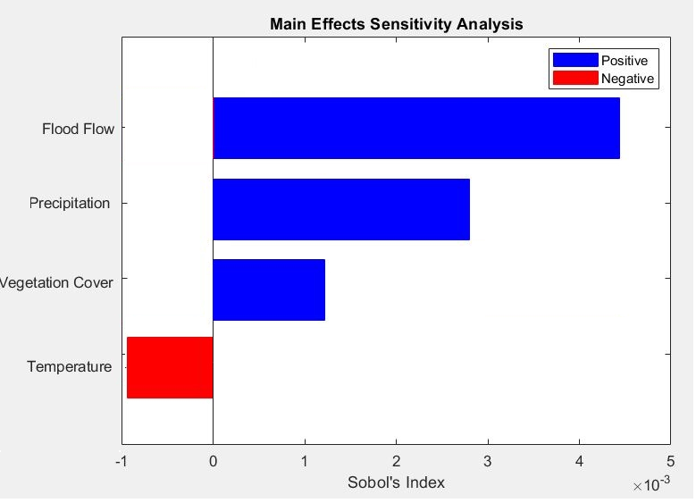
Fig. 17. The Tornado diagram of sensitive analysis of input data on flood occurrence in this study.
Flood flow, with a Sobol's index of 4.7×10⁻³, holds significant importance in flash flood occurrences. Flash floods are sudden and localised rises in water levels and flow rates in rivers and streams. Various factors, such as watershed size, land use changes, channel morphology, and river network properties, influence the magnitude of flood flow. Accurate flood forecasting and warning systems require understanding the relationship between flood flow and flash floods. Timely monitoring of river levels, flow rates, and hydrological conditions enables anticipation of flash flood events and early warnings to at-risk communities. Analysing flood flow patterns helps hydrologists and emergency management agencies make informed decisions on evacuation protocols, emergency response strategies, and infrastructure planning to mitigate flash flood impacts. Although flood flow's Sobol's index is lower compared to temperature, vegetation cover, and precipitation, it represents the actual dynamics of water movement during flash flood events. While other parameters contribute to flash flood occurrence and intensity, flood flow reflects the consequences of these events on the hydrological system. Therefore, understanding and monitoring flood flow are vital components of comprehensive flash flood risk management strategies (Dahri and Abida, 2017). Precipitation plays a critical role in the occurrence of flash floods, as they are primarily driven by intense and localised precipitation events. These events can result from various meteorological phenomena, such as convective storms, frontal systems, or orographic lifting. The precipitation index, with a value of 2.9×10⁻³, emphasises its strong influence on flash flood occurrences. Understanding the characteristics of precipitation events is crucial for effective flash flood risk assessment and forecasting. This includes evaluating factors such as the intensity, duration, and spatial distribution of rainfall. By improving precipitation monitoring systems, early warning capabilities, and predictive models, it becomes possible to enhance flash flood preparedness and response. Timely and accurate information about precipitation patterns, including the identification of heavy rainfall events and their potential impacts, can help authorities issue appropriate warnings, implement evacuation measures, and coordinate emergency response efforts. Furthermore, ongoing research and technological advancements in precipitation forecasting can contribute to the development of more robust and reliable flash flood prediction models, ultimately leading to enhanced resilience in flash flood-prone regions (Chiang et al., 2007).
Vegetation cover plays a vital role in flash flood dynamics. Vegetation acts as a natural buffer by intercepting rainfall, promoting infiltration, and reducing surface runoff. It helps regulate water flow and prevents the rapid generation of runoff during intense rainfall events, mitigating the risk of flash floods. Additionally, vegetation cover contributes to the overall stability of slopes and reduces soil erosion, which can further minimise flash flood hazards. Changes in land use, such as deforestation or urbanisation, can substantially alter vegetation cover, resulting in decreased infiltration rates, increased surface runoff, and elevated flash flood risks. Therefore, protecting and restoring vegetation cover in flash flood-prone areas is crucial for reducing vulnerability to flash floods and maintaining the natural hydrological balance. Strategic land management practices, afforestation efforts, and land-use planning that prioritise vegetation conservation can contribute to effective flash flood mitigation strategies and enhance overall resilience to flash flood events (Mohamed and Worku, 2021).
In the sensitivity analysis, the temperature has a weight of -0.95×10⁻³, indicating a reverse relationship with flood occurrence, according to the Monte Carlo assessment. Flash floods are often triggered by intense rainfall events, and temperature plays a crucial role in modulating the meteorological conditions that lead to such events. Higher temperatures can increase the evaporation rate, potentially resulting in more moisture in the atmosphere. This increased moisture availability, combined with other atmospheric factors, can contribute to the formation of convective storms that generate heavy rainfall and, consequently, flash floods. The significant Sobol's index for temperature (-0.95×10⁻³) indicates that changes in temperature can have a substantial impact on flash flood occurrences. As temperatures rise due to climate change or natural variability, the likelihood of extreme rainfall events and flash floods may also increase. Therefore, understanding the relationship between temperature and flash floods is crucial for effective flash flood management and adaptation strategies (Gázquez et al., 2016).
Precipitation plays a critical role in the occurrence of flash floods, as they are primarily driven by intense and localized precipitation events. These events can result from various meteorological phenomena, such as convective storms, frontal systems, or orographic lifting. The Sobol's index for precipitation, with a value of 0.73, emphasizes its strong influence on flash flood occurrences. Understanding the characteristics of precipitation events is crucial for effective flash flood risk assessment and forecasting. This includes evaluating factors such as the intensity, duration, and spatial distribution of rainfall. By improving precipitation monitoring systems, early warning capabilities, and predictive models, it becomes possible to enhance flash flood preparedness and response. Timely and accurate information about precipitation patterns, including the identification of heavy rainfall events and their potential impacts, can help authorities issue appropriate warnings, implement evacuation measures, and coordinate emergency response efforts. Furthermore, ongoing research and technological advancements in precipitation forecasting can contribute to the development of more robust and reliable flash flood prediction models, ultimately leading to enhanced resilience in flash flood-prone regions (Chiang et al., 2007).

Managerial perspective and decision support systems
The findings of the present study need to be put into practice in the case study to be useful. More specifically, this area of Iran is prone to destructive floods, and sustainable development can serve as a reliable guide for managing this issue effectively (Gheibi et al., 2022). The study is closely linked to two parameters of sustainable development: good health and well-being (Mohammadi et al., 2021; Erfani et al., 2019) and sustainable cities and communities (Gheibi et al., 2018; Shahsavar et al., 2021).
As there has been an increasing trend in the use of decision support systems (DSS) in recent years (2014-2022) (see bibliographic analysis in Fig. A.9), we propose a DSS as illustrated in Fig. 18 based on the findings in this study. DSS platforms generally have a wide range of applications and can be particularly useful for rapidly detecting problems and pursuing sustainable management practices. The DSS proposed in this study involves weather and field monitoring to collect historical data, which can be used to develop AI models for forecasting future conditions. The accurate data gathered through digital modelling applications such as GIS and WMS serves as the basis for various AI equipment used to build ML models. The system also involves analysing potential crisis scenarios with the help of experts to better manage them and ensure the safety and security of cities. It is important for managers/decision makers to consider using these smart systems to better manage flood crises by prioritising flood risks and implementing appropriate solutions to mitigate them.
The other aspect of the work concerns sustainable development in terms of good health and well-being. The decision support system proposed by the study can be environmentally friendly in terms of flood and water storage management, increasing safety and stabilising the economic conditions of the area (Shahsavar et al., 2022). Ultimately, by providing a reliable and accurate database, experts and decision-makers can make informed decisions that promote good health and well-being and sustainable cities and communities.
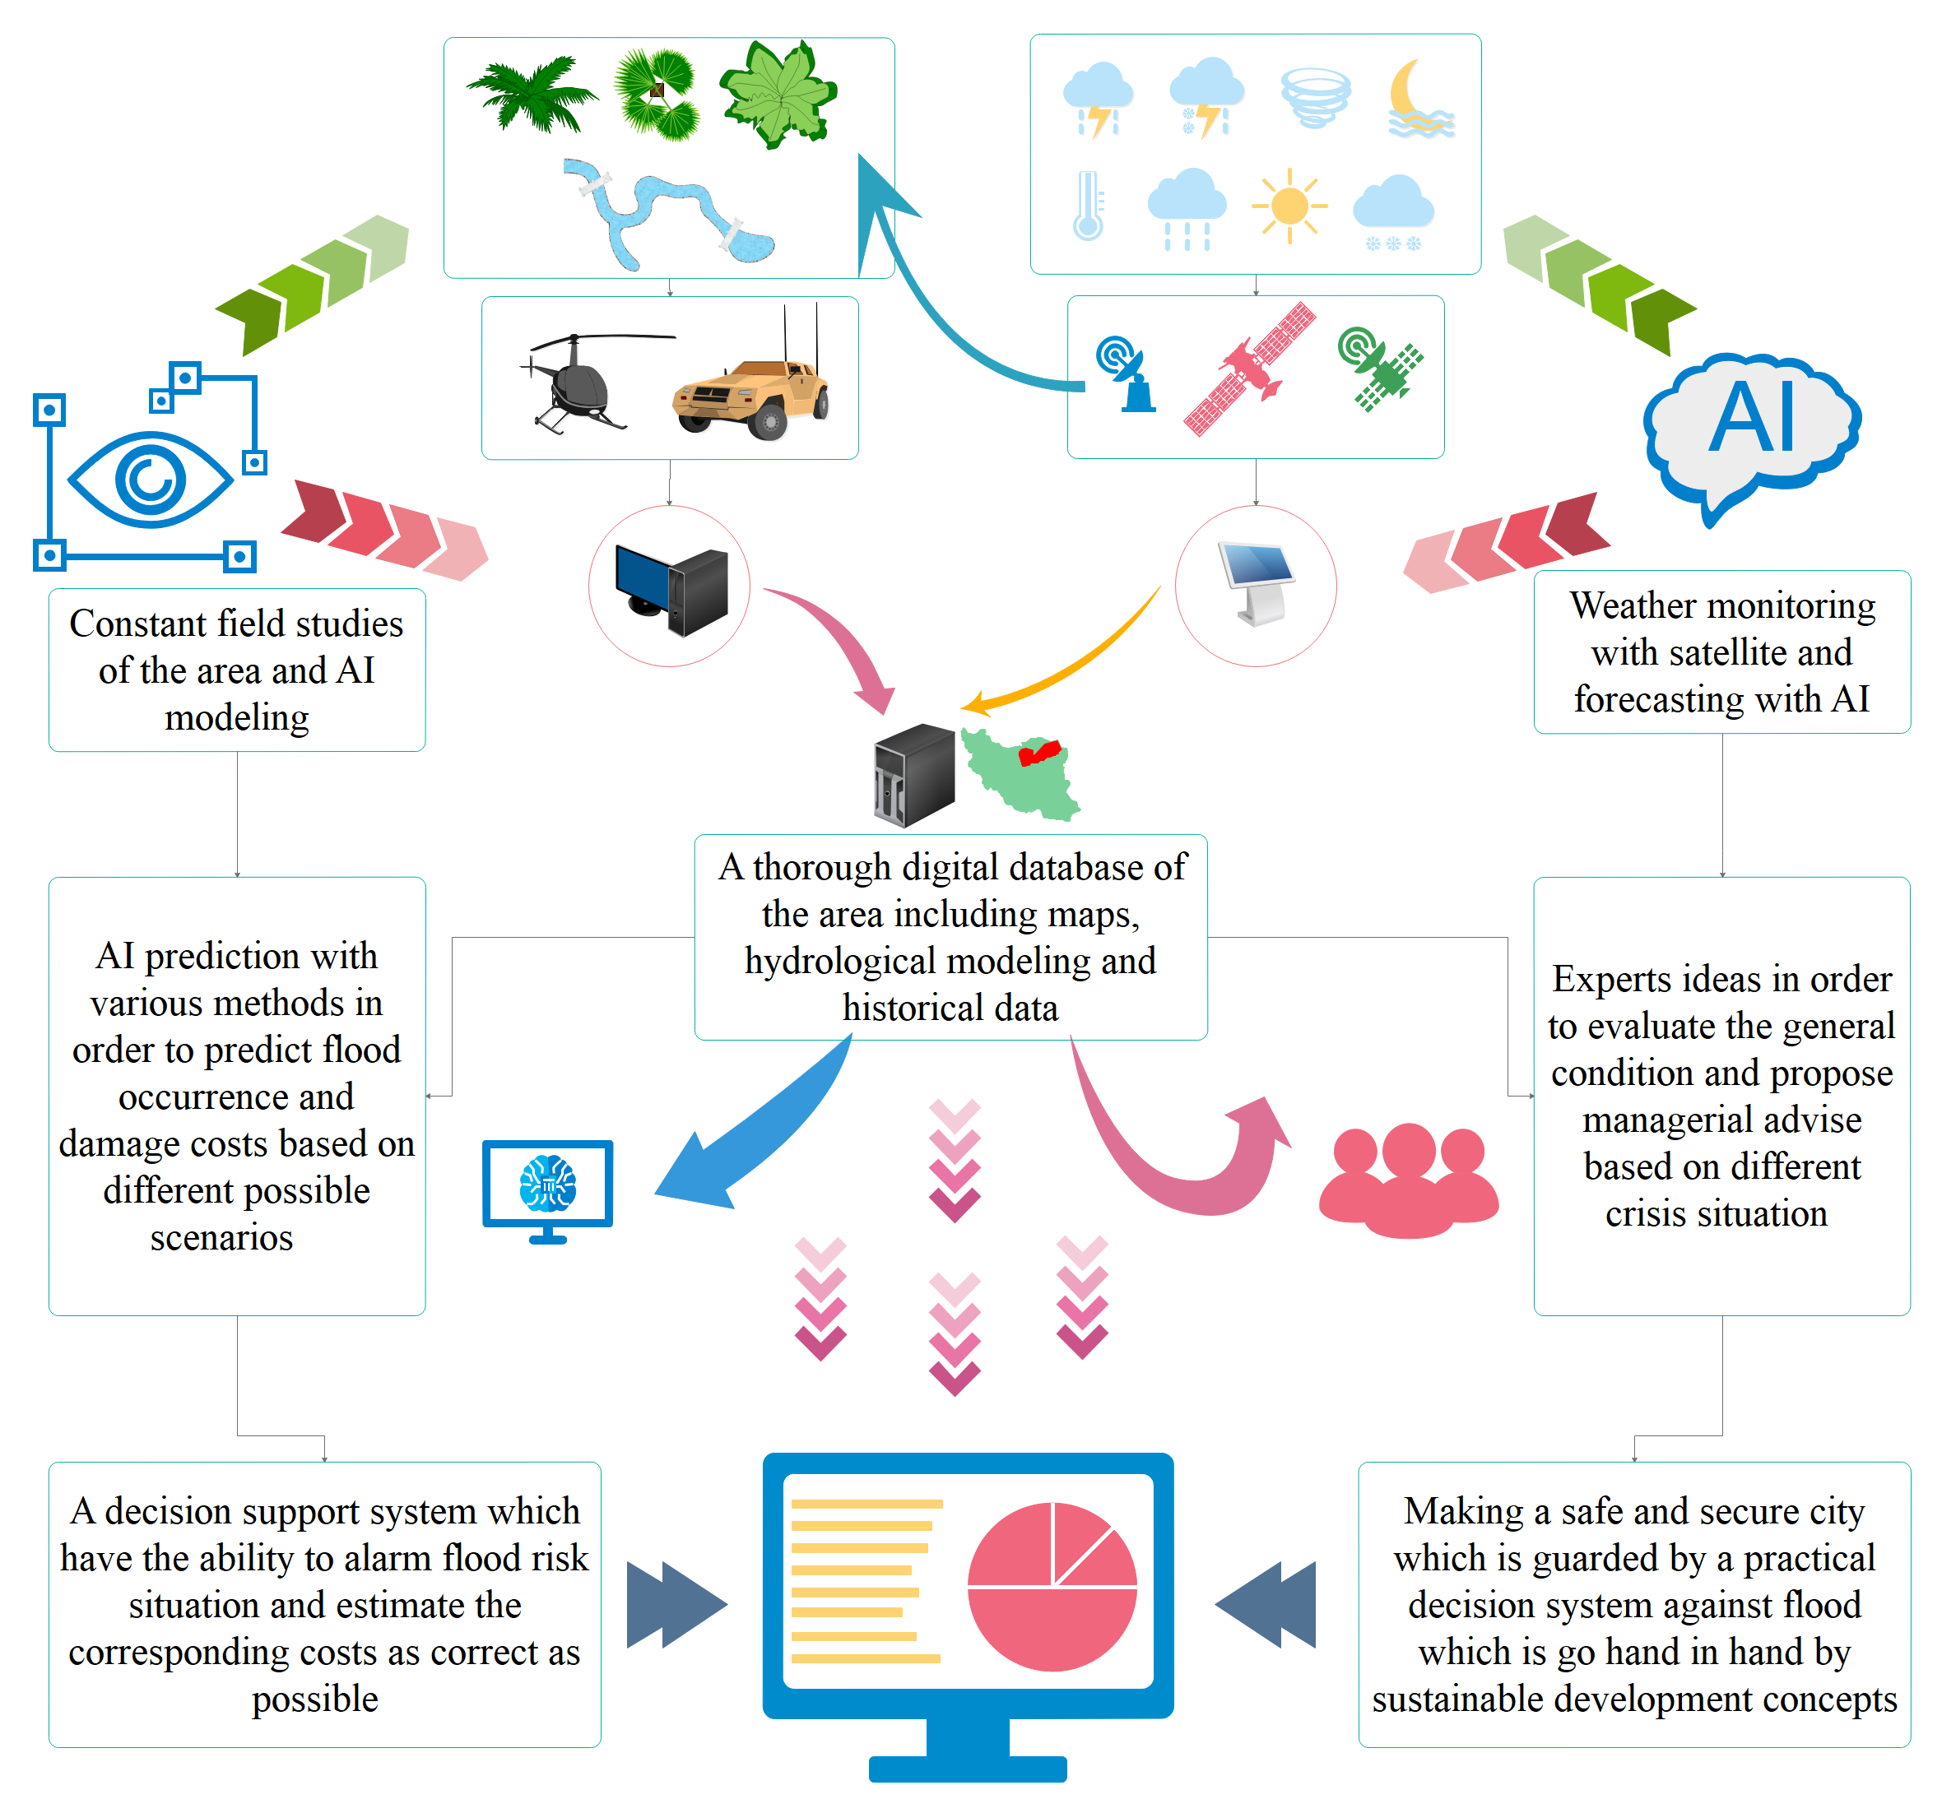
Fig. 18. The conceptual model for the decision support system proposed by the findings of this study

Future research

This study employs several AI methods (e.g., SVM, NNC and ANN) to predict and classify flash flood occurrences. However, there are plenty of other AI algorithms that are yet to be applied for solving challenging decision problems about this study. For example, to simplify the berth scheduling at marine container terminals and reduce the overall vessel service cost, a novel memetic method with deterministic parameter control has been developed by Dulebenets (2017). The study employed a local search heuristic that uses the first-come, first-served principle at the chromosomes and during the initialisation of the population stage in the developed memetic algorithm. Moreover, a learning approach is suggested by Zaho and Zhang (2019) in order to improve generalisation capabilities to solve many objective problems. A learning automaton (LA) is incorporated into the algorithm on the foundation of a many-objective optimisation framework based on decomposition. Furthermore, in order to help with the cross-docking terminal trucks (CDT) operations planning, a new Adaptive Polyploid Memetic Algorithm (APMA) has been developed by Dulebenets (2020) for the issue of scheduling CDT vehicles. Kavoosi et al., (2019) developed a novel island-based metaheuristic algorithm to solve the marine transportation berth scheduling problem and reduce the total cost of accommodating arriving boats at the marine container terminals. To search for islands, four different population-based metaheuristics are used in this study, including the evolutionary algorithm (EA), particle swarm optimization (PSO), estimation of distribution algorithm (EDA), and differential evolution (DE). In addition, in order to discover the best order of routes for each ambulance and reduce the latest service completion time as well as the number of patients whose conditions deteriorate as a result of obtaining delayed medical care, Rabbani et al. (2021) employed a mixed-integer linear programming model. Finding high-quality solutions quickly is done using Multi-Objective Particle Swarm Optimisation (MOPSO) and Non-dominated Sorting Genetic Algorithm II (NSGA-II). Pasha et al., (2022) created a novel multi-objective optimisation model for the vehicle routing problem with a factory-in-a-box that tries to reduce the overall cost associated with traversing the network's edges and the total cost associated with visiting network nodes. As a solution strategy, a customised multi-objective hybrid metaheuristic solution algorithm that explicitly considers problem-specific features is devised.

This study also suggests conducting a comparative analysis of different flood simulation modeling tools, such as Watershed Modelling System (WMS), with other available models to assess their accuracy and suitability for arid regions. This aims to compare their performance in different geographical and climatic contexts to identify the strengths and limitations of each model. This analysis can also provide insights into the most appropriate modeling tool for different regions and improve the reliability of flood simulations. Furthermore, exploring the integration of diverse data sources, including satellite imagery, remote sensing data, climate models, and social data, to enhance the accuracy and reliability of the risk management framework. By incorporating a wide range of data types and sources, the framework can capture a more comprehensive understanding of the factors influencing flood risks in arid regions and improve the effectiveness of risk assessment and decision-making processes. In addition, integrating socio-economic factors into the risk management framework for better understanding of the impacts of flash floods on communities in arid regions plus considering aspects, such as population density, infrastructure vulnerabilities, economic indicators, and social dynamics. Furthermore, conducting in-depth stakeholder engagement activities is crucial to ensure the framework's relevance and acceptance by local communities, policymakers, and other relevant stakeholders. Additionally, exploring the integration of participatory decision-making approaches and stakeholder feedback mechanisms can enhance the inclusivity and effectiveness of the decision-making module in the framework.

Conclusions
This study developed a smart framework for assessing flash flood risk to improve community resilience in arid regions. The framework consists of three components: (1) integration of GIS-WMS simulsoft sensorsI computations to create flash flood predictions using soft-sensors; (2) development of a valid decision databank through the integration of Classic Delphi method and risk assessment techniques for flash flood events; (3) combination of WMS simulation with FMEA/HAZOP risk models to identify hazardous sites during flash flooding. The main objectives of the study were to: (1) assess the feasibility of using AI-based soft-sensors for early flood warning; (2) minimise the time required for decision-making during flash flood events through smart flood risk management; (3) provide useful managerial insights by proposing a DSS in flash flood disasters.
The GIS-WMS model proved to be highly accurate in providing values for flash-flood flow, which were used to populate the databank of AI systems. Regression evaluations revealed that precipitation and vegetative ground covers had the most significant effect on flash flood damage costs in the study. The most efficient algorithms for classification and prediction were found to be NNC (with an R² value of 0.89) and two-three degrees of polynomial regression (with an R² value of 0.82).
The results in the case study showed, using both FMEA and HAZOP risk analysis methods, points A and C were classified as HRR, and the CD method identified the best solution for reducing flood damage costs at these points as HHR1. This solution involved the installation of surveillance cameras equipped with image processing systems to detect rising water in the seasonal riverbed quickly, with 86% of experts agreeing in the first cycle. Point B was classified as HRA, and the most effective solution for this point was similar to the previous points (A and C) and involved the implementation of image processing technology, with 66% of experts agreeing in the first cycle. This framework and the findings of this study can help in developing better early action and fast reaction flood control systems for the areas that are at high risk of flash floods especially in developing countries by providing valuable managerial insights in flash flood disasters. This can also help for better early action and fast reaction of flood control systems.
Comparing different geographical lands in terms of hydrologic modelling and AI application would provide valuable insights and help create a more comprehensive decision support system. Additionally, using AI-computer vision techniques could be a promising alternative to the current integration of WMS and GIS. Furthermore, the combination of CD and risk analysis online could lead to an even more efficient flood control system. Additionally, the application of System Dynamic models could be an attractive option for smart decision-making in flood risk control. Lastly, the idea of coupling System Dynamic models with knowledge management in flash-flood control approaches and creating Dynamic Knowledge Management is an innovative concept that could lead to improved decision-making in the field. These suggestions could inspire future research and help advance the field of flood risk management.

Notations
Category | Notation | Description
Abbreviations | IDMC | Internal Displacement Monitoring Centre
 | CRED | Centre for Research on the Epidemiology of Disasters
 | GIS | Geographic Information System
 | WMS | Watershed Modeling System
 | AI | Artificial Intelligent
 | SVM | Support Vector Machine
 | NN | Neural Network
 | NNC | Nearest Neighbors Classification
 | LPR | Linear & Polynomial Regression
 | FMEA | Failure Mode and Effects Analysis
 | HAZOP | Hazard and Operability
 | CD | Classical Delphi
 | DSS | Decision Support System
 | Sin | The sinuosity factor of the stream
 | CSS | The slope of the CSD
 | CSD | The distance from the centroid of the basin to a point in the stream which is a part of the MFD
 | MFS | The slope of the catchment
 | MFD | The maximum flow distance within a basin including both overland and channel flow
 | AVEL | The mean basin elevation
 | SF | The percentage of the basin whose aspect is directed South where South is defined as the negative Y  direction
 | P | The perimeter of the basin
 | A | The area of the basin in the units specified prior to computing basin parameters
 | PI | Primary Infiltration
 | IP | Impenetrable Percentage
 | CN | Curve Number
 | MCN | Mean Curved Number
 | D | Detectability rate
 | O | Occurrence rate
 | S | Severity rate
 | RI | Risk Intensity
 | RP | Risk Possibility
 | RM | Risk Matrix
 | FUM | Ferdowsi University of Mashhad
 | BUT | Birjand University of Technology
 | UT | University of Tehran
 | MUSD | Million United State Dollar
 | DEM | Digital Elevation Model
 | HRR | High-Risk Regions
 | HRA | High Resilience Area
 | FAP | Flood Action Plan
Variables | S | Potential maximum retention
 | Pr | Rainfall
 | Q | Runoff volume
 | Δh | Difference of maximum and minimum height of region
 | L | Flow length
 | Tc | Time of concentration

References
Abd El Shafy, M., & Mostafa, A. (2021). Flash Flood Modeling Using HEC-RAS (2D) model on Wadi Reem in the western region, Kingdom of Saudi Arabia. Journal of Egyptian Academic Society for Environmental Development. D, Environmental Studies, 22(1), 17-32.
Akbarian, H., Gheibi, M., Hajiaghaei-Keshteli, M., & Rahmani, M. (2022a). A hybrid novel framework for flood disaster risk control in developing countries based on smart prediction systems and prioritized scenarios. Journal of environmental management, 312, 114939.
Akbarian, H., Jalali, F. M., Gheibi, M., Hajiaghaei-Keshteli, M., Akrami, M., & Sarmah, A. K. (2022b). A sustainable Decision Support System for soil bioremediation of toluene incorporating UN sustainable development goals. Environmental Pollution, 119587.
Al Qundus, J., Dabbour, K., Gupta, S., Meissonier, R., & Paschke, A. (2020). Wireless sensor network for AI-based flood disaster detection. Annals of Operations Research, 1-23.
Ali, A., Khattabi, A., & Lahssini, S. (2022). Characterizing fluvial geomorphological change using Google Earth Engine (GEE) to support sustainable flood management in the rural municipality of El Faid. Arabian Journal of Geosciences, 15(5), 1-16.
Al-Zahrani, M., Al-Areeq, A. and Sharif, H.O., 2017. Estimating urban flooding potential near the outlet of an arid catchment in Saudi Arabia. Geomatics, Natural Hazards and Risk, 8(2), pp.672-688.
Arora, A., Arabameri, A., Pandey, M., Siddiqui, M. A., Shukla, U. K., Bui, D. T., ... & Bhardwaj, A. (2021). Optimization of state-of-the-art fuzzy-metaheuristic ANFIS-based machine learning models for flood susceptibility prediction mapping in the Middle Ganga Plain, India. Science of the Total Environment, 750, 141565.
Avand, M., & Moradi, H. (2021). Using machine learning models, remote sensing, and GIS to investigate the effects of changing climates and land uses on flood probability. Journal of Hydrology, 595, 125663.
Avand, M., Kuriqi, A., Khazaei, M., & Ghorbanzadeh, O. (2022). DEM resolution effects on machine learning performance for flood probability mapping. Journal of Hydro-environment Research, 40, 1-16.
Begnudelli, L., Sanders, B. F., & Bradford, S. F. (2008). Adaptive Godunov-based model for flood simulation. Journal of Hydraulic Engineering, 134(6), 714-725.
Bera, S., Das, A., & Mazumder, T. (2022). Evaluation of machine learning, information theory and multi-criteria decision analysis methods for flood susceptibility mapping under varying spatial scale of analyses. Remote Sensing Applications: Society and Environment, 25, 100686.
Bralewski, A., & Bralewska, K. (2021). Publicly Available Data-Based Flood Risk Assessment Methodology: A Case Study for a Floodplain in Poland. Water, 14(1), 61.
Brammer, H. (2010). After the Bangladesh flood action plan: looking to the future. Environmental Hazards, 9(1), 118-130.
Chiang, Y.M., Hsu, K.L., Chang, F.J., Hong, Y. and Sorooshian, S., 2007. Merging multiple precipitation sources for flash flood forecasting. Journal of Hydrology, 340(3-4), pp.183-196.
Chang, K.H. and Cheng, C.H., 2010. A risk assessment methodology using intuitionistic fuzzy set in FMEA. International Journal of Systems Science, 41(12), pp.1457-1471.
Chao, L., Zhang, K., Yang, Z. L., Wang, J., Lin, P., Liang, J., ... & Gu, Z. (2021). Improving flood simulation capability of the WRF-Hydro-RAPID model using a multi-source precipitation merging method. Journal of Hydrology, 592, 125814.
Chen, C., Jiang, J., Liao, Z., Zhou, Y., Wang, H., & Pei, Q. (2022). A short-term flood prediction based on spatial deep learning network: A case study for Xi County, China. Journal of Hydrology, 607, 127535.
Chen, J., Li, Y., Zhang, C., Tian, Y. and Guo, Z., 2023. Urban Flooding Prediction Method Based on the Combination of LSTM Neural Network and Numerical Model. International Journal of Environmental Research and Public Health, 20(2), p.1043.
Chen, Y. C., Chang, T. Y., Chow, H. Y., Li, S. L., & Ou, C. Y. (2022). Using Convolutional Neural Networks to Build a Lightweight Flood Height Prediction Model with Grad-Cam for the Selection of Key Grid Cells in Radar Echo Maps. Water, 14(2), 155.
Dtissibe, F.Y., Ari, A.A.A., Titouna, C., Thiare, O. and Gueroui, A.M., 2020. Flood forecasting based on an artificial neural network scheme. Natural Hazards, 104, pp.1211-1237.
Dulebenets, M.A., 2017. A novel memetic algorithm with a deterministic parameter control for efficient berth scheduling at marine container terminals. Maritime Business Review.
Dulebenets, M.A., 2021. An Adaptive Polyploid Memetic Algorithm for scheduling trucks at a cross-docking terminal. Information Sciences, 565, pp.390-421.
Elmer, F., Seifert, I., Kreibich, H. and Thieken, A.H., 2010. A Delphi method expert survey to derive standards for flood damage data collection. Risk analysis: An international journal, 30(1), pp.107-124.
Erfani, S. M. H., Danesh, S., Karrabi, S. M., Gheibi, M., & Nemati, S. (2019). Statistical analysis of effective variables on the performance of waste storage service using geographical information system and response surface methodology. Journal of environmental management, 235, 453-462.
Ertan, S., & Çelik, R. N. (2021). The Assessment of Urbanization Effect and Sustainable Drainage Solutions on Flood Hazard by GIS. Sustainability, 13(4), 2293.
Fazel-Rastgar, F. (2020). Contribution of deforestation to severe flooding in southeast parts of the Caspian Sea: a case study with NDVI analysis. Journal of Extreme Events, 7(01n02), 2050008.
Feng, C., Zhang, N., Habiyakare, T., Yan, Y., & Zhang, H. (2021). Prospects of eco-hydrological model for sponge city construction. Ecosystem Health and Sustainability, 7(1), 1994885.
Garen, D.C. and Moore, D.S., 2005. Curve number hydrology in water quality modeling: uses, abuses, and future directions 1. JAWRA Journal of the American Water Resources Association, 41(2), pp.377-388.
Gázquez, F., Calaforra, J.M. and Fernández-Cortés, Á., 2016. Flash flood events recorded by air temperature changes in caves: A case study in Covadura Cave (SE Spain). Journal of Hydrology, 541, pp.136-145.
Gheibi, M., Eftekhari, M., Akrami, M., Emrani, N., Hajiaghaei-Keshteli, M., Fathollahi-Fard, A.M., Yazdani, M. (2022). A Sustainable Decision Support System for Drinking Water Systems: Resiliency Improvement against Cyanide Contamination. Infrastructures, 7, 88.
Gheibi, M., Emrani, N., Eftekhari, M., Akrami, M., Abdollahi, J., Ramezani, M., & Sedghian, A. (2019). Experimental investigation and mathematical modeling for microbial removal using potassium permanganate as an oxidant—case study: water treatment plant No. 1, Mashhad, Iran. Environmental monitoring and assessment, 191(3), 1-10.
Gheibi, M., Karrabi, M., Shakerian, M., & Mirahmadi, M. (2018). Life cycle assessment of concrete production with a focus on air pollutants and the desired risk parameters using genetic algorithm. Journal of environmental health science and engineering, 16(1), 89-98.
Ghosh, S., Kumar, D., & Kumari, R. (2022). Evaluating the impact of flood inundation with the cloud computing platform over vegetation cover of Ganga Basin during COVID-19. Spatial Information Research, 30(2), 291-308.
Gowthamani, R., Rani, K. S. K., Abishek, S. R., Akash, G., & Kumar, A. K. (2021). Efficient detection and prediction of flood severity using machine learning algorithm. Materials Today: Proceedings, 47, 376-380.
Goyal, H. R., Ghanshala, K. K., & Sharma, S. (2021). Post flood management system based on smart IoT devices using AI approach. Materials Today: Proceedings, 46, 10411-10417.
Grimaldi, S., Petroselli, A., Tauro, F. and Porfiri, M., 2012. Time of concentration: a paradox in modern hydrology. Hydrological Sciences Journal, 57(2), 217-228.
Haile, A. T., & Rientjes, T. H. M. (2005). Effects of LiDAR DEM resolution in flood modelling: a model sensitivity study for the city of Tegucigalpa, Honduras. Isprs wg iii/3, iii/4, 3, 12-14.
Hashim, H. Q., & Sayl, K. N. (2021). Detection of suitable sites for rainwater harvesting planning in an arid region using geographic information system. Applied Geomatics, 13(2), 235-248.
Hishinuma, K., & Iiduka, H. (2019). Incremental and parallel machine learning algorithms with automated learning rate adjustments. Frontiers in Robotics and AI, 6, 77.
Hong, Y., & Abdelkareem, M. (2022). Integration of remote sensing and a GIS-based method for revealing prone areas to flood hazards and predicting optimum areas of groundwater resources. Arabian Journal of Geosciences, 15(1), 1-14.
Hosseinzadeh, A., Behzadian, K., Rossi, P., Karami, M., Ardeshir, A., & Torabi Haghighi, A. (2023). A new multi‐criteria framework to identify optimal detention ponds in urban drainage systems. Journal of Flood Risk Management, e12890.
Hu, C., Xia, J., She, D., Song, Z., Zhang, Y., & Hong, S. (2021). A new urban hydrological model considering various land covers for flood simulation. Journal of Hydrology, 603, 126833.
Iqbal, U., Perez, P., Li, W., & Barthelemy, J. (2021). How computer vision can facilitate flood management: A systematic review. International Journal of Disaster Risk Reduction, 53, 102030.
Islam, A.R.M.T., Talukdar, S., Mahato, S., Kundu, S., Eibek, K.U., Pham, Q.B., Kuriqi, A. and Linh, N.T.T., 2021. Flood susceptibility modelling using advanced ensemble machine learning models. Geoscience Frontiers, 12(3), p.101075.
Izanloo, A., Zabet, M., Ramazani, S. H. R., & Jami, A. (2019). Evaluation of different ecotypes of fennel based on morpho-phenological and quantitative characteristics under water stress conditions. Agroecology, 11(3), 877-892.
Jadouane, A., & Chaouki, A. (2022). Simulation of the Flood of El Maleh River by GIS in the City of Mohammedia-Morocco. In Climate Change and Water Security (pp. 93-104). Springer, Singapore.
Kalantar, B., Ueda, N., Saeidi, V., Janizadeh, S., Shabani, F., Ahmadi, K., & Shabani, F. (2021). Deep neural network utilizing remote sensing datasets for flood hazard susceptibility mapping in Brisbane, Australia. Remote Sensing, 13(13), 2638.
Karami, M., Behzadian, K., Ardeshir, A., Hosseinzadeh, A. and Kapelan, Z., (2022). A multi-criteria risk-based approach for optimal planning of SuDS solutions in urban flood management. Urban Water Journal, 19(10), pp.1066-1079.
Kavoosi, M., Dulebenets, M.A., Abioye, O., Pasha, J., Theophilus, O., Wang, H., Kampmann, R. and Mikijeljević, M., 2019. Berth scheduling at marine container terminals: A universal island-based metaheuristic approach. Maritime Business Review, 5(1), pp.30-66.
Kelly, M., Schwarz, I., Ziegelaar, M., Watkins, A.B. and Kuleshov, Y., 2023. Flood Risk Assessment and Mapping: A Case Study from Australia’s Hawkesbury-Nepean Catchment. Hydrology, 10(2), p.26.
Khamutova, M. V., Kushnikov, V. A., & Dranko, O. I. (2022). A mathematical model for choosing an action plan for the prevention and elimination of flood effects. IFAC-PapersOnLine, 55(3), 113-118.
Kumar, R., Manzoor, S., Vishwakarma, D. K., Al-Ansari, N., Kushwaha, N. L., Elbeltagi, A., ... & Kuriqi, A. (2022). Assessment of climate change impact on snowmelt runoff in himalayan region. Sustainability, 14(3), 1150.
Kunverji, K., Shah, K., & Shah, N. (2021). A Flood Prediction System Developed Using Various Machine Learning Algorithms. Available at SSRN 3866524.
Lin, B., Wicks, J. M., Falconer, R. A., & Adams, K. (2006, March). Integrating 1D and 2D hydrodynamic models for flood simulation. In Proceedings of the institution of civil engineers-water management (Vol. 159, No. 1, pp. 19-25). Thomas Telford Ltd.
Ling, L., Lai, S. H., Yusop, Z., Chin, R. J., & Ling, J. L. (2022). Formulation of Parsimonious Urban Flash Flood Predictive Model with Inferential Statistics. Mathematics, 10(2), 175.
Liu, B., Lu, J., Chen, Y., Sun, P., Zhao, K., Han, M., ... & Yin, Z. (2021). AI-Driven Multiobjective Scheduling Algorithm of Flood Control Materials Based on Pareto Artificial Bee Colony. Wireless Communications and Mobile Computing, 2021.
Liu, Y., Li, Z., Liu, Z., & Luo, Y. (2022). Impact of rainfall spatiotemporal variability and model structures on flood simulation in semi-arid regions. Stochastic Environmental Research and Risk Assessment, 36(3), 785-809.
Liu, Z., Xiong, Y. and Xu, J., 2023. Flood Simulation and Flood Risk Reduction Strategy in Irrigated Areas. Water, 15(1), p.192.
Luino, F., Cirio, C. G., Biddoccu, M., Agangi, A., Giulietto, W., Godone, F., & Nigrelli, G. (2009). Application of a model to the evaluation of flood damage. Geoinformatica, 13(3), 339-353.
Ma, W., Ishitsuka, Y., Takeshima, A., Hibino, K., Yamazaki, D., Yamamoto, K., Kachi, M., Oki, R., Oki, T. and Yoshimura, K., 2021. Applicability of a nationwide flood forecasting system for Typhoon Hagibis 2019. Scientific reports, 11(1), pp.1-12.
Mahato, S., Pal, S., Talukdar, S., Saha, T. K., & Mandal, P. (2021). Field based index of flood vulnerability (IFV): A new validation technique for flood susceptible models. Geoscience Frontiers, 12(5), 101175.
Mahesh, R. B., Leandro, J., & Lin, Q. (2022). Physics Informed Neural Network for Spatial-Temporal Flood Forecasting. In Climate Change and Water Security (pp. 77-91). Springer, Singapore.
Mikaniniki, J., Esmaeilnezhad, M., & Akbarpour, M. (2019). Evaluation of the Vulnerability of Rural Settlements Against Environmental Hazards: A Case Study of Birjand and Khosf. Journal of Rural Research, 10(2), 244-257.
Moezzi, R., Taghavian, H., Gheibi, M., Koci, J. and Cyrus, J., 2023. Integrated HAZard & OPerability study (HAZOP) and Adaptive Neuro Fuzzy Inference System (ANFIS) as an early alarm framework for Glycerin emission control of a chemical plant during floods: A case study of Liberec city, Czech republic (No. EGU23-17416). Copernicus Meetings.
Mohammadi, M., Gheibi, M., Fathollahi-Fard, A. M., Eftekhari, M., Kian, Z., & Tian, G. (2021). A hybrid computational intelligence approach for bioremediation of amoxicillin based on fungus activities from soil resources and aflatoxin B1 controls. Journal of Environmental Management, 299, 113594.
Mohamed, A. and Worku, H., 2021. Urban land cover and morphometric analysis for flash flood vulnerability mapping and riparian landscape conservation in Kebena River watershed, Addis Ababa. Applied Geomatics, 13(1), pp.15-28.
Mourato, S., Fernandez, P., Marques, F., Rocha, A., & Pereira, L. (2021). An interactive Web-GIS fluvial flood forecast and alert system in operation in Portugal. International Journal of Disaster Risk Reduction, 58, 102201.
Newson, M., Lewin, J., & Raven, P. (2022). River science and flood risk management policy in England. Progress in Physical Geography: Earth and Environment, 46(1), 105-123.
O'Brien, J. S., Julien, P. Y., & Fullerton, W. T. (1993). Two-dimensional water flood and mudflow simulation. Journal of hydraulic engineering, 119(2), 244-261.
Ouyang, L., Che, Y., Yan, L. and Park, C., 2022. Multiple perspectives on analyzing risk factors in FMEA. Computers in Industry, 141, p.103712.
Pally, R., & Samadi, S. (2021). Application of Image Processing and Big Data Science for Flood Label Detection. European Geosciences Union.
Panchal, U. K., Ajmani, H., & Sait, S. Y. (2019). Flooding level classification by gait analysis of smartphone sensor data. Ieee Access, 7, 181678-181687.
Pareta, K. and Pareta, U., 2012. Landslide modeling and susceptibility mapping of Giri river watershed, Himachal Pradesh (India). International Journal of Science and Technology, 1(2), pp.91-104.
Parvez, M. R., Hu, W., & Chen, T. (2022). Real-time pattern matching and ranking for early prediction of industrial alarm floods. Control Engineering Practice, 120, 105004.
Pasha, J., Nwodu, A.L., Fathollahi-Fard, A.M., Tian, G., Li, Z., Wang, H. and Dulebenets, M.A., 2022. Exact and metaheuristic algorithms for the vehicle routing problem with a factory-in-a-box in multi-objective settings. Advanced Engineering Informatics, 52, p.101623.
Peddi, S., Lanka, K. and Gopal, P.R.C., 2023. Modified FMEA using machine learning for food supply chain. Materials Today: Proceedings.
Piadeh, F., Behzadian, K. and Alani, A., 2022. A critical review of real-time modelling of flood forecasting in urban drainage systems. Journal of Hydrology, p.127476.
Piadeh, F., Behzadian, K., Chen, A. S., Campos, L. C., and Rizzuto, J. P. 2023 Real-time flood overflow forecasting in Urban Drainage Systems by using time-series multi-stacking of data mining techniques, EGU General Assembly 2023, Vienna, Austria, 24–28 Apr 2023, EGU23-8574, https://doi.org/10.5194/egusphere-egu23-8574, 2023.
Pistrika, A. (2010). Flood damage estimation based on flood simulation scenarios and a GIS platform. European Water, 30, 3-11.
Psomiadis, E., Soulis, K. X., Zoka, M., & Dercas, N. (2019). Synergistic approach of remote sensing and gis techniques for flash-flood monitoring and damage assessment in Thessaly plain area, Greece. Water, 11(3), 448.
Puttinaovarat, S. and Horkaew, P., 2020. Flood forecasting system based on integrated big and crowdsource data by using machine learning techniques. IEEE Access, 8, pp.5885-5905.
Quesada-Román, A., Ballesteros-Cánovas, J. A., Granados-Bolaños, S., Birkel, C., & Stoffel, M. (2022). Improving regional flood risk assessment using flood frequency and dendrogeomorphic analyses in mountain catchments impacted by tropical cyclones. Geomorphology, 396, 108000.
Quintana-Romero, T., & Leandro, J. (2022). A method to devise multiple model structures for urban flood inundation uncertainty. Journal of Hydrology, 604, 127246.
Rabbani, M., Oladzad-Abbasabady, N. and Akbarian-Saravi, N., 2022. Ambulance routing in disaster response considering variable patient condition: NSGA-II and MOPSO algorithms. Journal of Industrial and Management Optimization, 18(2), pp.1035-1062.
Rincón, D., Velandia, J. F., Tsanis, I., & Khan, U. T. (2022). Stochastic Flood Risk Assessment under Climate Change Scenarios for Toronto, Canada Using CAPRA. Water, 14(2), 227.
Saghari, M., Rostampour, M., Mahmoudi Moghaddam, G., & Chakoshi, B. (2019). Investigation of the Effect of Constructing Small Arc Basins System on Vegetation Composition and Biodiversity in Aridland Ecosystems in the East of Iran (Case study: Rangelands of Sarbisheh, South Khorasan Province). Desert Ecosystem Engineering Journal, 8(23), 33-44.
Saint-Fleur, B.E., Allier, S., Lassara, E., Rivet, A., Artigue, G., Pistre, S. and Johannet, A., 2023. Towards a better consideration of rainfall and hydrological spatial features by a deep neural network model to improve flash floods forecasting: case study on the Gardon basin, France. Modeling Earth Systems and Environment, pp.1-16.
Sedighkia, M., & Datta, B. (2022). A simulation-optimization system for evaluating flood management and environmental flow supply by reservoirs. Natural Hazards, 111(3), 2855-2879.
Sermet, Y., & Demir, I. (2019). Towards an information centric flood ontology for information management and communication. Earth Science Informatics, 12(4), 541-551.
Shahabi, H., Shirzadi, A., Ghaderi, K., Omidvar, E., Al-Ansari, N., Clague, J. J., ... & Ahmad, A. (2020). Flood detection and susceptibility mapping using sentinel-1 remote sensing data and a machine learning approach: Hybrid intelligence of bagging ensemble based on k-nearest neighbor classifier. Remote Sensing, 12(2), 266.
Shahsavar, M. M., Akrami, M., Gheibi, M., Kavianpour, B., Fathollahi-Fard, A. M., & Behzadian, K. (2021). Constructing a smart framework for supplying the biogas energy in green buildings using an integration of response surface methodology, artificial intelligence and petri net modelling. Energy Conversion and Management, 248, 114794.
Shahsavar, M. M., Akrami, M., Kian, Z., Gheibi, M., Fathollahi-Fard, A. M., Hajiaghaei-Keshteli, M., & Behzadian, K. (2022). Bio-recovery of municipal plastic waste management based on an integrated decision-making framework. Journal of Industrial and Engineering Chemistry, 108, 215-234.
Shahzadi, S., Ahmad, F., Basharat, A., Alruwaili, M., Alanazi, S., Humayun, M., ... & Naseem, S. (2021). Machine learning empowered security management and quality of service provision in SDN-NFV environment. Computers, Materials & Continua, 66(3), 2723-2749.
Siddiqui, D.N., Nandan, A., Sharma, M. and Srivastava, A., 2014. Risk management techniques HAZOP and HAZID study. Int J Occup Health Saf, Fire Environ Allied Sci, 1(1), pp.5-8.
Sikorska‐Senoner, A. E. (2022). Clustering model responses in the frequency space for improved simulation‐based flood risk studies: The role of a cluster number. Journal of Flood Risk Management, 15(1), e12772.
Stelling, G. S., & Verwey, A. (2006). Numerical flood simulation. Encyclopedia of hydrological sciences.
Talukdar, S., Ghose, B., Salam, R., Mahato, S., Pham, Q. B., Linh, N. T. T., ... & Avand, M. (2020). Flood susceptibility modeling in Teesta River basin, Bangladesh using novel ensembles of bagging algorithms. Stochastic Environmental Research and Risk Assessment, 34(12), 2277-2300.
Van Der Knijff, J. M., Younis, J., & De Roo, A. P. J. (2010). LISFLOOD: a GIS‐based distributed model for river basin scale water balance and flood simulation. International Journal of Geographical Information Science, 24(2), 189-212.
Wallemacq, P. and House, R.U. (2018). CRED report: economic losses, poverty & disasters (1998-2017). Brussels: Centre for Research on the Epidemiology of Disasters (CRED).
Wang, R. Q. (2021). Artificial intelligence for flood observation. In Earth Observation for Flood Applications (pp. 295-304). Elsevier.
Wang, Z., Sun, Y., Li, C., Jin, L., Sun, X., Liu, X., & Wang, T. (2021). Analysis of Small and Medium–Scale River Flood Risk in Case of Exceeding Control Standard Floods Using Hydraulic Model. Water, 14(1), 57.
Wasko, C., Westra, S., Nathan, R., Orr, H. G., Villarini, G., Villalobos Herrera, R., & Fowler, H. J. (2021). Incorporating climate change in flood estimation guidance. Philosophical Transactions of the Royal Society A, 379(2195), 20190548.
Yang, W., Zhang, L. and Gao, Y., 2023. Drought and flood risk assessment for rainfed agriculture based on Copula-Bayesian conditional probabilities. Ecological Indicators, 146, p.109812.
Yeganeh, A., Younesi Heravi, M., Razavian, S.B., Behzadian, K. and Shariatmadar, H., (2022). Applying a new systematic fuzzy FMEA technique for risk management in light steel frame systems. Journal of Asian Architecture and Building Engineering, 21(6), pp.2481-2502.
Zabihi, O., Siamaki, M., Gheibi, M., Akrami, M. and Hajiaghaei-Keshteli, M., 2023. A smart sustainable system for flood damage management with the application of artificial intelligence and multi-criteria decision-making computations. International Journal of Disaster Risk Reduction, 84, p.103470.
Zaffaroni, M., Lopez-Fuentes, L., Farasin, A., Garza, P., & Skinnemoen, H. (2019). AI-based flood event understanding and quantification using online media and satellite data.
Zalnezhad, A., Rahman, A., Vafakhah, M., Samali, B. and Ahamed, F., 2022. Regional flood frequency analysis using the FCM-ANFIS algorithm: A case study in South-eastern Australia. Water, 14(10), p.1608.
Zhang, K., Shalehy, M. H., Ezaz, G. T., Chakraborty, A., Mohib, K. M., & Liu, L. (2022). An integrated flood risk assessment approach based on coupled hydrological-hydraulic modeling and bottom-up hazard vulnerability analysis. Environmental Modelling & Software, 148, 105279.
Zhao, H. and Zhang, C., 2020. An online-learning-based evolutionary many-objective algorithm. Information Sciences, 509, pp.1-21.
Zhou, Q., Teng, S., Liao, X., Situ, Z., Feng, J., & Chen, G. (2022). A deep learning technique-based data-driven model for accurate and rapid flood prediction. Hydrology and Earth System Sciences Discussions, 1-22.
Zhou, Y., Cui, Z., Lin, K., Sheng, S., Chen, H., Guo, S., & Xu, C. Y. (2022). Short-term flood probability density forecasting using a conceptual hydrological model with machine learning techniques. Journal of Hydrology, 604, 127255.

