Ealing Positive Parenting Pilot Evaluation

Authors:
Dr Neha Shah, Specialty Registrar in Public Health
Dr Nirandeep Rehill, Specialty Registrar in Public Health
Lisa Burrage, Senior Project Manager, Ealing CCG
Dr Jane Thomas, Consultant in Public Health

November 2018

Acknowledgements: Jo Nicoll, Caroline Penney & Crispin Day from EPEC for contribution to planning of evaluation and delivery of project.

Contents
Summary 4
Background 5
Multidisciplinary Training 5
The programme 6
Aims 6
Methods 7
Programme Delivery 7
School selection 7
Intervention description: 8
Evaluation 8
Theory of change model 8
Quantitative 11
Outcome measures 11
Analysis 12
Qualitative 12
Data Collection 12
Analysis 13
Mixed Methods 13
Economic 13
Results 13
Recruitment 13
Quantitative 14
Demographics 14
Behavioural Problems 17
Change in outcome measures post-course 18
Qualitative 21
Pre-Course 21
Post Course 21
Facilitator Interviews 24
Mixed Methods 25
Recruitment and demand 25
Behaviour and wellbeing outcomes 26
Ongoing Delivery 27
Economic 27
Discussion 29
Summary of key findings 29
Relation to other evaluations 29
Process and feasibility 30
Project and relationship management 30
Considerations for proposed scale-up 31
Limitations 32
Conclusions 32
A note on future provision in Ealing 33

Summary

This report presents the evaluation findings from a pilot project to increase access to evidence-based parenting in the London Borough of Ealing. Empowering Parents Empowering Communities (EPEC) were commissioned to deliver their ‘Being a Parent Plus facilitator training to a multi-disciplinary cohort of staff within Ealing, who then delivered a programme of group education in parenting, open to parents of children in seven primary schools, between September 2017 and September 2018.
The project was jointly commissioned by North West London Collaboration of CCGs, using funding from Health Education England North West London, and Ealing Clinical Commissioning Group (CCG).

Conclusion and Recommendations
- The EPEC programme has demonstrated improvements in child behaviour, parental wellbeing and community connectedness and is feasible as a universal community prevention programme.
- Uptake from schools has been favourable and evidence supports improvements in classroom behaviour, however this would be strengthened by increased numbers and validation of measures.
- The programme provides opportunities for professional development for staff and future recruited parents.
- Scale up must take into consideration the operative demands of multidisciplinary and integrated working and find ways of streamlining these processes.
- Costs per parent trained were high due to initial set-up and training costs but would drop significantly in a second year, when cost per parent completing a 10-week course could be as low as £371.
- Recruitment into groups could be improved and new strategies should be trialled going forward. This would increase efficiency and cost-effectiveness.
- The programme has developed a sense of community for parents and facilitators and several parents have been encouraged to train as Parent Group Leaders going forward, thus providing an option for sustainability and further outreach into local communities. For Ealing the aim is to build capacity to be able to offer group parenting to all parents of children with suspected neurodevelopmental disorder.

Background

The Ealing Positive Parenting Pilot is a health and education integrated approach to the prevention of conduct disorder and ADHD in children, through early identification, training and positive parenting support delivered within schools. The pilot forms part of the commitment, set out in North West London’s Sustainability and Transformation Plan, to radically upgrade prevention and wellbeing and enable children to get the best start in life.
Almost 16,000 North West London children are estimated to have severe behavioural problems (conduct disorder) which impacts negatively on their progress and incurs costs across the NHS, social services, education and the criminal justice system. NICE guidance recognises parenting as an effective intervention for children aged between 3 and 11 years at high risk of conduct disorder, and for ADHD. Mapping of parenting provision across NW London carried out in 2015 showed that provision of parenting support is patchy, often not sustained and poorly evaluated.
The pilot was delivered in Ealing, with the aim that evaluation findings would inform wider delivery across NW London. Ealing is London’s third largest borough, and increasingly diverse, with an estimated 53.1% of its population made up by Black and Minority Ethnic groups in 2016, projected to rise to 55.4% by 2026. The evaluation was to assess effectiveness (primarily improvement in child behaviour outcomes), sustainability of delivery and scalability across NW London.

Multidisciplinary Training
The Ealing Positive Parenting Pilot was supported by a wider programme of education in children and young people’s mental health aimed at professionals working across primary care, community care, schools and social care as well as parents and carers. It was anticipated that parents for the course would be identified by schools and community health professionals (including GPs) who through this wider training and development will identify children at risk in the context of NICE and local pathways. The parenting programme would become the next appropriate step before specialist service involvement (see figure 1). However, targeted recruitment to parenting groups can be stigmatising and a barrier to engagement(1). The course providers also reported that having a range of parents in the groups allowed for a richer exchange and peer support element of the programme. The programme was therefore opened to all parents, not just those with children with identified behavioural problems.

Figure 1: Tiered approach to addressing behavioural problems in Ealing

The programme
Empowering Parents Empowering communities (EPEC) is a cost effective, evidence-based intervention that increases the scale and availability of effective parenting support(2). EPEC trains facilitators to deliver a manualised, group-based parenting intervention in community settings. Research and on-going service outcome evaluation have demonstrated EPEC’s parenting programmes achieve significant improvements in children’s social, emotional and behavioural development, parenting and parent wellbeing, is highly acceptable to families with higher needs from target populations, and thrives within socially disadvantaged communities More traditionally it has been delivered to parents to train them as peer facilitators, with the aim of embedding the practice within the local community.
The service has been commissioned in this instance to train school staff, with the aim that this model will have greater sustainability locally and may accrue added benefits of better working relationships between parents and school staff and influencing local systems. The course was selected for this purpose on the strength of its RCT outcomes, it’s suitability for delivery by teaching assistants (Band 3 or 4 equivalent), and the ability to tailor delivery to local requirements. Notably, many parenting programmes insist on delivery by more highly trained individuals. Delivering through schools also afforded the opportunity for the programme to reach and become embedded into other community hubs, or build community parent cohorts around the school, so that the parent peer led model can also be adopted going forward. The training has been delivered to school staff before in an area outside of NW London but not formally evaluated.

Aims
The evaluation aimed to address the following objectives:
- To evaluate the effectiveness of training
- provided (universal training and facilitator training) in equipping education staff with the skills needed to deliver the parenting course
- To evaluate effectiveness of the pilot in improving children’s behaviour
- To evaluate the effectiveness of the pilot in improving the parenting behaviours, reducing stress and improving wellbeing of parents undertaking the course, and improving child parent relationships
- To evaluate the effectiveness of training school staff as facilitators instead of parents
- To assess whether the pilot is likely to reduce demand on schools and on related health and education services (the Primary Behaviour Service, Children and Adolescent Mental Health Services)
- Following completion of the pilot, to assess how committed are schools to the on-going delivery of parenting courses within their schools into the future (i.e. is this a sustainable model of delivery?)
- To understand what the costs would be involved in rolling this delivery model out at scale

Methods

Programme Delivery

School selection
The pilot aimed to recruit 8 schools, with a focus on children aged up to 8 years (early years & key stage 1); 4 schools with high need (classed as high referral rates to the primary behaviour service in the context of a deprived population) and 4 schools not classed as high need. This balance was chosen as it was felt that in order to create a whole system change, reduce stigma and enhance likelihood of sustainability, a universal rather than targeted approach should be taken.
Adverts were sent out during Summer term 2017 and nine schools applied, three after having been approached personally by members of the steering group. Eight schools were formally recruited onto the programme following an information session in mid-June 2017. One school dropped out at the beginning of implementation due to capacity problems, and due to timeframe and logistics was not replaced, leaving seven schools in total. Four of the remaining schools (A, C E, F) were classed as high need.
The schools were required to release two staff members (ideally one teacher and one other member of staff, with the preference for this to be a Teaching Assistant) for training in facilitation of a group parenting programme. These staff were to deliver parenting courses to two groups of up to 12 parents each, over 10 weeks during spring (Group 1) and summer (Group 2) school terms in 2018. Seven local health professionals were also trained as supervisors for facilitators and provided face to face support for 10 hours total per course, with a session before and after and four sessions with 1-hour observation of teaching plus 1 hour supervision and feedback.

Intervention description:
Being a Parent Plus (BaPP) is based on attachment, social learning, relational, and cognitive-behavioural theories and methods. The programme was informed by neuroscience on how the brain is affected by the stress response on how to manage children with complex behaviour issues and difficulty with regulating emotions. BaPP course sessions are highly interactive involving information sharing, group discussion, demonstration, video vignettes, role play and reflection. Practice and use of skills in everyday life are key features. Programme content examines parenting roles and beliefs, family stress, the role of child and parent feelings, culture in parenting, listening, play and interaction skills, positive behaviour strategies, problem solving, boundaries and discipline. These topics are consistent with the NICE 2013 guidelines on working with children with antisocial behaviour and conduct disorders. In addition, parents are also offered Open College Network accreditation at entry level, level one or level two.
The programme is traditionally delivered over 9 weeks using local parents as facilitators. Trained supervisors deliver fortnightly supervision to provide guidance, help with safeguarding issues and maintain quality and fidelity of the course delivery, and themselves receive support from the EPEC Hub team. For this course the programme was adapted to 10 weeks in order to meet NICE approval criteria for preventing or managing ADHD and conduct disorder. To make the programme feasible to introduce locally, training was delivered straight to facilitators without facilitators having attended the course first and supervision was reduced to fit in with local capacity and availability. Facilitator training was also reduced from 8 to 5 days to enable school staff to attend.

Evaluation

A mixed methods evaluation was carried out:
- Descriptive process evaluation capturing uptake, accessibility and feasibility of programme delivery.
- Controlled quantitative evaluation using validated questionnaires pre and post course with control parents matched via age and sex of children.
- Qualitative thematic analysis of focus groups pre and post course with parents in each school and facilitators.
- Economic evaluation calculating cost per child for carrying out the intervention

Theory of change model
A ‘Theory of Change’ approach to the evaluation was adopted(3). This model was chosen as the intervention was complex and given the ambition to scale the approach across all eight CCGs, this was felt to be the best method for gathering information on multiple processes and contextual factors influencing success of the intervention. The model was initially drawn up by the lead evaluator following a literature review and was approved by members of the steering group consisting of members of Ealing Council, CCG, clinicians and emotional wellbeing support staff; and consulted on with behaviour service team.
Evaluation indicators and questions for qualitative analysis were identified from the Theory of Change Model (Figure 2).

Quantitative
Parents participating in the course were asked to fill in questionnaires in session 2 and session 10 of the course. Session two was designated as the ‘pre’ course time to allow the parent to feel safe to be open within the environment. This was to reduce the risk of bias in answering questions, as parents may not wish to answer honestly about difficulties of parenting for fear of being judged. Questionnaires asked about demographic data: age, ethnicity, occupation of parent as well as containing validated outcome measures. Schools were asked to indicate whether the child had known behavioural problems, or was on an Education, Health and Care Plan.
To limit length of questionnaires and maximise validity of the overall validation, different measures were used for Groups 1 and 2.
- Group 1 received Concerns about my Child, Child-Parent Relationship Scale, Short-Warwick Edinburgh Mental Wellbeing Scale.
- Group 2 received Concerns about my Child Scale, The Parenting Scale, Short Warwick-Edinburgh Mental wellbeing Scale.
Schools were asked to identify teachers of the children of participant parents who were sent an online (Term 1) or paper (Term 2) questionnaire to fill in to feedback on the child’s classroom behaviour. As no appropriate validated scale was found, an abbreviated version of the unvalidated ‘Behaviour for Learning Rating Scale’ used by EPEC was chosen.
At the same time schools were asked to recruit control parents with children in the same class and of the same gender as those of the parents participating in the course. These parents were sent two online questionnaires, with the same content as the paper questionnaires filled in by participants, approximately 10 weeks apart and reimbursed £20 worth of shopping vouchers.

Outcome measures

Concerns About My Child Scale (CAMC)
The CAMC is a three-item visual analogue scale that asks parents to identify problems with their child’s behaviour and rates them. The scale has the advantage of using parent centred outcomes and has been used extensively and shown to be responsive to change in EPEC’s evaluations(4).

Short Warwick-Edinburgh Mental Wellbeing Scale (SWEMWBS)
SWEMWBS is a seven item 5point Likert scale that assesses mental wellbeing. All items are positively worded. It has been shown to be valid in several different cultural settings(5) for ages 13years and up(6).

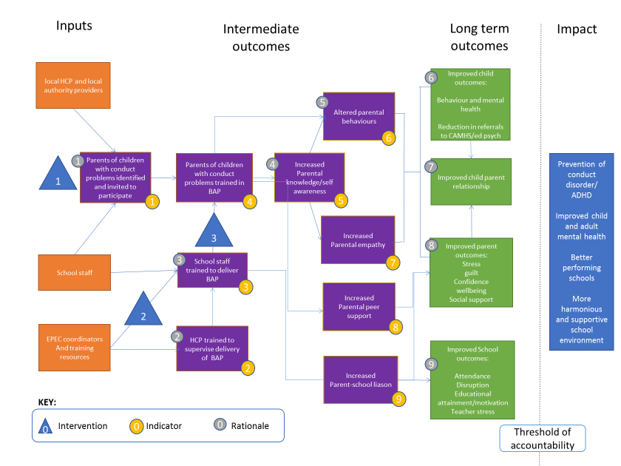

Interventions
1. Universal training delivered for Ealing professionals
2. EPEC trains facilitators and supervisors
3. Facilitators train parents

Rationale
- Schools that have had training will be able to identify children with behavioural problems
- Supervisors trained by EPEC will sustainably be able to supervise facilitators
- School staff trained by EPEC will be able to deliver BAP programme independently
- Parents receiving BAP course will increase knowledge & self-awareness
- Parents who have received training will alter behaviours and be more empathic to children
- Children will adapt behaviours as their needs are better met and they learn to self-regulate their own behaviour
- Changes to parent & child behaviour will improve parent-child relations
- Parents will experience less guilt and better psychosocial health
- Less disruptive children and better parent-school liaison will increase attendance, educational attainment and decrease disruption caused by children with conduct disorder. These changes may also benefit other pupils in the class and reduce teacher stress.

Assumptions
(these factors will not adversely impact upon success of intervention)
- Links to CAMHS and other relevant services
- School engagement with pupils’ mental health
- Feasibility of SENCO/TAs to deliver training in addition to day job
- Attitudes of school staff towards CAMHS/ parents and vice versa
- Cultural beliefs regarding parenting
- Availability of parents to attend
- Parental socioeconomic pressure
- Languages and literacy; parental readiness/willingness to learn
- Adequate facilities available
Figure 2: Theory of change model for Ealing Positive Parenting pilot programme

Child Parent Relationship Scale Short Form (CPRS-SF)
The CPRS-SF is a fifteen item 5point Likert scale developed to measure the relationship between parents and children along two dimensions – conflict and closeness. The scale is validated for this purpose for 3 year olds and older(7) and has been used in the National Head Start Impact Study in the US and the National Evaluation of Sure Start in the UK.

The Parenting Scale
The Parenting Scale is a 30 item 7point Likert scale which scores parenting behaviours along dimensions of verbosity (talking a lot), laxity and over-reactivity and is validated for use in parents of 3-8year olds(8).

Abbreviated Behaviour for learning rating scale
The behaviour for learning rating scale is an unvalidated scale developed by EPEC consisting of 25 items on a 4point Likert scale covering the following dimensions: managing feelings and behaviour; motivation and educational attainment; social skills; attendance; home-school relationship. To maximise chance of return from teachers the evaluation team decided to abbreviate the scale to 10 items.

Analysis
Quantitative data was transcribed by NR and NS into Excel. Control parents were manually matched to intervention parents from the same school based on child gender and date of birth (within 1 year). Descriptive analyses were undertaken in Excel. Paired tests (or signed rank test if data was non-normally distributed) was used to test for significance of change in outcomes post-course. Post-course scores for parents attending the course and control parents were tested using ANCOVA, including school and ‘intervention’ (whether they attended the course) and controlling for pre-course scores as a covariate in the model. Statistical analyses were performed by NR in STATA 9. Responses with missing data were dropped for any analyses involving the missing data points.

Qualitative

Data Collection

Pre-Course
Focus groups were held at each of the seven schools taking part before the start of the Being a Parent programmes. Schools were asked to place adverts inviting parents to take part, with compensation of £20 of shopping vouchers for their time. A focus group was also held with facilitators during their training. A guide was developed based upon the theory of change pathway, aiming to investigate parent’s beliefs and attitudes around parenting, the school and factors affecting parenting locally, as well as exploration of parents’ attitudes toward seeking help for parenting and attending parenting courses.

Post Course
Focus groups were carried out at participating schools at the end of the course. In five of the schools these were post Group 1. In the remaining two, and for facilitators, these were post Group 2. Questions were designed to investigate parent’s beliefs and attitudes around parenting, the school and factors affecting parenting locally, as well as exploration of parents’ attitudes toward seeking help for parenting and attending parenting courses.

Facilitator Interviews
All facilitators from the second term (7 schools, 7 facilitator pairs) were asked to be interviewed. Semi-structured interviews were undertaken with 4 facilitator pairs from 4 of the schools (A, B, F & G) who offered availability for interview. Questions were designed to investigate facilitators’ observations of the families taking part, and their experience of delivering the course in the school setting.
All focus groups and interviews were facilitated by one of four experienced members of the evaluation team. Interviewers were prompted to adopt a semi-structured interview style, allowing conversation to flow naturally yet aiming to cover all key points addressed by the questions.

Analysis
Focus groups were transcribed verbatim and uploaded onto NVivo 11 software to aid thematic analysis. NS and NR read all transcripts and agreed a coding frame for key themes. Codes were then fragmented to identify deeper themes for discussion.

Mixed Methods
Quantitative and qualitative findings were analysed together using triangulation to look for convergence and divergence of findings(9).

Economic
Costs of procurement of an evidence-based package, staff training, school recruitment, project management & supervision were collated alongside activity to generate (I) an average cost per parent participating and completing the programme, and (ii) a cost per school. Costs for continued delivery in Year 2 were modelled according to different scenarios.

Results

Recruitment
Recruitment and retention into courses is presented in Table 1. The recruitment target was 12 parents per course, this being the optimal group size quoted by NICE with respect to cost-effectiveness. Achievement of the target was mixed, with schools either easily meeting and even exceeding the target or falling far short.
Retention was defined as parents who were present at the Week 10 session. This is a conservative definition, as there may have been parents who did attend most of the course but were unable to make Week 10. Across all schools, over two thirds (69%) of all parents commencing a course were still attending at session 10 – this varied considerably between schools, with larger courses generally having better retention rates.
Of note schools A, B and G, with highest recruitment rates, were all schools that wrote applications without being approached by the pilot team. A had also been a school identified as one to target due to having a high number of referrals to the primary behavioural service.
Table 1: Recruitment and retention of parents by school
School & COURSE | Term | Recruitment (target = 12) | Retention at Week 10 |  |  | Extra support offered
 |  | N |  | n | % of all recruited
A1 | 1 | 13 |  | 10 | 77% |  | Tesco vouchers for course completion + creche
A2 | 2 | 13* |  | 7 | 54%
B1 | 1 | 19 |  | 13 | 68% |  | Creche
B2 | 2 | 13 |  | 10 | 77%
C1 | 1 | 5 |  | 4 | 80%
D1 | 1 | 4 |  | 2 | 50%
D2 | 2 | 8 |  | 6 | 80% |  | Tesco vouchers
E1 | 1 | 6 |  | 2 | 33%
E2 | 2 | 5 |  | 2 | 40%
F2 | 2 | 8 |  | 5 | 63%
G1 | 1 | 12 |  | 11 | 92%
G2 | 2 | 13 |  | 10 | 77%
TOTAL |  | 119 |  | 82 | 69%
* plus 6 others who had done the course before and wanted to repeat it, 5 of whom completed to Week 10.

Quantitative

Demographics
Demographic data is presented in Figure 3.

Age and gender
Of parents recruited to Week 1, only six (5%) were male, of whom 2 were no longer attending at Week 10. Most parents (77%) were aged 30–44 years. Age seemed to have no bearing on whether parents attended the Week 10 session.
The age profile of the nominated child is illustrated in Figure 3. Three quarters of children were aged between 3 and 7 years. Children of parents not attending at Week 10 were slightly older (Table 2).

Ethnicity
A minority of parents were White-British (17%). Ethnic mix varied considerably from school to school (Figure 3), and in all but one school the parents were predominantly non-White. Parents not attending at Week 10 were more likely to be from ‘Mixed’ or ‘Other’ ethnicities than those still engaged with the course.

Table 2: Recruitment and retention: demographic populations
 |  | Parents present at week 10 | Parents absent at week 10
Parent factors:
Gender | F | 91% | 92%
Age group | median | 35-39 | 35-39
Ethnicity | White | 39% | 19%
 | Asian | 44% | 25%
 | Black | 22% | 8%
 | Mixed | 7% | 14%
 | Other | 14% | 25%
Child factors:
Child – gender | F | 48% | 50%
Child – age | mean | 6.6years | 8.3years
baseline scores:
concerns about my child | mean | 62 | 53
Swemwbs | mean | 23.9 | 24.0
TOTAL | n | 69* | 36

*2 of ‘71’ are not included here as they gave post-course but not pre-course data the first time, they completed the course

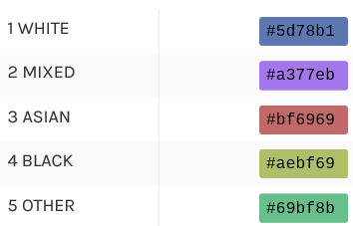
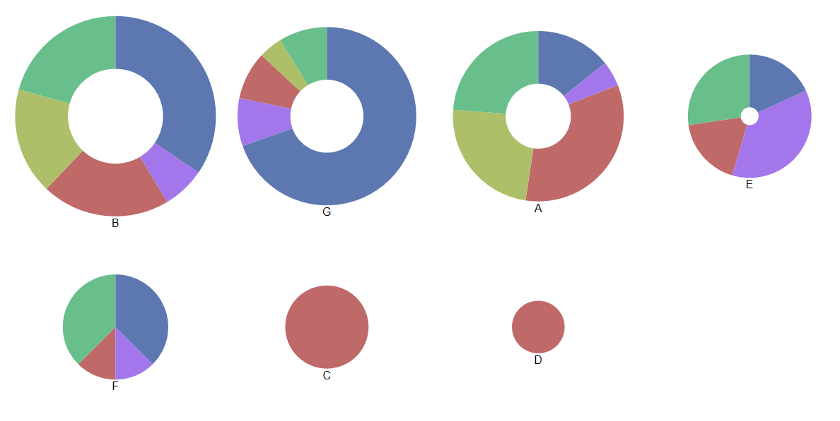
Figure 3: Demographics of recruited parents
Ethnicity of Parents by School

Controls
In total over the two terms, 35 controls were recruited overall, of whom 28 completed a second questionnaire after an approximate 10-week interval. A comparison of baseline data between controls and all participating parents for whom pre and post questionnaire data was collected, is outlined in Table 3. Controls were less likely to be female, were older and more likely to be of White ethnicity. Their children were more likely to be female and were on average 1 year older than children of participating parents. Control parents were also less troubled with concerns about their children and had on average a 1-point higher wellbeing score than participating parents.
Table 3: Parent participants versus controls: demographic populations
 |  | Parents | Controls
Parent factors:
Gender | F | 91% | 82%
Age group | median | 35-39 years | 40-44 years
Ethnicity | White | 40% | 68%
 | Asian | 22% | 11%
 | Black | 11% | 7%
 | Mixed | 8% | 7%
 | Other | 14% | 7%
Child - gender | F | 47% | 57%
Child – age | mean | 6.5 years | 7.6 years
baseline scores:
concerns about my child | mean | 62 | 37
Swemwbs | mean | 23.9 | 24.9
TOTAL |  | 72 | 28

Behavioural Problems

Table 4: Proportion of participant children with behavioural or educational problems noted by school
 | All recruited parents |  | Parent present  at week 10 |  | Parent absent at Week 10
No problems observed in school | 59 | 67% | 42 | 7% | 17 | 0.61%
Behavioural problems observed by the school | 17 | 19% | 11 | 0.18% | 6 | 0.21%
Special Educational Need identified | 12 | 14% | 7 | 0.12% | 5 | 0.18%
Grand Total | 88 | 100% | 60 | 100% | 28 | 100%
For the 88 children on whom we were able to obtain data, most participants’ children did not have behavioural problems observed by the school as far as school facilitators were aware. Numbers are very small, but parents with children who did have problems were at least as likely to drop out than other parents, if not more likely.

Change in outcome measures post-course

Course Parents
There was a clear improvement in reported child behaviour among parents completing the course, with problems improving by over 50%. Parents also reported a significant improvement in their own wellbeing (a 1 point improvement is considered ‘clinically’ meaningful(10). There was also a statistically significant improvement in the parenting scale, and a small but not significant improvement in the conflicts score of the CPRS-SF, but no change in mean closeness score.

Teacher-rated outcome
There was a 3-point increase (improvement) in the abbreviated behaviours for learning scale reported by teachers of the children involved in the programme, which was statistically significant.

Comparison with control
Within our control sample, there was no significant change in concerns about my child, parenting scale or parental wellbeing. There was however an observed improvement in conflicts score with a contradictory fall in closeness score. However random variation is likely to play a role as there were only 9 observations for each of these measures. Average values for concerns about my child and parental wellbeing by school are presented in Figure 4. This illustrates that large changes from baseline scores were observed in all courses irrespective of group size – for example, Schools C, E and F had groups sizes below 6 at Week 10 but demonstrated large benefits in those who had completed the course.
In the matched pairs analysis, however, using 20 matched pairs, we did not find that the effect of the intervention explained the variation in scores observed for either child problems or parental wellbeing, after adjusting for baseline score and school. Given the visible difference in outcomes between the two groups (figure 4) this is likely due to poor recruitment of controls meaning our study was underpowered to detect a difference – our recruitment target had been 30.

Table 5: Pre and post outcome scores
Measures | Parents completing the course |  |  |  | Control parents
 | N | baseline | Week 10 | Mean difference (95% CI), p value | N | baseline | Week 10 | Mean difference (95% CI), p value
Concerns about my child | 51 | 62.0 | 29.4 | 32.7  (25.6 to 39.7), p<0.00001 | 21 | 37.5 | 34.0 | 3.4  (-8.0 to 14.9), p=0.54
Closeness | 28 | 31.6 | 31.6 | P=0.75* | 9 | 33.0 | 19.0 | P=0.17*
Conflicts | 26 | 23.7 | 22.0 | P=0.12* | 9 | 17.6 | 9.4 | P=0.10*
The Parenting Scale | 28 | 3.4 | 2.6 | P<0.00001* | 5 | 2.8 | 2.8 | P=0.58*
Short Warwick & Edinburgh Mental Wellbeing Scale | 60 | 24.3 | 27.3 | 3.07  (1.9 to 4.3), p<0.00001 | 28 | 24.9 | 24.7 | -0.2  (-1.2 to 0.9), p=0.71
Abbreviated Behaviour for Learning | 37 | 29.4 | 32.3 | 3.0  (1.8 to 4.1), p<0.00001 | - | - | - | -
*Signed rank test. p-values are for H0 = no diff

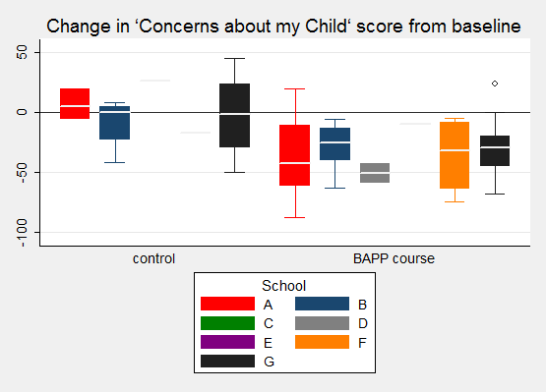
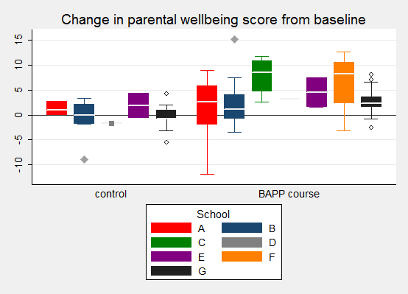
Figure 4: Change in baseline scores: comparison with control parents

Qualitative

Pre-Course
Size of the focus groups ranged between 4 and 10 participants and length of focus groups ranged between 35 and 56 minutes. Key themes emerged around the experience of being a parent in Ealing, parenting styles and attitudes, learning to parent, parents and the school.
These groups confirmed that parents felt under pressure; in particular with juggling the demands of working and spending ‘quality time’ with their children. Many felt they were negotiating parenting in a way that was different to their own experiences, due to changes in cultural norms around the acceptability of slapping, for example. Lack of support was also an issue; with few relatives close by and a lack of neighbourly relations to assist with practical difficulties such as picking children up from school when they were sick. Although many acknowledged ‘every parent makes mistakes’, fear of judgement and shaming were prevalent.
Parenting was often seen as something done intuitively, based upon parents’ own experiences of being parented and learning from family. Parents who did not turn to family for support cited reasons as: wanting to parent differently due to their own perceived bad experiences, the need to parent differently due to cultural changes around parenting, their child having specific problems or physical distance from family. Some did turn to peers, social media and books, as well as school and health services, with varying success. Ultimately parents felt they had to learn from their own mistakes and develop their own style. Stigma associated with attending parenting courses was present -notably most were offered in the context of children with recognised behavioural problems or special needs. Parents discussed that they thought stigma would be lesser the younger the child was and that specific courses for specific problems would also be more popular.
There was recognition that the school was responsible for looking after the child’s pastoral and wellbeing needs whilst the child was there, and the parents looked after that child’s educational development outside of school. Often there was conflict when parents and the school had different ideas of where these boundaries lay, but recognition on both sides that working together was in the interest of the child. Building a good relationship was requiring active engagement from the school and not all parents felt this had been achieved by their schools. However, where achieved this built the foundation for negotiating problems well rather than consolidating stigma and engendering a defensive or denial response from parents. Parents valued school’s interest in health and wellbeing but some raised concerns where this did not happen, with several raising lack of supervision in the playground facilitating bullying.

Post Course

Pathways of change
There was remarkable consistency across all schools in regard to describing the effects of the course. The course was seen to act as a forum for allowing exploration and of what it is like to be a parent, and validation that parents were not alone in their struggles. Role plays, tasks and shared experience provided a route to which parents could understand the theory in relation so themselves and develop insight into their and their child’s feelings and behaviours. Parents particularly highlighted learning how their actions may be taken very differently to that intended from a child’s perspective and to appreciate their children’s feelings, capacity to understand and take responsibility for decisions. Parents also appreciated reinforcement that they needed to look after their own wellbeing in order to be good parents.
This new insight coupled with skills in how to alter communication or handle situations differently (e.g. Rewards systems and positive praise over punishment) enabled them to step back from a situation, reflect and address it differently. As a result of this, parents reported perceived prevention of tantrums and children becoming more able to openly communicate and express their feelings, at times being able to make mature decisions like choosing to do their homework now so they can play later or owning up to taking a sibling’s book. Parents reported themselves feeling calmer as a result of these changes and their children being brighter and happier. Many parents commented on an improved quality of relationship between them and their child.

System and community effects
Outside of the parent and child the family system was affected. Few fathers took part in the course directly, but some mothers reported teaching their husbands what they had learnt and instigating strategies such as parent-child individual quality time that increased involvement of fathers in parenting. Many expressed wishes that their partners could attend too to improve consistency in parenting at home. Others remarked inter-sibling relationships and respect had also improved.
For many parents the course provided a hub for bonding with peers and community building. This aspect was of relevance to those who had recently immigrated to London or were without local family and thus had little existing support network. Of interest the course where only 2 participants remained at final session and thus where the peer support element was less, parents were much less effusive and more nuanced about the benefits of the course, suggesting the peer support element may be an important factor relating to the effectiveness of the course.
The course also seemed to have most profound impact for those with authoritarian background cultures or upbringing, as it provided a more radically different approach to parenting. This was received positively by focus group participants, and one discussed how the ‘official’ training had given her authority to question her parents’ approach to parenting and validate her views.
Parents reported feeling valued by the school because the school had taken time and effort to support them. They also valued feeling more connected with the school’s approach to managing behaviour which was well regarded. Outside of the course facilitators, with whom they shared trust and respect, parents were less sure that their relationship with the school had changed particularly. Parents did not feel more confident or knowledgeable in where to turn to for help with their child’s behaviour.

Course accessibility
Course timings were accessible for non or part-time working mums, the main attending demographic, but were reported to be difficult for working parents. Where a creche was not provided attendance was also difficult for those with young children.
Parents attending courses appreciated having parents of children of different ages present to learn with and the participation of parents with special needs or behavioural problems and those without in one course did not appear to cause any problems. Parents did indicate that they would appreciate courses from much earlier, one even suggesting this course was delivered antenatal as it was much more useful than the physical health information. Another highlighted after 5years of age resources and forums for accessing parental support diminish and the focus on emotional literacy was particularly useful at this age.
Some parents mentioned they would have liked more information on what the course would entail and focus on at the onset and though that this would have increased uptake, as well as handouts and more widespread advertising.
Language was raised an issue for some participants and other potential participants. One school devised PowerPoint slides with key translations for every session but were not able to do this for all languages. Several parents mentioned wanting to learn how to deliver this course in their own communities and many were already acting as course advocates or imparting information learnt on the course to other parents in their family and social networks.
Parents appreciated having the school as a basis for courses as it formed a natural hub for a parental community and, as already mentioned, enhanced a sense of support from and connection with the school. On the other hand, community based courses may be more flexible and thus open access to working parents or those with insufficient English to be able to take advantage of the course.
Some groups had formed WhatsApp or other groups to allow ongoing support and networking or had arranged to meet outside of school. One had linked in with the PTA and were planning to run regular parent forums after the courses had ended. In one school, where only two parents attended the final focus group, this had not happened, and parents were a little more cautious about keeping up contact after the course.
Having completed the course parents were vocally supportive of its relevance to every parent and felt positive about the impacts ‘this will make a better generation’. However, they also alluded to the stigma in taking part in the course especially if you had been asked specifically by a teacher. Many were hesitant to open up initially for fear of judgement by other parent and school staff but were reassured by icebreakers and confidentiality agreements.

Facilitator Interviews

Effects on children
One school noted an obvious difference in one child’s behaviour which they felt was attributable to the course but on the whole facilitators felt it was hard to say and they didn’t always have much contact with children at school. One facilitator noticed that the child was able to trust and come to them more because they had seen her bond with their mum and therefore knew that she could be trusted. Facilitators highlighted that a child’s behaviour at home and whilst at school was often very different.

Working with parents
Facilitators felt parents had bonded and in majority of schools had set up WhatsApp groups or coffee mornings for ongoing peer support.
The majority of the schools had predominantly parents from different cultures and that did not speak English as a first language. This meant a lot of the course material needed to be adapted into simpler language and some of the course materials e.g. A video of the TV show ‘Absolutely Fabulous’ did not culturally connect. Facilitators reported more visual cues would have been useful. Language barriers did slow things down, but this was helped by other parents translating and by visual cues.

Wider Impacts
For parents from different cultures the course was a route to improving confidence, English and self-development. One school reported that they had never been able to engage parents like this in wider social issues, and they were delighted that parents were asking for more information on issues such as nutrition and first aid. As such this seemed to be a route to enhancing community engagement and fostered an improved relationship for communication around health and education between the school and the parents. This school mentioned it would be useful to have more resources to support parents readily available egg leaflets so that they could make helpful connections and signpost more easily.
Some facilitators spoke about how this was an especially bonding intercultural experience: ‘despite such different backgrounds we found ourselves in the same room understanding each other’s challenges [which was] incredibly moving’.
Facilitators report increased confidence when talking to parents and guiding them, also that parents were more able to approach them with issues. Some facilitators reported improvements in their own family and personal lives:
‘I’m a nicer mother, nursery nurse’, ‘I am more aware of myself and the impact I have. [the course has] also increased my confidence in talking to parents’
In the schools with the highest recruitment, there was a desire to maximise the strategic potential of the course. One school offered an evening session for parents, another asked the facilitators to run sessions for all school staff, and a couple of schools spoke of aligning course principles with the school ethos.

The course and supervision
In some of the school’s parents had disclosed distressing experiences or had needed safeguarding involvement. Schools seem to manage this well but very much valued supervision to guide through this process. They felt that this was not covered in detail during the training. On the whole supervision was valued but there were some schools that felt it was less useful and highlighted the importance of having a supervisor who was experienced and had expert knowledge.
There were some concerns over parents running courses in regard to confidentiality, boundaries and how to contain/raise safeguarding issues should courses run in community. Facilitators felt it was important to have a good relationship and be able to ‘offload’ onto each other…. there were some concerns about doing this with a parent where there would have to be some boundaries. Yet it was also highlighted that parents running the course in the community would have better reach and could offer course at more convenient times.
Most facilitators liked the course, felt it was the right length and felt comfortable adapting the course to meet the group’s needs. Key criticisms were around language needing simplifying, cultural disconnect of videos and that visual prompts would help those with poorer English. Those who had previously done other courses struggled most with learning the new course material and felt maybe this course was more technical and less nurturing. This was not noted by other facilitators and may be a reflection on the course manual which is content rather than delivery focussed, relying on the facilitators themselves to bring out the nurturing elements through their delivery.

Mixed Methods
Results from quantitative and qualitative data were compared for areas of convergence and divergence and triangulated. The final mixed methods data was used to redraw the Theory of Change post intervention (see Figure 5: Post intervention Theory of change).

Recruitment and demand
Quantitative data indicated variable demand between schools. Some schools were oversubscribed while others struggled to recruit parents. Qualitative data indicated that parents do feel in need of support, however barriers to access included availability: courses were not convenient for working parents, and stigma. Parents expressed a fear of judgement and shaming, and acknowledged stigma associated with attending parenting courses – especially when children were older. It is unclear whether stigma is a greater barrier in some schools or communities, or whether demand was impacted by the variable recruitment methods. The schools that added incentives such as Tesco vouchers for course completion or a crèche had improved recruitment but not retention. School G had the highest retention rates overall: this school did not offer incentives but did have predominantly white-British parents, and a more affluent community, which suggests retention may be more difficult with minority ethnic communities, or more deprived communities. Logistic factors such as finding work were also cited as reasons for dropping out.
The majority of the parents who attended the course did not have children who exhibited behavioural problems: the baseline abbreviated behaviour for learning scales were not especially poor. Facilitators reported some difficulties in targeting the more difficult parents, who may not have been reached by the programme.

Behaviour and wellbeing outcomes
Both quantitative and qualitative data supported the idea that parent and child behaviour and wellbeing had improved. The data was divergent in regards to child-parent relationship, where many parents reported and improved relationship with their child, however the CPRS-SF indicates much smaller improvement in conflicts and no improvement in closeness. Both Parenting scale & CPRS-SF were the most challenging of the scales to complete for parents with English as 2nd language, as was the case for most parents in 6 of the 7 schools. The Parenting scale perhaps reflects more closely the skills taught by the course, while CPRS-SF tries to measure the anticipated effects of implementation of these skills on relationships. In this case the divergence in data may be due to either lack of validity of the scales in this setting due to language and comprehension barriers, or a lag in effect of the intervention in relationships.
The abbreviated behaviour for learning scale was completed on a small sample of students, however indicated improvement in children’s classroom behaviour. Facilitator feedback was more hesitant on this account, although it is to be acknowledged that facilitators would not be directly involved in the day to day teaching of children of participating parents. There were positive accounts of parents feeling better connected to the school and improved relationships between facilitators and parents, with facilitators reporting increased confidence and capacity to manage conversations with parents about child behaviour.
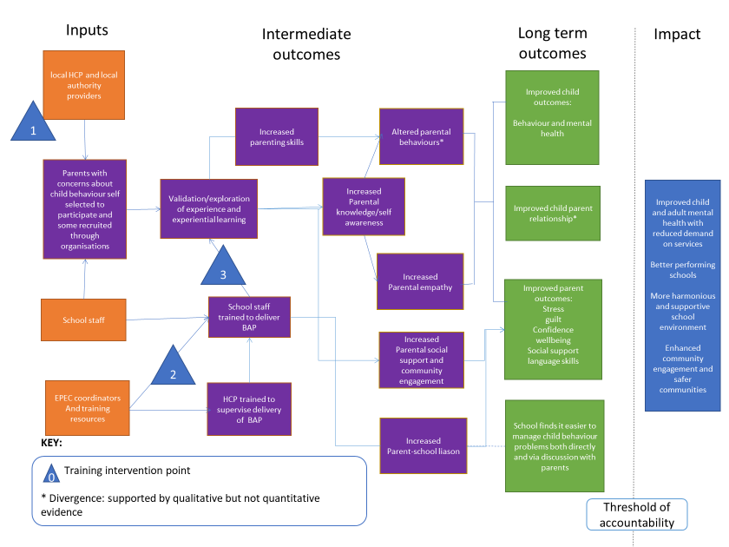
Figure 5: Post intervention Theory of change

Ongoing Delivery
All parents completing the course felt strongly that it had been an incredibly valuable experience and should be part of a regular offer to parents within the school. In all four schools questioned, facilitators reported the course delivery to date had been well supported by the heads of school. Where facilitators were sufficiently senior, they were clear that they would advocate for continued delivery within the school, as wished by parents. There was an acknowledgement that it had taken considerable time and effort to become familiar with the course, although it had been easier running the course a second time, and that it would therefore make sense to continue the momentum. However, it was acknowledged that ongoing delivery would ultimately be decided by the Head, and available resources would be an important factor to consider.

Economic
In total to date the project has delivered 12 programmes in 7 schools and trained 21 facilitators and 7 supervisors (one has since left). The costs for the pilot are outlined in Table 6.

Table 6: Ealing Positive Parenting Pilot Outline Costs
Pilot component | unit Cost | Total Cost
facilitator and supervisor training in ‘Being a Parent Plus’ | £40,000
Cover for staff | £24,500
Total staff training |  | £64,500
School Administrative costs | £500 per course
Supervision per school | £931 per course
Total course DELIVERY | £1,431 per course | £10,017
Supervisor training – additional  (due to staff withdrawal through sickness) | £3,635
Project management for 18 months  (planning, implementation & delivery) | £14,000
Total PROJECT MANAGEMENT |  | £17,635
TOTAL COSTS |  | £99,307

It cost £1,431 to deliver each course in each school, once the staff had been trained. Using these costs, we can calculate costs per parent for the pilot year and also model ongoing delivery costs in subsequent years (Table 7).
Table 7: Ealing Positive Parenting Pilot – modelled costs for ongoing provision
YEAR | Model description* | TOTAL COST | Cost per parent recruited | Cost per parent retained*
 |  |  | n=119 in pilot | n=69 in pilot
year 1 (pilot) |  | 99,307 | £834 | £1,439
YEAR 2 | Model 1: all 7 schools repeat delivery as per pilot year (n=119) | £28,798 | £242 | £417
 | Model 2: all 7 schools continue and deliver 2 courses to 10 parents each (n=140) | £31,640 | £226 | £323
 | Model 3: 5 most successful pilot schools continue and deliver 2 courses to 10 parents each (n=100) | £26,000 | £260 | £371
*Assumes retention rate is unchanged, equivalent project management costs pro-rata for 12 months as pilot, and no additional training of staff required.

Discussion

Summary of key findings
This pilot saw 10% of Ealing primary schools running parenting courses for parents of children within their schools. One hundred and nineteen parents were enrolled (the target had been 168) and at least 82 completed the course (69%). 29 (33%) were parents of children with either behavioural problems within school or special educational needs. Stigma and timing were the key cited barriers to access for the course. Incentives improved recruitment but had less impact on retention.
Parents completing the course reported considerably improved child behaviour and parental wellbeing. Parenting skills also improved. Parents also valued the peer support opportunities and feeling more involved with their child’s school and ethos. There was also a small but consistent improvement in children’s behaviour observed by teachers in the classroom.

Relation to other evaluations
Findings from this study resonate with findings from the government evaluation of the Parenting Early Intervention Programme (PEIP) where four parenting programmes were rolled out nationally, which found:
-Nearly a third of participating parents had children who (31%) received additional support from the school
-Improved parenting behaviours, increased parenting wellbeing in over 70% of parents, and improved child behaviours with a reduction of those with significant behaviours problems from 56% to 38%.
The EPEC RCT also found improvements in child behaviour and parenting competencies and wellbeing. In this study mean baseline CAMC was slightly higher than in the EPEC RCT,62.0 cf 52.0, and greater reduction was seen in scores, with a mean difference of -32.0 post intervention in this pilot cf. a mean difference of -23.01 post intervention in the EPEC RCT.
The cost of running the programme in its pilot year was considerably higher per parent than the PEIP intervention where the average cost of funding a parent through a parenting programme was £1,244, increasing to £1,658 when taking into account the fact that only 73% of parents completed the programme. It should be noted that the proportion spent on management costs reduced over time as the PEIP became established, and modelling continuation of the pilot into the second year assuming no additional training costs and the same level of project management already brings the cost per parent much closer to the PEIP estimates.
Encouragingly, the direct costs of running the programme in this school setting are already significantly lower (at £1431 per course) than those quoted in the EPEC RCT, which found that the direct costs of running the programme (including facilitators’ wages, travel expenses, printing of materials, accreditation, crèche workers, refreshments, and rental of a room) were about £2700 per group.
Similarly, in the PEIP evaluation, strategic leadership and operational coordination were seen as essential to ensure reach and effectiveness of the programme. The PEIP found that sustainability was increased when there was a good fit between the local infrastructure and the way the PEIP parenting programmes were delivered, there was a multiagency delivery model, having ‘trained the trainers’ during the pilot and schools / local authorities having the opportunity to ‘buy in’ to the delivery of parenting programmes to suit local need.
Retention rates of 69% were lower than both PEIP (73%) and EPEC RCT (92%). However in the latter case, attendance of at least 5/8 sessions was used to define course retention. Reasons for non-attendance in the EPEC RCT were similar to those found in this pilot: new employment, travel overseas to care for a relative, lack of readiness to engage.

Process and feasibility
This pilot has shown that, with school commitment, it is feasible to deliver effective parenting courses delivered by school staff within a school setting. The setting was very convenient for parents working part time or at home, with sessions scheduled either after school drop-off or before pick-up. In addition to the peer-support ethos which the course is built on, parents valued the opportunity to be supported by the school and develop a greater sense of belonging to the (school) community. The qualitative feedback also highlighted benefits for the facilitators in terms of personal and professional development, with delivering the course giving them more confidence in speaking to and relating to parents and also developing expertise in behaviour management for other staff
However, the inability for full-time working parents to attend was acknowledged as a barrier to inclusion. Fathers were less able to attend, and many parents expressed wishes that their partners could attend too to improve consistency in parenting at home. In response to this, one school offered a one-off evening event specifically for partners where they ran through the core course content for fathers. Other schools facilitated ongoing opportunities for the parents to meet through coffee mornings. Thus, the facilities and organisational capabilities of a school can act as enablers for continuation of learning and sharing.
There have been difficulties with staff recruitment and retention during the pilot: this was more pronounced with supervisors than with school staff. Two of the healthcare professionals identified did not pass initial training assessment to supervise/facilitate groups. One supervisor resigned from their role in between the two cohorts requiring reshuffling of supervision arrangements. There was also difficulty in releasing supervisors from day commitments for the required number of sessions. Scale up will need to ensure there is commitment and resource for healthcare professionals to carry out supervision.

Project and relationship management
A major learning point from the pilot was the considerable project and management time required to co-ordinate the programme across schools, trainers and supervisors. Communicating across schools was challenging as email is not always the preferred communication channel, especially for more junior staff. Scale up of the project will require dedicated resource to oversee this locally.

Considerations for proposed scale-up
There are 67 infant, primary & junior schools in Ealing, so the schools taking part in this pilot represented just over 10% of all schools. Four of these were in areas with high referral rates to primary behaviour teams, demonstrating that the intervention is feasible and acceptable across a wide range of schools in Ealing. However, schools had to apply for the pilot with endorsement from the head teacher and so exhibited an interest in engaging with parents. Scale up across Ealing may mean schools with less motivation take place which may impact on staff retention and engagement.
The programme was run universally, and despite recruitment aimed at targeting 50% with known behavioural problems in order to maximise outcomes in terms of prevention of conduct disorder, only 33% was achieved. The current evaluation indicates that the programme is operating primarily as a primary preventative measure rather than a secondary preventative measure. Stigma was identified as a barrier to help seeking and may be further hindered by attempts at more targeted provision. Three quarters of nominated children were infant rather than junior school-aged, which suggests that the course attracts more parents with younger children. One quarter were aged under 5 years, which would support the proposed rollout into primary years further rollout into early years.
Our evaluation has indicated that course delivery may need adaptation to achieve cultural relevance and address language capabilities of the diverse mix of parents in the borough. There will be a balance required between maintaining course fidelity and giving flexibility to facilitators to adapt. This may be aided by working with EPEC to identify what is core and what should vary in order to give schools the capacity and confidence to adapt as necessary.
The course has currently been delivered by school staff, with intention to roll out delivery by parents in the community. Benefits of this are greater reach of parents, however risks include a less strict confidentiality and safeguarding structure. There would also be loss of the observed benefit of parent-school engagement and the building of a diverse community around the school.
It is feasible that there would be economies of scale if further schools in Ealing could be trained to deliver these courses within their schools. However, provision of supervision and co-ordinating this with schools was both challenging and a considerable resource requirement, and in its current form would be a barrier to wider rollout. It would make more sense to involve additional schools or settings incrementally once capacity to provide supervision has been identified. Consideration would need to be made as to whether supervisory requirements can be adjusted as facilitators become more experienced if this delivery model is to be sustained.
The expansion of parenting provision in Ealing has changed the pathways into referral into the neurodevelopmental service. The number of accepted referrals within NDS have dropped as those children referred with suspected ADHD have not been accepted until the parents have attended an approved course. At the moment it is not certain how many children have been re-referred after attending this or any other parenting course over the last year

Limitations

It proved challenging to collect evaluation data given the busy school setting. Facilitators reported feeling overwhelmed with the administration involved, particularly when running their first course. As a result, we were unable to meet our targets for recruiting controls, limiting the power - and therefore certainty - of our matched pairs comparison.
For the teacher observations, in the absence of any obvious easy-to-use validated alternative, we adapted an unvalidated questionnaire for the purpose of this study. It is therefore not clear how important the observed improvement in behaviour is in practice, nor whether a similar change would have been observed in ‘control’ children as we did not collect this data. However, it was encouraging that an effect was observed given the relatively small sample size.
Given the timeframes of this evaluation, we do not have long term follow up data on parents who did complete the course, as to how well these changes are sustained over time.
Facilitator interviews were predominantly with those schools running larger groups, so we have not been able to fully capture the barriers to implementation in these schools.

Conclusions

For those that participated in the programme, significant improvements were seen in parent reported wellbeing and child behaviour, not witnessed in controls. This was evident in all schools, regardless of number of parents recruited. The assumed route through which this happened was increased parent insight leading to altered parent behaviours and parent child relationship, thus causing improved wellbeing and behaviour. This was supported by qualitative analysis but not clearly by quantitative – however feedback suggested problems with validity of scales used in the current setting. There was also some suggestion of small improvement in child classroom behaviour. Additional benefit was seen in parent engagement with the school, and enhancement of community and social relationships, especially given the diverse cultural backgrounds of participants. It was not possible to identify impact on referrals to services within this small cohort.
The programme retention rate of 69% was better than some parenting programmes but less than the EPEC RCT(2). It is unclear whether the school-based recruitment used here was less effective than the parents and community-based recruitment used in the RCT and whether this may change with parent-based scale up.
The programme overall achieved primary desired outcomes, was popular with parents and facilitators and the majority of schools were enthusiastic about continued engagement. The programme operated universally, and a minority of parents had high risk children, limiting the immediate impact the programme will have on preventing conduct disorder, although a strong case can still be made for primary prevention and reduction of stigma via keeping the programme universal. Successful delivery requires dedicated resource for project management and relationship building, and adequate commitment and resource provided by supervisors, a factor which was problematic during this pilot.

Next Steps in Ealing

This pilot and the process of evaluation has acted as an enabler for Ealing, through providing strong local insights and engagement with local schools and parents. The programme has been very popular with many of the participants from a range of ethnic and socioeconomic backgrounds.
As a result of this pilot Ealing is taking part in a NESTA-funded project to deliver the EPEC programme as a parent-delivered programme within early years settings. In Ealing this will be combined with ongoing delivery of the course in the pilot primary schools. Ealing has recruited 11 parents for the first cohort of Parent Group Leader training in Ealing and there are a further 7 parents for a second course in January 2019.
Knowledge of the pilot has also been a catalyst for other Children Centres and a school to open their doors and offer free space for the delivery of training sessions and Parent Led Groups across the borough. Furthermore, it has inspired collaborative enterprise across the border in Hounslow, where a primary school is offering free space training and is putting forward Teaching Assistants to be trained so they can co-host parent/TA groups in their school in the summer term
Of the 11 parents currently being trained as Parent Group Leaders, 8 have children with ASD, ADHD, dyslexia or learning disabilities and are all keen to run groups and take parents from Ealing’s ASD waiting lists to offer them support which they feel is much needed. Local clinicians are keen to develop this model and ensure that this provision becomes part of the Neurodisability pathway moving forward, which was the local vision and the plan for Ealing that has been enabled through this pilot.
References
1. Lindsay G, Totsika V. The effectiveness of universal parenting programmes: the CANparent trial. BMC Psychol. 2017 Oct 23;5(1):35.
2. Day C, Michelson D, Thomson S, Penney C, Draper L. Evaluation of a peer led parenting intervention for disruptive behaviour problems in children: community based randomised controlled trial. BMJ. 2012 Mar 13;344:e1107.
3. Breuer E, Lee L, De Silva M, Lund C. Using theory of change to design and evaluate public health interventions: a systematic review. Implement Sci. 2015 Dec 6;11(1):63.
4. Charalambides M. Title:Appraisals of Anomalous Experiences in Need for Care versus Non-Need for Care Groups Examining the Cognitive Route of Impact of Victimisation Life Events.
5. Taggart F, Friede T, Weich S, Clarke A, Johnson M, Stewart-Brown S. Cross cultural evaluation of the Warwick-Edinburgh mental well-being scale (WEMWBS) -a mixed methods study. Health Qual Life Outcomes. 2013 Feb 27;11(1):27.
6. Clarke A, Friede T, Putz R, Ashdown J, Martin S, Blake A, et al. Warwick-Edinburgh Mental Well-being Scale (WEMWBS): Validated for teenage school students in England and Scotland. A mixed methods assessment. BMC Public Health. 2011 Dec 21;11(1):487.
7. Driscoll K, Pianta RC. Mothers’ and Fathers’ Perceptions of Conflict and Closeness in Parent-Child Relationships during Early Childhood.
8. Arnold DS, O’Leary SG, Wolff LS, Acker MM. The Parenting Scale: A measure of dysfunctional parenting in discipline situations. Psychol Assess. 1993;5(2):137–44.
9. Hanson WE, Creswell JW, Plano Clark VL, Petska KS, David Creswell J, Clark P, et al. Mixed Methods Research Designs in Counseling Psychology. 2005;373.
10. Shah, N., Cader, M., Wijesekera, D., Stewart-Brown S. Responsiveness of The Short Warwick Edinburgh Mental Wellbeing Scale, Health and Quality of Life Outcomes (paper forthcoming).

NW London Sustainability and Transformation Plan: 'Our plan for North West Londoners to be well and live well' V01. 21 October 2016. Available at https://www.healthiernorthwestlondon.nhs.uk/documents/sustainability-and-transformation-plans-stps (Accessed 17.01.2017)
Greater London Authority’s 2015 Round Ethnic Group Population Projections
Lindsay, G., Strand, S., Cullen, M.A., Cullen, S., Band, S., Davis, H., Conlon, G., Barlow, J. and Evans, R., 2011. Parenting Early Intervention Programme Evaluation (Research report DFE-RR121 (a)).

