**Conduct in Dementia: Video Analysis of Arts Interventions**

**Abstract**

This study applies video analysis to an investigation of interactions among people with dementia in a cultural context, specifically a visual art exhibition in a gallery. The study adopts a sociologically-informed approach to explore the role of artworks and how these may be beneficial to dementia care, by focusing on meaning-making conversational practices among people living with dementia. The interactions of different individuals with various forms of dementia were recorded during three gallery visits, including their engagement with gallery attendants and artworks. The findings reveal the socially empowering impact of interactions related to artwork, with complex patterns in bodily behaviour and facial expressions meaning that orientation to dementia became negligible. The paper makes a contribution to the growing field of sociology of aging and well-being from an interaction analytic perspective, indicating that cultural values can play a greater role in the care of people living with dementia.

**Keywords**: dementia, art, video analysis, meaning-making, sociology of aging, interaction

**Introduction: Conversation Analysis and Sociology of Ageing**

Conversation analysis (CA) is concerned with the sociological study of interaction in everyday life, including that produced in institutionalised settings. Although the vast majority of CA research has focused on interaction between conversational partners for whom there is no noticeable communicative impairment, since the early days of CA, studies also have involved interactions that were from a linguistic perspective more challenging (Schegloff 2003, Wilkinson 2008). Over the past years, more attention within CA has been paid to such interactions that involve speakers whose verbal or non-verbal capabilities and competencies do not easily fit into established everyday standards, including people who have experienced some form of cognitive impairment due to conditions such as aphasia (speech impairment) (e.g., Wilkinson 2008), Parkinson’s Disease (degenerative disorder of the central nervous system) (e.g., Griffiths et al 2015), following a stroke (e.g., Goodwin 2000), or due to declining executive functioning in ageing (Gregory et al. 2002). Furthermore, there is a growing interest in CA in the field of ageing studies and more recently CA and in particular video analysis have also entered the field of dementia studies (see Kitzinger & Jones 2007, Mikesell 2009, Dooley et al 2015, Kindall et al. 2017).

The current exploratory paper aims to make a contribution to this emerging sociological field by addressing the role of arts interventions and engagements for people living with dementia. This research makes a number of innovative contributions. First, it demonstrates in line with other studies (see for instance the papers presented at the ‘Atypical Interaction Conference’ 2016, Center for Social Practices and Cognition, University of Southern Denmark) the sociological relevance of applying video analysis to a dementia-related setting. Second, it aligns with Büscher (2005), Mittelman & Epstein (2009) as well as Basting et al. (2016) to shift the focus to people with dementia and their interactions by capturing their interactions *in situ*. Third, it seeks to present an alternative picture of meaningful conduct that does not focus solely on oral communication (see Beard 2011: 634), but also considers the interactions with objects (Latour 1996).

The first part of the paper provides a brief review of the literature, summarising some key issues in the field of arts intervention, art therapy and dementia studies. Also in this section, we report on our critical reading of these issues with a conceptual view and some methodological problems in the existing research in the field, followed by a methodological overview outlining ethical considerations and video analysis. By employing a video analytic methodology in the empirical section, the present research reveals how people with dementia engage with their environment and the associated process of assigning meaning to it, for instance, how works of art unlock a domain of topics, giving voice to people with dementia and enabling a type of interaction that seems to neutralise their stigmatisation. In the final section, we will embed our findings into the broader debate on arts interventions and make suggestions on how this research can have an impact on improving people’s lives.

**Background: Arts Interventions and Dementia**

Arts therapy typically employs creative methods of expression, like painting, drawing, writing, singing, in the interactions between patient and therapist. While arts therapy was initially used mainly as a diagnostic tool in psychotherapy, its application and its recognition as a form of treatment have changed (see Junge 2010). It is now used for a wide range of mental health issues, such as treating traumatised adults and children (Schouten et al. 2015) and people living with HIV/AIDS (Feldman et al. 2014), and to assist with the acculturation of immigrants (Linesch et al. 2014). This research will focus on arts interventions and art therapies in the field of dementia studies (e.g., Aigen 2008, Beard 2011, Cowl & Gaugler 2014, Daykin 2008, Evans 2002, Robinson et al. 2006, Young et al. 2016). In the absence of prospects in the near future for a cure for degenerative dementias or efficient pharmacologic treatment, arts interventions and art therapies have emerged that aim to improve the neuropsychiatric symptoms and the quality of life of people with dementia. The first neurological aspect is based on a tacit understanding that the arts (signing, dancing, viewing visual works of art) possess a complexity that stimulates and activates large parts of the brain, including the language and motoric areas (Chancellor et al. 2013). The second quality of life aspect operates with an understanding that arts interventions and therapies provide pleasure and enjoyment, offer engagement and participation and, as a consequence, improve self-esteem (Kontos & Martin 2013). While such thinking provides a laudable approach, according to the authors of this paper, the research has a number of conceptual, methodological and policy related issues that the present paper aims to overcome.

These studies often work with an almost limitless range of activities—dance/movement, music, drama, pottery, painting, drawing, gardening, baking, aromatherapy, Tai Chi, Montessori programmes and social outings—some of which have rarely have any direct connection to works or art or art institutions. This looseness of conception means that intermediary variables can easily distort findings. For instance, in a study of their arts initiative ‘Coffee, Cake & Culture’, Roe et al. (2016) noted that the taxi journey, the changed circumstance of being away from the care home and the visible interest of the researchers seemed to engender an enjoyable experience more than the actual arts intervention. It therefore seems reasonable to suggest that many of the benefits claimed for art-related interventions may be due to intervening factors such as social contact or getting out of the house (see Chung 2004). For that reason, we will give the interactions that emerge directly around works of art that are presented in an art world context a central role.

A second and related issue concerns the methodological strategy employed to capture such interactions. The main body of research has favoured a causal model that measures the impact of art activity as an after-effect—asking, for instance, whether a person’s behaviour has somehow changed as a result of the activity (drawing, dancing etc.). Moreover, this question is typically addressed to the carer rather than to the person with dementia, so introducing another intermediary variable to the process (see Goulding 2013). In contrast, we propose an approach where we address art as an activity embedded in the social conduct of people with dementia. The term *social conduct* refers to the work of Erving Goffman, who uses it to explain how people manage their interactions with other people, and how such interactions facilitate meaning-making and meaningful behaviour. Unlike research that focuses only on the after-effects of arts intervention, the present research is conducted *in situ*, capturing the process of interaction between the individual with dementia and the artworks, as facilitated by a gallery attendant. By analysing video recordings of these interactions from the more embedded perspective of how social conduct is managed, we reveal how arts activities contribute to meaningful behaviours among people with dementia (see also Hanson 1994). This methodological approach should avoid analysing such arts interventions in terms of their after-effects and thereby analysing the above-mentioned intermediary variables.

A third issue is that in existing healthcare literature as well as policy documents, people with dementia are represented as ‘socially dead’ (Dupuis et al. 2016, O'Connor et al. 2018). This is an important point because the speech impairment that can develop as dementia progresses often leads to a perception of overall loss of meaningful interaction and a consequent inability to account for other strategies of conversational repair, signalling of meaning and negotiation of meaning (see Perkins et al., 1998, Rousseaux et al. 2010, Watson 1999, Wilkinson 2013). While other research in this area has focused on more narrowly-specified outcomes such as memory (Eekelaar et al. 2012), level of animation (MacPherson et al. 2009), the caring relationship (Camic et al. 2014) and self-esteem (Platt et al. 2015), we explore how works of art can affect the process of meaningful interaction by opening up a different channel of interacting with others. The term *meaningful conduct* (interaction) was coined by the sociologist Goffman (1961, 1967) to refer to the management or performance of behaviour or activities in a particular social setting. This term is used to describe behavioural elements such as gaze, gestures, positionings, movements and verbal statements that people continuously feed into a situation as meaningful signs of orientation and involvement. In this context, some authors have suggested that works of art could be viewed as meaningful signs rather than neutral objects, and that they can make a communicative contribution to the process of meaningful interaction (Alexander 2008: 6) through which people with dementia are able to reclaim a voice and challenge existing stigmas (Birt et al. 2017).

**Methodology, Case Design and Analysis**

In this study, video analysis was used to understand interaction-based processes of meaning-making (Heath and Hindmarsh 2002). Video analysis is open to review, reanalysis and re-presentation by giving third-party access to anyone who is interested (in this case, participants, carers, artists, gallery staff, researchers and the advisory group) to the fine details of the recorded behaviour, both verbal and non-verbal, which can be elucidated through close and repeated scrutiny. The analysis draws on methodological approaches developed in the field of Conversation Analysis (Sacks, Schegloff & Jefferson 1974). Although early CA work focused primarily on social action produced in talk-in-interaction, more recent interaction analytic work has increasingly included those communicative resources that involve the close coordination of vocal conduct, the bodily-visual, and the material surround (e.g., Streeck, Goodwin & LeBaron 2013). The ease with which video-data can be produced has contributed strongly to this expansion, which Nevile (2015) has characterised as the ‘embodied turn’ in research on language and interaction.

Video analysis was used for three principal reasons: First, it can capture meaningful conduct within interactions. Second, video analysis can reveal meaning-making processes produced through a wider range of embodied conduct than that produced in speech. Finally, one of the study’s aims was to achieve a broader understanding of the role of artworks in facilitating interaction between people living with dementia and others in their social environment.

Research Ethics

Both ethical and pragmatic reasons lead to a participatory action research design highlighting participation and action with a view to understand the world by trying to change it. It is ethically problematic to study people who lack capacity to give informed consent (typically assessed according to the Mental Capacity Act 2005). Our approach was therefore to apply Dewing’s ‘process consent model’ for conducting the study (Dewing 2007). We recruited six participants, people with dementia + carers, from a local community memory café. The recruitment of couples ensure the presence of a carer who could give advice about the participation of the individual with dementia. Carers were thus consultees in the term of the Mental Capacity Act 2005. Their presence at the filming, albeit in a separate room, ensured that there was someone close at hand who was attuned to the person with dementia in case of distress or reluctance to participate. We negotiated consent at the outset, taking account of the individual’s background, and using a person-centred approach in which the unique person and their preferences are emphasized, instead of their medical condition (see Kitwood 1993). This was revisited regularly during the filming for both the person with dementia and their carer. All participants and/or their carers signed consent forms to use images as well as extracts from transcripts. Ethical approval was granted by the University of Nottingham School of Sociology & Social Policy (Ref: 58/15-16/S; website: https://www.nottingham.ac.uk/sociology/research/ethics.aspx). The project was funded by Alzheimer’s Research UK (A931B6), but it did not have any input in the recruitment process of the participants.

Briefing Gallery Personnel

We sought to allay any fears that participants would be required to draw on memory, by introducing people with dementia to works that were by definition new; a BA degree show of Fine Art students from the University of Nottingham. The gallery personnel had previously received some basic sensitivity training on dementia, provided by the research team. This consisted of viewing the video used to recruit Dementia Friends (see Alzheimer’s Society https://www.dementiafriends.org.uk/), and one, medically-focussed video (Your Amazing Brain - Dementia Explained - Alzheimer's Research UK), followed by a question and answer session.

Recording Procedure

The participants were able to look at any artwork on display however attendants were briefed to draw their attention to particular works where the cameras were positioned. Gallery visits lasted approximately 60 mins. Camcorders were set up at strategic points in the galley and some still photographs were taken of the exhibits. The recordings were hosted in a secure online environment for data-sharing between members of the research team and to protect participant anonymity. For similar reasons, we held the videoed gallery sessions while it was closed to the public. The gallery staff facilitators are referred to as GA1 and GA2. The pseudonyms for the participants with dementia whose data is analysed in this paper are Bert and Tom.

Analysis and Transcription of Data

In line with Conversation Analysis and its ethnomethodological foundations (Garfinkel 1963, for a more recent overview of this development, see vom Lehn 2014), the current study works from a natural observational perspective, favouring recordings of people engaged in interaction in seemingly everyday settings. Although being video-recorded is not a natural feature of this type of everyday activity, research elsewhere has shown how the presence of a video camera does not impact on the quality of the data, and is commonly only oriented to at points of social transgression (e.g., Hazel 2016).

Data were annotated in ELAN (The EUDICO Linguistic Annotator, http://tla.mpi.nl/tools/tla-tools/elan/) (Wittenburg et al. 2006), which allowed the researchers to parse the recordings into discrete phases of the overall activities recorded in the gallery. Relevant sections were selected and subsequently exported to the CLAN (Computerized Language Analysis) transcription tool for further treatment (MacWhinney & Wagner 2010). Software tools such as ELAN and CLAN provide researchers with user interfaces that allow for the audio or video data to be temporally aligned with the transcription. This helps ensure that transcripts of interactional events do not come to be treated as the primary data (see Hazel et al. 2012). Rather, the linking of different lines of transcript with the data recordings provides analysts with greater control over the recorded data, allowing for immediate search and play access to relevant sections of the recordings. Following the principles of Conversation Analysis, we adopt an emic approach to the analysis of the interaction. This entails limiting the analytic focus to how participants display to one another their understanding of the ongoing social activities, through talk as well as other body-visual resources. The aim of this line of research is not to guess at what is going on inside the minds of the participants, which is challenging to get at even in more experimental approaches, let alone in the type of natural observational approach adopted here. Rather, it is to observe how parties to an interactional event regulate its trajectory, both through how they design their contributions to the interaction, and how they monitor one another’s contribution and produce particular types of social action in response. One Conversation Analytic tool is to adopt what is known as a next-turn proof procedure (Hutchby & Wooffitt 1999), where the analyst focus is not on a particular contribution (e.g. line of speech, gesture) on its own, but rather how it builds on the preceding contribution in the interaction, and how it subsequently responded to in next turn by the conversational partner.

This facility forms the basis for carrying out video analysis of interactional events, but it also allows researchers to perform different types of analysis on the data, for example acoustic analyses of particular turns or utterances (this was especially relevant when analysing data which featured a participant whose speech was so severely affected that she was only able to produce non-linguistic vocalisations, Schneider et al. 2018), or multimodal practices in turn-design.

In what follows, transcripts of the vocal production were produced using transcription conventions modified from those common in Conversation Analysis, attributed to Gail Jefferson (e.g. 2004, see Appendix for conventions used here). Where visual features judged relevant to the interactions were included in the analysis, supplementary video-stills were included. As such, readers will be in some, albeit limited, position to review the visual features described, and to judge the strength of the claims made.

**Findings: Meaningful Conduct, Arts and Dementia**

Overall, we found that the activity of exploring and talking about conceptual art with others involves a sharing of personal responses to the art, with each member allowed time and space to present their own viewpoint, and neither viewer accorded epistemic primacy to determine one particular meaning of the artwork, or undermine someone’s else’s interpretation. We found that the facilitator would draw attention to an artwork as they approached it, focus on some aspect(s) of it, or offer some background information on a perceived theme of the piece. This opening gambit framed the art as an actant (Hennion & Latour 1993), and opened up a topic for the conversational space. Such an opening does not pre-define the space and what contributions can be made, and the participants’ take on the discussion was correspondingly unrestricted.

In the following section we will present a number of illustrative examples of such interactions, with gallery facilitators engaging in conversation with the participants about the various art works being exhibited. Each of the participants is living with dementia, albeit with different levels of severity. We will present short analyses of the cases, and discuss the wider possibilities that these art activities appear to offer.

**The Artwork as a Doorway into the Lifeworld of the Participants**

In several cases, the analysis shows that the participants use a component of the artwork to link to prior knowledge or experiences on which they subsequently expand.

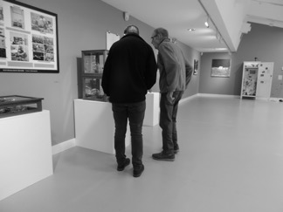

(Installation 1: Pictures were taken by the authors)

One work presented in the gallery consisted of an old cabinet with birdsong playing from inside the cabinet. As such, the work was a multimodal artefact, combining the materiality of the case, its visual properties, and an aural component (see Installation 1). It could be suggested that the artist has incorporated an incongruence into the piece, with birdsong not conventionally being associated with this item of furniture. It challenges the viewer to make some sense of the aggregate of components drawn from resources in different modalities. In the following extract, the facilitator (gallery assistant, GA 1) and Bert approach the old cabinet from which birdsong can be heard coming from within.



Excerpt 1, Bert 2

Fig 1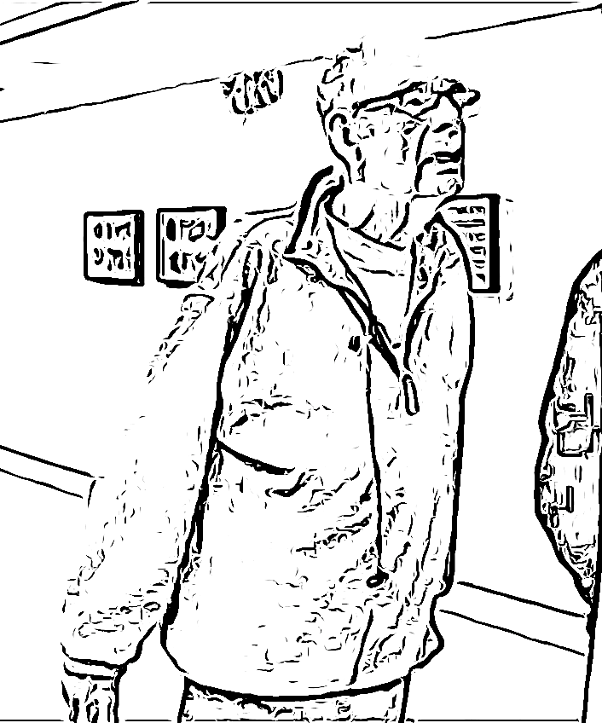 Fig 2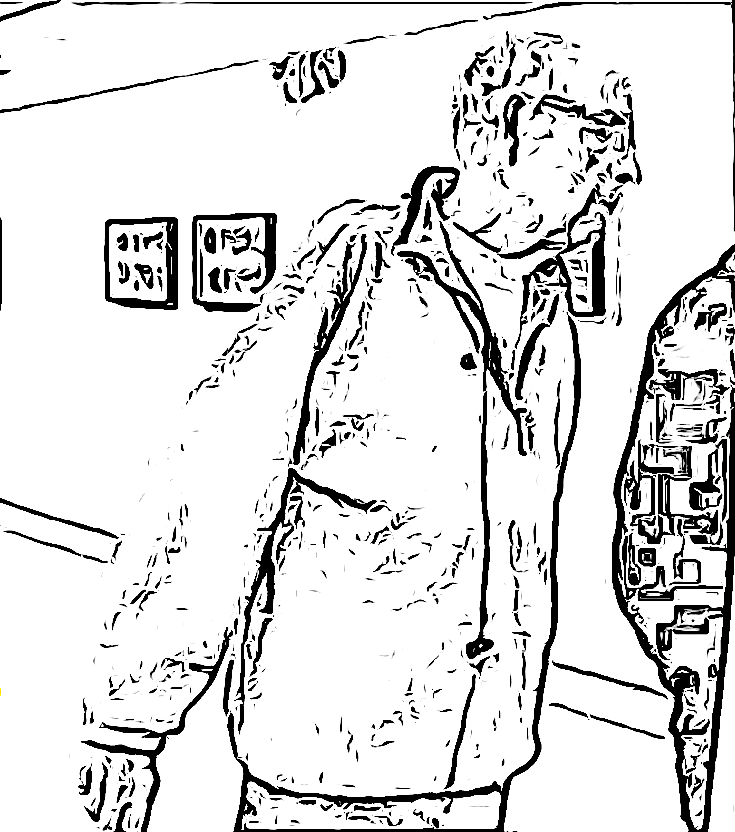 Fig 3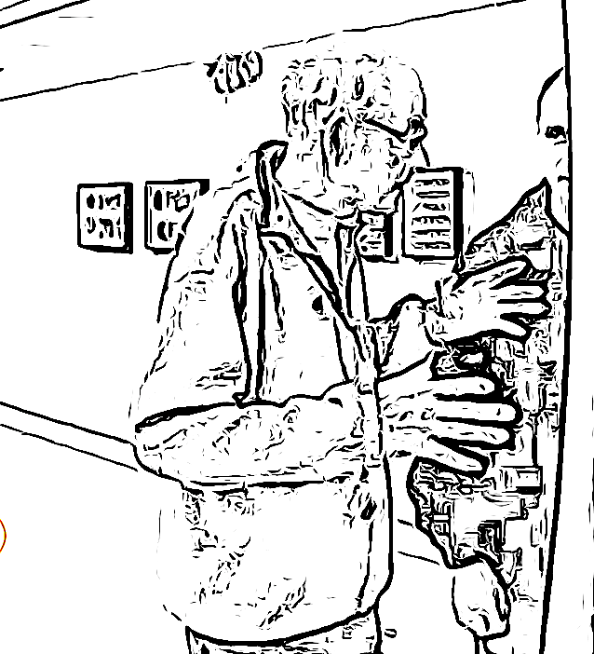

As Bert and the facilitator draw near to the art piece (see Excerpt 1, Bert 2 and Figures 1-3), GA1 draws attention to the work with “this is a” (line 02), which prompts Bert’s gaze to move to the object. Following a pause, GA1 proceeds to produce a description of the construction, “an old cabinet with bird sounds inside↗”. The rising intonation invites confirmation from participant Bert that he perceives the same multimodally-constituted artwork. Bert foregrounds the aural component in his acknowledgment, “yeah I can hear it” (line 07), while maintaining his gaze in the direction of the cabinet (Fig. 1). Although this displays his awareness of the aural component, it does not amount to a comment on the artwork. With GA1 holding off from contributing further talk, the turn-at-talk remains that of Bert (Sacks, Schegloff & Jefferson 1974), and after a pause in which he remains focused on the artwork, it is he who proceeds to formulate a response to the piece (09).

What is of interest here, is that Bert responds by providing an account of some aspect of his own lifeworld and experience. Withdrawing his gaze from the object, he turns his head toward GA1 and leans in that same direction (Fig. 2). By maintaining his lower body in the direction of the artwork, feet firmly rooted to the spot, Bert displays an ongoing primary orientation to the artwork, with the talk to GA1 being a secondary, temporary activity (Schegloff 1998). It also provides a posturally-constituted link between the two activities, on the one hand the looking at the artwork while on the other verbalizing a response for the benefit of a conversational partner. This is mirrored by GA1, who also maintains a body-visual orientation towards the artwork, turning only his gaze to face the person addressing him (Fig. 3). As such, the participants display mutual alignment to the ongoing composite activity.

As mentioned, the line of talk pursued by Bert here relates not to the artwork itself, but to his own lifeworld, here in terms of the birdlife found at his place of residence. Hence, the shared orientation to the artwork provides the grounds for developing talk, but the topic of the talk is not constrained by the activity of contemplating the art.

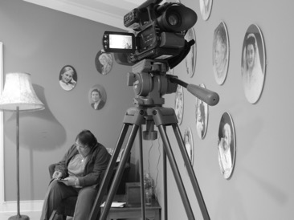

(Installation 2: Pictures were taken by the authors)

We see a similar pattern in other instances in the data set. For example, in the extract below and concerning a different art installation, a second participant, Tom’s comment foregrounds his ability to discern the date of the photographs used in the piece (see Installation 2).



Excerpt 2, Tom 2

As in Excerpt 1, Bert 2, in this extract (Excerpt 2, Tom 2) we note how the facilitator initiates talk about the artwork, and subsequently introduces the theme of the art installation, providing background information on the work and the artist’s intentions (lines 18-34). Although this account foregrounds maternal relationships as the topic of the piece, Tom’s initial response is to select one of the photographs in the collage and speculate on the year in which it was taken (line 36). Again, this does not equate with a response to the artwork *as* artwork, but directs the talk to a topic upon which he is able to contribute a display of knowledge. Like Bert in the previous example, this draws on lifeworld experience and the ability to identify the historical context of a particular artefact.



Excerpt 3, Tom 2

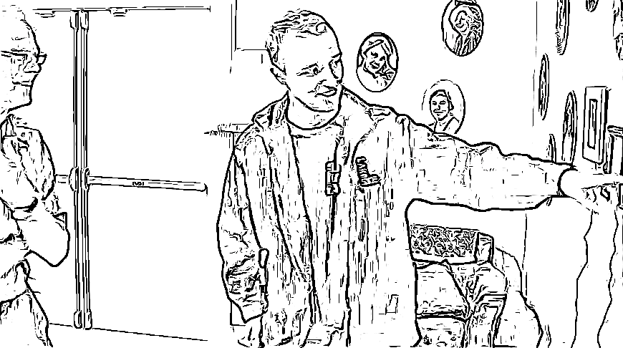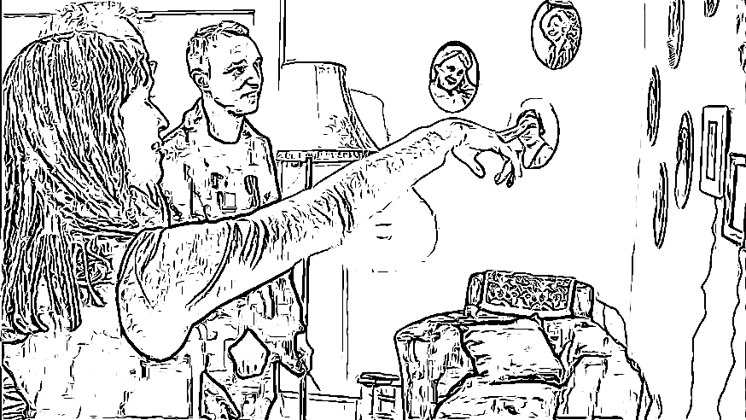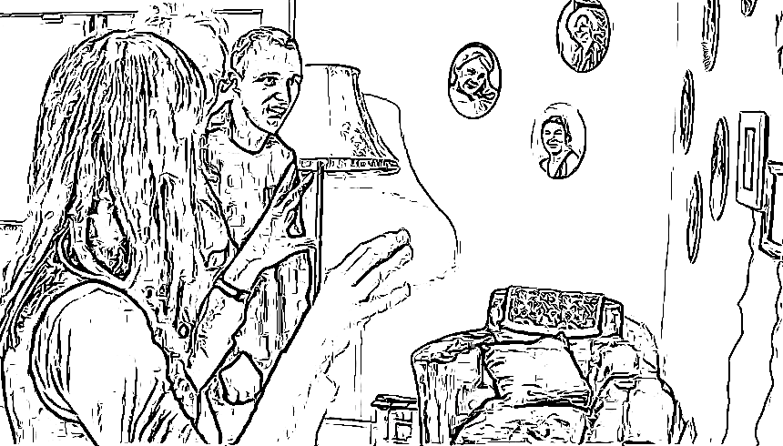

Fig 4 Fig 5 Fig 6

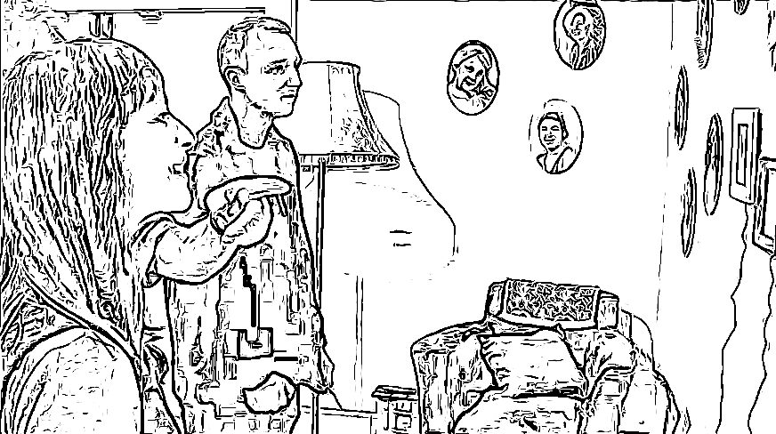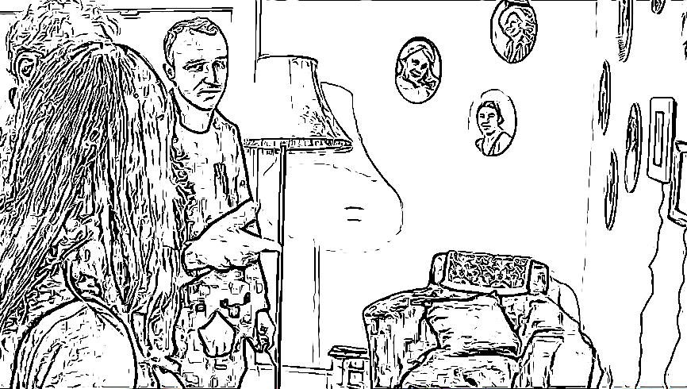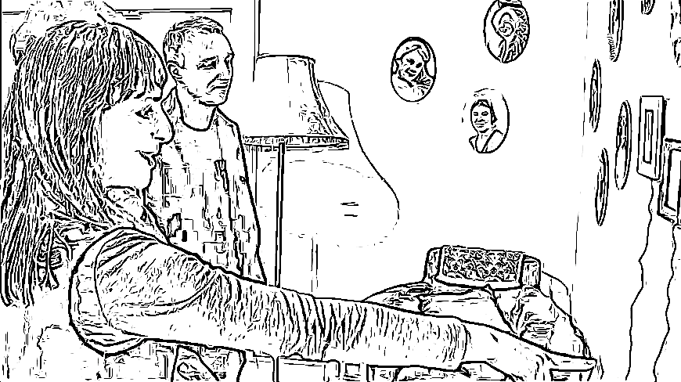

Fig 7 Fig 8 Fig 9

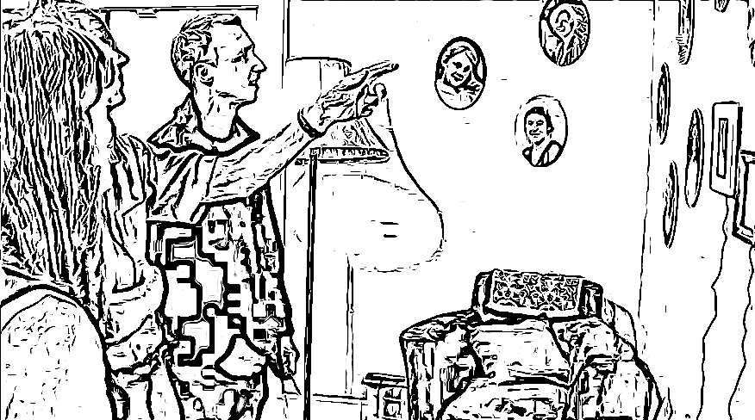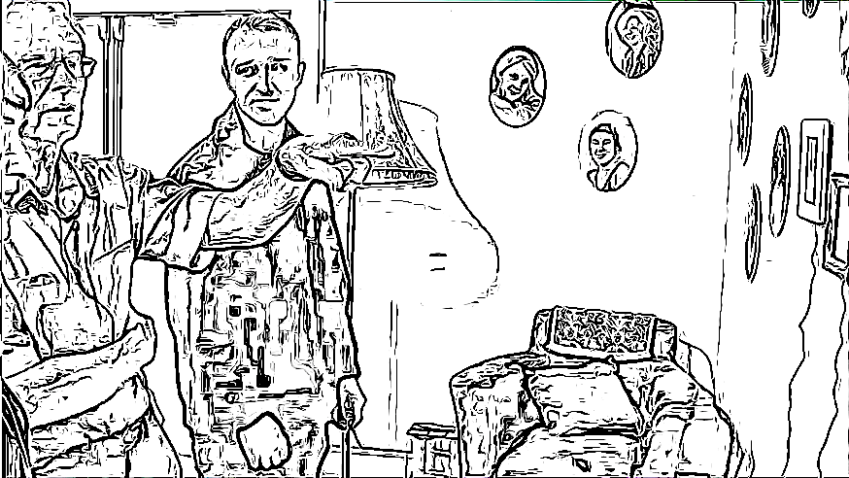

Fig 10 Fig 11

In the following excerpt (see Excerpt 3, Tom 2 continued and Figures 4-11), GA1 attempts to direct Tom away from his chosen line of topic development (lines 48-59), here a photograph that features a number of monkeys dressed in clothes. However, this topic proposal elicits only minimal responses from Tom, and the second facilitator subsequently steers the conversation back to Tom’s initial theme (line 60-106). In line 60, GA2 re-introduces the topic of providing an approximate date for the photographs. Using a two-handed gesture, she broadens out the shared focal point (fig. 5), away from the single image that GA1 had highlighted (fig. 1), and toward the range of photos on display on the wall. As she does this, she introduces a theme of temporal differentiation, with her “you can almost tell decade by decade” (line 60). She singles out one of the photographs with a single pointing gesture (fig. 6), and suggests “because that's quite nineteen fifties”, formatted with a rising intonation contour, which invites confirmation from an addressee. This she duly receives from both GA1 and Tom (lines 62 & 63), and she follows this up with an account of the feature with which she was able to arrive at the date, “by the dress” (line 64). GA2 continues along this line, singling out another photograph and projecting a similar analysis (line 65, fig. 7).

Here, however, she suspends the upshot of the analysis midway, and the turn takes on the shape of a *designedly incomplete utterance* (Koshik 2002), a form of elicitation, where an interlocutor is required to provide the missing part of an incomplete sentence. The formatting features of such speech structures include syntactic incompletion, and sound stretches with flat or rising intonation, as we see in line 65, “and then this is probably:→”. At the point of suspension, GA2 turns and solicits mutual gaze from TOM (fig. 8), thereby implicitly allocating him the next turn-at-talk, which he duly takes, offering a partial completion to the initiated analysis, “that’s further forward”. GA2 aligns with this reading in next position, confirming his suggestion, and offering the 1960s as potential decade (line 69).

Tom subsequently adopts GA2’s behaviour, by pointing to other photographs (fig. 9-11), and giving them a suggested timeframe, while adding some form of account for the analysis. This is produced in the form of a personal link (“when I was a boy”, line 72) or associated with some historical event (“first world war”, line 96). Over the course of this topic, Tom has the larger part of the contributions to the talk, with the others offering acknowledgment in the form of minimal responses, a pattern which carries on (not included here) through to line 133.



Excerpt 4, Tom 2

It is only in line 134 (see Excerpt 4, Tom 2) when GA1 returns the talk to the photograph with the monkeys, his earlier gambit for opening up a conversation about the artwork, that Tom relinquishes the floor and returns to providing minimal responses to the talk. We note here how GA1’s attempt to open up a new line of conversation is only partially successful. Even with the support of GA2, who offers to augment the topic development in 155 and 158, Tom only acknowledges the discussion, but abstains from building on it. The move results in a dissolution of the activity framework at this artwork, and the participants move on to the next piece.

In sum, it seems that although the artworks that feature in this gallery exhibition triggers and stimulates talk between people, evidently this does not necessarily lead to discussion that remains focused *on the artworks themselves*. In the above examples, both Bert and Tom find in the artworks a trace of something that they can utilize in directing the conversation to a personal experience away from the gallery. This in turn unlocks a domain of topic materials that they are able to exploit to develop conversation, which allows them also keeping the floor more strongly (see Edelsky 1981). It may be that memory problems make people less comfortable about discussing new information, stimuli, or knowledge, although these are the kinds of contributions that shared art viewing might elicit in people without memory difficulties. However the artworks do trigger lines of conversation with which the participants to the gallery are more confident engaging, topics that may not emerge otherwise. Other studies have suggested that such conversations could build alternative narratives, which reinforce the reclamation of citizenship and voice for people living with dementia (Dupuis et al. 2016). In what follows, we will give two more examples of such contributions in detail, relating to (1) overcoming hierarchical conversations and allowing epistemic authority, and (2) activating and valuing knowledge.

**Authority, Valuing Knowledge and Meaning-Making**

In excerpts 1-4, we saw how shared viewings of art installations enabled participants to talk about their lifeworld experiences. This also allows for an inversion of the asymmetrical epistemic primacy in the talk, with the participants able to assert the knowledge domains where they are the authority, over the facilitator knowledge domains of the art works.

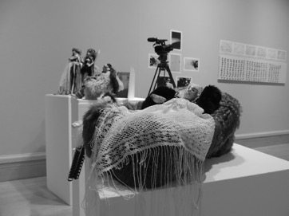

(Installation 3: Pictures were taken by the authors)

We see an example of such a discursive move elsewhere in Tom’s gallery tour (see Installation 3). As GA1 and Tom approach one section of the exhibition, GA1 introduces the theme of the artwork, and highlights the artist’s technique.



Excerpt 5, Tom 1

This leads Tom to volunteer that he used to paint (see Excerpt 5, Tom 1). We note that GA1’s response to Tom’s former interest is formatted with enthusiasm, with a change-of-state token (Heritage & Atkinson, 1984) “ah did you”, produced here with high pitch (line 44). This overlap in shared interest offers to the facilitator a device for pursuing affiliation, and he proceeds to talk with Tom about the paintings that are included in the gallery exhibition. At a certain point, however, Tom segues into talk about football (see Excerpt 6, Tom 1 and Figures 12-13).



Excerpt 6, Tom 1

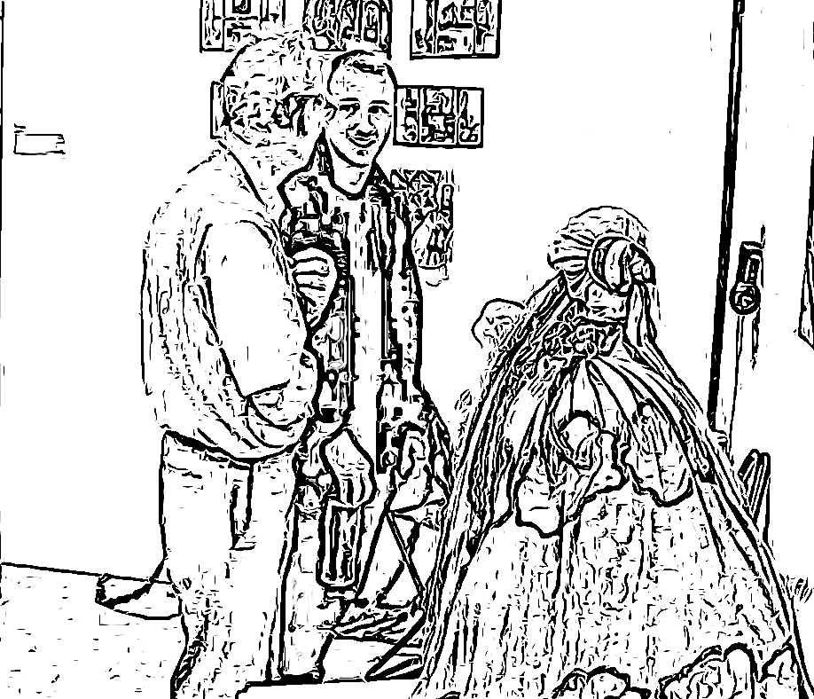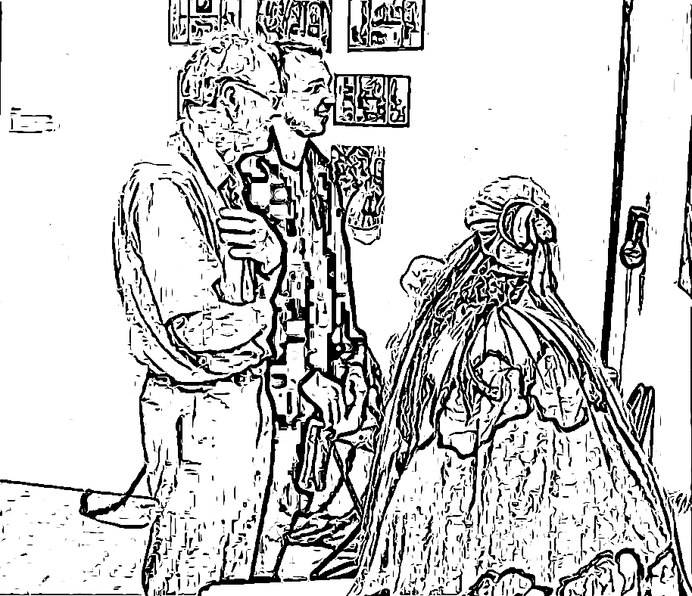

Fig 12 Fig 13

In line 63, we see how he introduces the topic of sport. The adverbial ‘too’ here links the new topic to previous talk, and as such it appears that he is mobilising the topic area ‘Tom’s interests’ to link to the new talking point, without it seeming incongruous.



Excerpt 7, Tom 1

Over the course of the subsequent talk (lines 63-128, see Excerpt 7, Tom 1), Tom expands on this shared interest with accounts of his own involvement in football; his cousin’s background as professional player; the relative qualities of different teams and different eras; and the current international tournament that was ongoing at the time of the visit. The talk affords Tom the opportunity to display authority in a knowledge domain located in their lifeworlds. We note again a similar bi-directional postural configuration as was described for excerpt 1, which displays a maintained stable orientation to the artwork, while treating the talk about the sport as a temporary secondary activity. This allows the pair to mark the art viewing as ongoing rather than suspended, and to return to the topic of the installation without needing to negotiate a way back into it; evidence of the interactional competence of both participants. Finally, we see that GA1 directs the conversation back to the artwork at hand (line 131). At this point, Tom assumes the role of ‘mentee’, listening to GA1’s account of the artwork, while offering only minimal responses.

Running the data through a speech duration analysis, we see how marked a shift there is in floor-holding between the conversational partners. For example, during the football talk, of the 75 seconds of conversation, Tom talks for 36 seconds, with GA1 only speaking for 22.7 seconds (with 16 seconds of gaps in talk). In the subsequent section, during the 91 seconds in which they discuss the artwork, it is GA1 who has the vastly larger part of the turns at talk, 42 seconds in comparison with Tom’s 10 seconds (with 38.5 seconds of gaps in talk).

In sum, we see how the facilitator turns the topic of the talk back to the artwork, and how this impacts the distribution of contributions to the conversation. A similar interactional move happens between Tom and GA1 in the ‘Tom 2’ excerpt (see Excerpt 2, Tom 2). Tom was identifying the timeframes of the different photographs, and held the floor while engaging in this thematic treatment of the artwork (see Installation 2).



Excerpt 8, Tom 2

GA1 finally returns the focus to the one photograph that he had highlighted initially, namely the image of dressed-up monkeys (see Excerpt 8, Tom 2). It would appear that GA1 is sometimes inclined to work against the topic choice of the participants, where discussions prompted by the artwork veer away from the topic *of* the art. Yet the conversational space provides a relatively open setting of subsequent contributions, with this openness also inverting the asymmetrical and hierarchical structure that often defines processes of meaning-making for people with dementia. In these sequences, they are able to assume the social identity of someone with epistemic authority on a topic of shared orientation. Artworks can be liked or disliked, but there is no universal standard or authority that predefines such preferences. Quite the contrary, the uniqueness and interrupting quality of the artwork seems to ring-fence a space, where authority does not simply rely on a form of superior knowledge or skills. Arguably, this episode illustrates such a process, where the gallery experience grants epistemic authority on a topic, reinforcing the speaker’s ‘social competence’ (Kitwood 1993), both objectively and in his own subjective estimation.



Excerpt 9, Bert 3

For another example of this, we return to Bert, this time as he and GA1 attend to the art installation piece on the theme of maternal relationships (Installation 2 and Excerpt 9, Bert 3). We saw Tom earlier refraining from pursuing the line of conversation proposed by GA1, instead proposing an analysis of the timeframe of the photographs (see Installation 2). Bert too abstains from GA1’s thematizing of the artwork, but takes two different routes into the discussion, neither of which centre on the artwork *as artwork*. First he responds to the photographs that form a central component in the piece with an account of having lost a lot of photos in a house move (lines 35-43). Here, it is the *type of artefact* that precipitates an account of an event in his personal history relating to similar artefacts. Second, he draws attention to one of the images, and the *likeness* that the person bears to someone in his past (lines 45/46). The story of the person whose likeness this bears is subsequently developed over an extended stretch (lines 50-87), with Bert providing the vast majority of the contributions (see Excerpt 10, Bert 3).



Excerpt 10, Bert 3

Here, a face contained in single photograph (see Installation 2) and selected from among many in a collage that makes up an art installation leads to Bert reminiscing about a family from a period in his distant past. Although Bert’s account was preceded by GA1 articulating the theme of the artwork, here the maternal relationship, it does not follow this theme. The artwork sparks a possible topic to explore from Bert’s background, one for which he has epistemic primacy.



Excerpt 11, Bert 2

Whereas Bert has earlier been able to present epistemic authority on the basis of recounting from personal experience that others do not have access to, in his interaction with the birdsong cabinet (see Excerpt 11, Bert 2) he is able to activate his knowledge of wildlife (see Installation 1). In line 38, we see Bert draw on the aural component of the artwork – birdsong - to initiate a redirection of topic to a discussion of the wildlife where he lives. He broaches the subject with a description of the setting (lines 38 & 39), before connecting it back to the prior talk (line 41), which involved a shared focusing on the artwork. This is responded to with a minimal response from GA1 (‘mm’), with Bert treating this as a continuer, expanding on the account with further details of one of the types of bird in the local environment (line 43). He follows this with an assessment, which makes a second assessment procedurally relevant (Pomerantz, 1984). When GA1 does not provide this, it leads to a noticeable silence, before Bert continues building his account with a number of grammatically incomplete increments (lines 46, 48 & 50), interspersed with lengthy silences (lines 47, 49, 51 & 53). This appears to evidence Bert’s difficulties in producing the kind of account that would warrant the preceding assessment.

Although attending to this account, GA1 does not display any uptake of what the target was of the assessment. Finally, following another lengthy pause in line 53, GA1 suggests the conclusion of Bert’s account is that the birdsong is ‘quite noisy’ (line 54). This connects back to the opening discussion of the artwork, which had focused on the sound effects coming from inside the cabinet. As discussed in the earlier examples, this evidences a divergence in orientation between facilitator and participant, with the facilitator privileging contemplations of the art over talk where lifeworld topics are developed. Here, we see that Bert explicitly rejects GA1’s candidate upshot (line 56), specifying the topic as relating to the conduct of the different species, rather than to the soundscape. This is responded to with a change-of-state token (“ar::::↘”), which Bert accepts with positive acknowledgements and further topic development. During this sequence, Bert displays his knowledge of numbers of birds in the vicinity and the location of their nests, before returning to the sound effects from the artwork, and being able to differentiate the calls from different species (63 & 64).

Taking the time and space to do this work, displaying knowledge of the avian wildlife where he lives, Bert is able to affirm his epistemic status on this particular topic, by building an account from his lifeworld, rather than focusing on the artwork, as suggested by the activity in which they are engaged. It results in GA1 stating in line 67 that Bert knows more on this topic than he does himself. This is acknowledged by Bert, and he provides a jocular account for this, one relating to his relative seniority (line 72).

It could be suggested that the activity of co-participatory art viewing allows one party to dictate the terms of the discussion, and in the case of this activity gives the person with dementia a space to assert epistemic authority in a discussion. Where successful, this offers people with dementia opportunities to experience this aspect of their identity, which in other everyday social activities may be rare.

**Discussion and Conclusion**

Our ethnomethodologically oriented framework emphasises an interactive approach to the study of arts interventions in people with dementia by researching meaningful conduct as it unfolds through the use of video analysis. In the context of symbolic interaction, we aimed to demonstrate Blumer’s (1963) well-known thinking in a dementia context, where people with dementia do not simply react to other people’s actions, but rather they actively engage in defining and giving meaning to each other’s actions. This line of thought enabled us to address three main limitations in current research on dementia and arts interventions and related healthcare discourse. (1) There is a lack of conceptual direction that only loosely connects art and dementia, posing the risk that any identified benefits of intervention might owe to intervening factors such as change of scene or social contact. (2) Existing research relies mostly on small samples or on interviews with carers and third persons but rarely addresses how art may contribute to the formation of meaningful interactions in people with dementia. (3) Healthcare literature continues to represent people with dementia as ‘socially dead’, as being unable to engage in meaningful conduct.

Our findings indicate that, within an arts context, people with dementia engage in complex meaningful interactions with the objects and people around them, are able to manage a complex set of expressions and behaviour. They are able to lead the conversation and define meaning across a continuous series of actions, thus giving people with dementia a voice. This may include small subsets of behaviour and cognition related to processing time, attending to and waiting for other speakers, and actively following a conversation to respond in turn-taking. It may also include broader issues of reactivating memory, use of personal biography and responding to feedback from other speakers. In this context, three findings are of particular interest: (1) how viewing artworks affords participants a range of conversational avenues to develop and explore; and (2) how allowing a person with dementia to lead the direction of topic development enables them to contribute more actively and meaningfully to the conversation, offering them the opportunity to reaffirm themselves as fully competent social actors with their own lifeworld experience and knowledge and (3) how objects can become actants that motivate action and stimulate social conduct.

Our research confirms that both verbal and non-verbal communication can prompt primary and secondary conversations within the same situation. For instance, Bert’s engagement with the work of art is not solely aesthetic but is also marked by an account of his own lifeworld and experiences. It is within such a context that people with dementia can share their experiences as equals. However, this topic does not unfold in isolation from the work of art, as his bodily attention is still directed towards the art object, which is integral to the arts viewing activity. From this primary focus on the work of art, he is able to open a secondary temporary activity, turning his upper body and engaging with the facilitators. These parallel conversation streams combining micro bodily movement and verbal utterances can only be captured through video analysis, which can reveal the complexity and nuance of meaning-making in such settings. An approach focusing only on verbal contributions or on the effect of these activities may also overlook the importance of gaze in directing conversation. We were able to show that purposefully incomplete utterances are a typical feature of conversation, and are even more likely to occur in settings where one person has difficulties in verbalising. This does not mean that the conversation is interrupted, as the suspension can be overcome by soliciting a mutual gaze that implicitly allocates the next turn in the conversation to the other speaker.

For these reasons, video analysis makes an important contribution to accessing interactions among people with dementia. This approach can usefully be applied to interactions in care homes and for further development of interventions and treatments; it also facilitates closer monitoring of skills and capabilities in people with dementia and how to support these over time and contributes to the wider debate on restoring social meaning to the final stage of life (Gilleard and Higgs 1998).

In the present study, the small sample means that long-term effects cannot be determined and the study does not provide insight into the participants’ cognitive experiences. However, this study focused on social interactions and we wanted to see how people in these events constitute themselves as social beings with one another, rather than making claims to know why or on what grounds they choose to do this. However, we believe that some of our findings contribute to the wider field of person-centred practice, which highlights the role of social interaction (e.g. Young et al. 2016). As discussed by Kontos and Martin (2013), it seems likely that self-assurance and self-esteem can be enhanced by activating and valuing knowledge, managing and directing a conversation or being talked to and responded to; in particular, this may challenge established conventions for meaningful conduct in dementia settings, and how cultural institutions might facilitate interventions.

Our findings promise to contribute to such interventions in several ways, not least by confirming the importance of both verbal and non-verbal communication. Communication that is not directly about the artwork does not mean that it is off-topic, or that the intervention is misleading. Instead, it shows that primary and secondary communication can unfold within this context that enhances the visitor’s experience. Museum and gallery personnel may also benefit by better understanding the complexity of managing such interactions. In particular, it is important to recognise pauses and micro-sounds as potential contributions to the interaction rather than as mere gaps, and to build a meaningful conversation around these.

These findings have intriguing implications for the sociology of aging. The loss of linguistic communication or physical impairments among people with dementia means that there is a tendency to overlook meaningful constructions and complex patterns in their interactions (see also Baker et al. 2015, Buse & Twigg 2014, Söderlund et al. 2016, Willemse et al. 2015), putting them at risk of becoming socially isolated. Artworks provide and facilitate a conversational space in which experiences can be shared, where there is no right or wrong answer, where less importance is assigned to rational cognitive responses and, in particular, where personal experiences are valid (see Fenner & Allen 2014). These qualities are strongly reflected in the examples cited above, as both Bert and Tom find in the artworks a trace of something that enables them to direct the conversation to a personal experience in their lifeworld away from the gallery, enabling them to more strongly control the floor. In this way, art viewing can elicit forms of meaningful interaction that might otherwise be less accessible for people with dementia.

**Acknowledgments**

We would like to thank the participants in the study, the student volunteers and, in particular, Wayne Marriott and Liz Hay Lewis, for their help and support. We also would like to thank Tom Dening and Steve Dyer for their comments on an earlier version of the manuscript.

**References**

Alexander, J. (2008) ‘Iconic Experience in Art and Life: Beginning with Giacometti’s ‘Standing Woman’’, *Theory, Culture and Society*, 25: 5, pp. 1-19.

Baker, R. Angus, D. Smith-Conway, E., Baker, K. Gallois, C., Smith, A. Wiles, J, Chenery, H.J. (2015) ‘Visualising conversations between care home staff and residents with dementia’, *Ageing and Society*, 35: 2, pp. 270-297.

Basting, A., Towey, M. and Rose E. (eds.) (2016) *The Penelope Project: An Arts-Based Odyssey to Change Elder Care*, Iowa City: University of Iowa.

Beard, R. L. (2011) ‘Art therapies and dementia care: A systematic review’, *Dementia*, 11: 5, pp. 633–656.

Birt, L., Poland, F., Csipke, E. and Charlesworth, G. (2017) ‘Shifting dementia discourses from deficit to active citizenship’, *Sociology of Health and Illness*, 39: 2, pp 199-211.

Blumer, H. (1963) ‘Society as Symbolic Interaction’, in Rose, A. (ed.) *Human Behavior and Social Processes*, Boston: Houghton Mifflin, pp. 179-192.

Büscher, M. (2005) ‘Social Life Under the Microscope?’, Sociological Research Online, 10: 1, <http://www.socresonline.org.uk/10/1/buscher.html>.

Buse, C. and Twigg, J. (2014) ‘Looking “out of place”: analysing the spatial and symbolic meanings of dementia care settings through dress’, *International Journal of Ageing and Later Life*, 9: 1, pp. 69-95.

Camic, P.M., Tischler, V., and Pearman, C.H. (2014) ‘Viewing and making art together: a multi-session art-gallery-based intervention for people with dementia and their carers’, *Aging & Mental Health*, 18: 2, pp. 161-168.

Chancellor B., Duncan A. and Chatterjee A. (2014) Art Therapy for Alzheimer's Disease and Other Dementias, *Journal of Alzheimer's Disease*, 39:1, pp. 1-11.

Chung, J. (2004) ‘Activity participation and well-being of people with dementia in long term care settings’, *Occupation, Participation, and Health*, 24, pp. 22–31.

Cowl, A. L. and Gaugler, J. E. (2014) ‘Efficacy of Creative Arts Therapy in Treatment of Alzheimer’s Disease and Dementia: A Systematic Literature Review,’ *Activities, Adaptation & Aging*, 38: 4, pp. 281-330.

Daykin, N., Byrne, E., Soteriou, T., O’Connor, S. (2008) ‘The impact of art, design and environment in mental healthcare: a systematic review of the literature’, *The Journal of The Royal Society for the Promotion of Health*, 128: 2, pp. 85-94.

Dewing J. (2007) ‘Participatory research: A method for process consent with persons who have dementia’, *Dementia*, 6: 1, pp. 11-25.

Dooley, J., Bailey, C., and McCabe, R. (2015) ‘Communication in healthcare interactions in dementia: A systematic review of observational studies’, *International Psychogeriatrics*, 27: 8, pp. 1277-1300.

Dupuis, S.L., Kontos P., Mitchell G., Jonas-Simpson C. and Gray J. (2016) Re-claiming citizenship through the arts, *Dementia*, 15:3, pp. 358-80

Edelsky, C. (1981) ‘Who’s Got the Floor?’, *Language in Society*, 10: 3, pp. 383-421.

Eekelaar, C., Camic, P. M. and Springham, N. (2012) ‘Art Galleries, Episodic Memory and Verbal Fluency in Dementia: An Exploratory Study’, *Psychology of Aesthetics Creativity and the Arts*, 6: 3, pp. 262-272.

Evans, D. (2002) ‘The effectiveness of music as an intervention for hospital patients: A systematic review’, *Journal of Advanced Nursing*, 37, pp. 8–18.

Feldman, M.B, Betts, D.J. and Blausey, D. (2014) Process and Outcome Evaluation of an Art Therapy Program for People Living With HIV/AIDS, *Art Therapy*, 31:3, pp. 102-109.

Fenner, P. and Allen, J. (2014) ‘The participatory installation – Forming the evidence of experience’, *Journal of Applied Arts & Health*, 5: 2, pp. 179-187.

Gilleard, C. and Higgs, P. (1998) ‘Ageing and the Limiting Conditions of the Body’,

Goffman, E. (1961) *Asylums: Essays on the Social Situation of Mental Patients and Other Inmates*, New York: Anchor Books.

Goffman, E. (1967) *Interaction Ritual*, New York: Pantheon Books.

Goulding, A. (2013) ‘A critical comparison of methods for evaluating Arts and Dementia programmes’, *Journal of Applied Arts & Health*, 4: 2, pp. 133-149.

Hanson, B. G. (1994) ‘The potential of videotape data: Emotional correlates of senile dementia in families as a case in point’, *Quality and Quantity*, 28: 3, pp. 219–232.

Hazel, S. (2016) ‘The Paradox from Within – Research Participants Doing-Being-Observed’, *Qualitative Research*, 16: 4, pp. 446-467.

Hazel, S., Mortensen, J. and Haberland, H. (2012) ‘Transcription linking software: integrating the ephemeral and the fixed in interaction research’, In K. Ikeda and A. Brandt (eds.) *Proceedings for the symposium ‘Challenges and New Directions in the Micro-Analysis of Social Interaction’*, Osaka: Kansai University Press, pp. 13-17.

Heath, C. and Hindmarsh, J. (2002) ‘Video, Ethnography and Situated Conduct’, in T. May (ed.) *Qualitative Research in Action*, London: Sage, pp. 99-121.

Hennion, A. and Latour, B. (1993) ‘Objet d’art, objet de science. Note sur les limites de l’anti-fétichisme’, Sociologie de l’art, 6, pp. 7-24.

Heritage, J. and Atkinson, M. (1984) Introduction, in J. M. Atkinson and J. Heritage (eds). *Structures of Social Action*, Cambridge, Cambridge University Press, pp. 1-15.

Hutchby, I. & R. Wooffitt (1999) *Conversation Analysis: Principles, Practices and Applications*, Cambridge UK: Polity Press.

Jefferson, G. (2004) ‘Glossary of Transcript Symbols with an Introduction’, in G. Lerner (ed.) *Pragmatics & Beyond New Series*, Amsterdam: John Benjamins Publishing Company, pp.13–31.

Junge, M. B. (2010) *The Modern History of Art Therapy in the United States*, Springfield, IL: Charles C Thomas.

Kitwood, T. (1993) ‘Person and Process in Dementia’, *International Journal of Geriatric Psychiatry*, 8: 7, pp. 541-545.

Kitzinger, C., and Jones, D. (2007) ‘When May calls home: The opening moments of family telephone conversations with an Alzheimer’s patient’, *Feminism and Psychology*, 17: 2, pp. 184–202.

Kontos, P. and Martin, W. (2013) ‘Embodiment and dementia: Exploring critical narratives of selfhood, surveillance, and dementia care’, *Dementia*, 2: 3, pp. 288-302.

Koshik, I. (2002) ‘Designedly Incomplete Utterances: A Pedagogical Practice for Eliciting Knowledge Displays in Error Correction Sequences’, *Research on Language and Social Interaction*, 35: 3, pp. 277-309.

Latour, B (1996) ‘On Interobjectivity’, *Mind, Culture, and Activity: An International Journal Traduction*, 3: 4, pp. 228-245 & 246-269

Linesch, D., Ojeda, A., Fuster, M.A., Moreno, S. and Solis, G. (2014) Art Therapy and Experiences of Acculturation and Immigration, *Art Therapy*, 31:3, pp. 126-132.

MacPherson, S., Anderson, B.M., Davis, K., Blair, T. A. (2009) ‘An Art Gallery Access  
 Programme for people with dementia: ‘You do it for the moment’’, *Aging & Mental   
 Health*, 13: 5, pp. 744-752.

MacWhinney, B. and Wagner, J. (2010) ‘Transcribing, searching and data sharing: The CLAN software and the TalkBank data repository’, *Gesprächsforschung*, 11, pp. 154-173.

Mikesell, L. (2009) ‘Conversational practices of a frontotemporal dementia patient and his interlocutors’, *Research on Language and Social Interaction*, 42: 2, pp. 135–62.

Mittelman, M. and Epstein, C. (2009) ‘The NYU evaluation of Meet Me at MoMA’, in Rosenberg, F., Parsa, A., Humble, L., McGee, C. (eds.) *Meet Me: Making Art Accessible for People with Dementia*, New York, NY: Museum of Modern Art, pp. 87–105.

Nevile, M. (2015) ‘The Embodied Turn in Research on Language and Social Interaction, *Research on Language and Social Interaction*, 48: 2, pp. 121-151.

O'Connor D., Mann J. and Wiersma E. (2018) Stigma, discrimination and agency: Diagnostic disclosure as an everyday practice shaping social citizenship, *Journal of Aging Studies*, 44, pp. 45–51.

Perkins, L. Whitworth, A., Lesser, R. (1998) ‘Conversing in dementia: A conversation analytic approach’, *Journal of Neurolinguistics*, 11: 1–2, pp. 33-53.

Pomerantz, A. (1984) ‘Agreeing and Disagreeing with Assessments: Some Features of Preferred/ Dispreferred Turn Shapes’, in J. M. Atkinson and J. Heritage (eds). *Structures of Social Action*, Cambridge: Cambridge University Press, pp. 57-101.

Robinson, L., D. Hutchings, L. Corner, F. Beyer, H. Dickinson and A. Vanoli (2006) A systematic literature review of the effectiveness of non-pharmacological interventions to prevent wandering in dementia and evaluation of the ethical implications and acceptability of their use, *Health Technology Assessment*, 10, pp. 1–124.

Roe, B., McCormick, S., Lucas, T., Gallagher, W., Winn, A. and Elkin, S. (2016) ‘Coffee, Cake & Culture: Evaluation of an art for health program me for older people in the community’, *Dementia*, 15: 4, pp. 539-559.

Rousseaux, M. Sève, A., Vallet, M., Pasquier, F. and Mackowiak-Cordoliani, M.A. (2010) ‘An analysis of communication in conversation in patients with dementia’, *Neuropsychologia*, 48: 13, pp. 3884-3890.

Sacks, H., E.A. Schegloff, G. Jefferson, (1974) ‘A simplest systematics for the organization of turn-taking for conversation’, *Language*, 50, pp. 696-735.

Schegloff, E. A. (2003) ‘Conversation analysis and communication disorders’, in C. Goodwin (ed.) *Conversation and brain damage*, Oxford: Oxford University Press, pp. 21–55.

Schegloff, E.A. (1998) ‘Body Torque’, *Social Research*, 65: 3, pp. 536–596.

Schneider, J., Hazel, S., Morgner, C., & Dening, T. (2018). Facilitation of positive social interaction through visual art in dementia: A case study using video-analysis. Ageing and Society, 1-21. Aigen, K. (2008) ‘An analysis of qualitative music therapy research reports 1987–2006: Articles and book chapters’, *The Arts in Psychotherapy*, 35, pp. 251–261.

Schouten, K. A., de Niet, G. J., Knipscheer, J. W., Kleber, R. J., and M., G. J. (2015) The Effectiveness of Art Therapy in the Treatment of Traumatized Adults: A Systematic Review on Art Therapy and Trauma, *Trauma, Violence, & Abuse*, 16:2, pp. 220–228.

*Sociological Research Online*, 3: 4, <http://www.socresonline.org.uk/3/4/4.html>

Söderlund, M., Cronqvist, A., Norberg, A., Ternestedt, B.-M., Hansebo, G. (2016) ‘Conversations between persons with dementia disease living in nursing homes and nurses – qualitative evaluation of an intervention with the validation method’, *Scandinavian Journal of Caring Sciences*, 30: 1, pp. 37-47.

Streeck, J., Goodwin, C., LeBaron, C. (Eds.) (2013) *Embodied Interaction: Language and Body in the Material World*, Cambridge: Cambridge University Press.

Vom Lehn, D. (2014) *Harold Garfinkel: The Creation and Development of Ethnomethodology*, London: Routledge.

Watson C. M. (1999) ‘An analysis of trouble and repair in the natural conversations of people with dementia of the Alzheimer's type’, *Aphasiology*, 13: 3, pp. 195-218.

Wilkinson, R. (2008) ‘Conversation analysis and communication disorders’, In M. Ball, M. Perkins, N. Muller, and S. Howard (eds.) *The handbook of clinical linguistics*, Oxford, England: Wiley-Blackwell, pp. 92–106.

Willemse, B.W., Downs, M., Arnold, L., Smit, D., de Lange, J., Pot, A. M. (2015) ‘Staff–resident interactions in long-term care for people with dementia: the role of meeting psychological needs in achieving residents’ well-being’, *Aging & Mental Health*, 19: 5, pp. 444-452.

Young, R., Camic, P. M. and Tischler, V. (2016) ‘The impact of community-based arts and health interventions on cognition in people with dementia: a systematic literature review’, Aging & Mental Health, 20: 4, pp. 337-351.