Drinking vessel preferences in older nursing home residents: optimal design and potential for increasing fluid intake
Abstract
Background: Residents in nursing and residential care homes are at risk of dehydration due to both resident and institutional factors. Previous studies have focused on improving fluid intakes by concentrating on types of fluids offered and assisting residents to drink. Aim: To determine resident opinion of the optimal features of drinking vessels and evaluate the impact of improving vessel design on fluid consumption. Methods: Residents from two units (25 and 21 bed) in one nursing home evaluated a range of drinking vessels. Vessels with preferred features were introduced on a 25-bed unit. The effect was tested by observing residents’ fluid consumption during breakfast on three consecutive days and comparing to baseline intakes. Results: Vessels which received the highest ratings were lightweight, had large handles and held 200-300ml of fluid. Following the introduction of the new drinking vessels, mean fluid intakes at breakfast increased from 139ml (±84ml) to 205ml (±12ml, n=65), p= 0.003. Conclusion: Some drinking vessels used in nursing homes may be difficult for residents to handle. Making improvements to the design of drinking vessels has the potential to increase fluid intakes without increasing staff workload.
Key words: aged, assistive devices, dehydration, fluid intakes, nursing homes, older people

Key points:
- Some drinking vessels commonly used in nursing homes may be difficult for residents to handle.
- Residents prefer to drink from conventional vessels rather than assistive devices.
- Lightweight mugs with large wide handles and plastic tumblers with horizontal ridges were preferred by residents.
- Introducing drinking vessels that residents find easier to handle can help to increase their fluid intakes.
Reflective questions:
- What are the important features of the drinking vessels that help older people drink independently?
- Think about the drinking vessels used in your workplace. Is it easy for older people to handle them?
- How often do you serve drinks in a beaker? How do you think this might make the patients/residents feel?

Background
Water is essential for the human body to maintain homeostasis. Older people are predisposed to dehydration because the physiological changes associated with aging impair their ability to maintain fluid balance. The potential consequences of dehydration include urinary tract infection, falls, constipation, delirium, and result in frailty and increased mortality (Beetz, 2003; Thomas et al, 2008; Benelam and Wyness, 2010).
A recent study identified that the prevalence of dehydration in emergency hospital admissions is ten times higher in care (nursing and residential) home residents than older people living in the community (Wolff et al, 2015). The fluid intake required to avoid dehydration varies between individual people depending on personal characteristics such as the size of the person, the amount and quality of food consumed, physiological state or activity level, as well as external factors such as the surrounding temperature. Different methods for calculating individual fluid requirements exist based on a person’s weight, body surface area, amount of calories or amount of protein consumed (Zeman, 1991), but these are complex to calculate and therefore not suitable for general use. For this reason, experts have attempted to establish the minimum amount of fluids to be consumed daily for maintaining health. European Food Safety Authority as well as British Nutrition Foundation recommend 2000ml/day for females and 2500ml/day for males (Benelam and Wyness, 2010; EFSA, 2010). Although not recommended, it has been recognised that the elderly tend to consume less than other adults (EFSA, 2010). Studies in nursing/residential care settings have used 1500ml per day as a minimum fluid intake requirement (Kayser-Jones et al, 1999; Ferry et al, 2005), but there is evidence that many consume less than 1500ml (Wilson et al, 2018).
Previous studies have described interventions to increase fluid intakes in nursing home residents, although these have been primarily focused on providing preferred fluids, and assistance with drinking and toileting (Robinson and Rosher, 2002; Spangler et al, 1984; Simmons et al, 2001; Mentes and Culp, 2003).
Research on the impact and suitability of drinking vessels for use by older people has concentrated on overcoming the visuospatial challenges experienced by people with Alzheimer’s disease (Dunne et al, 2004) or the provision of assistive devices (Stabell et al, 2004; Godfrey et al, 2012). Despite many frail older people experiencing difficulty in lifting and handling drinking equipment due to underlying conditions such as muscle weakness, arthritis or tremors, no studies have explored the effect of vessel design on fluid intake. Our preliminary investigations of hydration practice in the nursing home setting identified that residents found the routinely available drinking vessels difficult to hold and too small (Wilson et al, 2018).
The purpose of this improvement project was to determine the characteristics of drinking vessels that best met the needs of nursing home residents and to evaluate the effect of introducing alternative drinking vessels on residents’ fluid intake.
Methods
Setting: The improvement project was undertaken in two units within a 160-bed nursing home in North West London. The units were designated for frail older people who did not have severe cognitive impairment. The residents on these units had a wide range of underlying health conditions and a level of physical and/or cognitive impairment, which made them dependent on carers to meet their needs. The work was conducted in two phases (Figure 1).
Ethical considerations
This improvement project was assessed by the Heath Research Authority not to require NHS Research Ethics Committee approval. It was reviewed, and ethical approval given by the College of Nursing, Midwifery and Healthcare research ethics panel at the University of West London. Since this was an improvement project a formal consent procedure was not required.
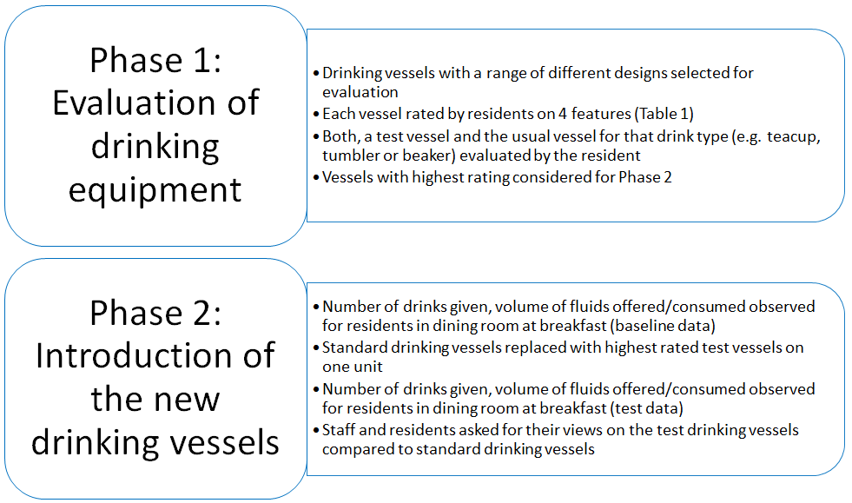
Figure 1: Description of methodology used in the improvement project.
Phase 1 Evaluation of drinking equipment:
China teacups with saucers (volume 150ml), glass tumblers (volume 150ml) and semi-opaque plastic spouted beakers (volume 200ml) were the standard, existing equipment provided by the nursing home. These were of a type commonly used across health and social care settings in the United Kingdom (Figure 2). Staff did not make formal assessments of resident’s drinking ability and all, except two residents with their own dysphagia cups were given drinks in standard vessels. Residents who experienced difficulty handling the cups or required full assistance were given drinks in beakers. The nursing home allowed residents to bring their own cups and mugs, however these were not routinely used to serve drinks.
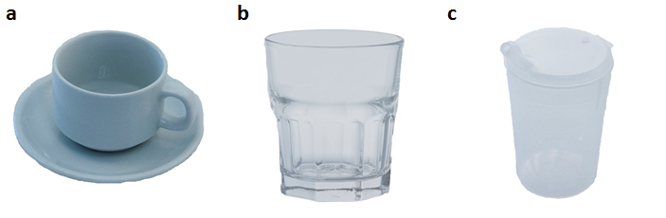
Figure 2: Illustrations of the vessels previously used in a nursing home a) standard cup, b) standard tumbler and c) standard beaker
Drinking vessels covering a range of styles, weight and design were chosen for testing. They included 12 ceramic mugs (china, bone china, small/large etc), one cup/saucer, two ceramic double handled mugs, four plastic mugs, two plastic tumblers, four plastic beakers of different designs and one mug adapted for people with swallowing difficulty and one for use by people with shaky hands. Preliminary data identified that small handles and heavy cups caused problems for residents and this was considered in selecting vessels for testing. The range of vessels available from the care home suppliers was limited and therefore some were purchased from local stores and selected from mobility aid websites (Complete Care Shop, Kapitex, Hand-Steady and Secure Grip Tableware). The intention was to test each vessel on at least ten residents, although this was not always possible, e.g. some vessels were broken before testing was completed.
Residents were approached and asked if they would participate in the testing of drinking vessels. Those who agreed, were asked to evaluate either a conventional drinking vessel or one adapted for drinking difficulties that was relevant to their clinical condition e.g. with double-handles, a spout or dysphagia adaption. Participants were offered a choice of fluids suitable to the type of cup being tested, e.g. cold drink in a glass (juice, squash, water, milk) and hot drink (tea, coffee, hot chocolate) in a cup/mug. Two identical drinks were prepared and presented to the resident, one was served in a standard vessel while the second was given in a test vessel of a similar type (e.g. when testing a mug, a tea was given in a standard tea cup and the test mug).
Once the resident had drunk from both vessels, they were asked to rate each vessel on four features: 1) ease of handling, 2) volume, 3) ease and pleasantness of drinking, and 4) appearance. These features were chosen following the preliminary feedback from the residents who identified these as important factors. Residents rated each vessel using a five-point Likert scale questionnaire based on a communication tool described by Pouyett et al (2015). This method of data collection was chosen as it supports communication with people with cognitive impairment. The original tool was used to obtain data on food preference in cognitively impaired nursing home residents and the responses ranged from ‘like very much’ to ‘dislike a lot’. The tool prompted the first question whether the resident liked the food, followed by the question how much the resident liked or disliked it. If the resident was undecided, the middle answer (‘neither like nor dislike’) was selected, and the second question was not asked. For the purpose of this project, the tool was adapted to include questions and answers related to handling and experience of drinking from the vessels (Table 1).
Questions and answers were communicated verbally, and the responses were noted down. The median scores for each feature were calculated for each vessel. The resident’s responses for each of the four features were summed to obtain a total score of the vessel. To assess whether resident rating was influenced by the features of the vessels, correlations between the actual volume, the volume perceived by the residents, the weight of the cup with and without fluid, and ease of handling were assessed. Spearman’s rho was used because it allows the testing of the ordinal variables such as the responses of the Likert scale.
Table 1: Scoring system for evaluating the drinking vessels.
How would you rate the ease of handling?  (How easy is it to hold it, lift it, drink from it, etc.?)  1 Very hard  2 Hard  3 Neither hard nor easy  4 Easy  5 Very easy | How would you rate the volume of the cup?  (The amount of fluid the vessel contains)  1 Far too little  2 A bit too little  3 Just right  4 A bit too much  5 Far too much
How do you like the feel of the cup?  (How does it feel to the touch or to drink from it?)  1 Dislike very much  2 Moderately dislike  3 Neither like nor dislike  4 Moderately like  5 Like very much | How do you like the appearance of the cup?  (The colour, shape, design, decorations etc.)  1 Dislike very much  2 Moderately dislike  3 Neither like nor dislike  4 Moderately like  5 Like very much

Phase 2: Introduction of the new drinking vessels
The standard drinking vessels were replaced by the vessels that scored highest in resident testing on one 25-bed unit. Posters were created to inform all staff about the new drinking vessels and staff were asked to use the new equipment unless residents requested otherwise.
Observations were carried out during breakfast on three consecutive days. Breakfast was chosen because most residents received their first drink at this time. Data was collected on the type of drink and vessel provided, and the amount of fluid served and consumed for all residents present at that time. The data on fluid intakes prior to the introduction of the drinking vessels was obtained from the last four episodes of monthly fluid intake observations collected routinely to measure the progress throughout the entire improvement project. No other improvement activities focused on fluid intake at breakfast were being undertaken at this time. Mean fluid intake before and after the introduction of the vessels was calculated and compared using a Mann-Whitney U test. The proportion of residents receiving more than one drink before and after the testing were compared using McNemar test. In line with the improvement paradigm (Health Foundation, 2013), we worked closely with staff and residents to introduce the new vessels and obtain their views on their acceptability and practicality. The opinion of residents, healthcare assistants (HCA) and nursing staff were sought by obtaining verbal responses through face-to-face questioning during and after the interventions. Resident fluid intake and staff and resident opinion were also captured approximately two weeks after introduction of the new drinking vessels to assess their acceptability over a longer period.
Results
Phase 1: Evaluation of drinking equipment
A total of 496 tests were conducted, of which 248 tests were for 27 test vessels and another 248 for three standard vessels, with 37 residents participating. Individual residents tested between 1-17 vessels. The number varied because the residents’ physical ability sometimes prevented them from using some vessel designs e.g. residents with severe swallowing difficulty were only able to test dysphagia cups. A greater number of evaluations were captured for the standard vessels as these were used for comparison with the relevant test vessels at each evaluation.
For the 12 mugs and cups, the median scores (combined from four features) ranged from 12 to 16 (min-max 5-18); from 8 to 17 (min-max 5-18) for the plastic mugs, 14 to 17 (min-max 8-18) for the tumblers, 11 to 16 (min-max 4-18) for the beakers, and was 16 (min-max 8-18) for the two double handled mugs tested. Residents rated the ease of handling the most important feature of the vessels.
The china mug/cup with the highest overall score (16, min-max 13-18) was a bone china mug. All residents (n = 9) gave this mug an ease of handling score of ‘very easy’. Key characteristics of this mug included: low weight (under 250g), volume of 250ml, as well as a large, wide handle that allowed four fingers to fit comfortably and enable grip for those with difficulty closing their fingers (see Figure 3 d). This mug was also rated highly on other parameters; the median feel of the vessel was ‘like very much’ (ranging from ‘neither like nor dislike’ to ‘like very much’), while median appearance was ‘moderately like’ (ranging from ‘neither like nor dislike’ to ‘like very much’). Four other china cups/mugs with the next highest combined score (n= 10 each, 15 min-max 9-18) had similar features; three were lightweight and made of bone china but with smaller handles, and one that had a larger handle but was tall and slightly heavier. For the standard teacup (see figure 3a, median overall score 14, min-max 5-18) the median score for ease of handling was ‘neither hard nor easy’ with responses ranging from ‘very hard’ to ‘very easy’ (n = 179).
Two of the four plastic mugs tested had high overall scores of 17 (each n = 10 min-max 11-18). This reflected a consistently high score for the assessment of volume, which ranged from ‘just about right’ to ‘a little too much’. However, the responses for ease of handling for these mugs were less consistent (median ‘easy’, ranging from 'very easy' to ‘very hard’.
For cold drinks, a clear, plastic tumbler (figure 3b) with horizontal ridges was preferred to the standard tumbler (figure 2b). The median score for ease of handling of the plastic tumbler (n = 10) was ‘very easy’ (ranging from ‘hard’ to ‘very easy’), while the median rating for the standard tumbler (n = 32) was ‘neither hard nor difficult’ (ranging from ‘very hard’ to ‘very easy’). The median ratings for feel of the vessel and appearance were similar for both tumblers. The plastic tumbler had the additional advantage of being convertible into a beaker (figure 3b).
Residents who usually drank from the beaker highly rated three alternative vessels. The first plastic mug with a large handle had median score for ease of handling of ‘very easy’; for feel of the vessel - ‘like very much’ and for appearance - ‘moderately like’ (n =10). Both double handled mugs included in the testing (n = 10 each) had median scores for ease of handling of ‘very easy’; for feel of the vessel - ‘like very much’ and for appearance - ‘moderately like’). A transparent beaker (n = 10) had median scores for ease of handling of ‘very easy’; for feel of the vessel - ‘like very much’ and for appearance - ‘like very much’. The standard beaker was rated equally on the features of ease of handling (median score ‘very easy’) and feel of the vessel (median score ‘like very much’) and slightly lower on the appearance (‘moderately like’) (n=32). However, the alternative beaker had an advantage over the standard beaker because it was easily converted to an alternative tumbler that the residents rated highly because of its horizontal ridges, hence reducing the need for buying separate equipment.
Two specialist devices were tested, a vessel with a rotating handle to reduce spilling due to tremors, and a beaker with a device that dispensed a controlled amount of fluid at each sip for residents with dysphagia. (Data for these were not presented because they were only evaluated by small number of residents, n= 5 and 4 respectively). Some residents refused to trial them based on their appearance, while others regardless of their cognitive ability, could not follow the instructions to use them.
With few exceptions, residents rated the volume of most vessels as ‘just right’, regardless of the volume they actually held (150ml-300ml). Some vessels, which contained 300ml or more and one vessel of 250ml were rated lower and were perceived by residents to contain too much fluid. These vessels were also found to be rated poorly on ease of handling, which suggests that the residents found them too heavy to lift.
The ratings from all 496 tests were pooled to test the correlations between different variables. Correlation between the actual volume and the volume perceived by the resident was significant, but only moderate (r=0.415, p<0.001), which suggests that the resident ratings were influenced by other features of the vessel, e.g. ease of handling. The feel of the vessels and their appearance were also correlated with ease of handling (r=0.372, p<0.001; r=0.447, p<0.001 respectively), which suggests that these were also influenced by whether the resident was able to handle the vessel. Residents’ ability to handle the vessels was weakly influenced by the vessel’s weight, either with or without fluid (r=-0.171, p<0.001; r=- 0.140, p=0.002 respectively). It could be expected that the fluid would add to the weight of the vessel and increase difficulty of lifting the vessels, but there was no relationship between the ease of handling and the volume of the vessel (r=0.33, p=0.457). This suggests that residents can manage the additional amount of fluid if other features of the vessel (such as a large handle) were present to support ease of handling.
Ten residents commented on the characteristics of the vessels they perceived as important. All ten residents (100%) stated that ease of handling was important to them. The features most commonly mentioned as contributing to ease of handling were a large handle (6/10, 60%) and the lightness of the vessel (5/10, 50%). Seven of the ten residents (70%) reported the ease and pleasantness of drinking as important, and the same number reported the volume of the vessel as important. Those who found the ease and pleasantness of drinking important mentioned the value of a thin edged vessel (4/7, 57%), which prevented fluids escaping from the corners of the mouth (2/7, 29%). Appearance of the vessel was important to two (20%) of the residents, who indicated that vessels should look clean and undamaged. While the residents scored the plastic mugs highly because of ease of handling, three also stated that they preferred china mugs.
Since ease of handling was found to be the predominant influence on the rating of the vessels, only those that received the highest score in this characteristic were considered for testing the effect on fluid intake. A plastic mug was not included in the evaluation because although they had high overall scores, the ease of handling scores were lower and some residents did not like drinking from plastic vessel.
Phase 2: Introduction of the new drinking vessels
The drinking vessels that were chosen for implementation on the unit are shown in Figure 3. During this phase the new drinking vessels were used for 76 (96%) of a total 79 drinks served to the residents.
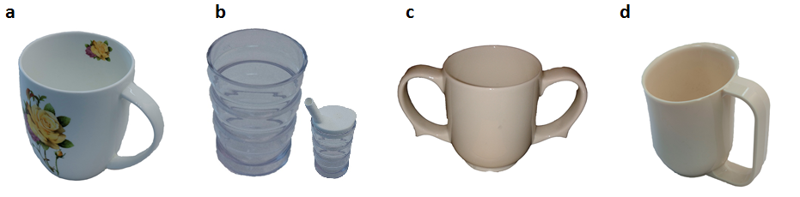
Figure 3: Illustrations of the vessels introduced on the unit following the testing; a) a new mug, b) a plastic tumbler with horizontal ridges (smaller vessel shows the same tumbler converted to a beaker), c) double handled mug, d) dysphagia cup (not previously tested but highly recommended by Speech and Language Therapist)
On average, a total fluid consumption observed during breakfast at baseline (before the implementation of the new drinking vessels) was 139ml (±84ml, n=24). Following the introduction of the new vessels, total fluid intakes increased to 205ml (±12ml, n=65, p= 0.003). At baseline only 29.2% (7/24) of the residents consumed more than 150ml; with the new vessels, 62% (40/65) of residents consumed more than this amount (p=0.002). Although more residents were given more than one drink during the baseline measurement (29.2% vs 16.9%, p<0.001), the amount of fluids served was higher with the test vessels (293ml ±73ml vs 212ml ±92ml, p=0.001). This is because new vessels contained more fluid (up to 300ml vs 150ml for the standard equipment) and therefore required staff to deliver less refills to the residents. The residents consumed on average 71.5% of the fluid served to them after the introduction of the vessels. This is similar to the average 67.9%, which was consumed at baseline (p=0.652), suggesting that introducing larger vessels positively influences the amount of fluids served and ultimately results in a higher fluid consumption.
Twenty residents who were present at implementation phase agreed to give feedback, 17 (85%) of whom reported a preference for the new drinking vessels and eight reported that they consumed more fluids after the implementation of the new vessels. Sixteen residents (16/20, 80%) stated that they preferred the test mugs to the standard teacups. They gave the following reasons: mug provided more volume (12/16, 75%), had a better handle (8/16, 50%), and was lighter (4/16, 25%). Four of six (67%) residents who used the double handled mug thought it useful but felt they did not need to use it. The perceived benefits of the plastic tumblers included the light weight (7/20, 35%), horizontal ridges for an easier grip (8/20, 40%), larger volume (8/20, 40%), and thinner edges (2/20, 10%). Three residents with swallowing difficulties tried the dysphagia cup. Although they did not like its appearance, all recognised its benefit and were willing to use it.
Staff (n=15) said that the increased volume of the new vessels saved time enabling them to serve fewer additional drinks (13/15, 87%). The staff liked the plastic tumblers because they did not break and could be easily converted into beakers. A few staff (3/15, 20%) were concerned that double handled mugs were too heavy for some residents, and one HCA felt seeing two handles would confuse some residents. Some noted that the residents coughed less when using dysphagia cup (5/15, 33%), although not all staff reported trying this mug with the residents (9/15, 60%). Seventy three percent of staff (11/15) thought that with new vessels residents were drinking more fluids. Seven HCA (54%) thought that the new equipment made their job easier, while the remaining six (46%) reported that whilst it made little difference to them but benefited the residents.
Observations highlighted some challenges with implementing the new equipment. Some staff perceived the mugs to be too big and were observed to only half fill them, even though residents reported being able to hold and consume a full mug.
Discussion
This small-scale improvement project demonstrated that some standard drinking equipment, which is widely used in health and social care settings, is not suited to the needs of frail older people. Providing residents in nursing homes with lightweight, high volume and easy to handle drinking vessels, increased the amount of fluid they consumed.
Whilst unwillingness or lack of desire to drink may contribute to poor fluid intakes in nursing homes (Hooper, 2016), this paper provides evidence that residents are willing to drink more. However, the amount they consume is constrained if fluids are served in small vessels and refills are not offered. Improving the design and availability of appropriate drinking vessels that better meet the needs of older people, offers a simple strategy for nursing homes to increase fluid intake of their residents.
The analysis suggests that the residents’ perception of a vessel’s weight and volume are influenced by the ease of handling. Thus, provided a drinking vessel is easy to handle, the residents do not perceive that it contains too much fluid. Specific features that enable easier handling can therefore help residents overcome barriers associated with the weight of the vessel and the vessel can contain as much as 300ml of fluid. Improved drinking vessels also have the potential to increase resident hydration with no impact on staff workload. Staff in our improvement project reported that the introduction of larger vessels was of benefit as more fluid was provided for and consumed by the residents without increasing staff workload.
Vessels that were easier to handle positively influenced the residents’ ability to drink independently. This was important because another part of our improvement project identified that residents who needed assistance were at higher risk of low fluid consumption (Wilson et al, 2018). Providing vessels that are easier to use can promote independence and enable residents to increase their fluid intake.
Other studies have demonstrated the efficacy of assistive devices but identified that the acceptability of these devices is poor amongst older people (Lilja et al, 2003; Sutton et al, 2013; Gitlin et al, 1996). One study found that older people had difficulty in learning new skills to use such devices (Lilja et al, 2003). Our findings reflected this. Some residents refused to trial beakers and specialist cups, and had difficulty understanding the principles for using them. Denial of need for assistive devices has previously been described (Gitlin et al, 1996). This highlights the importance of improving standard drinking equipment, especially since older people experience a decline in upper extremity motor task performance, such as required for drinking (Maitra and Junkins, 2004).
Many mugs and cups available on the market reflect the triumph of visual aesthetics over utility. As a result, most do not meet the practical requirements that we have identified as important in supporting older people to drink. More work is required to create a sustainable supply of ergonomically designed drinking vessels for this market, and other similar healthcare settings.
Although the evaluation of residents’ preferences for drinking vessels that we have described is an important first step in understanding more about topic, there are some limitations to our approach. Firstly, we have obtained feedback from a relatively small number of residents. A larger number of tests on each vessel-type and opportunity to conduct more extensive thematic analysis of opinions may enhance the data. Secondly, since nothing is currently known about the preferred features of drinking vessels in this population, we explored a wide range of ‘off-the-shelf’ products. Another limitation of this project is the use of single location for testing the effect on fluid intake. A more extensive testing of our findings is required to determine the efficacy in other homes. It was not feasible to get all the residents to test every vessel, but we aimed to get at least 10 independent tests for each one. Since it would be expected that the more functional residents who were able to handle the standard vessels would rate the assistive devices as less appealing, we chose not to ask them to test these vessels. This could potentially influence the results we obtained. Due to time constraints, observations were limited to the breakfast period and it was not possible to determine whether the vessels resulted in an increase in residents’ fluid intakes throughout the day, or to control for the effect of other factors influencing fluid intake. The durability of the vessels over time and implications for cost effectiveness were not tested, although some feedback from the staff a month after the introduction of the new drinking vessels suggested that this was not a problem. This small-scale study has shown that older nursing home residents prefer drinking vessels that are lightweight (ideally made of conventional material such as bone china) with a large wide handle that makes them easier to hold, and a volume of between 250 and 300ml. They also prefer drinking vessels that are not obviously assistive devices. Further studies are required to investigate in more detail the relationship between the mechanics of drinking and specific design features of drinking vessels.
Conclusion
Some drinking vessels currently used in many nursing homes are not easy for older residents to use. Optimising the design of drinking vessels to better suit the needs and preferences of residents is a simple and practical solution to increase fluid intakes without increasing staff workload. Future studies should focus on evaluating this strategy on a larger scale and in other healthcare settings.
Reference List
Beetz R. 2003. Mild dehydration: a risk factor of urinary tract infection? Eur J Clin Nutr. 57(Suppl 2):S52-S58.
Benelam B, Wyness L. 2010. Hydration and health: a review. Nutr Bull. 35(1):3-25.
Dimant J. 2001. Delivery of nutrition and hydration care in nursing homes: assessment and interventions to prevent and treat dehydration, malnutrition, and weight loss. J Am Med Dir Assoc. 2(4):175-182.
Dunne TE, Neargarder SA, Cipolloni PB, Cronin-Golomb A. 2004. Visual contrast enhances food and liquid intake in advanced Alzheimer's disease. Clin Nutr. 23(4):533-538.
European Food Safety Authority Panel on Dietetic Products. Scientific opinion on dietary reference values for water. EFSA Journal 2010;8(3):1459. [www.efsa.europa.eu/en/scdocs/ doc/1459.pdf]
Ferry M, Dal Canton A, Manz F, Armstrong L, Sawka M, Ritz P, et al. 2005. Strategies for ensuring good hydration in the elderly. Nutr Rev. 63(6):S22-29.
Gitlin L, Schemm R, Landsberg L, Burgh D. 1996. Factors predicting assistive device use in the home by older people following rehabilitation. J Aging Health. 8(4):554-575.
Godfrey H, Cloete J, Dymond E, Long A. 2012. An exploration of the hydration care of older people: a qualitative study. Int J Nurs Stud. 49(10):1200.
Health Foundation. 2013. Quality Improvement Made Simple: What Every Board Should Know About Healthcare Quality Improvement. London: Health Foundation.
Hooper L. 2016. Why, oh why, are so many older adults not drinking enough fluid? J. Acad. Nutr. Diet. 116(5):774-8.
Kayser-Jones J, Schell E, Porter C, Barbaccia J, Shaw H. 1999. Factors contributing to dehydration in nursing homes: inadequate staffing and lack of professional supervision. J Am Geriatr Soc. 47(10):1187-1194.
Lilja M, Bergh A, Johansson L, NygÅrd L. 2003. Attitudes towards rehabilitation needs and support from assistive technology and the social environment among elderly people with disability. Occup Ther Int. 10(1):75-93.
Maitra KK, Junkins MD. 2004. Upper extremity movement pattern of a common drinking task in well elderly women: a pilot study. Occup Ther Int. 11(2):67-81.
Mentes JC, Culp K. 2003. Reducing hydration-linked events in nursing home residents. Clin Nurs Res. 12(3):210-225.
Pouyet V, Cuvelier G, Benattar L, Giboreau A. 2015. Influence of flavour enhancement on food liking and consumption in older adults with poor, moderate or high cognitive status. Food Qual. Prefer. 44:119-129.
Robinson SB, Rosher RB. 2002. Can a beverage cart help improve hydration? Geriatr Nurs. 23(4):208-211
Sheehy C, Perry P, Cromwell S. 1999. Dehydration: biological considerations, age-related changes, and Risk Factors in Older Adults. Biol Res Nurs. 1(1):30-37.
Simmons SF, Alessi C, Schnelle JF.2001. An intervention to increase fluid intake in nursing home residents: prompting and preference compliance. J Am Geriatr Soc. 49(7):926-933.
Spangler PF, Risley TR, Bilyew DD. 1984. The management of dehydration and incontinence in nonambulatory geriatric patients. J Appl Behav Anal. 17(3):397-401.
Stabell A, Eide H, Solheim GA, Solberg KN, Rustøen T. 2004. Nursing home residents’ dependence and independence. J Clin Nurs. 13(6):677-686.
Sutton D. 2013. Does hands-free drinking improve patient hydration? Nurs Times. 109(29):14-16.
Thomas DR, Cote TR, Lawhorne L, Levenson SA, Rubenstein LZ, Smith DA, et al. 2008. Understanding clinical dehydration and its treatment. J Am Med Dir Assoc. 9(5):292-301.
Wilson, J., Bak, A., Greene, C., Tingle, A., Tsiami, A., Canning, D., & Loveday, H., 2018. I-Hydrate: A service improvement project to optimise the hydration of older nursing home residents. Final project report
Wolff A, Stuckler D, McKee M. 2015. Are patients admitted to hospitals from nursing homes dehydrated? A retrospective analysis of hypernatraemia and in-hospital mortality. J R Soc Med. 108(7):259-65.
Zeman, F. (1991) Clinical nutrition and dietetics. 2nd ed. New York: Macmillan Publishing Company.

