Automatic Detection of End-Diastolic and End-Systolic Frames in 2D Echocardiography
Massoud Zolgharni^{a,b}, PhD
Madalina Negoitaª, PhD
Niti M Dhutiaª, PhD
Michael Mielewczikª, PhD
Karikaran Manoharanª, MSc
S M Afzal Sohaibª, PhD
Judith A Finegoldª, MD
Stefania Sacchi^{a,c}, MD
Graham D Coleª, PhD
Darrel P Francisª, MD

ªFaculty of Medicine, Imperial College London, London, W12 0NN, UK
^{b}School of Computer Science, University of Lincoln, Lincoln, LN6 7TS, UK
^{c}Heart and Vessels Department, University of Florence, Florence, Italy

Corresponding author:
Massoud Zolgharni
Email: massoud@zolgharni.com
Tel: +44 798 594 9440
Fax: +44 208 082 5109
National Heart and Lung Institute, Imperial College London
Du Cane Road, London W12 0NN, UK

Running head: ECG-free cardiac timing
Abstract
Background
Correctly selecting the end-diastolic and end-systolic frames on a 2D echocardiogram is important and challenging, for both human experts and automated algorithms. Manual selection is time-consuming and subject to uncertainty, and may affect the results obtained, especially for advanced measurements such as myocardial strain.
Methods and Results
We developed and evaluated algorithms which can automatically extract global and regional cardiac velocity, and identify end-diastolic and end-systolic frames. We acquired apical 4-chamber 2D echocardiographic video recordings, each at least 10 heartbeats long, acquired twice at frame rates of 52 and 79 frames/s from 19 patients, yielding 38 recordings. Five experienced echocardiographers independently marked end-systolic and end-diastolic frames for the first 10 heartbeats of each recording. The automated algorithm also did this.
Using the average of time points identified by 5 human operators as the reference gold-standard, the individual operators had a root mean square difference from that gold-standard of 46.5 ms. The algorithm had a root mean square difference from the human gold-standard of 40.5 ms (p < 0.0001). Put another way, the algorithm-identified time point was an outlier in 122/564 heartbeats (21.6%), whereas the average human operator was an outlier in 254/564 heartbeats (45%).
Conclusions
An automated algorithm can identify the end-systolic and end-diastolic frames with performance indistinguishable from that of human experts. This saves staff time, which could therefore be invested in assessing more beats, and reduces uncertainty about the reliability of the choice of frame.

Keywords
Echocardiography; Cardiac imaging; Ultrasound imaging; Myocardial velocity
Introduction
The assessment of left ventricular (LV) function constitutes the most frequent indication for an echocardiographic exam and is of crucial importance for patient evaluation. Quantification of LV function markers such as ejection fraction (EF) and global longitudinal strain (GLS) can be performed using different imaging modalities. However, 2D echocardiography continues to be the most commonly utilized technique in clinical Practice¹. Such echocardiographic measurements usually relate to time points such as end-diastole and end-systole and, therefore, the detection of the end of the left ventricular systole and diastole is important.
In clinical practice, the end-diastolic frames are manually determined by using the cues such as mitral valve closure, R-wave of ECG, and maximum size of LV volume. For the end-systolic, mitral valve opening, LV volume minimum, aortic valve closure, or end of T-wave are used. In addition to being laborious and time-consuming, any manual assessment is inherently subjective and operator-dependent. Furthermore, it will prohibit the development of fully automated systems for estimating LV function markers such as EF and strain measurements. Therefore, reliable techniques for the automatic detection of cardiac cycle events are highly desirable.
There have been a few recent attempts to address this problem. Automatic detection of end-diastole and end-systole frames has been reported by applying manifold learning techniques to 2D echocardiography images, and for the calculation of the ejection fraction². However, the studied images were acquired from a relatively small population of healthy subjects. In another study, nonlinear dimensionality reduction method was used for the same purpose, and performance of the automated system was examined against only one manual expert judgement³.
Detection of aortic valve closure timing from the tissue velocities obtained by Doppler and speckle tracking has been studied in the normal subjects⁴ and in patients with high heart rates⁵. The same research group proposed the concept of echocardiography without electrocardiogram where the cycle length was estimated by periodicity analysis of apical B-mode intensities. They assumed upper and lower bounds of 1.33s (45 bpm) and 0.67s (90 bpm) for the cycle length⁶. The cardiac cycle was then estimated using the speckle tracking of the B-mode images. ECG-based detection was used a reference for evaluating the performance of the automated algorithm, and any recording for which the ECG deemed to be inconsistent in estimating the cycle start point was manually discarded. The authors concluded that while the cycle length estimation showed high feasibility, the cycle start estimation was less feasible. The main limitations of the proposed algorithms were a relatively narrow assumed heart range, and the need for a database containing all signatures to be generated using a training set.
The detection of cardiac quiescent phases from B-mode echocardiography using a correlation-based frame-to-frame deviation measure^{7,8} and nonlinear filtering and boundary detection techniques⁹ have also been reported. This was done to investigate whether the information about the mechanical motion of the heart obtained from B-mode echocardiographic data can be used for gating purposes instead of ECG signal which lacks the information about the instantaneous mechanical state of the heart. The authors reported improved cardiac gating which can potentially be used to obtain motion-artefact-free images of the heart by cardiac computed tomography.
Recently, there have been reports of commercially available echocardiography systems, featuring automated LV function analysis, where automated end-diastolic and end-systolic frame selection forms part of the process. The accuracy of such automated frame selection features, however, has never been investigated. Additionally, this cardiac phase detection is usually provided by obtaining an ECG during the image acquisition by such systems. However, it may not be convenient to connect ECG cables, particularly in an era when highly portable scanners may be used to undertake focused studies lasting only a few minutes.
This study tested the hypothesis that a fully automated method using speckle tracking analysis in apical 4-chamber 2D echocardiographic images will provide rapid, reliable, and objective detection of end-diastolic and end-systolic frames. The performance of the automated method was examined by comparisons to the gold-standard reference data.

Methods
Patient population
2D echocardiographic images were collected from 19 patients (9 males), with an age range of 27-80 and a mean age of 59, who were referred for echocardiographic examination in the Echocardiography Department at St Mary's Hospital in May 2014. There were no selection criteria, and all patients were in sinus rhythm. The study was approved by the local ethics committee and written-informed consent was obtained from all patients.

Data collection
Standard transthoracic echocardiography was performed using a commercially available GE Vivid.i (GE Healthcare, U.K.) ultrasound machine equipped with a 1.5-3.6 MHz transducer (3S-RS). For each subject, an apical 4-chamber view was first obtained in left lateral decubitus position as per standard clinical guidelines¹⁰. The sector was then adjusted to obtain two different relatively moderate and high acquisition frame rates; namely 52 and 79 frames/s. The operators performing the exam were instructed not to change other machine settings (e.g. gain, depth, etc.) and the probe position during the acquisition period in order to obtain consistent data. The acquisition period was 20 s to make sure at least 10 cardiac cycles were present in all 38 cine loops (19 patients, 2 acquisition frame rates). The images were stored digitally for subsequent offline analysis. The ECG trace was present on all echocardiographic recordings.

Automated definition of end-diastolic and end-systolic frames
Speckle tracking echocardiography was performed using an automated in-house toolbox. A description of this technique is provided in Appendix, and further details on its optimisation can be found elsewhere^{11,12}. The myocardial velocity profile was estimated from two measurement sites. First site was the automatically detected septal annulus whose location, in current practice, is identified manually by the experts^{13,14}. Hereinafter, the results obtained from this regional approach will be referred to as the ‘auto-septum’. In the second approach, a global velocity profile, representing the motion of the entire heart muscle, was used to calculate the ‘auto-global’ results. The two extracted velocity profiles were then used for detection of end-diastolic and end-systolic frames. Further details are provided in Appendix and elsewhere¹⁵. The location of detected frames from the regional approach (auto-septum) are plotted in figure 1 as blue square markers on the velocity profiles spanning three cardiac cycles.

ECG-derived event detection
The ECG signal, recorded simultaneously with the image acquisition, appears as a transverse trace, being updated from left to right. This ECG signal has a higher temporal resolution than the echo images; the trace progresses several columns of pixels between two consecutive echo frames. The ECG trace was extracted from the image sequences using a combination of constraints where the trace was assumed to (i) be continuous, (ii) have a consistent colour profile, and (iii) be distinct from the background. The extracted signal was then used to identify end-diastolic and end-systolic time markers.
The peak of an ECG R-wave is commonly assumed as the beginning of the cardiac cycle and to mark the end-diastolic frame¹⁶⁻¹⁹. The Pan-Tompkins algorithm, which has been found to have a higher accuracy for various beat morphologies than other traditional real-time methods, was used in this study for the QRS detection^{20,21}. The QRS complexes were recognised based on analysis of the slope, amplitude and width information. Once a valid QRS complex was recognised, the R-wave was detected as the largest wave.
The common approach for defining the end-systolic frames from the ECG is end of the T-wave. A robust algorithm, efficient in presence of acquisition noise, T-wave morphological variations, and baseline wander was adopted for detecting the end of T-wave²².

Human expert identification of end-diastolic and end-systolic frames
Five accredited and experienced cardiology experts manually selected end-diastolic and end-systolic frames, each blinded to the judgment of all others. We developed a custom-made program which closely replicated the interface of the echo hardware. Operators visually inspected the cine loops by controlled animation of the loops using a trackball or arrow keys. The operators were asked to pick end-diastolic and end-systolic frames in the apical 4-chamber view as they would in preparation for a Biplane Simpson’s measurement in clinical practice. They made their selections in one or more sessions at their convenience, and the time taken was recorded. All video loops were renamed and provided to one operator in a random order for a second analysis, and no previous result was shown on the images. This way, and given the large number of loops, we made sure that the operator was blinded from their own previous frame selections. Where an operator judged a beat to be of low quality, they declared it invalid and did not make a selection for that heartbeat. Therefore, since the operators were blinded to each other and their own previous frame selections, there were heartbeats which were delineated on one or two viewings only by each operator. These data was used to define the reference end-diastolic and end-systolic frames. The location of the typical frames identified by the operators are plotted as red circular markers in figure 1.

Data Analysis
Speckle tracking was implemented using C++ (Microsoft Visual Studio®). The code development for data analysis was performed using Matlab (MathWorks Inc.). All computations in this study were conducted using an Intel Xeon E5630 CPU, with an internal clock frequency of 2.53 GHz.
For estimating the cardiac cycle length, in order to quantify the agreement between the ECG-based and velocity-derived methods, linear regression and Bland-Altman analyses were performed. For linear regression, the coefficient of determination (R²) was computed. For Bland–Altman analysis, bias (mean) and standard deviation (SD) were calculated where the confidence interval was defined as ±2SD. For all time difference parameters (i.e., the choice of frame by either the automated algorithms or each of the human operators relative to the mean choice of all 5 operators), mean ± SD was calculated. Significance was defined as p<0.05. Statistical analyses were also performed using Matlab.
Results
All 5 operators were able to identify 10 end-diastolic and 10 end-systolic frames within each recording. Our custom-made program did not compel them to identify a frame for every beat, but rather only 10 end-diastolic and 10 end-systolic frames from each recording. For the purposes of this analysis, we identified the 285 end-systoles and 279 end-diastoles upon which all 5 operators rendered a choice of frame.
Operators sometimes disagreed on which frame was the end-systolic (or end-diastolic) frame. For instance, left bar of the top left panel in figure 2 shows that when only pairs of operators are addressed; in 10% of the heartbeats, the operators agree on which beat is end-diastolic. The second bar of that panel shows that in 20% of cases the operators disagree by one frame, and so on. The median disagreement was 3 frames.
The second panel in the top row shows, for all combinations of three operators examining a single beat, the range between the earliest and latest frame selected as end-diastolic. The remaining plots in the top row show this for combinations of four and five operators. The more operators considered together, the wider the range between the earliest and the latest frames selected by each such combination of operators. From a median of 3 frames for 2 operators, this range increased to a median of 5 frames for 3 operators, 6 frames for 4 operators, and 7 frames for 5 operators (p < 0.0001 by ANOVA).
A similar pattern was seen for end-systolic frames. The range progressively widened from a median of 3 frames for 2 operators, to a median of 6 frames for 5 operators (p < 0.0001 by ANOVA).
The average time (mean±SD) taken by the operators was 23±10 s and 26±11 s per frame for the recordings at frame rates of 52 and 79 frames/s, respectively. The equivalent time for the automated techniques, including the speckle tracking process, was 8.8±1.9s and 14.1±3.3s per frame for the recordings at frame rates of 52 and 79 frames/s, respectively. The majority of this time was consumed by the speckle tracking process. Beyond the speckle tracking process, the time taken by the automated frame detection was only 0.6±0.1 s and 1.0±0.2 s per frame for the recordings at frame rates of 52 and 79 frames/s, respectively. All durations were significantly shorter than the manual process.
In the recordings analysed, heart rate ranged from 31 to 115 bpm. Average cardiac cycle length, estimated by the autocorrelation of the velocity profile, was used to compute the heart rate for each patient. All echocardiographic recordings contained an average heart rate measured by the echo machine which uses the ECG signal information for calculating the cardiac cycle length. For two patients, the average heart rate estimated by the echo machine was incorrect due to the noisy ECG traces. In addition, the speckle-tracked velocity profile for one recording did not meet the quality requirements. These recordings were excluded from heart rate comparisons. For all the retained recordings, the difference between the two methods was not statistically significant as shown in figure 3 (p = 0.21).
From the total number of the end-diastolic frames identified by all 5 operators, automated measurements were feasible in 96%, 93%, and 94% of the beats for ECG-derived, auto-global, and auto-septum automated candidates, respectively. Similar percentages were found for end-systolic frames.
The choice of frame by each operator and by each of the three automated algorithms (two image-based and one ECG-based) are shown relative to the mean choice of all 5 operators in figure 4. It can be seen that individual operators showed tendencies to select slightly earlier or later frames. For the pooled data from the 5 individual operators, the standard deviation of the time differences, indicating the inter-observer variability, was 47.1 ms and 45.9 ms for end-diastolic and end-systolic frames, respectively.
The mean difference between two annotations on separate occasions by the same operator (i.e., intra-observer variability) was 3.2±49.6 ms and -2.8±50.6 ms for end-diastolic and end-systolic frames, respectively.
Of the automated candidates, the auto-global had the greatest discrepancy with the mean of operators. Its mean difference was 6.9±45.1 ms and -37.4±63.7 ms for end-diastolic and end-systolic frames, respectively. The auto-septum candidate had a smaller discrepancy from the mean of operators, with a mean difference of -21.2±35.4 ms and -2.5±39.7 ms for end-diastolic and end-systolic frames, respectively. The automatic ECG-based frame detection showed comparable results of 2.8±44.3 ms and 0.7±65.4 ms for end-diastolic and end-systolic frames, respectively. Of the two image-based algorithms, the auto-septum showed higher consistency and was, therefore, used for further analysis.
The simple plot in figure 4 which uses a common reference (average of all operators) unfairly favours the human operators because they are part of the reference; the common reference could not be considered independent from the operator under study. A fairer comparison is shown in figure 5, where each human operator in turn is compared with only the other 4 human operators. The auto-septum algorithm is in each case compared with the same 4 human operators. The 10 panels suggest that performance of the auto-septum algorithm is similar to that of an individual operator, if using the other operators as a reference standard.
Since different experts make different judgements, it is not possible for any automated algorithm to agree with all experts. However, it is desirable for the automated algorithms to not be an outlier when compared with the distribution of human judgments, i.e. to behave approximately as well as human operators. To test this, figure 6 shows, for each heartbeat, the range of human operator judgements as a shaded area with small red dots denoting the relative timing identified by each of the human operators overlaid on this. The relatively larger blue dots denote the relative timing identified by the auto-septum algorithm. The vertical axis is fixed at -200 ms to +200 ms. In many patients, the automated assessments generally lay within the range of the human expert counterparts. In some cases, however, the automated annotation fell outside the manual range. This was particularly notable in misdetection of patient 14’s end-diastolic frames. The image quality in patient 13 was too low for any meaningful automated analysis, and the peak detection algorithm failed to detect any of the cardiac events.
The range of human expert judgements for each heartbeat may be assumed as the uncertainty of the reference method and, therefore, the highest accuracy obtainable. The mean time interval was 116.5±64.9 ms and 104.3±58.3 ms for end-diastolic and end-systolic frames, respectively.
For each heartbeat, there were 6 assessments of the end-systolic frame (5 human and 1 automated). By chance alone, in ⅓ of the cases the assessment of an individual ‘operator’ (human or automated) would be the earliest or the latest among the 6 assessments (⅙ chance of being latest + ⅙ chance of being earliest). As shown in figure 7, auto-septum algorithm performs similarly to human operators: it is an outlier sometimes, but so is each of the humans. For end-systolic frames, Operator 2 had the highest percentage of 61% for being at an extreme, predominantly being the latest (1% earliest + 60% latest). Operator 3 had the second highest percentage of heartbeats for being the outlier, but mainly being the earliest. The automated system was the outlier in only 20% of the heartbeats.
For end-diastolic frames, the auto-septum candidate (23%) was second only to operator 5 (14%) in avoiding being an outlier. This suggests that the automated system performed no worse than human experts in identifying the end-systolic and end-diastolic frames.

Influence of frame rate
Figure 8 shows the same data as figure 4 but with the recording at 52 frames/s and 79 frames/s analysed in separate groups. The appearance depends on whether the vertical axis is denominated in frames, or in milliseconds. In frames (upper panel), it appears that the 79 frames/s recordings show greater disagreements. However, when the same data is redrawn in milliseconds (lower panel), it can be seen that the disagreements are of similar size between the two frame rates. This suggests that when humans disagree, this is not because they accidently moved forward or backward by a frame (which would cause the discrepancies be a similar number of frames at different frame rates), but rather that they were looking for slightly different visual events (which causes the discrepancies to be similar number of milliseconds at different frame rates).
The auto-septum algorithm showed the same phenomenon as the human operators. Its discrepancy from the mean of human experts was at a constant number of milliseconds rather than constant number of frames, when frame rate changed. Similar results were observed for end-systolic frames.

Discussion
This study investigates the feasibility of a fully automated identification of end-diastolic and end-systolic frames, derived from 2D echocardiographic images only and independent from the ECG signal. The automated algorithms were successful in detecting end-diastolic and end-systolic frames identified by the human experts for >93% of the heartbeats. The missing beats were due to the speckle-tracked velocity profiles being of low quality which resulted in the peak systole s’ not being detected for those particular beats during the beat isolation process. This is similar to the concept of a poor quality ECG trace which, could result in overlooking or misdetection of R-wave for the corresponding heartbeats.
The performance of the automated system is similar to that of human experts. Experts do not completely agree on which is the end-diastolic and end-systolic frame, because the judgment is complex, but the automated algorithm behaves similarly to human experts, being no more likely to be an outlier than the experts.
Of the automated candidates, the auto-global had the greatest discrepancy with the mean of operators. Its mean difference was -15.0±59.3 ms. This could be because the auto-global algorithm, which includes vectors from all regions of the image, suffers from the influence of vectors that are not representing the longitudinally moving ventricular walls. The velocities of some such vectors, for example near valve leaflets, may not correlate usefully with those of the main ventricular walls and so incorporating them is effectively introducing noise into the timing detection process.
The auto-septum candidate had a relatively smaller discrepancy from the mean of operators, with a mean difference of -11.9±38.7 ms, for which the standard deviation was smaller than both inter- and intra-observer variabilities. Its first step, automatic detection of the septal annulus, may be beneficial because it is rich in vectors that behave consistently and have a largely vertical direction of motion, with relatively little loss of tracking speckles from frame to the next due to movement of the speckles out of the imaging plane. The auto-septum performed similarly to the automated ECG-based algorithm, but without using any ECG information.
We believe that performing as well as a human operator and as well as ECG-based selection indicates reasonable performance of an automated ECG-free image-based algorithm.
The performance of the automated system, measured as the processing time, is superior to that of human operators. Including the speckle tracking process, an improvement of >1.8 times was achieved. However, our preliminary work on implementing the tracking algorithms on Graphic Processing Units for parallel computing indicates that real-time speckle tracking is feasible. By the tracking process excluded as having no bearing on the post-analysis, then the frame detection process would benefit from a speed up of >26 times.

Potential applications
Reliable and reproducible methods of detecting end-diastolic and end-systolic frames would allow developing fully automated techniques for the objective quantification of the LV function including automated calculation of EF and stroke volume, strain rate, and wall thickening. The deployment of such a fully automated system, which would remove all manual intervention, would not require any extra training for the operators. The developed algorithms can easily be integrated into the embedded software, without the need for additional hardware resources.
The importance of correct identification of end-diastolic and end-systolic frames has been highlighted recently by Mada et al¹⁹. A two or three frames difference end-systolic time elicited an approximate 10% difference in segmental end-systolic strain. The sensitivity to frame selection was even greater in left bundle branch block. As discussed by Amundsen²³, the consequence of misidentification of end-diastolic and end-systolic frames can be extensive, impairing concordance between observers in both research and clinical practice. Providing feasible methods of resolving this could contribute to improving the consistency of echocardiographic quantification.
In many cases, cardiac timing is provided by obtaining an ECG signal during the image acquisition. Although having the ECG information provides the possibility of computing some parameters of clinical importance such as temporal intervals from the R-wave peaks, it may not be convenient to connect ECG cables in some patients. Additionally, in an era when highly portable scanners may be used to undertake focused studies lasting only a few minutes, the capacity of detecting cardiac timing events independent from the ECG signal could potentially be very useful for implementing the automated technology on such handheld devices.
The ability to acquire and automatically analyse large number of heartbeats in reasonable time windows would permit clinical protocols to be developed for multi-beat measurements to reduce undesirable variability between clinical assessments. In such measurements, the exact time of events for each heartbeat is required.

Study limitations
The auto-septum algorithm does not use ECG, but rather focuses on the mechanical events captured and available on the images. Human experts were free to use or not use the ECG trace that was present on the echocardiographic recordings in their decision-making process. We did not mandate exactly how they should make their judgement, but rather asked them to follow their understanding of best practice as used in their day-to-day clinical work. If we had prevented the experts from seeing the ECG, we would not know whether their judgements in this research would correspond to their judgements in their everyday practice where the ECG signal is visible. We used the manual annotations by only 5 human experts. If we had obtained the results from a larger number of experts, however, the range of expert’s judgements would have been even wider, favouring the automated algorithms.
The automated algorithm proposed in this study was tested only on apical 4-chamber views, and all recordings were obtained with a constant image resolution of 640×480 pixels. We believe, however, the principles of speckle tracking applies to other views and image resolutions. The detection of fiducial points on the computed velocity profiles for beat isolation and event detection, however, might be different for other views.
The patients were a convenience sample drawn from those attending a cardiology outpatient clinic; consecutive subjects who agreed to participate in the study. They therefore may not be representative of patients who enter trials with particular enrolment criteria or of inpatients or of the general population. We only included patients in sinus rhythm, since the regular cycle length is part of our algorithm. A future evolution of the software will need to address the irregular cycle length of atrial fibrillation.
As described in the Appendix, an average cardiac cycle length for each patient is estimated using the autocorrelation method. This is needed for the subsequent signal analysis and automated frame detection. In order for the heart rate estimation to be reliable, the data for multiple cardiac cycles should be available. In this study, because of the acquisition period of 20s, each cine loop contained a minimum of 10 cardiac cycles. We conducted a small study to investigate the minimum number of cycles required for this process by truncating the cine loops. When the number of cardiac cycles was lower than 4, the estimated heart rates deviated from the original one by more than 2 bpm. The automated system would, therefore, require a minimum of 4 heartbeats to work reliably. Additionally, assessing more beats could potentially reduce the uncertainty of the measurements for different types of the LV function markers, and having fully automated systems would make multi-beat analyses more practical.
Image acquisition was performed at frame rates of 52 and 79 frames/s. The database used in this study comprised a relatively small number of 19, but unselected, patients who were representative of those who attend cardiology units. All patients in our study were at rest with a heart rate range of 31-115 bpm. In a recent study we have shown that a frame rate of >40 frames/s is sufficient for reliable speckle tracking²⁴. The automated algorithm also showed similar levels of disagreement foe the two acquired frame rates. However, at higher heart rates, for example during stress tests when the heart rates are higher by two- to threefold, the time intervals shorten. This may require higher frame rates for adequate speckle tracking and to capture cardiac events.
The cycle length estimation algorithm assumes a heart rate range of 24-200 bpm, which is typical for resting subjects. This is to prevent misdetection of the fundamental frequency of myocardial motion in case of analysing noisy velocity profiles, obtained from the recordings of relatively lower image quality. Again, for stress test conditions with higher heart rates, a different algorithm design and optimisation may be required.

Conclusions
The time-consuming and operator-dependent process of manual identification of end-diastolic and end-systolic frames on a 2D echocardiographic recording could be assisted by the automated algorithms that do not require ECG data. Our study investigated the feasibility of such an automated method which performs no worse than human experts.

Acknowledgements
This study was supported by the European Research Council and the British Heart Foundation. M.Z., M.N., N.D., and D.F. were funded by the ERC (281524). G.C. was funded by the BHF (FS/12/12/29294). M.M. was supported by a Junior Research Fellowship at Imperial College London.

References
- Knackstedt, C., Bekkers, S.C., Schummers, G., Schreckenberg, M., Muraru, D., Badano, L.P., Franke, A., Bavishi, C., Omar, A.M.S. and Sengupta, P.P., 2015. Fully automated versus standard tracking of left ventricular ejection fraction and longitudinal strain: the FAST-EFs multicenter study. Journal of the American College of Cardiology, 66(13), pp.1456-1466.
- Gifani, P., Behnam, H., Shalbaf, A. and Sani, Z.A., 2010. Automatic detection of end-diastole and end-systole from echocardiography images using manifold learning. Physiological measurement, 31(9), p.1091.
- Shalbaf, A., AlizadehSani, Z. and Behnam, H., 2015. Echocardiography without electrocardiogram using nonlinear dimensionality reduction methods.Journal of Medical Ultrasonics, 42(2), pp.137-149.
- Aase, S.A., Torp, H. and Støylen, A., 2008. Aortic valve closure: relation to tissue velocities by Doppler and speckle tracking in normal subjects. European Heart Journal-Cardiovascular Imaging, 9(4), pp.555-559.
- Aase, S.A., Björk‐Ingul, C., Thorstensen, A., Torp, H. and Støylen, A., 2010. Aortic valve closure: relation to tissue velocities by Doppler and speckle tracking in patients with infarction and at high heart rates. Echocardiography, 27(4), pp.363-369.
- Aase, S.A., Snare, S.R., Dalen, H., Støylen, A., Orderud, F. and Torp, H., 2011. Echocardiography without electrocardiogram. European Heart Journal-Cardiovascular Imaging, 12(1), pp.3-10.
- Tridandapani, S., Fowlkes, J.B. and Rubin, J.M., 2005. Echocardiography-based selection of quiescent heart phases implications for cardiac imaging. Journal of ultrasound in medicine, 24(11), pp.1519-1526.
- Wick, C.A., McClellan, J.H., Ravichandran, L. and Tridandapani, S.R.I.N.I., 2013. Detection of cardiac quiescence from B-mode echocardiography using a correlation-based frame-to-frame deviation measure. Translational Engineering in Health and Medicine, IEEE Journal of, 1, pp.1900211-1900211.
- Ravichandran, L., Wick, C.A., McClellan, J.H., Liu, T. and Tridandapani, S., 2014. Detection of Quiescent Cardiac Phases in Echocardiography Data Using Nonlinear Filtering and Boundary Detection Techniques. Journal of digital imaging, 27(5), pp.625-632.
- Lang, R.M., Bierig, M., Devereux, R.B., Flachskampf, F.A., Foster, E., Pellikka, P.A., Picard, M.H., Roman, M.J., Seward, J., Shanewise, J. and Solomon, S., 2006. Recommendations for chamber quantification. European Heart Journal-Cardiovascular Imaging, 7(2), pp.79-108.
- Dhutia, N.M., Cole, G.D., Zolgharni, M., Manisty, C.H., Willson, K., Parker, K.H., Hughes, A.D. and Francis, D.P., 2014. Automated speckle tracking algorithm to aid on-axis imaging in echocardiography. Journal of Medical Imaging, 1(3), pp.037001-037001.
- Dhutia, N.M., Zolgharni, M., Willson, K., Cole, G., Nowbar, A.N., Dawson, D., Zielke, S., Whelan, C., Newton, J., Mayet, J. and Manisty, C.H., 2014. Guidance for accurate and consistent tissue Doppler velocity measurement: comparison of echocardiographic methods using a simple vendor-independent method for local validation. European Heart Journal-Cardiovascular Imaging, 15(7), pp.817-827.
- Quiñones, M.A., Otto, C.M., Stoddard, M., Waggoner, A. and Zoghbi, W.A., 2002. Recommendations for quantification of Doppler echocardiography: a report from the Doppler Quantification Task Force of the Nomenclature and Standards Committee of the American Society of Echocardiography. Journal of the American Society of Echocardiography, 15(2), pp.167-184.
- Dhutia, N.M., Cole, G.D., Willson, K., Rueckert, D., Parker, K.H., Hughes, A.D. and Francis, D.P., 2012. A new automated system to identify a consistent sampling position to make tissue Doppler and transmitral Doppler measurements of E, E′ and E/E′. International journal of cardiology, 155(3), pp.394-399.
- Zolgharni, M., Dhutia, N.M., Cole, G.D., Bahmanyar, M.R., Jones, S., Sohaib, S.M., Tai, S.B., Willson, K., Finegold, J.A. and Francis, D.P., 2014. Automated aortic doppler flow tracing for reproducible research and clinical measurements. Medical Imaging, IEEE Transactions on, 33(5), pp.1071-1082.
- Kachenoura, N., Delouche, A., Herment, A., Frouin, F. and Diebold, B., 2007, August. Automatic detection of end systole within a sequence of left ventricular echocardiographic images using autocorrelation and mitral valve motion detection. In Engineering in Medicine and Biology Society, 2007. EMBS 2007. 29th Annual International Conference of the IEEE (pp. 4504-4507).
- Mynard, J.P., Penny, D.J. and Smolich, J.J., 2008. Accurate automatic detection of end-diastole from left ventricular pressure using peak curvature. Biomedical Engineering, IEEE Transactions on, 55(11), pp.2651-2657.
- Barcaro, U., Moroni, D. and Salvetti, O., 2008. Automatic computation of left ventricle ejection fraction from dynamic ultrasound images. Pattern Recognition and Image Analysis, 18(2), pp.351-358.
- Mada, R.O., Lysyansky, P., Daraban, A.M., Duchenne, J. and Voigt, J.U., 2015. How to define end-diastole and end-systole?: Impact of timing on strain measurements. JACC: Cardiovascular Imaging, 8(2), pp.148-157.
- Pan, J. and Tompkins, W.J., 1985. A real-time QRS detection algorithm. Biomedical Engineering, IEEE Transactions on, (3), pp.230-236.
- Arzeno, N.M., Deng, Z.D. and Poon, C.S., 2008. Analysis of first-derivative based QRS detection algorithms. Biomedical Engineering, IEEE Transactions on, 55(2), pp.478-484.
- Zhang, Q., Manriquez, A.I., Médigue, C., Papelier, Y. and Sorine, M., 2006. An algorithm for robust and efficient location of T-wave ends in electrocardiograms. Biomedical Engineering, IEEE Transactions on, 53(12), pp.2544-2552.
- Amundsen, B.H., 2015. It is all about timing!. JACC: Cardiovascular Imaging, 8(2), pp.158-160.
- Negoita, M., Zolgharni, M., Dadkho, E., Pernigo, M., Mielewczik, M., Cole, G., Dhutia, N.M. and Francis, D.P., 2016. Frame rate required for speckle tracking echocardiography: A quantitative clinical study with open-source, vendor-independent software. International Journal of Cardiology, 218, pp.31-36.

Figures
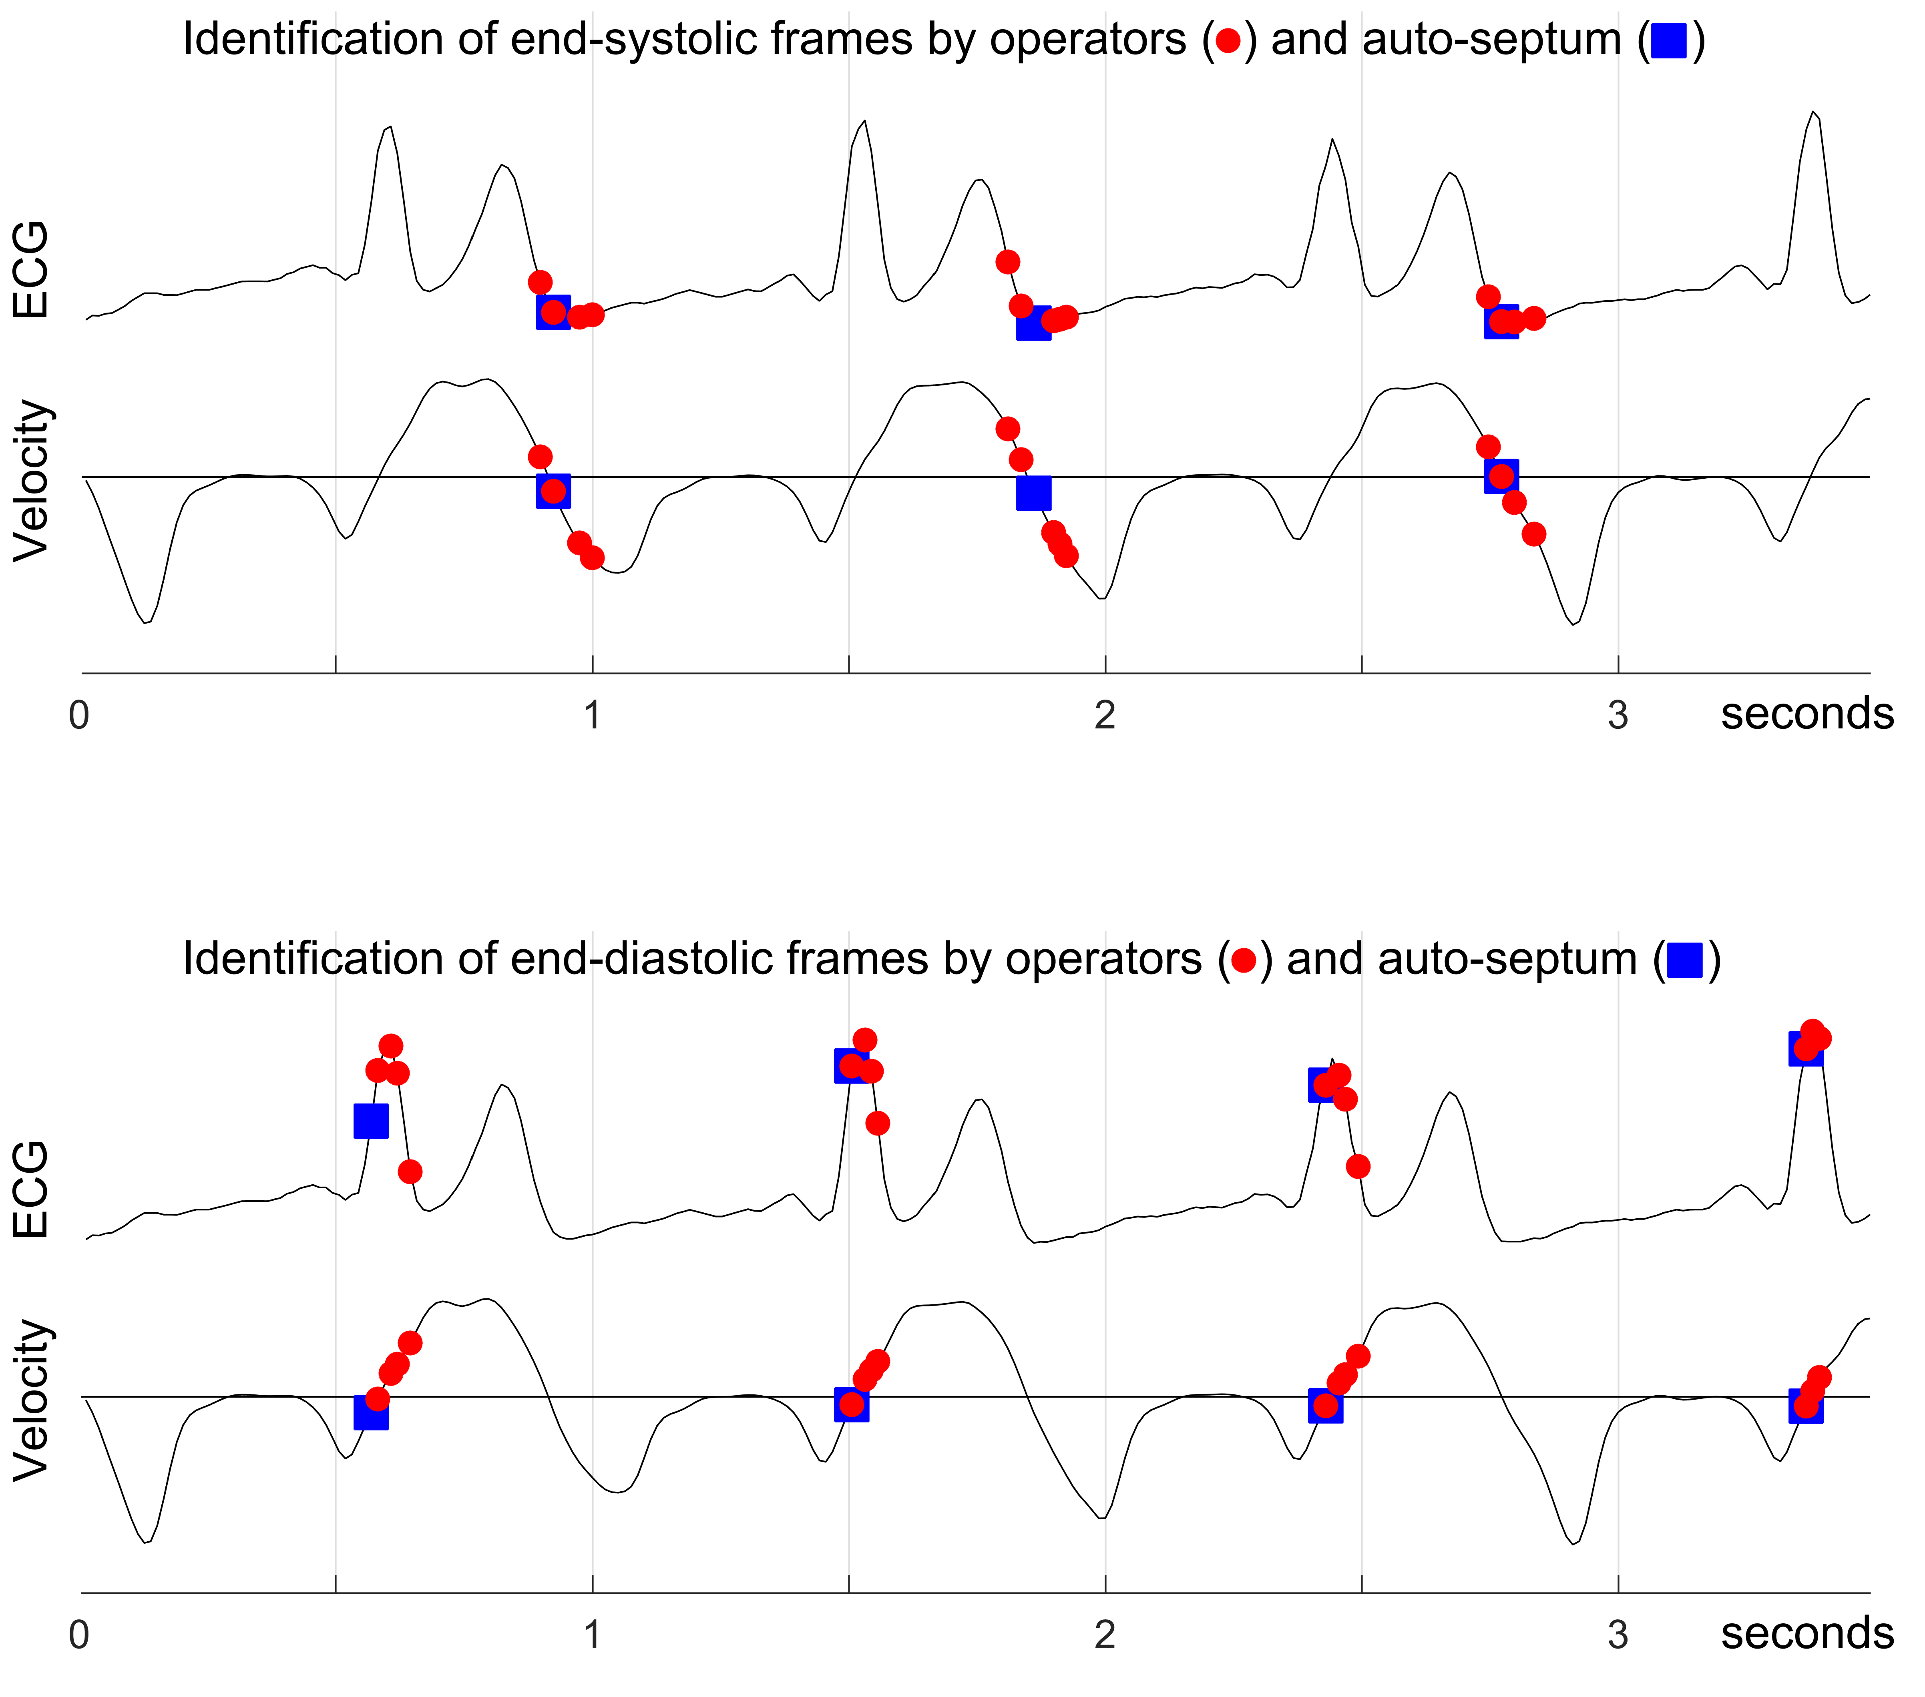
Figure 1. Extracted ECG trace and normalised speckle tracked regional velocity traces spanning three heartbeats for a random patient, delineated showing the manually selected, and auto-septum end-systolic and end-diastolic frames.

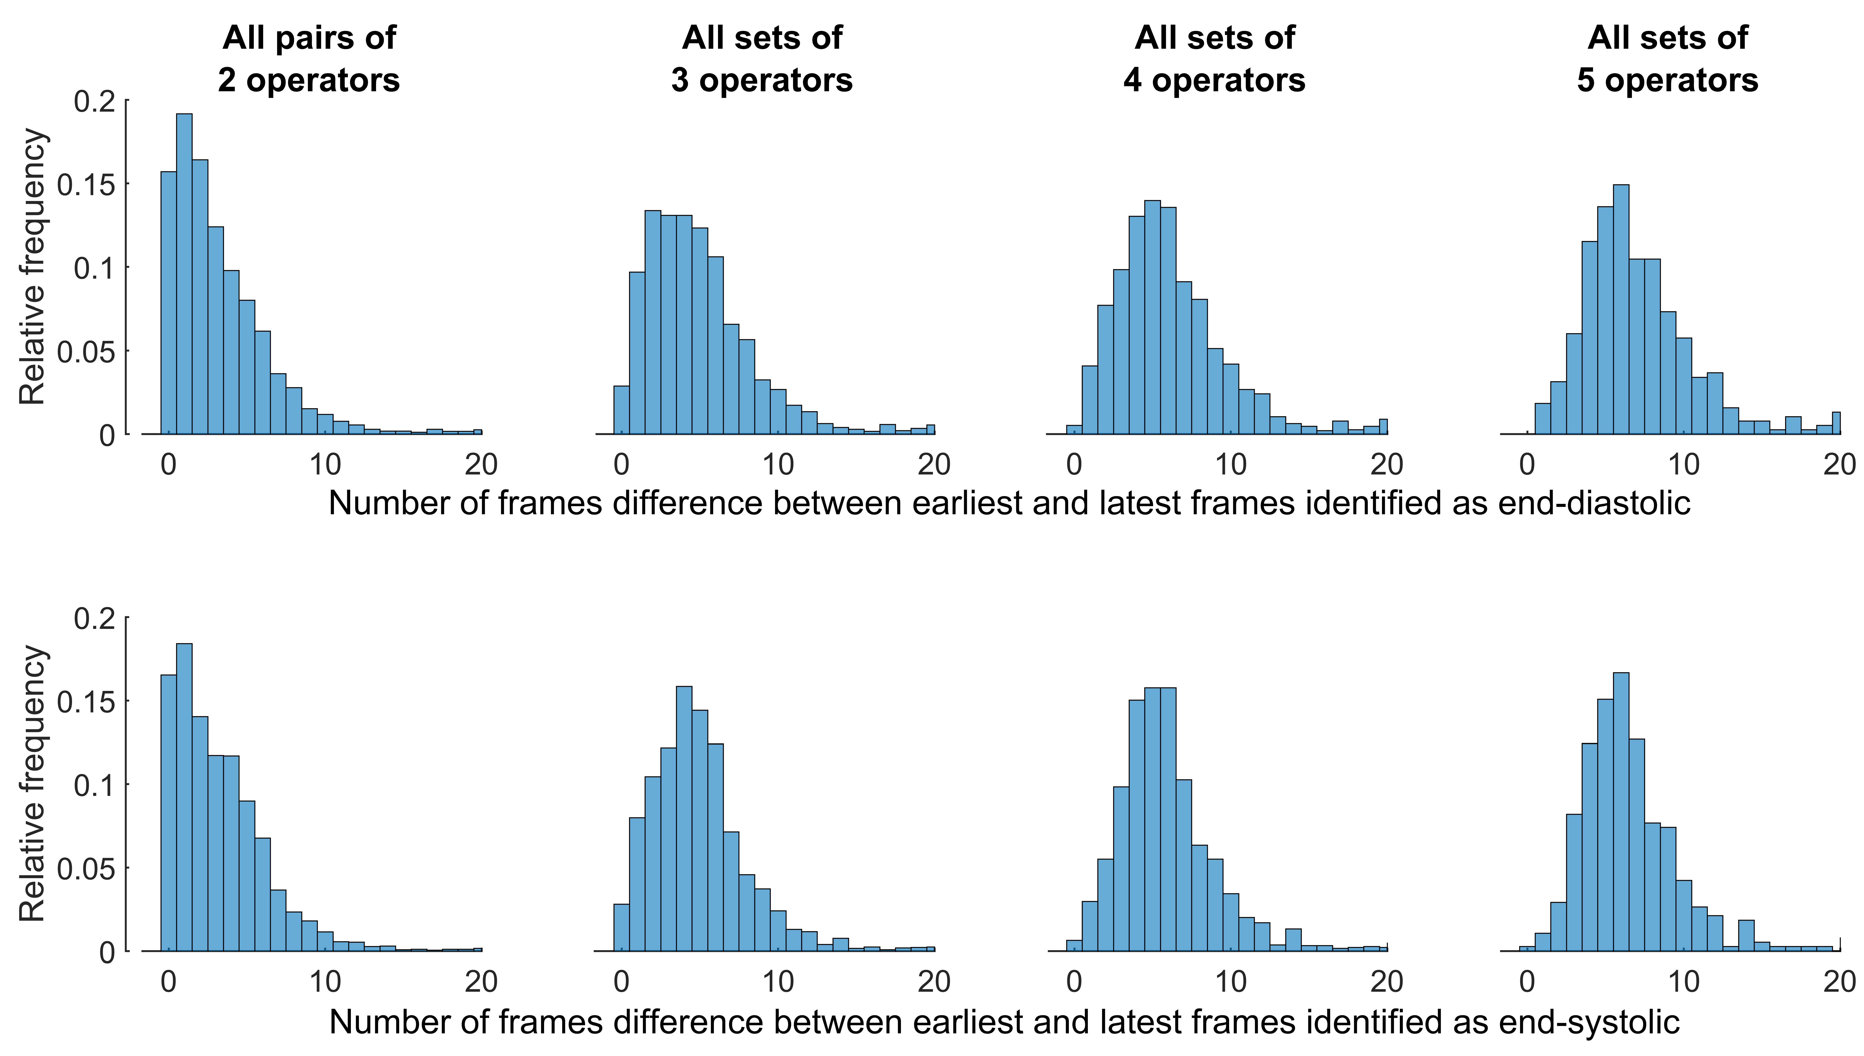
Figure 2. Distribution of magnitude of disagreement, within different-sized groups of operators, on which frames are end-diastolic and end-systolic.

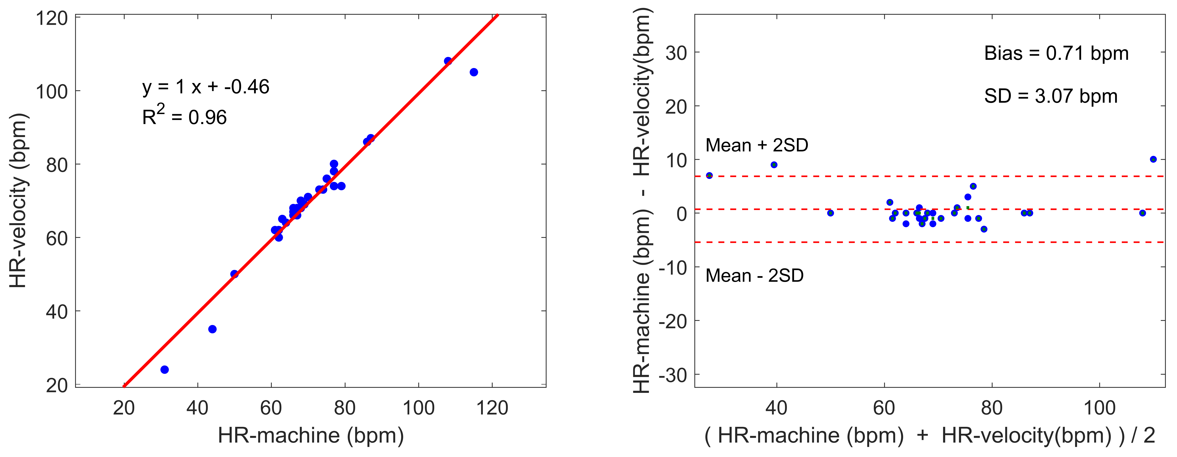
Figure 3. Linear regression (left) and Bland-Altman (right) analyses between ECG-derived by the echo machine and velocity-derived by our algorithms estimations for heart rates (bpm) for different recordings, where x and y axes have the same scale in each panel.

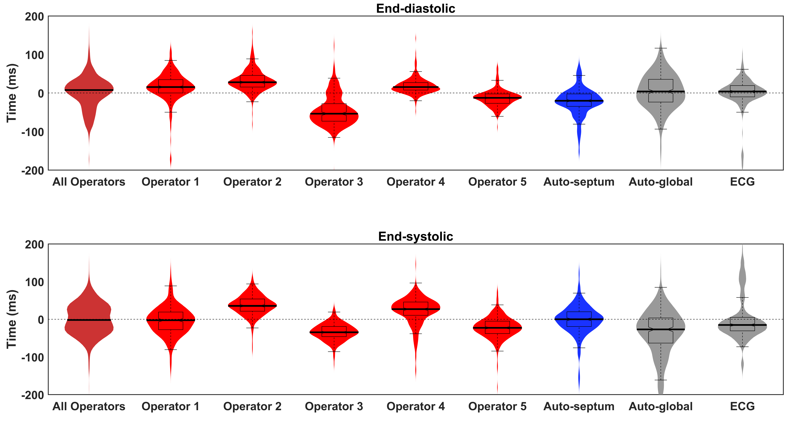
Figure 4. Times identified as end-diastolic or end-systolic by each operator (red), auto-septum (blue), and auto-global and ECG-derived algorithms (both gray). On the far left is the pooled data from the 5 individual operators. All values are expressed relative to the mean of all operators. Within the violin-plot shape which represents the distribution, the thick line represents the median, the box represents the quartiles, and the whiskers represent the 2.5% and 97.5% percentiles.

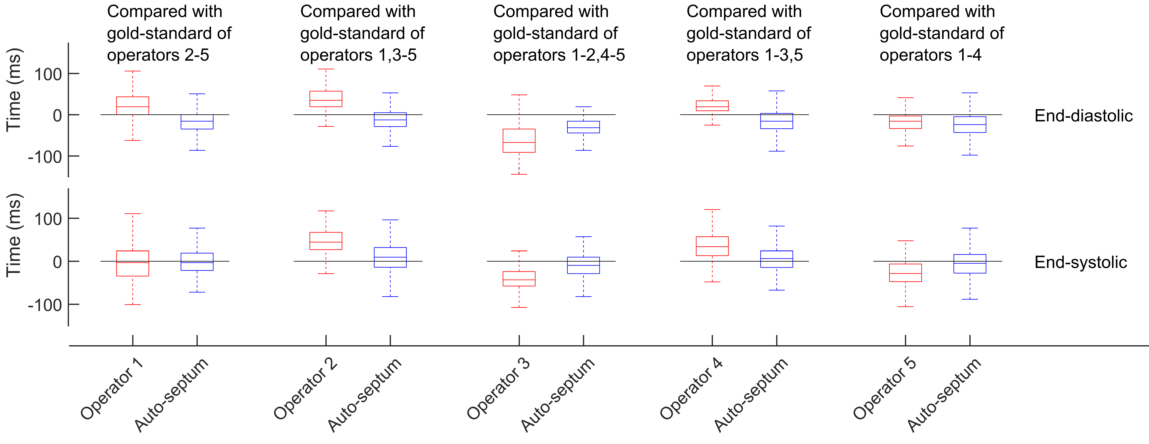
Figure 5. Times identified as end-diastolic or end-systolic by each operator, expressed relative to the mean of all other 4 operators. In each case, alongside these times, are those identified by auto-septum algorithm, again expressed relative to the same 4 operators. In the box-and-whisker plots, the thick line represents the median, the box represents the quartiles, and the whiskers represent the 2.5% and 97.5% percentiles.

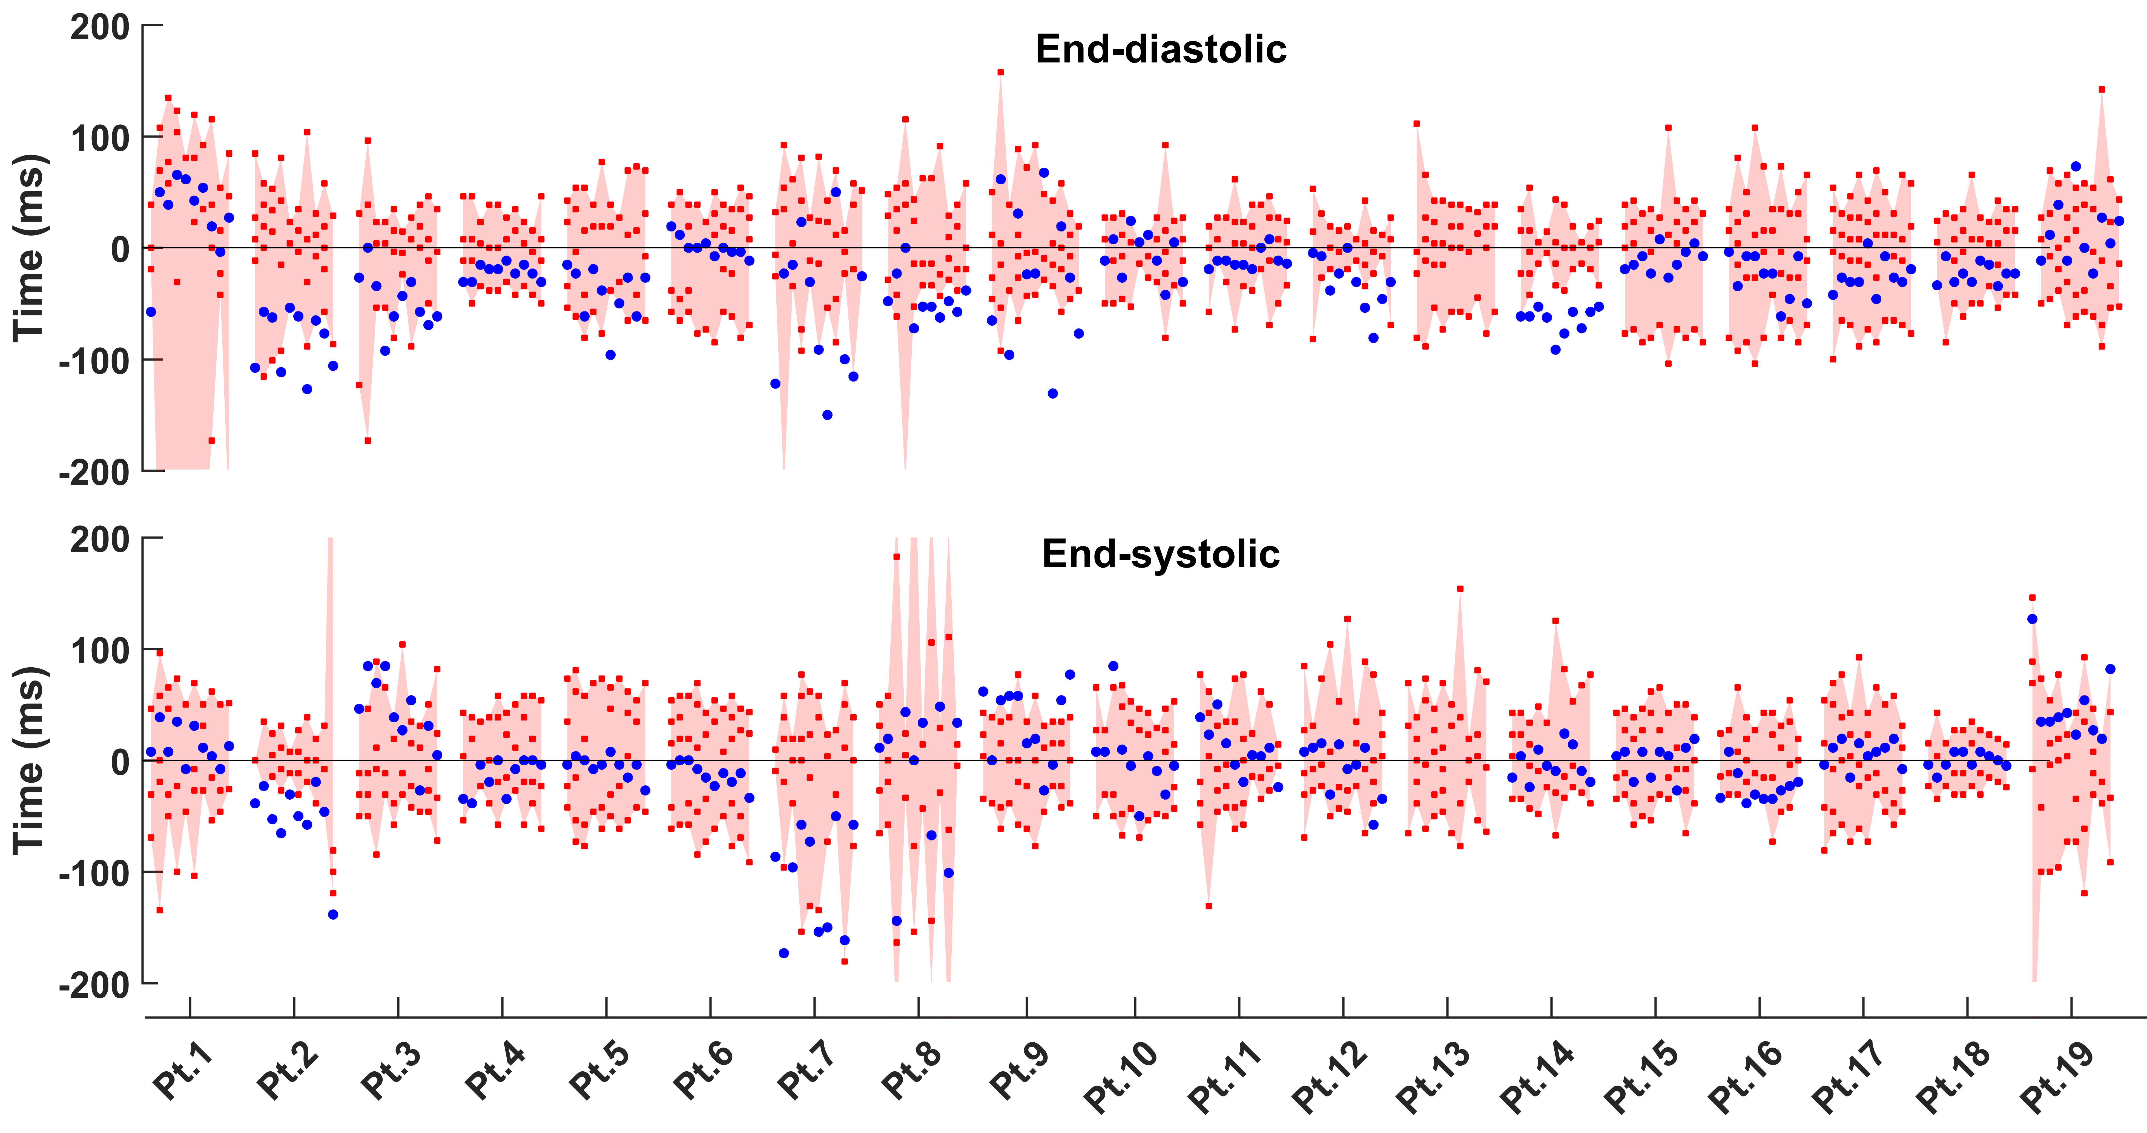
Figure 6. Timing of the automatically identified frames (blue dots) in the context of the range (pink shading) of times identified by the five human operators (red dots), for each heartbeat in all patients for the recording at the frame rate of 52 frames/s. Images, and the resulting velocity profiles, in patient 13 were of too low quality for any meaningful automated analysis.

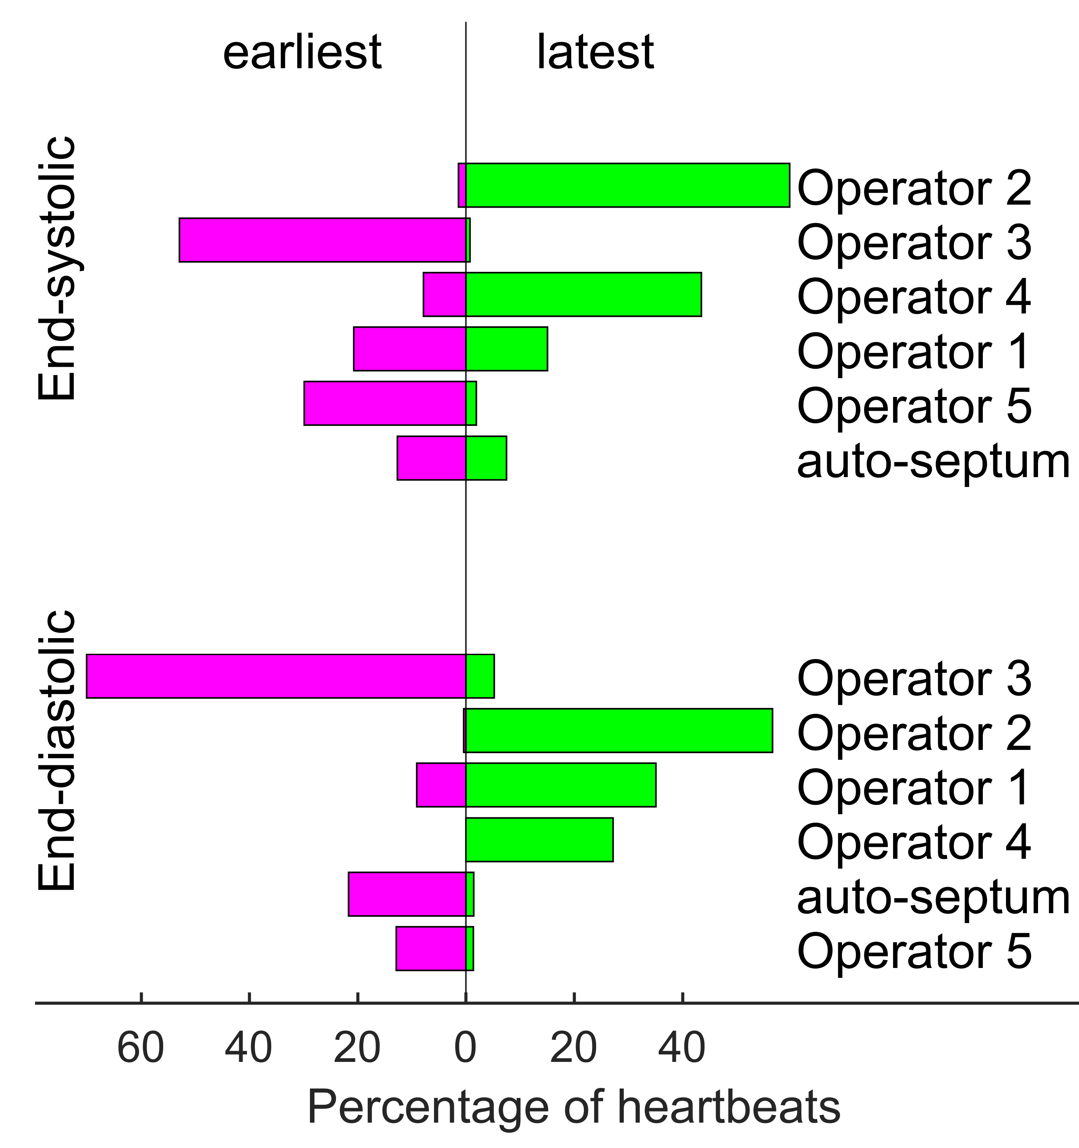
Figure 7. Relative frequency of picking the earliest (left side) or latest (right side) frames as end-systolic or end-diastolic. In the upper and lower panel separately, the operators and algorithm are sorted according to the frequency of being the earliest or latest.

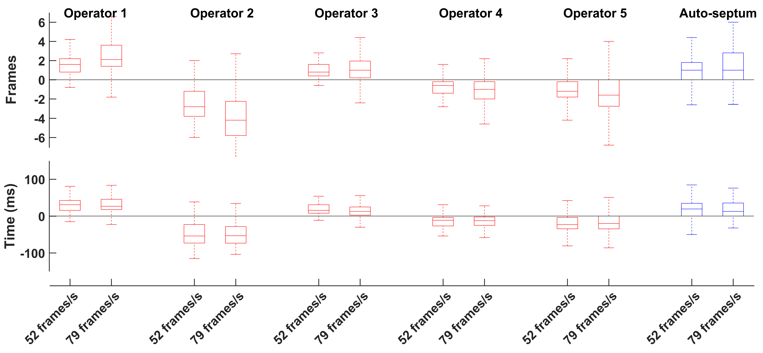
Figure 8. Do operators tend to disagree by a certain number of frames or a certain number of milliseconds? For each operator, the end-diastolic frame they select is expressed relative to the mean frame selected by the human operators. The distribution of these discrepancies is shown in box-and-whisker plots, separately for the 52 frame/s and 79 frames/s recordings. The upper panel shows these discrepancies expressed in frames; the lower panel shows them in milliseconds.

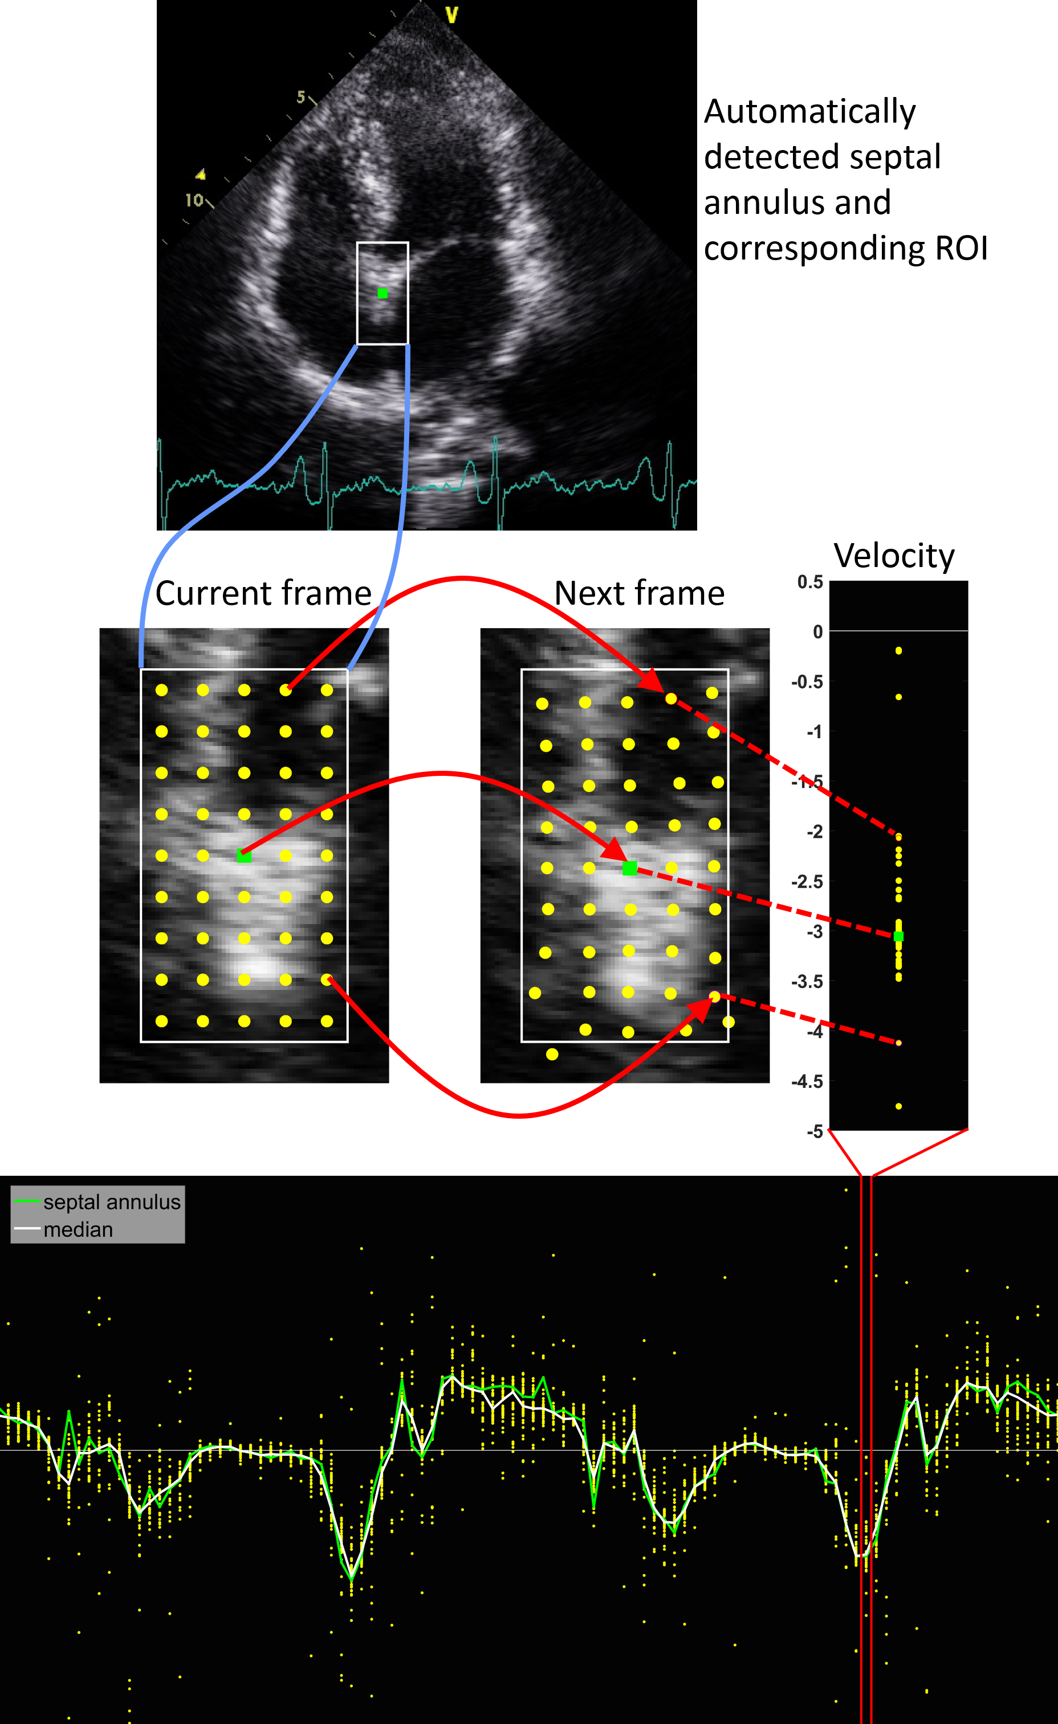
Figure A1. Speckle tracking echocardiography: (top panel) a 4-chamber view image with the automatically detected septal annulus, shown by green square marker; (middle panel) magnified views of the region of interest, identified by the white rectangle, showing the location of the tracking kernels for two consecutive frames, and the calculated velocity points for each kernel; (bottom panel) regional velocity profile (vertical axis) across frames (horizontal axis) where each data point represent the velocity estimated by one tracking kernel in the region of interest, and the median of all kernels in the region as the white continuous line.

Appendix
Two dimensional speckle tracking echocardiography was performed using a fully automated in-house toolbox which relies on the block matching technique. The block matching is a standard technique for encoding motion in video sequences. The tracking system is based on gray-scale B-mode images. Speckle tracking analyses motion by tracking the natural acoustic reflections and interference patterns within an ultrasonic window. To this end, a region in the image (kernel) is selected and sought for in the next image frame and within a search window by sequentially trying out different positions and by determining the similarity between the kernel and the pattern observed in that position. The position where the similarity between the kernel and the observed pattern is maximal is accepted as the new position of the speckle pattern. This procedure is repeated for all regions in the image to obtain a velocity vector field. By repeating this measurement within the image sequence, a dynamic velocity vector field can be obtained.
Each block matching kernel had a size of 9×9 mm and was applied over a search window of 6.5×10 mm, where the longer side of the rectangle lied along the radial direction, allowing for larger displacements along this direction. For fairly on-axis apical 4-chamber views, the lateral movement of the myocardium, particularly the septal wall, is assumed to be of smaller scale; hence the smaller side of the searching window. The kernels were placed in equally-spaced distance of 6.5 mm from one another.
Additionally, each block matching kernel was assigned a score based on several quality measures such as contrast of pixels values within the kernel, spatial neighbourhood and temporal consistency of the estimated velocity vectors, and skewness. The low quality kernels were assumed to be invalid and were removed from the velocity vector field obtained from the speckle tracking. Further details on the quality measures used in this study, and also optimisation of the block matching parameters in our toolbox, can be found elsewhere^{11,12}. It is worth noting that the concept of speckle tracking used in our study is of Eulerian type, similar to that in Doppler imaging, which estimates the velocity of a fixed point on the image rather than the velocity of an individual object by following its trajectory, i.e. Lagrangian description of the motion.
The myocardial velocity vector field, obtained from the speckle tracking, was utilised to automatically define end-diastolic and end-systolic frames. To this end, two approaches were investigated. First, we utilised the physiological landmarks to identify the clinically optimal positions for measurement of the velocity. One measurement site, which is also used in tissue Doppler imaging, is septal annulus whose location is currently identified manually by the experts through visual inspection of the video loop¹³. We have previously reported on the successful automated detection of septal annulus position in apical 4-chamber windows using the global image parameters and speckle tracking results¹⁴. Figure A1 illustrates an example of septal annulus site which has been detected automatically by our automated system.
Once identified, a region of interest (ROI) is considered surrounding septal annulus. This ROI, limits of which is shown by a rectangle overlaid on apical 4-chamber image in the figure, is similar to the concept of sample volume in spectral Doppler measurements. In order to extract a regional velocity profile, only those speckle tracking kernels falling within the ROI are taken into account for subsequent velocity estimations. The location of these kernels overlaid on example image frame is shown. The size of ROI was 26×52 mm, comprising 45 block matching kernels. The new position of kernels in the following frame, determined by block matching, and the resulting velocity values calculated for each kernel are also shown.
Despite assigning the quality score to each block matching kernel and discarding the ones deemed to be of low quality, there still remains random noisy velocity values. These can be seen as isolated points in figure A1 (bottom panel) which plots the velocity of kernels within the ROI for multiple frames spanning 2 cardiac cycles. The median velocity, calculated as the median of the velocities of the retained kernels within the ROI which met the quality thresholds, deemed to be a better representative of the regional velocity at each time point and is plotted in the figure. Velocity of the single kernel, detected as septal annulus is also plotted. Compared with the median velocity profile, this velocity appears to be more prone to the noise as it relies on the estimated velocity by one kernel only. The median velocity was, therefore, adopted as the regional velocity.
In the second approach, a global velocity profile was obtained by computing an average velocity for all tracked kernels spread over apical 4-chamber image. This velocity profile would represent the motion of entire heart muscle, captured in the B-mode image.
The two extracted velocity profiles were then used for the detection of end-diastolic and end-systolic frames. An average cardiac cycle length for each patient was first estimated using the autocorrelation method and computing the fundamental frequency of cardiac motion. A constraint was imposed as the feasible cycle lengths by assuming the upper and lower bounds of 2.5 s (24 bpm) and 0.3 s (200 bpm) for the cycle length. Further details on this estimation method which we have also applied to the long strips of spectral Doppler traces can be found elsewhere¹⁵.
In order to filter out the high frequency noise, a low-pass first-order Butterworth digital filter was applied to the crude velocity profiles. The cut-off frequency was estimated from the cardiac cycle length; any frequency 10 times higher than the fundamental frequency of heart motion was filtered out. This ratio was selected empirically as a trade-off between noise removal and maintaining the desired features of the velocity profile. The low-pass filter also suppresses the high-amplitude outliers and artefacts in the velocity profile. This step is crucial for isolation of the individual cardiac cycles.
In the next processing step, the individual heartbeats were isolated by locating of the peak systole s’ which are found as the peak positive velocity points on the velocity profiles. This was done by imposing the constraint that the distance between two consecutive peaks should not be smaller than 80% of the estimated cardiac cycle length. This ensured that potential noisy spikes, still present after the filtering process, are not selected as genuine peak points. The peak systole points were then used as the anchor points. The first zero-crossings of the velocity profile at either side of the peak systole were assumed to be the changing phase time points; the first zero-crossing on the left was considered to be the end-diastolic frame, and the one on the right was assumed to be the end-systolic frame. The location of example frames, detected automatically, are plotted in figure 1.

