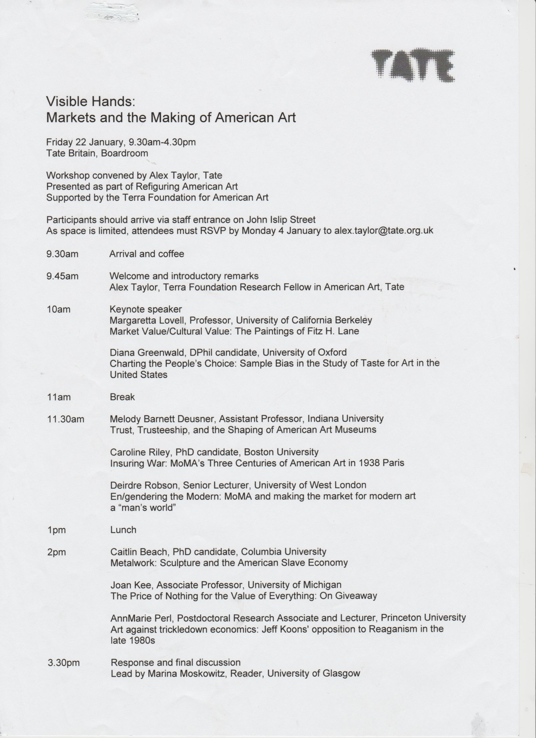
The Museum of Modern Art, New York, and Making the Market for Modern Art a Man’s World

In the late 1960s it was claimed that in North America “art has long been recognized as a sound area of investment” (Porter, 1969 in Cras, 2013), an assessment echoing Fortune magazine’s 1955 claim that it was possible to “draw useful parallels between investment in the art market and investment in the stock market” (Hodgins and Lesley, 1955). Such claims were markedly different to Time magazine’s 1934 assessment that “the work of living artists is necessarily a gamble in the minds of most collectors; fingers burnt along Wall Street are not likely to be present along Fifty-Seventh Street.” In this paper, I will argue that what underpins these changing views about the art market is a re-gendering of American attitudes involving a move away from the then conventional expectation that the arts and culture were “women’s work,” toward a re-alignment of “patronage” with the public, masculine, realm of market exchange.

The focus of today’s paper is the role that the Museum of Modern Art in New York played in this re-gendering. When it opened its doors in November 1929, the Modern was committed: “to help people enjoy, understand, and use the visual arts of our time” (Catalogue of the Collection, 1948, n.p.). Alongside this more general taste-making aim, was the intention that efforts be made to “encourage patronage of modern art by the public” (Soby, 1944, qtd. in Messer, 1979, p 152). The Modern’s Director, Alfred Barr Jr., realised it was not enough to “mak[e] modern art chic” (Lynes, 1973, p 56) among America’s socio-economic elite, it was imperative that more men be encouraged to collect modern art. As I hope to show, this was achieved via a twin-barrelled strategy. One strand involved the more overt means of the Museum’s public relations to emphasise the market exchange status of modern art. The second strand involved using a narrative of gallery display—the “white cube”—to promote modernism as, if not masculine, then at least not feminine.

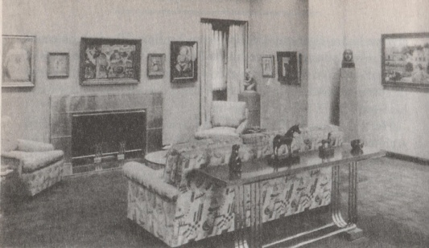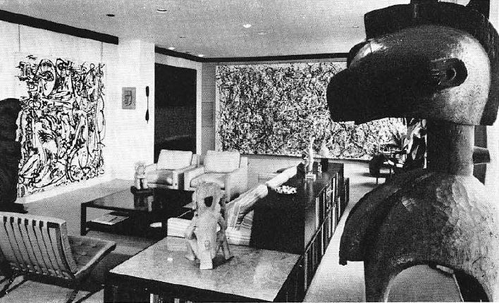
(1)
The success of these strategies, overall, can be tracked in American commentary about modern art. In 1939 Fortune magazine, the business ‘bible’ of the time, opined that “modern art is far more respectable today than it was in 1929” (Dec. 1938, p127), ergo “respectable” in the terms of the public realm of market exchange. By the 1950s, the Modern was itself judging its success in stock market terms. As curator Andrew Ritchie put it:

“Don’t forget that the Museum was the Bourse. Everything we did the dealers knew about before we did it, and prices were affected accordingly. It was inevitable” (Qtd in Lynes, 1973, p 250).

As I hope to show, the re-gendering of modern art patronage in the United States can be demonstrated by differences in modes of presentation of two private collections: Abby Aldrich Rockefeller’s collection, on display in her attic apartment at 10 West 53rd Street circa 1935 (on the left), and collector Ben Heller’s collection in his Manhattan apartment in 1961 (on the right).

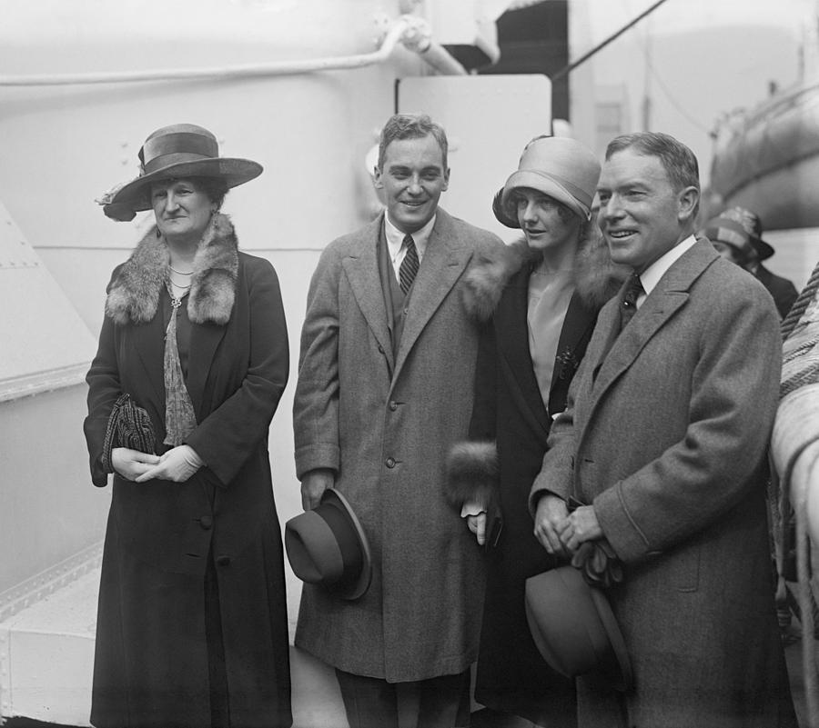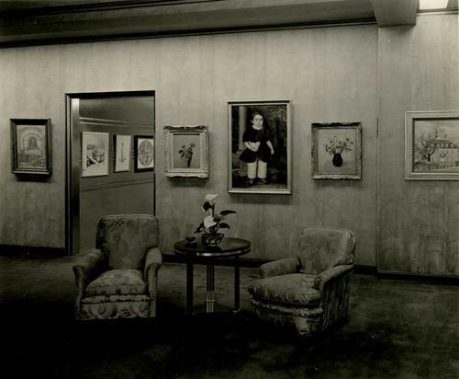
(2)
Some consideration of Abby Aldrich Rockefeller’s collection will hopefully provide a useful starting point for exploring why Barr saw encouraging patronage of modern art by men to be necessary. Abby, wife to John D. Rockefeller Jr., was one of the three founders of the Museum of Modern Art, along with Elizabeth (Lillie) Bliss (unmarried scion of a wealthy East coast family), and Margaret Sullivan, (wife of a prosperous New York lawyer, and friend of collector John Quinn before his death in 1926). All had started collecting art about the time of the 1913 Armory Show. Abby, with advice from museum director William Valentiner and New York dealer Edith Halpert, collected recent European, but predominantly, contemporary American, art ranging from a Heckel watercolour (her first purchase) to a fairly wide range of modestly sized and priced paintings and prints by contemporary American artists such as John Sloan, Walt Kuhn, Edward Hopper and John Marin.

The social status of Museum trustees such as Mrs Rockefeller would perhaps suggest that raising the status of modern art in the States could depend upon links being built between the Modern and members of New York’s Social Register. Indeed, for Fortune magazine in 1938, the activities of Museum founders and trustees such as Abby Rockefeller, provided the
“provocative spectacle of the thickest pillars of conservative society upholding a distinctly radical artistic cabal, and upholding it not merely with cash but also with vigorous personal effort” (December 1938, p 127).

For Sidney Janis, New York dealer in the 1950s, social status was seminal in encouraging the collecting of modern art:
“if Mrs Rockefeller would spend good money of these things, there must be something to them. It was as simple as that. That caught on with many people –‘If she can do it I can do it’” (Interview with Paul Cummings, 06/06/1972, Archives of American Art).

More recently, Wilson has suggested that in the museum’s first premises on 53rd Street (a Rockefeller owned townhouse) the traces of ornate plaster ceiling and wall mouldings, although painted white to minimize their visual impact, in effect served to link the art works shown, just like the architectural spaces, to the “right sort of people” (Wilson, 2009, p 143-144). Similarly, Grunenberg has argued that these gallery spaces could be seen as “a reminder of a private home, a reminder that many works in the museum previously belonged to wealthy collectors …” (1994, p 204).

It is debatable, however, that social status played the key part in encouraging patronage of modern art in the U.S. Indeed, Barr had his doubts that appeals to social status were going to be enough to encourage the desired “patronage” of modern art. In 1936 he wrote:
"one of the greatest barriers to the healthy development of art interest in America is unquestionably the fact that it has been so largely cultivated hitherto an interest peculiar to women" (Qtd in Chamberlain, n.d, p 152).

The key reason why being “an interest peculiar to women” should be seen as a barrier to modern art’s acceptance and status was the continuing hold of 19th century gender stereotypes, more particularly the notion of “separate spheres.” This term refers to an ideology of gendered social relations based upon binary polarities—city/home, public/private, production/reproduction, men/women—by which social attitudes and gender hierarchies were “continually reproduced” (Rendell, 2000, p 106). Within this social ideology, women were identified with the private realm of the home and all that this connoted: emotion, morality, social aspiration, the exercise of taste and display, and consumption (Sparke, 1995, p 4), while the “competitive capitalist arena of the market economy … for the middle class, effectively become the man’s sphere” (Wall, 1994, p 5). It was noted by some commentators in the early 19th century that this division into “separate” spheres was more marked in the U.S.A. than in Europe, resulting in what Ann Douglas has called the “feminization of culture” in the United States, and the perception that the arts were more properly to be seen as “women’s work.”

The ideological discourse of “separate spheres” meant that women were regarded as inherently inferior to men in terms of intellectual capacities. Men were identified with the more “rational” and “active” worlds of work, progress, technology and utility; women were characterised as “subjective, emotional and passive” in their aesthetic and intellectual capacities (Andreas Huyssen, qtd. in Sparke, 1995, p 120). These views impacted upon pre-conceptions of women as “patrons” or collectors of art. According to Tierstein (1996, p 31), notions of “true” art collectors were differenced in the early 20th century:
“Men were said to exhibit objects in both public and private venues for the spectatorial pleasure of others; women, by contrast, did not so much display objects as surround themselves with them.”’
The impact such gendered preconceptions might have upon women’s status as art collectors can be inferred from 1931 comments made about Lillie Bliss by New York critic Forbes Watson (very similar statements were also made about Abby’s collecting):
”Miss Bliss could never have enjoyed the confidently impersonal attitude towards art or the confident superiority … that Mr. Frick enjoyed. Before she could advance very far in collecting it was necessary for her to feel a personal friendship” (Arts 17, April 1931, p 451).

The suggestion here is of women as genteel “patrons” whose “charitable instincts” were central to their essentially philanthropic role as custodians of American culture, rather than their having the ability to make disinterested choices as to artistic or aesthetic quality (Hankins, 1999, p 106). The presumption that “The basic difference between the picture buyer and the collector is that the one acquires a work of art for an empty wall space, the other buys for himself” (and it is not by chance that the pronoun used for collector is masculine) (Soby, 1946, p 42) was still current in mid-1940s. If men were to be encouraged to become collectors of modern art, then buying such artworks had to be linked to the category “collector”, one capable of making supra-personal judgements.

To overcome what he saw a the gender “barrier” to “the healthy development of art interest in America”, Barr set out to target what he termed the "Action Group": wealthy business people (ergo men) who might be attracted by the modernity of the Museum’s image, who wanted to “do something” about what they saw, and who, though they had not yet accepted the idea that “good art is good for business,” were not opposed to the idea (Chamberlain, n.d., p 150). In order to do this, one means advocated was to stress the speculative possibilities of modern art in general, either verbally or in print. As Barr urged his staff in 1934:
"the question of the value of modern pictures is very important, especially if you, as salesmen, are going to talk over the desks of businessmen who may not be interested in modern pictures but who certainly are interested in an increase in value of 200,000 per cent " (Qtd. in MacDonald, 1953, p 52).

From the late 1930s onwards press releases and articles in the mainstream press were used to emphasise increases in the monetary values of art in the Modern’s permanent collections as, to quote Vogue, “a record of rewarding speculation, backed by some brilliant hunches and rare streaks of luck,” as Vogue put it in 1954, language which surely echoes the vocabulary of venture capitalism more than the supposed aesthetic disinterest of the museum (Vogue, 1/11/1954, p 169). This was very different to how women collectors such as Abby Rockefeller might be discussed as ‘investors. In their case, as Time noted in a 1936 profile of Abby Rockefeller:

“One can consider one’s collection a sort of private investment, to provide artists with a little more money to paint more and better pictures” (Time, 27/01/1936, p 28).

One of Modern’s efforts to attract the so-called “Action Group” was to publicise the identities, including the “sound” business credentials, of those already involved with either MoMA itself or with collecting modern art. Part of this was achieved via a sequence of special exhibitions. A few were devoted to a single collector, the majority—such as ‘Selections from 5 New York Private Collections’ (1951) or ‘Paintings from Private Collections’ (25th Anniversary Exhibition” (1955)—were anthologies of works from different collections. The en-gendering agenda of these anthologies becomes obvious when one notes that the ratio of male to female collectors shown was about 3:1. A sub-set of using private collections to promote “patronage” was guided visits to the homes of New York private collectors associated with the Modern in some way.

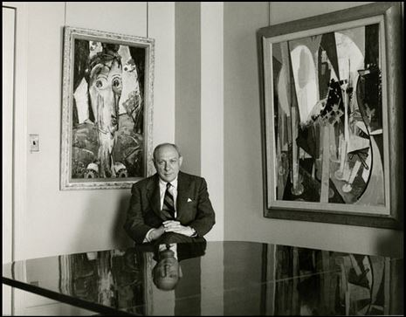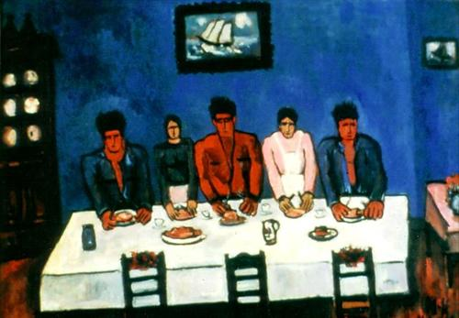

One of the early examples, in 1944, of the programme of visits to private collections involved Roy R. Neuberger, ostensibly because of his growing reputation as a “brave collector willing to take a chance on new artists” (Neuberger, 2003, p 97). This choice is surely interesting in the context of Barr’s “Action Group” for by profession Neuberger was a newly wealthy partner in his own stock-brokerage firm, who had made his first significant art purchase only in 1939. Neuberger was indeed a risk-taker of sorts: as he noted, “collecting the work of young, relatively unknown artists did carry with it a sense of adventure and the need for quick decisions similar to the lure of Wall Street” (Neuberger, 2003, p 23). It must be noted, however, that this “risk taking” was more aesthetic than pecuniary as the prices of the works he acquired in the early 1940s from painters such as Ben Shahn, Abraham Rattner or Milton Avery were then more usually only in the US$100s. In his belief that he should “buy the artist wherever you were” (Roy R Neuberger, Paul Cummings, interview 19/9 and26/9/1975, Oral History Series, Archives of American Art), he surely shared some of Abby Rockefeller’s stress upon a more informal and artist-centred approach to art collecting. Indeed, Neuberger’s insistence that “most of what I bought reflected my instinctive emotional reactions to particular works of art” (Neuberger, 2003, p 31) might be seen to be almost “feminine” in ethos. One might suggest that Neuberger should be seen as being impacted upon partially by Barr’s strategies to attract male patrons for modern art: his speculation was still conceived primarily in terms of the personal; his “profits” in terms of social or cultural capital. However, in Neuberger, we can also see an early example of a man who would not be thought “unsound” for displaying the artworks he owned in the premises of his stock-broking partnership; and by 1950 collectors such as Neuberger were being featured in surveys such as Fortune magazine’s “The Businessman and Picasso”.

It has not been possible to identify quite how Neuberger displayed his collection in his home, although a contemporary Art News article notes the “informality of the setting”, wherein “one is hardly aware of the comfortable, non-descript furniture … In crowded profusion from foyer to the younger child’s room the paintings dominate” (May 1946, p 54). However, a key player in the re-gendering of modern art, and encouragement of men as collectors of said art, was to be how modern art was displayed, both in private collections and in museum galleries. If one returns to Mrs Rockefeller’s collection, it can be seen that it was carefully, and tastefully, presented in a setting representative of what was, in the early 1930s, seen as the most sophisticated ‘modern’ interior design: the “moderne” or “streamline” Art Deco. Abby commissioned the scheme in 1929 from Donald Deskey, architect of the interiors of Radio City Music Hall, to produce a setting which was unique for the time in its overt linkage of contemporary art and novel interior design, a setting in which “many of her friends saw modern American art for the first time” (Kert, 2003, p 299).

The presentational narrative staged for visitors to the Modern, particularly that achieved in the 1939 Durrell-Stone building, has conventionally been seen as aiming to create a curatorial narrative in which modernist art would be viewed as aestheticised, universal, timeless, disinterested, high culture. However, from the very start gallery displays at the Modern “foreshadowed the gendered struggles the museum repeatedly encountered as it sought to define itself as the modern cultural authority” (Hankins, 1999, p 84). The curatorial narrative adopted by Barr, his means by which to achieve “cultural authority” and embed the Modern’s aesthetic choices as “the” modern, drew heavily upon existing modernist critical discourses. As Wigley notes, modernist theorists from Alfred Loos to Le Corbusier recurrently discussed the “white wall” of modernism” in gendered terms. In this discourse the “white wall” of modernism was recurrently likened to the standardised, disciplined, austerity of men’s clothing (the suit was conceived of as a rational ordered garment dictated by utility); the “white wall” was also contrasted to fashionability and “opposed to the seductions of women’s dress” (Le Corbusier, cited in Wigley, 2001, p 92). Within the terms of this discourse, the “furnished” appearance of the modernistic design favoured by Abby Rockefeller for her private gallery would be seen to recall the “feminine domestic”. It was the pared-down simplicity of the “white cube” which connoted the masculine “realm of exchange, money and masks.”

One particular MoMA exhibition of private collections should be discussed in the context of the aim of re-gendering the market for modern art in New York. This is the 1951 “Selections from 5 New York Private Collections” which showcased the modern art collections of
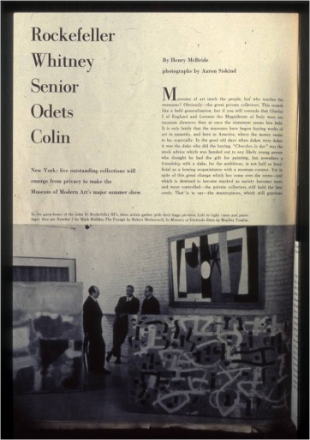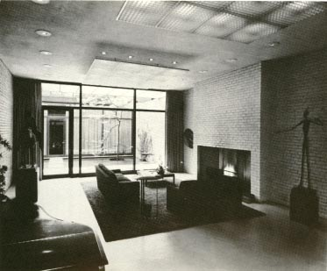

Blanchette Rockefeller (wife of John D Rockefeller III), ambassador John Hay (Jock) Whitney (collector of late 19th and early 20th European modernism), playwright Clifford Odets (the U.S.’s most notable collector of Paul Klee), lawyer Ralph Colin, and businessman John L. Senior, President of the “fledgling” New York Airways, who owned the largest U.S. private collection of Mondrian. Senior had featured alongside Neuberger in Fortune magazine’s 1950 “The Businessman and Picasso”, but it is the 1951 show’s presentation in what Art News called the Rockefeller’s “ingeniously modern guest-house and gallery” which is more significant. However, it is not simply that the Rockefeller name had considerable social cachet. The fact that the “guest house” had been designed by arch-modernist Philip Johnson, and must be seen as epitomising the critical discourse distancing modernism from the “feminine” decorative, leads one to suggest that this choice of venue must be seen as part of Barr’s strategy to re-gender the collecting of modern art. [It might be worth noting that although publicity for the show emphasised Blanchette’s use of the guest house to “get to know” contemporary American art, what was shown in her name had in fact been selected by MoMA curators to make up a collection bearing her name, and can be seen as part of Barr’s efforts to raise the profile of American Abstract Expressionism: she only owned the works shown in 1951 for 4 years and never lived with them.]

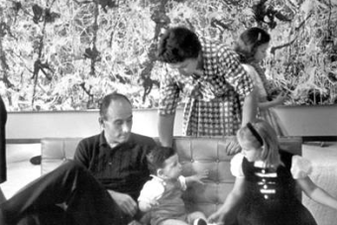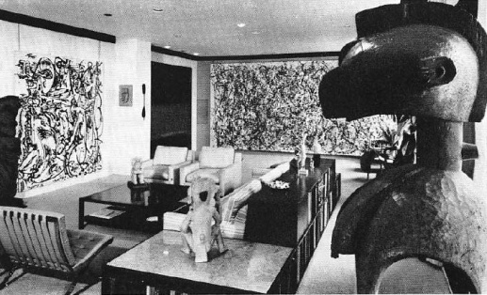

Subsequently New York businessman Ben Heller (he ran a textile manufacturing business), and who began collecting in the early 1950s, noted the importance of this 1951 MoMA show in encouraging him to take an interest in art collecting. The show, for him, suggested that “art was going to be the big way that a lot of rich people were going to express themselves. It was just going to become the thing” (Ben Heller, interview with Avis Berman, 18 April 2001, Museum of Modern Art Archives). His collection was subsequently to be given its own museum-sponsored display when the Modern organised a touring show of his collection in 1961. By the late 1950s his collection had become synonymous with post-war American Abstract Expressionism (he owned major paintings by Gottlieb, Motherwell, Barnett Newman, Pollocks and Rothko among others). His Pollock purchases in particular can be taken as an exemplar of how attitudes toward art collecting, and more particularly collecting contemporary American art, had changed in 25 years. Unlike Neuberger, who acquired his first Pollock from Betty Parson’s gallery in 1949, ostensibly so that Pollock could afford to heat his studio for the winter, Heller acquired his first Pollock—One (1950)—only in 1954, from New York dealer Sidney Janis, for a then record-setting $8000. The new kind of attitude exemplified by Heller is suggested by his claim: “Always a top price at the time. Always a record price! I bought only one work of art "cheap" in my life … Everything else was expensive” (Ben Heller, interview with Avis Berman, 18 April 2001, MoMA Archives). In 1958 Heller once again hit the art market headlines when he paid $35,000 for Pollock’s Blue Poles (1953), buying it from the private collector who had first acquired the painting before Pollock’s death (Ben Heller, interview with Paul Cummings, 8 January 1973, Archives of American Art). In 1973 Heller once again attracted press attention when he re-sold Blue Poles to the National Gallery of Australia for A$ 1.3 million.

Last but not least, a final way to note evidence of a re-gendering of the market for modern art (including American post-war art), is the way Heller presented his collection in his apartment. As Heller himself noted, One was the largest contemporary painting to go into private hands, and “it was important for people to know that such a work could be hung in a home” (Museum of Modern Art, 1961, n.p.). To achieve this, Heller’s “at home with art”—which in 1961 was in effect a private museum of Abstract Expressionism—involved the radical remodelling, by New York architects Kramer & Kramer, of a “middle-aged” Manhattan apartment. What is significant is that this remodelling created an interior which resembled nothing so much as a modernist “white cube,” or perhaps Philip Johnson’s Rockefeller “guest house”. The Heller apartment is surely a key signifier of the success of the Modern’s re-gendering of art ‘patronage’ over the previous 25 years.

In conclusion, over 25 years the status of modernist art in a market context radically changed in the United States. In this the Museum of Modern Art, and its first Director, Alfred Barr, surely played a key role in subverting the then conventional expectations that culture was most properly to be seen as “women’s work” and attracting the attention of the businessman as potential supporters of modern art. Women remained key doyennes of new experimental artists in the post-war era but, as a result of the Modern’s efforts, by the 1960s any discussion of the “urge of possession” in the United States was increasingly dominated by the discourse of market exchange. Modern art was no longer a “gamble” (as it had been in 1934), it was now safely to be discussed in terms of “growth” investments or “blue chip” stocks.

Bibliography
‘53rd Street Patron’, Time, 27/01/1936, p 28.
Alcoff, L. M. ‘Feminist Theory and Social Science: New knowledges, new epistemologies’, p 15, in Nancy Duncan (1996, ed.): Bodyspace: Destabilizing geographies of gender and sexuality, Routledge, London.

Anger, Jenny ‘Forgotten Ties: The Suppression of the Decorative in German Art and Theory, 1900-1915’, in Christopher Reed (1996, ed.): Not at Home: The Suppression of Domesticity in Modern Art and Architecture, London: Thames & Hudson, pp 130-146.

Cras, Sophie (2013) ‘Art as an Investment and Artistic Shareholding Experiments in the 1960s’, American Art, Vol. 27, No. 1 (Spring 2013), pp 3-23.

Chamberlain, Betty ‘History of the Museum of Modern Art’, unpublished typescript, History Archive, Museum of Modern Art.

Duncan, Carol and Wallach, A . ‘MoMA: ordeal and triumph on 53rd Street’, Studio International, 1978, pp 48-57.

Grant, Ron ‘The Art of Investment”, The Montreal Gazette, 4 August 1968, p 25.

Grunenberg, Cristophe ‘The Politics of Presentation: The Museum of Modern Art, New York’, in Pointon, Marcia (1994, ed.) Art Apart: Art Institutions and Ideology across England and North America, Manchester: Manchester University Press, pp 192-211.

Hankins, Evelyn C. En/gendering Modern Art Display in New York City, 1913-39, Stanford University, Ph.D. thesis.

Hodgins, Eric and Lesley, Parker ‘The Great International Art Market’, Fortune, December 1955, pp 118-120, 150-152, 157-62, 169.

Kert, Bernice (1993) Abby Aldrich Rockefeller: A Woman in the Family, New York: Random House.

Lynes, Russell (1973) Good Old Modern: An Intimate Portrait of the Museum of Modern Art, Kingsport: Kingsport Press.

MacDonald, Dwight ‘Action on 53rd Street’, New Yorker, 12/12/53, pp 49 ff.

Messer, Helaine R. , MoMA: Museum in Search of an Image, Columbia University, Ph.D. thesis, 1979.

Neuberger, Roy R. (2003) The Passionate Collector, Hoboken, New Jersey: J. Wiley & Sons.

Newhouse, Victoria (2005) Art and the Power of Placement, New York: The Monacelli Press.

O’Doherty, Brian (1986) Inside the White Cube: The Ideology of the Gallery Space, London: University of California Press.

Rendell, Jane (2000): Gender Space Architecture: An interdisciplinary introduction, London: Routledge.

Schor, Naomi (1987) Reading in Detail – Aesthetics and the Feminine, New York: Methuen.

Soby, James Thrall, ‘Collecting Today’s Pictures’, Saturday Review of Literature, 25/5/1946, pp 42-44.
,
Sparke, Penny (1995): So Long as it’s Pink, London: Harper/Collins,.

Staniszewski, Mary Anne (1998) The History of Display: A History of Exhibition Installations at the Museum of Modern Art. London: MIT Press.

‘The Big Gamble’, Vogue, 1/11/1954, pp 106-109.

The Collection of Ben Heller, Museum of Modern Art, 1961, exhibition catalogue.

‘The Museum of Modern Art’, Fortune, December 1938, pp 73-75, 127-28, 131-134.

‘Today’s Collectors: Broker Buys American’, Art News, XLV (3) (1946-7), pp 54-55, 68-69.

Tierstein, Lisa ‘The Chic Interior and the Feminine Modern: Home Decorating as High Art in Turn-of-the-century Paris’, p 31, in Reed, Christopher (1996): Not At Home: The Suppression of Domesticity in Modern Art and Architecture.

Wall, Diana de Zerega (1994) The Archaeology of Gender: Separating the Spheres in Urban America, New York: Springer.

Wigley, Mark (2001) White Walls and Designer Dresses: The Fashioning of Modern Architecture, London: MIT Press

Wilson, Kristina (2009) The Modern Eye: Stieglitz, MoMA, and the art of the exhibition, 1925-1934, New Haven, Yale University Press.

