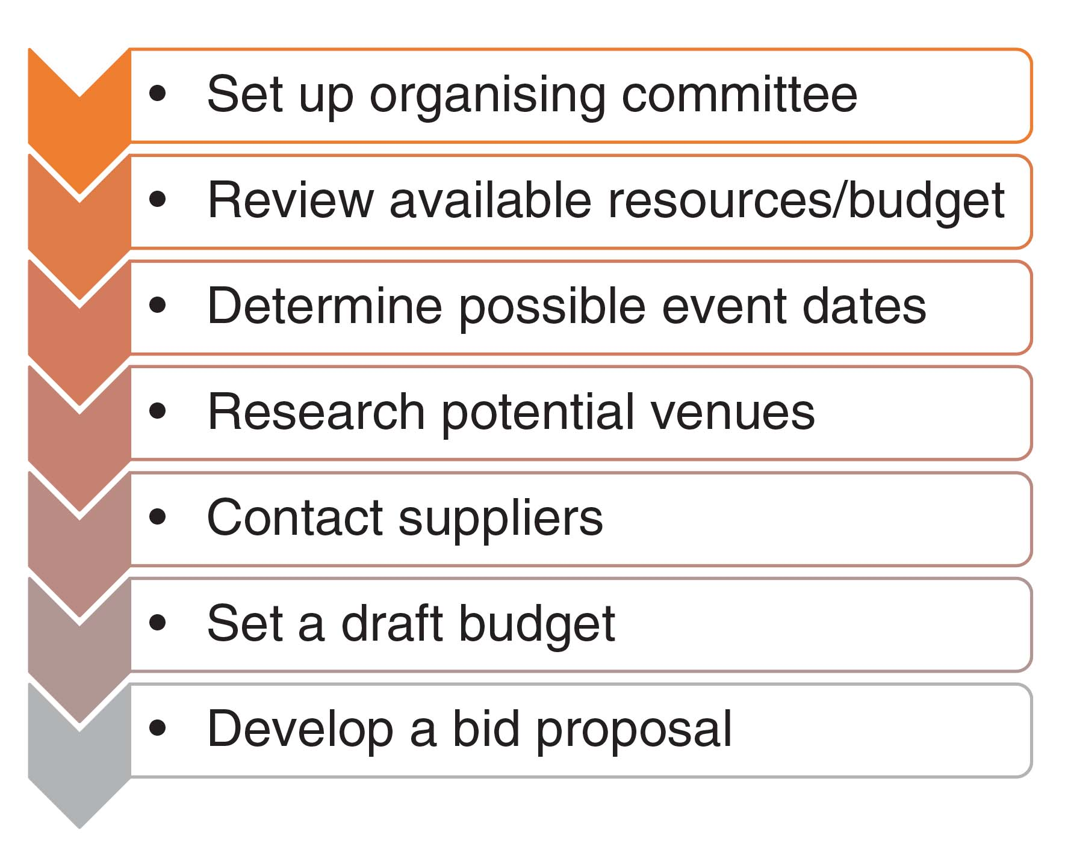
Figure 5.1 The bid process
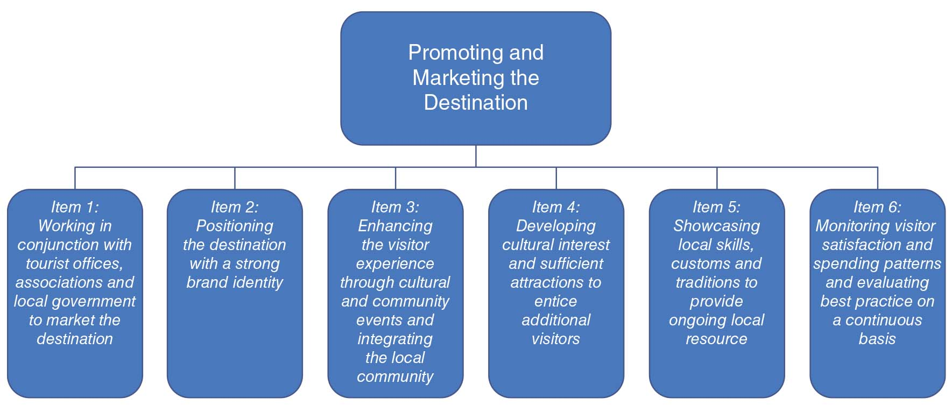
Figure 5.2 Promoting and Marketing the Destination
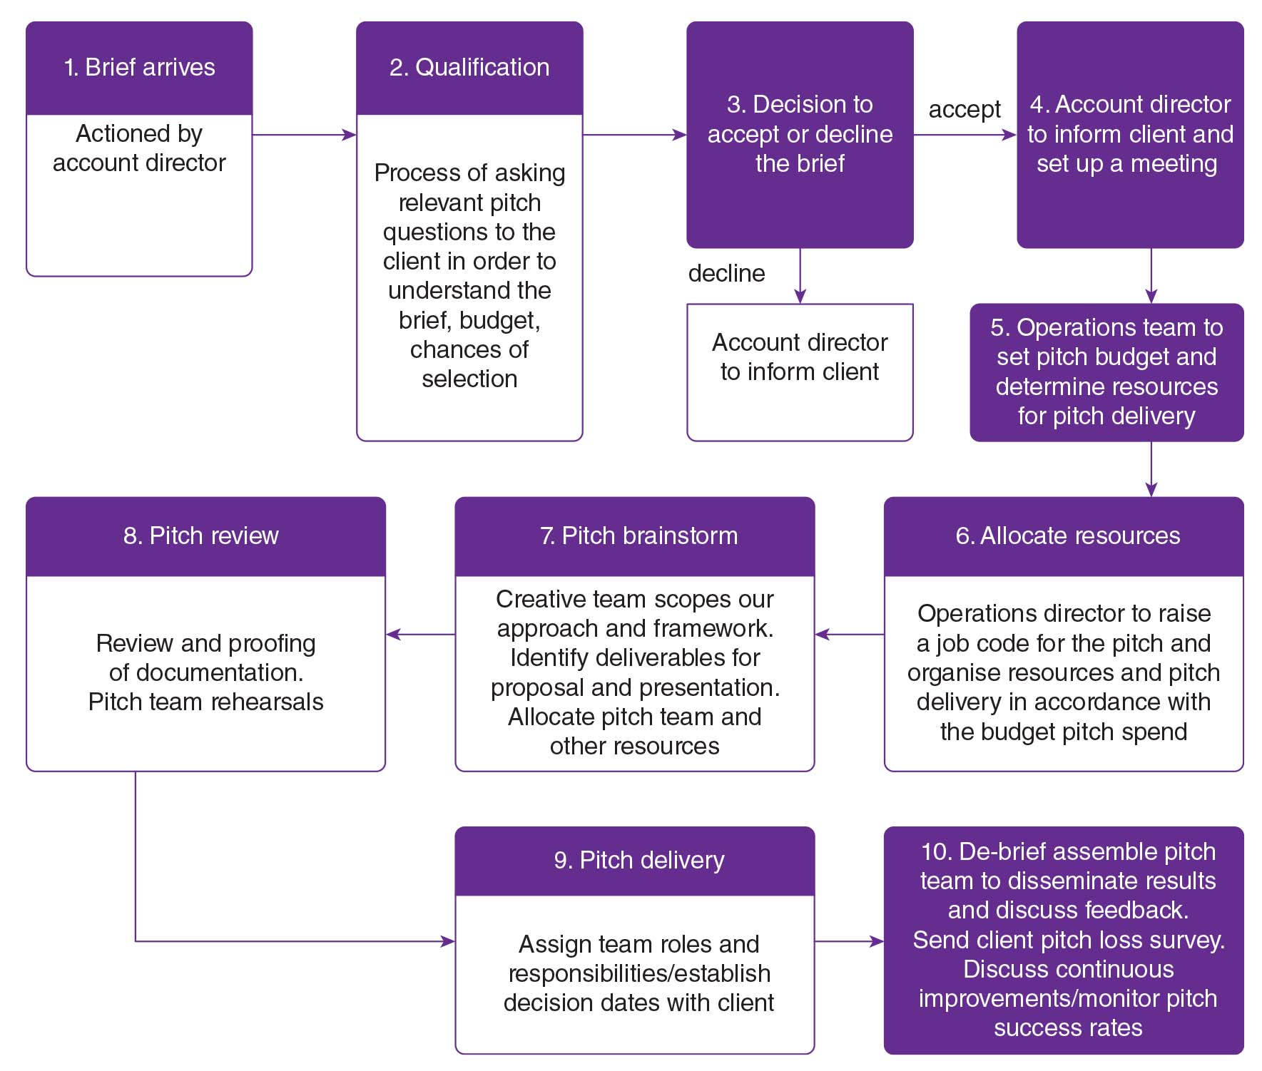
Figure 5.3 Event bidding analysis
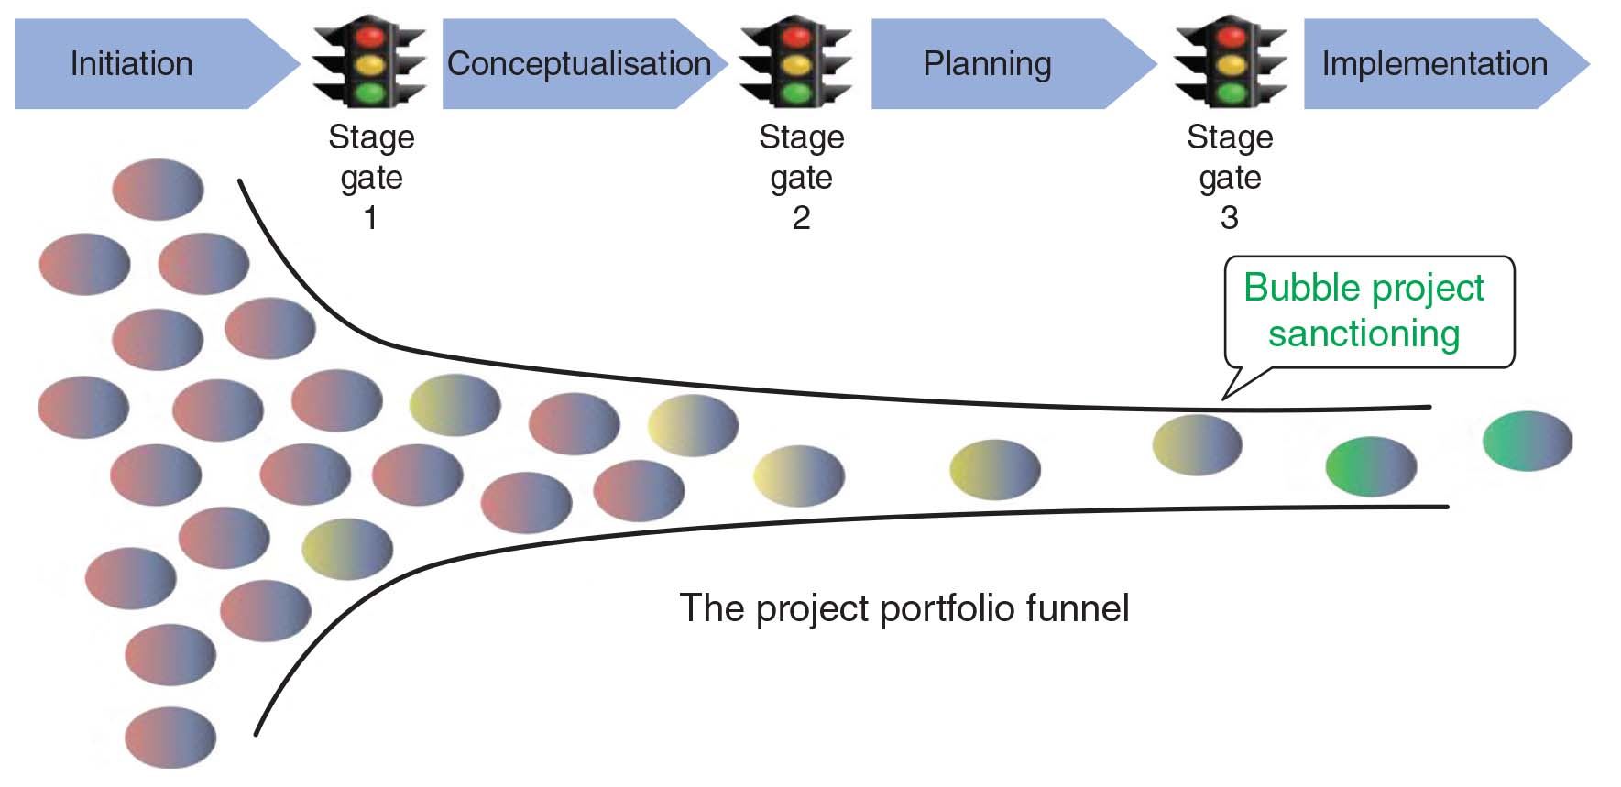
Figure 5.4 The project process

