Sociotechnical HCI for Ethical Value Exchange

José Abdelnour-Nocera1, Torkil Clemmensen 2

1University of West London and Madeira Interactive Technologies Institute

[abdejos@uwl.ac.uk](mailto:abdejos@uwl.ac.uk)

2Copenhagen Business School

[tc.digi@cbs.dk](mailto:tc.digi@cbs.dk)

**Abstract.** Ensuring ethical value exchange is moving to the forefront of the global challenges that HCI will have to address in the coming years. In this position paper, we argue that applying a context-sensitive, sociotechnical approach to HCI can help meet the challenge. The background is that the life of marginalized people in contemporary society is challenging and uncertain. The marginalized can face health and cognitive issues as well as a lack of stability of social structures such as family, work and social inclusion. Three questions are of concern when innovating together with people ‘at the margins’: how can we describe users without attempting to stereotype badly, what sociotechnical HCI methods fit the local societal context, and how to make the design sustainable in face of current planetary challenges (e.g., climate change)? We adapt the sociotechnical HCI approach called human work interaction design (HWID) to meet the challenges of designing for ethical value exchange. We present three cases of service design, and suggest how to add a fourth similar case using the HWID approach during a field trip and workshop at the INTERACT 2017 conference in Mumbai. We conclude that applying a context sensitive sociotechnical HCI framework implies that both the backend and frontend of service design and product innovations should be executed and valorized from within the local context.

**Keywords:** sociotechnical, human work interaction design, international development, ethics.

1 Introduction

Ethical value exchange is moving to the foreground of Human-Computer Interaction (HCI) in these years, adding a new dimension to the current user experience and web 2.0 platform designs [1]. For example, an emerging network focused on product and service innovations in resource constrained environments explores new design methods, experiences and knowledge of doing innovation with people ‘at the margins’, for example in South Africa, India, Brazil, Denmark and UK [2]. In these projects that look at Global South Service Innovation there is a lot of focus on a frontstage mindset (e.g., touchpoints, user friendliness, user interfaces), but the methods, tools and infrastructure used to analyze and/or do backstage ‘work’ are envisioned and driven to a large extent by Global North assumptions (e.g., analytical cognitive styles, horizontal decision making structures, economically-driven thinking). We argue that through a sociotechnical HCI design approach, exemplified with the Human Work Interaction Design (HWID) model [3], researchers and designers can visualize and do something about these critical gaps, and more generally, contribute to an ‘HCI of ethical value exchange’.

The life of marginalized people is challenging and uncertain. The marginalized lack stable social structures such as family, work and social inclusion. People are typically said to be marginalized due to unequal social structures and a lack of education, proper housing, it-services and healthcare. Marginalized people in Denmark and UK share some of these traits, but in what we might call a first-world guise. Meaning that for example the elderly, refugees, and the disabled in UK or Denmark compared to Brazil or South Africa have more economic resources. However, relative to the rest of the British and Danes they are marginalized and suffer the ill effects associated with that position such as estrangement and a lack of participation in innovation. The elderly may for example be marginalized due to cognitive and physical decline associated with the aging process. In South Africa, black students are presented with equal opportunities to attend university, but its very different socio-economic and cultural background make it challenging for them to remain in higher education leading to high drop-out rates for this sector of society. Approaching marginalized people is challenging – their exclusion from society and societal resources has created estrangement. Moreover, a lack of resources may make it hard to take part in the dominant patterns of innovation and consumption. In addition, a significant problem is that stereotypes of these marginalized people fail to understand their experiences and life perspectives [4].

There is therefore a need to revisit sociotechnical HCI analysis and design methods with the aim to co-create alternative patterns of innovation that include the marginalized. Furthermore, in the emerging transformation economy, the focus on ethical value exchange with trust and collaboration in the foreground requires empathic, in-context experimentation and data collection through living labs [1], which requires a sociotechnical, context-sensitive approach such as HWID [3].

The larger questions that we want to discuss by analyzing cases of innovating together with people ‘at the margins’ are: how can we describe users without attempting to stereotype badly, what sociotechnical HCI methods fit the local societal context, and how to make the design sustainable in face of current planetary challenges (e.g., climate change)? We suggest the IFIP WG 13.6 Human Work Interaction Design HWID framework as an example of a sociotechnical HCI approach to frame service design cases and assess the extent to which HWID is suitable and how it should be modified to support open, bottom-up innovation in the global south.

2 Why Service Design Cases?

The service design field emanated from the appearance of information technology and an increased design focus within management and organizational studies. The field is relatively new, but stems partly from interaction design and participatory design (PD), [5,6,7]. PD plays an important role in service design [6]. Thus, what is transferred to service design is a basic structure consisting of involvement techniques, collaborative approaches, and liberating objectives.

As fig. 1 points out there are three key elements in service design: users, touch-points, and the service journey. Contrary to many design methods service design tries to capture what is outside of the IT system and has a focus also on the surroundings and contexts of use as well as the different sequences of interactions. Similar to PD techniques such as future workshop, service design looks at both the frontend and the backend users of the IT system [8]. Service design focuses on the contexts around the solutions and as such has a holistic approach to problem solving.

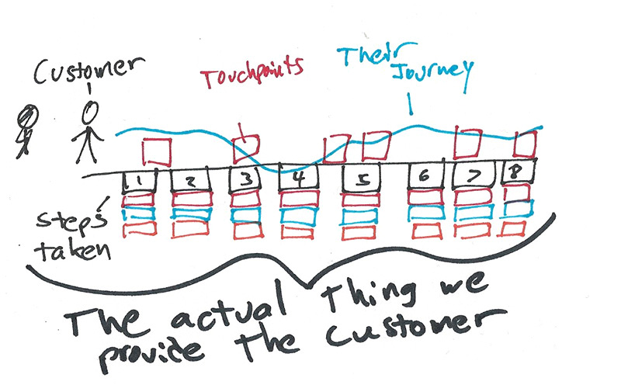

Figure 1. Customer service journey

3 Sociotechnical HCI for Ethical Value Exchange

The value propositions for a design approach should be rethought in relation to the paradigmatic economy that the designers attempt to contribute to [1]. In this paper, we use Human Work Interaction Design (HWID) to contribute to ethical value exchange, and hence present the HWID approach in relation to value propositions relevant to ethical value exchange. HWID is illustrated in fig. 2.



Figure 2. The HWID framework [3]

The left side of the figure illustrates the *social,* which is analyzed as end-users’ work tasks performed through IT systems within a given work domain. The right side illustrates the *technical* in HWID, which focuses on interaction designs as such, and on interaction design methods and techniques. The approach is *context-sensitive*, which is illustrated by the lower bar. The top bar indicates that researchers need to choose appropriate theories and methods for the phenomena under study. Obviously, at the center of the approach is the services and products being designed.

The value propositions for a HWID for ethical value exchange are inspired by Gardien [1]:

* End-user benefit – apply HWID theories to conceptualize not only interaction at individual level, but also HCI as organizational, societal, and global issues, and to help determine what is ethical peace of mind when speaking of HCI
* Cause of decline – using HWID to mitigate HCI’s native risk of focusing too much on interface functionality and forgetting the social life of humans
* People research objective – the aim with using HWID should include not stereotyping users (badly), executing sociotechnical HCI methods from within the local societal context, and designing for planetary sustainability (e.g., climate change)
* People research method – HWID analysis and design should be conducted in the context of everyday life
* Aesthetics – HWID as a design approach should be thought of as a parametric platform that can be valorized for a given local context
* Innovative integration – cradle to cradle sustainability achieved by the continuous, never ending analysis-design relations in HWID
* Brand – transparent and easy to understand what HWID analysis and design activities that have been done so far, and thus instantiating trust.

3 Description of Three Service Design Cases

Each of the projects described below shares a common interest in answering the questions presented in section 1 within a service design framework.

The first project is concerned with socio-cultural and human interaction approaches in the design of interventions to support students at risk in South African universities. In South Africa (SA) 25% of schools are functional, the rest are dysfunctional in terms of accountability, teachers’ knowledge of content, absenteeism, coverage of curriculum; high dropout and poor performance on national assessments [9]. Many dysfunctional schools are in townships and rural areas - in black communities. Consequently, many black students are underprepared to enter university and successfully complete their studies within the set time. There is a 50% higher completion rate for white students compared to black students [10]. The dropout rate at university is a serious concern that results in wastage and perpetuates the vicious poverty cycle. Research on designing information systems as intervention for students at the risk of dropping out or failing to complete their studies in the minimum set time is critical in SA.

SA universities attract students from diverse races, religions and cultures. Sometimes students at risk are identified late and the tendency is often to offer more readings and remedial classes thus adding an information burden to them. Given the situation, through an existing Newton Mobility Grant between the University of West London (UWL), University of Cape Town, and Cape Town University of Technology, we are exploring how service design approaches can be used to design an intervention information system for students at risk in SA universities.

The second project is led by the University of Bradford, IIT Madras and UWL and is concerned with critically examining city-wide strategic framing using concepts such as smart cities and sustainable cities and embedding inclusiveness as a central plank of such city-wide frames. In this regard, achieving Sustainable Development Goals (SDGs) at the city level requires resolving overlapping and inter-connected SDGs whereby inclusiveness becomes a very important element. Though the rhetoric suggests that all cities claim to be inclusive, in reality smart cities exclude those who do not have access to digital technologies; sustainable cities focus on environmental issues the benefits of which are predominantly manifested through housing price appreciation in better neighborhoods. Chennai is one of 100 smart cities chosen by the Government of India and it has also been one of the earliest members of the UN-Habitat’s Sustainable Cities Programme. In our project, we are examining the scope for such city-wide framing approaches to exclude particular groups including women, children, elderly people, and those living in slums.

The third project is at the proposal stage with the Danish research councils and is concerned with establishing a strong alliance between related research interests in two different continents: The IT University of Copenhagen, Universidade do Estado de Santa Catarina,and The Institute of Computing in Brazil. In Brazil and in Denmark digitalization of both public and private services are implemented and are to be implemented in the nearest future. The digitalization of services often overlook the less privileged citizens - the marginalized. By marginalized we understand the elderly, handicapped, poor, not educated, among other main categories. The main question to explore from the HWID perspective is how service design methods, originating from the global north, should be changed and innovated upon in order to adapt to local contexts in the global south. The focus is on design with and for people at the margins, in this particularly case focusing on Brazilian run projects in game design for elderly and interaction design for down syndrome children. Through this exploration new design methods may arise that can bridge the differences in cultural circumstances and contexts.

4 The Alibaug Fishery Case Study

The above projects illustrate the kind of cases that sociotechnical HCI for ethical value exchange aims to support. For the INTERACT TC 13.6/13.8 workshop WS11: Human Work Interaction Design meets International Development reported in this paper, the approach was similar. Since the workshop took place at the INTERACT 2017 conference in Mumbai, there was a unique opportunity to observe technology-mediated innovative work practices in informal settings. In this context, away from the mainstream industrial sites of the global north, the workshop used the HWID approach to analyze findings related to opportunities for design research in this type of work domain. On day one, workshop participants did a field trip to visit a fishery in a small village that has had a ICT business solution implemented with the support of the India-based company TATA and the Central Marine Fisheries Research Institute (CMFRI). On day 2, the workshop participants gathered at the workshop and reflected critically over the ethical value exchange aspects of the ICT solution, and proposed possible add-ons and new designs. The workshop participants and the TATA and CMFRI representatives shared interpretations from the field trip and discussed HWID activities for ethical value exchange.

An observation script based on the above presented HWID model and research objective was used to collect data and engage during the field trip and workshop. Below we present selected findings and insights on the Alibaug fisher case.

## 4.1 Interaction design related findings

The ICT solution was based on an Android app consisting of screens that offered functionality to the fishers. During interviews with the fishers, it was revealed that a key service provided was wind speed, as shown in fig. 3 and in the interview excerpt below involving a researcher, a TATA designer, and a fisher. The designer also took the role as interpreter between the researcher and the fisher.

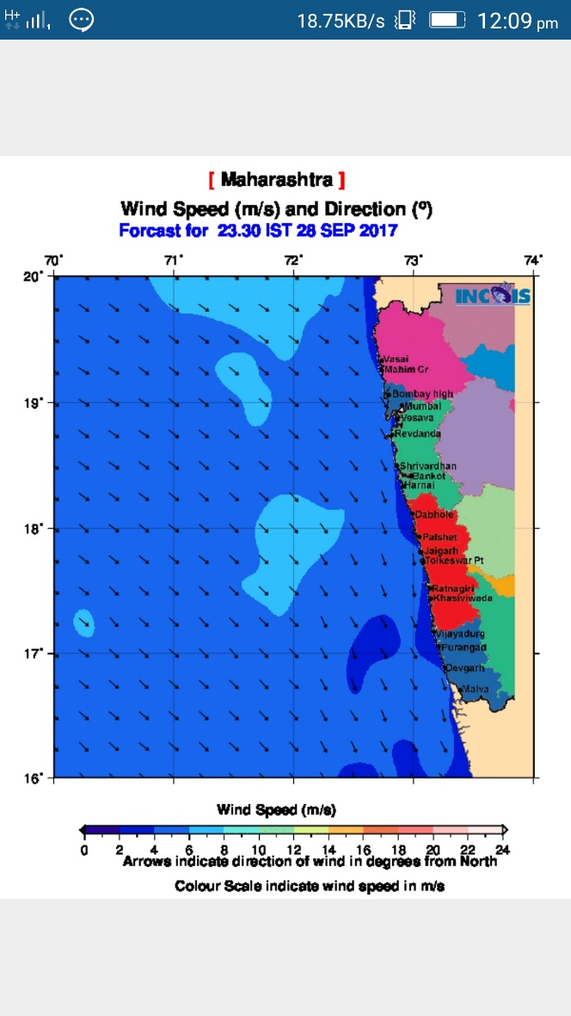

Figure 3. Screen from app, showing wind speed danger areas

Designer [interpreting what the fisher is saying]: *so here is this where his experience [fisher’s] and the information match, and that is why his confidence in the app is there…*

Researcher: *and then what happens?*

Designer [interpreting what the fisher is saying]: *and he actually calls those people and say don’t go, and the people who are already gone, they started to ....they were called on the wireless radio and asked to come back.*

Researcher: *how much money did you save by that?*

Designer [interpreting what the fisher is saying]: *so they think it was a loss, because they had to come back without fish, but at least the boats were saved.*

Designer: *also fifty people did not go so that is a saving, correct?*

In the excerpt above, the TATA designer explains how the fisher uses the wind speed information to warn his colleagues not to go fishing if the wind is too strong or coming from the wrong direction, and how this functionality saves the boats from damage. Fishers do have opinions and feedback to the designers, as can be seen below when a fisher, the TATA designer and researcher discuss the bottom bar in fig. 3.

*Designer: this is good info, he [fisher] is saying that the index shows meter per second and it should be km/hour.*

*Researcher: so you [TATA designer] will change that?*

*Designer: yes.*

The designer/translator who is from TATA acknowledges that the fisher has a point about the format of the wind speed, and says that the designers will change that.

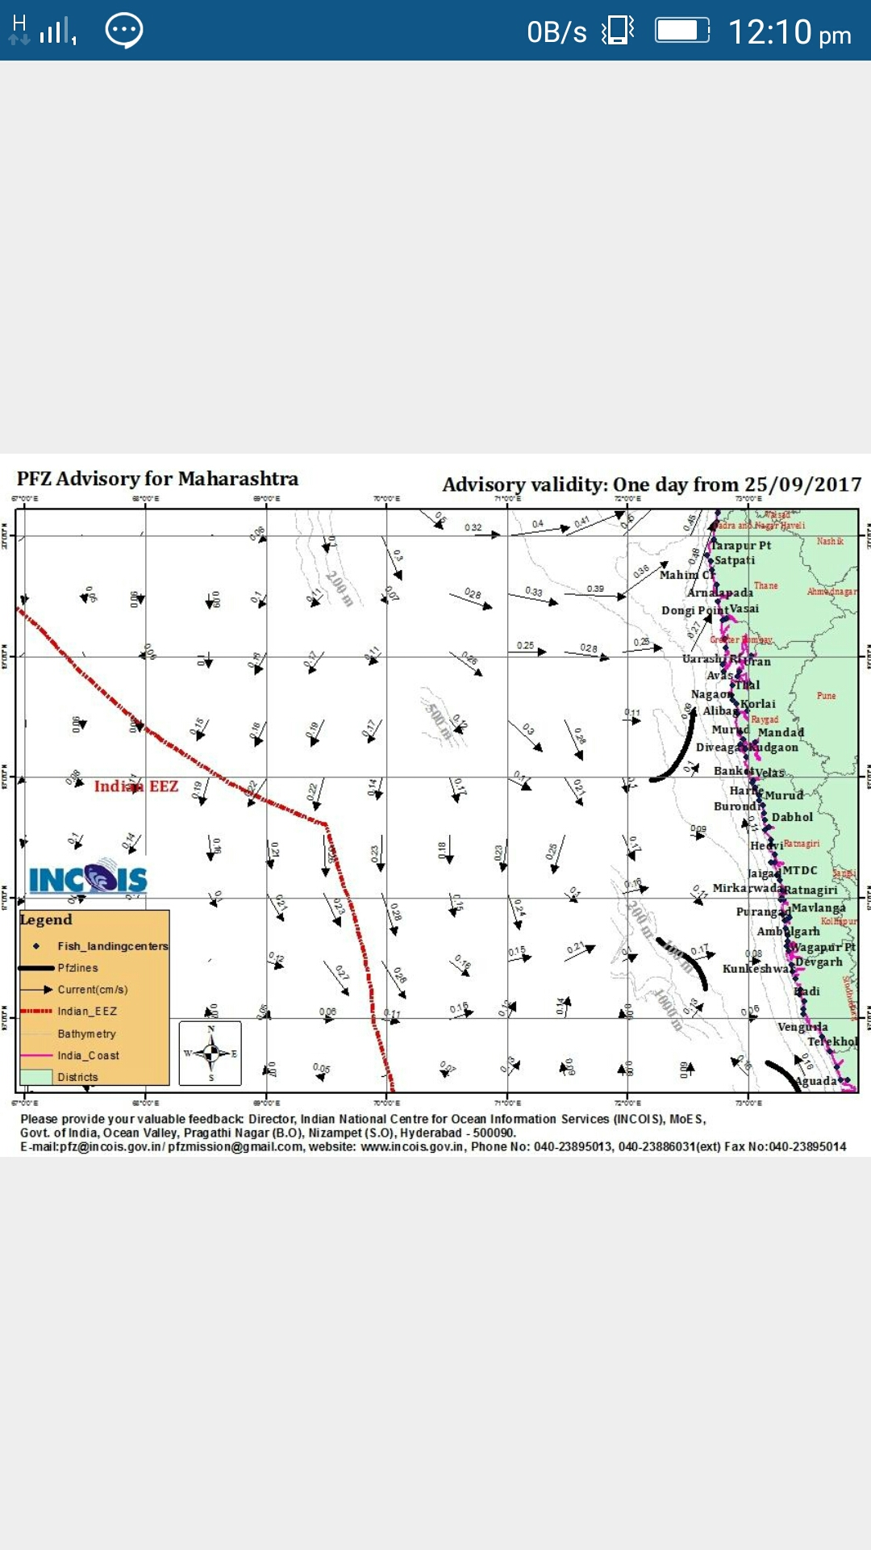

Figure 4. Map showing the location of fish

The key important service, however, is shown in figure 4. The location of fish is marked by thick curved lines, each illustrating a probability band that there will be fish in this km-wide zone. The map is based on a satellite photo from the day, which captures the color, i.e. the amount of plankton [fish food], and the temperature of the water, and uses this to infer the amount of fish in each square of the map. Then the squares with most fish are marked to make it easy for the fishers to find the fish location of the day.

Designer [interpreting what the fisher is saying]: *this is a different service, this map shows potential fishing zones, where the fish are....you can go and catch fish everywhere but the marking shows more fish there.*

Researcher: *how much trust do you have in this service?*

Designer [interpreting what the fisher is saying]: *confidence...approximately 70%, minimum*

As the excerpt illustrates the fishers has great confidence in this fish location service. However, it is not entirely clear to the fishers how this is calculated:

Researcher: *another thing, so if we look at this [the line showing the location of the fish], how is this calculated? how does he think it is calculated, what is his mental model?*

Designer [interpreting what the fisher is saying]: *so he says [Fisher] the only thing he knows is that he does not know how it is calculated.*

Researcher: *can you ask him to guess?*

Designer [interpreting what the fisher is saying]: *he says that probably they understand the environment in which the fish lives, and environment information can tell where the fish is - which is actually right*

Researcher: *so ask him where the scientist get the information about the environment from.*

Designer [interpreting what the fisher is saying]: *he cannot, does not know.*

So, not surprisingly, the basic wind speed service in Figure 3 is understandable by the fishers and quite useful, while the more advanced algorithm behind the fish location service is less understandable though it is still trusted to a high degree.

## 4.1 Human Work: Related findings

The meeting with the fishers’ association, see figure 5, revealed the key role of this organizational body in the fishers’ use of the ICT solution. The fishery association distribute the diesel to the boats, and in other ways is the central coordinating and support body. The discussions were mediated by Dr. Singh, the scientist and project lead from CMFRI, who also took the role as translator between the fishers and the researchers..

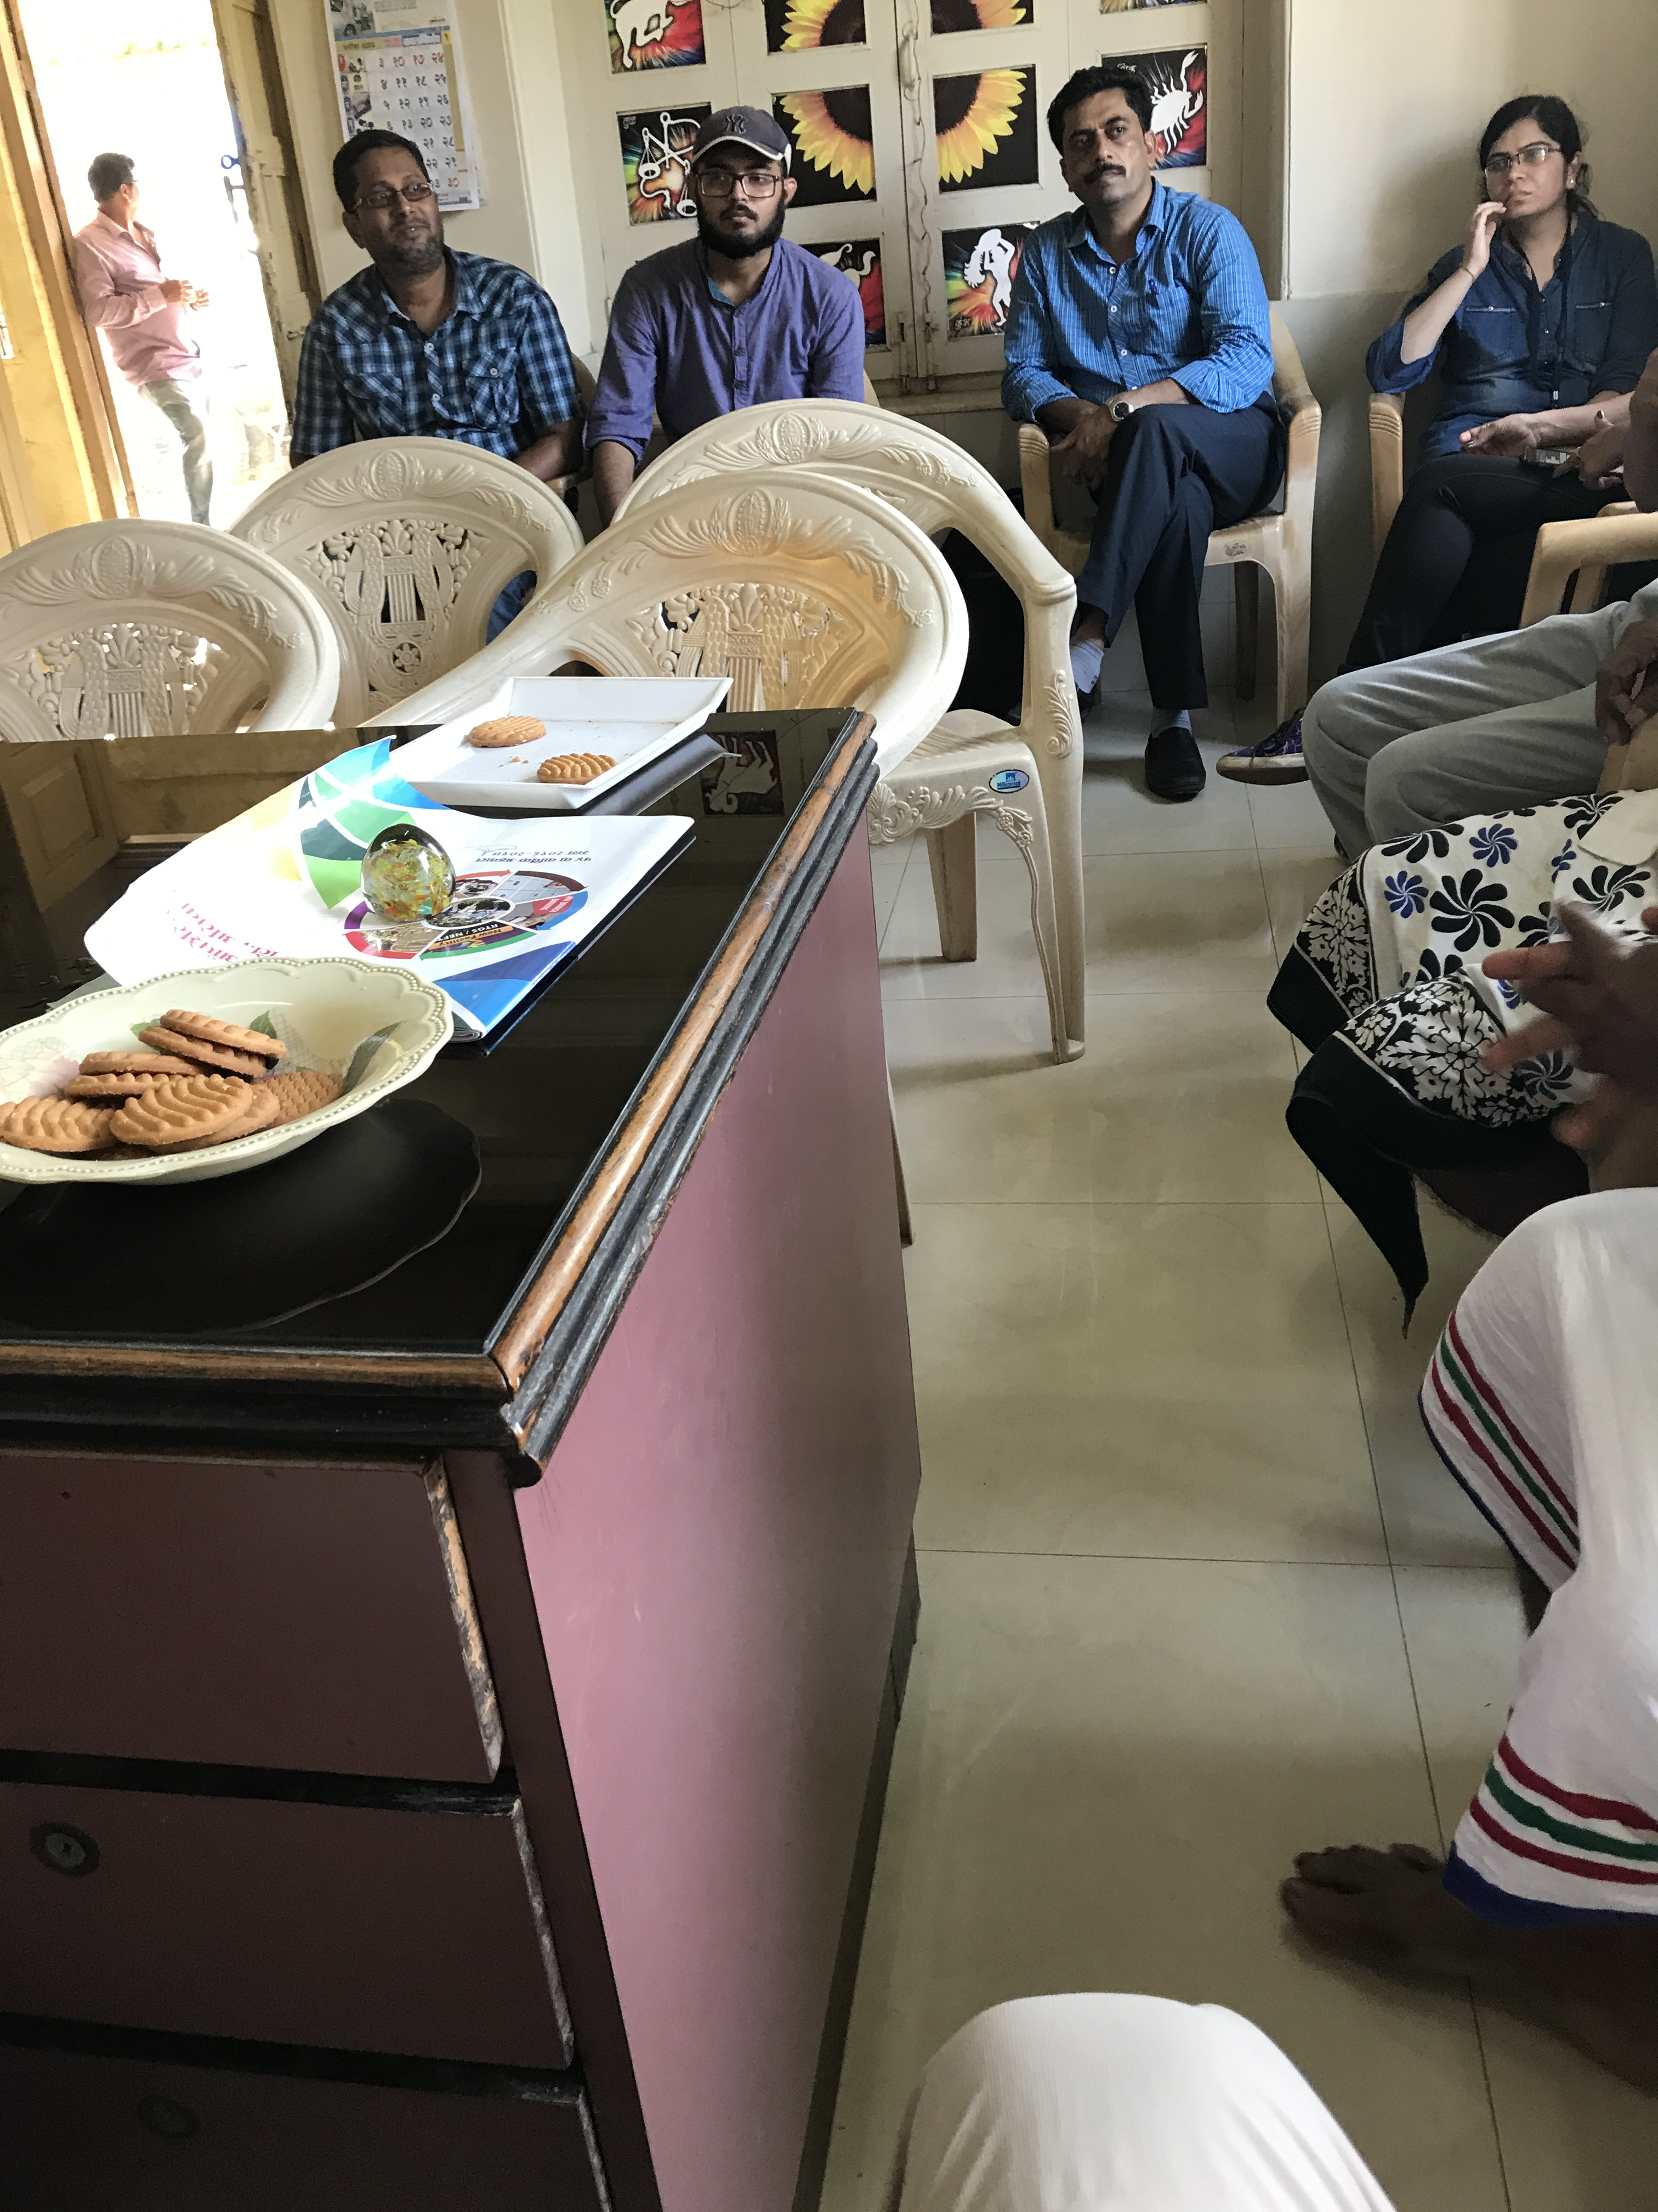

Figure 5. Photo from meeting in fishers association, Alibaug

Researcher: *how many people come here every day?*

Project lead scientist [interpreting what the fisher is saying]: *100 people come every day, but there are 300 in total, some are at sea.*

Researcher: *what do they do when they come here?*

Project lead scientist [interpreting what the fisher is saying]: *they get the diesel, they are given the diesel, the government diesel*

Researcher: *in a carry on can?*

Project lead scientist [interpreting what the fisher is saying]: *in a drum, and that drum they carry to sea, so when they are at sea, they can add more diesel*

Researcher: *diesel is cheap?*

Project lead scientist [interpreting what the fisher is saying]: *government of Maharashtra subsidize the diesel, 8 rupees per liter, so if market price is 60 rupees, they will get it for 50 [something] rupees.*

The above excerpt shows how the society has a key role in the everyday practice of the Alibaug fishers. However, the society also acts as the interface between fishers and the larger society, represented by the designers from TATA who need data for their research, and the state government who needs someone accountable for the support they provide to the fishers. This is illustrated in the next excerpt.

Project lead scientist: *and that is why it was very easy for us to know the consumption, number of boats, how much diesel each boat consumed, before our app and after.*

Researcher: every fisher gets the same amount of diesel or it depends on the size of the boat?

Project lead scientist [interpreting what the fisher is saying]: *yes, size of the boat, or rather, how many cylinders is there [in the engine], so a small boat has one cylinder, a little bigger has two cylinders, so according to that, they [the association] decide the amount of diesel.*

Researcher: *are all fishers always honest, they never cheat and say I have two cylinders?*

Project lead scientist [interpreting what the fisher is saying]: *largely - because these societies have been founded in Maharashtra, based on [name] movement. these societies are unique in Maharashtra and in the country. This society is 70 years old (…)they spend the money from the society, and then twice a year, they get the money from government. They maintain a 100% record.*

As the excerpt illustrates, the fishery society distributes diesel across boats. The diesel is cheap due to specific government support. In fact, it turns out that nobody in the fishery community pays any taxes to government. The app plays a key role in the optimum use of diesel as fishers will welcome any information about good areas to fish. However, this also disrupts to some extent the previous division of labor and fishing knowledge between small and big boats, and potentially undermines the competitive advantage of certain fishers, who were better at finding fishing spots without the help of the app.

Taken together, the fishers’ trust in the fish location algorithm and the key role of the fishers’ society in providing information to the TATA ICT designers may indicate that though the initiative by researchers to support the fishers is based on deep knowledge of fishers’ practices, the app solution places more emphasis on the introduction of new practices, than on the support of existing individual fishers’ subjective view of their world and previous knowledge. This requires a sociotechnical effort to also ‘redesign’ the social system by trying to mitigate or rearticulate some of these potentially negative effects. This could be done through helping to change the value systems underpinning fishing practices in these communities as well as co-designing new rules of engagement between all stakeholders involved in the fishing support service.

5 Overall Objectives

In summary, the overall objective of this paper was to hint at a possible sociotechnical HCI framework, customize value propositions, and present cases, to enable discussion of:

* how can we describe users without attempting to stereotype badly?
* what sociotechnical HCI methods fit the local societal context?
* how to make the design sustainable in face of current planetary challenges (e.g., climate change)?

One of the answers that the cases may support is to see service design’s backend issues as the *social* side of HWID, and the frontend issues as the *technical* side of HWID.

The Alibaug fishers case study surely provided another case study where we can explore how service design could be adapted, through the sociotechnical lens of HWID, to articulate ethical issues of value exchange. In this case study it is highlighted how a focus on the frontend use and experience of the service provided by the app could overlook delicate and tacit social and cultural backend arrangements. Given the *context-sensitivity* of the framework, both sides and their interrelations should thus be considered as a design platform that is executed and valorized from within the local context. This is what we hoped to illustrate with this paper.

References

1. Gardien, P, Djajadiningrat, T, Hummels, C, Brombacher, A: Changing your hammer: The implications of paradigmatic innovation for design practice. International Journal of Design. 8(2) (2014).

2. Abdelnour-Nocera, J., Nielsen, L., Anand, P., Gasparini, I., Bitso, C., Trevisan, D., Christensen, L., Hounsell, M., Money, A.: Service Design and Innovation ‘at the Margins’ in Resource Constrained Environments. In: EDTPD’17 Workshop. , Troyes, France (2017).

3. Clemmensen, T.: A Human Work Interaction Design (HWID) Case Study in E-Government and Public Information Systems. International Journal of Public Information Systems. 2011, 105–113 (2011).

4. Cabrero, D.G., Winschiers-Theophilus, H., Abdelnour-Nocera, J.: Re-Conceptualising Personas across Cultures: Stereotypes, Archetypes and Collective Personas in Pastoral Namibia. In: Cultural Attitudes Towards Technology and Communication. pp–35. http://philo.at/ocs2/index.php/london16/catac_16/paper/viewFile/332/101 (2016).

5. Blomkvist, J., Holmlid, S.: Existing Prototyping Perspectives: Considerations for Service Design. In Proceedings of the Nordes’ 11: The 4th Nordic Design Research Conference, Making Design Matter, 29-31 May Helsinki, Finland (2011).

6. Holmlid, S.: Interaction Design and Service Design: Expanding A Comparison Of Design Disciplines. Nordes, 2 (2009).

7. Sanders, E. and Jan Stappers, P.: Co-creation and the new landscapes of design. Co-design 4, 1: 5–18 (2008).

8. Kensing, F. Simonsen, J., Bødker, K. and Ueno, N.: Participatory IT Design–an exemplary case. Journal of the Center for Information Studies 5, 3 (2004).

9. Leibowitz, B. and Bozalek., V.:Access to higher education in South Africa. Widening Participation and Lifelong Learning 16, 1: 91–109. <https://doi.org/doi:10.5456/WPLL.16.1.91> (2014)

10. Murray, M.: Factors affecting graduation and student dropout rates at the University of KwaZulu-Natal. South African Journal of Science 110, 11–12: 1–6 (2014).