Desert/Oasis: Interruption and Continuation
Matilde Nardelli

While the presence of oases in deserts has historically been a crucial factor in their accessibility, much of the popularity of both is owed to their circulation as images. The cultural visibility of deserts, and their oases, received a great boost in the wake of the diffusion, from the second half of the nineteenth century onwards, of those media that Walter Benjamin famously described as of ‘mechanical reproduction’. Surely, deserts and oases had been turned into ‘pictures’ before photography and cinema, but it is with these media that the production of such pictures achieved mass proportions. With photography and cinema, pictures of deserts and oases could not only be ‘captured’ – taken, as one tends to say of a photographic image, rather than made, like a painting – but they could be reproduced in multiple copies and circulated more widely than ever before. In this respect, these media contributed both to the revelation of deserts and oases and their crystallization into images.

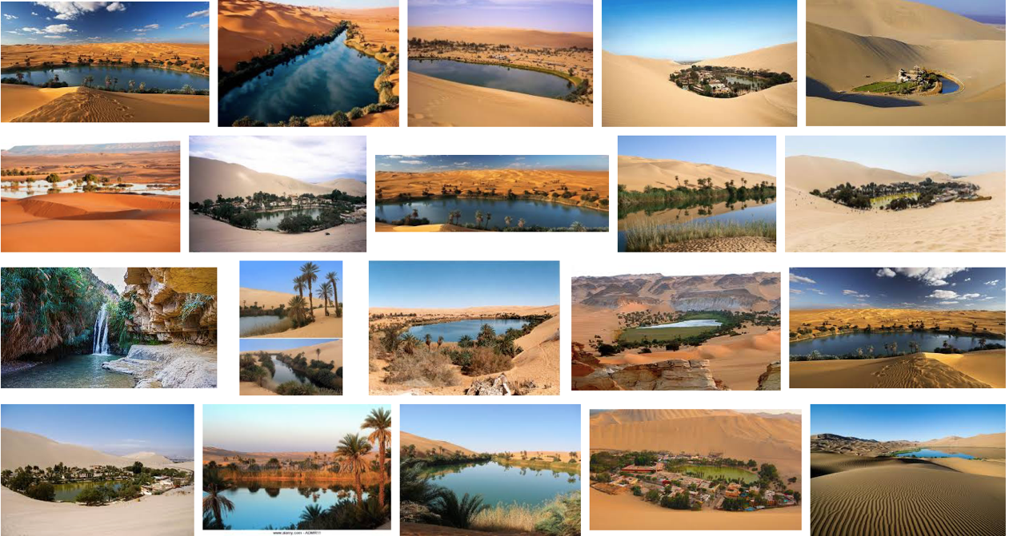

Fig. 1 Some Google-images ‘oases’ London, UK, 13th January 2017
In the digital present, thousands of images of desert oases can effortlessly be made available on the screens of our devices: from photographic images, whether retouched or not, to computer-generated renditions, such as the brief 3D animations available for purchase on sites such as Shutterstock, a seemingly endless grid of thumbnails can be produced almost instantly in front of our eyes. Orange-beige sand dunes, a light- or dark-blue water feature, and a more or less abundant patch of green vegetation, with or without palms, feature regularly, if not inevitably, for a long way down the grid of results. Many these images may be, yet their visual and formal repertoire appears to be relatively modest. Yet, the visual repetitiousness of these vernacular, stock images of oases helps to bring into relief the conceptual core of ‘oasis’ itself.

Though the oasis is inextricable from the desert, the desert itself is what the oasis seemingly negates or opposes. Inextricable from it, the oasis is also an interruption of the desert. To think of the oasis is to think of the desert and respite from it. The oasis offers an alternative, if not an otherness, to what the desert is: a space of suspension of the desert, where the desert is put ‘on hold’, within the desert itself.

Possibly one of the most compelling articulations of the thrust of oasis as ‘interruption’ can be found in Michelangelo Antonioni’s 1964 film Il deserto rosso (Red Desert) – perhaps, indeed, because both oasis and desert are mobilized conceptually. One of the titles Antonioni contemplated during production was The Desert and the Oasis and, on watching the film, the ‘desert’ invoked by the title is revealed as the newly industrialized landscape of Northern Italy – primarily, the polluted industrial area and the wastelands around the port of Ravenna, where refineries and petrochemical plants were erected in the course of the 1950s – which constitutes the setting of most of the story. More than halfway through the film, however, this drab landscape is briefly replaced by something radically different: the fine-sand beach, with lush green vegetation and crystal-clear water, of the sequence shot on the island of Budelli. This is a small island off the northern coast of Sardinia, which, a private property until recently (Red Desert’s opening credits thank the then owner), is now part of the National Park of the Archipelago of La Maddalena. As the visualization of a fictional story the protagonist (Monica Vitti’s Giuliana) tells her son, this is the ‘oasis’ that interrupts and offers respite from the ‘desert’ of the rest of the film.

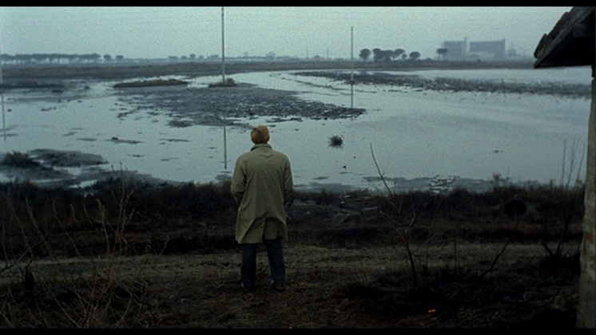 | 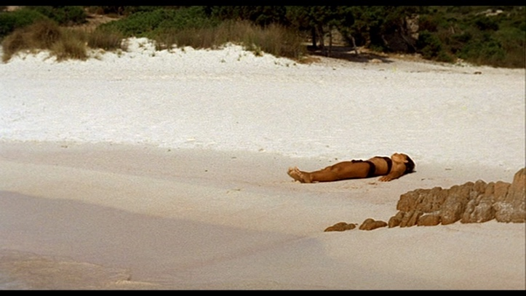
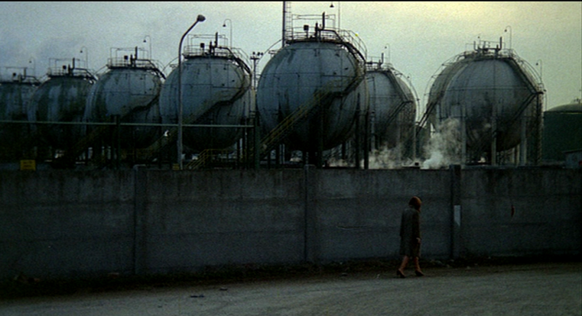 | 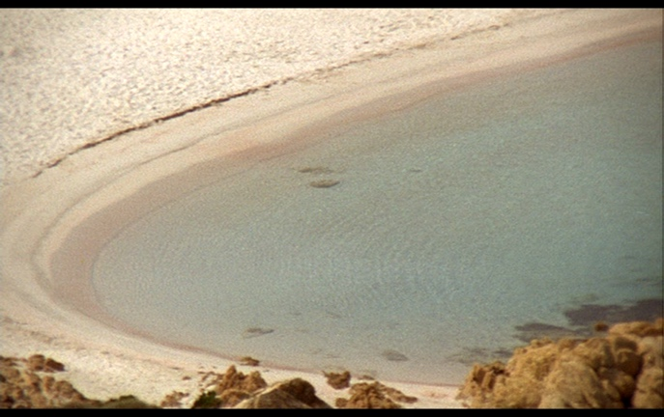
Figs. 2-5 Michelangelo Antonioni, Il deserto rosso (Red Desert, 1964): oasis as interruption

Yet, the oasis of Budelli and its ‘Pink Beach’ is also, in turn, itself a kind of desert: an uninhabited island in the story within the story presented in the film as well as in reality, to which access, as a protected natural landmark, is restricted and controlled. From this perspective, while the inextricability between oasis and desert remains, the sense of an opposition or antithesis between them appears more ambiguous. Is a desert island a desert or an oasis?

Perhaps, considered through this lens, the oasis emerges not so much as an interruption or suspension of the desert, but rather as a modulation, continuation, or even reproduction of it. A few years after Antonioni’s Red Desert, at a time of renewed and intense cultural visibility of the desert, a number of artists begun introducing some subtle alternative or counter-images to the dominant oasis imaginary. The ones that interest me most are those in which the distinction or opposition between ‘desert’ and ‘oasis’ becomes increasingly subtle, to the point where the two may seem to converge, super-impose or not be clearly discernible from one another. This is perhaps most apparent in Ettore Sottsass’s photographic series Metaphors (1972-1979), many of which feature deserts, including, in the earlier photographs, the less obviously iconic ones in the southern regions of Spain, such as in Almería. In Sketch for a Door to Step into the Shadow (1973), via the makeshift door made of palm fronds, the oasis is adumbrated – perhaps, literally so, presented as that where ‘a shadow is cast’ – as an area within the desert which is only marginally different from the rest of the desert itself (Fig. 6). Perhaps the oasis is ‘made’ by the minimal architectural intervention of Sottsass himself, as in other Metaphors in which it is outlines of human architecture that mark and suggest the spot of an oasis (Fig. 7). For me, these images work as a deceivingly simple de-naturalization of the dominant oasis imaginary, as well as an invitation to reflect on the shifting boundary between desert and oasis, as both are subject to the now more inextricable than ever combination of the anthropogenic and the natural: deserts and oases may be ‘found’, but they are also made, and preserved or maintained as well as destroyed.

Lastly, thinking that in the same period between the late 1960s and the mid-1970s, as some of his drawings suggests, Sottsass himself was imagining overtly artificial and constructed oases in deserts landscapes, while also, at the same time, calling for the bringing of the ‘desert’ within architecture as an oasis, I would like to conclude with Alice Aycock’s 1971 installation Sand/Fans (1971) (Fig. 8), which brought the desert indoors, as an oasis in the architecture, while also, via the interventions of the electrically produced air currents continually shifting the sand, inviting an understanding of these interrelated categories in terms of continuous processuality and change.

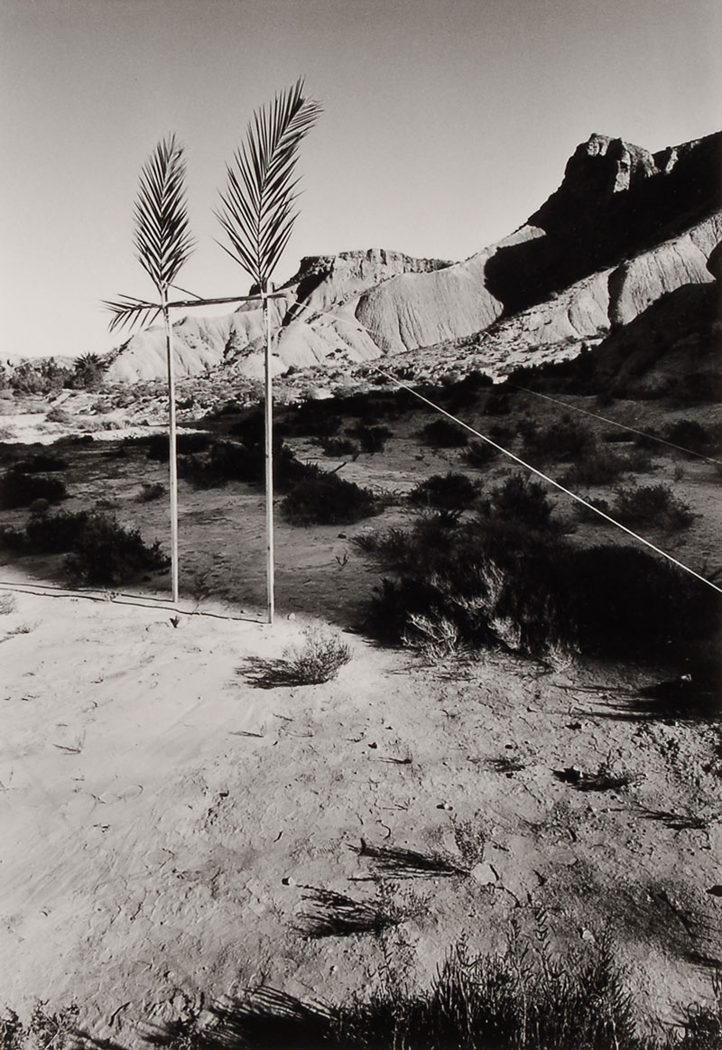
Fig. 6 Ettore Sottsass Jr, Disegno di una porta per entrare nell’ombra (Sketch for a door to step into the shadow), Aigua Brava, 1973 – from the series Metaphors (1972-1979): oasis and continuation.

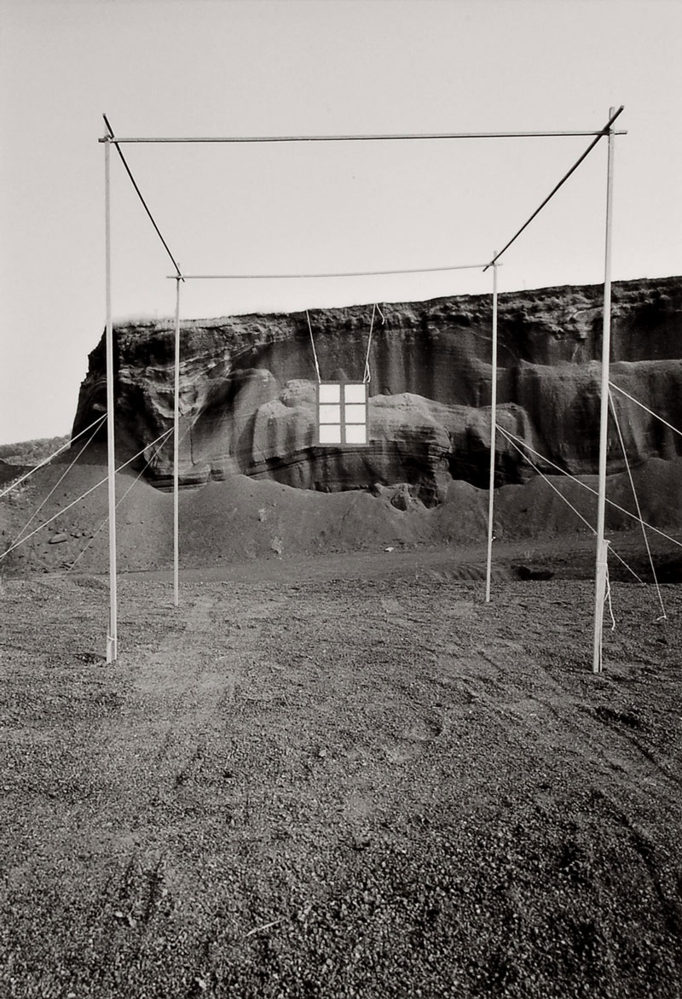
Fig. 7 Ettore Sottsass Jr, Architettura Virtual (Virtual Architecture), Seo de Urgel (1973).

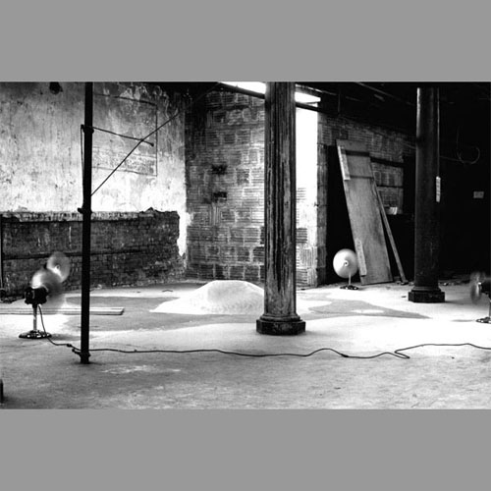
Fig. 8 Alice Aycock, Sand/Fans (1971). Installation: Sand, four industrial fans. Approximately 20' square. (Four industrial fans placed opposite each other and equidistant from a center pile of sand. The fans were turned on and left on during the time in which the piece was shown. The distribution of the sand depended on the distance of the fans from the center. The canceling out process of air currents moving against one another kept the sand moving within one general area. Finally, the pile of sand became so low that most of the air passed over it.)

Rebecca Lawton, ‘Midnight at the Oasis’, Aeon, 6th November 2015 < https://aeon.co/essays/palm-trees-amid-the-sand-the-origins-of-the-oasis-fantasy > (accessed 10th January 2018).
Walter Benjamin, ‘The Work of Art in the Age of Mechanical Reproduction’ (1936), trans. Harry Zohn, in Illuminations, intr. Hannah Arendt (London: Fontana Press, 1992), pp. 211-244.
Ironically, and famously, this sequence shot on Budelli’s ‘Pink Beach’ is the only one for which, unlike in the rest of the film, no coloured lens filters – or, even, paint applied on the physical landscape – were used to obtain the hues Antonioni desired. The sand is actually pink, though the colour registered only very faintly on Technicolor film stock. Contemporary pictures shows the pinkness more vividly. See e.g. Silvia Marchetti, ‘The Battle for Italy’s Pink Island’, < http://www.news.com.au/travel/travel-ideas/adventure/the-battle-for-italys-pink-island/news-story/0810490d4f6d9c577097196742586c08 > Accessed 15th Jan 2017.
See e.g. Tom Holert, ‘Political Whirlpools and Deserts: Michaelangelo Antonioni, Robert Smithson and Michael Snow’ now available at < http://www.medienkunstnetz.de/themes/art_and_cinematography/deserts_of_the_Political/print/ > Accessed 24th January 2018, and my ‘No End to the End: The Desert as Eschatology in Late Modernity’, Tate Papers 22 (Autumn 2014), < http://www.tate.org.uk/research/publications/tate-papers/22/no-end-to-the-end-the-desert-as-eschatology-in-late-modernity > .
See Milco Carboni and Barbara Radice, eds., Metaphors – Ettore Sottsass (Milan: Skira, 2003).

