**An Integrated RF and Ambient Magnetic Field Approach for Indoor Positioning**

Weiwei Zhang,1 Zhao Dong,1 Congcong Zhang,2 and Xinheng Wang3

*1 Anyang Institute of Technology, Anyang, Henan province 455000, China*

*2 Alcatel-Lucent Shanghai Bell Co., Ltd., Nanjing 210037,*

*3 University of West London，London W5 5RF, UK*

**Abstract:** A new technology for indoor positioning is proposed in this paper by applying combined RFID (Radio Frequency ID) / IRID (Infrared ID) and spatial fluctuations of the ambient magnetic field. Due to the presence of interior reinforced concrete construction, furniture, electronics and other indoor subjects, the distribution of the magnetic field intensity is fluctuated. Based on the spatial fluctuations, a particle filter algorithm can be employed to locate the indoor target. However, the computation power required for positioning in a large area could be very high because of the complexity of the application of the particle filter. Similar patterns of magnetic field in large area could also result in wrong location. Because of the short and tunable radiating range of the RF signal and the short response time of identification signal, the target may be positioned within a certain range by using RFID. Therefore, RFID/IRID positioning technique is introduced to approximate the position of the target and then particle filter is applied for precise positioning in the range of RFID/IRID signals. This can effectively reduce the number of required particles to carry out the particle filter algorithm, thereby reduce the amount of computation power, reduce the response time of the positioning and improve the accuracy of the estimated target position.

**Keywords:** RFID/IRID; ambient magnetic field; particle filter; indoor global positioning

## 1. Introduction

Current location positioning methods are broadly classified into three categories, Cell of Origin (CoO), trigonometric and pattern matching/fingerprinting. These three categories have advantages and disadvantages. CoO [1] is simple. If a signal is only received from one cell, the location is determined by the location of the cell. No mistake could be made. However, if signals are received from multiple cells, because of multipath effects, sometimes stronger signals are received from farther cells rather than the closest one, which would make the wrong decision of the real location. Accuracy is not its strength either. Trigonometric method [2] is a relatively accurate positioning method. The challenge for this method is to determine the accurate distance or angle from the reference points. On top of this, a large number of reference nodes must be deployed to overlap the coverage of the interested area to enable the positioning, at least two for triangulation and three for trilateration. This increases the chances of signal interference and collision, and thus reduces the accuracy of positioning and, sometimes, makes positioning impossible. It also increases the cost, including devices cost and labor cost to deploy them. In some places, the deployment of location node is impossible, which makes this method unable to work. Fingerprinting [3] solves the positioning accuracy problem of CoO. However, this method depends on enough information to be acquired. If the object is moving and the coverage of the cell is small, it is difficult to find the right position either.

Previously in order to reduce the cost of using positioning devices and installation of these devices, and also reduce the interference to existing communication system, a magnetic field based positioning method was proposed [4]. A key advantage is that it doesn’t need to install any location tags to transmit signals. On top of this, a simultaneous localization and mapping method based on magnetic field is also proposed for practical applications [5] and some interesting phenomena were discovered [6]. The localization method is particle filter based probabilistic localization.

Probabilistic localization is a popular approach for localization based on the measurement of magnetic field, as well as measurement of radio signals, i.e., localization in wireless sensor networks [7-8] . However, in order to successfully implement the probabilistic localization technology, two key challenges must be addressed. First challenge is the prior of probabilistic is known. That is to say that the initial location is known. Second challenge is the computational complexity. The complexity affects the real-time applications.

In this paper, a new combined positioning method is proposed, which uses pre-deployed, previously developed, RFID/IRID location tags [9] and magnetic field. The purposes are to provide a prior location for magnetic localization, to reduce the computational complexity, and to increase the accuracy of localization.

The rest of the paper is organized as below. Section 2 describes the key techniques and algorithms to achieve a combination of RFID and ambient magnetic field. Experimental results are presented in Section 3. It demonstrates that a more accurate location could be determined even faster by the combined method. Lastly this paper is summarized in Section 4.

## 2. RFID combined with the Earth's magnetic field

RFID [10] is a signal-emitting source from a tag. Within a certain distance from transmitter, the receiver can receive the signal with certain strength [11].The advantage of RF is its non-contact operation, convenient applications, good sensitivity, environmental adaptability, safety, and the information on the RFID tags can be repeatedly modified. However, RFID also has its disadvantages [12]. Because of fading, the RF emitted signal strength is not decreasing linearly, it will cause huge errors to determine the position from a mobile object. In addition, the positioning accuracy of the system is determined by the positions of the reference tags. In order to improve the positioning accuracy the system needs to increase the density of reference tags, but higher density will cause a greater interference affecting the signal strength. Calculating the distance between the reference tags and pending object by Euclidean distance will need a greater amount of computation power.

Figure 1 illustrates the RF operating principle for determining a location:

Figure 1. RF working scheme

Because of the interference from RF tags and readers, there might cause tag collision, reader collision, and also tag and reader collision. The collisions may disable the RFID system working if large number of tags and readers deployed. To solve this problem, an infrared ID (IRID) system was introduced in previous work [13]. Infrared ID complements the RFID system whenever collision occurs and makes the CoO localization available anytime and accurate. This guarantees the accuracy of priori for magnetic based localization.

To use IRID is an engineering solution to tackle the collision problem. More fundamental research work has been done by other researchers to address this issue, including application of multiplexed antennas [14] and antenna array [15]. The collision problem under dynamic environments was also investigated [16], where some insight views were proposed. All these research work has paved the way to using RFID in complex environments, however, there are not the focus of this paper and further details will be skipped.

Within the walking distance of people or vehicles, the magnetic field at the Earth's surface change very small, almost negligible [17], so compass instrument may determine the orientation in a corresponding position. But in the indoor environment, reinforced concrete structures and appliances will greatly affect the distribution of the geomagnetic field and make the distribution fluctuate spatially. Therefore, the fluctuations in the magnetic field could be used to achieve the indoor positioning. Currently, researchers only use the fluctuations of the ambient magnetic field to achieve two-dimensional positioning of a mobile target [17]. Most of the studies are based on the particle filter algorithm and the positioning accuracy is not high. If a higher accuracy needs to be achieved, the higher complex algorithm must be used, which increases the computation time and makes the real-time application impossible. Therefore, the computation power and time need to be reduced to achieve the target of real-time applications.

Fig. 2 displays the distribution of a magnetic field in one specific area. The strength of the field is rather stable and unchanging if indoor furniture doesn’t move.

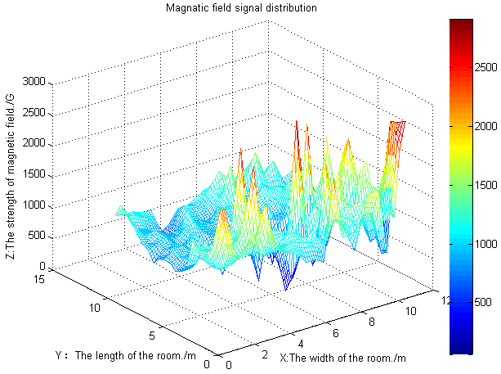

Figure 2. Indoor fluctuation of geomagnetic field intensity profile

The approach to reduce the computation power and time proposed in this paper is the application of combined RF, RF and Infrared also is possible, and magnetic field. This combination has several purposes. First the rough position from RF technology gives a priori location for localization based on measuring magnetic field by using particle filter method. Second, the area enclosed by the RF radiation limits the global localization for the magnetic field in whole area into a small circle, while reduces the number of samples for particle filter and thus reduces the computation time. Third feature of the magnetic field may, on the other hand, help identify the right RF node whist receiving signals from multiple ones.

Positioning process in this paper is divided into two stages. In the first stage, it uses the distribution of RF signals and applies nearest neighbor [18] method to determine which RF tag that moving object receives the signals from. This will narrow the positioning area from global area into a small one. In the second stage, the measured magnetic fluctuations are used to accurately determine the location of the moving object based on particle filter algorithm in the range of the area obtained from the first stage. The flowchart described in Fig.3 illustrates the whole procedure.



Figure 3. The algorithm flowchart

## *2.1 RF positioning method- Nearest Neighbor algorithm*

Nearest Neighbor [18] is the easiest and fastest method to be implemented in this scenario to locate the RF tag.  Generally, the algorithm only provides information about the relative position of the target. The RF location tags will be deployed in advance and therefore the position of each tag is known to the system. Therefore, when the target is moved to the vicinity of a transmitter, the receiver will receive the signals from that tag/transmitter and be aware of the approximate location of the target. If the targeted user can simultaneously receive signals from several transmitters, the location of the target can be determined by comparing the received signal strength.

The algorithm is based on the following theory. For a $C$ category problem, every class has ${ N}_{i} (i=1,2,…,C)$ samples, the discriminant function of the class $i$ belongs to ${ ω}_{i}$ is:

$g_{i}\left(x\right)=min\left|\left|x-x_{i}^{k}\right|\right|,k=1,2,…, N_{i}$ (1)

where $\left|\left|∙\right|\right|$ denotes certain distance (similarity) measure, $x$ is the base received signal strength of the moving object and $x_{i}^{k}$ is the received signal strength of the moving object from tag $i$. Usually Euclidean distance is used as a similarity metric. Decision rule is:

$if{ g}_{j}\left(x\right)=min{ g}_{i}\left(x\right) then x∈ω_{i}$ (2)

But the nearest algorithm error rate is higher than Bayes error rate. The general relationship is:

$$P^{*}≤P≤2P^{*}$$

where $P^{*}$ is the Bayes error rate and $P$ is the nearest neighbor algorithm error rate.

Nearest Neighbor is easy to be implemented and its hardware requirement is low, so in some situations where low positioning accuracy is required, this method is very suitable. In this paper, the received signal strengths are compared. The maximum signal strength where the tag with an ID radiates is considered as the coarse positioning range of the current target.

## *2.2 Indoor magnetic positioning - Particle Filter*

Generally Bayesian estimation for ambient magnetic indoor positioning is known to have two stages: prediction and update [19]. The ultimate goal of the estimation is to strike the updated value which is the posterior probability density of the target state. Therefore, the ultimate aim of particle filter is also to strike posterior probability density target state. Bayesian analysis is defined as the following:

Supposing at time *t* discrete system’s state transition equation and observation equation can be expressed as：

$\left\{\begin{aligned}x_{t}=f_{t}（x_{t-1}，v_{t}） \\ y_{t}=h_{t}(x_{t},z_{t},w_{t})\end{aligned}\right.$ (3)

where ${ f}_{t }$ is transfer function of state $x_{t-1}$ at time *t*, $\left\{v_{t},t∈N\right\}$ is the measurement noise, on behalf of the uncertainty of state transition, $h_{t}$ is the observation function of $x_{t}$ state at time *t*, $\left\{w_{t},t∈N\right\}$ is the observation noise which represents the measured value and the actual value of the error. In this paper, $x_{t}$ represents a moving target’s position and orientation coordinate state at time *t*, $z_{t}$ represents the RF signal strength and the geomagnetic field value of the target that are detected by the receiver and sensor at time *t*.

According to Bayesian theory, supposing that we know the initial distribution function $p(x_{0}|y_{0})$. Due to the random distribution of the target initial position, the random distribution represents the initial distribution. According to Chapman - Kolmogorov equation [20] and assuming that the system is a first-order Markov process, we can get state prediction equation as:

$p\left(x_{t} | z_{1:t-1}\right)=\int{p\left(x_{t}|x_{t-1}\right)p\left(x_{t-1}|z_{1:t-1}\right)dx_{t-1}}$ (4)

After obtaining the measurement $z_{t}$ at time *t*, we make use of Bayesian to update state predictive value. The status update equation is:

$p\left(x_{t} | z_{1:t}\right)=\frac{p\left(z_{t} | x_{t}\right)p\left(x_{t} | z_{1:t-1}\right)}{\int{p\left(z_{t}|x_{t}\right)p\left(x_{t}|z_{1:t-1}\right)dx_{t}}}$ (5)

It can calculate the posterior probability density of targets, and the iterative recursion relations constitute Bayesian estimation. The particle filter [21] is based on the law of large numbers using Monte Carlo Bayesian estimation algorithms to achieve the integration operation. Its essence is to use a discrete probability measure composed by random particles and their weight distribution to approximate related distribution and then update recursive algorithm based on discrete stochastic measurement.

## *2.3 Interference noise*

In the radio transmitting and receiving system, noise is the electrical signal which does not carry useful information. These noises can be classified into radio noise, industrial noise, electrical noise and internal noise depending on the source of the noise [22], where internal noise is the dominant noise that is also known as fluctuating noise. It mainly consists of the channel noise inside the device, thermal noise and noise from the space of the universe. This noise is irregular stochastic process. In order to obtain a convenient theoretical analysis, communication system generally assumes that the system channel thermal noise is Gaussian white noise. Therefore, in the RF receiving and transmitting system, we assume that the noise combines random noise with Gaussian white noise. In the study of indoor positioning based on the magnetic field, the existing literature gives the corresponding noise model [23], namely the Gaussian white noise, and this paper will directly utilize the existing simulation models. On our experiment, the geomagnetic field systems Gaussian white noise $N\left(0,σ_{B}^{2}\right)$ integrating with random noise $S\sim U[S_{1},S_{2}]$ and Gaussian white noise $N(0,σ_{R}^{2})$ of RF system noise act as the full noise.

## *2.4 Algorithm Implementation Process*

Here is the combination of algorithmic process used in this paper:

1. Initialization: The initial particles are uniformly distributed in the chamber. Where the position of the particle is ${ X}_{0}^{(i)}$, particle weight is ${ ω}_{0}^{\left(i\right)}(i=1,2,…,N_{s})$, and the number of particles $N_{s}$ is 200.
2. Importance sampling: Based on the Monte Carlo method, we use random sampling to approximate the distribution of the target function. At time *t*, according to the RF-based nearest neighbor algorithm and particle filter algorithm, the collection of particles updates from ${ X}_{t-1}^{(i)}$ to $X_{t}^{(i)}$. Within the area of rough location through nearest algorithm, we randomly sample $N_{s}$ particles, and implement particle filter algorithm to obtain a "new" particle collection $X_{t}^{(i)}$. These new estimate of particles will act as the probability distribution of the position of the object.
3. Weight calculation [24]: Weight of the particles is calculated as follows:

$ω_{t}^{\left(i\right)}=\frac{p(X_{t}^{\left(i\right)}|z_{1:t},u_{0:t})}{q(X_{t}^{\left(i\right)}|z_{1:t},u_{0:t})}$ (6)

where $p(X_{t}^{\left(i\right)}|z_{1:t},u_{0:t})$ is the true distribution, and $q(X_{t}^{\left(i\right)}|z_{1:t},u_{0:t})$ is suggestive distribution. The two distributions are not the same. The database is composed of three mesh maps that have the same size, namely $\sqrt[ 2]{H_{x}+H_{y}+H_{z}}$, $\sqrt[2]{H_{x}+H_{y}}$ and $H_{z}$, where the value of $H_{x},H_{y}$ will be changed by the direction of the sensor, but here the sensor orientation does impact reference component.

1. Normalized weights:

$ω_{t}^{\left(i\right)}={ω_{t}^{\left(i\right)}}/{\sum_{i=1}^{N_{s}}{ω_{t}^{\left(i\right)}}}$ (7)

1. Calculate the exact location of the target:

$\hat{X_{t}}≈\sum_{i=1}^{N_{s}}{ω_{t}^{i}X_{t}^{(i)}}$ (8)

1. Judgment: Determining whether the target moves or not, if it moves, it returns to step 2, otherwise stop computing.

## 3. Experimental results

We selected a space of 10 m * 10 m in the room as an experimental area, and then assigned six RF tags within this space. The distribution of Tags and Tag5 signal strength, as an example, are shown in Figure 4. Figure 4 shows that the intensity distribution of the RF transmitted signal is not linearly decreasing from the signal source, but within a certain range, the receiver can receive the signal. The strength distribution of all Tags is similar to Tag5. In order to verify the feasibility of the proposed algorithm, we used MicroMag3 magnetic sensor to measure the real indoor magnetic field in the experiment, and the sensor can measure in the horizontal and longitudinal planes, respectively ${ H}_{x},H_{y},H_{z}$. In addition, we utilize the RF receiver to detect the emitted signals from the RF transmitters. In the lab, the magnetic field was measured every 0.5 m, and totally 441 groups of data is acquired. These data acts as test reference database and was imported into the data processing unit. During the course of the measurement, laboratory personnel can’t carry any electronic product, since these electronic products can interfere the stability of the magnetic field and the space tag signal.

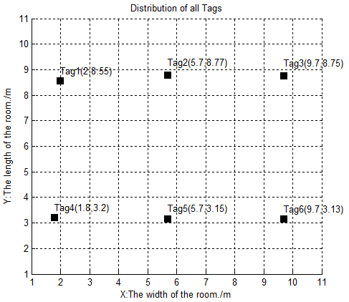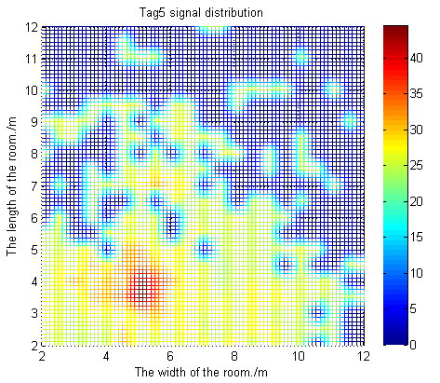

Figure 4. Tag positions in the test area and RF signal distribution of Tag5

Figure 5 shows the simulation results of algorithm implementation. The left diagram shows that the combined RF and magnetic field to realize the target indoor positioning after random-step walk. The right diagram shows the position by using only the geomagnetic field with particle filter. In Figure 5, star represents the estimated position by the algorithms, whereas red dot indicates the real position. Compared to that not using RFID to perform preliminary positioning, the proposed algorithm herein can more accurately determine the position of the moving object in the room, more effectively improve the utilization and convergence of particles, and also save time required for positioning.

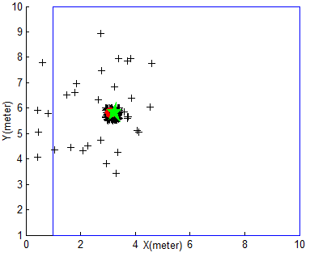

Fig. 5(a) Positioning based on RF and magnetic field

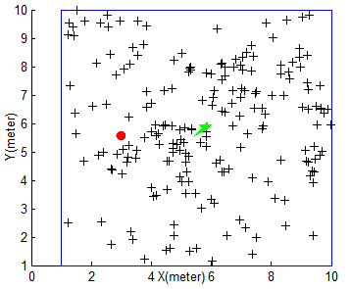

Fig. 5(b) Positioning based on pure magnetic field

Figure 5. Global Positioning indoor target simulation Results

We repeatedly simulated proposed algorithm and existing algorithm by using only magnetic field 10 times, and after the end of each simulation the object is moving two steps further. Figure 6 shows the positioning errors and also the calculation times of using the proposed method and pure magnetic field method. Form the figure, we can see that in the target global localization process, the positioning error of the mean distance from the proposed algorithm is about 0.7 m, on average, and each of the running time is about 1.8 s; However, the positioning error of the mean distance is about 3.3 m and the running time is about 2.4 s by using pure magnetic method. Therefore, the proposed algorithm in this paper reduces the average time required and obtains a higher positioning accuracy.

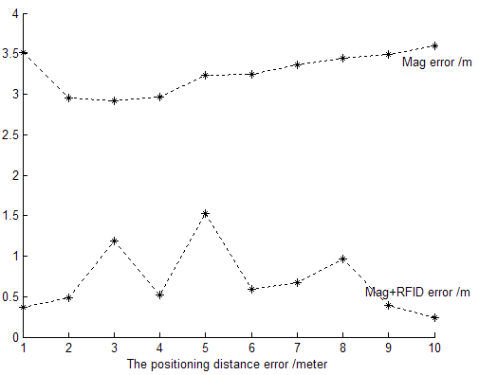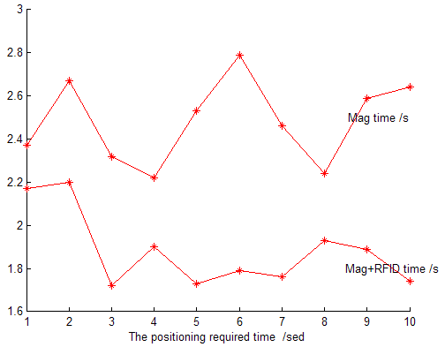

Figure 6. The comparison chart of both algorithms on positioning error and the consumption of time

The reason of the localization accuracy is improved after separating a large area into several small areas by using RFID tags, but using the same type of particle filter, is because particle filter uses the similarity between the characteristics of the environment and its target to determine the location. In a small environment, the characteristics of the environment are less, which makes the particle filter easily identify them, and thus improve the accuracy. In addition, in a large area, the similar patterns of magnetic field may appear in several parts of the map, which leads to the localization totally to a different area. By separating the large area into smaller ones, the pattern repeats in a small area becomes slim, which also increases the localization accuracy.

## 4. Conclusion

In this paper, a combined RFID with ambient magnetic field to achieve the indoor global positioning is proposed. Simulation results demonstrate the combined solution can improve the accuracy of localization and reduce the computation time. This makes a further step implemented in practice. During the development of this technique, a collaboration has been establish with a company who operates smart trolley at airports, where indoor localization and navigation is a fundamental service. The proposed approach in this paper will be implemented and tested in smart trolleys. Further experimental results will be reported in due course.

## References

[1] Chu H C, Jan R H. Cell-based positioning method for wireless networks[C]. IEEE, 2002: 375-380.

[2] Wang Y, Yang X, Zhao Y, et al. Bluetooth positioning using RSSI and triangulation methods[C]. IEEE, 2013: 837-842.

[3] Maev R G, Bakulin E Y, Maeva A, et al. High resolution ultrasonic method for 3d fingerprint recognizable characteristics in biometrics identification [M]. Springer Netherlands, 2011: 11-16.

[4] Lu X, Dong Y, Wang X. A Monte Carlo Localization algorithm for 2-D indoor self-localization based on magnetic field[C]//. IEEE, 2013: 563-568.

[5] Zhang C, Wang X, Dong Y. Simultaneous localization and mapping based on indoor magnetic anomalies [J]. Chinese Journal of Scientific Instrument, 2015, 36(1):181-186.

[6] Wang X, Zhang C, Liu F, Dong Y, Xu X. Exponentially Weighted Particle Filter for Simultaneous Localization and Mapping Based on Measurements of Magnetic Field [J]. IEEE Trans. Instrumentation and Measurement, 2017, 66(7): 1658 -1667.

[7] Zhang L, Cheng Q, Wang Y, Zeadally S. A Novel Distributed Sensor Positioning System Using the Dual of Target Tracking [J]. IEEE Transactions on Computers, 2008, 57(2): 246-260.

[8] Zhang L, Zhou X, Cheng Q. Landscape-3D: A Robust Localization Scheme for Sensor Networks over Complex 3D Terrains [C]. 31st IEEE Conference on Local Computer Networks, Tampa, FL. 2006: 239-246.

[9] Hahnel D, Burgard W, Fox D, et al. Mapping and localization with RFID technology[C]. IEEE, 2004, 1: 1015-1020.

[10] Wallbaum M, Spaniol O. Indoor Positioning Using Wireless Local Area Networks[C].IEEE, 2006: 17-26.

[11] Bekkali A, Matsumoto M. RFID indoor tracking based on inter-tags distance measurement[C]. IEEE, 2007: 1-1.

[12] Wang Y, Lin J. Indoor location Technique Based on RFID [J]. China Instrumentation, 2011(2):54-57.

[13] Chen T, Zheng C, Lan W et al. An ID Device, Identification Method and Applications[P]. China Patent CN101276403 A.

[14] Jankowski-Mihułowicz P, Węglarski M. Interrogation zone determination in HF RFID systems with multiplexed antennas [J]. Archives of Electrical Engineering, 2015, 64(3): 459-470.

[15] Jankowski-Mihułowicz P, Węglarski M. The idea of enhancing directional energy radiation by a phased antenna array in UHF RFID system [J]. International J. of Electronics and Telecommunications, 2016, 62(2):115-120.

[16] Jankowski-Mihulowicz P, Kalita W, Pawlowicz B. Problem of dynamic change of tags location in anti-collision RFID systems. Microelectronics Reliability [J]. 2008, 48(6): 911-918.

[17] Angermann M, Frassl M, Doniec M, et al. Characterization of the indoor magnetic field for applications in localization and mapping[C]. 2012, 13: 15th.

[18]Liu H., H. Darabi, P. Banerjee, and J. Liu. Survey of wireless indoor positioning techniques and systems. IEEE Transaction on Systems, Man, and Cybernetics, Vol. 37, No. 6, 1067-1077, Nov. 2007

[19]Blodgett J D, Dykes R A, Dykes A A. Verifying a new design using Bayes' Theorem[C]. IEEE, 1995: 200-206.

[20]Metzler R, Klafter J. From a generalized Chapman-Kolmogorov equation to the fractional Klein-Kramers equation [J]. The Journal of Physical Chemistry B, 2000, 104(16): 3851-3857.

[21]Piché R, Koivisto M. A method to enforce map constraints in a particle filter's position estimate[C].IEEE, 2014: 1-4.

[22]Li B, Que T. Research on Denoising for Radio Frequency Signals [J]. 2009.

[23]Storms W, Shockley J, Raquet J. Magnetic field navigation in an indoor environment[C], 2010. IEEE, 2010: 1-10.

[24]Haverinen J, Kemppainen A. Global indoor self-localization based on the ambient magnetic field [J]. Robotics and Autonomous Systems, 2009, 57(10): 1028-1035.